1. Environment setups
a. Download the .exe file from the website
b. Decompress the programming package as Fig.1
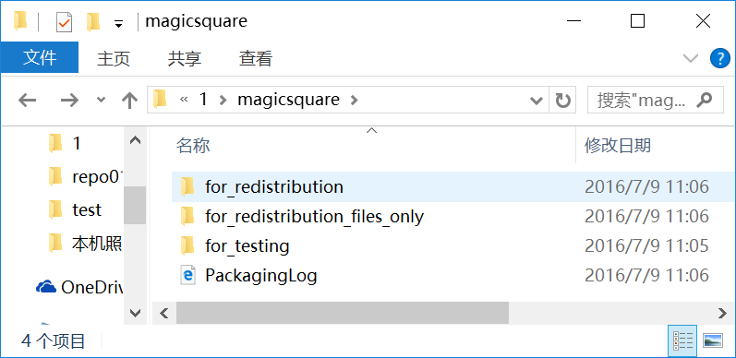
Fig.1
c. Open the for redistribution file and install the “MyAppInstaller_web.exe”as shown in Fig.2
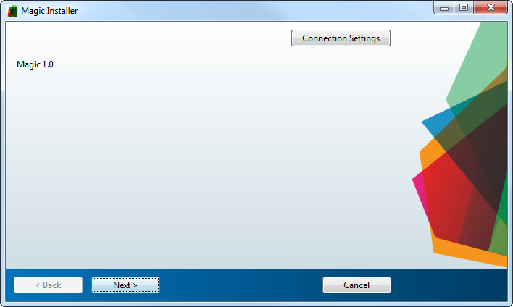
Fig.2
d. Follow the instructions until the .exe file are installed as shown in Fig.3
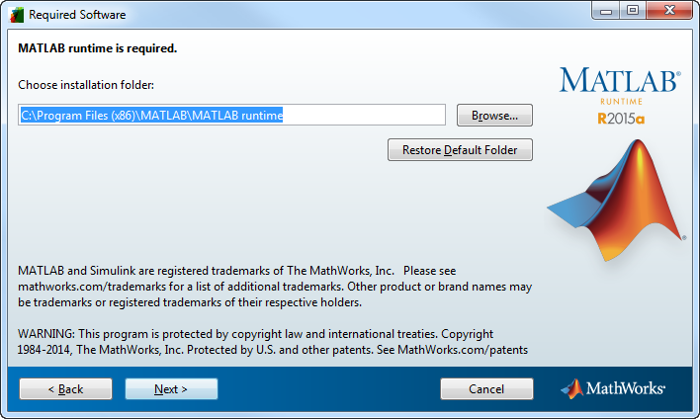
Fig.3

2. Operate the program
a. Open the main.exe in the for_testing file

