A Two-Phase Genetic Algorithm Approach for Academic Timetabling

Suryanarayan Pillai
Information Technology
St. John College of Engineering and Management
India
122suryanarayan4019@sjcem.edu.in
Raviprakash Gupta
Information Technology
St. John College of Engineering and Management
India
221raviprakash4008@sjcem.edu.in
Ayush Raut
Information Technology
St. John College of Engineering and Management
India
122ayush4004@sjcem.edu.in
Mr.Pankaj Kumar
Information Technology
St. John College of Engineering and Management
India
pankajk@sjcem.edu.in

Abstract—Timetable generation in curriculum-based programs is a challenging scheduling problem, especially when schedules must be created simultaneously for multiple academic years. While lecture sessions can be accommodated in larger classrooms, practical sessions are more complex due to labs having lesser capacity and the need for effective guidance and management leading to creation of batches. As a result, practical scheduling becomes the most constrained component of the timetabling process.This project presents a hybrid approach for timetabling where practical sessions are first allocated using a backtracking algorithm. After fixing practicals, Genetic Algorithm (GA) is used to schedule lectures while avoiding conflicts. The proposed method ensures clash-free scheduling across all academic years.
Keywords— Timetable scheduling, curriculum-based scheduling, Genetic Algorithm (GA), Backtracking algorithm, Laboratory scheduling

Introduction
Timetable generation for academic institutions includes assigning lectures, practical sessions, instructors, rooms on different available time slots while satisfying the institution constraints. In curriculum-based programs, each academic year follows a fixed set of subjects, and timetables must be prepared simultaneously for multiple years. In this the student conflicts are minimized which makes the problem easier.
Practical sessions are more difficult than lectures due to limited laboratory capacity and specialized infrastructure. While Lectures are conducted in classrooms with higher capacities and even if a classroom is not able to then they are further divided into divisions which can be treated as another year only. Due to the lab constraints, students in a single year are divided into smaller batches due to the capacity limitations of the laboratories and to ensure effective supervision and meaningful student teacher interaction. However, these batches cannot be scheduled independently. Since lectures require the entire year to attend together, all batches of a course must have their practical sessions in the same time slot. Therefore, the practical scheduling becomes difficult to schedule as compared to the lectures.
Manual timetable preparation is time-consuming and prone to conflicts, particularly in multi-year programs with shared resources. Automated approaches such as constraint-based, heuristic, and metaheuristic methods—including Genetic Algorithms (GA)—have been explored. However, satisfying strict laboratory-related constraints while being scalable and fast remains challenging. This work presents a hybrid approach in which practical sessions are first allocated using a backtracking algorithm to satisfy laboratory capacity, faculty availability, and required teaching hours. An occupancy matrix is then constructed to track resource usage, after which a Genetic Algorithm schedules lecture sessions while avoiding inter-year conflicts.

Related work
Timetable generation in universities is modeled as the University Course Timetabling Problem (UCTP), which involves assigning courses to time slots, rooms, and instructors while avoiding conflicts and satisfying institutional constraints. It is mostly divided into Curriculum-Based Course Timetabling (CB-CTT) and Post-Enrollment Course Timetabling (PE-CTT). This study is on the curriculum-based setting, where each academic year follows a fixed set of subjects.
The problem is considered NP-hard because multiple constraints must be handled simultaneously, and its complexity increases with institutional size [1]. Early approaches relied on manual scheduling and simple heuristics, but later research applied mathematical models such as Integer Programming and Constraint Programming [2]. As problem size grew, metaheuristic methods like Genetic Algorithms, Tabu Search, and Simulated Annealing became popular for producing near-optimal solutions efficiently [3]. Genetic Algorithms, in particular, showed strong results in benchmark studies such as the International Timetabling Competition (ITC-2007) [4].
One persistent challenge in departmental scheduling is the allocation of practical sessions. Unlike lecture sessions, laboratory sessions require labs with limited capacity. In multi-year undergraduate programs, accommodating all student batches within available laboratory resources increases the scheduling complexity. Many systems handle lectures and practical sessions simultaneously, which expands the search space and can reduce overall efficiency.
To manage this complexity, hybrid strategies that combine deterministic and evolutionary methods have been proposed [5]. Deterministic approaches, such as backtracking, are well suited for tightly constrained tasks like laboratory allocation, whereas evolutionary methods like Genetic Algorithms are effective for optimizing lecture scheduling and balancing workloads. The present work adopts such a hybrid framework to produce practical and balanced timetables for multi-year, curriculum-based academic programs.
Recent studies highlight the increasing use of hybrid meta-heuristic approaches for solving the University Course Timetabling Problem. A comprehensive survey of modern methods reports that genetic algorithms, swarm intelligence techniques, and hybrid meta-heuristics have been widely applied to generate high-quality timetables for both benchmark and real-world datasets.[6]

Proposed methodology

System Overview
The university timetabling problem considered in this work follows a curriculum-based structure where each academic year operates under a fixed semester schedule. Each year consists of a set of lecture subjects, practical subjects, laboratory batches, and a predefined weekly timetable grid.
A specific constraint in the institution is that all batches belonging to the same academic year must conduct their practical sessions at the same time, as the students in same year can attend lectures together. Because of this synchronization requirement, the scheduling process becomes more restrictive than in standard curriculum-based timetabling problems.
The scheduling model uses several institutional and academic parameters, including faculty availability, classroom and laboratory resources, student enrollment strength, batch size limits, and the required number of teaching hours for each subject per week. The institutional working time grid is used for calculating available time slots. These parameters together determine the feasible space for timetable generation.

Constraint Modelling
To generate a valid timetable, the system considers two types of constraints: hard constraints and soft constraints.
Hard constraints are mandatory and must always be satisfied.
Global Hard Constraints:
Applied on both lecture and practical scheduling.
- A teacher cannot be assigned to more than one session in the same time slot.
- A classroom or laboratory cannot host more than one session at the same time.
- A student cannot attend more than one session simultaneously.
- Room or laboratory capacity must not exceed the number of assigned students.
- Once a subject or practical is assigned to a teacher, the same teacher must handle it for the entire timetable.
Practical-Specific Hard Constraints:
The following constraints apply only to practical sessions.
- If a practical slot is assigned to an academic year, all batches of that year must have practical sessions.
- Once a laboratory is allocated to a batch, the same laboratory is used for all practical sessions of that batch.
- The required weekly practical hours for each subject must be satisfied exactly.
- A maximum of two practical sessions can be assigned to a batch in a single day.

Soft Constraints:
Applied only on lectures. Soft constraints are not mandatory but help improve the quality of the timetable. Violations of these constraints are penalized during optimization.
- Minimising free slots between lectures
- Maintaining balanced teaching loads for faculty members
- Distributing lectures evenly across the week

Two-Phase Scheduling Strategy
The scheduling process is divided into two stages. First, practical sessions are assigned using a backtracking algorithm. Then, the remaining lecture sessions are scheduled using a Genetic Algorithm (GA).
Practical sessions are handled first because they require strict coordination of batches, laboratories, and instructors, which significantly limits feasible scheduling options. A backtracking approach ensures that these sessions are assigned without conflicts, reducing the search space for phase two.
Once a feasible practical timetable is found, those time slots are fixed and recorded. The Genetic Algorithm then schedules lectures in the remaining slots around the practical sessions. The overall workflow of the proposed hybrid scheduling strategy is illustrated in Figure 1.

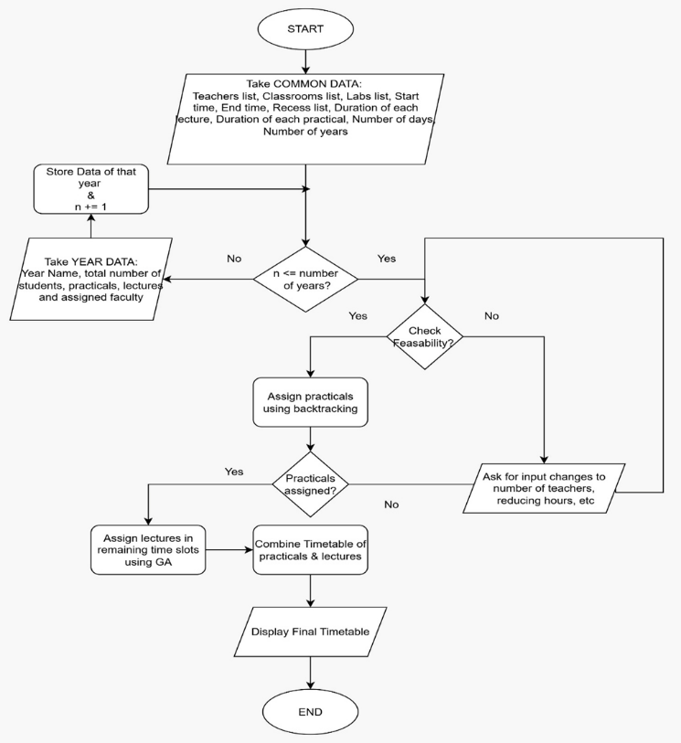
Fig. 1. Flowchart of the Proposed Approach
Practical Scheduling:
In this phase, only practical sessions are scheduled. The synchronized scheduling of batches makes the practical scheduling more difficult. For example, let’s take a single academic year/class with 60 students and average lab capacity of 20. Due to the limited lab capacity and for effective management, the 60 students are divided into 3 batches (B1, B2, B3) each containing 20 students for only practical sessions. Which means that all batches must have practical Sessions at the same time so that they can attend the lectures together. But each batch can have a different practical session in separate labs with different instructors.
A Single practical time slot of a year for this example is shown in Table I.
- Example of one slot of practical
Batch | Practical | Lab | Teacher
B1 | AIML Lab | L1 | F1
B2 | IP Lab | L2 | F2
B3 | CN Lab | L3 | F3

Multiple such slots are assigned in the practical timetable until all batches complete each practical’s required number of hours given by the user. The program keeps tracks of the number of sessions assigned to the batch and continues allocating practical slots until all the constraints are met.
We used a simple backtracking algorithm to create the practical’s timetable. Then the time slots which are occupied by practical’s are removed from the available timeslots and a matrix is created to track teachers, labs occupancy which is used by the GA.
In some cases, it is not possible to generate a valid practical timetable due to insufficient resources. Therefore, first a basic feasibility check is done to determine if the resources given by the user are feasible to generate the practical timetable as well as the lecture one.
Lecture Scheduling:
After fixing the practical timetable, lectures are scheduled using Genetic Algorithm in remaining free time slots. In this phase, each chromosome represents a possible lecture slot containing information about the subject, instructor, classroom, and time slot. The initial population is generated randomly while respecting the constraints such as number of hours of each lecture and faculty eligibility set by the user. It also avoids assigning lectures with teachers occupied in practicals of other academic years, which reduces the convergence time of the Genetic Algorithm.
An individual is a complete timetable of all academic years. The fitness function is used to evaluate each individual, based on the hard constraints and additional soft constraints. Hard constraints are given higher penalties as they should be always satisfied to create a valid usable timetable and soft constraints are given lower penalty. Soft constraints improve the overall quality of the timetable. We assigned higher weight to the soft constraint of minimizing free slots between non-free slots among the other soft constraints.
The GA uses standard evolutionary operators including tournament selection, one point crossover which chooses a random day as the point of crossover between the two parents. Elitism is applied so that the best solutions from one generation are carried forward and not lost.
After the program reaches the set number of generations or a set fitness score, it is stopped and the final timetable is shown along with a bar chart to visualize teachers hours assigned over the entire timetable, which helps user improve the practical-faculty pairing.

Justification of Two phases
Traditional single stage Genetic Algorithm approaches for timetable generation are effective in finding feasible timetables, but the time taken by them is also more. The practical scheduling for batches introduce a lot of constraints, which increases the time taken by GA to find a solution. To make the timetable generation faster, we used the two phases.
The approach separates the problem by first handling the more difficult and constrained part of practicals using a deterministic method of backtracking. By fixing the practicals before, the overall search space is significantly reduced, allowing the Genetic Algorithm to operate more effectively for lecture scheduling. This increases the efficiency of the search process.

Experimental Setup

Dataset description
The evaluation dataset is of a curriculum-based academic program consisting of three different academic years. Lecture subjects requiring on average 4 sessions weekly and each lecture session is of 1 hour, while practical subjects are conducted once per week occupying 2 hours but divided into multiple batches due to laboratory capacity limitation. Table II and Table III show the important details about the dataset and the parameters set for Genetic Algorithm respectively.
The problem size is the sum of total lecture sessions and practical batch sessions of all academic years. Execution time is measured from start of the practical scheduling phase till the lecture scheduling phase and generation of the complete timetable obtained by combining the two.
- Dataset parameters
Parameter | Value
Number of Academic Years to generate timetables of | 3
Total Number of Teachers | 12
Total Labs | 4
Total Classrooms | 3
Total Lecture Subjects | 16
Total Practical Subjects | 12
Practical batches/year | 3
Total Weekly timetable slots for each academic year | 30
- Genetic algorithm parameters
Parameter | Value
Population size | 50
Generations | 200
Crossover Rate | 0.8
Mutation Rate | 0.2
Selection Method | Tournament selection
Crossover Method | One point crossover

Results and Discussion

Execution Time Analysis
Table IV represents the execution time required to generate timetables of different sizes derived from all three academic years.
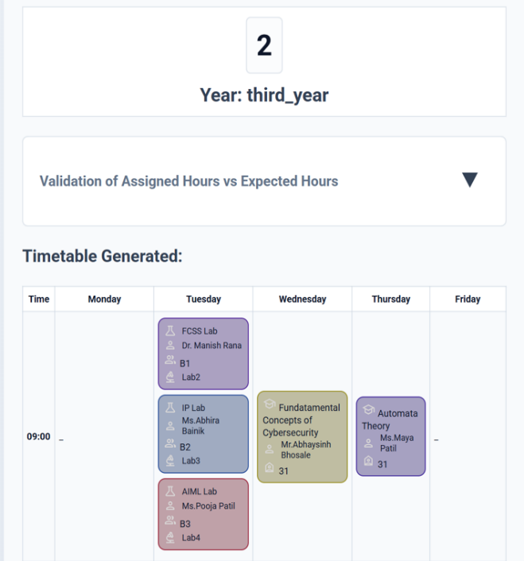
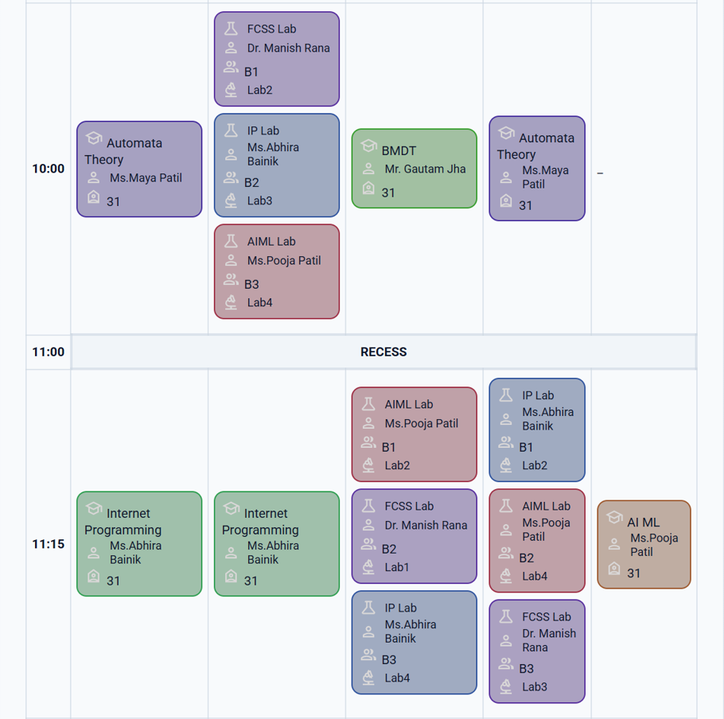
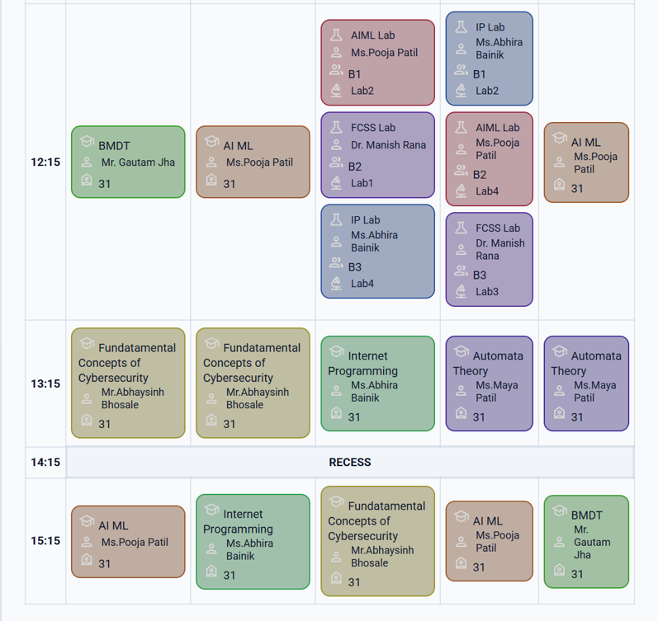
- execution time analysis table
Academic Year | Practical Events | Lecture Events | Problem Size | Practical Scheduling Time (s) | Lecture Scheduling Time (s) | Total Time (s)
Only  Year 1 | 15 | 15 | 30 | 0.12 | 1.45 | 1.57
Only  Year 2 | 9 | 21 | 30 | 0.25 | 1.68 | 1.93
Only  Year 3 | 12 | 13 | 25 | 0.08 | 1.41 | 1.42
All Years | 36 | 49 | 85 | 0.28 | 3.57 | 3.85

The results show that timetable generation remains computationally efficient even as the problem size increases. Practical scheduling is faster as we are scheduling them first without any lectures and backtracking algorithm is able to find a solution easily. The lecture scheduling phase is slower as it uses GA to arrange lecture sessions in between the practical time slots using multiple generations.
When timetable for all 3 years was generated simultaneously, the problem size increased to 85 and despite that complete timetable that satisfied the constraints was produced under 4 seconds, indicating that the proposed methodology scales reasonably for medium sized departments.
Comparing to a standard Genetic Algorithm that schedules both lectures and practicals together is expected to struggle with strict synchronization constraints, leading to larger infeasible areas in the search space. Whereas the proposed approach reduces the complexity by separating the practical scheduling, resulting in faster convergence.

System Output
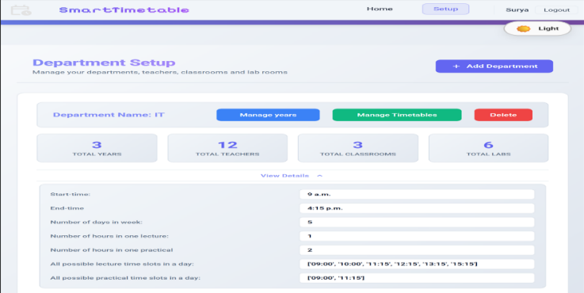
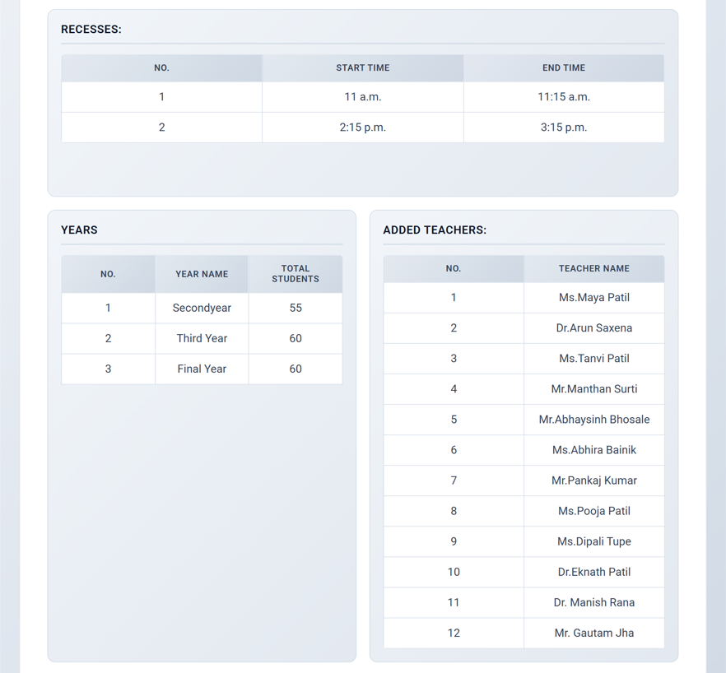
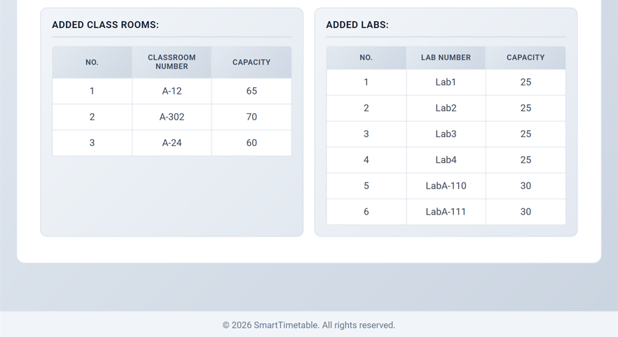
The system provides a user friendly interface for managing and generating timetables. Fig. 2 shows the department page.
Fig. 2. Department dashboard showing input parameters for timetable generation
Fig. 3. Generated timetable of one single year
The project was implemented using Python along with DEAP library for implementing Genetic Algorithm. The frontend was created using HTML, CSS, Javascript. The backend was created using Django framework and SQLite was used for database which is configured in Django.
The User interface is divided into four pages. First page being the dashboard where we show all the department’s resources such as timeslots, recess time slots, teachers, classrooms, laboratories, and academic years added. The second page is for managing years which allows users to add new years or change data from existing years added by them. It also displays a pie chart that visualizes the distribution of time across categories of recess hours, free hours, practical hours, lecture hours. The third page allows users to actually generate the timetable for that department and also displays timetables saved by the users. The final fourth page is for displaying the generated or saved timetable which also shows a bar chart of assigned hours vs teachers that visualizes teachers workload across all academic years.
When timetable for all 3 years was generated simultaneously, the problem size increased to 85 and despite that complete timetable that satisfied the constraints was produced under 4 seconds, indicating that the proposed methodology scales reasonably for medium sized departments. The generated timetable scheduled the practicals and lectures effectively without any conflicts. Fig. 3 shows the timetable of one single academic year.

Limitations
Despite the computational efficiency, the proposed approach has some limitations. The more constrained part of practical scheduling is assigned before the less constrained part of lecture scheduling which reduces the flexibility in lecture placements, as the genetic algorithm has to fit lectures around fixed practicals. But if the less constrained part is larger and has more search space then theoretically is would not lead to this problem.
But the lecture scheduling had a large number of possible arrangements and was less constrained than the practicals. This allowed the Genetic Algorithm to effectively explore the remaining search space and generate feasible timetables despite having reduced flexibility.
This trade-off reflects the decision to prioritize the feasibility of high constrained components over the flexibility of less constrained ones.

Conclusion and Future Work
In this study we focused on the problem of curriculum based timetable generation, where multiple academic years share common resources such as teachers, classrooms, and laboratories. In this the practical sessions where more difficult to manage due to limited laboratory capacity which leads to the need of dividing each academic years into batches only for practicals. This differentiates the practicals from lectures because of the need to coordinate multiple batches at the same time.
To address these challenges, a two-phase approach is used. In the first phase, practical sessions are scheduled using a backtracking method to ensure that all practical specific constraints are satisfied. Once a practical timetable is found, they are fixed and then lectures are scheduled in the remaining time slots using a Genetic Algorithm.
Results show that this approach is able to generate feasible timetables in less time while satisfying all required constraints. By separating the hard constrained part with less constrained part leads to reduction of overall complexity.
Looking ahead, we plan to create a detailed comparison between the proposed approach and a standard Genetic Algorithm, where both practical and lecture sessions are scheduled together. This would help us further evaluate the effectiveness of the hybrid approach in terms of feasibility and computational efficiency.

References
- A. Schaerf, “A survey of automated timetabling,” Artificial Intelligence Review, vol. 13, no. 2, pp. 87–127, 1999.
- E. K. Burke and S. Petrovic, “Recent research directions in automated timetabling,” European Journal of Operational Research, vol. 140, no. 2, pp. 266–280, 2002.
- D. E. Goldberg, Genetic Algorithms in Search, Optimization, and Machine Learning. Addison-Wesley, 1989.
- E. K. Burke et al., “The second international timetabling competition (ITC-2007): Curriculum-based course timetabling,” Annals of Operations Research, vol. 194, no. 1, pp. 7–30, 2012.
- S. Abdullah, E. K. Burke, and B. McCollum, “A hybrid evolutionary approach to the university course timetabling problem,” IEEE Transactions on Evolutionary Computation, vol. 16, no. 1, pp. 86–98, 2012.
- S. Ahmadi et al., “Meta-heuristic approaches for the university course timetabling problem: A survey,” Computers & Operations Research, 2023.
- K. Socha, J. Knowles, and M. Sampels,“A MAX–MIN ant system for the university course timetabling problem,” Lecture Notes in Computer Science, vol. 2463, pp. 1–13, 2002.
- E. K. Burke, J. P. Newall, and R. F. Weare, “A memetic algorithm for university exam timetabling,” Proceedings of the International Conference on the Practice and Theory of Automated Timetabling (PATAT), 1996.
- B. McCollum, “A perspective on bridging the gap between theory and practice in university timetabling,” Practice and Theory of Automated Timetabling, Lecture Notes in Computer Science, vol. 2740, pp. 3–23, 2003.
- E. K. Burke and J. P. Newall, “Enhancing timetable solutions with local search methods,” Practice and Theory of Automated Timetabling, Lecture Notes in Computer Science, vol. 2079, pp. 195–206, 2001.

