# 

# TRIBHUVAN UNIVERSITY

**FACULTY OF HUMANITIES AND SOCIAL SCIENCES**

**Boxing Club Registration System**

**A PROJECT REPORT**

**Submitted To**

**Department of ComputerApplication**

**Model Campus Damak**

**In partial fulfillment of the requirement for the bachelors in Computer Application**

Submitted By

Dibash Khatiwada

DATE OF SUBMISSION:

Under the Supervision of

**Mr.Randhir Kumar Singh**



**Tribhuvan University**

**Faculty of Humanities and Social Sciences**

**Model Campus Damak**

**Supervisor’s Recommendation**

I hereby recommend that this project prepared under my supervision by “**Dibash Khatiwada”** entitled “**Boxing Club Registration System”** in partial fulfillment of the requirements for the degree of Bachelor of Computer Application is recommended for the final evaluation.

**SIGNATURE**

Randhir Kumar Singh

SUPERVISOR

Model Campus Damak

Deparement of Science and Technology

Damak



**Tribhuvan University**

**Faculty of Humanities and Social Sciences**

**Model Campus Damak**

**LETTER OF APPROVAL**

This is to certify that this project prepared by **Dibash Khatiwada** entitled “**Boxing Club Registration System”** in partial fulfillment of the requirements for the degree of Bachelor in Computer Application has been evaluated. In our opinion it is satisfactory in the scope and quality as a project for the required degree.

| **SIGNATURE**  Mr. Randhir Kumar Singh  Supervisor | **SIGNATURE**  HOD/ Coordinator |
| --- | --- |
| SIGNATURE  Internal Examiner | SIGNATURE  External Examiner |

**ABSTRACT**

As modern technologies evolve, the process of managing registrations and event details online is rapidly transforming. For boxing event organizers, handling registrations, maintaining participant records, and distributing necessary information can be challenging. The Boxing Registration System provides a streamlined approach for both participants and organizers to manage the registration process, event details, and important documents. Participants can register for events from anywhere, and organizers can manage these registrations efficiently. Generally, the system is managed by an administrator.

The Boxing Registration System is a web-based framework specifically designed for boxing events. The project is developed in Visual Studio using HTML, CSS, JavaScript, and PHP as the primary programming languages. The application allows users to register for events, view schedules, and access important event-related documents easily. This system caters to participants who are interested in registering for boxing events, and it offers free access to event information and documents. Users can register and access event details from anywhere at any time, provided they have internet access on their devices.

While the current implementation does not include all possible event features and details, it has the scope for customization and expansion to become a fully developed system encompassing comprehensive event management functionalities.

**Table of contents**

**Preliminary**

* Supervisor's Recommendation .................................................................. 2
* Letter of Approval ...................................................................................... 3
* Abstract ....................................................................................................... 4
* List of Abbreviations ................................................................................... 6
* List of Figures ..............................................................................................7
* List of Tables ...............................................................................................8

**Main Content**

**Chapter 1: Introduction**

1.1 Introduction .................................................................................................9   
1.2 ProblemStatement........................................................................................9   
1.3 Objectives ................................................................................................... 9   
1.4 Scope and Limitations ................................................................................9,10   
1.4.1 Scope ....................................................................................................... 9   
1.4.2 Limitations ...............................................................................................10  
1.5 Report Organization ....................................................................................10

**Chapter 2: Requirement Analysis and Litreture Review**

2.1 Background Study .......................................................................................11   
2.2 Literature Review ........................................................................................12

**Chapter 3: System Analysis and Design**

3.1 System Analysis ..........................................................................................13  
3.1.1 Requirement Analysis ..............................................................................14  
3.1.2 Feasibility Analysis .................................................................................15,16  
3.1.3 Data Modeling (ER-Diagram) ..................................................................17

3.2 System Design .............................................................................................18   
3.2.1 Architectural Design .................................................................................19   
3.2.2 Database Design Schema...........................................................................20   
3.2.3 Interface Design ........................................................................................21   
3.2.4 Physical DFD ............................................................................................22

**Chapter 4: Implementation and Testing**

4.1 Implementation ............................................................................................23   
4.1.1 Tools Used ................................................................................................23  
4.1.2 Implementation Details of Modules .........................................................24

4.2 Testing .........................................................................................................24  
4.2.1 Test Cases for Unit Testing.......................................................................25  
4.2.2 Test Cases for Integration Testing ............................................................26

**Chapter 5: Conclusion and Future Recommendation**

5.1 Lesson Learnt/Outcome ..............................................................................27  
5.2 Conclusion ..................................................................................................27  
5.3 Future Recommendation .............................................................................27

**Appendix** ..................................................................................................28,29

**References/Citation** .................................................................................30

**LIST OF ABBREVIATIONS**

**PHP** Hypertext Pre-processor

**HTML** Hypertext Markup Language

**PC** Personal Computer

**BCA** Bachelor in Computer Application

**MySQL** My Structured Query Language

**WIFI** Wireless Fidelity

**OS** Operating System

**GUI** Graphical User Interface

**IDE** Integrated Development Environment

**API** Application Programming Interface

**OOP** Object Oriented Programming

**App** Application

**UI** User Interface

**ER** Entity Relationship

**HOD** Head of Department

**CSS** Cascading Style Sheet

**CSIT** Computer Science and Information Technology

**TU** Tribhuvan University

**LIST OF FIGURES**

**Figure 1**: Waterfall Model for Boxing Registration System...................................13

**Figure 2**: Use Case Diagram for Boxing Registration System...............................14

**Figure 3**: ER-Diagram for Boxing Registration System........................................18

**Figure 4**: Architectural Design of Boxing Registration System.............................19

**Figure 5**: Database Schema Design of Boxing Registration System.....................20

**Figure 6**: Login Page of Boxing Registration System............................................21

**Figure 7**: Admin Dashboard of Boxing Registration System................................22

**Figure 8**: Registration Page of Boxing Registration System.................................23

**Figure 9**: DFD Diagram of Boxing Registration System......................................23,24

**LIST OF TABLES**

**Table 1**: Gantt Chart for Boxing Registration System ...........................................17

**Table 2**: Test Case for User Registration of Boxing Registration System ............26

**Table 3**: Test Case for User Login of Boxing Registration System ......................26

**Table 4**: Black Box System Testing ......................................................................27

**CHAPTER 1**

**INTRODUCTION**

**1.1 Introduction**

The Boxing Registration System is a web-based application designed to transform the current manual registration process for boxers entering competitions into a streamlined, digital experience. This system addresses the inefficiencies and inaccuracies inherent in the traditional method, which often relies on paper forms and manual data entry. By digitizing the registration process, the system aims to provide a more efficient and user-friendly solution that can be accessed from anywhere, eliminating the need for physical presence or postal submissions. This approach not only speeds up the registration process but also enhances the accuracy of the data collected, reducing errors associated with manual entry.

Additionally, the Boxing Registration System offers robust data management capabilities, allowing for easy storage, retrieval, and analysis of boxer information. This digital solution supports competition organizers by automating administrative tasks, thereby freeing up time to focus on other important aspects of event planning and management. The system's user-friendly interface ensures that both boxers and organizers can navigate the registration process with ease, improving overall satisfaction. This document outlines the problem statement, objectives, scope, limitations, and the overall organization of the report, providing a comprehensive overview of the system and its benefits.

**1.2 Problem Statement**

The manual registration process for boxing competitions is time-consuming, prone to errors, and often leads to mismanagement of data. This inefficiency can result in registration delays, lost records, and difficulties in managing large volumes of participant information. There is a need for a digital system that can handle registrations efficiently, maintain accurate records, and provide easy access to information.

**1.3 Objectives**

The objectives of the Boxing Registration System are as follows:

* To develop a web-based platform for boxer registrations and ensure the accuracy and integrity of registration data.

**1.4 Scope and Limitations**

**1.4.1 Scope**

* The system will support boxer registrations for various competitions.
* It will include modules for user management, registration management
* The system will be accessible via web browsers on PCs and mobile devices.

**1.4.2 Limitations**

* The system will require internet access to function.
* Initial deployment will focus on regional competitions before expanding to national or international levels.
* Data migration from existing manual records to the digital system is beyond the initial scope.
* Payment Gateway is not available.

**1.5 Report Organization**

**Introduction**

This section provides an overview of the project, including the problem it addresses, its objectives, and its scope and limitations.

**Background Study and Literature Review**

This section reviews existing literature and studies related to digital registration systems, focusing on their benefits, challenges, and implementation in sports, particularly boxing.

**System Analysis and Design**

This section details the system requirements, analysis of the current manual process, and the design of the proposed system. It includes data modeling, process modeling, and architectural design.

**Implementation and Testing**

This section describes the tools used for development, the implementation process, and the testing methodologies employed. It includes test cases for unit testing and system testing to ensure the system functions correctly.

**Conclusion and Future Recommendation**

This section summarizes the outcomes of the project, lessons learned, and provides recommendations for future enhancements and potential expansions of the system.

## Chapter 2

## Background Study and Review

### 2.1 Background Study

The need for a Boxing Registration System arises from the inefficiencies and challenges associated with the traditional manual registration process. This section provides an overview of the current practices in boxer registration and the inherent problems they pose.

#### 2.1.1 Current Registration Process

In many boxing organizations, the registration process for competitions involves filling out paper forms, manual data entry, and physical storage of records. This process is not only time-consuming but also prone to errors such as data duplication, loss of records, and difficulty in retrieving information.

#### 2.1.2 Challenges of the Manual System

* **Inaccuracy**: Manual data entry increases the risk of errors in boxer information, which can lead to issues during competition.
* **Inefficiency**: Handling large volumes of paper forms is cumbersome and slows down the registration process.
* **Data Management**: Storing and organizing physical records is challenging, making it difficult to access and update information quickly.
* **Security**: Paper records are susceptible to damage or loss due to environmental factors or mishandling.

### 2.2 Literature Review

This section reviews existing literature on digital registration systems, focusing on their implementation in sports and the benefits they offer over traditional methods.

#### 2.2.1 Digital Registration Systems in Sports

Research indicates that digital registration systems have been successfully implemented in various sports, offering improved efficiency, accuracy, and data management. Studies highlight the positive impact of such systems on participant experience and administrative processes.

* **Efficiency and Time-Saving**: According to a study by Smith et al. (2020), digital registration systems reduce the time required for registering participants by up to 50%, allowing organizations to manage more registrations in less time.
* **Data Accuracy and Integrity**: Jones and Brown (2019) found that digital systems significantly decrease data entry errors, ensuring that participant information is accurate and up-to-date.
* **Enhanced User Experience**: Digital platforms provide a user-friendly interface that allows participants to register easily from any location, improving the overall experience for users .

**2.2.2 Case Studies of Digital Registration Systems**

Several case studies demonstrate the successful implementation of digital registration systems in various sports organizations:

* **Youth Soccer Leagues**: A case study by the National Youth Soccer Organization (2019) showed that implementing a digital registration system resulted in a 60% increase in registration efficiency and a 40% reduction in administrative workload.
* **Marathon Events**: The Boston Marathon's transition to an online registration system in 2018 led to improved data management and enhanced security, as reported by the event's organizing committee.

#### 2.2.3 Feasibility Analysis for Boxing Registration System

The feasibility of implementing a digital registration system for boxing is supported by the success of similar systems in other sports. Key factors to consider include:

* **Technical Feasibility**: Modern web development technologies and tools make it feasible to develop a robust and scalable registration system. Cloud-based solutions can ensure data security and accessibility.
* **Economic Feasibility**: The initial investment in developing the system can be offset by long-term savings in administrative costs and improved efficiency.
* **Operational Feasibility**: Training staff and users to operate the digital system can be achieved through comprehensive guides and support, ensuring a smooth transition from the manual process.

## Chapter 3: System Analysis and Design

### 3.1 System Analysis

#### 3.1.1 Requirement Analysis

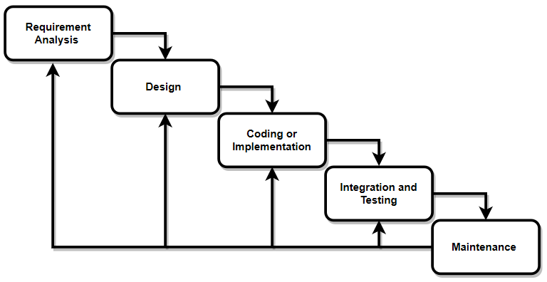This report is designed for developing a Boxing Registration System targeting students. In the process of designing, different steps were taken into consideration. Among the different steps, the major steps involved an analysis of various functional and non-functional requirements, gathering and feasibility study carried out as part of system analysis. Similarly, process modeling and data modeling were also drawn for analyzing purposes to develop the system according to the requirements.

fig1:waterfall model

**i. Functional Requirements**

* **User Registration and Login**: The system must allow new users to register and existing users to log in using a secure authentication process.
* **Event Registration**: Users must be able to register for boxing events and view their registration status.
* **Administration Module**: Administrators should have the capability to manage events and view registrations.
* **Search** : The system must provide search functionality for admin.

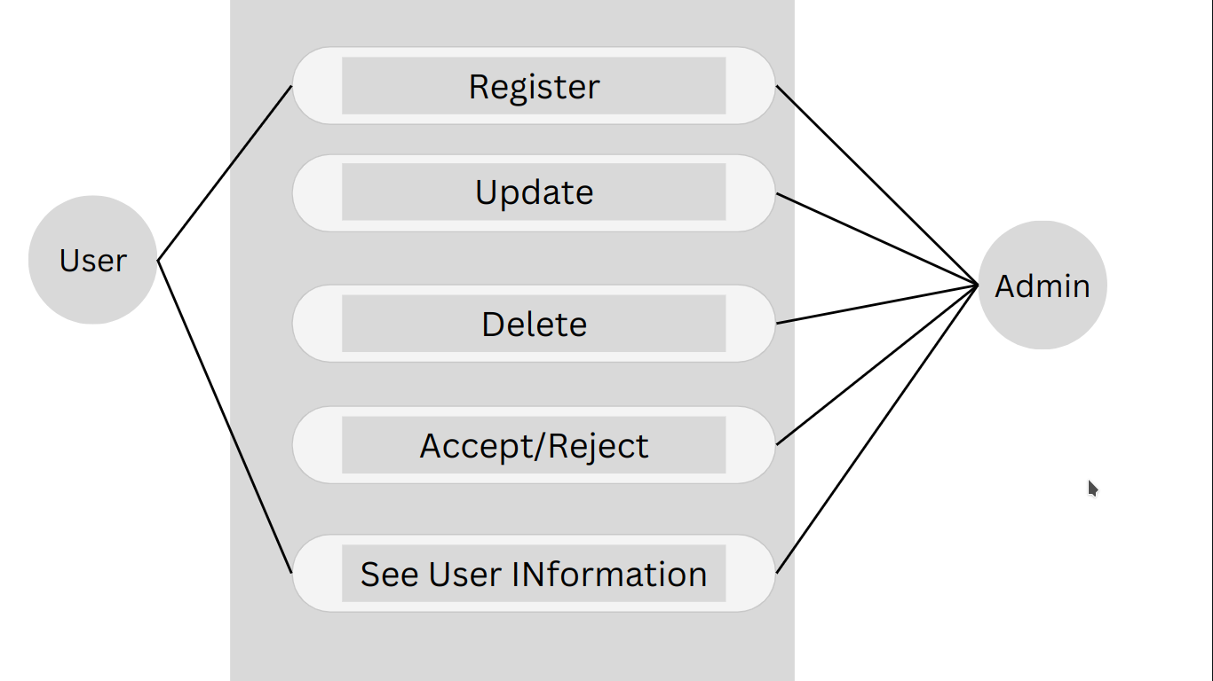

fig 2:Use case diagram for Boxing club Registration

##### ii. Non-Functional Requirements

* **Performance**: The system should be able to handle multiple simultaneous users without performance degradation.
* **Usability**: The interface should be user-friendly and intuitive, ensuring ease of use for all types of users.
* **Security**: The system must ensure data protection through secure data transmission and storage practices.
* **Scalability**: The system should be designed to accommodate future growth in the number of users and events.
* **Reliability**: The system should be available with minimal downtime and ensure data integrity.

#### 3.1.2 Feasibility Study

##### i. Technical Feasibility

In order to develop the system, various software and hardware technologies were considered, with Visual Studio being one of the most commonly used technologies. Visual Studio proved to be a technically viable option for developing the system. Some non-technical hurdles were also encountered during the system development.

**ii. Economic Feasibility**

This system does not require any additional hardware or software; it is developed using existing resources and technologies. Therefore, there is no additional cost other than the internet connection.

**iii.Operational Feasibility**

This project is operationally feasible, as it ensures the system can be accessed via a web browser, which is common to all and used by everyone in today's world. So, it is user-friendly.

**iv.Schedule Feasibility**

To build this project, we spent a total of 116 days. We spent 10 days in requirement gathering and analysis, 30 days in designing, 40 days in coding, 20 days in testing, and 16 days in implementation and deployment.

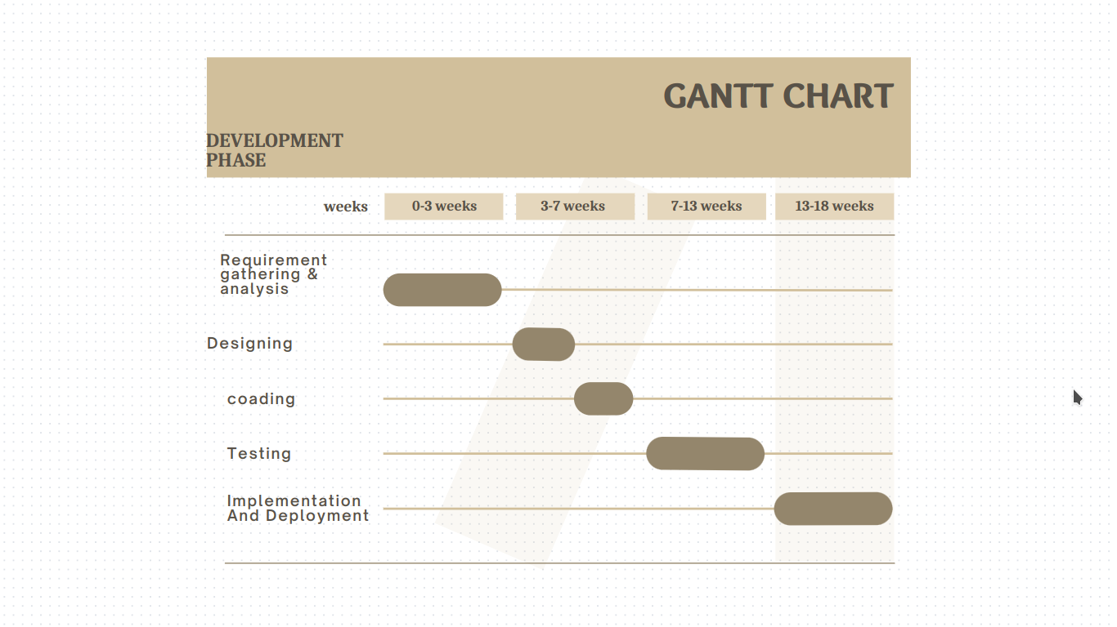

table1: Gantt chart of boxing club Registration

#### 3.1.3 Data Modeling (ER-Diagram)

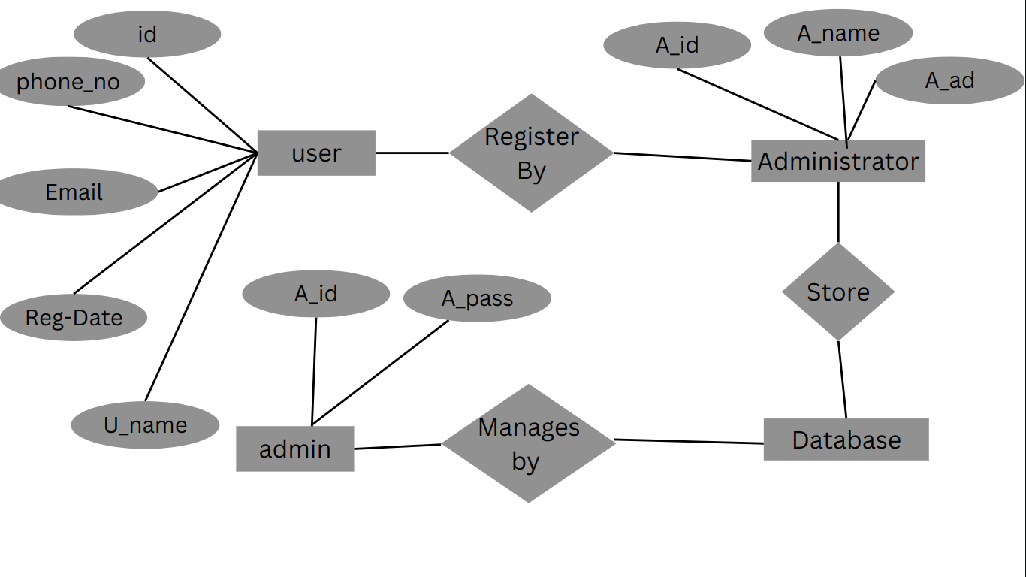The Entity-Relationship (ER) Diagram represents the data model for the Boxing Registration System. Key entities include Users, Events, Registrations, and Notifications. The ER-Diagram helps visualize the relationships between these entities.

figure 4: ER diagram of Boxing Club Registration System

### 3.2 System Design

To realize the different functional requirement of the system in graphial form different design diagram of the system has been prepared which are as follows.

**3.2.1 Architectural Design**

For this system , three tier architectre i used which includes user interface ,web server and database. In architectural design , basic architecture of the system is shown.

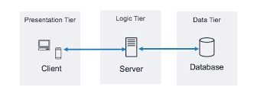

figure: Architectural Design of Boxing Registration System

The three-tier architecture is a well-established software design pattern that organizes applications into three distinct layers: the presentation layer, the application (or business logic) layer, and the data layer. The presentation layer is the user interface, where users interact with the application, typically through a web browser or mobile app. The application layer contains the business logic and processes the user inputs, making decisions and performing computations. It acts as a mediator between the presentation and data layers. The data layer is responsible for storing and managing data, typically using a database management system. This separation of concerns enhances scalability, maintainability, and flexibility, as each layer can be developed, updated, and scaled independently.

**3.2.2 Database Schema Design**

The database design involves creating a schema to define how data is stored, organized, and accessed. The design should include:

**a) Admin Table**

| Field Name | Datatype | Description |
| --- | --- | --- |
| Username  Password | Varchar(20)  varchar(8) | Admin Username  Admin Password |

**b)members Table**

| Field Name | Datatype | Description |
| --- | --- | --- |
| id  rno  name  city  pcont  Level  approved  reject | int()  int()  varchar(30)  varchar(50)  varchar(10)  varchar(30)  tinyint(1)  tinyinnt(1) | Primarykey, Uique ID  Member First Name  Member Last Name  Member Address  Members Parents contact  Basic OR Advance Booxig  member approved by admin  member approved by admin |

**c)Registration_request Table**

| Field Name | Datatype | Description |
| --- | --- | --- |
| id  email  reg_no  used | int  varchar(80)  int  int | Primary key  user Email  User Registration Number  Check the User Registration umber checked or not |

**d) Valid reg_nos Table**

| Field Name | Datatype | Description |
| --- | --- | --- |
| id  reg_no  used | int  int  int | Primary key  User Registration Number  Check the User Registration umber checked or not |

**figure:Database Schema of Boxing Registration System**

**3.2.3 Interface Design**

The interface design focuses on the user experience and usability of the system:

* **User Interface (UI)**: Designing a clean, intuitive, and responsive UI for different user roles.
* **Navigation**: Ensuring easy navigation and accessibility of features.
* **Accessibility**: Making the system accessible to users with disabilities by following best practices and guidelines.

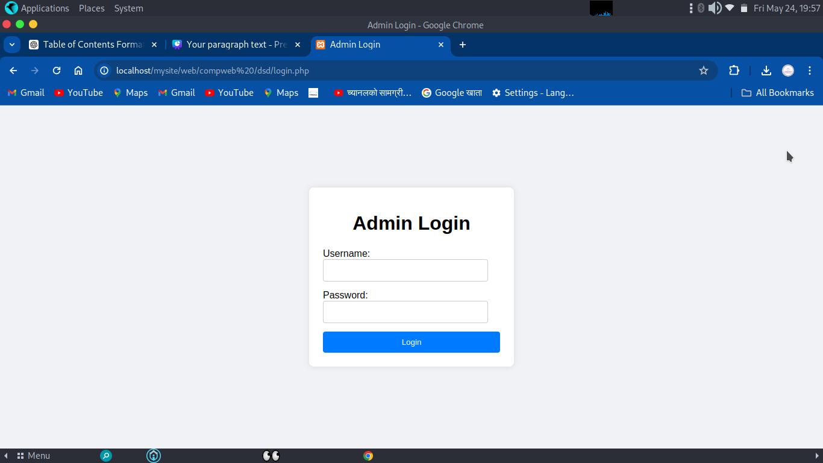

figure:Login Page of Boxing Club Registration System

figure:Admin Dashboard of Boxing Club Registration System

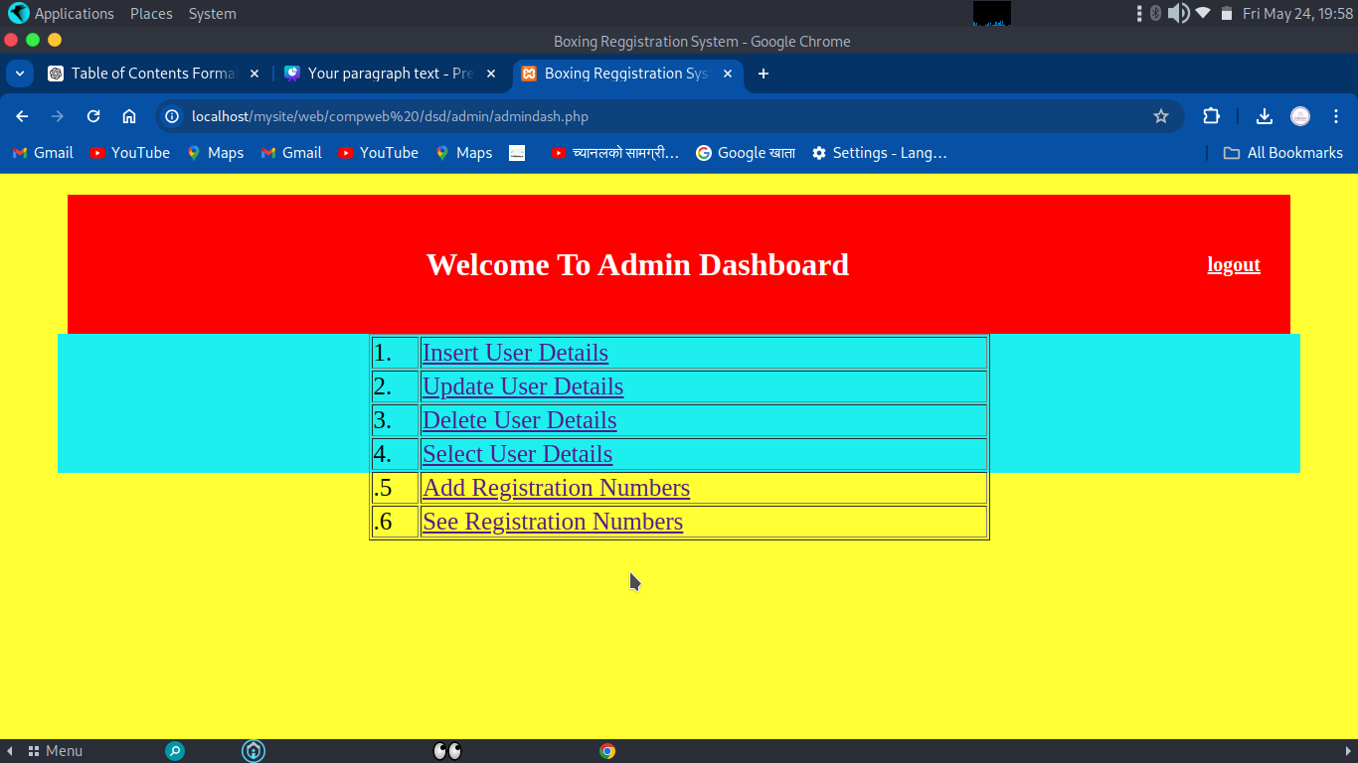

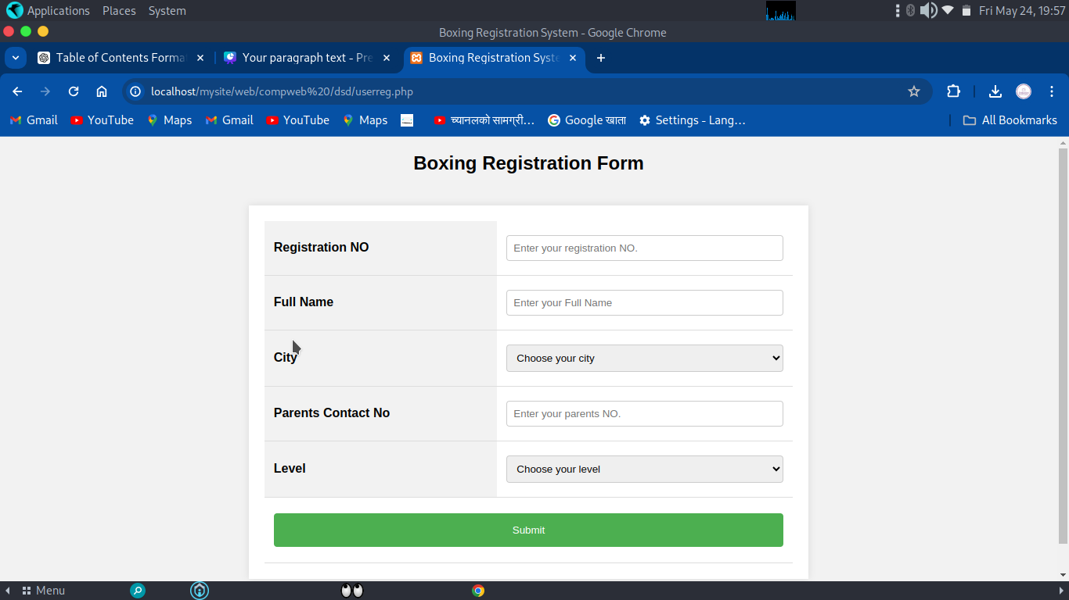

figure:registration page of Boxing Club Registration System

#### 3.2.4 DFD

The Data Flow Diagram represents the physical implementation of the system's data flow.

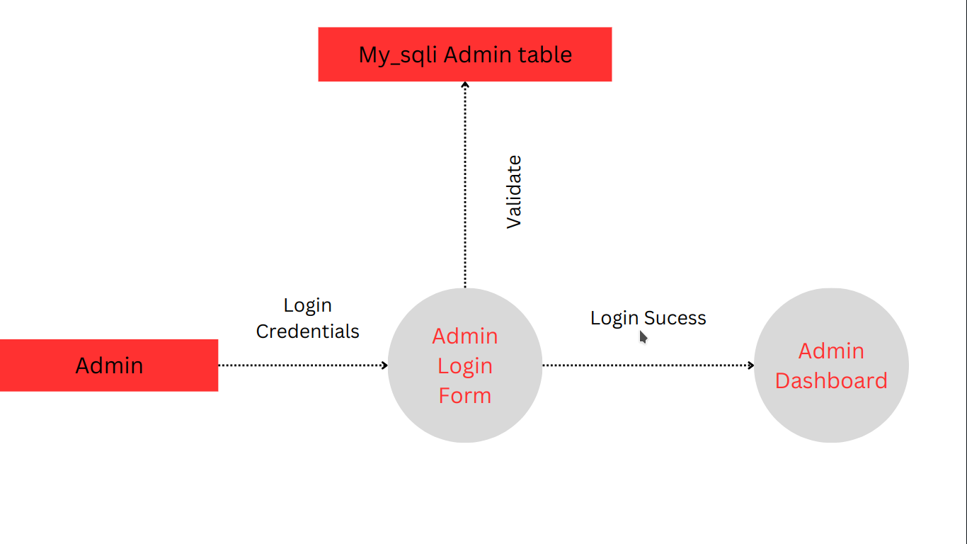

figure: 0-level Dfd of Boxing Club Registration System

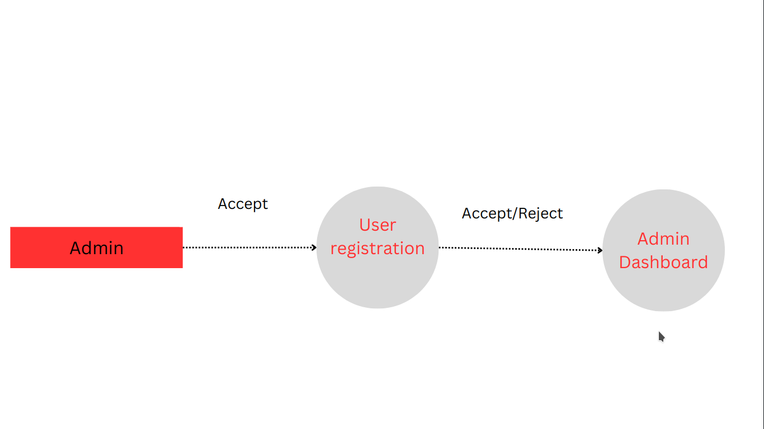

figure : one-level DFD

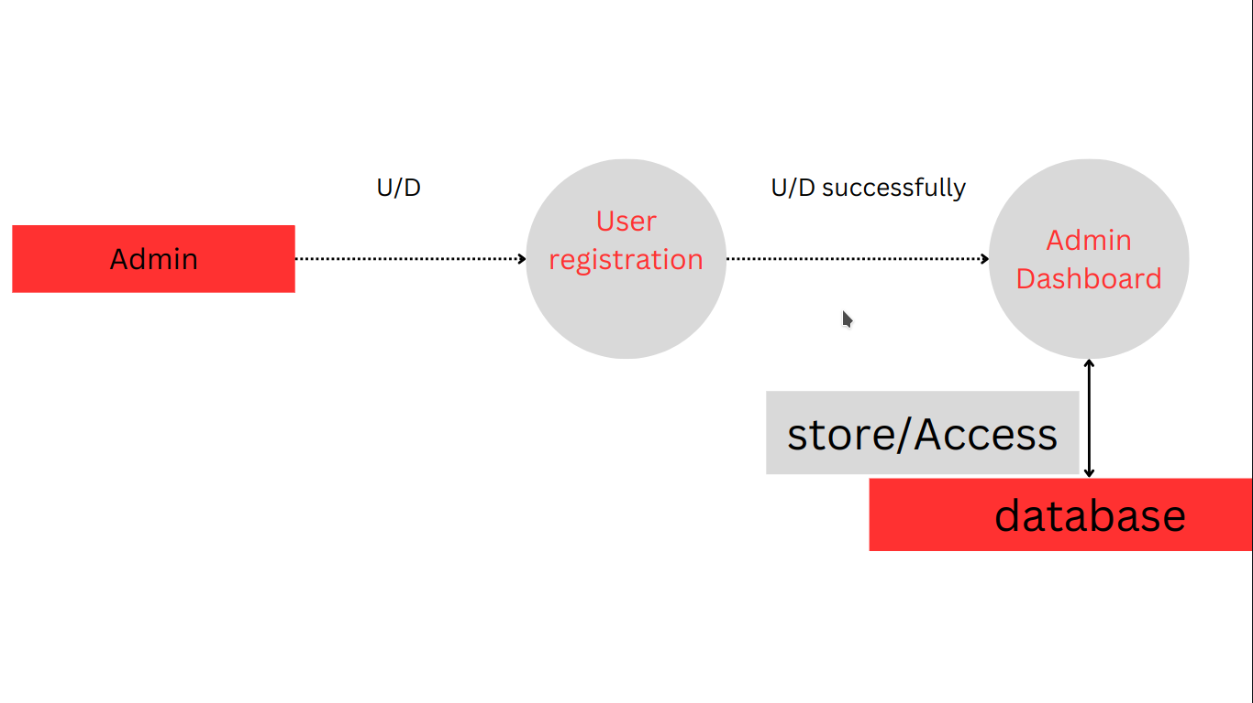

Figure:Two level DFD

**CHAPTER 4**

**IMPLEMENTATION AND TESTING**

4.1 Implementation

4.1.1 Tools Used (CASE tools,Programming Language,Database Platform)

Following are the tools and frameworks used for the accomplishment of this project:

**Front End Tools**

* **HTML**

In the Boxing Registration System, HTML is used for creating various web pages and sites. It structures sections, headings, links, and paragraphs using various tags and elements. We define headers, paragraphs, links, and images of the boxing registration system using HTML.

* **CSS**

In the Boxing Registration System, CSS is used for designing different HTML tags. It designs various components with the help of classes and IDs. Different types of CSS, such as inline CSS, internal CSS, and external CSS, are used to style this system. CSS is used for defining styles for web pages, controlling text color, font style, spacing between paragraphs, sizing of columns, layout designs, and more.

* **JavaScript**

In the Boxing Registration System, JavaScript is used for client-side validation and to make dynamic, interactive, and responsive web pages. It adds dynamic behavior and special effects to web pages.

**Back End Tools**

* **PHP**

In the Boxing Registration System, PHP is used for backend purposes and creating dynamic web pages. It is used for server-side scripting to add database connectivity, encrypt data, validate user data, confirm user access to certain pages, and manage login functionalities. PHP also allows adding, updating, and deleting data from the database.

**Server**

* **Apache Server**

In the Boxing Registration System, Apache Server is used to run PHP files and create fast and dynamic web pages.

**Database**

* **MySQL**

MySQL is used to store all information required by the database in the Boxing Registration System. It performs CRUD operations such as creating, deleting, and updating data in the database as requested by the user.

**Documentation Tools**

* **MS Office**

MS Office is used for writing and editing the documentation of the Boxing Registration System.

* **Canva**

Canva is used to generate diagrams for system analysis and design. Diagrams were created using this tool to save time since all components are available with drag and drop functions.

**Code Editor**

* **Microsoft Visual Studio Code**

Visual Studio Code (VS Code) is a free open-source text editor by Microsoft. It is available for Windows, Linux, and macOS. VS Code includes powerful features that have made it one of the most popular development environment tools.

**4.1.2 Implementation Details of Modules**

A module is a software component or part of a program that contains one or more routines. One or more independently developed modules make up a program. The application named Boxing Registration System is divided into different modules.

**User Module:**

The user module allows users to register. Users can view and manage their registration details.

**Admin Module:**

The admin module allows the admin to log in and log out of the system. The admin can manage registrations, view the list of registered users, delete registrations, remove users, and view feedback sent by users.

### 4.2 Testing

The developer team thoroughly tested the system's functionality using dummy data. This system is entirely tested to allow some users to trial the web application. The system has been tested using the following testing techniques.

**4.2.1 Test Case For Unit Testing**

**User information**

**Table 2:Test Case for User view Information of boxing Club Registration System**

| **S.N** | **Test**  **Name** | **Input** | **Expected Output** | **Actual**  **Output** | **Test Result** |
| --- | --- | --- | --- | --- | --- |
| 1. | Open the web application | localhost/mysite/web/compweb/dsd/index.php | View User Information | View User Information | Pass |
| 2. | Enter Invalid level,  Registration Number | LEVEL=Basic  Registration Number=3334 | The Registrtion Number does not approved or does not registered | View user information failed | Pass |
| 3. | Enter  valid level,  Registration Number | LEVEL=Basic  Registration Number=1234 | View user information Successful | View user information Successful | Pass |

**User Registration**

**Table 3:Test Case for User Registration of boxing Club Registration System**

| **S.N** | **Test**  **Name** | **Input** | **Expected Output** | **Actual**  **Output** | **Test Result** |
| --- | --- | --- | --- | --- | --- |
| 1. | Open the web application | localhost/mysite/web/compweb/dsd/userreg.php | BRS  Register  Page | BRS  Register  Page | pass |
| 2. | Enter name, registratio Number,  parents contact Number,level,City | Name=Dinesh Karki  Registration No=1123  city=damak  Parenta contact number=9876543218  Level=Basic | Registration Successful | Registration Successful | pass |
|  |  |  |  |  |  |

**4.2.2 Test Cases for System Testig**

The system testing has been performed by testing the entire software in the developer’s hardware .From This System we can conclude the entire Boxing Registration System runs smoothly and show the working functionality as per expected.

Black box testng as a software testing method has been used for this system testing.

**Table 4:Black Box System Testing**

| **S.N** | **Description** | **Requirements** | **Result** | **Test Status** |
| --- | --- | --- | --- | --- |
| 1. | Rights of admin | view user/update User/add User/Accept User | Admin can view Users details ,update details,add user,accept user registration,delete user | passed |
| 2. | Rights of admin | Register Them/view details | User ca Register them and View His Details acept his registration or not | Passed |

## Chapter 5

### Conclusion and Future Recommendation

#### 5.1 Lessons Learned/Outcome

Every project teaches us and helps us gain knowledge in different aspects. In the following project, we have learned a lot of problem-solving skills and gained experience in teamwork, finding solutions independently, proper use of guidelines, communication and writing skills, and team management.

**Problem-Solving Skills**

From this project, we have developed numerous problem-solving skills. We learned to identify various errors in the system and find solutions for them.

**Writing Skills**

We have learned how to prepare proposals and documentation related to the project. We also learned to use different CASE tools for use case diagrams, data flow diagrams, and ER diagrams.

**Time Management**

Managing time was the most important lesson we learned while working on this project.

#### 5.2 Conclusion

The Boxing Registration System has been developed with predefined objectives. This system fulfills the objectives set for its development, allowing users to view and manage their registrations. Users can register and log in to the system to access and manage their details. This system provides an easy and smooth user interface that can be used by non-technical users.

#### 5.3 Future Recommendation

The development project could have been handled more efficiently in terms of design and development. The documentation process might have been better if it had been done prior to programming the project. The system can be updated based on users' requirements and recommendations. The page load and server load speed could also be improved. Some future recommendations for this system are:

* Adding an OTP (One Time Password) feature.
* Sending notifications to users when their registration request is processed.

**APPENDIX**

**Some Screenshots:**

**Source Code**

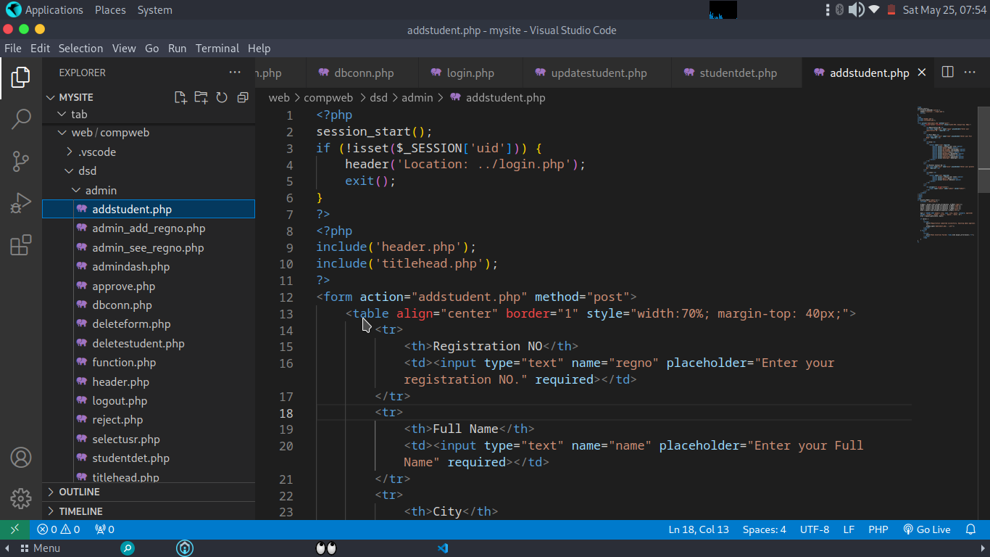

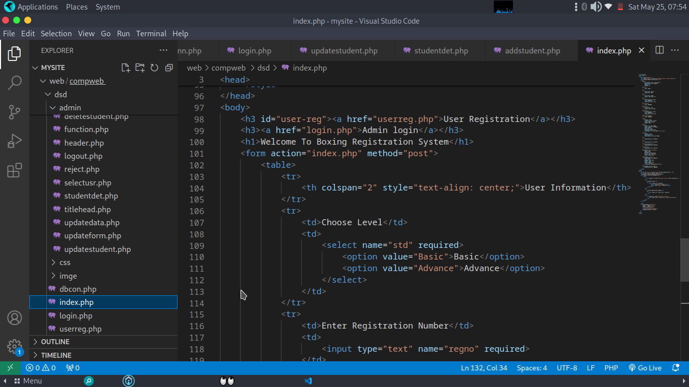

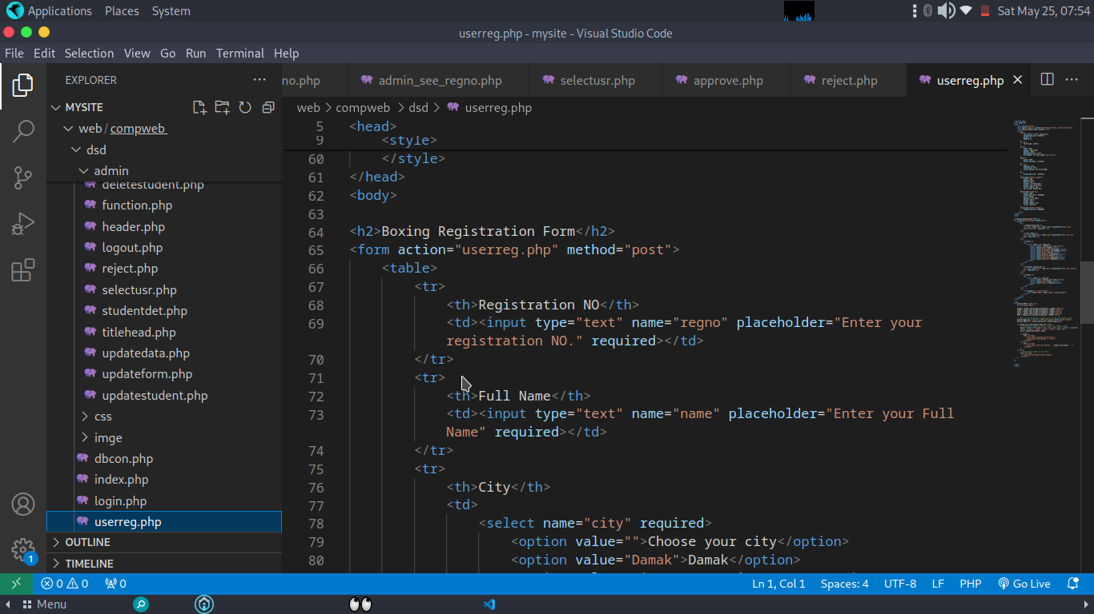

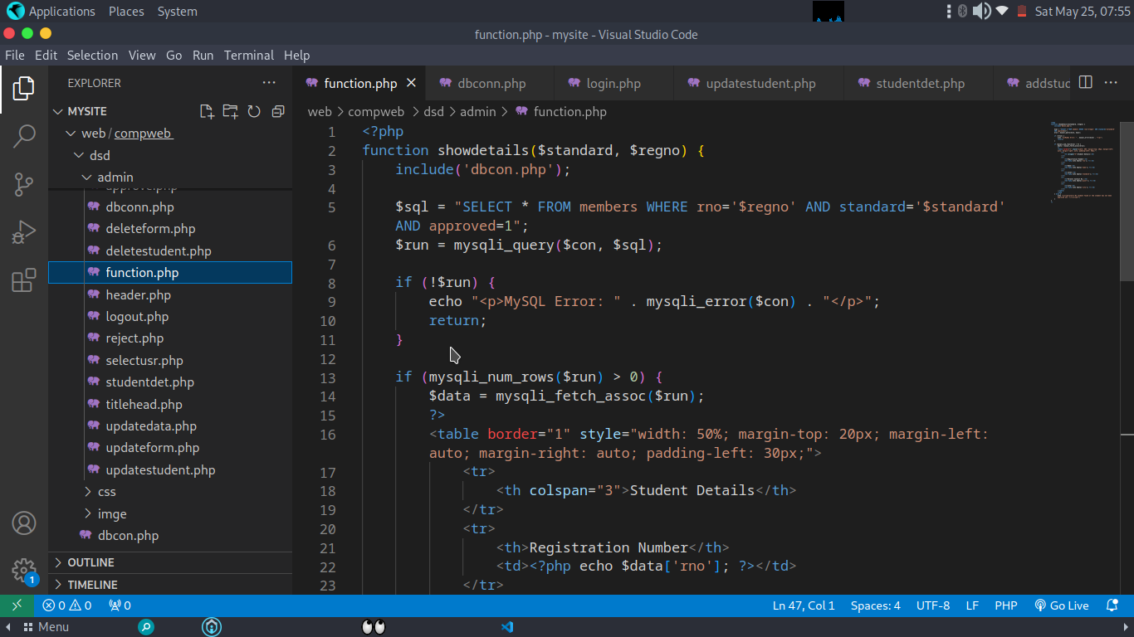

**References/Citation**

**References:**

[1] OpenAI. (n.d.). *ChatGPT*. Retrieved from https://openai.com

[2] W3Schools. (n.d.). Retrieved from https://w3schools.com

[3] TutorialsPoint. (n.d.). Retrieved from https://tutorialspoint.com

[4] 1000ProjectsOnline. (n.d.). Retrieved from https://1000projectsonline.com