实验医学中心临床检验

质量与安全管理月总结

( 2022年{month}月)

1. 上月质控存在问题及整改情况
2. **人员管理方面**

{people}

1. **仪器、试剂管理方面**

{equip}

1. **信息、流程、实验室环境方面**

{information}

1. **新冠专项**

{cov19}

二、本月质量安全工作情况总结

(一)医疗工作量统计

|  |  |  |  |  |  |  |
| --- | --- | --- | --- | --- | --- | --- |
|  | 生化 | 免疫 | 临检 | 微生物 | 分子诊断 | 总计 |
| 本月标本总数 | {shenghua.num0} | {mianyi.num0} | {linjian.num0} | {weishengwu.num0} | {fenzi.num0} | {zongji.num0} |
| 上月标本总数 | {shenghua.num1} | {mianyi.num1} | {linjian.num1} | {weishengwu.num1} | {fenzi.num1} | {zongji.num1} |
| 本月血标本总数 | {shenghua.num2} | {mianyi.num2} | {linjian.num2} | {weishengwu.num2} | {fenzi.num2} | {zongji.num2} |
| 本月体液（尿液、粪便、体液及排泄物）标本总数 | {shenghua.num3} | {mianyi.num3} | {linjian.num3} | {weishengwu.num3} | {fenzi.num3} | {zongji.num3} |
| 本月其他标本总数 | 0 | 0 | 0 | 0 | 0 | 0 |

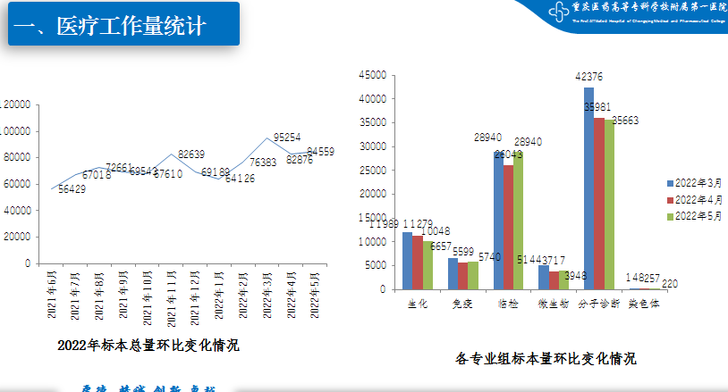

1. 检验质量指标

1.月度质量指标统计

|  |  |  |  |  |  |  |  |  |  |  |  |  |  |  |  |  |  |  |
| --- | --- | --- | --- | --- | --- | --- | --- | --- | --- | --- | --- | --- | --- | --- | --- | --- | --- | --- |
|  | 生化 | | | 免疫 | | | 临检 | | | 微生物 | | | 分子诊断 | | | 总计 | | |
| 分子 | 分母 | 率% | 分子 | 分母 | 率% | 分子 | 分母 | 率% | 分子 | 分母 | 率% | 分子 | 分母 | 率% | 分子 | 分母 | 率% |
| 标本标签不合格率 | {count1.num1} | {count1.num2} | {count1.num3} | {count1.num4} | {count1.num5} | {count1.num6} | {count1.num7} | {count1.num8} | {count1.num9} | {count1.num10} | {count1.num11} | {count1.num12} | {count1.num13} | {count1.num14} | {count1.num15} | {count1zongji.count1Fenzi} | {count1zongji.count1Fenmu} | {count1zongji.count1Ratio} |
| 抗凝标本凝集率（应＜  0.0851  %） | {count2.num1} | {count2.num2} | {count2.num3} | {count2.num4} | {count2.num5} | {count2.num6} | {count2.num7} | {count2.num8} | {count2.num9} | {count2.num10} | {count2.num11} | {count2.num12} | {count2.num13} | {count2.num14} | {count2.num15} | {count2zongji.count2Fenzi} | {count2zongji.count2Fenmu} | {count2zongji.count2Ratio} |
| 标本类型错误错误率（应＜  0.0137  %） | {count3.num1} | {count3.num2} | {count3.num3} | {count3.num4} | {count3.num5} | {count3.num6} | {count3.num7} | {count3.num8} | {count3.num9} | {count3.num10} | {count3.num11} | {count3.num12} | {count3.num13} | {count3.num14} | {count3.num15} | {count3zongji.count3Fenzi} | {count3zongji.count3Fenmu} | {count3zongji.count3Ratio} |
| 标本容器错误错误率（应＜  0.0100  %） | {count4.num1} | {count4.num2} | {count4.num3} | {count4.num4} | {count4.num5} | {count4.num6} | {count4.num7} | {count4.num8} | {count4.num9} | {count4.num10} | {count4.num11} | {count4.num12} | {count4.num13} | {count4.num14} | {count4.num15} | {count4zongji.count4Fenzi} | {count4zongji.count4Fenmu} | {count4zongji.count4Ratio} |
| 采集量错误错误率（应＜  0.0216  %） | {count5.num1} | {count5.num2} | {count5.num3} | {count5.num4} | {count5.num5} | {count5.num6} | {count5.num7} | {count5.num8} | {count5.num9} | {count5.num10} | {count5.num11} | {count5.num12} | {count5.num13} | {count5.num14} | {count5.num15} | {count5zongji.count5Fenzi} | {count5zongji.count5Fenmu} | {count5zongji.count5Ratio} |
| 标本溶血率（应＜  0.0286  %） | {count6.num1} | {count6.num2} | {count6.num3} | {count6.num4} | {count6.num5} | {count6.num6} | {count6.num7} | {count6.num8} | {count6.num9} | {count6.num10} | {count6.num11} | {count6.num12} | {count6.num13} | {count6.num14} | {count6.num15} | {count6zongji.count6Fenzi} | {count6zongji.count6Fenmu} | {count6zongji.count6Ratio} |
| 丢失率（应为0） | {count7.num1} | {count7.num2} | {count7.num3} | {count7.num4} | {count7.num5} | {count7.num6} | {count7.num7} | {count7.num8} | {count7.num9} | {count7.num10} | {count7.num11} | {count7.num12} | {count7.num13} | {count7.num14} | {count7.num15} | {count7zongji.count7Fenzi} | {count7zongji.count7Fenmu} | {count7zongji.count7Ratio} |
| 检验报告不正确率（应＜0.0184%） | {count8.num1} | {count8.num2} | {count8.num3} | {count8.num4} | {count8.num5} | {count8.num6} | {count8.num7} | {count8.num8} | {count8.num9} | {count8.num10} | {count8.num11} | {count8.num12} | {count8.num13} | {count8.num14} | {count8.num15} | {count8zongji.count8Fenzi} | {count8zongji.count8Fenmu} | {count8zongji.count8Ratio} |
| 报告召回率 | {count9.num1} | {count9.num2} | {count9.num3} | {count9.num4} | {count9.num5} | {count9.num6} | {count9.num7} | {count9.num8} | {count9.num9} | {count9.num10} | {count9.num11} | {count9.num12} | {count9.num13} | {count9.num14} | {count9.num15} | {count9zongji.count9Fenzi} | {count9zongji.count9Fenmu} | {count9zongji.count9Ratio} |
| 危急值通报率（应为100%） | {count10.num1} | {count10.num2} | {count10.num3} | 无 | | | {count10.num7} | {count10.num8} | {count10.num9} | {count10.num10} | {count10.num11} | {count10.num12} | 无 | | | {count10zongji.count10Fenzi} | {count10zongji.count10Fenmu} | {count10zongji.count10Ratio} |
| 危急值通报及时率（应为100%） | {count11.num1} | {count11.num2} | {count11.num3} | {count11.num7} | {count11.num8} | {count11.num9} | {count11.num10} | {count11.num11} | {count11.num12} | {count11zongji.count11Fenzi} | {count11zongji.count11Fenmu} | {count11zongji.count11Ratio} |
| 血培养污染率（应＜1.6667%） | 无 | | | | | | | | | {count12.num10} | {count12.num11} | {count12.num12} | 无 | | | {count12zongji.count12Fenzi} | {count12zongji.count12Fenmu} | {count12zongji.count12Ratio} |
| 室内质控项目开展率（42.6471%） | {count13.num1} | {count13.num2} | {count13.num3} | {count13.num4} | {count13.num5} | {count13.num6} | {count13.num7} | {count13.num8} | {count13.num9} | {count13.num10} | {count13.num11} | {count13.num12} | {count13.num13} | {count13.num14} | {count13.num15} | {count13zongji.count13Fenzi} | {count13zongji.count13Fenmu} | {count13zongji.count13Ratio} |
| 室内质控失控率 | {count14.num1} | {count14.num2} | {count14.num3} | {count14.num4} | {count14.num5} | {count14.num6} | {count14.num7} | {count14.num8} | {count14.num9} | {count14.num10} | {count14.num11} | {count14.num12} | {count14.num13} | {count14.num14} | {count14.num15} | {count14zongji.count14Fenzi} | {count14zongji.count14Fenmu} | {count14zongji.count14Ratio} |
| 定量项目室内质控覆盖率 | {count15.num1} | {count15.num2} | {count15.num3} | {count15.num4} | {count15.num5} | {count15.num6} | {count15.num7} | {count15.num8} | {count15.num9} | {count15.num10} | {count15.num11} | {count15.num12} | {count15.num13} | {count15.num14} | {count15.num15} | {count15zongji.count15Fenzi} | {count15zongji.count15Fenmu} | {count15zongji.count15Ratio} |
| 室内质控项目CV不合格率（应＜ 1.25%） | {count16.num1} | {count16.num2} | {count16.num3} | {count16.num4} | {count16.num5} | {count16.num6} | {count16.num7} | {count16.num8} | {count16.num9} | {count16.num10} | {count16.num11} | {count16.num12} | {count16.num13} | {count16.num14} | {count16.num15} | {count16zongji.count16Fenzi} | {count16zongji.count16Fenmu} | {count16zongji.count16Ratio} |
| 室间质评项目参加率（应＞83.3333% ） | {count17.num1} | {count17.num2} | {count17.num3} | {count17.num4} | {count17.num5} | {count17.num6} | {count17.num7} | {count17.num8} | {count17.num9} | {count17.num10} | {count17.num11} | {count17.num12} | {count17.num13} | {count17.num14} | {count17.num15} | {count17zongji.count17Fenzi} | {count17zongji.count17Fenmu} | {count17zongji.count17Ratio} |
| 室间质评项目不合格率（应＜2.3256 ） | 年度指标 | | | | | | | | | | | | | | | | | |
| 实验室间比对率（应＞0.5925% ） | {count19.num1} | {count19.num2} | {count19.num3} | {count19.num4} | {count19.num5} | {count19.num6} | {count19.num7} | {count19.num8} | {count19.num9} | {count19.num10} | {count19.num11} | {count19.num12} | {count19.num13} | {count19.num14} | {count19.num15} | {count19zongji.count19Fenzi} | {count19zongji.count19Fenmu} | {count19zongji.count19Ratio} |
| 国家级室间质评项目参加率（应＞ 65.8228%） | {count20.num1} | {count20.num2} | {count20.num3} | {count20.num4} | {count20.num5} | {count20.num6} | {count20.num7} | {count20.num8} | {count20.num9} | {count20.num10} | {count20.num11} | {count20.num12} | {count20.num13} | {count20.num14} | {count20.num15} | {count20zongji.count20Fenzi} | {count20zongji.count20Fenmu} | {count20zongji.count20Ratio} |
| 国家级室间质评项目不合格率（应＜ 2.3121%） | 年度指标 | | | | | | | | | | | | | | | | | |
| POCT项目室间质评参加率 | 年度指标 | | | | | | | | | | | | | | | | | |
| POCT项目室间质评合格率 | 年度指标 | | | | | | | | | | | | | | | | | |
| 检验前周转时间中位数（分钟） | {count24.num1} | | | | | | | | | | | | | | | | | |
| 实验室内周转时间中位数（分钟） | {count25.num1} | | | | | | | | | | | | | | | | | |
| 本月度因分析设备故障导致检验报告延迟的次数 | {count26.num1} | | | {count26.num2} | | | {count26.num3} | | | {count26.num4} | | | {count26.num5} | | | {count26zongji.count26Fenzi} | | |
| 本月度实验室信息系统（LIS）故障数 | {count27.num1} | | | {count27.num2} | | | {count27.num3} | | | {count27.num4} | | | {count27.num5} | | | {count27zongji.count27Fenzi} | | |
| LIS系统传输准确性符合率 | {count28.num1} | | | | | | | | | | | | | | | | | |
| 医护满意度 | {count29.num1} | | | | | | | | | | | | | | | | | |
| 患者满意度 | {count30.num1} | | | | | | | | | | | | | | | | | |
| 实验室投诉数 | {count31.num1} | | | {count31.num2} | | | {count31.num3} | | | {count31.num4} | | | {count31.num5} | | | {count31zongji.count31Fenzi} | | |
| 血培养阳性率 | 无 | | | | | | | | | {count32.num10} | {count32.num11} | {count32.num12} | 无 | | | {count32zongji.count32Fenzi} | {count32zongji.count32Fenmu} | {count32zongji.count32Ratio} |
| 苛养菌分离率 | 无 | | | | | | | | | {count33.num10} | {count33.num11} | {count33.num12} | 无 | | | {count33zongji.count33Fenzi} | {count33zongji.count33Fenmu} | {count33zongji.count33Ratio} |
| 临床微生物标本送检率 | 无 | | | | | | | | | {count34.num10} | {count34.num11} | {count34.num12} | 无 | | | {count34zongji.count34Fenzi} | {count34zongji.count34Fenmu} | {count34zongji.count34Ratio} |

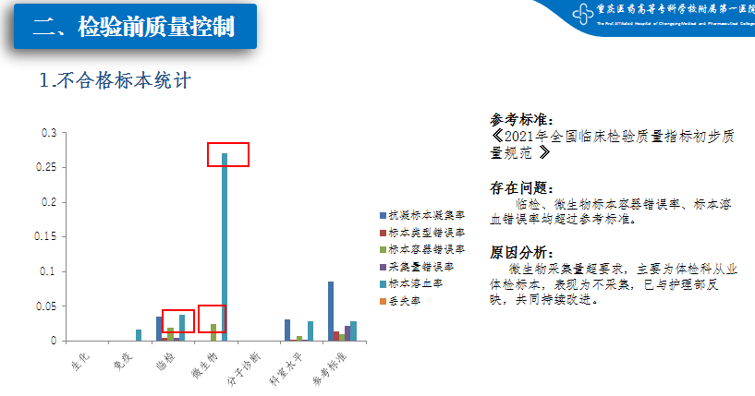

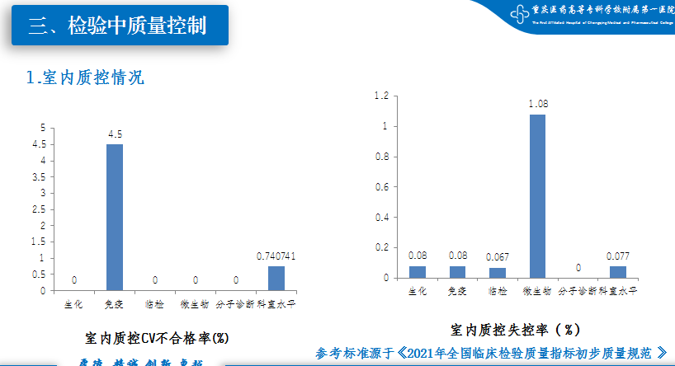

（三）周转时间

1.各组周转时间（min）

|  |  |  |  |  |  |  |  |  |  |  |  |  |  |  |
| --- | --- | --- | --- | --- | --- | --- | --- | --- | --- | --- | --- | --- | --- | --- |
|  | 生化 | | | 自动化免疫 | | | 三大常规 | | | | 凝血 | | | |
| 中位数 | 第90百分位 | | 中位数 | 第90百分位 | | 中位数 | 第90百分位 | | | 中位数 | 第90百分位 | | |
| 该专业住院检验月标本总数 |  | | |  | | |  | | | |  | | | |
| 该专业急诊检验月标本总数 |  | | |  | | |  | | | |  | | | |
| 该专业门诊检验月标本总数 |  | | |  | | |  | | | |  | | | |
| 急诊检验前周转时间 |  | |  |  | |  |  | | |  |  | |  | |
| 常规（住院）检验前周转时间 |  | |  |  | |  |  | | |  |  | |  | |
| 常规（门诊）检验前周转时间 |  | |  |  | |  |  | | |  |  | |  | |
| 急诊实验室内周转时间 |  | |  |  | |  |  | | |  |  | |  | |
| 常规（住院）实验室内周转时间 |  | |  |  | |  |  | | |  |  | |  | |
| 常规（门诊）实验室内周转时间 |  | |  |  | |  |  | |  | |  | | |  |

2.各项目周转时间

|  |  |  |  |  |  |  |  |  |  |  |  |  |
| --- | --- | --- | --- | --- | --- | --- | --- | --- | --- | --- | --- | --- |
|  | 检验前周转时间(min) | | | | 实验室内周转时间(min) | | | | | | | |
| 本实验室规定时间（ | 月中位数 | 月第90百分位数 | 月标本数 | 本实验室规定时间 | | 月中位数 | | | 月第90百分位数（min） | | 月标本数 |
| 急诊项目 | | | | | | | | | | | | |
| 血钾 |  |  |  |  |  |  | | |  | | |  |
| 肌钙蛋白I或肌钙蛋白T |  |  |  |  |  |  | | |  | | |  |
| 白细胞计数 |  |  |  |  |  |  | | |  | | |  |
| 国际标准化比值（INR） |  |  |  |  |  |  | | |  | | |  |
| 三大常规 |  |  |  |  |  |  | | |  | | |  |
| 血糖 |  |  |  |  |  |  | | |  | | |  |
| Na |  |  |  |  |  |  | | |  | | |  |
| Ca |  |  |  |  |  |  | | |  | | |  |
| 门诊项目 | | | | | | | | | | | | |
| 血钾 |  |  |  |  |  |  | | |  | | |  |
| 肌钙蛋白I或肌钙蛋白T |  |  |  |  |  |  | | |  | | |  |
| 白细胞计数 |  |  |  |  |  |  | | |  | | |  |
| 尿常规 |  |  |  |  |  |  | | |  | | |  |
| 国际标准化比值（INR） |  |  |  |  |  |  | | |  | | |  |
| 住院项目 | | | | | | | | | | | | |
| 血钾 |  |  |  |  |  |  | |  | | |  | |
| 丙氨酸氨基转移酶 |  |  |  |  |  |  | |  | | |  | |
| 肌钙蛋白I或肌钙蛋白T |  |  |  |  |  |  | |  | | |  | |
| 促甲状腺激素 |  |  |  |  |  |  | |  | | |  | |
| 甲胎蛋白 |  |  |  |  |  |  | |  | | |  | |
| 白细胞计数 |  |  |  |  |  |  | |  | | |  | |
| 尿常规 |  |  |  |  |  |  | |  | | |  | |
| 国际标准化比值（INR） |  |  |  |  |  |  | |  | | |  | |

（四）设备完好率

|  |  |  |  |  |  |
| --- | --- | --- | --- | --- | --- |
|  | 生化 | 免疫 | 临检 | 微生物 | 分子诊断 |
| 万元以上医疗设备、仪器完好率（应≥95％） | 100% | 100% | 100% | 100% | 100% |
| 大型设备安检率（应为100％） | 100% | 100% | 100% | 100% | 100% |
| 急诊器械、仪器完好率（应为100％） | 100% | 100% | 100% | 100% | 100% |
| 仪器日常维护保养情况 | 良好 | 良好 | 良好 | 良好 | 良好 |

（五）传染病上报

|  |  |  |  |  |  |  |  |  |
| --- | --- | --- | --- | --- | --- | --- | --- | --- |
| 免疫 | | | 临检 | | | 微生物 | | |
| 分子 | 分母 | 率% | 分子 | 分母 | 率% | 分子 | 分母 | 率% |
|  |  |  |  |  |  |  |  |  |

（六）核心制度执行情况

|  |  |
| --- | --- |
| 医疗核心制度执行 | 交接班制度执行情况：交接班制度执行较好，但交接班记录有漏签的情况。 |
| 新技术准入制度执行情况：本月未开展新项目新技术。 |
| 查对制度执行情况：执行较好。 |
| 医疗（安全）不良事件和投诉 | 不良事件2次。 |

1. 本月主要存在问题、原因分析、整改措施
2. **人员管理方面**

**（二）仪器、试剂管理方面**

**（三）信息、流程、实验室环境方面**

**（四）新冠专项**

**三、下月质控重点内容（选1-2项）**

科室质控小组组长签字：

年 月 日