**Market Segmentation**

**Analyzing Ed-Tech Market in India using Segmentation analysis to launch learning Assistant App**

**BY Team A**

**Rahul Sircar**

**Anirudh Sonwane   
 Akshat Banga**

**Devendra Kolhe**

**Problem Statements**

Analyzing Ed-Tech Market in India using Segmentation analysis and come up with a feasible strategy to enter the market, targeting the segments most likely to use their product in terms of Geographic, Demographic, Psychographic, Behavioral.

* As of[2020](https://www.statista.com/statistics/271315/age-distribution-in-india/), education in India statistics show that about 26 per cent of the Indian population (1.39 billion) falls into the 0–14-year category, which provides a great opportunity for the primary education sector.
* Furthermore,[18 per cent of the population](https://www.indexmundi.com/india/demographics_profile.html), or approximately 500 million, fall into the **15–24-**year category, allowing for opportunities for growth across the secondary and higher education institutions in India.
* Additional Indian education [statistics reveal](http://mospi.nic.in/sites/default/files/reports_and_publication/statistical_publication/social_statistics/WM17Chapter3.pdf) how the literacy ratio of India for adults (15+ years) is **69.3** per cent, with male literacy at 78.8 per cent and female literacy at 59.3 per cent.
* In April 2021, India joined the[United Nation’s E9 initiative](https://en.unesco.org/education2030-sdg4/coordination/e9-partnership), whose purpose is to create an initiative on digital learning and skills, targeting marginalized children and youth, especially girls.
* According to[Union Budget 2021-22](https://pib.gov.in/PressReleasePage.aspx?PRID=1693907), the Indian government allocated an expenditure budget of US5.28billionforhighereducationandUS7.56 billion for school education and literacy.
* By[2030](https://www.ibef.org/industry/education-presentation), it’s estimated that India’s higher education system will have more than 20 universities among the global top 200 universities. It’s also thought that it will be among the top five countries in the world in terms of research output, with an annual research and development (R&D) spend of US$140 billion.

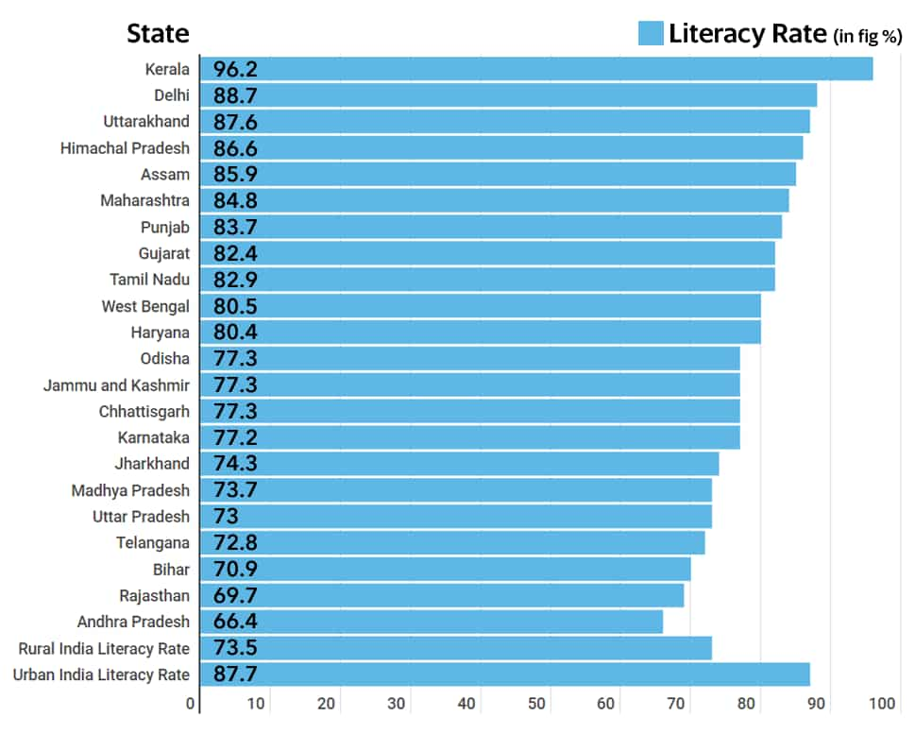

Assuming Ed tech company targeting customer and Market are up to higher secondary school.

In problem statement we have data columns such as State code, District Code, State Name, District Name, No. of district, No. of blocks, No. of villages, No of Clusters and ranging from Rural to urban , Male to female , Income of households , grades ,etc.

**Using Fermi Estimation**

There are 1.3 billion population in India and 25 to 26 % percentage of population falls category below 14 years ages. Education depends not only one factors but several factors, Parents Education Environments, students’ future aspiration, family income, whether area is rural or Urban Female and male ratios.

Taking into consideration primary education is everyone rights, so students 1.30 Billon * 22% come arounds .286 billion students comprising both gender ratios, now on the basis of that dividing them urban and rural, Govt and Non Govt, CBSE, State board students, state education policy and customer and their prior experience we can devise segmentation strategy, and product offering strategy.

# Technology adoption life cycle

The technology adoption lifecycle is a sociological model that describes the adoption or acceptance of a new product or innovation, according to the demographic and psychological characteristics of defined adopter groups. The process of adoption over time is typically illustrated as a classical [normal distribution](https://en.wikipedia.org/wiki/Normal_distribution) or "bell curve". The model indicates that the first group of people to use a new product is called "[innovators](https://en.wikipedia.org/wiki/Innovators)", followed by "[early adopters](https://en.wikipedia.org/wiki/Early_adopters)". Next come the early majority and late majority, and the last group to eventually adopt a product are called "Laggards" or phobic." For example, a phobic may only use a cloud service when it is the only remaining met.

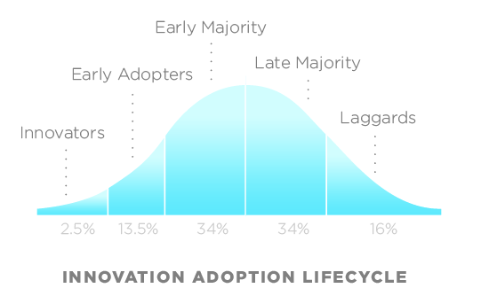

New Player Strategy

**If you’re a new player in the EdTech sector, one point worth noting is that buyer journeys here are often longer than in the case of other products or services**. There’s typically more decision-making and back-and-forth involved. But this presents an opportunity you can make the most of. Cue, detailed buyer journey mapping. If you outline the exact steps between a potential customer discovering your product and making that final purchase, you can determine the use cases or problems leading to a need for your product, the pros and cons of competitor acquisition strategies, your USPs that trigger purchase behaviors, along with a host of other business indicators. By creating marketing content perfectly aligned with different points of the buyer’s journey and different kinds of buyer personas, you will be able to move them along faster from researching to purchasing. To make buyer journey mapping more fruitful, on can do it in conjunction with the keyword research, and I strongly endorse the practice. Labelling different keywords to different junctions of the buyer journey meets the dual purpose of attracting customers with relevant content, AND keeping the search engine gods pleased.

1. **Data Source**

Ed-tech is exponentially growing sector, but finding correct data for market segmentation is not easy task as it seems, we have wrangled so many websites for finding relevant and need matching data, after deep hard work finally arrived at point where we have found this data sets.

<https://www.kaggle.com/datasets/rajanand/education-in-india/download>

1. **Data Pre-processing (Steps a nd Libraries used** )

Data Analysis Methods

Data Analysis Methods After the questionnaires were collected, the researcher encoded the questionnaires and applied statistical analysis methods as follows:

1. Descriptive statistics: Analysis was done to show the sample distribution, percentage distribution, average, and standard deviation of the subjects’ answers.

2. Cluster analysis: Cluster analysis was performed on the four factors, considered by TVE freshman students when choosing a school/department, in order to distinguish a different segment.

3. Discriminate analysis: The study applied discriminate analysis and conducted examination of the cluster division results. Lateral cluster analysis was then used to categorize the students into various cluster groups; this was related to the examination of the segment’s stability.

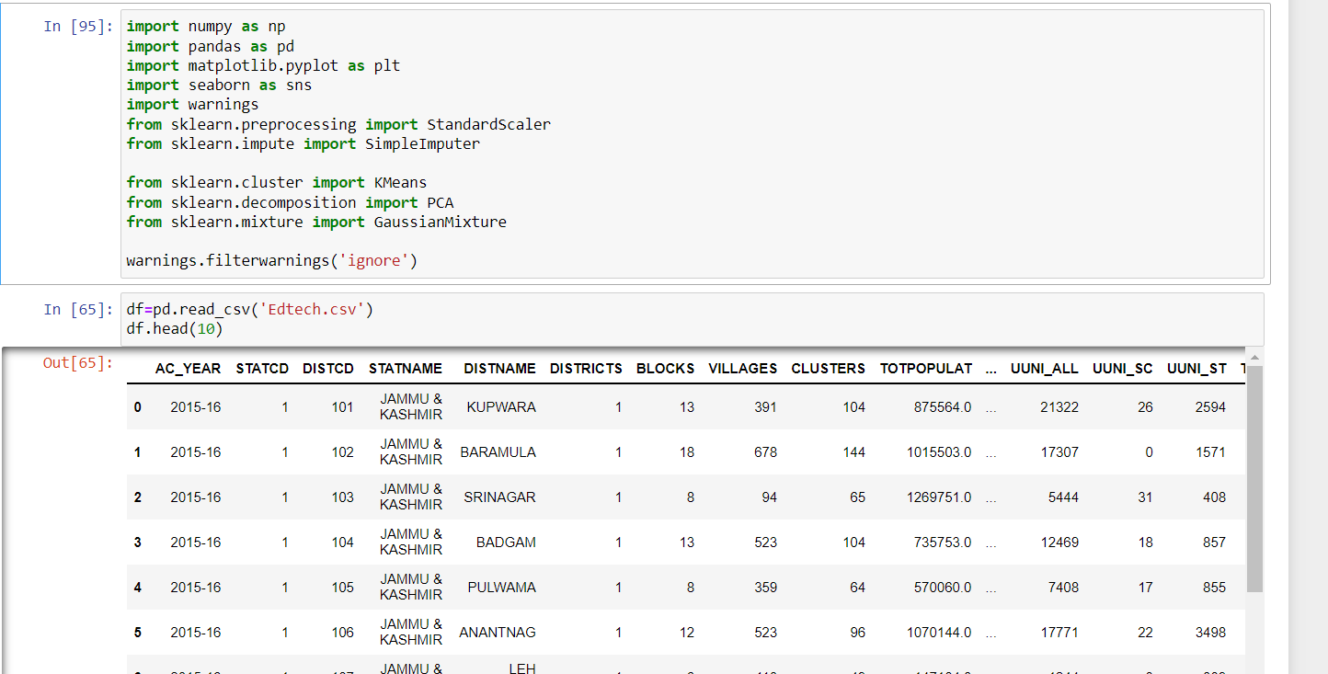

**No. of Columns**

**There are 816 columns and 821 rows**

**Data descriptions**

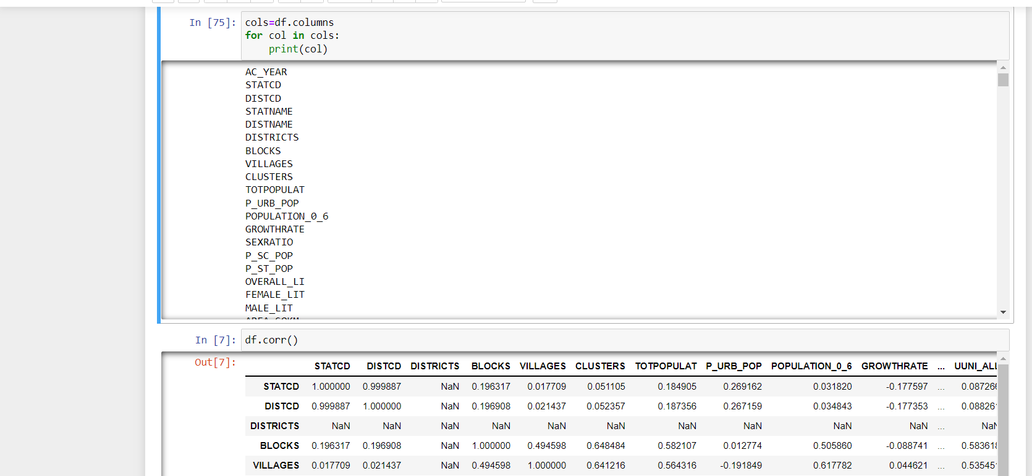

**Plotting Data by Using Seaborn library**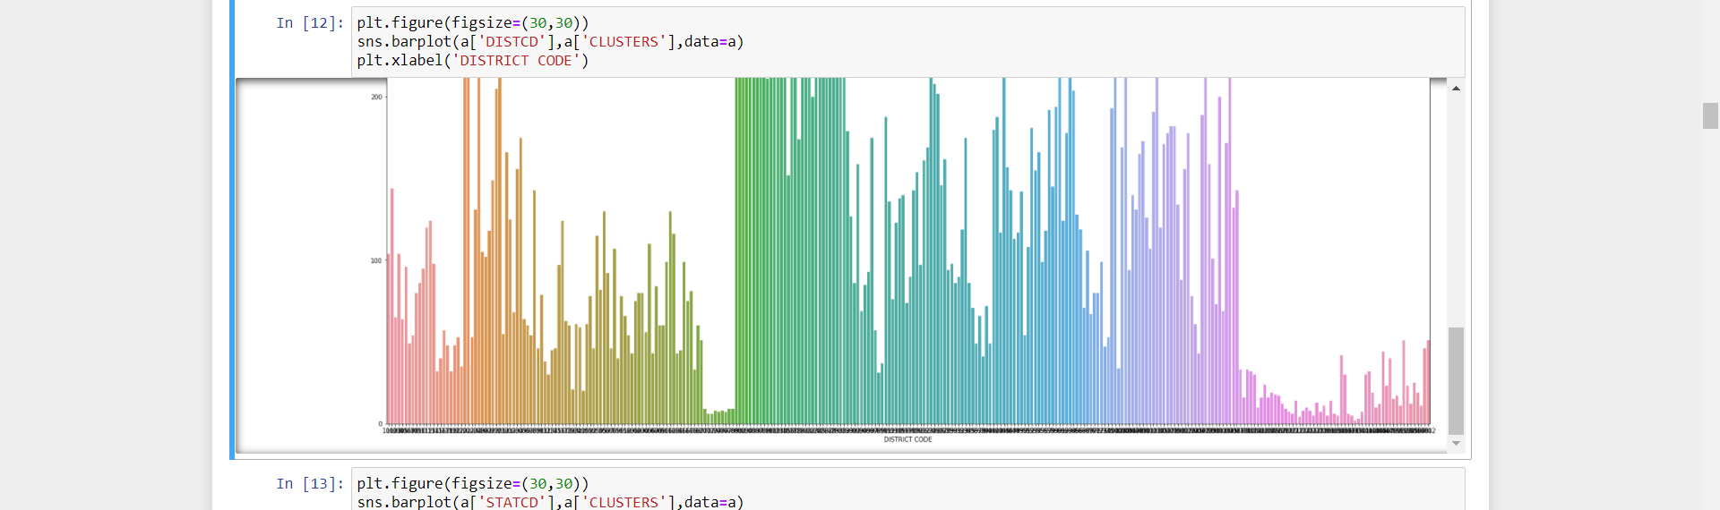

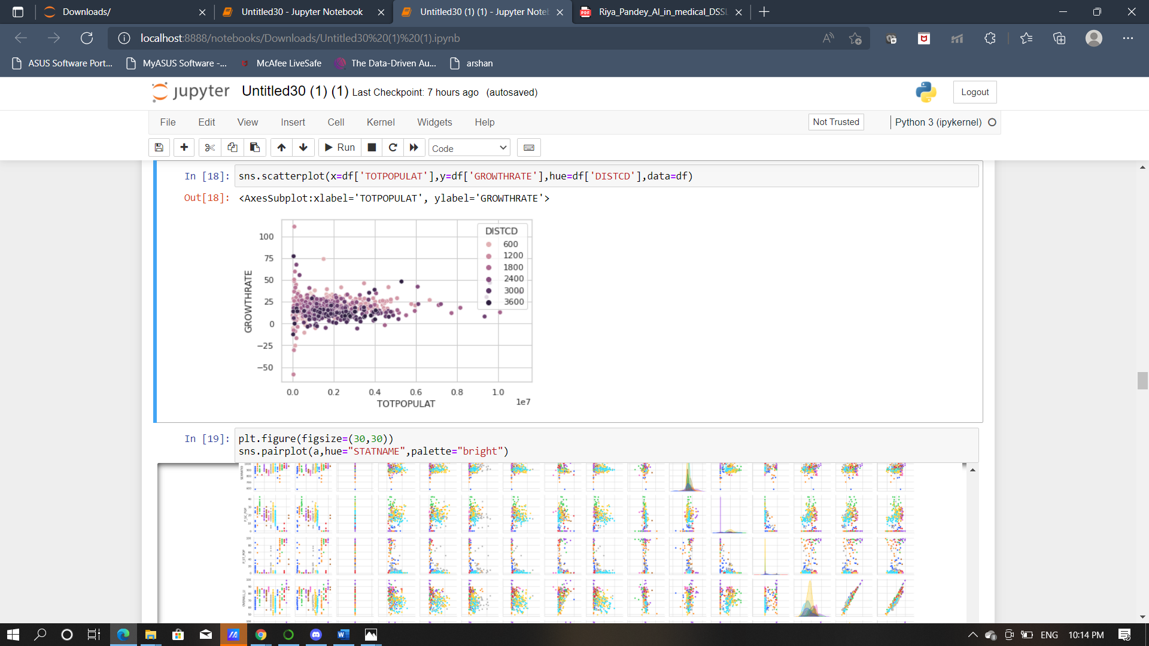

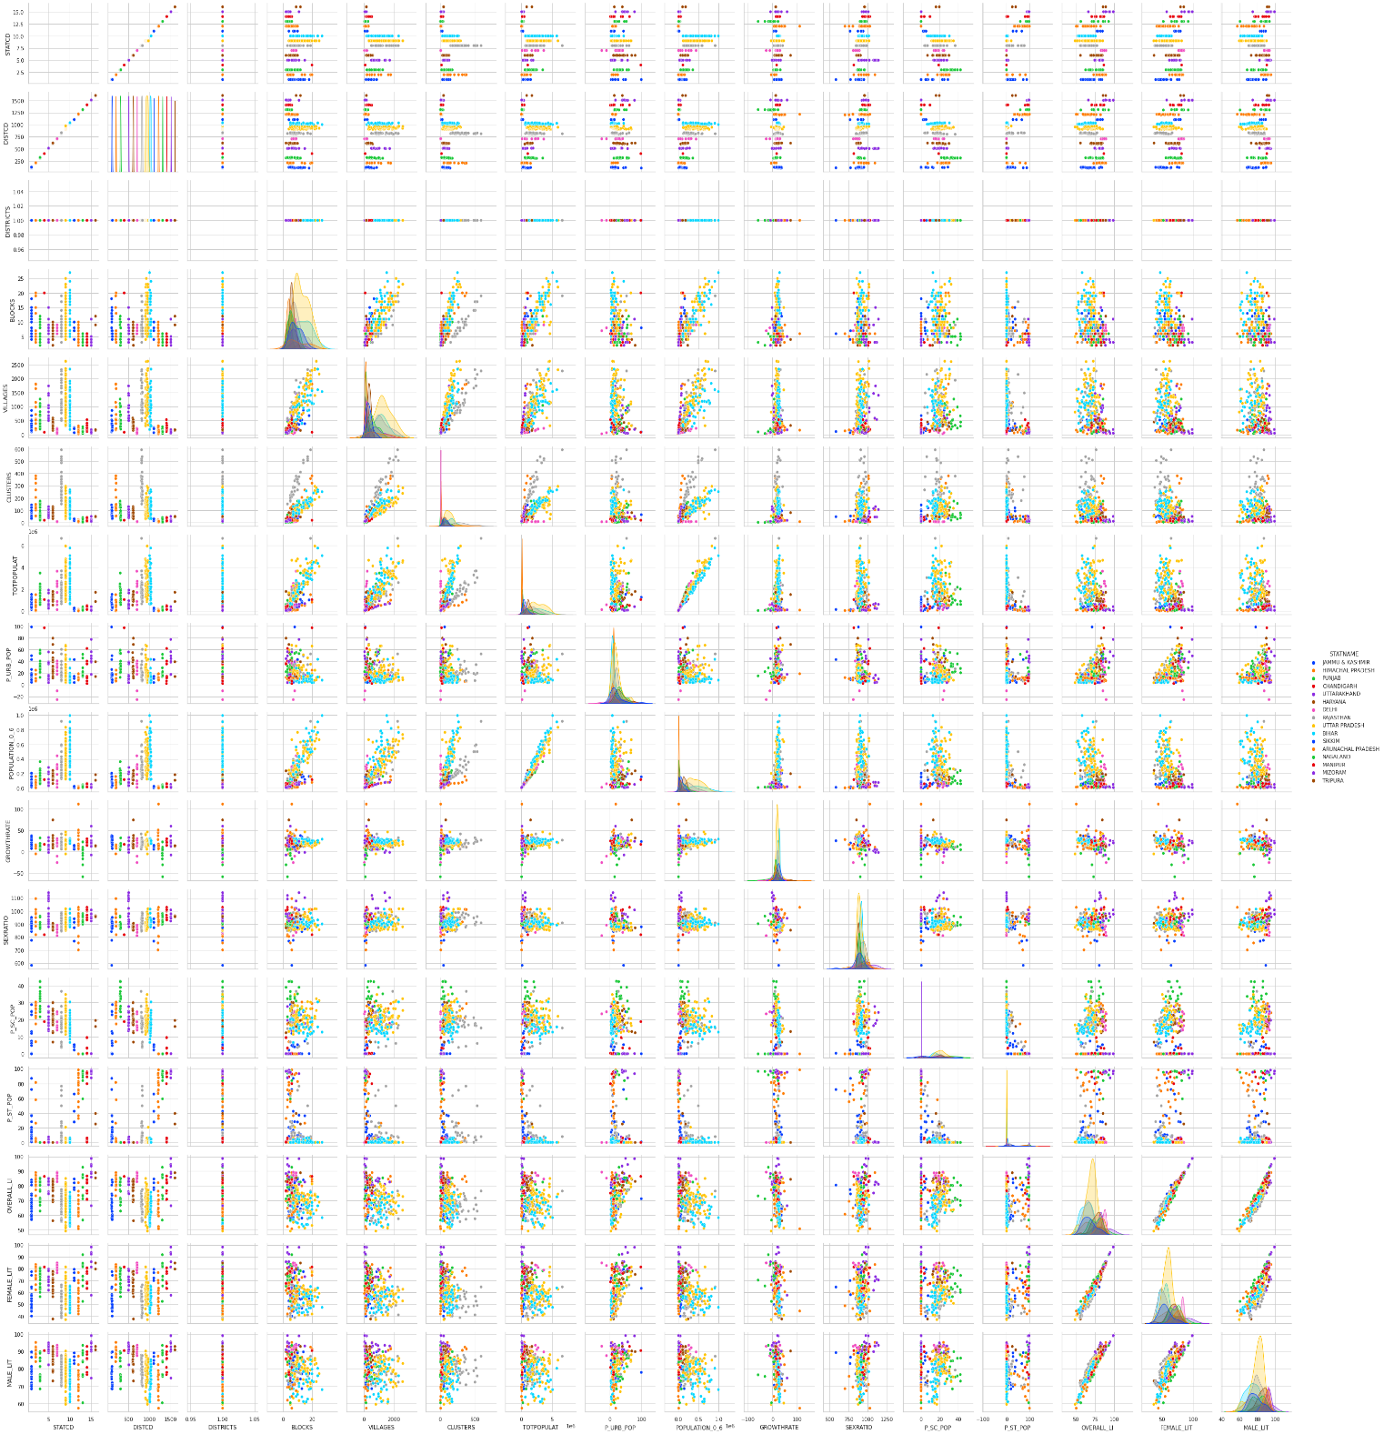

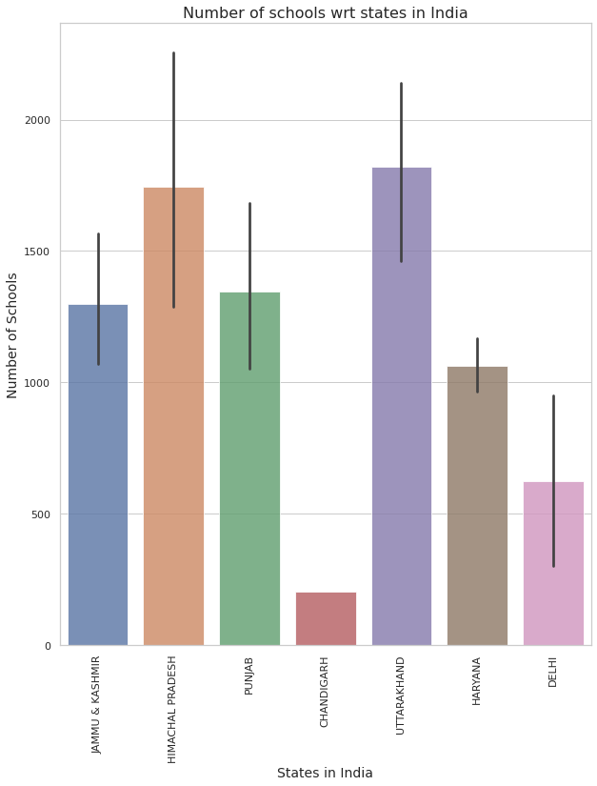

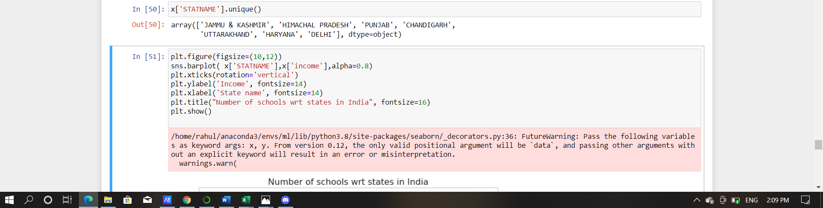

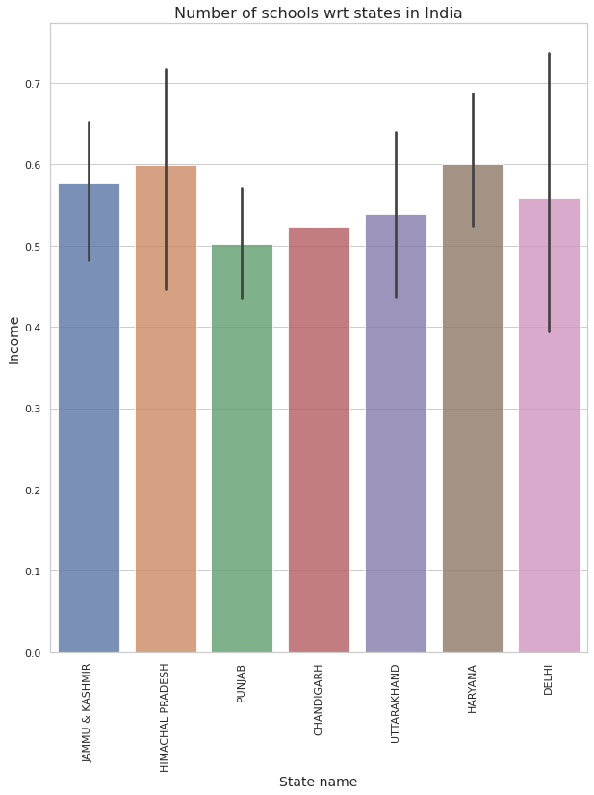

**We have not Plotted each chart used in data analysis, however following factors are identified during data analysis.**

**Result of data Analysis.**

1.Highest Literacy rate Kerala

2. Highest Female literacy rate Mizoram & Kerala

3. Highest Growth rate Arunachal Pradesh

4**.** Highest Sex ratio rate Puducherry

5. Highest Population rate Maharashtra

6. Highest Government School rate Lakshadweep

1. Segment Extraction (ML techniques used)

Base and Steps of Market Segmentation Peter and Donnelly (2000) indicated that the segmentation bases applied by market segmentation are as follows:

1. **Geographic segmentation**: refers to geographical variables used as bases for market segmentation, e.g., state, country, area, climate, etc.

2. **Demographic segmentation**: uses basic demographic statistics to segment the market, e.g., gender, age, income, career, educational level, race, etc.

3. **Psychographic segmentation**: market is segmented according to lifestyle, interests, opinions, personality, and values.

4. **Behavioral segmentation**: Market groups are formed according to the consumers’ knowledge, attitude, and utilization or response. In other words, purchasing timeframe, utilization rate, use situation, degree of loyalty, and others.

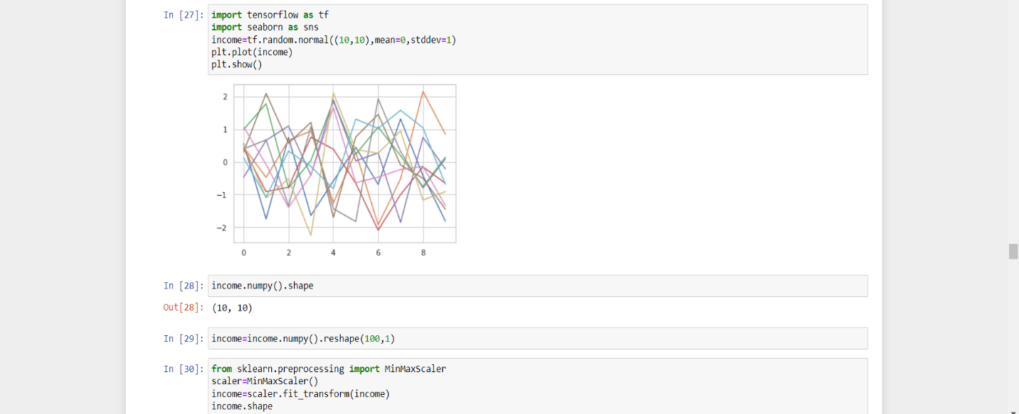

**For better understanding and market segmentation we have added income column , with respect to identify & clustering with other aligned variables.**

**We used K-means clustering**

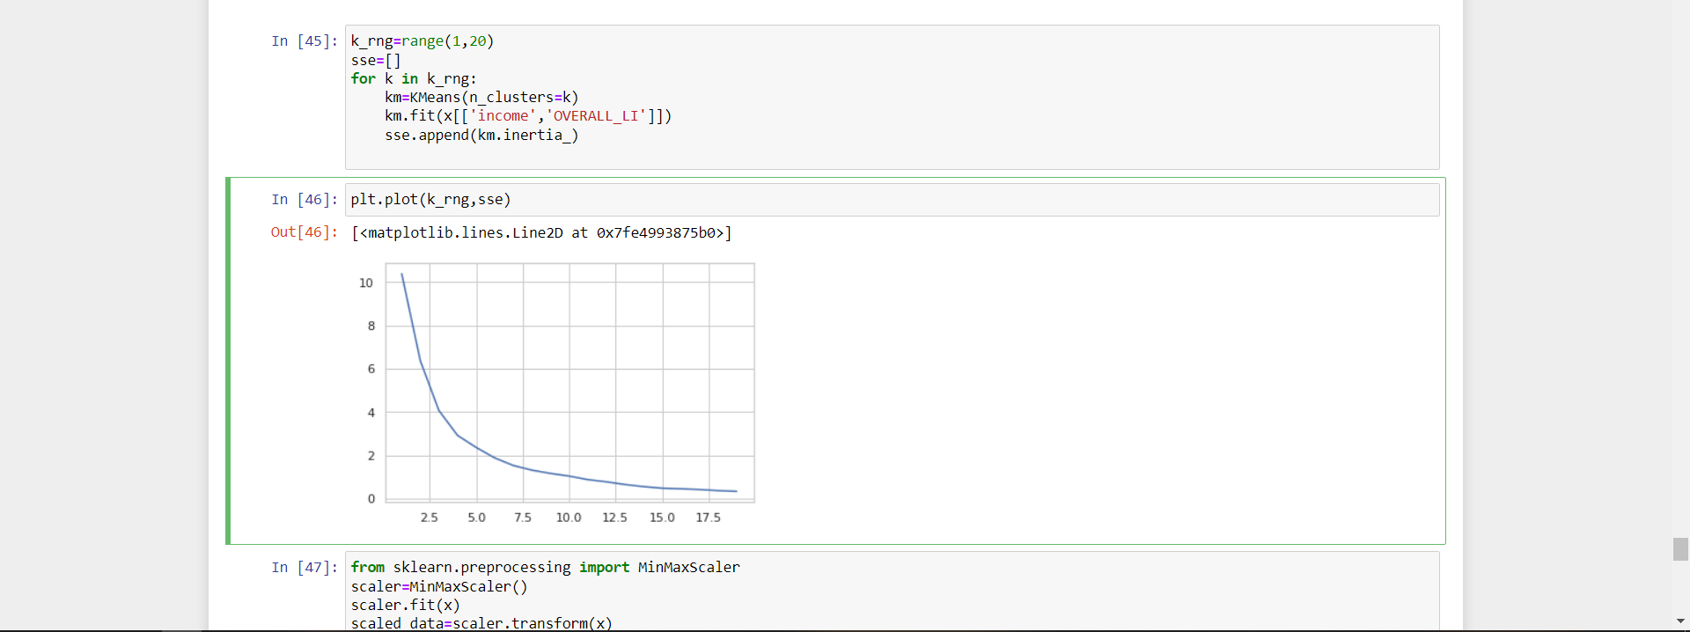

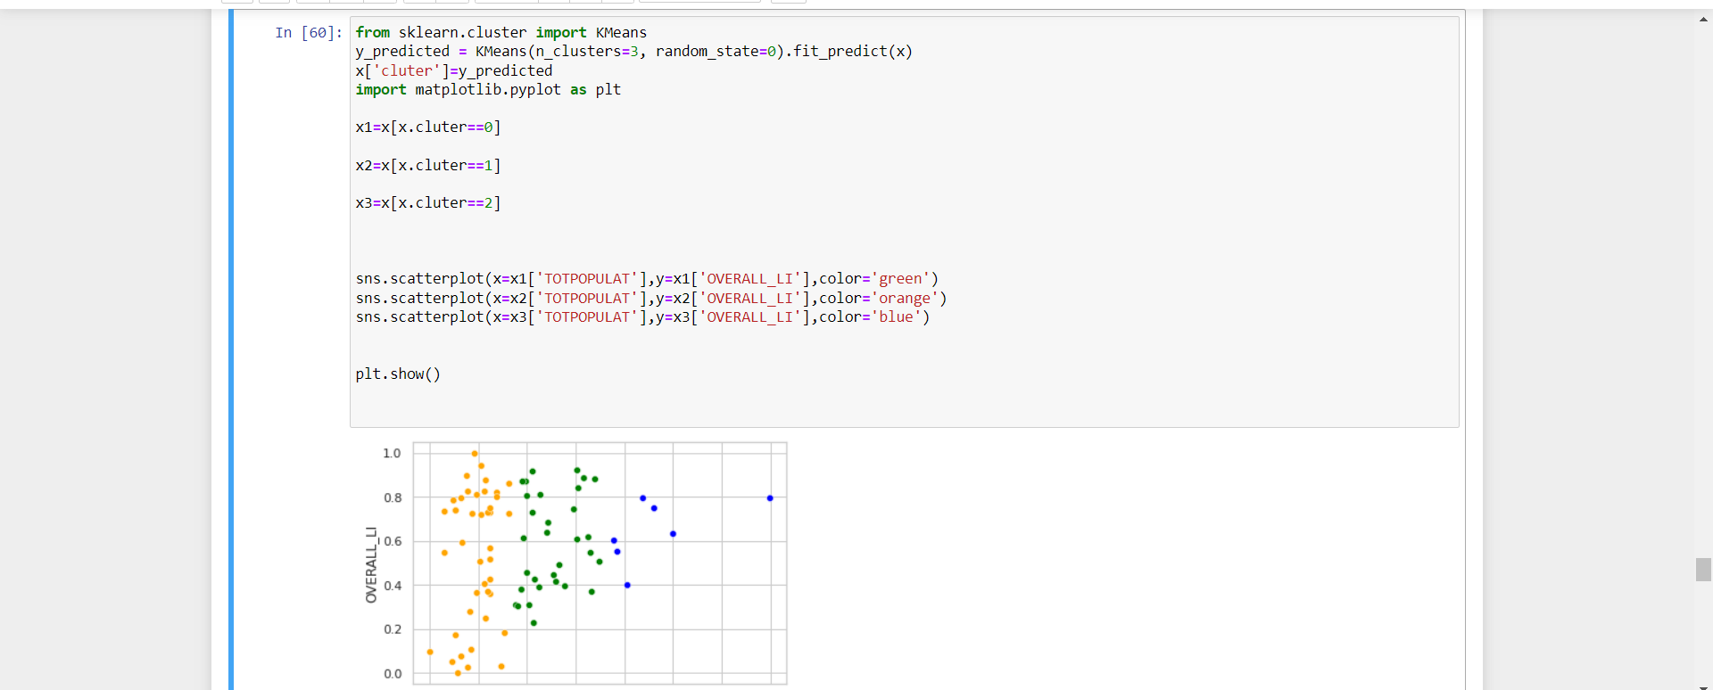

Types and Properties of Segmentation Type of Segmentation Properties Variables Used Geographical Segmentation **Variables Used**

• **Geographical properties** are one of the oldest basics for segmentation **States**

• Users are separated into segments according to different geographical units. **Districts**

• For education, geographical segmentation is related to learner's place of residence. This approach includes the clarification of messages, differentiated communication, scholarship services and the promotion of academic programs. **Population Density**

**Demographical Segmentation**

* The most common properties used for segmentation are demographical ones because requests, preferences and using rates are closely**. Age, Size**
* Variables are easy to measure **Gender, Income**
* Motivations and barriers for registration in education generally vary according to demographical segments. **Profession, Education level**
* Addressing these differences during marketing processes may increase the possibility of institutions to be preferred. family **Religion, Nationality, Social Caste**

**Psychographic Segmentation**

* This is the most powerful type of segmentation but also the most difficult to be applied. **Psychological-personality characteristics**
* Psychographic data can be used to understand users in a better and more detailed way, and concrete data could be obtained when used with demographical data.

**Socioeconomic status**

* The problem in this approach is to access appropriate information about learner-specific psychographic properties **Lifestyle, Motive**
* • After creating the psychographic profile, the custom communication channels and social activities should be combined with this information. **Values**

**Behavioral Segmentation**

* Users are grouped according to the behavioral similarities for the product. **Information on Product**
* Behavioral segmentation is related to the learner purposes within academic context, and more significant guidance can be provided if the purposes are known Information on product.

**User status • Benefit**

4. Profiling and describing potential segments.

Market profiling and segmentation generally yields customer profiles that are based on the customers’ geographic location (geographic), traits or characteristics (demographic), personality and lifestyle (psychographic), and buying patterns (behavioral). Altogether, profiling and segmentation-related activities will help business owners understand the reason behind under-performing business areas or marketing campaigns that did not fare well among others.

**Profiling means how do the segments differentiate each other based on the KPI’s (or variables)**. For instance, what is the average income of each segment, and then on comparing the segments, can understand one group has a high income, another group has low income. This way can see that the groups are getting differentiated on the basis of income or income is segregating the segments.

The goal of Profiling is to be able to differentiate between the groups with the proper distinction that means each group has some unique characteristics about it and then that cluster is the ideal solution to segment the values.

The steps to perform profiling are as follows:

1. Find the count of each segment which gives how many observations or records are present in each of the segments.
2. Find the overall average and the individual segment-wise average for each of the attributes.
3. To find the best profiling, perform the above two steps for each of the k-values (k = cluster).

We identified different cluster with respect to

1. populations
2. income
3. gender ratio
4. Population in Rural or in Urban
5. female literacy ratio
6. Govt school or Private School
7. Growth rate.
8. Literacy ratio.

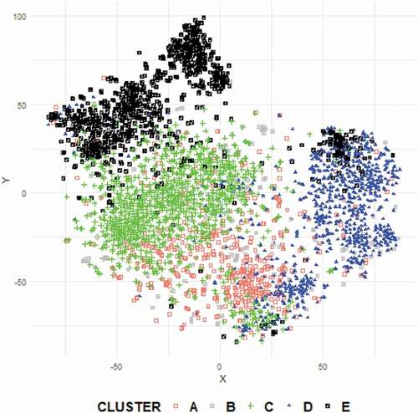

* We have found that **higher income** worth people tend to educate their children in Private school in Urban area.
* Students belonging to lower income group study in Govt school both in urban and Rural area.
* Some states have lower population, but they have higher **literacy rate.**
* Female literacy ration also effects education in their families.

On the basis of identified Market segmentation we have market in

* 1. Urban category with reasonable income.
  2. Urban category with not having reasonable income
  3. Rural population having good female literacy ratio.
  4. Private school having high fees.

Potential Segment

**Based on data finding and profiling Segment we found that potential customer can be high income or stable income group people, living in urban area, where education are just formalities but not carrier building.**

**Same can be Urban area also , but depicting fact and product strategy our product can be succeed in urban area on initial basis.**

**5.** Selection of target segment

Defining Target Market, we are considering Porter 5 Models.

following are 5 criteria that indicate whether you have selected a viable target market: size, expected growth, competitive position, cost to reach, and compatibility.

1. **Size**- how large is this target market? Worth pursuing?
2. **Expected Growth**- even if the market is small, it may be profitable if there are indications that it will grow.
3. **Competitive Position**- low competition equals attractive market.
4. **Cost to Reach**- is this market accessible with our tactics?
5. **Compatibility**- how aligned is this market to our goals?

There are three standard approaches to target marketing. The first approach is the Single Target Market approach whereby the firm selects one particular market segment and makes every effort to “own” that space. The second approach is the Multiple Target Market approach in which the firm selects two or more segments to go after, requiring a separate marketing mix for each.

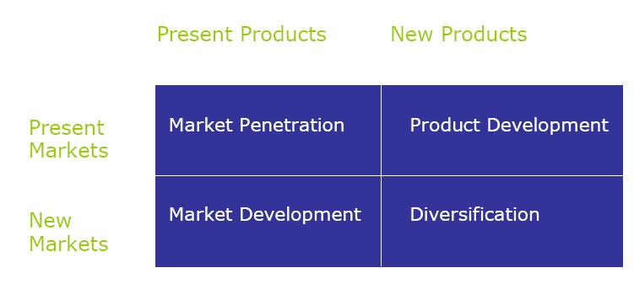

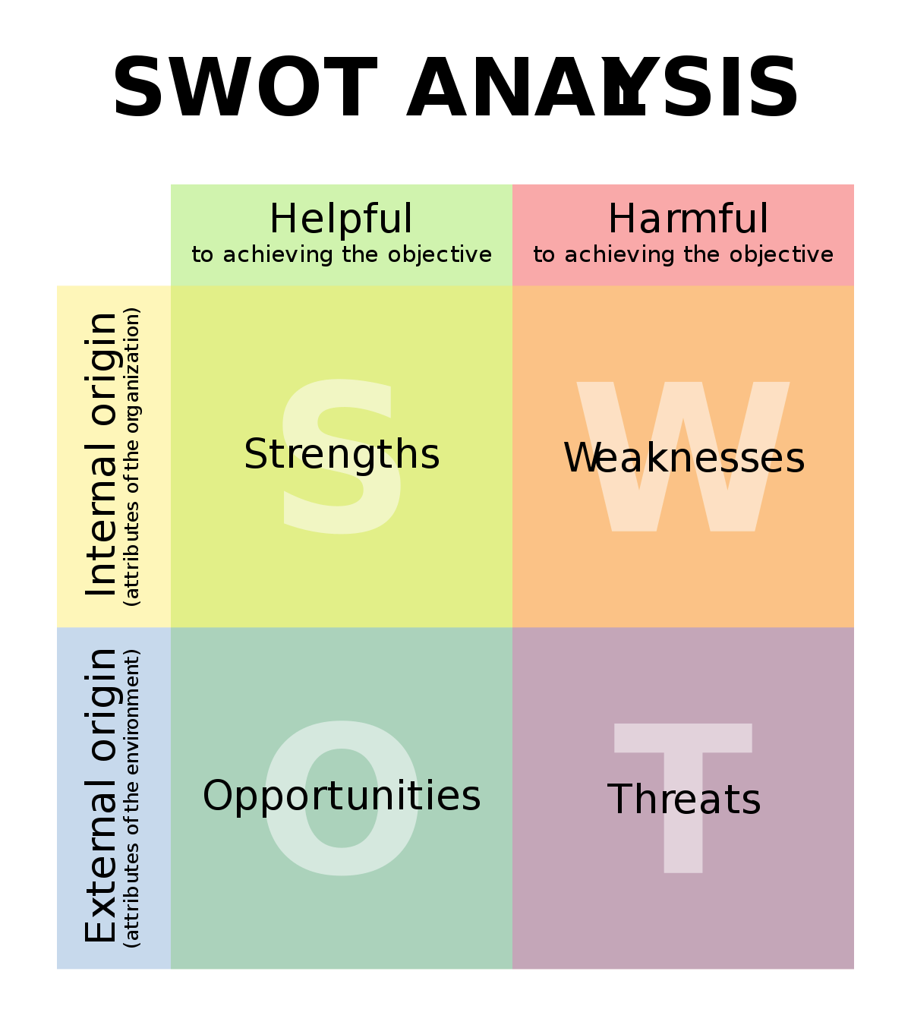

On the basis of above- 006Dentioned theory, Product can be better performed in selected customer segments.

Two Market segment have been identified

1. One who lives in urban area and having stable income, can expense reasonable amount of money for quality education.
2. Other segment having not reasonable income, but still want to purse high quality education.

As data provided in the dataset, and considering Indian education policy up to higher secondary school target is pass to pass maximum students, so it can not be concluded solely on the basis of data higher literacy ratio indicate in urban area with respect to GOVT school also satisfying.

So, leaving literacy and considering population and income we designed relevant marketing strategies for our products.

1. Customizing the Marketing Mix

On the basis of identified Market segmentation we have market in

* 1. Urban category with reasonable income.
  2. Urban category with not having reasonable income
  3. Rural population having good female literacy ratios.
  4. Private school having high fees.

Our Team have devised Customer and high-quality education strategies.

1. **Premium Product:** - Product has been implemented keeping in mind of 1st and 4th  target segment, where price would be reasonable but less than higher schools’ fees. Which will cater highest markets.
2. **Economy Product: -** Mere difference between above product is that lateral product server all minimum benefits , but less than first one , as cost of designing both product are same but lateral will benefit for customer aquation , so that they can be converted into premium products.
3. (for Business Markets)Potential customer base in the early market, thereby calculating the potential sale (profit) in the early market (Potential Customer Base * Your Target Price Range = Potential Profit).

Assuming target Customer in segments 1.

14 states Average students in target segment is 4.5 million People.

38% of above would be in 1st and 4th Segments (4.5 * 38%) = 1.71

Customer success ration 10% considering competition (1.71*10%) = **0.171 Million students**.

Assuming target Customer in segments 2nd and 3rd .

10 states Average students in target segment is 2.75 million People.

38% of above would be in 1st and 4th Segments (2.75* 15%) = .4125

Customer success ratio 10% considering competition (.4125*10%) = **.004125 Million students**.

**Roughly estimated Cost structure**

**1.**

* + 1. Selling Price for 1st and 4th = 96500 Rs.
    2. Operating Cost = 60570 Rs.

Gross Profit (A-b) = 35930 Rs.

* + 1. Selling Price for 2nd and 3rd = Rs. 65700
    2. Operating Cost = 45000 Rs.

Gross Profit (A-b) = Rs 20700

Total gross profits

= (.171*100000*35930) + (.004125*100000*20700)

= 6144030000+85387500

= 6229417500

= 6229.41 Million Rs.