# PIC Microcontroller:

## Introduction

PIC Stand for Peripheral Interface Controller and it is Made by Micro Chip Technology in Chandler, Arizona. A microcontroller is a compact microcomputer designed to govern the operation of embedded systems in motor vehicles, robots, office machines, medical devices, mobile radios, vending machines, home appliances, and various other devices. A typical microcontroller includes a processor, memory, and peripherals. Early Models of PIC had the read only memory (ROM) or field programmable EPROM for program storage. All Current models use Flash Memory for program storage, and newer models allow the PIC to reprogram itself. Program memory and data memory are separated. Data memory is 8-bit, 16-bit and in latest models, 32-bit wide. Program instructions vary in bit-count by family of PIC, and may be 12, 14, 16, or 24 bits long. The instruction set also varies by model, with more powerful chips adding instructions for [digital signal processing](https://en.wikipedia.org/wiki/Digital_signal_processing) functions. PIC microcontrollers are very popular amid hobbyists and industrialists; this is only cause of wide availability, low cost, large user base & serial programming capability, and re-programmable Flash-memory capability.

The hardware capabilities of PIC devices range from 8-pin DIP chips up to 100-pin SMD chips, with discrete I/O pins, ADC and DAC modules, and communications ports such as UART, I2C, CAN, and even USB. Low-power and high-speed variations exist for many types.

The manufacturer supplies computer software for development known as MPLAB, assemblers and C/C++ compilers, and programmer/debugger hardware under the MPLAB and PIC Kit series. Third party and some open-source tools are also available. Some parts have in-circuit programming capability; low-cost development programmers are available as well has high-production programmers ease of reprogramming with built-in EEPROM (electrically erasable programmable read-only memory), an extensive collection of free application notes, abundant development tools, and a great deal of information available on the Internet. The PIC microcontrollers often appear under the brand name PIC micro.

## Types Of PIC

1. Base Line PIC
2. Mid-Range PIC
3. Enhanced Mid-Range PIC
4. PIC18
5. PIC24
6. PIC32

1.**Base Line PIC**

Base Line PICs are the least complex **PIC microcontrollers**. These microcontrollers work on 12-bit instruction architecture which means that the word size of instruction sets are of 12 bits for these controllers. These are smallest and cheapest PICs, available with 6 to 40 pin packaging.  The small size and low cost of Base Line PIC replaced the traditional ICs like 555, logic gates etc. in industries.

2.**Mid-Range PIC**

Mid-Range PICs are based on 14-bit instruction architecture and are able to work up to 20 MHz speed. These controllers are available with 8 to 64 pin packaging. These microcontrollers are available with different peripherals like ADC, PWM, Op-Amps and different communication protocols like USART, SPI, I2C (TWI), etc. which make them widely usable microcontrollers not only for industry but for hobbyists as well.

3. **Enhanced Mid-Range PIC**

These controllers are enhanced version of Mid-Range core. This range of controllers provides additional performance, greater flash memory and high speed at very low power consumption. This range of PIC also includes multiple peripherals and supports protocols like USART, SPI, I2C and so on.

4. **PIC18**

PIC18 range is based on 16-bit instruction architecture incorporating advanced RISC architecture which makes it highest performer among the all 8-bit PIC families. The PIC18 range is integrated with new age communication protocols like USB, CAN, LIN, Ethernet (TCP/IP protocol) to communicate with local and/or internet based networks. This range also supports the connectivity of Human Interface Devices like touch panels etc.

### Baseline

### 

### Mid-Range

### PIC18

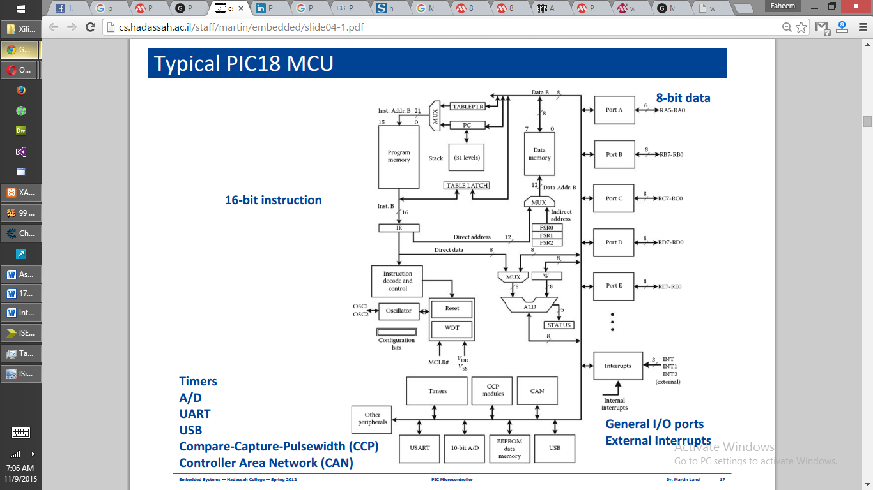

## Applications

* Robots
* Phone Dialers
* Clocks and timers
* Volt Meter
* Measuring revolving objects
* Current Meters
* Hand Held Metering Systems
* Light sensing & controlling devices
* Temperature sensing and controlling devices
* Fire detection & safety devices
* Industrial instrumentation devices
* Process control devices
* Industrial instrumentation devices
* Process control devices

Typical Applications

* Baseline
  + Replace discrete
    - logic functions Gates, simple state machines, encoders/decoders, etc.
  + Disposable electronics
    - Drug / pregnancy testers, dialysis monitor, etc
* Mid-Range
  + Digital sensors, displays, controllers, telecom equipment
  + Glucose / blood pressure set
* PIC18
  + Integration with peripherals + networks
    - USB, Ethernet, MCU-to-MCU, etc
  + Higher level analog peripherals, industrial control, major appliances
* PIC24 / dsPIC30
  + 16-bit ALU with integrated DSP
    - Portable EGK
* PIC32
  + General purpose RISC microprocessor + controller
    - MRI

## General Architecture

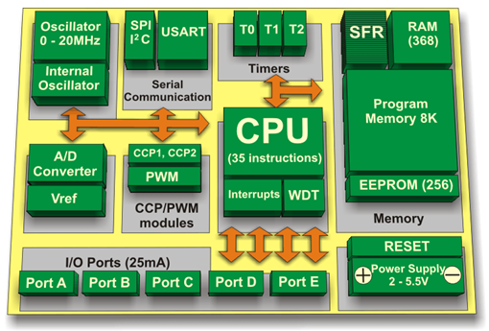

**CPU:**CPU is not different from other microcontrollers CPU. PIC microcontroller CPU consists of Arithmetic logic unit (ALU), memory unit (MU), control unit (CU), Accumulator etc. we know that ALU mainly used for arithmetic operations and taking the logical decisions, memory used for storing the instruction which is to processed and also storing the instructions after processing, Control unit is used for controlling the all the peripherals which are connected to the CPU both internal peripherals and external peripherals. Accumulator is used for storing the results and used for further processing. As I said earlier PIC micro controller supports the RISC architecture that is reduced instruction set computer, if a computer or controller is said that it supports reduced instruction set you should remember the following points:

1. RISC has very few instructions (approx. ~ 35) which are used in the program.
2. Length of the instruction is small and fixed and takes same amount of time for processing.
3. As the instruction is small it will take less time to process another words CPU will be fast.
4. Compiler need not be complex and debugging will be very easy in the programmer point of view.

**Memory:**Memory module in the PIC consists of RAM, ROM and STACK

**RAM:** we know that RAM (Random Access Memory) which is a volatile memory used for storing the data temporarily in its registers. RAM memory is divided in to Banks, in each banks we have number of registers. The RAM registers is divided into 2 types. They are General purpose registers (GPR) and Special purpose registers (SPR).

1. **GPR:** general purpose registers as the name implies for general usage. For example if we want to multiply any two numbers using PIC we generally take two registers for storing the numbers and multiply the two numbers and store the result in other registers. So general purpose registers will not have any special function or any special permission, CPU can easily access the data in the registers.
2. **SPR:** Special function registers are having the specific functions, when we use this register they will act according to the functions assigned to them. They cannot be used like normal registers. For example you cannot use STATUS register for storing the data, STATUS registers are used for showing the status of the program or operation. User cannot change the function of the Special function register; the function is given by the vendor at the manufacturing time.

**ROM:** we know that ROM (Read Only memory) is a non volatile memory used for storing the data permanently. In microcontroller ROM will store the complete instructions or program, according the program microcontroller will act. Rom is also called program memory in this memory user will write the program for microcontroller and save it permanently and get executed by the CPU. According to the instruction executed by the CPU the PIC microcontroller will perform the task. In ROM there are different types which are used in different PIC microcontrollers.

* **EEPROM:** In the normal ROM we can write the program for only one time we cannot reuse the Microcontroller for another time where as in the EEPROM (Electrically Erasable Programmable Read Only Memory) we can program the ROM for number of times.
* **Flash Memory:** flash memory is also PROM in which we can read write and erase the program more than 10,000 times. Mostly PIC microcontroller uses this type of ROM.

**Stack:** when an interrupt occur PIC has to first execute the interrupt and the existing process address which is being executed is stored in the stack. After completing the interrupt execution, PIC will call the process with the help of address which is stored in stack and get executing the process.

**Bus:**Bus is mainly used for transferring and receiving the data from one peripheral to another. There are two types of buses.

* Data Bus: It is used to transfer/receive only the data.
* Address Bus: is used to transmit the memory address from peripherals to CPU.

I/O pins are used for interfacing the external peripherals, UART and USART is serial communication protocol which is used for interfacing serial devices like GPS, GSM, IR, Bluetooth etc.