Charts Finder

## Welcome to Charts Finder, a small tool to get charts for your flight. Charts Finder 2 is a new re-write of the original Charts Finder with C++ and Qt.

Features

### Download charts and save to a specific folder.

### Use a modify-able database.

### Ability to open charts after downloading.

### Ability to download multiple files for one airport (aka. Folder charts)

### Easy to use graphical interface.

### Freeware and open-source!

How to use

### Just open Charts Finder.exe file. The simple interface will appear. Enter the ICAO code for the airport (You can enter multiple codes, separated by spaces), and click ‘Get charts’ button. The program will download the charts. You can see the progress on the main interface. The charts can be found in the ‘Charts’ folder, which exists in the program folder (The same folder ‘Charts Finder.exe’ exists). You can cancel the process at any time by pressing the ‘Cancel’ button.

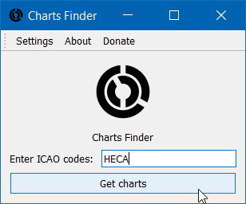

Settings

General

### Charts folder: You can select where you want to save charts. Press the ‘Change’ button to change. A dialog will appear. Select the charts folder and press ‘Select Folder’.

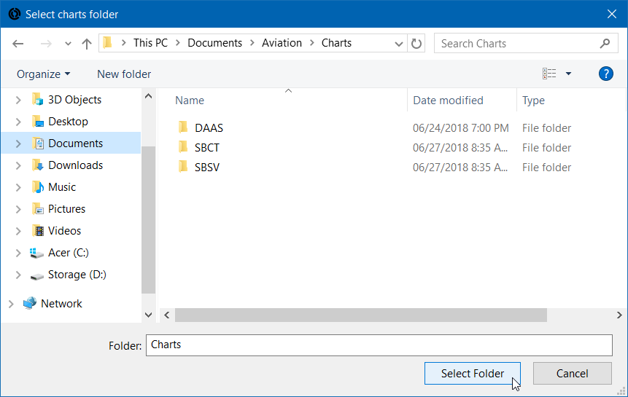

### Open charts after download: Check this box to open the chart’s file/folder after downloading.

### Remove downloaded files after cancellation: Check this box to remove the downloaded files if the process was canceled and some files are downloaded.

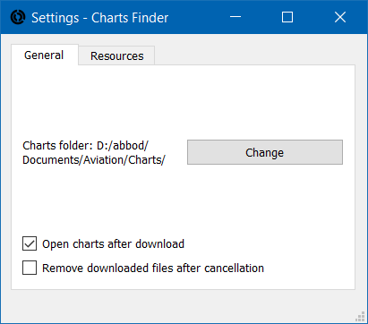

Resources

### You can modify the websites that are used by the program to download charts. There are 2 types of charts: Normal and folder charts.

### A normal chart is a single PDF file contains the whole airport charts. That means all of the airport charts are put into one PDF file. The program will download the file normally inside the charts folder.

### A folder chart is multiple PDF files. Every chart is put into a PDF file, so multiple files must be downloaded to complete the airport charts. The program will download every PDF file exists in the provided URL.

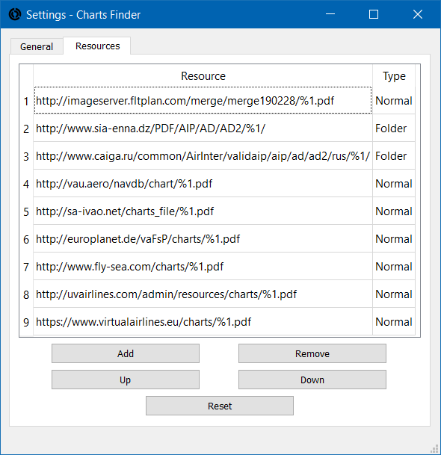

### To add a resource, press ‘Add’ button. The addition dialog will appear. You must add the URL in the following syntax for normal charts: [http://website.com/charts/%1.pdf](http://website.com/charts/%251.pdf), and the following for folder charts: [http://website.com/charts/%1/](http://website.com/charts/%251/). %1 will be replaced with the airport code. If you want to download HECA charts, for example, the URL will be <http://website.com/charts/HECA.pdf>, and the chart will be downloaded. For folder charts, the URL will be <http://website.com/charts/HECA/>. The program will download all PDF files exist in that URL.

### Then you have to select the type and order. The order is important; as the program will download the chart from the first one, and if the chart doesn't exist it’ll download it from the second, etc. So the newest charts should be put first.

### Then press ‘Add’ button to add the resource to the resources list.

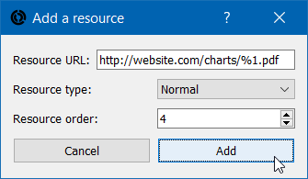

### If there is an error in the syntax, the program won’t add the resource, and a message will be shown in the status bar.



### You can change the resource’s order using ‘Up’ and ‘Down’ buttons. Select the resource and press the suitable button.

About

### The program is written with C++, Qt 5.11, and QGumboParser. It’s open-source under GPL 3 license. You can find the source code on the [Github repository](https://github.com/abdullah-radwan/ChartsFinder2).

### If you liked the program, you can consider a [small donation](https://www.paypal.me/abdullahradwan1). All amounts are appreciated.

### Copyright © Abdullah Radwan