AgPerfMon

This software distribution contains the AgPerfMon data capture infrastructure. It includes a full-featured GUI for capturing and displaying data, as well as a variety of command-line utilities. AgPerfMon can be used to capture various data from the Ageia PhysX hardware, from the Ageia PhysX SDK, and from any application software compiled with the AgPerfMon “Source API”.

A self-installing executable is available in the Ageia Perforce repository:

//perf/tools/AgPerfMon/distribution/AgPerfMon-N.M.exe

Additional documentation can be found at http://intranet.ageia.com/bin/view/Brain/PerfMON.

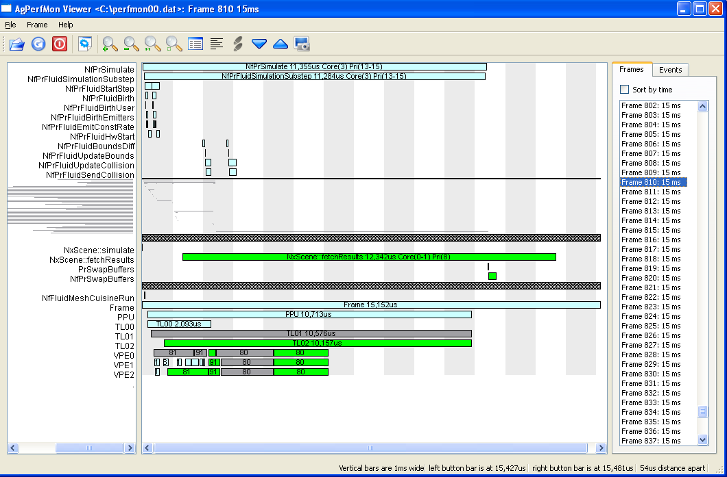

Installation instructions

Run the “AgPerfMon-N.M.exe” self-installer.

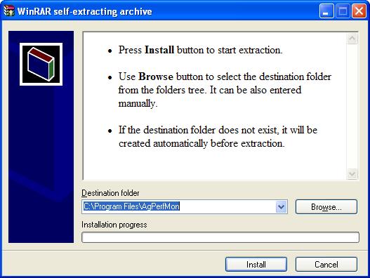

Add the installation directory to your Windows $PATH environment variable. By default, this is “C:\Program Files\AgPerfMon”

Run a PhysX System Software installer from December 22, 2006, or NEWER.
E.g.: “PhysX_6.12.22_SystemSoftware.exe”.

If you want to capture data from the Ageia PhysX SDK, replace your copy of "PhysXCore.dll" with one that supports AgPerfMon. Your copy will either be in the application's working directory, or in “C:\Program Files\Ageia Technologies\vX.X.X”. AgPerfMon supports PhysX SDK versions 2.6.4 and greater. An AgPerfMon compatible version can be built from source code as follows:
Run “novodex/SDKs/compiler/xpj/create_vc71win32_projects.bat” to rebuild the solution and project files. Launch the “novodex/SDKs/compiler/vc71win32/NovodeX_agperfmon.sln” solution file using MS Visual Studio. Build the “release_agperfmon” or “debug_agperfmon” configuration.

Data Capture

Run “AgPerfMon.exe”.

You can configure the name of the file that you wish to write the data to. Normally, the capture method should be ‘Direct to File’, however, if you are debugging an application, and will be running for a long time before you need to capture data, the ‘Event Ring’ method can be used to only capture the most recent N events before the capture is stopped.

Various event filters can be configured. The more events you enable, the greater the impact on performance will be. Custom filters can be saved and re-loaded later.

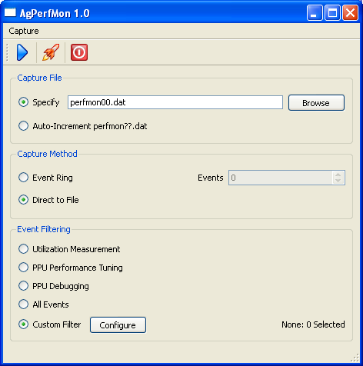

Run your application. If you are using the PhysX hardware, it is important to start the PhysX simulation before you start capturing. Otherwise, when the PhysX hardware is initialized, the data capture will fail.

Click on the ‘Start Capturing’ button (blue triangle icon) in AgPerfMon to start collecting events. Click on the button again to stop capturing. This will produce a binary data file called "perfmon00.dat" in the current directory (unless you override this setting in AgPerfMon).

You can launch the viewer to examine the events you have just captured by clicking on the ‘Launch Viewer’ button (rocket icon), or you can follow the instructions below to do more advanced data mining.

The Viewer

Once you have captured data, you can use the viewer to analyze the data. The viewer can be started by clicking on the ‘Launch Viewer’ button (rocket icon) in “AgPerfMon.exe”, or by directly running “agperfviewer.exe”.

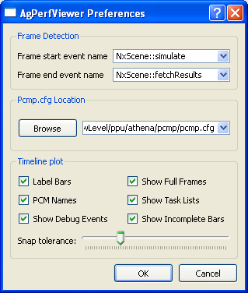
By default, frames are delimited by calls to the PhysX SDK API method: NxScene::simulate(). If you are not capturing data from the PhysX SDK, or if you have added a suitable frame delimiting event in your application, this can be changed in the Preferences dialog. In the viewer, frames are delimited by the configured start-event, but only if an end-event has occurred since the preceding start-event. If no start-events can be found, the entire file will be displayed as a single frame.

If you are analyzing data from the PhysX hardware, you can optionally configure a path to the “pcmp.cfg” file. This will allow the viewer to identify PhysX PCM’s by name rather than by number.

Adding AgPerfMon events to your application

You can easily add new event sources in your application.

Simply add the following source files to your project:
- AgPerfMonEventSrcAPI.cpp
- AgPerfMonEventSrcAPI.h
- AgPerfMonEventAPI.h
- AgTypes.h

In all of your source files, include AgPerfMonEventSrcAPI.h:

#include “AgPerfMonEventSrcAPI.h”

At initialization, create a single instance of the AgPerfUtils class, and register the event names that your application will use:

AgPerfUtils *pu = new AgPerfUtils;

AgEventID ev1 = pu->registerEvent(“BeginFrame”);
AgEventID ev2 = pu->registerEvent(“EndFrame”);
AgEventID ev3 = pu->registerEvent(“Stat1”);

Then, throughout the application, submit events by calling the startEvent(), stopEvent(), statEvent(), or debugEvent()methods of the AgPerfUtils class. Use startEvent()and stopEvent()to bracket interesting sections of code, and use statEvent()to log various statistics or counters:

pu->startEvent(ev1);
// do something useful here
pu->stopEvent(ev1);

pu->statEvent(ev3, 42);

Before exiting, delete the instance of the AgPerfUtils class:

delete pu;

Data Analysis using “LaneTimeline.exe” (optional)

Once you have captured data in a “perfmon00.dat” file, you can use "LaneTimeline.exe" to analyze the data. By default, frames are delimited by calls to the PhysX SDK API method: NxScene::simulate(…). This can be changed with the “-b” and “-B” options.

Number of frames in a capture file

Use "LaneTimeline.exe -n" to find out how many frames have been captured in "perfmon00.dat".

Display complete frame(s)

Use "LaneTimeline.exe N M" to display all the events in frames N through M. If M is omitted, only frame N is displayed.

Display list of event names

Use "LaneTimeline.exe -l" to display the event-name to event-id mapping table from the capture file.

Dump statistics to CSV file

Use "LaneTimeline.exe –s > stats.csv" dump all of the per-frame statistics into a CSV file

Plotting a graph of all frame times in a capture file

If you want to see all the frame times in a capture file, use “LaneTimeline.exe –T”
You can plot the results with “gnuplot” or MS-Excel.

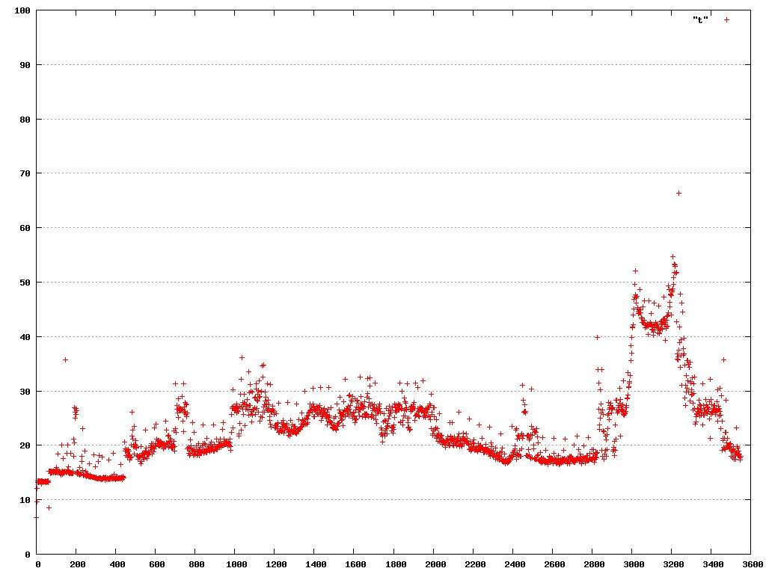
Data Graphing using Ploticus (optional)

Installation instructions

Install Cygwin (if you don't already have it).
Add the directory where you installed AgPerfMon to the BEGINNING of your Cygwin path.

Basic Data Graphing instructions

Edit "unitimeline.sh" and set PLSCRIPTDIR to the Cygwin path to the directory where you unzipped these files. E.g.: PLSCRIPTDIR=/cygdrive/c/agperfmon_distribution

Open a Cygwin window and run "unitimeline.sh FIRSTFRAME LASTFRAME"
(E.g.: unitimeline.sh 0 99 ) (FYI: run "LaneTimeline.exe -n" to find out how many frames have been captured)

Open "frames.html" in a web browser to view the graphs.

Multiple frames on one graph

You can use “multitimeline.sh” to plot multiple frames on one graph. This is particularly useful in games that use multiple NxScenes, whose simulation times do not overlap. Normally, with “unitimeline.sh”, each NxScene would be plotted on a separate graph, appearing as separate frames.

Open a Cygwin window and run “multitimeline.sh FIRSTFRAME LASTFRAME FILENAME”
E.g.: multitimeline.sh 521 522 image.gif

PCM enumeration decode table (from pcmp.cfg) for PhysX SDK 2.7.*

PCM  Number | Name | Feature
1 | Scene Update | Rigid Body
2 | AABB Update | Rigid Body
3 | Broad Phase ( VPC delete ) | Rigid Body
4 | Broad Phase ( SAP update ) | Rigid Body
5 | Broad Phase ( SAP radix sort ) | Rigid Body
6 | Broad Phase ( VPC insert ) | Rigid Body
8 | Mid Phase | Rigid Body
9 | Narrow Phase | Rigid Body
11 | Touch Update | Rigid Body
12 | Joint Prep | Rigid Body
15 | Island Detection | Rigid Body
16 | IBU Prep | Rigid Body
17 | Body Prep | Rigid Body
18 | Constraint Solver | Rigid Body
19 | Pose Update | Rigid Body
20 | Pack | Rigid Body
21 | Scene Cleanup | Rigid Body
80 | Fluid Packet Pipeline | Fluid
81 | Fluid Make Packet Hash | Fluid
82 | Fluid Halo Reorder | Fluid
84 | Fluid PPU Sync | Fluid
85 | Fluid Host Sync | Fluid
90 | Fluid Profiling Sync | Fluid
91 | Fluid Simple Particle | Fluid
92 | Fluid Send Packet Table | Fluid
93 | Fluid Collision Update | Fluid
97 | Surface Calc Depth Density | Fluid Surface
98 | Surface Add Vertices | Fluid Surface
99 | Surface Generate Triangles | Fluid Surface
100 | Surface Profile | Fluid Surface
128 | Cloth Update | Cloth
129 | Cloth Self Collision | Cloth
130 | Cloth Collision | Cloth
131 | Cloth Solver | Cloth
132 | Cloth Profile | Cloth

Building your own PhysXCore.dll

You can build your own AgPerfMon compatible version of PhysXCore.dll if you are using one of the following branches:

- //novodex (The “Trunk”)
- //release/PhysX_2.6.4
- //release/PhysX_2.7.0 or newer

Simply run “novodex/SDKs/compiler/xpj/create_vc71win32_projects.bat” to rebuild the solution files.
Then launch “novodex/ SDKs/compiler/vc71win32/NovodeX_agperfmon.sln” in MS Visual Studio.
Build the “release_agperfmon” or “debug_agperfmon” configuration.

If you are using a branch not listed above, contact jpb@ageia.com for more information.

Adding new events in PhysXCore.dll

You can add new events in PhysXCore.dll by creating new profiling zones in the SDK. Add your new zone(s) to one of the following enumerations, depending on what part of the code you wish to profile:

Project | Enumeration | Enum Header File | Profiler Header
Software Low Level | PxsProfilerZoneDefs | PxsContext.h | PxcProfiler.h
Firmware Low Level | PxfProfilerZoneDefs | PxfContext.h | PxcProfiler.h
High Level | ProfileZones | Scene.h | Profiler.h
Fluid or Cloth | NfProfileZones | NfScene.h | Profiler.h
HSM | HSMProfileZones | HardwareAbstraction.h | Profiler.h

