Since X-Ivap 0.4, we added few commands you can map to your keyboard or joystick button.

The commands will toggle the state of the following actions:

* Connect
* Debug Console
* Flight Plan
* Main Window

In order to map these commands, please do the following:

**Step 1:** Open X-Plane keyboard or joystick settings

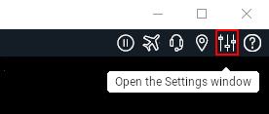

# **Keyboard Example**

**Step 2:** Press the Keyboard tab.   
Once the Keyboard settings is open scroll and find the X-IVAP node (see below):

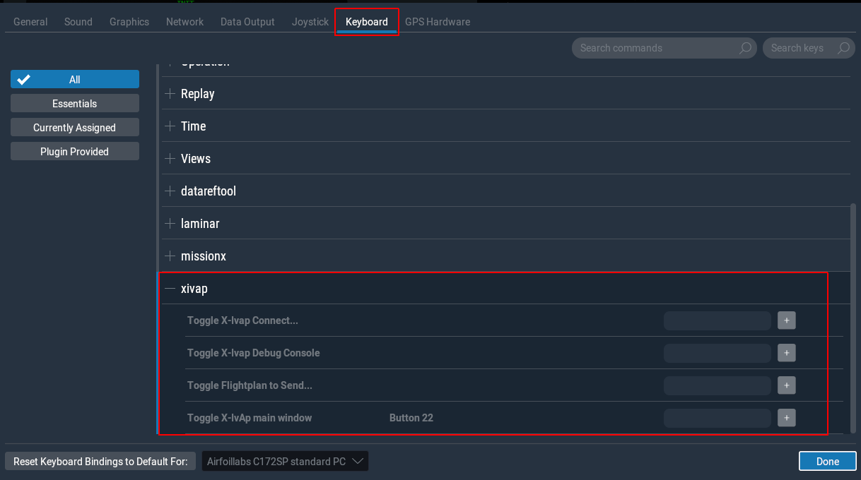

**Step 3:** Map keyboard command to X-Ivap Command.

I will map the “Flightplan to Send…” to “[Alt]+[F]”.

First I’ll press on the [+] button next to the command:



Now I’ll enter the key combination I want.

If all is OK, you will see the following mapping:



# **Joystick Example**

Joystick mapping is pretty much similar.

**Step 1:** You need to use the “Joystick” tab, and pick your preferred Joystick and button to map to.

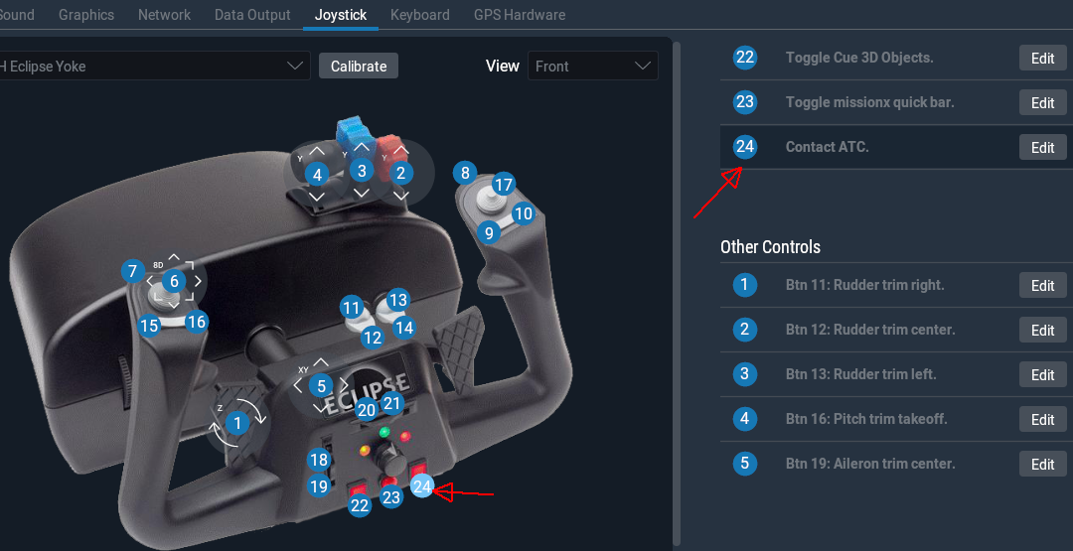

**Step 2:** Click the [Edit] option next to the button you picked, on the right side, and search for   
X-Ivap.

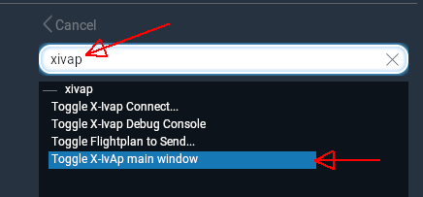

**Step 3:** Pick the command you want to map the button. In this case, I’ll pick “Toggle X-Ivap main window” and press the [Apply] button.

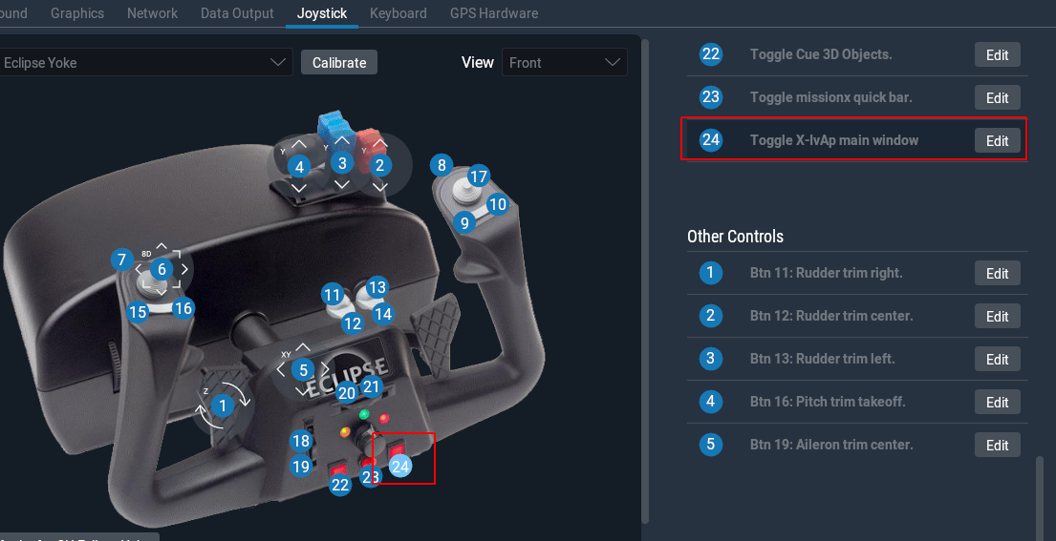

Button is now mapped to the X-Ivap toggle command.