**COMPUTER PROGRAMMING**

**PRACTICAL RECORD FILE**

2021-22

Name: ARIJIT KAR

Roll No.: 2021UEA6592

Branch: ECAM

Section: 2

SUMBITTED TO: MS. BARKHA NANDWANA



# **Netaji Subhas University of Technology**

**SECTOR 3, DWARKA**

**DELHI 110078**

**TABLE OF CONTENTS**

|  |  |  |  |
| --- | --- | --- | --- |
| Serial no. | **PROGRAM** | Page no. |  |
| **1.** | HELLO WORLD | **1** |  |
| **2.** | ADDITION OF 2 INTEGERS | **2** |  |
| **3.** | MULTIPLICATION OF 2 INTEGERS | **3** |  |
| **4.** | CHECK IF NUMBER IS EVEN | **4** |  |
| **5.** | CHECK IF NUMBER IS EVEN OR ODD | **5** |  |
| **6.** | GREATEST OF THREE NUMBERS | **6** |  |
| **7.** |  |  |  |

# PROGRAM 1: PRINT HELLO WORLD

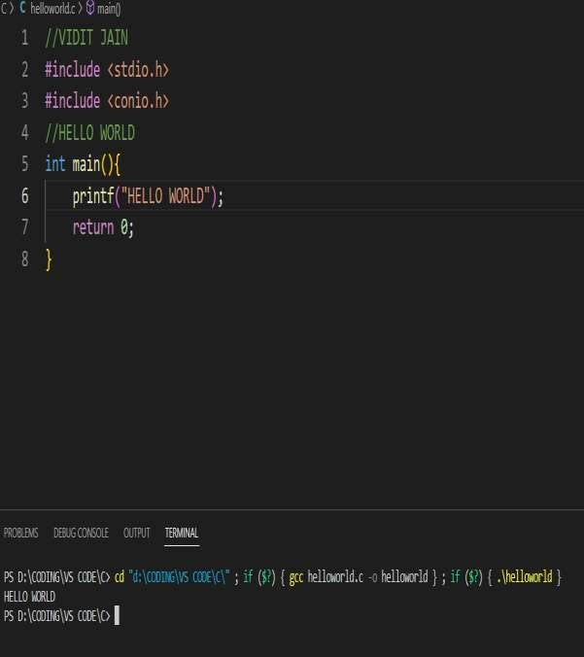

# PROGRAM 2: ADDITION OF TWO INTEGERS

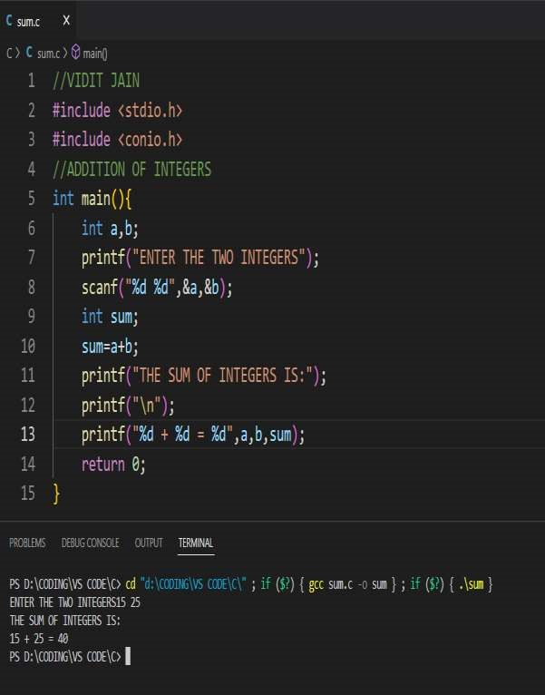

# PROGRAM 3: MULTIPLICATION OF TWO INTEGERS

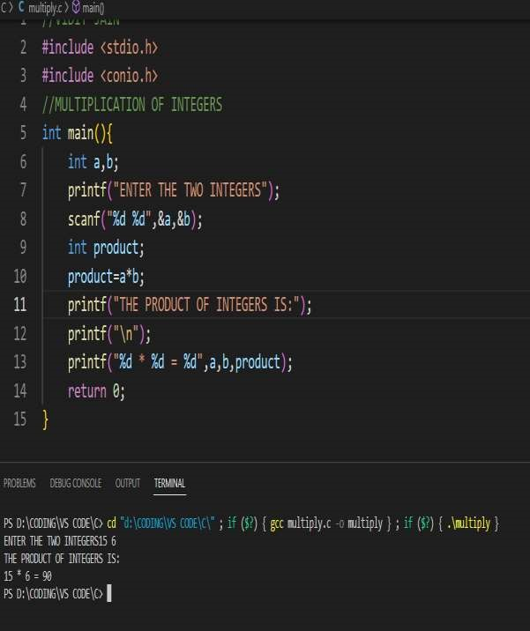

# PROGRAM 4: TO CHECK IF NUMBER IS EVEN

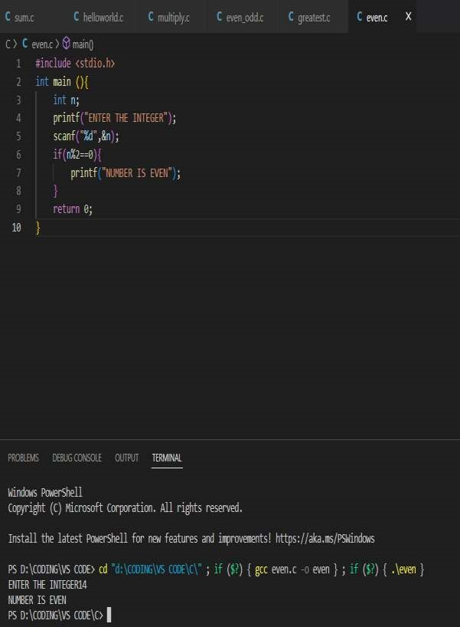

# PROGRAM 5: TO CHECK IF NUMBER IS EVEN OR ODD

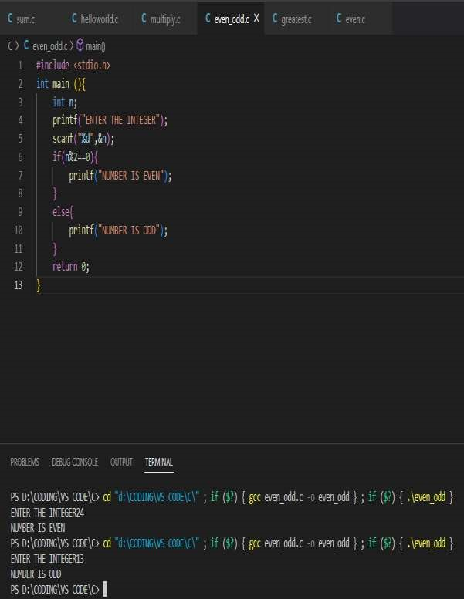

# PROGRAM 6: MAXIMUM OF THREE NUMBERS

