online_gaming_behavior_dataset

Всего записей – 40034

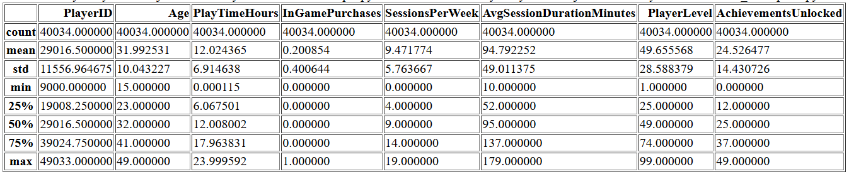

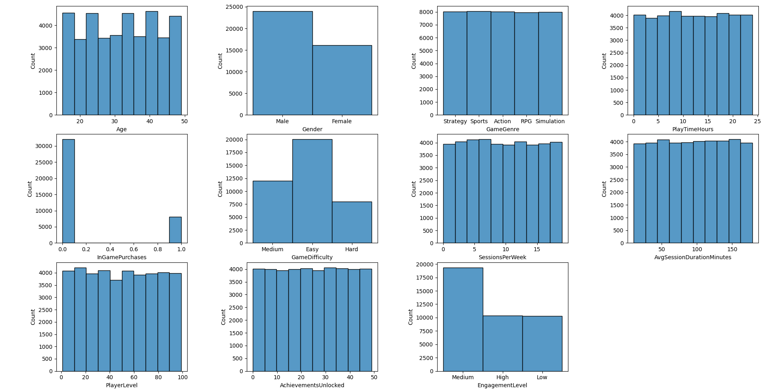

Gender

{'Male': 0, 'Female': 1}

GameGenre

{'Strategy': 0, 'Sports': 1, 'Action': 2, 'RPG': 3, 'Simulation': 4}

GameDifficulty

{'Medium': 0, 'Easy': 1, 'Hard': 2}

EngagementLevel

{'Medium': 0, 'High': 1, 'Low': 2}

