Створення гілки branch Develop, та добавлення в репозиторій файлу index.html

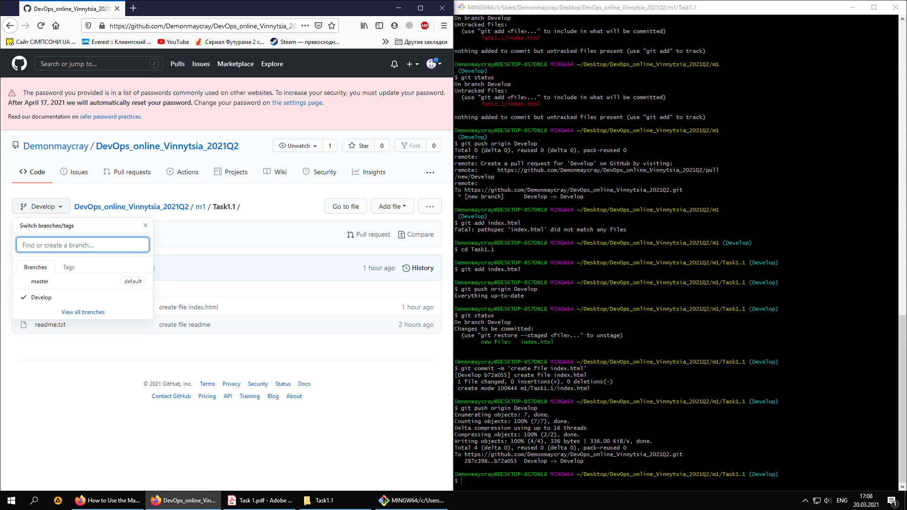

Створення гілки branch images, та добавлення в репозиторій файлів

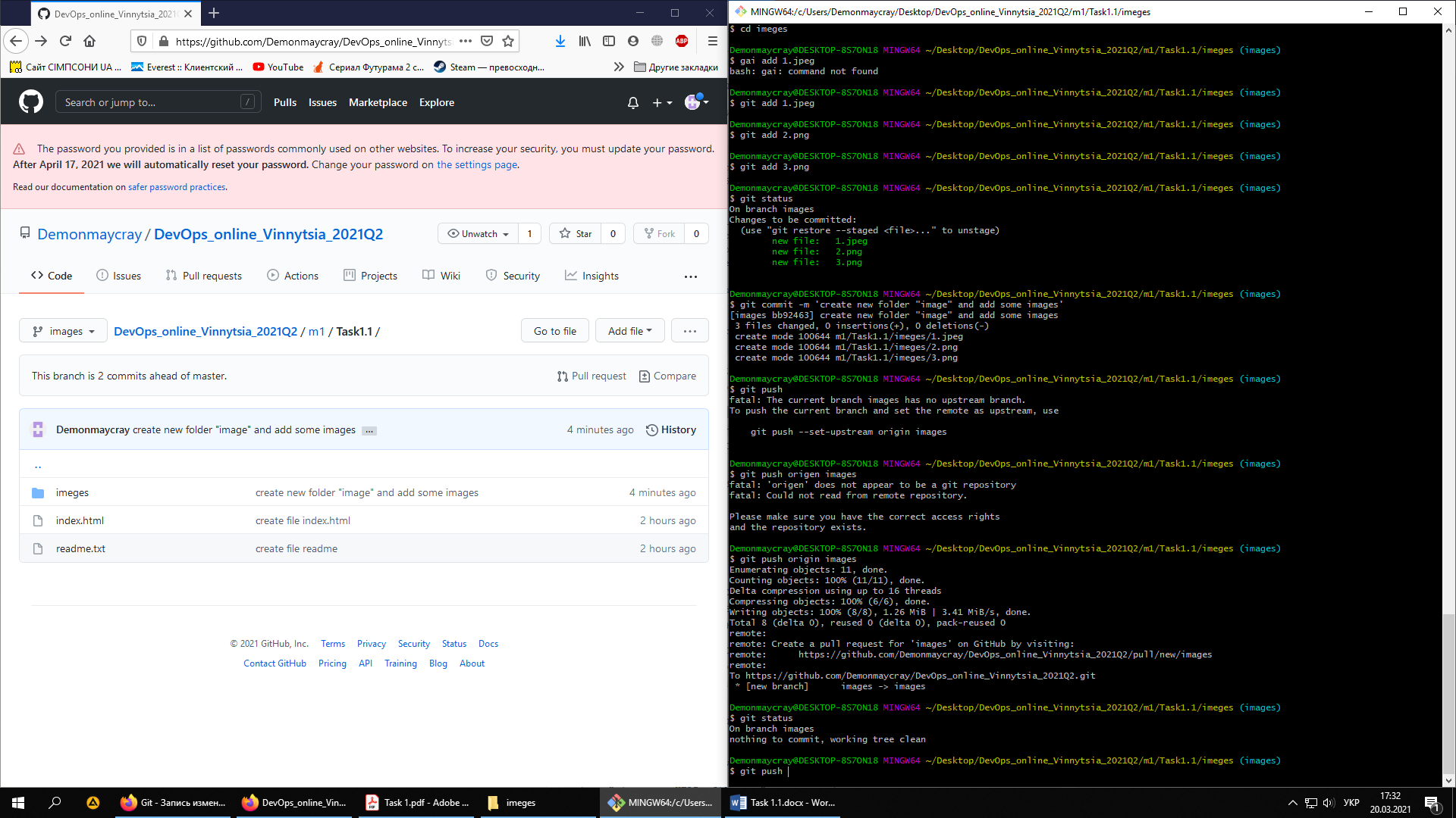

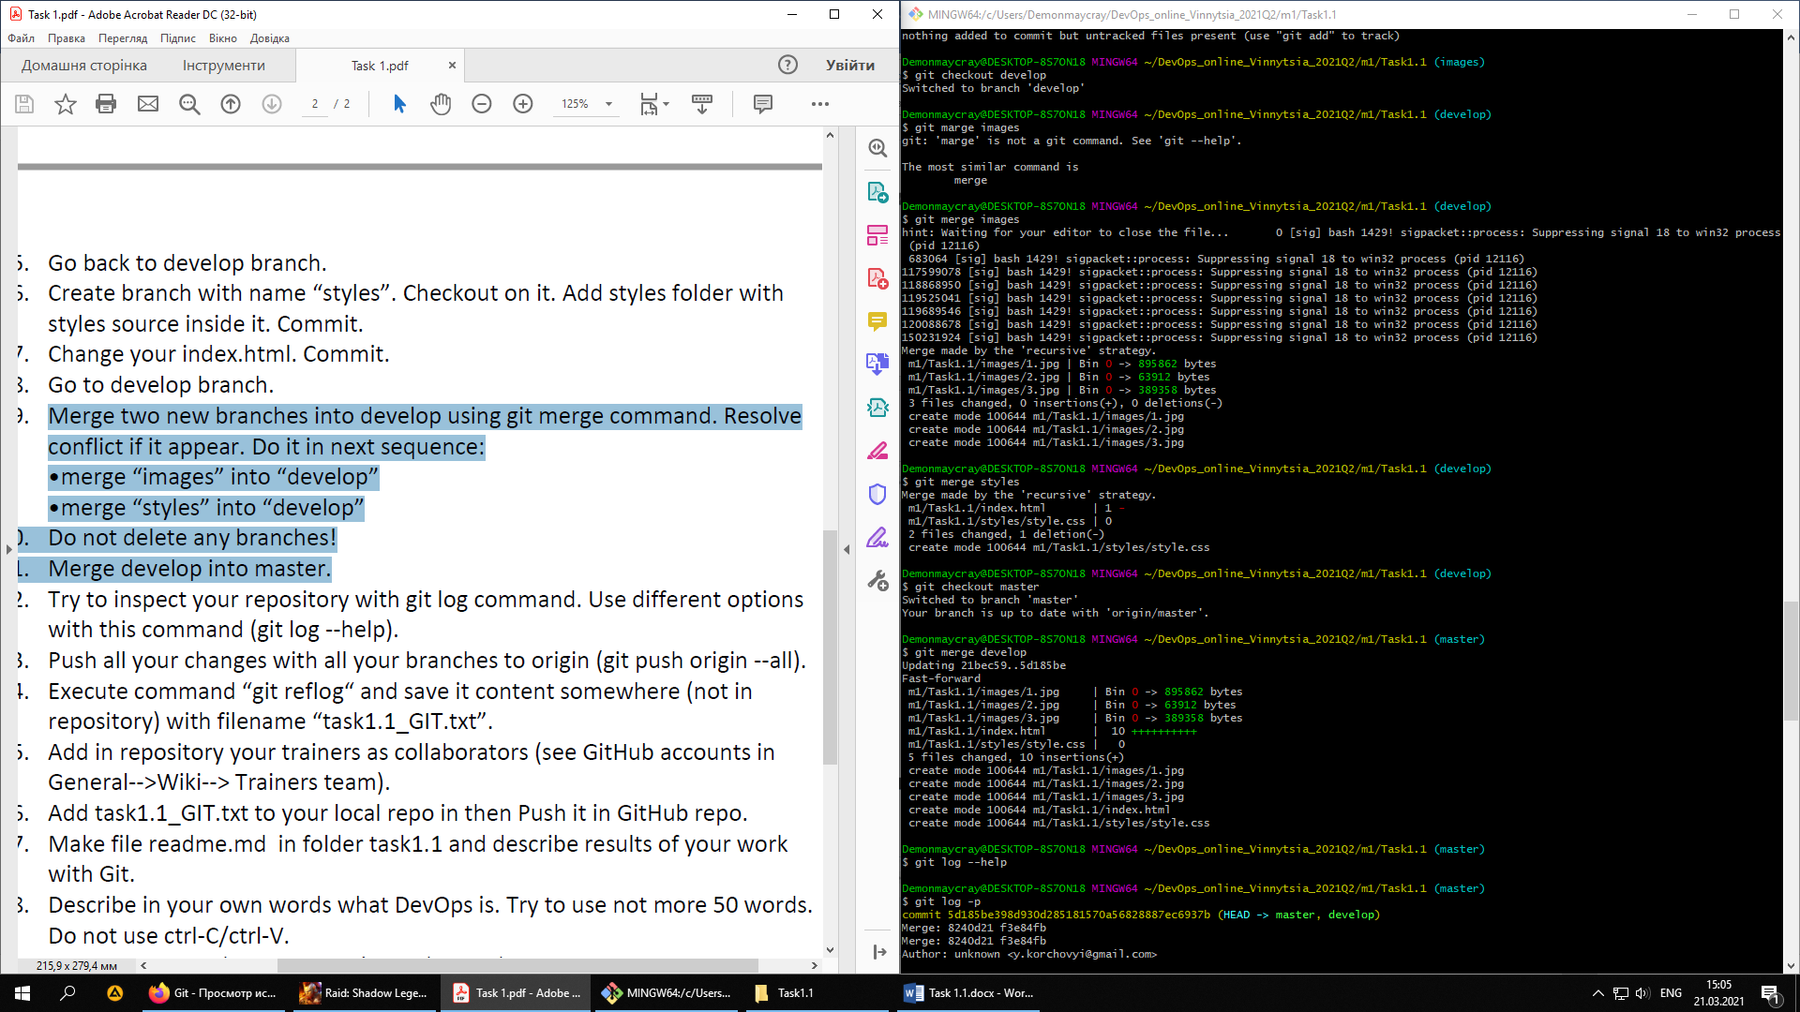

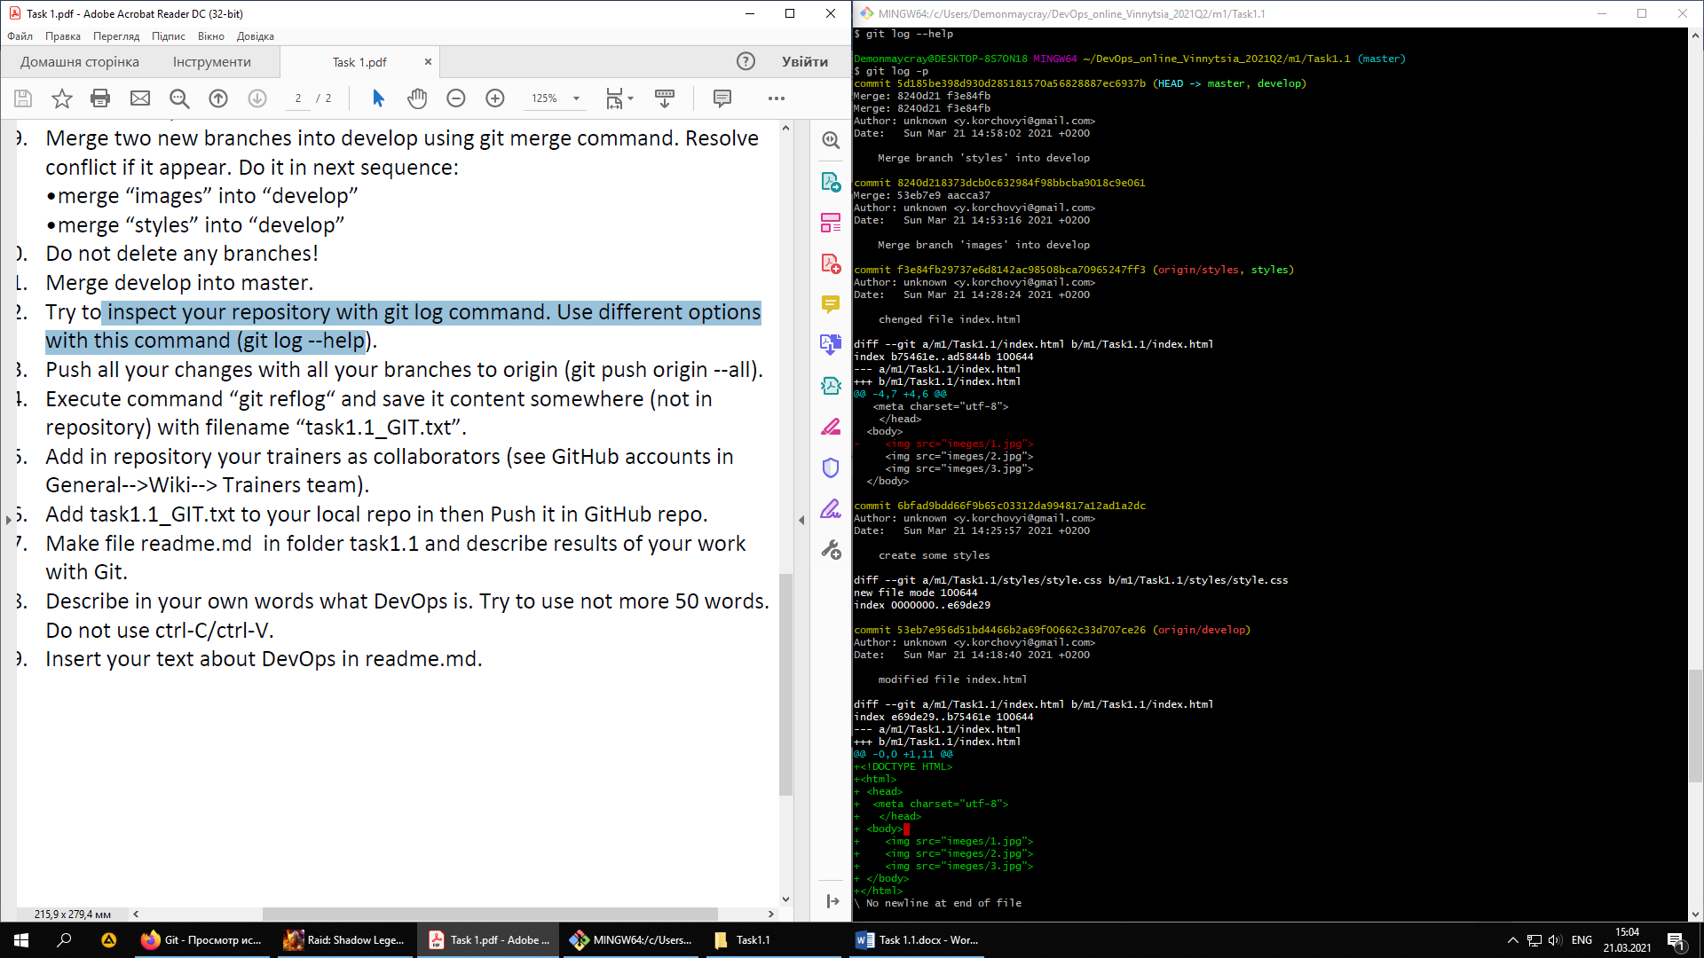

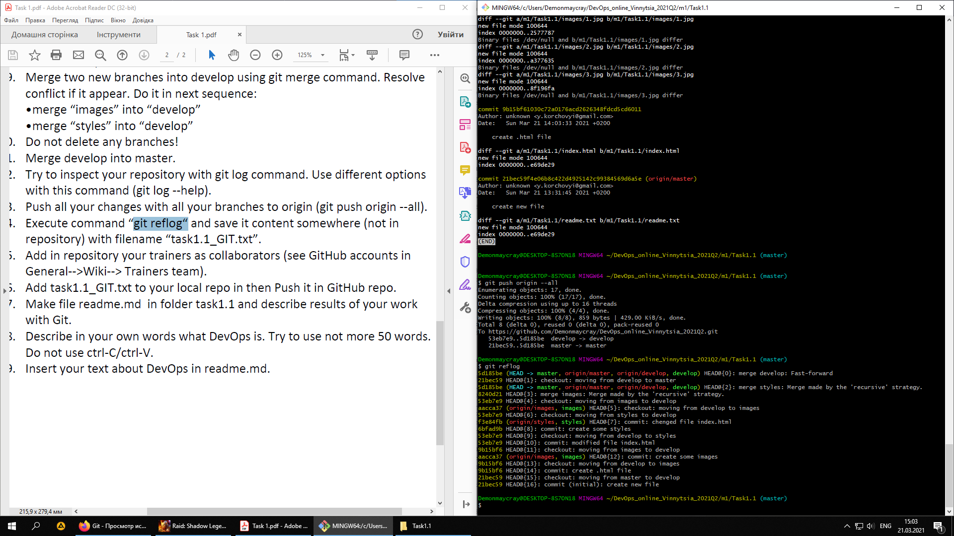

$ git reflog

5d185be (HEAD -> master, origin/master, origin/develop, develop) HEAD@{0}: merge develop: Fast-forward

21bec59 HEAD@{1}: checkout: moving from develop to master

5d185be (HEAD -> master, origin/master, origin/develop, develop) HEAD@{2}: merge styles: Merge made by the 'recursive' strategy.

8240d21 HEAD@{3}: merge images: Merge made by the 'recursive' strategy.

53eb7e9 HEAD@{4}: checkout: moving from images to develop

aacca37 (origin/images, images) HEAD@{5}: checkout: moving from develop to images

53eb7e9 HEAD@{6}: checkout: moving from styles to develop

f3e84fb (origin/styles, styles) HEAD@{7}: commit: chenged file index.html

6bfad9b HEAD@{8}: commit: create some styles

53eb7e9 HEAD@{9}: checkout: moving from develop to styles

53eb7e9 HEAD@{10}: commit: modified file index.html

9b15bf6 HEAD@{11}: checkout: moving from images to develop

aacca37 (origin/images, images) HEAD@{12}: commit: create some images

9b15bf6 HEAD@{13}: checkout: moving from develop to images

9b15bf6 HEAD@{14}: commit: create .html file

21bec59 HEAD@{15}: checkout: moving from master to develop

21bec59 HEAD@{16}: commit (initial): create new file