将每个洲的605个变量进行聚类分析

**CA**

1、可以导出分类结果到附录

**2、二步聚类结果**

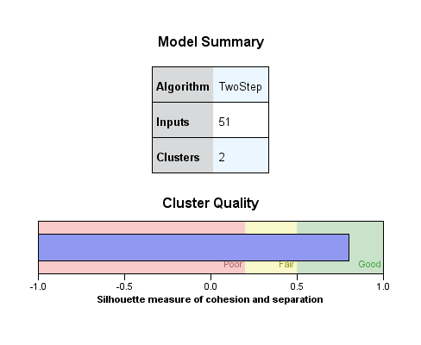

3、K-均值聚类结果

2类

**Iteration Historya  Number of Cases in each Cluster**

| Iteration | Change in Cluster Centers | |
| --- | --- | --- |
| 1 | 2 |
| 1 | 11.077 | 29.420 |
| 2 | 14.816 | .283 |
| 3 | 1.140 | .000 |
| 4 | .088 | 8.657E-7 |
| 5 | .007 | 1.513E-9 |
| 6 | .001 | 2.646E-12 |
| 7 | 3.990E-5 | 4.556E-15 |
| 8 | 3.070E-6 | 1.908E-17 |
| 9 | 2.361E-7 | .000 |
| 10 | 1.816E-8 | .000 |

| Cluster | 1 | 13.000 |
| --- | --- | --- |
| 2 | 570.000 |
| Valid | | 583.000 |
| Missing | | .000 |

**3类**

| Cluster | 1 | 18.000 |
| --- | --- | --- |
| 2 | 13.000 |
| 3 | 552.000 |
| Valid | | 583.000 |
| Missing | | .000 |

**Iteration Historya Number of Cases in each Cluster**

| Iteration | Change in Cluster Centers | | |
| --- | --- | --- | --- |
| 1 | 2 | 3 |
| 1 | 4.295 | 22.051 | 23.588 |
| 2 | 7.032 | 1.696 | .113 |
| 3 | 3.543 | .130 | .122 |
| 4 | .666 | .010 | .015 |
| 5 | .037 | .001 | 2.741E-5 |
| 6 | .002 | 5.939E-5 | 4.939E-8 |
| 7 | .000 | 4.569E-6 | 8.898E-11 |
| 8 | 6.347E-6 | 3.514E-7 | 1.604E-13 |
| 9 | 3.526E-7 | 2.703E-8 | 3.406E-16 |
| 10 | 1.959E-8 | 2.079E-9 | .000 |

4类

| Cluster | 1 | 534.000 |
| --- | --- | --- |
| 2 | 18.000 |
| 3 | 5.000 |
| 4 | 26.000 |
| Valid | | 583.000 |
| Missing | | .000 |

**teration History Number of Cases in each Cluster**

| Iteration | Change in Cluster Centers | | | |
| --- | --- | --- | --- | --- |
| 1 | 2 | 3 | 4 |
| 1 | 24.972 | 4.295 | 11.077 | 8.195 |
| 2 | .186 | 7.032 | 1.846 | 2.025 |
| 3 | .127 | 3.543 | .308 | .384 |
| 4 | .016 | .666 | .051 | .014 |
| 5 | 2.924E-5 | .037 | .009 | .001 |
| 6 | 5.454E-8 | .002 | .001 | 1.951E-5 |
| 7 | 1.018E-10 | .000 | .000 | 7.227E-7 |
| 8 | 1.896E-13 | 6.347E-6 | 3.957E-5 | 2.677E-8 |
| 9 | 3.901E-16 | 3.526E-7 | 6.595E-6 | 9.914E-10 |
| 10 | .000 | 1.959E-8 | 1.099E-6 | 3.672E-11 |
| 5类 | | | | |

**Iteration Historya Number of Cases in each Cluster**

| Iteration | Change in Cluster Centers | | | | |
| --- | --- | --- | --- | --- | --- |
| 1 | 2 | 3 | 4 | 5 |
| 1 | 1.190 | 12.721 | 7.496 | 4.295 | 11.077 |
| 2 | .179 | 2.558 | 1.499 | 7.032 | 1.846 |
| 3 | .127 | .435 | .300 | 3.543 | .308 |
| 4 | .122 | .017 | 8.152 | .666 | .051 |
| 5 | .130 | .001 | 3.531 | .037 | .009 |
| 6 | .000 | 2.786E-5 | .168 | .002 | .001 |
| 7 | 4.839E-7 | 1.114E-6 | .008 | .000 | .000 |
| 8 | 9.342E-10 | 4.457E-8 | .000 | 6.347E-6 | 3.957E-5 |
| 9 | 1.804E-12 | 1.783E-9 | 1.816E-5 | 3.526E-7 | 6.595E-6 |
| 10 | 3.537E-15 | 7.131E-11 | 8.645E-7 | 1.959E-8 | 1.099E-6 |

| Cluster | 1 | 517.000 |
| --- | --- | --- |
| 2 | 24.000 |
| 3 | 19.000 |
| 4 | 18.000 |
| 5 | 5.000 |
| Valid | | 583.000 |
| Missing | | .000 |

AZ

1、可以导出分类结果到附录

2**、二步聚类**结果

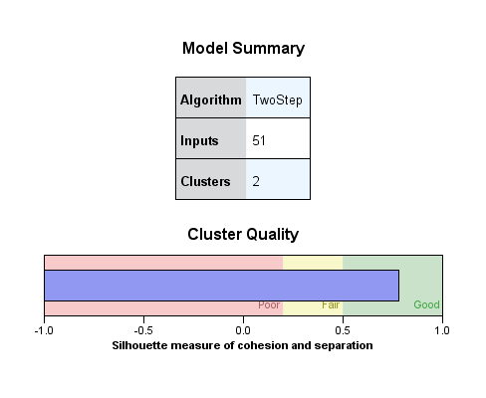

3、K-均值聚类结果

2类

**Iteration Historya Number of Cases in each Cluster**

| Iteration | Change in Cluster Centers | |
| --- | --- | --- |
| 1 | 2 |
| 1 | 15.848 | 31.202 |
| 2 | 1.761 | .054 |
| 3 | .196 | 9.405E-5 |
| 4 | .022 | 1.633E-7 |
| 5 | .002 | 2.835E-10 |
| 6 | .000 | 4.923E-13 |
| 7 | 2.982E-5 | 9.137E-16 |
| 8 | 3.313E-6 | .000 |
| 9 | 3.682E-7 | .000 |
| 10 | 4.091E-8 | .000 |

| Cluster | 1 | 11.000 |
| --- | --- | --- |
| 2 | 572.000 |
| Valid | | 583.000 |
| Missing | | .000 |

3类

**Iteration Historya Number of Cases in each Cluster**

| Iteration | Change in Cluster Centers | | |
| --- | --- | --- | --- |
| 1 | 2 | 3 |
| 1 | 25.752 | 2.095 | 16.370 |
| 2 | .045 | .419 | 1.819 |
| 3 | 7.871E-5 | .084 | .202 |
| 4 | 1.376E-7 | .017 | .022 |
| 5 | 2.406E-10 | .003 | .002 |
| 6 | 4.206E-13 | .001 | .000 |
| 7 | 8.309E-16 | .000 | 3.080E-5 |
| 8 | .000 | 2.681E-5 | 3.423E-6 |
| 9 | .000 | 5.363E-6 | 3.803E-7 |
| 10 | .000 | 1.073E-6 | 4.225E-8 |

| Cluster | 1 | 568.000 |
| --- | --- | --- |
| 2 | 4.000 |
| 3 | 11.000 |
| Valid | | 583.000 |
| Missing | | .000 |

**4类**

**Iteration Historya Number of Cases in each Cluster**

| Iteration | Change in Cluster Centers | | | |
| --- | --- | --- | --- | --- |
| 1 | 2 | 3 | 4 |
| 1 | 9.384 | 3.615 | 16.478 | 13.440 |
| 2 | 19.439 | .723 | .480 | 2.113 |
| 3 | .906 | .145 | .090 | .302 |
| 4 | .035 | .029 | .000 | .043 |
| 5 | .001 | .006 | 2.993E-7 | .006 |
| 6 | 5.155E-5 | .001 | 5.452E-10 | .001 |
| 7 | 1.983E-6 | .000 | 9.929E-13 | .000 |
| 8 | 7.626E-8 | 4.627E-5 | 2.015E-15 | 1.796E-5 |
| 9 | 2.933E-9 | 9.253E-6 | .000 | 2.566E-6 |
| 10 | 1.128E-10 | 1.851E-6 | .000 | 3.666E-7 |

| Cluster | 1 | 27.000 |
| --- | --- | --- |
| 2 | 4.000 |
| 3 | 546.000 |
| 4 | 6.000 |
| Valid | | 583.000 |
| Missing | | .000 |

5类

**Iteration Historya Number of Cases in each Cluster**

| Iteration | Change in Cluster Centers | | | | |
| --- | --- | --- | --- | --- | --- |
| 1 | 2 | 3 | 4 | 5 |
| 1 | 17.160 | 9.862 | .910 | 10.395 | 3.615 |
| 2 | 1.341 | 2.465 | .056 | 3.905 | .723 |
| 3 | .054 | .616 | .000 | .558 | .145 |
| 4 | .002 | .154 | 1.879E-7 | .080 | .029 |
| 5 | 8.583E-5 | .039 | 3.435E-10 | .011 | .006 |
| 6 | 3.433E-6 | .010 | 6.279E-13 | .002 | .001 |
| 7 | 1.373E-7 | .002 | 1.349E-15 | .000 | .000 |
| 8 | 5.493E-9 | .001 | .000 | 3.319E-5 | 4.627E-5 |
| 9 | 2.197E-10 | .000 | .000 | 4.742E-6 | 9.253E-6 |
| 10 | 8.789E-12 | 3.762E-5 | .000 | 6.774E-7 | 1.851E-6 |

| Cluster | 1 | 26.000 |
| --- | --- | --- |
| 2 | 3.000 |
| 3 | 544.000 |
| 4 | 6.000 |
| 5 | 4.000 |
| Valid | | 583.000 |
| Missing | | .000 |

NM

1、可以导出分类结果到附录

2、**二步聚类**结果

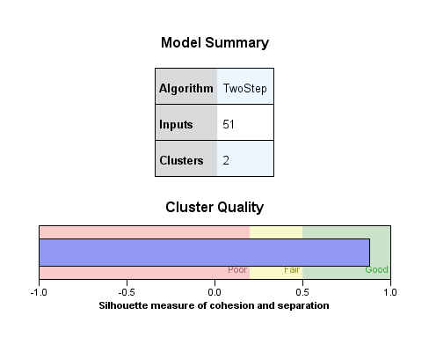

3、K-均值聚类结果

**2类**

**Iteration Historya Number of Cases in each Cluster**

| Iteration | Change in Cluster Centers | |
| --- | --- | --- |
| 1 | 2 |
| 1 | 52.929 | 19.613 |
| 2 | .091 | 4.903 |
| 3 | .000 | 1.226 |
| 4 | 2.699E-7 | .306 |
| 5 | 4.645E-10 | .077 |
| 6 | 7.995E-13 | .019 |
| 7 | 1.347E-15 | .005 |
| 8 | .000 | .001 |
| 9 | .000 | .000 |
| 10 | .000 | 7.482E-5 |

| Cluster | 1 | 580.000 |
| --- | --- | --- |
| 2 | 3.000 |
| Valid | | 583.000 |
| Missing | | .000 |

**3类**

**Iteration Historya Number of Cases in each Cluster**

| Iteration | Change in Cluster Centers | | |
| --- | --- | --- | --- |
| 1 | 2 | 3 |
| 1 | 44.626 | 19.613 | 16.207 |
| 2 | .077 | 4.903 | 3.241 |
| 3 | .000 | 1.226 | .648 |
| 4 | 2.323E-7 | .306 | .130 |
| 5 | 4.026E-10 | .077 | .026 |
| 6 | 6.978E-13 | .019 | .005 |
| 7 | 1.220E-15 | .005 | .001 |
| 8 | .000 | .001 | .000 |
| 9 | .000 | .000 | 4.149E-5 |
| 10 | .000 | 7.482E-5 | 8.298E-6 |

| Cluster | 1 | 576.000 |
| --- | --- | --- |
| 2 | 3.000 |
| 3 | 4.000 |
| Valid | | 583.000 |
| Missing | | .000 |

4类

**Iteration Historya Number of Cases in each Cluster**

| Iteration | Change in Cluster Centers | | | |
| --- | --- | --- | --- | --- |
| 1 | 2 | 3 | 4 |
| 1 | 10.473 | 28.255 | 16.207 | 19.613 |
| 2 | 2.618 | .049 | 3.241 | 4.903 |
| 3 | .655 | 8.576E-5 | .648 | 1.226 |
| 4 | .164 | 1.494E-7 | .130 | .306 |
| 5 | .041 | 2.603E-10 | .026 | .077 |
| 6 | .010 | 4.534E-13 | .005 | .019 |
| 7 | .003 | 9.161E-16 | .001 | .005 |
| 8 | .001 | .000 | .000 | .001 |
| 9 | .000 | .000 | 4.149E-5 | .000 |
| 10 | 3.995E-5 | .000 | 8.298E-6 | 7.482E-5 |

| Cluster | 1 | 3.000 |
| --- | --- | --- |
| 2 | 573.000 |
| 3 | 4.000 |
| 4 | 3.000 |
| Valid | | 583.000 |
| Missing | | .000 |

5类

**Iteration Historya Number of Cases in each Cluster**

| Iteration | Change in Cluster Centers | | | | |
| --- | --- | --- | --- | --- | --- |
| 1 | 2 | 3 | 4 | 5 |
| 1 | 8.404 | .000 | 10.473 | 16.207 | 7.204 |
| 2 | 1.050 | .000 | 2.618 | 3.241 | .013 |
| 3 | .131 | .000 | .655 | .648 | 2.225E-5 |
| 4 | .016 | .000 | .164 | .130 | 3.911E-8 |
| 5 | .002 | .000 | .041 | .026 | 6.873E-11 |
| 6 | .000 | .000 | .010 | .005 | 1.208E-13 |
| 7 | 3.206E-5 | .000 | .003 | .001 | 6.127E-16 |
| 8 | 4.007E-6 | .000 | .001 | .000 | .000 |
| 9 | 5.009E-7 | .000 | .000 | 4.149E-5 | .000 |
| 10 | 6.261E-8 | .000 | 3.995E-5 | 8.298E-6 | .000 |

| Cluster | 1 | 8.000 |
| --- | --- | --- |
| 2 | 1.000 |
| 3 | 3.000 |
| 4 | 4.000 |
| 5 | 567.000 |
| Valid | | 583.000 |
| Missing | | .000 |

TX

1、可以导出分类结果到附录

2、二步聚类结果

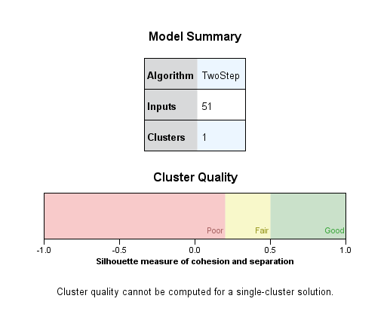

3、K-均值聚类结果

2类

**Iteration Historya Number of Cases in each Cluster**

| Iteration | Change in Cluster Centers | |
| --- | --- | --- |
| 1 | 2 |
| 1 | 20.762 | 45.065 |
| 2 | 5.435 | .141 |
| 3 | .320 | .000 |
| 4 | .019 | 4.378E-7 |
| 5 | .001 | 7.707E-10 |
| 6 | 6.507E-5 | 1.357E-12 |
| 7 | 3.828E-6 | 2.628E-15 |
| 8 | 2.252E-7 | .000 |
| 9 | 1.324E-8 | .000 |
| 10 | 7.791E-10 | .000 |

| Cluster | 1 | 19.000 |
| --- | --- | --- |
| 2 | 564.000 |
| Valid | | 583.000 |
| Missing | | .000 |

**3类**

**Iteration Historya Number of Cases in each Cluster**

| Iteration | Change in Cluster Centers | | |
| --- | --- | --- | --- |
| 1 | 2 | 3 |
| 1 | 19.405 | 20.762 | 20.360 |
| 2 | 4.272 | 5.435 | .142 |
| 3 | .427 | .320 | .000 |
| 4 | 3.085 | .019 | .077 |
| 5 | .220 | .001 | .000 |
| 6 | .016 | 6.507E-5 | 2.506E-7 |
| 7 | .001 | 3.828E-6 | 4.515E-10 |
| 8 | 8.030E-5 | 2.252E-7 | 8.134E-13 |
| 9 | 5.736E-6 | 1.324E-8 | 1.589E-15 |
| 10 | 4.097E-7 | 7.791E-10 | .000 |

| Cluster | 1 | 13.000 |
| --- | --- | --- |
| 2 | 19.000 |
| 3 | 551.000 |
| Valid | | 583.000 |
| Missing | | .000 |

**4类**

**Iteration Historya Number of Cases in each Cluster**

| Iteration | Change in Cluster Centers | | | |
| --- | --- | --- | --- | --- |
| 1 | 2 | 3 | 4 |
| 1 | 20.762 | 19.405 | 20.372 | 6.690 |
| 2 | 2.386 | 4.272 | .169 | 11.718 |
| 3 | .159 | .427 | .018 | 2.595 |
| 4 | .011 | 3.085 | .100 | 3.212 |
| 5 | .001 | .220 | .000 | .247 |
| 6 | 4.712E-5 | .016 | 3.371E-7 | .019 |
| 7 | 3.141E-6 | .001 | 6.185E-10 | .001 |
| 8 | 2.094E-7 | 8.030E-5 | 1.135E-12 | .000 |
| 9 | 1.396E-8 | 5.736E-6 | 2.044E-15 | 8.650E-6 |
| 10 | 9.308E-10 | 4.097E-7 | 5.551E-17 | 6.654E-7 |

| Cluster | 1 | 17.000 |
| --- | --- | --- |
| 2 | 13.000 |
| 3 | 541.000 |
| 4 | 12.000 |
| Valid | | 583.000 |
| Missing | | .000 |

5类

**Iteration Historya Number of Cases in each Cluster**

| Iteration | Change in Cluster Centers | | | | |
| --- | --- | --- | --- | --- | --- |
| 1 | 2 | 3 | 4 | 5 |
| 1 | .000 | 11.135 | 17.332 | 5.627 | 19.405 |
| 2 | .000 | 1.856 | .083 | .375 | 4.272 |
| 3 | .000 | .309 | .000 | .025 | .427 |
| 4 | .000 | .052 | .078 | .002 | 3.085 |
| 5 | .000 | .009 | .000 | .000 | .220 |
| 6 | .000 | .001 | 2.559E-7 | 7.410E-6 | .016 |
| 7 | .000 | .000 | 4.645E-10 | 4.940E-7 | .001 |
| 8 | .000 | 3.978E-5 | 8.431E-13 | 3.293E-8 | 8.030E-5 |
| 9 | .000 | 6.629E-6 | 1.493E-15 | 2.195E-9 | 5.736E-6 |
| 10 | .000 | 1.105E-6 | .000 | 1.464E-10 | 4.097E-7 |

| Cluster | 1 | 1.000 |
| --- | --- | --- |
| 2 | 5.000 |
| 3 | 547.000 |
| 4 | 17.000 |
| 5 | 13.000 |
| Valid | | 583.000 |
| Missing | | .000 |

挑选出比较好的分类

CA 二步聚类/KMEAN3

二步

AZ 二步聚类/kmean4

NM 二步聚类

TX kmean4

经过对聚类结果与清洁可再生能源与不可再生能源指标的仔细比较，我们发现，基本发现了分类上清洁可再生能源与不可再生能源指标的不同