## Project wiki: what and why we do this project

1. How does a compiler work?

Basic introduction

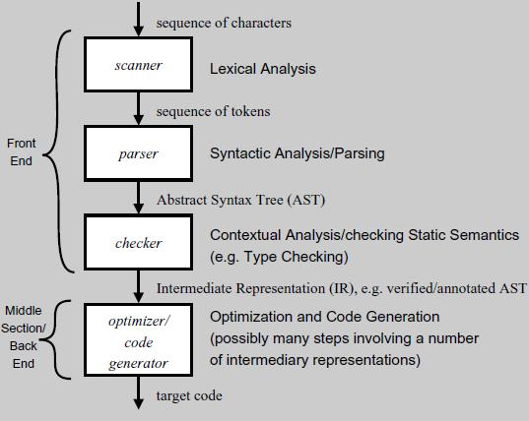

1. Our part: Bootstrapping

We can use C to write a compiler for java, then use what to write the compiler for C?

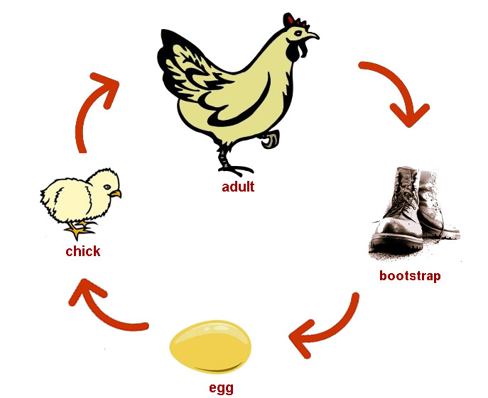

1. Introduction of F2J

fcore

lamda calculation

Give some equations here

1. Parser and Pretty Printer

Monadic Pacrat

Group layout

## Project method

1. Materials
2. Method
3. Additional work

## Project outcome

1. Important result
2. Conclusion

## Acknowledgement and Contact