|  |  |
| --- | --- |
| [A](https://codeforces.com/group/Vk6pDIfre6/contest/314195/problem/A) | [Нечетный делитель](https://codeforces.com/group/Vk6pDIfre6/contest/314195/problem/A) |

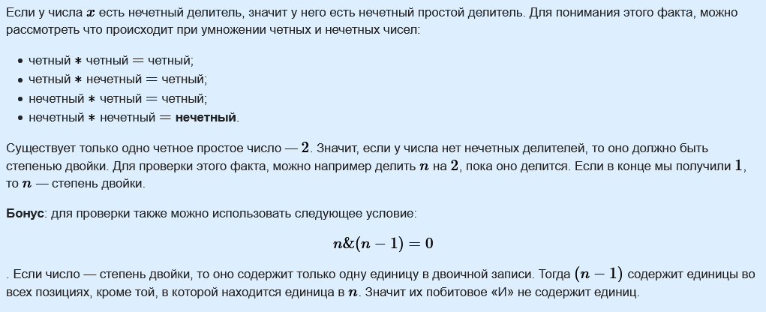

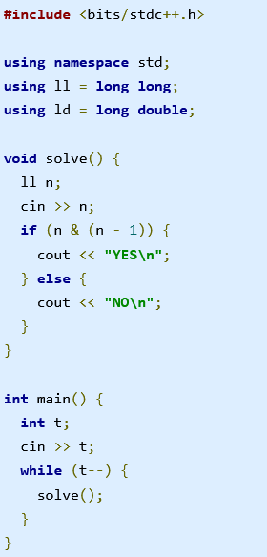

|  |  |
| --- | --- |
| [B](https://codeforces.com/group/Vk6pDIfre6/contest/314195/problem/B) | [Новогоднее число](https://codeforces.com/group/Vk6pDIfre6/contest/314195/problem/B) |

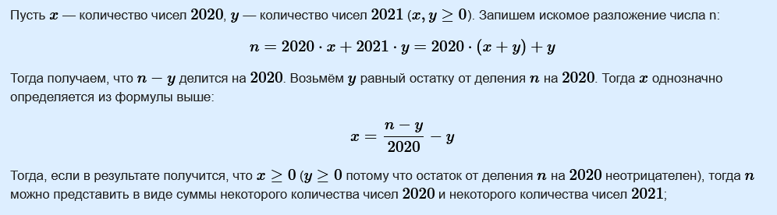

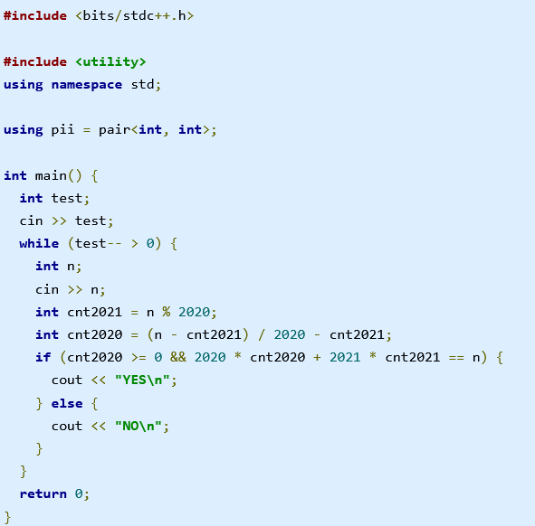

|  |  |
| --- | --- |
| [C](https://codeforces.com/group/Vk6pDIfre6/contest/314195/problem/C) | [Различные делители](https://codeforces.com/group/Vk6pDIfre6/contest/314195/problem/C) |

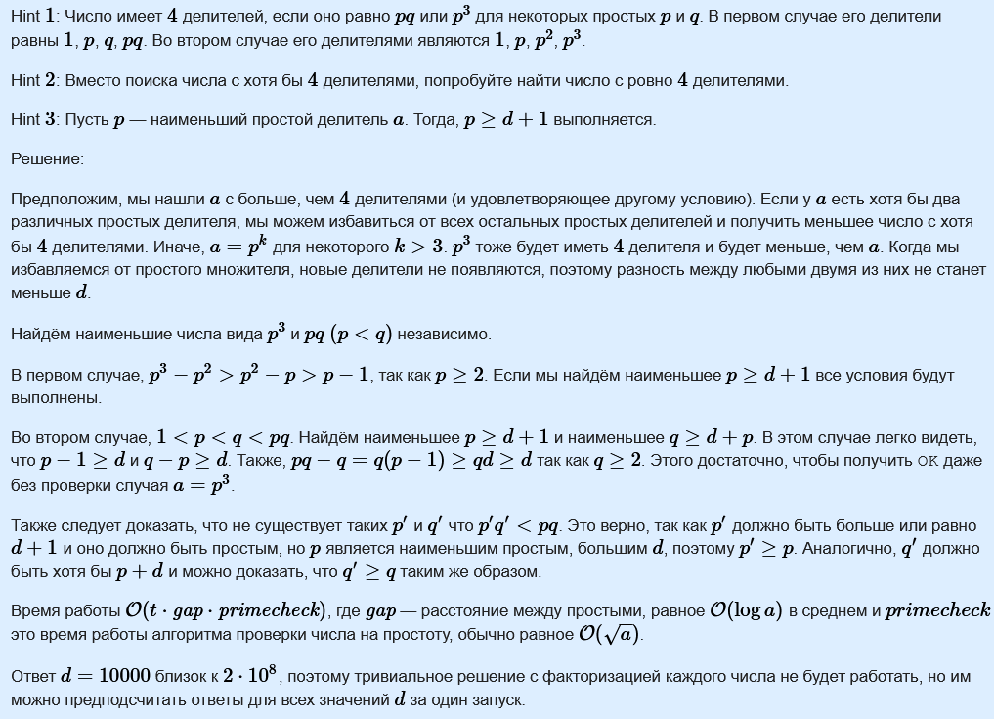

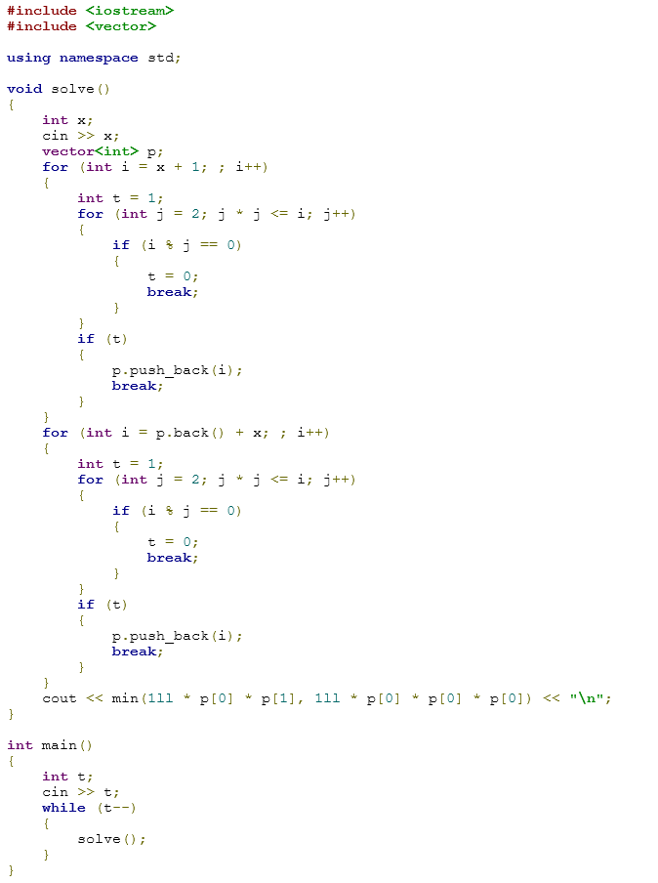

|  |  |
| --- | --- |
| [D](https://codeforces.com/group/Vk6pDIfre6/contest/314195/problem/D) | [Бал в Берляндии](https://codeforces.com/group/Vk6pDIfre6/contest/314195/problem/D) |

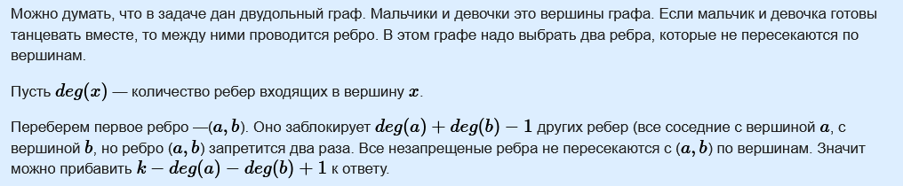

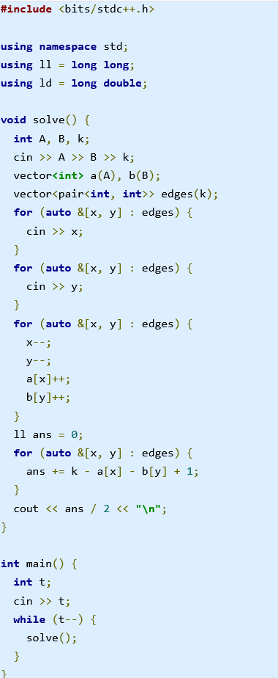

|  |  |
| --- | --- |
| [E](https://codeforces.com/group/Vk6pDIfre6/contest/314195/problem/E) | [Очистка телефона](https://codeforces.com/group/Vk6pDIfre6/contest/314195/problem/E) |

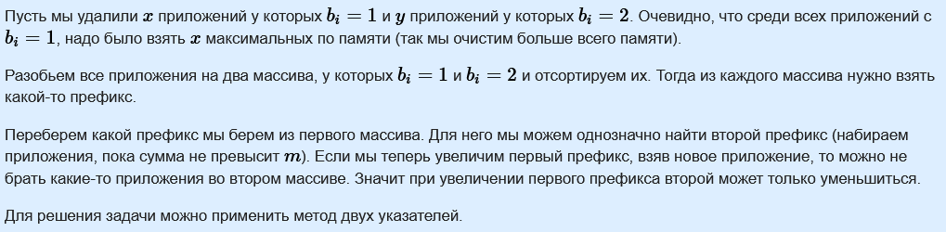

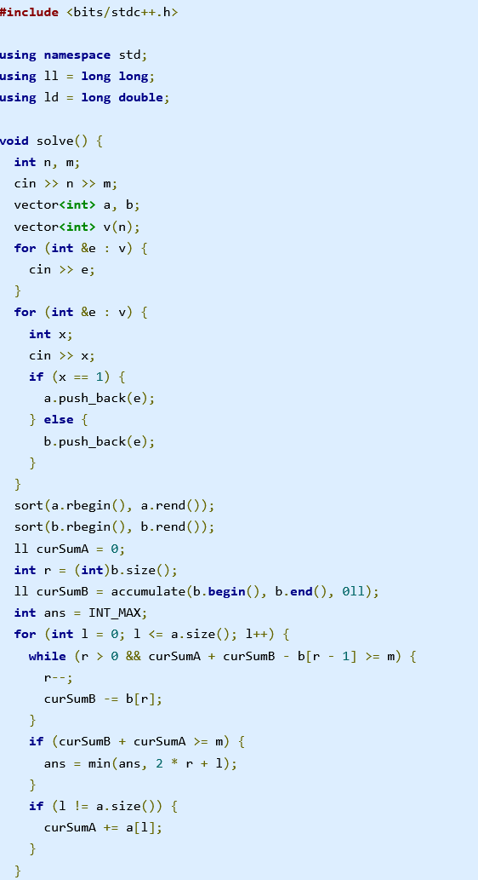

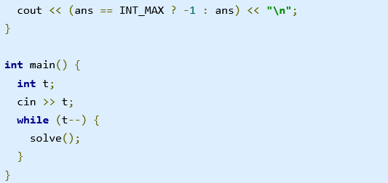

|  |  |
| --- | --- |
| [F](https://codeforces.com/group/Vk6pDIfre6/contest/314195/problem/F) | [Рекламное агентство](https://codeforces.com/group/Vk6pDIfre6/contest/314195/problem/F) |

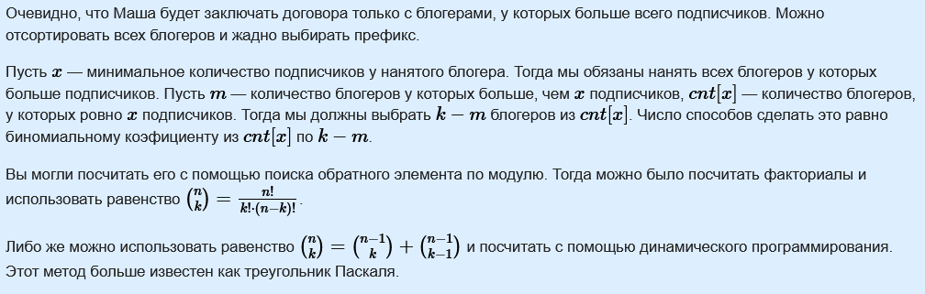

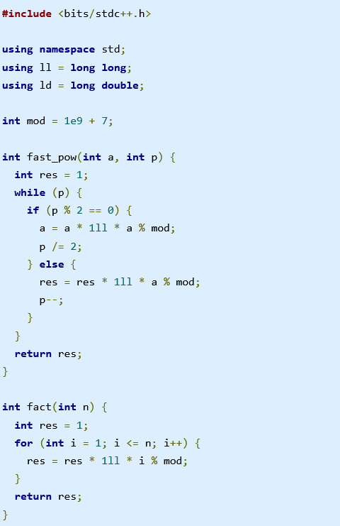

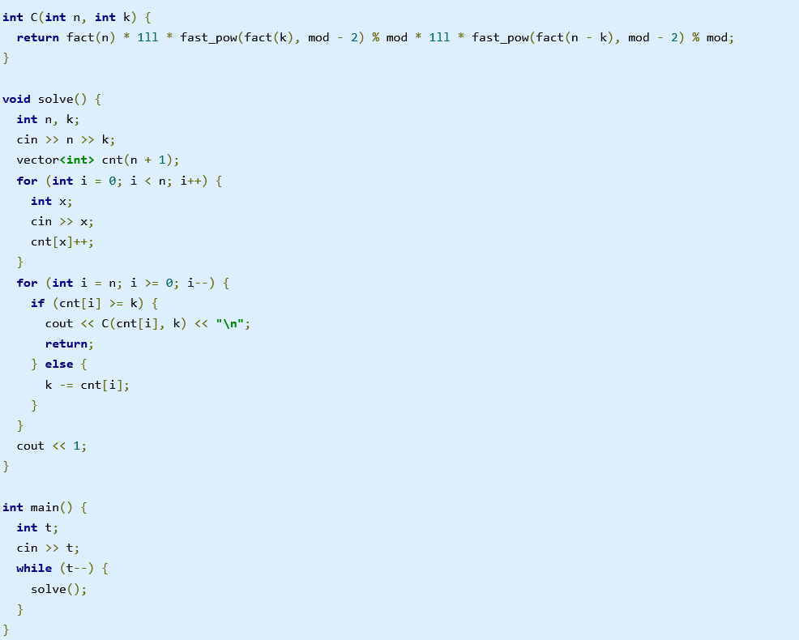

|  |  |
| --- | --- |
| [G](https://codeforces.com/group/Vk6pDIfre6/contest/314195/problem/G) | [Необычная матрица](https://codeforces.com/group/Vk6pDIfre6/contest/314195/problem/G) |

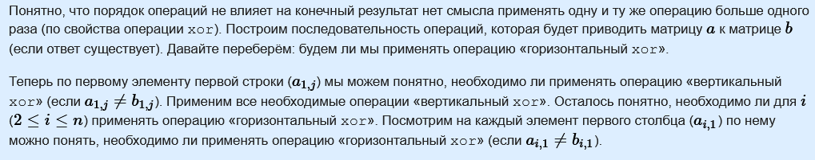

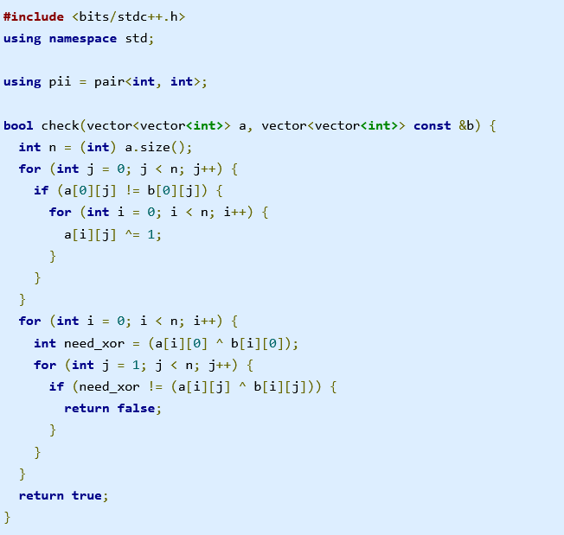

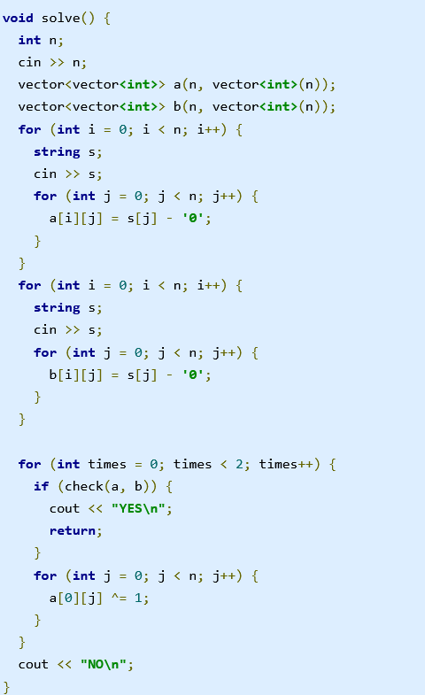

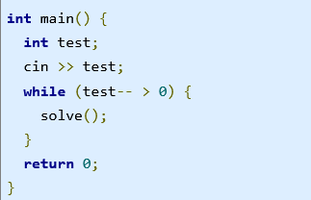

|  |  |
| --- | --- |
| [H](https://codeforces.com/group/Vk6pDIfre6/contest/314195/problem/H) | [Странная красота](https://codeforces.com/group/Vk6pDIfre6/contest/314195/problem/H) |

