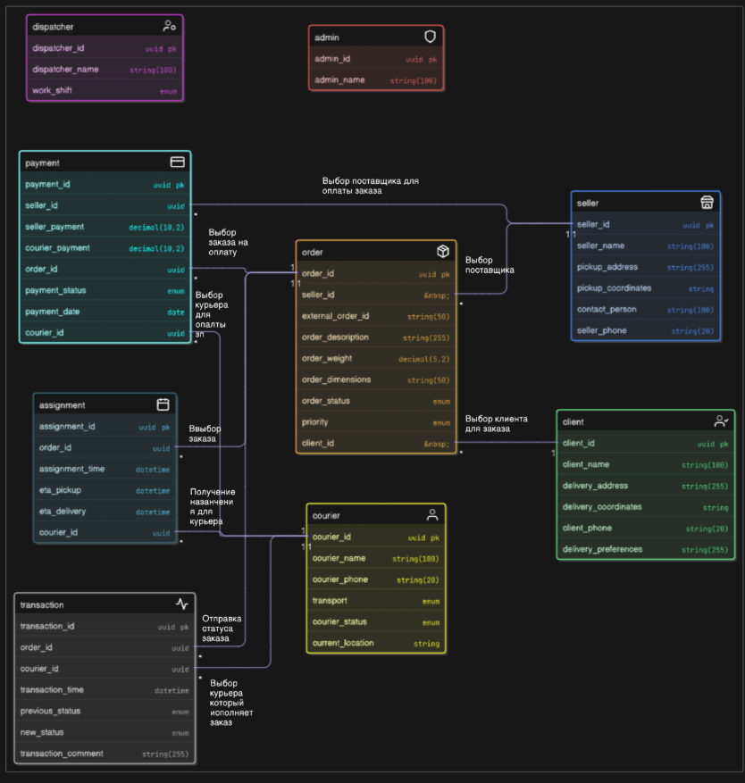

https://app.eraser.io/workspace/VKTsb7R0QHtpNBKHMH3h?origin=share