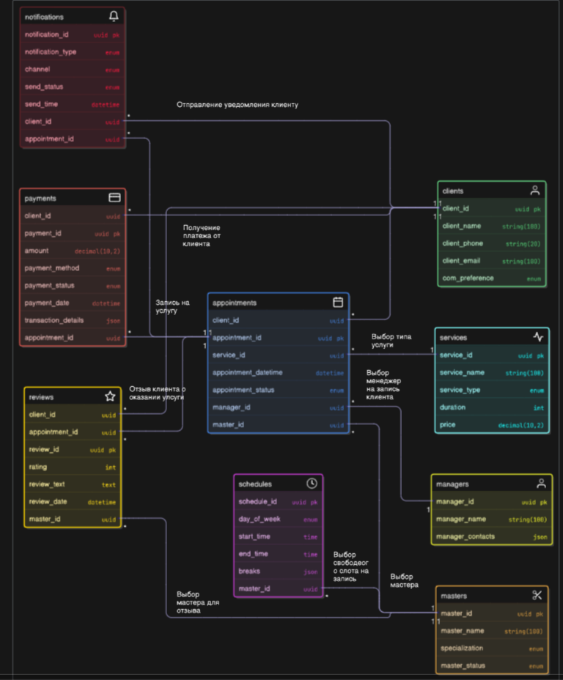

https://app.eraser.io/workspace/K8e8TWFkx0ZVAvh5BZz2?origin=share