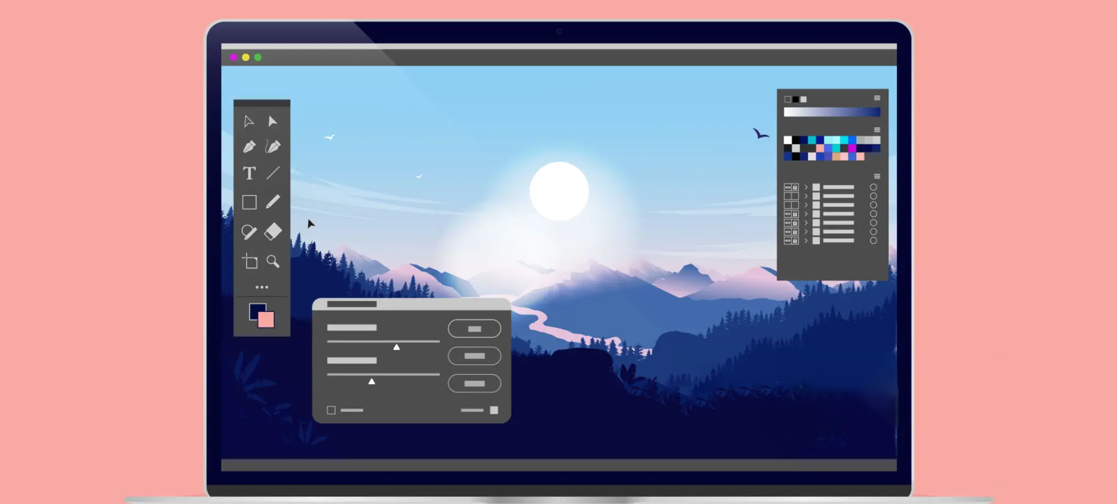

**🖌 Graphic editor SRS**

|  |  |
| --- | --- |
| Target release | v 1.0 |
| Date | 14.09.2025 |
| Document status | In the planning |
| Document owner | me (Daniil Daryev) |
| Designer | -/ /- |
| Tech lead | -/ /- |
| Technical writers | -/ /- |
| QA | -/ /- |
| Approved by | Zhereb Denis Valeriyovich |
| Approved status |  |

**INTRODUCTION**

This document describes the requirements for the MVP of the ‘Graphic editor’ application.

The document will be used by teams of developers, testers, project managers, and stakeholders as the primary source of information during development.

**Project scope:**

1. Basic editing functions:

* Drawing with brushes, lines, shapes (circle, rectangle, polygon).
* Selection tools (rectangular, lasso).
* Color filling (solid, gradient).
* Working with layers (adding, deleting, moving, changing transparency).

1. Image editing:

* Cropping, scaling, rotating.
* Changing brightness, contrast, saturation.
* Basic filters (blur, black and white effect, colour inversion).

1. Image formats:

* Import PNG, JPG.
* Export to PNG, JPG.

1. User interface:

* Toolbar.
* Layer panel.
* Action history (Undo/Redo).

1. System capabilities:

* Windows support (desktop version).
* Fast works with files up to ~50 MB in size.

**Out of scope:**

1. Advanced features:

* Vector graphics (SVG editing).
* Professional filters and effects.
* Animations and video editing.

1. Integrations:

* Cloud storage (Google Drive, Dropbox).
* Real-time collaborative editing.
* Plugins and scripts from third-party developers.

1. System support:

* Mobile apps (Android, iOS).
* Cross-platform support (Linux, macOS) in the first stage.
* Working with high-resolution files (4K+).

1. Non-functional aspects:

* Copyright protection and DRM.

**Methods of elucidation:**

**1. Interviews**

* Who: users, graphic designers, content creators.
* Why: to collect data and understand what end users want.
* Risks: everyone has their own opinion, so some people rely on requirements that suit them better, and contradictions arise.

**2. Questionnaires**

* Who: a broad group of users, various companies.
* Why: to collect statistics and quantitative data.
* Risks: limited depth of responses if questions are not formulated correctly.

**3. Observation**

* Where: in the environment where users work.
* Why: to understand which tools users use most often.
* Risks: time-consuming.

**4. Prototyping**

* Why: to show users a mock-up of the programme so that feedback can be collected and taken into account.
* Risks: focus on the appearance of the programme rather than its functionality.

**FUNCTIONAL REQUIREMENT**

1. The editor must allow the creation of new images with specified dimensions.
2. The user must be able to open files in PNG and JPG formats.
3. The system must ensure that images are saved in PNG and JPG formats.
4. The system must ensure compatibility with its own file format.
5. The editor must support the Undo operation (at least 20 steps).
6. The editor must support the Redo operation.
7. There must be a ‘Brush’ tool with the ability to select thickness, color and pattern.
8. There must be a ‘Line’ tool with the ability to select thickness and color.
9. There should be tools for drawing shapes (rectangle, circle, polygon).
10. The ‘Fill with colour’ function should be implemented.
11. Gradient fill should be supported.
12. There should be a ‘Selection’ tool (rectangular, lasso).
13. It should be possible to move the selected area.
14. The user should be able to crop images.
15. There should be an image resizing (scaling) function.
16. There should be an image rotation function.
17. There should be a mirroring option (vertical and horizontal).
18. There should be a ‘Text’ tool with font and color selection options.
19. The system should allow working with layers (creating, deleting, moving).
20. It should be possible to change the transparency of a layer.
21. It should be possible to hide/show a layer.
22. There should be basic filters (black and white, inversion, blur).
23. The user should be able to adjust brightness, contrast, and saturation.
24. There should be support for hotkeys for basic functions (Ctrl+Z, Ctrl+S, etc.).
25. The user should be able to zoom in/out (Zoom).
26. There should be a toolbar with available functions.
27. There should be a layer panel with the ability to rearrange layers.
28. There should be a preview of the result before applying the filter.
29. The user should be able to save their own canvas template (example 1920x1080).
30. There should be an auto-save function for the project.
31. There should be a help section (Help) with a description of the main functions.

**CLASSIFICATION OF REQUIREMENT**

|  |  |  |  |  |
| --- | --- | --- | --- | --- |
| **ID** | **Name** | **Type** | **Priority** | **Description** |
| FR-01 | Create new image | Functional | Must | The editor must allow the creation of new images with specified dimensions. |
| FR-02 | Open PNG/JPG files | Functional | Must | The user must be able to open files in PNG and JPG formats. |
| FR-03 | Save PNG/JPG files | Functional | Must | The system must ensure that images are saved in PNG and JPG formats. |
| FR-04 | Custom file format | Functional | Should | The system must ensure compatibility with its own file format. |
| FR-05 | Undo | Functional | Must | The editor must support the Undo operation (at least 20 steps). |
| FR-06 | Redo | Functional | Must | The editor must support the Redo operation. |
| FR-07 | Brush tool | Functional | Must | There must be a ‘Brush’ tool with the ability to select thickness, color, and pattern. |
| FR-08 | Line tool | Functional | Must | There must be a ‘Line’ tool with the ability to select thickness and color. |
| FR-09 | Shapes tool | Functional | Should | There should be tools for drawing shapes (rectangle, circle, polygon). |
| FR-10 | Fill with color | Functional | Must | The ‘Fill with colour’ function should be implemented. |
| FR-11 | Gradient fill | Functional | Should | Gradient fill should be supported. |
| FR-12 | Selection tool | Functional | Should | There should be a ‘Selection’ tool (rectangular, lasso). |
| FR-13 | Move selected area | Functional | Should | It should be possible to move the selected area. |
| FR-14 | Crop | Functional | Must | The user should be able to crop images. |
| FR-15 | Resize | Functional | Must | There should be an image resizing (scaling) function. |
| FR-16 | Rotate | Functional | Must | There should be an image rotation function. |
| FR-17 | Mirror | Functional | Should | There should be a mirroring option (vertical and horizontal). |
| FR-18 | Text tool | Functional | Should | There should be a ‘Text’ tool with font and color selection options. |
| FR-19 | Layers | Functional | Should | The system should allow working with layers (creating, deleting, moving). |
| FR-20 | Layer transparency | Functional | Should | It should be possible to change the transparency of a layer. |
| FR-21 | Hide/Show layer | Functional | Should | It should be possible to hide/show a layer. |
| FR-22 | Basic filters | Functional | Should | There should be basic filters (black and white, inversion, blur). |
| FR-23 | Adjust colors | Functional | Should | The user should be able to adjust brightness, contrast, and saturation. |
| FR-24 | Hotkeys | Functional | Must | There should be support for hotkeys for basic functions (Ctrl+Z, Ctrl+S, etc.). |
| FR-25 | Zoom | Functional | Must | The user should be able to zoom in/out. |
| FR-26 | Toolbar | Functional | Must | There should be a toolbar with available functions. |
| FR-27 | Layers panel | Functional | Should | There should be a layer panel with the ability to rearrange layers. |
| FR-28 | Filter preview | Functional | Should | There should be a preview of the result before applying the filter. |
| FR-29 | Canvas templates | Functional | Could | The user should be able to save their own canvas template (example 1920x1080). |
| FR-30 | Auto-save | Functional | Could | There should be an auto-save function for the project. |
| FR-31 | Help section | Non-functional | Could | There should be a help section (Help) with a description of the main functions. |

**DECOMPOSITION REQUIREMENT AND ACCEPTED CRITERIA**

Epic 1: File Management

**Goal:** Handle image files and templates.

Feature 11: Create and Open Files

* **US-111:** As a user, I want to create a new image with specified dimensions so that I can start editing.
  + **Acceptance Criteria:**
    1. User can specify width and height.
    2. A blank canvas is generated with specified dimensions.
* **US-112:** As a user, I want to open PNG or JPG files so that I can edit existing images.
  + **Acceptance Criteria:**
    1. User can select PNG/JPG files from file system.
    2. Image loads correctly on the canvas.
* **US-113:** As a user, I want the system to support its own file format so I can save projects with layers and settings.
  + **Acceptance Criteria:**
    1. User can save as .(imageFormat).
    2. Layers and settings are preserved when reopened.

Feature 12: Save and Auto-Save

* **US-121:** As a user, I want to save my work in PNG/JPG formats so I can share or export images.
  + **Acceptance Criteria:**
    1. User can select export format (PNG or JPG).
    2. Exported file preserves image resolution.
* **US-122:** As a user, I want the editor to auto-save my project so that I don’t lose progress.
  + **Acceptance Criteria:**
    1. Auto-save occurs at regular intervals (e.g., every 5 minutes).
    2. Auto-saved file can be restored if the app closes unexpectedly.
* **US-123:** As a user, I want to save canvas templates so I can reuse predefined sizes.
  + **Acceptance Criteria:**
    1. User can define a template size (e.g., 1920x1080).
    2. Template can be selected when creating a new image.

Epic 2: Basic Editing Tools

**Goal:** Provide essential drawing and editing functionality.

Feature 21: Brush and Line Tools

* **US-211:** As a user, I want a brush tool with adjustable thickness, color, and pattern so I can draw freely.
  + **Acceptance Criteria:**
    1. Brush thickness is adjustable.
    2. Brush color can be selected from palette.
    3. Brush pattern options are available.
* **US-212:** As a user, I want a line tool with thickness and color selection to draw straight lines.
  + **Acceptance Criteria:**
    1. Line thickness can be adjusted.
    2. Line color can be selected.

Feature 22: Shape Tools

* **US-221:** As a user, I want to draw basic shapes (rectangle, circle, polygon) so I can create structured graphics.
  + **Acceptance Criteria:**
    1. User can select shape type.
    2. Shapes are drawn with selected color and border.
* **US-222:** As a user, I want a fill tool to fill areas with solid color or gradient.
  + **Acceptance Criteria:**
    1. Fill tool fills selected area correctly.
    2. Gradient option is available.
* **US-223:** As a user, I want to add text with font and color options.
  + **Acceptance Criteria:**
    1. User can type text on canvas.
    2. Font and color can be changed before placement.

Epic 3: Image Manipulation

**Goal:** Modify images and selections.

Feature 31: Selection and Transformation

* **US-311:** As a user, I want a selection tool (rectangle/lasso) so I can manipulate part of an image.
  + **Acceptance Criteria:**
    1. User can draw selection area.
    2. Selection can be moved or resized.
* **US-312:** As a user, I want to move selected areas to reposition content.
  + **Acceptance Criteria:**
    1. Selected area moves correctly.
    2. Other areas remain unchanged.
* **US-313:** As a user, I want to crop images to remove unwanted parts.
  + **Acceptance Criteria:**
    1. Crop area can be selected.
    2. Cropped image preserves selected area only.
* **US-314:** As a user, I want to resize images for different dimensions.
  + **Acceptance Criteria:**
    1. Image dimensions can be adjusted.
    2. Aspect ratio option is available.
* **US-315:** As a user, I want to rotate and mirror images.
  + **Acceptance Criteria:**
    1. Rotation by 90°, 180°, or custom angle.
    2. Mirroring works vertically and horizontally.

Epic 4: Layers and Effects

**Goal:** Manage layers and apply visual effects.

Feature 41: Layer Management

* **US-411:** As a user, I want to create, delete, and move layers.
  + **Acceptance Criteria:**
    1. New layer can be added.
    2. Layers can be reordered.
    3. Layers can be deleted.
* **US-412:** As a user, I want to adjust layer transparency.
  + **Acceptance Criteria:**
    1. Opacity slider works correctly.
    2. Visual feedback is immediate.
* **US-413:** As a user, I want to hide/show layers.
  + **Acceptance Criteria:**
    1. Layer visibility toggles correctly.

Feature 42: Filters and Adjustments

* **US-421:** As a user, I want to apply basic filters (B/W, invert, blur).
  + **Acceptance Criteria:**
    1. Filters apply correctly to selected layer.
    2. User can preview filter before applying.
* **US-422:** As a user, I want to adjust brightness, contrast, and saturation.
  + **Acceptance Criteria:**
    1. Adjustments apply in real-time.
    2. Changes can be undone/redone.

Epic 5: User Interface and Usability

**Goal:** Ensure smooth interaction and workflow.

Feature 51: Toolbar and Panels

* **US-511:** As a user, I want a toolbar with all essential tools.
  + **Acceptance Criteria:**
    1. Toolbar shows all available tools.
    2. Icons respond to clicks.
* **US-512:** As a user, I want a layer panel for easy management.
  + **Acceptance Criteria:**
    1. Layers listed with names and order.
    2. Layers can be dragged to reorder.

Feature 52: Undo/Redo and Hotkeys

* **US-521:** As a user, I want Undo/Redo functionality for mistakes.
  + **Acceptance Criteria:**
    1. Undo reverts last 20 actions.
    2. Redo restores undone actions.
* **US-522:** As a user, I want hotkeys for common operations.
  + **Acceptance Criteria:**
    1. Ctrl+Z = Undo, Ctrl+S = Save, Ctrl+O = Open.
    2. Hotkeys work consistently across tools.

Feature 53: Zoom and Preview

* **US-531:** As a user, I want zoom in/out to examine details.
  + **Acceptance Criteria:**
    1. Zoom slider adjusts canvas view.
    2. Canvas content scales correctly.
* **US-532:** As a user, I want a preview before applying filters.
  + **Acceptance Criteria:**
    1. Filter preview shows expected result.
    2. User can cancel if preview is not satisfactory.

Feature 54: Help Section

* **US-541:** As a user, I want a help section describing main functions.
  + **Acceptance Criteria:**
    1. Help section lists all tools and features.
    2. Search function allows quick finding of topics.

Feature 55: Canvas Templates and Auto-Save

* **US-551:** As a user, I want to save canvas templates for future use.
  + **Acceptance Criteria:**
    1. Template sizes can be saved.
    2. Templates can be selected when creating new images.
* **US-552:** As a user, I want auto-save to prevent data loss.
  + **Acceptance Criteria:**
    1. Auto-save occurs periodically.
    2. Unsaved changes are recoverable after crash.

**REQUIREMENT ATTRIBUTE**

|  |  |  |  |  |  |
| --- | --- | --- | --- | --- | --- |
| **Epic** | **Feature** | **User Story** | **Priority** | **Effort** | **Value** |
| File Management | Create and Open Files | US-111: Create new image with specified dimensions | Must | Medium | High |
| File Management | Create and Open Files | US-112: Open PNG or JPG files | Must | Medium | High |
| File Management | Create and Open Files | US-113: Support custom file format | Should | Medium | High |
| File Management | Save and Auto-Save | US-121: Save PNG/JPG formats | Must | Medium | High |
| File Management | Save and Auto-Save | US-122: Auto-save project | Could | Medium | High |
| File Management | Save and Auto-Save | US-123: Save canvas templates | Could | Low | Medium |
| Basic Editing Tools | Brush and Line Tools | US-211: Brush tool with adjustable thickness, color, pattern | Must | Medium | High |
| Basic Editing Tools | Brush and Line Tools | US-212: Line tool with thickness and color selection | Must | Low | High |
| Basic Editing Tools | Shape Tools | US-221: Draw basic shapes (rectangle, circle, polygon) | Should | Medium | Medium |
| Basic Editing Tools | Shape Tools | US-222: Fill tool (solid/gradient) | Must | Medium | High |
| Basic Editing Tools | Shape Tools | US-223: Add text with font and color options | Should | Medium | Medium |
| Image Manipulation | Selection and Transformation | US-311: Selection tool (rectangle/lasso) | Should | Medium | High |
| Image Manipulation | Selection and Transformation | US-312: Move selected area | Should | Medium | Medium |
| Image Manipulation | Selection and Transformation | US-313: Crop image | Must | Medium | High |
| Image Manipulation | Selection and Transformation | US-314: Resize image | Must | Medium | High |
| Image Manipulation | Selection and Transformation | US-315: Rotate and mirror image | Should | Medium | Medium |
| Layers and Effects | Layer Management | US-411: Create, delete, move layers | Must | Medium | High |
| Layers and Effects | Layer Management | US-412: Adjust layer transparency | Should | Low | Medium |
| Layers and Effects | Layer Management | US-413: Hide/show layers | Should | Low | Medium |
| Layers and Effects | Filters and Adjustments | US-421: Apply basic filters (B/W, invert, blur) | Should | Medium | High |
| Layers and Effects | Filters and Adjustments | US-422: Adjust brightness, contrast, saturation | Should | Medium | High |
| User Interface and Usability | Toolbar and Panels | US-511: Toolbar with essential tools | Must | Low | High |
| User Interface and Usability | Toolbar and Panels | US-512: Layer panel | Should | Low | Medium |
| User Interface and Usability | Undo/Redo and Hotkeys | US-521: Undo/Redo functionality | Must | Low | High |
| User Interface and Usability | Undo/Redo and Hotkeys | US-522: Hotkeys for common operations | Must | Low | High |
| User Interface and Usability | Zoom and Preview | US-531: Zoom in/out | Must | Low | Medium |
| User Interface and Usability | Zoom and Preview | US-532: Preview before applying filters | Should | Medium | High |
| User Interface and Usability | Help Section | US-541: Help section describing functions | Could | Low | Medium |
| User Interface and Usability | Canvas Templates and Auto-Save | US-551: Save canvas templates | Could | Low | Medium |
| User Interface and Usability | Canvas Templates and Auto-Save | US-552: Auto-save | Could | Medium | High |
| File Management | Create and Open Files | US-111: Create new image with specified dimensions | Must | Medium | High |
| File Management | Create and Open Files | US-112: Open PNG or JPG files | Must | Medium | High |
| File Management | Create and Open Files | US-113: Support custom file format | Should | Medium | High |
| File Management | Save and Auto-Save | US-121: Save PNG/JPG formats | Must | Medium | High |
| File Management | Save and Auto-Save | US-122: Auto-save project | Could | Medium | High |
| File Management | Save and Auto-Save | US-123: Save canvas templates | Could | Low | Medium |
| Basic Editing Tools | Brush and Line Tools | US-211: Brush tool with adjustable thickness, color, pattern | Must | Medium | High |
| Basic Editing Tools | Brush and Line Tools | US-212: Line tool with thickness and color selection | Must | Low | High |

**USE CASE DIAGRAM**

**Abbreviated designations**

* Compl. – complentencess.
* Corr. – correctness.
* Cons. – consistency.
* Unam. – unambiguity.
* Feas. – feasibility.
* Necess. – necessity.
* Test. – testability.

|  |  |  |  |  |  |  |  |
| --- | --- | --- | --- | --- | --- | --- | --- |
| **Requirement Description** | **Compl.** | **Corr.** | **Cons.** | **Unam.** | **Feas.** | **Necess.** | **Test.** |
| The editor must allow the creation of new images with specified dimensions. | OK | OK | OK | OK | OK | Must | OK |
| The user must be able to open files in PNG and JPG formats. | OK | OK | OK | OK | OK | Must | OK |
| The system must ensure that images are saved in PNG and JPG formats. | OK | OK | OK | OK | OK | Must | OK |
| The system must ensure compatibility with its own file format. | OK | OK | OK | OK | OK | Should | OK |
| The editor must support the Undo operation (at least 20 steps). | OK | OK | OK | OK | OK | Must | OK |
| The editor must support the Redo operation. | OK | OK | OK | OK | OK | Must | OK |
| There must be a ‘Brush’ tool with the ability to select thickness, color and pattern. | OK | OK | OK | OK | OK | Must | OK |
| There must be a ‘Line’ tool with the ability to select thickness and color. | OK | OK | OK | OK | OK | Must | OK |
| There should be tools for drawing shapes (rectangle, circle, polygon). | OK | OK | OK | OK | OK | Should | OK |
| The ‘Fill with colour’ function should be implemented. | OK | OK | OK | Low clarity | OK | Must | OK |
| Gradient fill should be supported. | OK | OK | OK | Needs revision | OK | Should | OK |
| There should be a ‘Selection’ tool (rectangular, lasso). | OK | OK | OK | OK | OK | Should | OK |
| It should be possible to move the selected area. | OK | OK | OK | OK | OK | Should | OK |
| The user should be able to crop images. | OK | OK | OK | OK | OK | Must | OK |
| There should be an image resizing (scaling) function. | OK | OK | OK | OK | OK | Must | OK |
| There should be an image rotation function. | OK | OK | OK | OK | OK | Should | OK |
| There should be a mirroring option (vertical and horizontal). | OK | OK | OK | OK | OK | Should | OK |
| There should be a ‘Text’ tool with font and color selection options. | OK | OK | OK | OK | OK | Should | OK |
| The system should allow working with layers (creating, deleting, moving). | OK | OK | OK | OK | OK | Must | OK |
| It should be possible to change the transparency of a layer. | OK | OK | OK | OK | OK | Should | OK |
| It should be possible to hide/show a layer. | OK | OK | OK | OK | OK | Should | OK |
| There should be basic filters (black and white, inversion, blur). | OK | OK | OK | Needs revision | OK | Should | OK |
| The user should be able to adjust brightness, contrast, and saturation. | OK | OK | OK | OK | OK | Should | OK |
| There should be support for hotkeys for basic functions (Ctrl+Z, Ctrl+S, etc.). | OK | OK | OK | OK | OK | Must | OK |
| The user should be able to zoom in/out (Zoom). | OK | OK | OK | OK | OK | Must | OK |
| There should be a toolbar with available functions. | OK | OK | OK | OK | OK | Must | OK |
| There should be a layer panel with the ability to rearrange layers. | OK | OK | OK | OK | OK | Should | OK |
| There should be a preview of the result before applying the filter. | OK | OK | OK | OK | OK | Should | OK |
| The user should be able to save their own canvas template (example 1920x1080). | OK | OK | OK | OK | OK | Could | OK |
| There should be an auto-save function for the project. | OK | OK | Needs revision | OK | OK | Could | OK |
| There should be a help section (Help) with a description of the main functions. | OK | OK | OK | OK | OK | Could | OK |

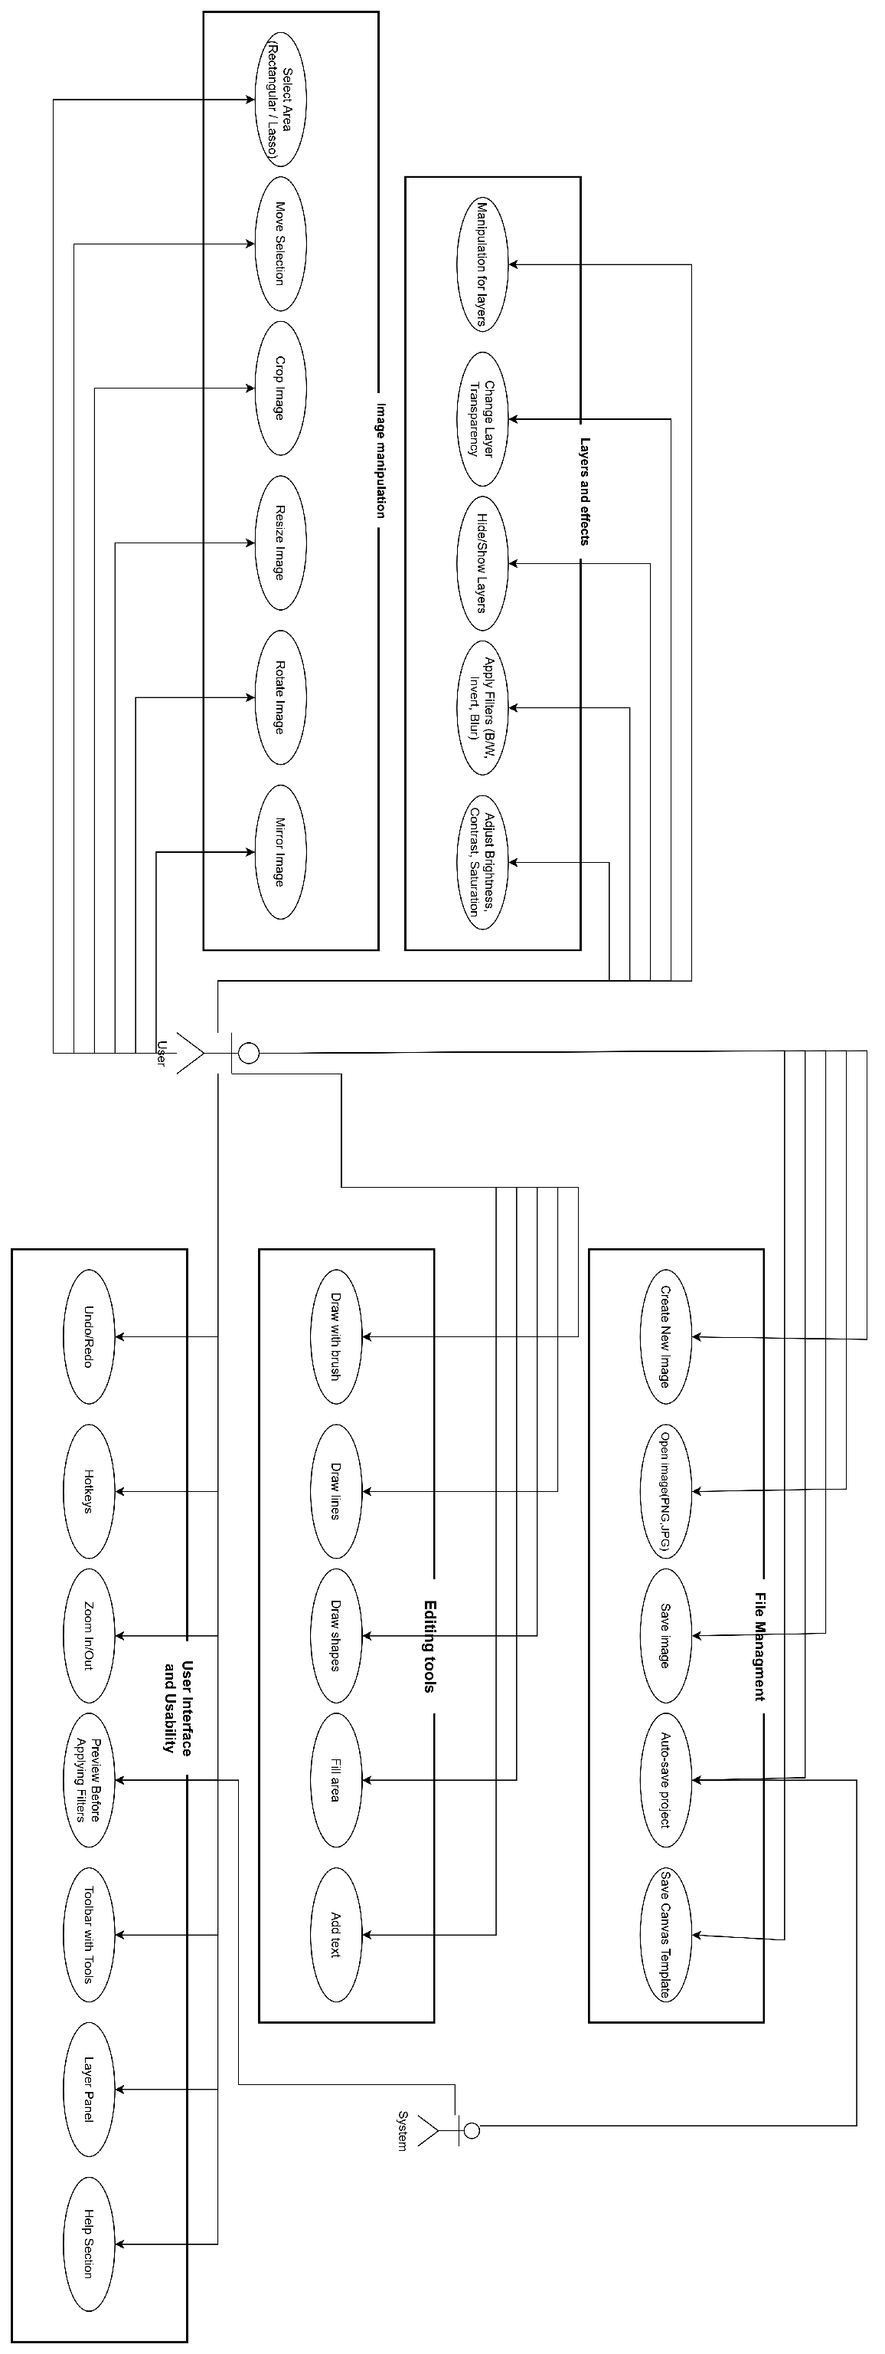

Рисунок 1 – Use Case Diagram

**SCRUM TEAM**

**SCRUM team for the Graphic Editor program:**

1. Product owner(Product Manager, Business Analyst) – 1 people
2. Scrum Master(Project Manager) – 1 people
3. UI/UX Designer – 1 people
4. QA Engineers - 2 people
5. Backend Developer – 1 people
6. Frontend Developer – 1 people

**PRODUCT BACKLOG + KANBAN BOARD**

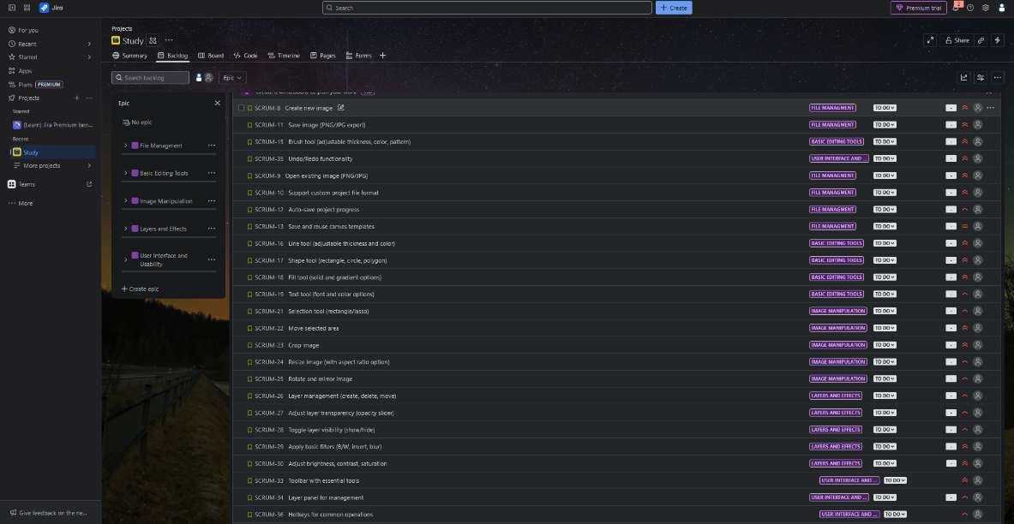

Рисунок 2 – Product backlog(Jira)

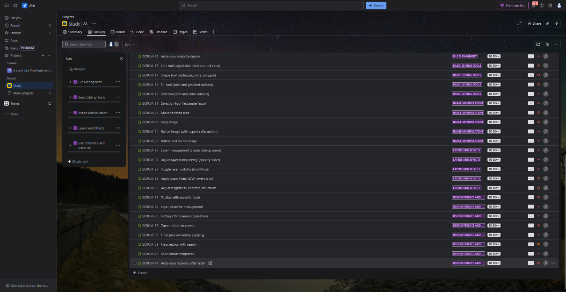

Рисунок 3 – Product backlog second part(Jira)

**Sprint 1: File Management (2 weeks)**

**Goal:** Provide basic work with files and creating a new project.

**User Stories:**

* + - * US-111: Create new image with specified dimensions
      * US-112: Open PNG/JPG files
      * US-121: Save PNG/JPG formats
      * US-113: Support custom file format
      * US-122: Auto-save project

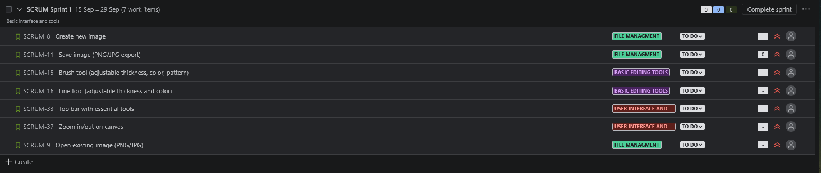

Рисунок 4 – First sprint backlog

**Sprint 2: Basic Editing Tools (1 week)**

**Goal:** Provide the user with basic drawing tools.

**User Stories:**

* + - * US-211: Brush tool (adjustable thickness, color, pattern)
      * US-212: Line tool (adjustable thickness, color)
      * US-221: Draw shapes (rectangle, circle, polygon)
      * US-222: Fill tool (solid/gradient)
      * US-223: Text tool with font and color options

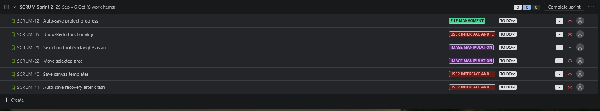

Рисунок 5 – Second sprint backlog

**Sprint 3: Image Manipulation (2 weeks)**

**Goal:** Perform basic image manipulation and selection.

**User Stories:**

* + - * US-311: Selection tool (rectangle/lasso)
      * US-312: Move selected area
      * US-313: Crop image
      * US-314: Resize image
      * US-315: Rotate and mirror image

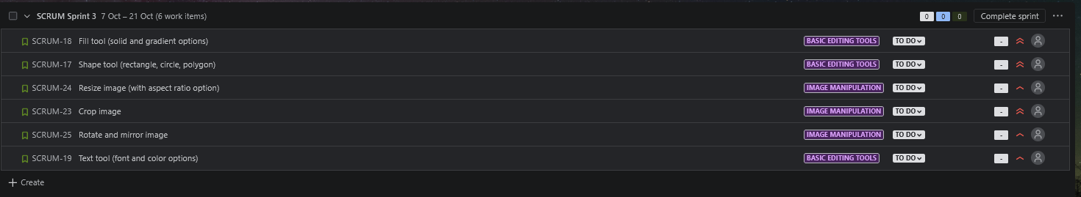

Рисунок 6 – Third sprint backlog

**Sprint 4: Layers & Effects**

**Goal**: Ensure working with layers and basic effects.

**User Stories:**

* + - * US-411: Create, delete, move layers
      * US-412: Adjust layer transparency
      * US-413: Hide/show layers
      * US-421: Apply basic filters (B/W, invert, blur)
      * US-422: Adjust brightness, contrast, saturation

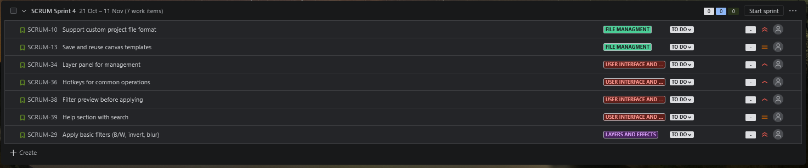

Рисунок 7 – Fourth sprint backlog

**Sprint 5: User Interface & Usability**

**Goal**: Improve the interface and UX for ease of use.

**User Stories:**

* + - * US-511: Toolbar with essential tools
      * US-512: Layer panel with drag & drop
      * US-521: Undo/Redo functionality (20 steps)
      * US-522: Hotkeys for common operations
      * US-531: Zoom in/out
      * US-532: Preview before applying filters
      * US-541: Help section describing functions
      * US-551: Save canvas templates
      * US-552: Auto-save recovery after crash

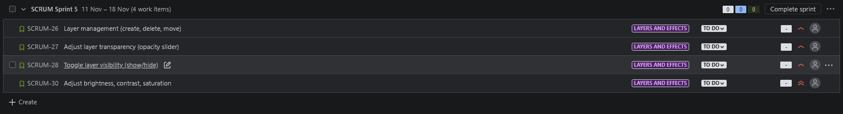

Рисунок 8 – Fifth sprint backlog

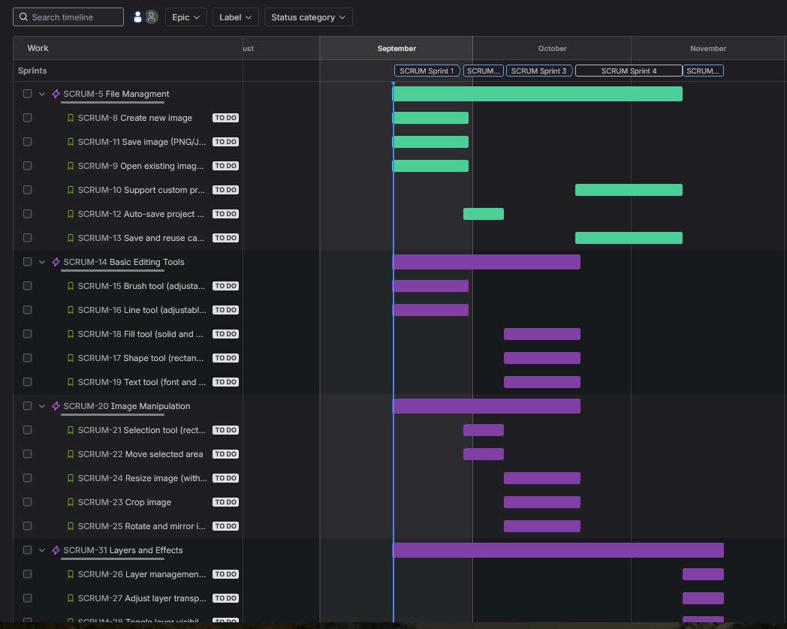

Рисунок 9 – Gannt diagram

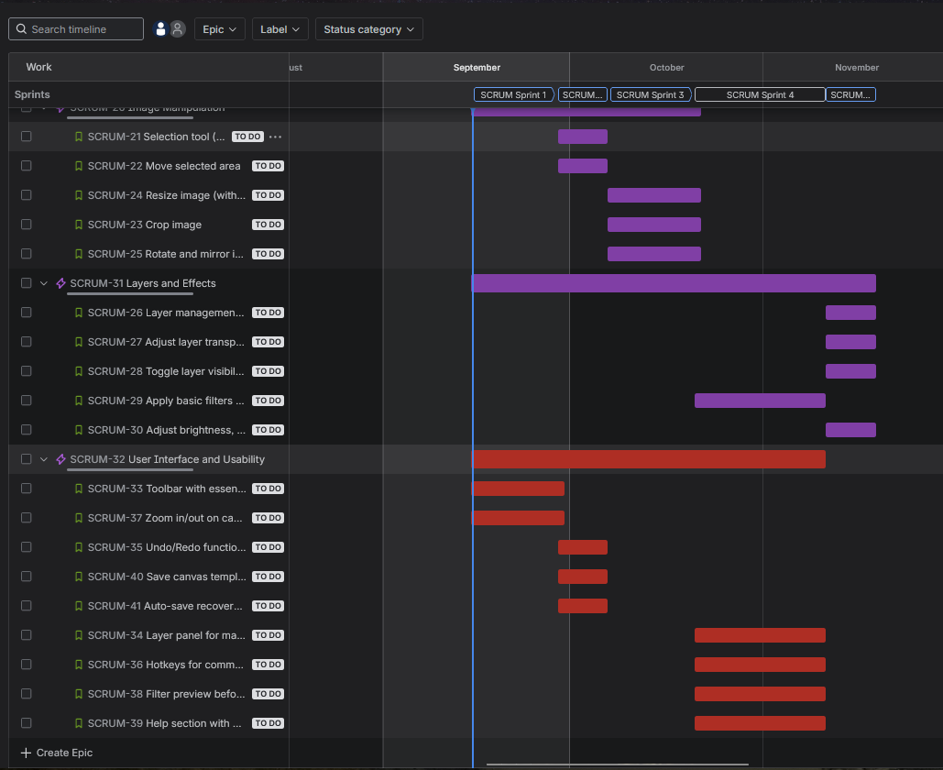

Рисунок 9 – Gannt diagram

**Висновок:**

На данній лабораторній роботі я засвоїв знання як збирати, аналізувати , валідувати, документувати та погоджувати вимоги до ПЗ, створювати SRS та формувати Product Backlog і базові виконання процесів SCRUM

та KANBAN