Aimon

Project Description
Make your AI's your own
Depending on your line of work, you might end up spending multiple hours a day sitting in front of a terminal or a minimalistic GUI interacting with a bunch of different AIs. I know I sure do. But unlike the table you're sitting at, the computer you are using or the virtual desktop withing in it, there is basically no way to personalize an AI, to make it your own. It always remains just a tool you use to make something else.
Aimon solves this problem. Aimon allows you to customize your experience with AI independent of which model you are using or what you are using it for. Visually with unique animations, stylistically with unique personalities adjusted based on the task, practically, allow you to use any combination of commercial AI models in whichever way you want.
And if you even want to download a custom profile, tweak it a bit, or just mess around with your own creation the portable, clearly structured configuration is at your fingertips.

Target Audience
People who use AI daily, people who enjoy desktop customization, virtual companions, aesthetics and personalized workflows.

User Experience
The user gets to create custom animations, personalities and interaction rules. As many as the user wishes, stylized for different situations, be it coding, writing a book, learning to play an instrument, researching new toping or just playing around. Profiles and be created with any level of AI assistance.

Technical Implementation
Aimon consists of the following components:

Profile Compiler
The profile compiler translates a plain language profile description into a structured profile with user review and confirmation.

Hard Settings
An optional safety feature allowing the user to fully block certain actions.

Router
The router interprets the profile, conversation state, hard settings, the user message and builds the context and execution plan.

Interpreter
The interpreter makes a request for a commercial AI provider.

Commercial AI Provider
Independently from Aimon, processes the request and streams the output.

Graphics Compiler
Builds whatever sketches, written ideas or other representations of a character the user has into a real animation library read by the Graphics Engine.

Graphics Engine
Based on the output stream from the Commercial AI Provider (text + events), build a graphical user interface, unique to the user and the ongoing conversation.

Conversation State Reducer
Based on the previous conversation state and the latest exchange, build a lightweight conversation state to be used by the Router.
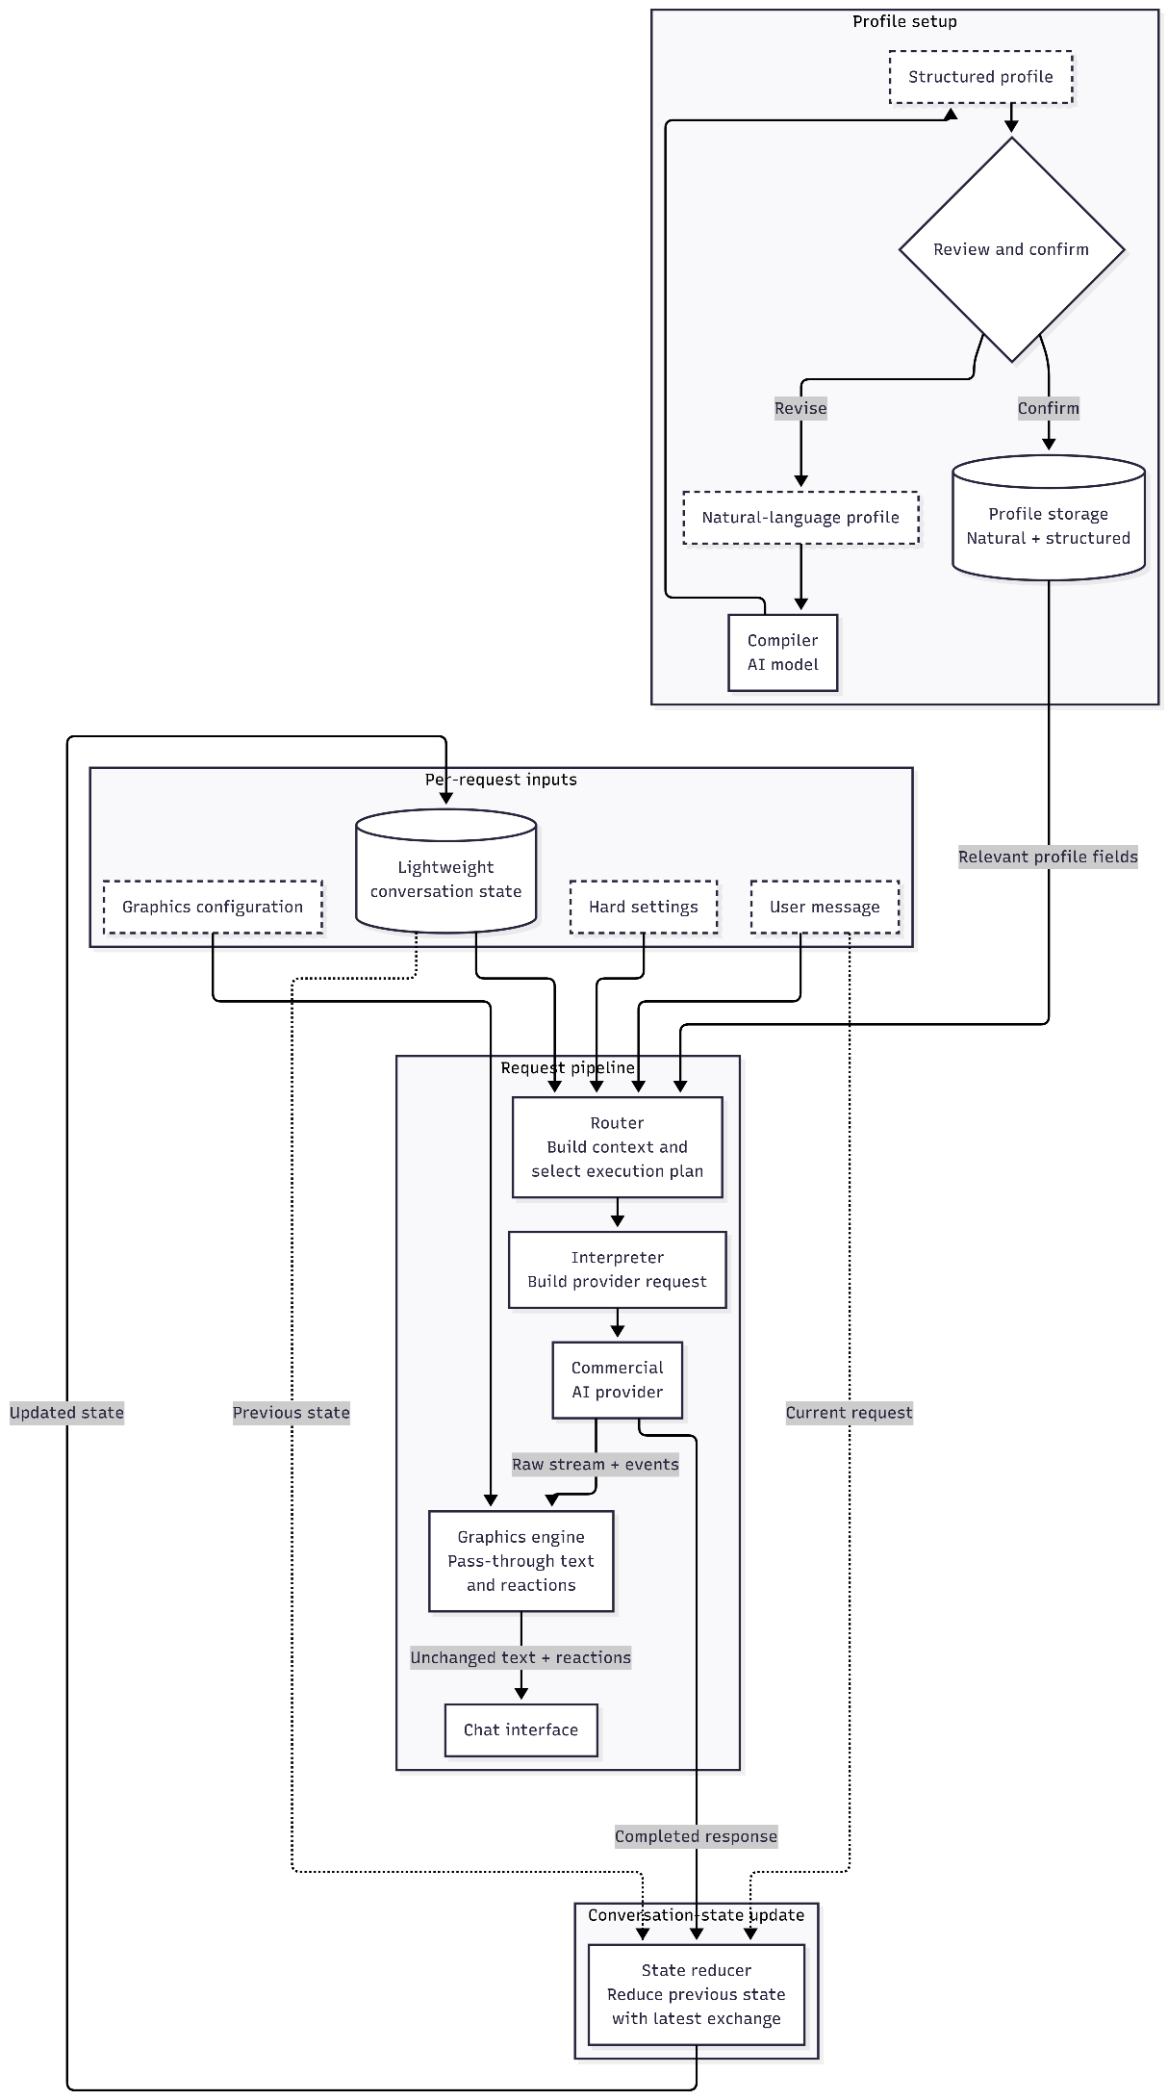

Development tools
For the initial release of Aimon .NET 10 and Avalonia will be used due to ease of development as well as relative ease of potential future migration.

Pricing
Aimon can be used for free with a few prebuilt profiles or maybe allowing the user to only have 1 custom profile built. This includes access to cheap low tier models and potentially very limited access to high tier ones.
For a very small fee (e.g. 1$), the user can customize their Aimon as much as they wish but either must use cheap low tier models or pay for the API themselves.
For a normal fee (7-25$), the user can take advantage of high tier models but also in a limited capacity.
For a large fee (40-100$), the user can take advantage of high tier models to a much higher capacity.
If the user wishes to have unlimited access to all models, they can enable pay-as-you-go functionality to cover the commercial AI API expenses.

Project Setup
The project is based on a template from Avalonia. A final project dependency structure might look something like this (non-final, only a possibility):
Aimon.Domain
No project dependencies

Aimon.Application
→ Aimon.Domain

Aimon.Infrastructure
→ Aimon.Application
→ Aimon.Domain

Aimon.Desktop
→ Aimon.Application
→ Aimon.Infrastructure

