1)
user@prometheus:~$ sudo cat /opt/prometheus/prometheus.yml
# my global config
global:
scrape_interval: 15s # Set the scrape interval to every 15 seconds. Default is every 1 minute.
evaluation_interval: 15s # Evaluate rules every 15 seconds. The default is every 1 minute.
# scrape_timeout is set to the global default (10s).

# Alertmanager configuration
alerting:
alertmanagers:
- static_configs:
- targets:
# - alertmanager:9093

# Load rules once and periodically evaluate them according to the global 'evaluation_interval'.
rule_files:
# - "first_rules.yml"
# - "second_rules.yml"

# A scrape configuration containing exactly one endpoint to scrape:
# Here it's Prometheus itself.
scrape_configs:
# The job name is added as a label `job=<job_name>` to any timeseries scraped from this config.
- job_name: 'prometheus'

# metrics_path defaults to '/metrics'
# scheme defaults to 'http'.

static_configs:
- targets: ['localhost:9090']

- job_name: node
static_configs:
- targets: ['178.128.254.27:9100']

- job_name: cadvisor
scrape_interval: 5s
static_configs:
- targets: ['178.128.254.27:8080']

- job_name: mysql
scrape_interval: 5s
static_configs:
- targets: ['178.128.254.27:9104']

2)
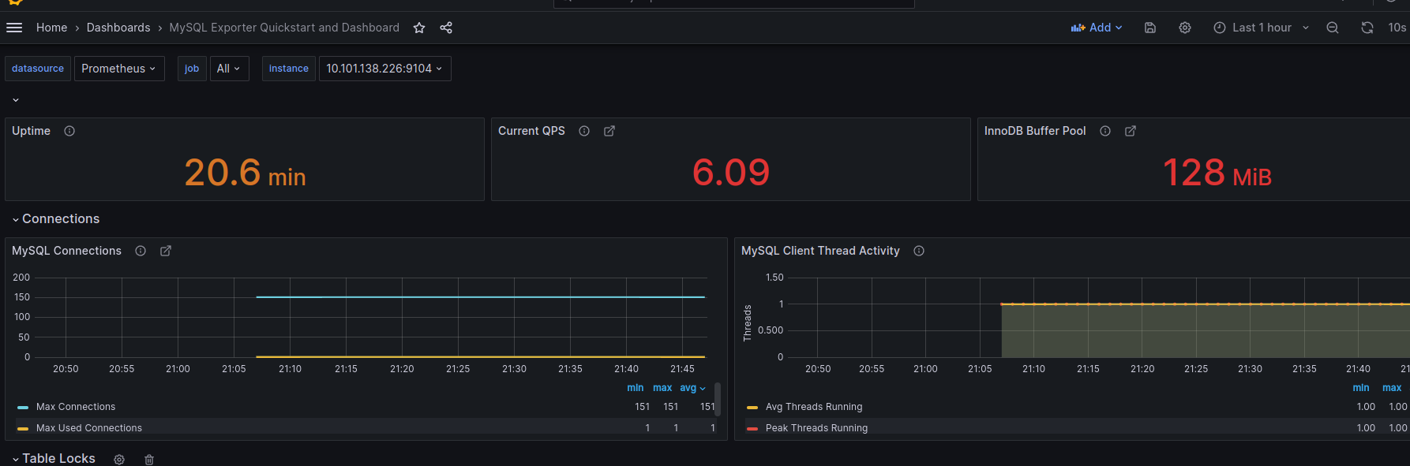
3)

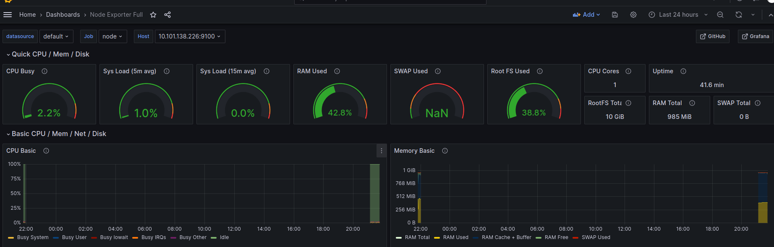
4)
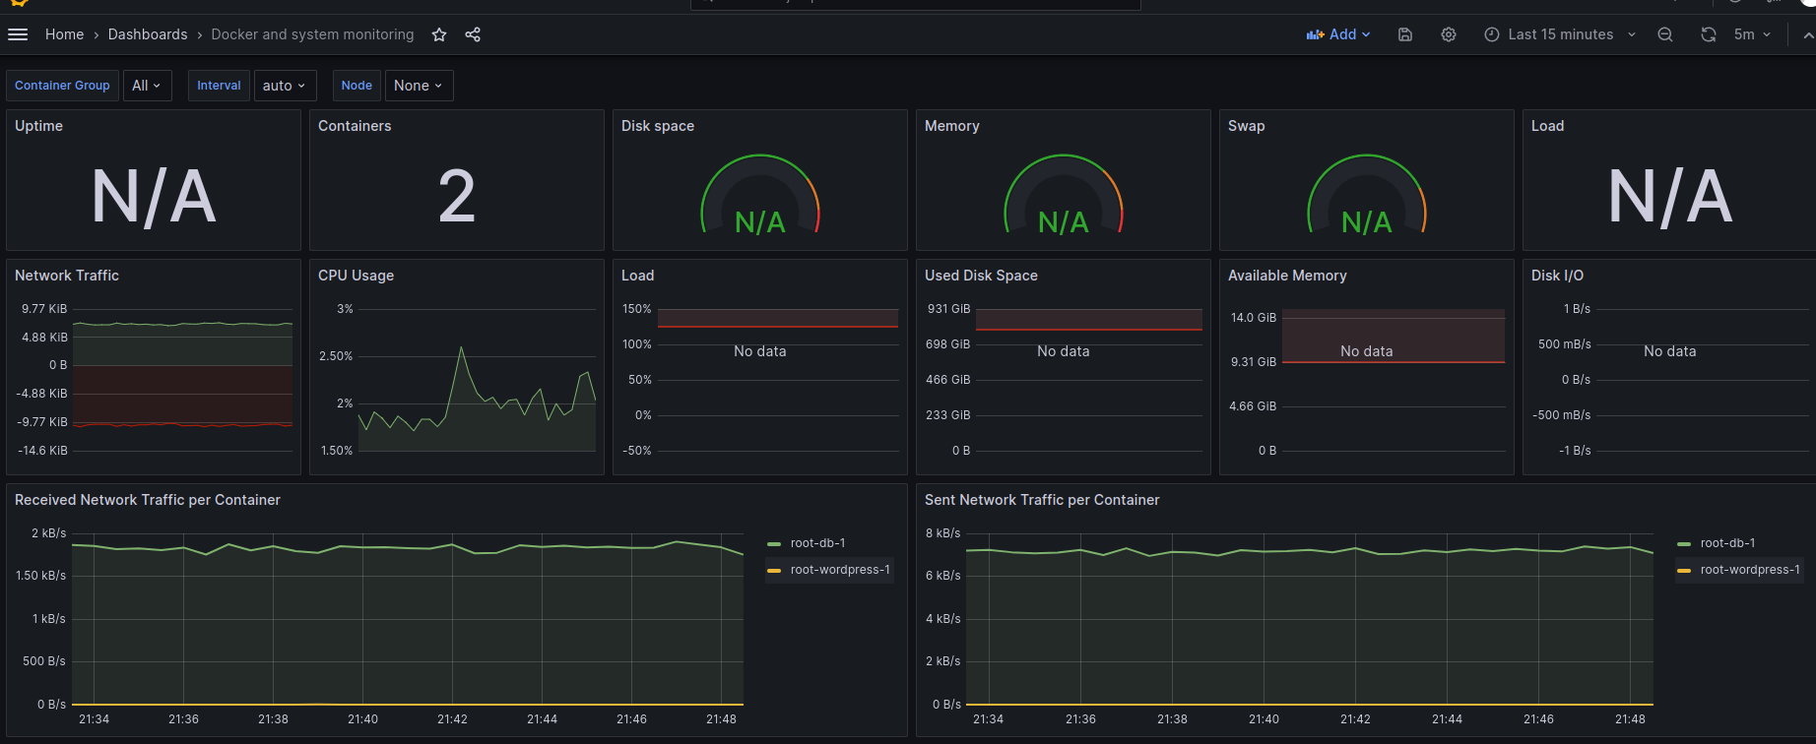
5)
