OGARD
Architecture and Data Model Specification
Minimum reference architecture, entity model, and control requirements for auditable grid-asset evidence
Deniz Bektas

Document status and use
Field | Value
Document | OGARD Architecture and Data Model Specification
Version | Public edition v0.1.1
Date | Original draft: August 2026; public edition: 24 September 2026
Author | Deniz Bektas
Public release status | Public — published in the OGARD GitHub repository
Related documents | OGARD Technical Whitepaper; OGARD Implementation Guide; OGARD Synthetic Benchmark Methodology and Validation Plan. Public editions v0.1.1; companion technical content: August 2026.
Scope | Minimum reference architecture and data model for electricity-network asset evidence
Repository | https://github.com/DenBek/ogard
Documentation license | Creative Commons Attribution 4.0 International (CC BY 4.0)
Reference implementation license | Apache License 2.0 for original repository code; see LICENSE.md.

Use boundary. This specification is a technical reference. It is not a production deployment design, an operational control system, a formal IEC CIM profile, a safety case, a cybersecurity certification, or evidence of operator adoption.
Independence and confidentiality. This document is independently authored and uses only original, synthetic, or publicly available material. It contains no employer source code, client data, non-public utility records, proprietary product architecture, or client-specific implementation detail.
Normative language. MUST identifies a minimum requirement for an implementation that claims alignment with this reference specification. SHOULD identifies a recommended control that may be adapted with documented rationale. MAY identifies an optional capability.

Abstract
This specification defines the minimum architecture and data model needed to implement OGARD as an auditable grid-asset evidence framework. It describes the system boundary, four logical data layers, core entities, temporal identity relationships, mapping and review records, contradiction handling, operator-governed derived asset status, security boundaries, and minimum conformance requirements. The design separates functional location, physical equipment identity, and telemetry identity; preserves source evidence and provenance; routes unresolved mappings to review; and prevents optional artificial-intelligence components from becoming the authority for canonical records or asset status. The specification is intentionally limited. It does not prescribe a vendor stack, a complete utility enterprise model, or a production-ready deployment pattern for every operator environment.

Contents
1. Purpose and scope
2. Minimum design principles and conformance
3. System context and trust boundaries
4. Logical architecture
5. Canonical asset-and-evidence model
6. Identifier regimes and temporal relationships
7. Mapping, review, contradiction, and derived status
8. Interfaces, security, and operational boundaries
9. Worked synthetic example
10. Reference repository artifacts and limitations
References
Appendices A-D
Change log

1. Purpose and scope
The purpose of this document is to make the OGARD architecture precise enough for technical inspection and reference implementation without turning the framework into an unnecessarily broad utility enterprise standard. It defines the minimum components and records required to preserve evidence, reconcile identity, record uncertainty, and produce controlled information products.

1.1. In scope
- Approved source records concerning electricity-network assets.
- Functional location, physical equipment identity, and telemetry identity.
- Evidence preservation, data conformance, identity reconciliation, contradiction handling, human review, and audit.
- Operator-governed derived asset status and diagnostic-support information.
- Public synthetic reference artifacts and operator-controlled implementation boundaries.

1.2. Out of scope
- Operational control commands, protection functions, switching instructions, or direct control of physical assets.
- Autonomous fault diagnosis, failure prediction, or replacement of operator engineering judgment.
- A complete IEC CIM profile, formal conformance claim, or universal utility data model.
- Live utility performance, outage reduction, production reliability, or operator adoption claims.

2. Minimum design principles and conformance
An implementation does not need to use a particular cloud platform, database, programming language, or deployment topology. It does need to preserve the following controls if it is described as aligned with OGARD.
Requirement | Minimum condition
Evidence preservation | Source evidence remains traceable to its original system, identifier, timestamps, schema, and retained payload or payload reference.
Distinct identity regimes | Functional location, physical equipment identity, and telemetry identity are represented separately and related through time-valid records.
Auditable reconciliation | Each accepted, rejected, deferred, or unresolved mapping has a recorded method, rule or score, version, outcome, and actor where applicable.
Explicit uncertainty | Insufficient or conflicting evidence may result in review, contradiction, or Unknown status rather than a forced mapping or status.
Operator authority | Only authorized rules and reviewers may approve canonical relationships or derived asset status.
Contradiction preservation | Material disagreement is recorded and routed; it is not silently overwritten by survivorship logic.
Protected-data boundary | Public artifacts contain no employer, client, or operator-controlled sensitive data.
AI limitation | Any AI capability is advisory, logged, evidence-bound, and unable to mutate canonical state or determine final asset status directly.

Conformance boundary. Alignment means satisfying the minimum control profile above. It is not a certification, endorsement, or claim of formal standards conformance.

2.1. Conformance self-assessment
An implementation claiming alignment should complete the objective pass/fail checklist in Appendix B and retain the cited evidence. A failed control means the implementation is not aligned for that release scope unless the claim is narrowed to exclude the unmet capability. Self-assessment does not constitute certification.

3. System context and trust boundaries
OGARD has two deliberately separate contexts. Public artifacts explain and demonstrate the method using original, synthetic, or public data. Any operator implementation runs inside an operator-controlled environment and inherits that operator's security, governance, retention, access, and review requirements.
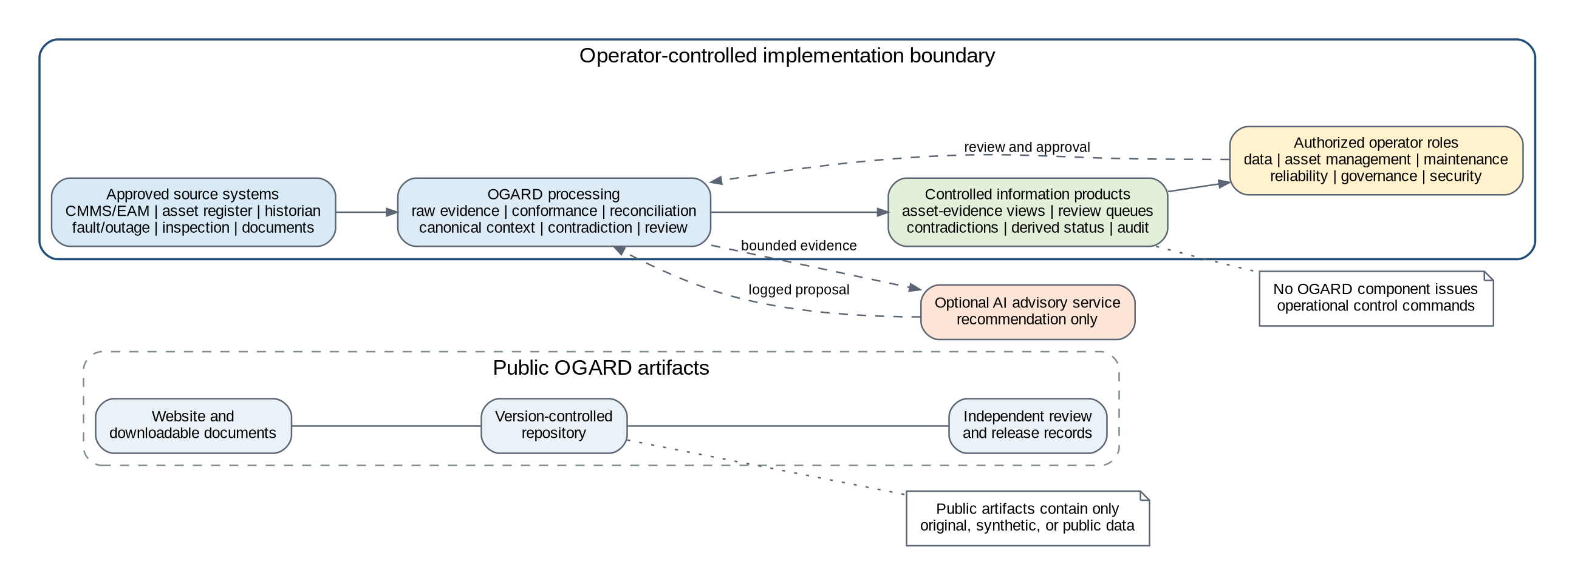
Figure 1. System context and trust boundaries.

3.1. Public reference boundary
The public website and repository MAY contain documentation, diagrams, schemas, synthetic examples, rules, evaluation logic, expected outputs, and review records. They MUST NOT contain protected operator records, credentials, internal configurations, employer code, client information, or proprietary product material.

3.2. Operator-controlled boundary
An operator implementation MUST define source owners, data-access permissions, security classification, retention, reviewer roles, decision rights, and approved downstream use before controlled outputs are relied upon. OGARD does not authorize data access or operational use by itself.

3.3. No control-plane function
OGARD outputs are information products. The reference architecture MUST NOT issue switching commands, protection actions, control-room instructions, or direct changes to operational technology. Any downstream operational action remains governed by the operator's approved systems and procedures.

4. Logical architecture
The reference architecture uses four logical layers. The layers may be implemented as separate services, schemas, tables, or processing stages, but their responsibilities and audit boundaries should remain distinguishable.
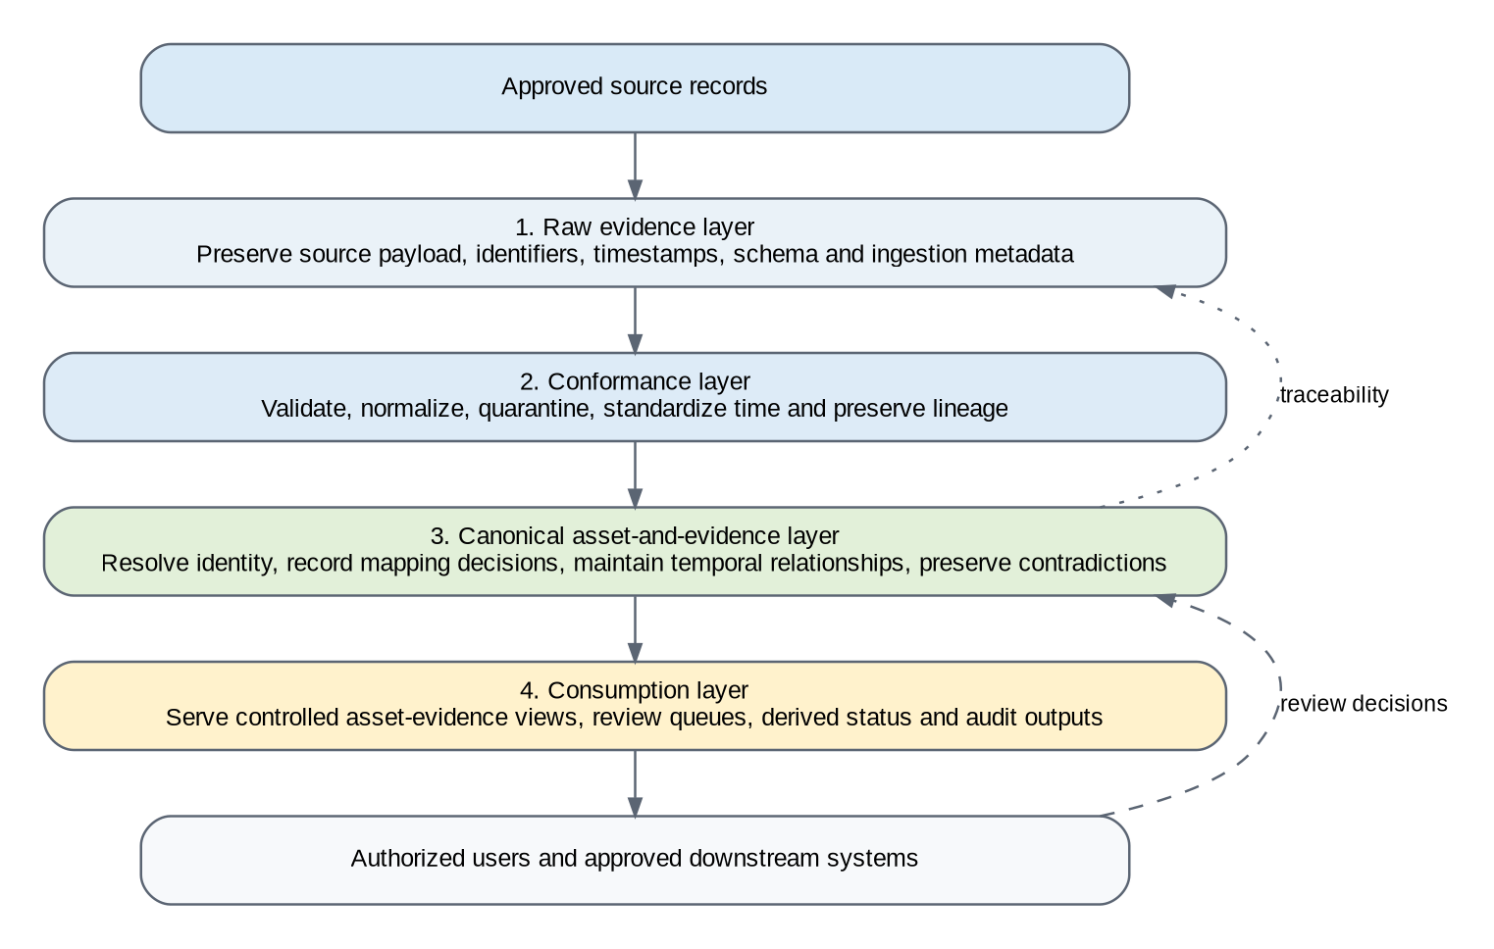
Figure 2. Minimum logical architecture.
Layer | Primary responsibility | Minimum guarantee
Raw evidence | Capture or reference source records with source identifiers, original values, timestamps, schema, and ingestion metadata. | The source record can be recovered or traced without relying on the canonical view.
Conformance | Validate schemas, normalize permitted fields, standardize time and units, identify duplicates, and route failures. | Normalization and quality decisions are explicit and do not erase the raw evidence.
Canonical asset and evidence | Maintain asset context, time-valid relationships, mapping decisions, review outcomes, contradictions, and derived status provenance. | Every material relationship or status can be explained from evidence, rules, and review records.
Consumption | Provide controlled asset-evidence views, queues, audit outputs, and approved information products. | Consumers receive authorized outputs with lineage and known quality or review state.

4.1. Source contract
Every ingested or referenced source record MUST provide, directly or through a controlled catalog, the source system, source record identifier, record type, event timestamp where available, extraction timestamp, ingestion timestamp, schema version, batch or stream identifier, and security classification. Missing required metadata MUST be recorded as a quality condition.

4.2. Failure behavior
Records that fail critical validation SHOULD be quarantined or excluded from controlled downstream use without being silently deleted. Processing failures, schema drift, stale sources, and incomplete audit records MUST be observable.

5. Canonical asset-and-evidence model
The model separates the asset context from the evidence records that describe or challenge it. The canonical view is therefore not a replacement for source records. It is a governed interpretation whose basis remains visible.
Versioning requirement. Every persisted canonical, evidence, mapping, review, contradiction, derived-status, and audit record should carry, or be traceable to, both model_profile_version and schema_version. Historical outputs must remain traceable to the model and schema in force when the decision was produced; later model changes must not silently reinterpret prior records.
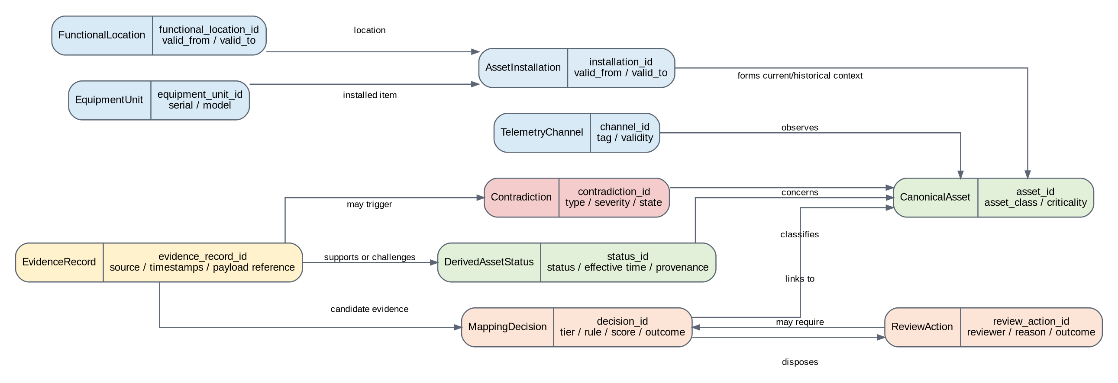
Figure 3. Core entity relationships.
Entity | Purpose | Minimum information
CanonicalAsset | Stable governed reference context for an asset within the selected implementation scope. | asset_id, asset_class, operator scope, created_at, updated_at; lifecycle or criticality fields only where defined; model_profile_version; schema_version
FunctionalLocation | Role or position in the network hierarchy. | functional_location_id, hierarchy or parent, location type, valid_from, valid_to, model_profile_version; schema_version
EquipmentUnit | Physical installed item. | equipment_unit_id, serial or alternative identity, equipment class, manufacturer/model where available, lifecycle dates, model_profile_version; schema_version
AssetInstallation | Time-valid relationship between a functional location and equipment unit. | installation_id, functional_location_id, equipment_unit_id, valid_from, valid_to, evidence reference, model_profile_version; schema_version
TelemetryChannel | Observation channel associated with a location, item, or aggregate. | channel_id, source system, tag, measurement type, valid_from, valid_to, mapping state, model_profile_version; schema_version
EvidenceRecord | Preserved source-level record or controlled source reference. | evidence_record_id, source system, source record ID, record type, timestamps, schema version, payload reference, quality state, model_profile_version
EvidenceRecord subtype examples | Typed extensions for maintenance or work orders, faults or outages, inspections or condition records, and technical documents. | evidence_record_id, record_type, subtype-specific fields, source references, model_profile_version; schema_version
MappingDecision | Auditable disposition of a candidate relationship. | decision_id, source record, candidate context, method tier, rule/model version, score, outcome, actor, timestamps, model_profile_version; schema_version
ReviewAction | Authorized human disposition of a review item. | review_action_id, review item, reviewer, decision, reason code, timestamp, evidence references, model_profile_version; schema_version
Contradiction | Typed disagreement or unresolved conflict between evidence classes. | contradiction_id, type, severity, implicated context, triggering evidence, state, owner, resolution, model_profile_version; schema_version
DerivedAssetStatus | Operator-governed status with evidence, rule, time, and review provenance. | status_id, asset_id, status, effective interval, evidence set, rule version, review state, contradiction references, model_profile_version; schema_version

WorkOrder, FaultEvent, InspectionRecord, and DocumentReference are treated as typed EvidenceRecord subtypes or implementation extensions. They do not replace the core EvidenceRecord and provenance requirements.

5.1. Relationship cardinality and time
A functional location MAY be occupied by different equipment units over time. An equipment unit MAY move between locations where the operator permits such history. A telemetry channel MAY observe a functional location, an installed item, or an aggregate and MUST therefore have its own time-valid mapping. Historical relationships SHOULD be closed with valid_to rather than overwritten.

5.2. Selected CIM relationship
OGARD MAY map entities to selected IEC Common Information Model concepts to improve interoperability. The mapping should be documented as guidance unless a version-specific profile, serialization, and conformance process have been implemented. Appendix D provides a short indicative crosswalk that supports the term CIM-informed without claiming a formal profile, complete semantic equivalence, compliance, or certification.

6. Identifier regimes and temporal relationships
Identifier regime | Represents | Common failure mode
Functional location | The role or position in the network hierarchy. | It survives equipment replacement and may be mistaken for the physical item.
Physical equipment identity | The installed item, commonly represented by serial, manufacturer, or operator identifier. | It may relocate, be replaced, or lack complete historical identity.
Telemetry identity | The tag or channel through which behavior is observed. | Tags may be renamed, reused, repointed, or left stale after configuration changes.

The model MUST NOT assume that equality within one identifier regime establishes equality across the others. Candidate mappings SHOULD use time windows, asset class, location context, approved aliases, replacement history, and source authority where available. Ambiguous relationships MUST be routed to review or remain unresolved.

7. Mapping, review, contradiction, and derived status

7.1. Reconciliation workflow
1. Generate a bounded candidate set using location, asset class, identifier fragments, time windows, approved aliases, or other documented constraints.
2. Apply versioned deterministic rules where the relationship is sufficiently explicit.
3. Apply reproducible similarity scoring only where deterministic evidence is incomplete and the method is approved for the source and asset class.
4. Route ambiguous, contradictory, or operationally consequential cases to an authorized review queue.
5. Record the final outcome, evidence, method, version, actor, and timestamps in the mapping and audit records.
Decision outcome | Meaning
Accepted | The relationship is approved for the stated scope and validity period.
Rejected | The candidate relationship is not approved and the reason is recorded.
Deferred | Evidence is insufficient; the case remains unresolved pending additional information.
Escalated | A specialist or higher-authority reviewer is required.
Contradiction recorded | The disagreement is preserved and routed without forcing a single answer.

7.2. Minimum mapping decision record
Field group | Required content
Identity | decision_id, source_record_id, candidate_asset_id or candidate set
Method | tier, rule or model identifier, version, score or confidence where applicable, threshold configuration
Outcome | accepted, rejected, deferred, escalated, or contradiction recorded
Authority | automatic rule authority or reviewer identity and reason code
Time | decision timestamp, effective validity period where applicable
Evidence | source evidence references and any competing candidates or contradictions

7.3. Contradiction handling
A contradiction MUST be preserved where material evidence disagrees on identity, time, status, installed configuration, telemetry association, or maintenance context. Contradictions SHOULD be typed, assigned severity under operator-approved rules, routed to an owner, and closed only through a recorded resolution or accepted residual risk. Appendix C defines the closed, versioned OGARD v0.1 contradiction taxonomy used for any benchmark precision or recall calculation. Operator implementations MAY extend the taxonomy, but extensions must use separate versioned codes and must not be mixed into v0.1 benchmark denominators without disclosure.

7.4. Derived asset status
Status | Reference meaning | Minimum interpretation safeguard
Available | Approved evidence supports expected availability within the defined scope, and no unresolved material contradiction blocks the classification. | Does not prove the absence of latent defect. Evidence coverage, freshness, and disqualifying contradictions must be operator-defined.
Degraded | Approved evidence supports impaired condition or reduced capability under an operator-defined rule. | Requires asset-class-specific criteria, time validity, and authorized engineering interpretation.
Offline | Approved evidence supports that the asset is unavailable, disconnected, or out of service. | Must distinguish planned, forced, temporary, and data-quality conditions using time-valid evidence.
At risk | Approved evidence indicates a condition requiring attention but does not support Degraded or Offline. | Must not be represented as a failure prediction; indicators, expiry, and review requirements must be defined.
Unknown | Evidence is insufficient, stale, ambiguous, outside scope, or materially contradictory. | Unknown is the safe default whenever another status cannot be justified.

Status boundary. Unknown is an intentional safe outcome. The framework should preserve uncertainty rather than manufacture a status that the evidence does not support.
Every derived status MUST record the applicable rule version, evidence set, effective time, review state, and any unresolved contradiction that affects interpretation. AI outputs MUST NOT determine final status directly.

8. Interfaces, security, and operational boundaries

8.1. Minimum interface records
Reference interfaces may be implemented as files, tables, messages, APIs, or controlled views. Regardless of technology, the implementation SHOULD expose stable records for source evidence, mapping decisions, review actions, contradictions, derived status, and audit events. Schema changes MUST be versioned and backward-impact assessed.

8.2. Security and confidentiality
- Access MUST follow operator-approved least-privilege roles and environment separation.
- Credentials, secrets, and restricted payloads MUST NOT be stored in public artifacts.
- Sensitive data SHOULD be encrypted in transit and at rest according to operator policy.
- Lineage, decision records, and security-relevant access SHOULD be auditable.
- Retention and deletion MUST follow applicable legal, contractual, regulatory, and operational requirements.

8.3. Optional AI boundary
An optional AI component MAY recommend candidate mappings, summarize evidence, classify documents, or prioritize review. Each use MUST identify the task, model and version where available, permitted inputs, output schema, evidence references, confidence or uncertainty, review requirement, retention, and evaluation method. The component MUST NOT write canonical relationships or final asset status without an approved non-AI authority path.

8.4. Observability
At minimum, an implementation SHOULD monitor source freshness, schema failures, quarantine volume, mapping outcomes by tier, review-queue depth and age, unresolved contradictions, status freshness, audit-log completeness, and controlled-output availability.

9. Worked synthetic example
A synthetic maintenance record references functional location FL-NE-SUB114-TX02 and contains no equipment serial number. Installation history shows former equipment unit TR-88-104553 at the location until 14 April 2026 and replacement unit TR-26-778204 from 15 April 2026. Historian tag NE114.TX2.OILTMP remains explicitly associated with the former equipment unit after replacement. The resulting stale tag-to-equipment relationship is preserved as a contradiction.
1. The functional-location rule links the work order to the location, but not automatically to a physical equipment unit.
2. The installation table limits candidate equipment units using the work-order date.
3. Similarity scoring and date context identify the replacement unit as the leading candidate, but the score remains below the operator's auto-accept threshold.
4. The case is routed to review with the candidate set, source evidence, time window, and score.
5. The reviewer accepts the replacement unit and records the reason and evidence references.
6. A stale telemetry association to the former unit is preserved as a contradiction and assigned for resolution.
7. Until the contradiction is resolved, any status that depends on that telemetry remains Unknown or carries an explicit limitation under operator rules.
This example demonstrates the intended control pattern: identity is resolved through time-valid evidence, the review decision is auditable, and contradictory information is retained rather than silently overwritten.

10. Reference repository artifacts and limitations

10.1. Minimum repository artifacts
Artifact | Purpose
Architecture diagrams | Editable or source-controlled versions of the system context, logical architecture, and entity model.
Machine-readable schemas | Reference definitions for the core entities and minimum records.
Example records | Synthetic examples showing valid, invalid, ambiguous, and contradictory cases.
Rule and threshold examples | Versioned starter rules and non-production scoring configuration.
Worked reconciliation | A traceable example from source evidence to final disposition.
Audit-log sample | Example accepted, rejected, reviewed, and contradiction events.
Change log and license | Version history, scope changes, and permitted use.

10.2. Known limitations
- The model is a minimum reference profile, not a complete utility enterprise model.
- Asset-class semantics, source authority, quality thresholds, and derived-status rules require operator and domain input.
- Selected CIM mapping guidance does not establish formal conformance.
- Synthetic examples cannot reproduce the full history, irregularity, access constraints, or organizational context of a live estate.
- This specification does not establish production suitability, operator adoption, or operational reliability outcomes.

10.3. Release condition
This document should be represented as a public v0.1 specification only when its diagrams, machine-readable schemas, examples, and companion documents agree with one another and the public release has a tagged repository state and clear change history.

References
[1] Bektas, D. OGARD: Open Grid Asset Reliability Data Framework. Draft Release Candidate v0.1, 2026.
[2] Bektas, D. OGARD Implementation Guide. Draft Release Candidate v0.1, 2026.
[3] National Institute of Standards and Technology. NIST Framework and Roadmap for Smart Grid Interoperability Standards, Release 4.0. NIST SP 1108r4, 2021.
[4] International Electrotechnical Commission. IEC 61970 and IEC 61968 Common Information Model publications. Referenced for conceptual interoperability guidance only.

Appendix A. Minimum entity dictionary
The following field sets are intentionally concise. A reference implementation may add fields, but it should not remove the provenance, identity, time, or decision information needed to reconstruct a material output.
Entity | Minimum fields
CanonicalAsset | asset_id; asset_class; operator_scope; created_at; updated_at; optional lifecycle or criticality fields only where defined; model_profile_version; schema_version
FunctionalLocation | functional_location_id; parent_location_id; location_type; valid_from; valid_to; model_profile_version; schema_version
EquipmentUnit | equipment_unit_id; serial_or_alternative_id; equipment_class; manufacturer/model if available; lifecycle dates; model_profile_version; schema_version
AssetInstallation | installation_id; functional_location_id; equipment_unit_id; valid_from; valid_to; evidence_reference; model_profile_version; schema_version
TelemetryChannel | channel_id; source_system; tag; measurement_type; unit; valid_from; valid_to; mapping_state; model_profile_version; schema_version
EvidenceRecord | evidence_record_id; source_system; source_record_id; record_type; event/extraction/ingestion timestamps; schema_version; payload_reference; quality_state; model_profile_version
EvidenceRecord subtype examples | evidence_record_id; record_type; subtype-specific fields; source references; model_profile_version; schema_version
MappingDecision | decision_id; source_record_id; candidate_asset_id or candidate set; method_tier; rule_or_model_id; version; score; outcome; actor; timestamp; evidence_references; model_profile_version; schema_version
ReviewAction | review_action_id; review_item_id; reviewer; decision; reason_code; timestamp; evidence_references; model_profile_version; schema_version
Contradiction | contradiction_id; type; severity; implicated context; triggering_evidence; state; owner; resolution; model_profile_version; schema_version
DerivedAssetStatus | status_id; asset_id; status; effective_from; effective_to; rule_version; evidence_set; review_state; contradiction_references; model_profile_version; schema_version

Appendix B. Minimum conformance self-assessment
The checklist is intentionally limited to controls that can be demonstrated from records or configuration. The assessor should record Pass, Fail, or Not applicable with a documented scope reason. An unsupported assertion is not evidence of a pass.
Table 11. OGARD v0.1 minimum conformance checklist.
Control | Objective pass condition | Minimum evidence
Evidence preservation | Every controlled output traces to a source record or controlled payload reference with source and time metadata. | Lineage walkthrough and sample records
Identity separation | Functional location, equipment unit, and telemetry channel are represented as separate entities or records. | Schema and example records
Temporal relationships | Installation and identity relationships carry valid-from and valid-to semantics or an equivalent versioned history. | AssetInstallation or equivalent history
Auditable mapping | Each accepted, rejected, deferred, escalated, or reviewed mapping records method, version, outcome, time, and authority. | MappingDecision and ReviewAction samples
Explicit uncertainty | Insufficient evidence can result in review, deferred disposition, contradiction, or Unknown rather than a forced answer. | Rules and test or example cases
Contradiction preservation | Material disagreement is recorded with a versioned type and is not silently overwritten by survivorship. | Contradiction record and resolution workflow
Operator authority | Final canonical relationships and derived statuses are approved only through authorized rules or reviewers. | Decision-rights register and rule authority
Model traceability | Persisted material records identify or trace to model_profile_version and schema_version. | Record samples and schema bundle
Protected-data boundary | Public artifacts contain only original, synthetic, or authorized public information. | Release review and repository inspection
AI limitation | Any AI function is advisory, logged, evidence-bound, and unable to mutate canonical state or determine final status directly. | Architecture and AI control record, if AI is used

Appendix C. OGARD v0.1 contradiction taxonomy
The following codes form the closed v0.1 benchmark taxonomy. A seeded contradiction must use exactly one primary code for metric accounting, although secondary context may be retained. Operator-specific extensions should use a separate namespace.
Table 12. Closed and versioned contradiction types for OGARD v0.1.
Code | Definition | Illustrative trigger | Expected safe treatment
STATUS_CONFLICT | Approved evidence sources report incompatible asset states for overlapping time. | Register active while fault or outage evidence reports offline. | Preserve both sources; route status review.
EQUIPMENT_LOCATION_CONFLICT | Equipment identity and functional-location history cannot both be true for the same interval. | One serial appears at two locations during overlapping validity. | Review installation history; do not force identity.
TELEMETRY_EQUIPMENT_CONFLICT | A telemetry channel is associated with an equipment unit inconsistent with time-valid installation evidence. | Tag remains mapped to the former unit after replacement. | Preserve channel evidence; route historian or instrumentation review.
TEMPORAL_VALIDITY_CONFLICT | Records imply relationships or events outside compatible validity intervals. | Late work order references equipment removed before the event. | Use event time; review or reject the relationship.
DUPLICATE_IDENTITY_CONFLICT | Competing records claim the same identity or one record appears to represent multiple assets. | Two active equipment records share one serial. | Retain candidates; review duplicate identity.
DOCUMENTED_CONFIGURATION_CONFLICT | Technical documentation and recorded installed configuration disagree. | Drawing names a different installed model or connection. | Engineering document and configuration review.
WORK_ORDER_REFERENCE_CONFLICT | A maintenance or work-order reference points to an incompatible asset context. | Work order location and equipment reference disagree. | Review source context and installation history.
STALE_EVIDENCE_CONFLICT | A source remains unchanged beyond an approved freshness or change event and conflicts with newer evidence. | Old register or tag mapping persists after an approved replacement. | Flag staleness; do not infer physical failure.

Appendix D. Indicative CIM concept crosswalk
This crosswalk is non-normative and intentionally incomplete. It indicates related CIM concepts that may support implementation analysis; it does not assert one-to-one equivalence or a version-specific CIM profile.
Table 13. Indicative, non-normative CIM relationship guidance.
OGARD concept | Indicative CIM concept family | Relationship | Limitation
CanonicalAsset | PowerSystemResource and related asset context | Provides the governed OGARD context to which evidence is attached. | Not asserted as a direct CIM class equivalence.
FunctionalLocation | Location, EquipmentContainer, and local hierarchy concepts | Represents the enduring network role or position. | Utility location hierarchies and functional-location semantics vary.
EquipmentUnit | Equipment and Asset-related concepts | Represents the physical installed item and lifecycle identity. | CIM operational equipment and asset-management representations may differ.
AssetInstallation | Time-valid relationship assembled from asset, equipment, and location information | Bridges equipment identity and functional location through time. | OGARD-specific relationship; not claimed as one standard CIM object.
TelemetryChannel | Measurement and MeasurementValue-related concepts | Represents the observation channel and its mapping context. | Historian tags and channel lifecycles require local extensions.
EvidenceRecord | No single direct equivalent; may reference CIM messages or domain records | Preserves source evidence, provenance, and quality state. | OGARD evidence wrapper extends beyond a semantic equipment model.
MappingDecision / Contradiction | No single direct equivalent | Records governance decisions and unresolved disagreement. | These are OGARD control records, not claimed CIM classes.

Change log
Version | Date | Status | Summary
Draft RC v0.1 | August 2026 | Not publicly released | Initial minimum specification aligned with the companion whitepaper, implementation guide, and benchmark methodology; establishes four layers, core entities, status taxonomy, trust boundaries, and release conditions.
Draft RC v0.1 - Batch 2 | August 2026 | Not publicly released | Batch 2 review revision: added an objective conformance checklist, a closed v0.1 contradiction taxonomy, and an indicative non-normative CIM crosswalk; linked them from the controlling sections.
Public edition v0.1.1 | 24 September 2026 | Public | Status updated; content unchanged. Publication metadata, running headers and edition history updated.

