GROUP 1- Budget Planner App
Gwen Dagcutan
Jetty Lyn R. Cahilog
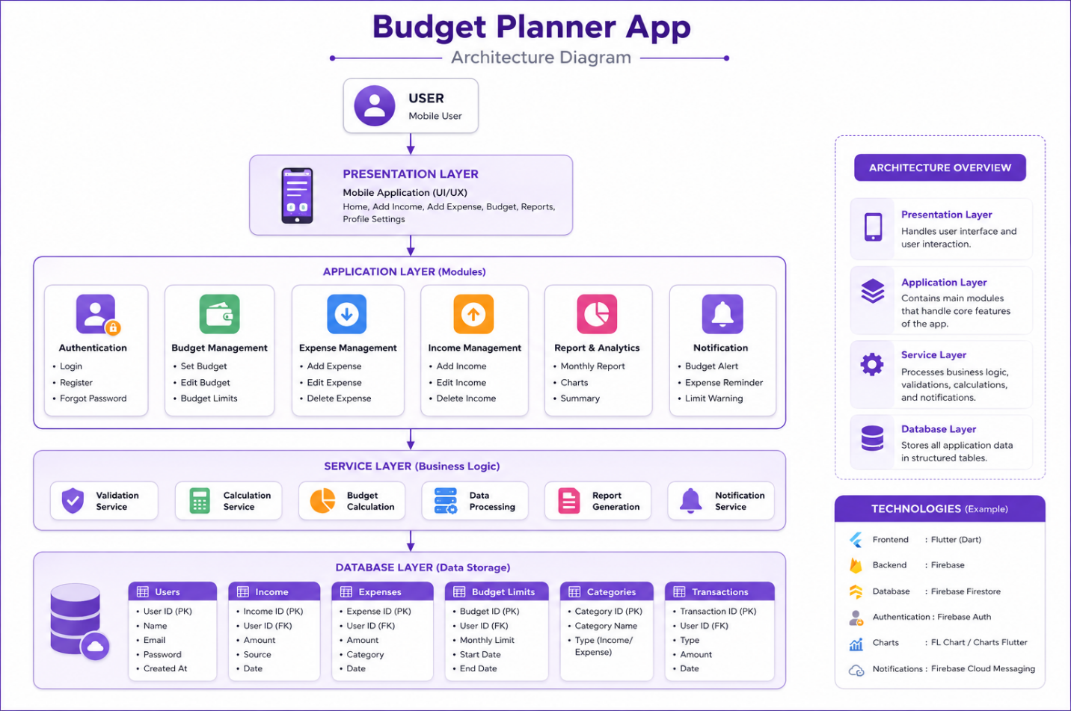
Den Jasper Caneos

- Architecture Diagram

- Component Or Data Flow
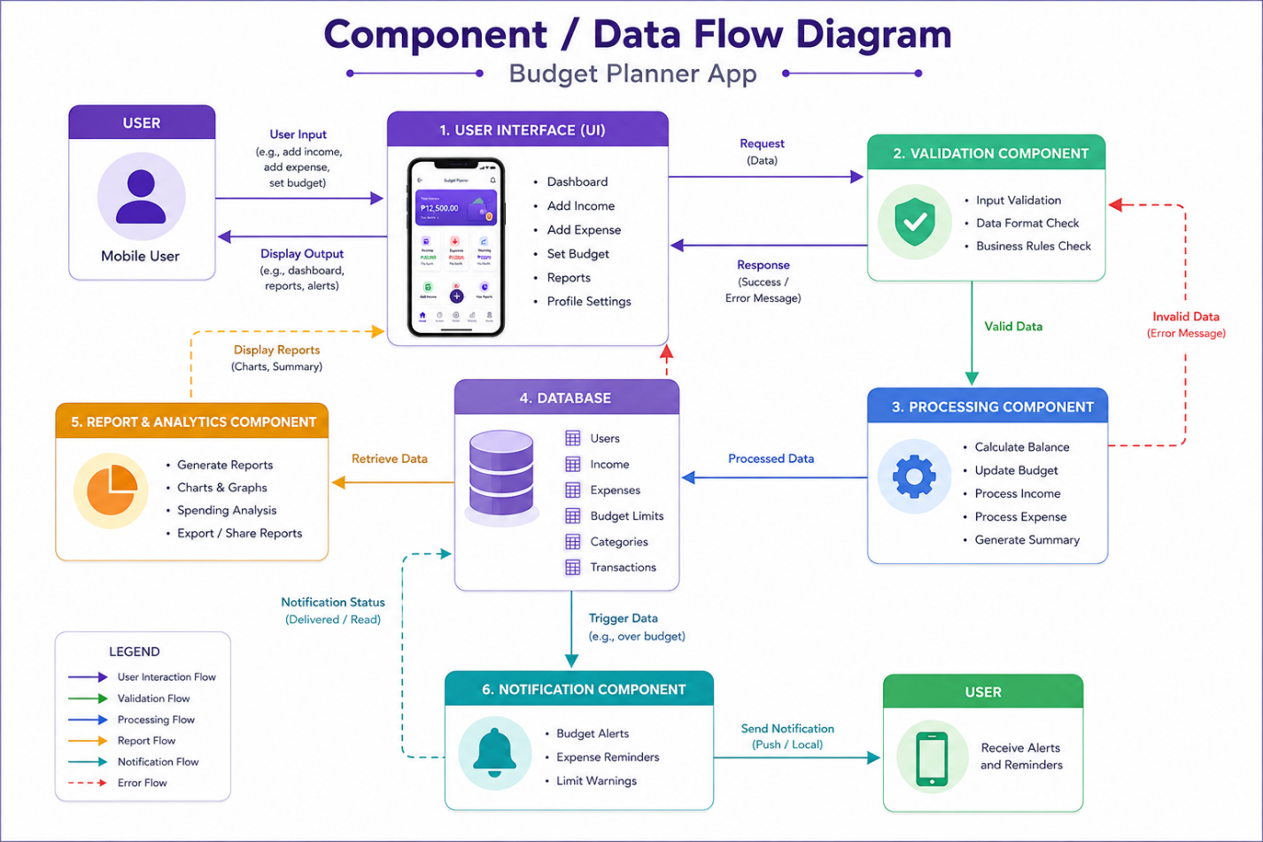

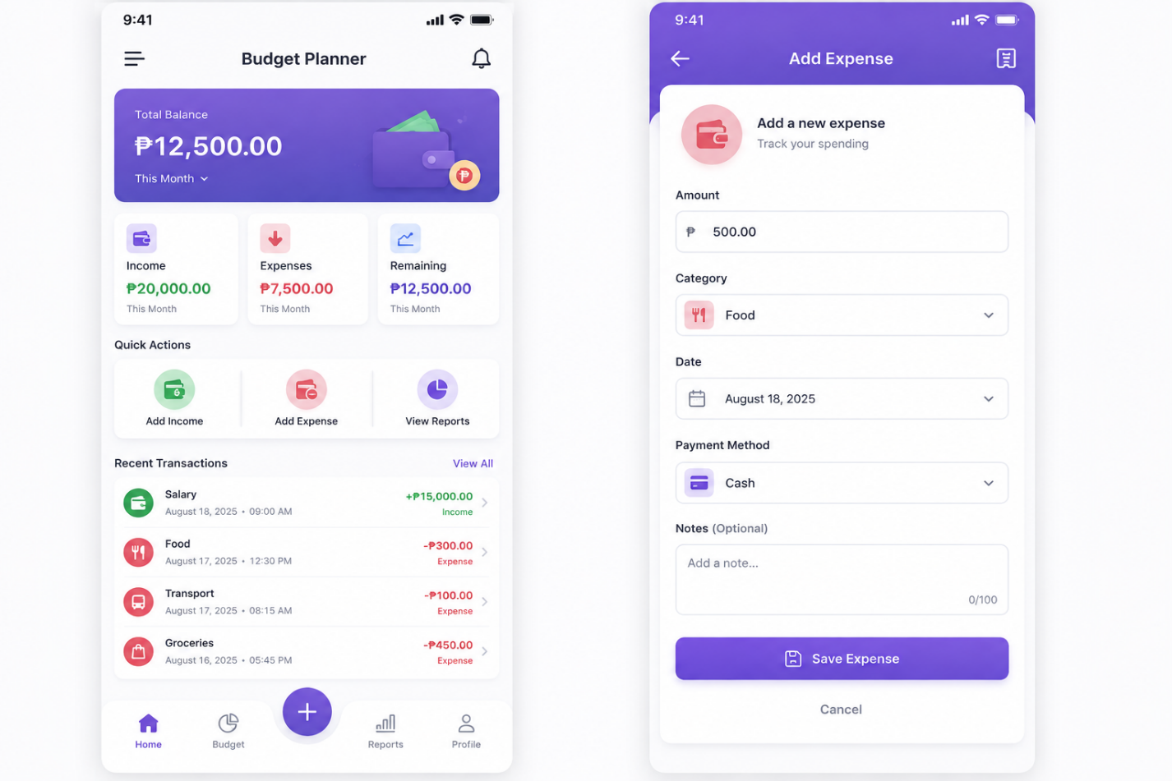

- Wireframes

Short Explanation of Design Principles
1. Modularity
The Budget Planner application is divided into separate modules, including the Authentication Module, Budget Management, Expense Management, Income Management, Report & Analytics, Notification Service, and Database. Each module has a specific responsibility, making the application easier to develop, maintain, and upgrade.
2. Low Coupling
Each module communicates only through well-defined interactions. For example, the Report & Analytics Module retrieves data from the database without directly depending on the Expense or Income modules. This reduces dependencies, allowing one module to be modified without affecting the others.
3. High Cohesion
Every module focuses on a single task. The Expense Management Module handles expense-related functions, while the Budget Management Module manages budget limits and calculations. Keeping related functions together improves organization and code quality.
4. Abstraction
The application hides complex processing from the user. Users only interact with simple features such as Add Income, Add Expense, Set Budget, and View Reports, while calculations, validations, and data processing are performed in the background by the system.
5. Simplicity
The high-fidelity wireframes use a clean and user-friendly interface with clear navigation, organized dashboards, and easy-to-understand buttons. This allows users to perform tasks quickly without unnecessary complexity.
6. Reusability
Common services such as input validation, budget calculation, notifications, and report generation are designed to be reusable across different parts of the application. This minimizes duplicate code and speeds up future development.
7. Maintainability
The layered architecture separates the Presentation Layer, Application Layer, Service Layer, and Database Layer, making the application easier to maintain. Developers can update or improve one layer without significantly affecting the others.
8. Scalability
The modular architecture allows additional features, such as bill reminders, savings goals, bank integration, or AI spending recommendations, to be added in the future without redesigning the entire system.

Conclusion
The Budget Planner App follows key software design principles by using a modular architecture, low coupling, high cohesion, abstraction, simplicity, reusability, maintainability, and scalability. These principles ensure that the system is organized, user-friendly, efficient, and easy to enhance as user requirements grow.

