Computer Science Department
Senior Project Requirements and Design Document – Fall 2026
AI-Based Medical Image Classification and Diagnostic Report Generation
Item | Details
Team Members | Daniyar Kshibekov; Daulet Kaskenov; Ayaulym Zhumagul; Assel Derbissova
Project Advisor | Prof. Min-Ho Lee
Course | CSCI 408 – Senior Project I, Fall 2026
Project Type | Research and Development (R&D)

1. Project Overview (20%)
Medical images such as chest X-rays contain clinically relevant information that can help physicians identify abnormalities and assess a patient’s condition. Interpreting these images and preparing radiology reports requires specialist knowledge and can be time-consuming. The project investigates whether deep-learning methods can assist with two related tasks: (1) classifying clinically relevant abnormalities in chest X-ray images and (2) generating corresponding radiology report text.
The project is a research-oriented clinical decision-support prototype, not a replacement for a qualified physician. Its purpose is to study the behavior, strengths, limitations, and consistency of modern vision and vision-language models on a controlled chest X-ray task.
The current experimental scope focuses on frontal Indiana University chest X-ray images and three balanced diagnostic categories: Normal, Cardiomegaly, and Pleural Effusion. The system uses two parallel branches. The classification branch compares a CNN baseline (ResNet-18) with a Vision Transformer (ViT-B/16). The report-generation branch uses a BLIP-based medical report generator (`nathansutton/generate-cxr`) and a separate experiment comparing randomized, pretrained baseline, and fine-tuned versions of the same BLIP architecture.
The prototype will develop and integrate the following work products:
• A reproducible chest X-ray data-preparation and preprocessing pipeline.
• A three-class image-classification pipeline with ResNet-18 and ViT-B/16.
• Model-confidence output and ResNet Grad-CAM visual explanations for selected predictions.
• A BLIP-based radiology report-generation pipeline operating directly on the input X-ray image.
• A controlled report-generation comparison using a fixed 270-image training split and 30 held-out images.
• Quantitative and qualitative evaluation of classification and generated text.
• An integrated research demonstration that presents classification results, explanation, and generated report together.

2. Requirements (30%)

2.1 Functional Requirements
ID | Requirement
FR-01 | The system shall accept a chest X-ray image as the primary input for inference.
FR-02 | The data pipeline shall merge Indiana projection metadata and report metadata using the shared `uid` identifier.
FR-03 | The data pipeline shall restrict the controlled experiment to frontal chest X-ray views and exclude cases that do not satisfy the project’s single-label selection rule.
FR-04 | The controlled classification dataset shall contain the three target categories Normal, Cardiomegaly, and Pleural Effusion, with a balanced 100-image subset per class for the current experiment.
FR-05 | The classification branch shall preprocess input images for pretrained vision models and produce a predicted class for each input image.
FR-06 | The classification branch shall support both ResNet-18 and ViT-B/16 so that their performance can be compared on the same task.
FR-07 | The classification output shall include model confidence/probability information in addition to the predicted class when used in the integrated prototype.
FR-08 | The system shall support Grad-CAM visualization for the ResNet-18 branch to provide an interpretable heatmap for selected predictions.
FR-09 | The report-generation branch shall send the X-ray image directly to a BLIP-based vision-language model and generate natural-language radiology report text.
FR-10 | The classification prediction shall not be used as an input to the BLIP report generator; the two branches shall remain logically independent and receive the same source image in parallel.
FR-11 | The report-generation experiment shall support comparison of three BLIP variants: randomized-weight BLIP trained on the project split, the existing pretrained baseline, and a version fine-tuned on the same project training split.
FR-12 | The system shall evaluate classification performance on held-out data and retain the split configuration used for reproducibility.
FR-13 | The report-generation experiment shall compute text-similarity metrics including BLEU-4, ROUGE-L, and BERTScore for the same held-out test examples.
FR-14 | The system shall support qualitative inspection of generated reports, including comparison with the corresponding reference findings/impression text.
FR-15 | The integrated prototype shall present, for a selected X-ray, the input image, classification result, relevant confidence information, generated report, and available Grad-CAM visualization.
FR-16 | Experiment outputs and evaluation results shall be saved in a reproducible form suitable for inclusion in the final report and presentation.

2.2 Non-Functional Requirements
ID | Requirement
NFR-01 – Reproducibility | Dataset selection and experimental splits shall use fixed random seeds where applicable, and the resulting split files/configuration shall be preserved.
NFR-02 – Consistency | Models being compared within the same experiment shall use the same held-out evaluation set and comparable preprocessing/evaluation procedures.
NFR-03 – Reliability | The pipeline shall explicitly detect missing required image files rather than silently dropping cases from an intended fixed evaluation protocol.
NFR-04 – Maintainability | The project shall separate data preparation, model training/inference, evaluation, and documentation so that individual components can be revised without rewriting the entire pipeline.
NFR-05 – Efficiency | The prototype shall support GPU execution for deep-learning training and inference. Resource-heavy report-generation experiments should use memory-conscious settings such as small batches and gradient accumulation when necessary.
NFR-06 – Portability | The report-generation comparison should be runnable in a supported notebook environment such as Kaggle or local Jupyter/VS Code, with automatic handling of the required image path where possible.
NFR-07 – Traceability | Major experiments shall record model name, split, key hyperparameters, metrics, and qualitative outputs so that results can be traced to a specific experiment configuration.
NFR-08 – Usability | The final research demonstration shall organize the model outputs in a form understandable to a technical reviewer without requiring inspection of raw tensors or internal model state.
NFR-09 – Version Control | Source code, notebooks, documentation, and lightweight configuration files shall be maintained in Git/GitHub; large medical image datasets shall not be committed to the repository.
NFR-10 – Research Integrity | The system shall distinguish text-similarity metrics from clinical correctness and shall not present BLEU/ROUGE/BERTScore as evidence of medical safety or diagnostic validity.

2.3 Domain Requirements
ID | Domain Requirement
DR-01 | The current prototype shall operate on chest X-ray images; CT imaging remains outside the immediate experimental scope unless project progress later justifies an extension.
DR-02 | The current controlled classification experiment shall use frontal views rather than mixing frontal and lateral projections.
DR-03 | The project shall use the defined target classes Normal, Cardiomegaly, and Pleural Effusion for the three-class controlled classification experiment.
DR-04 | Reference report text shall be taken from the available findings field, using impression as a fallback where findings are missing, according to the current Indiana pipeline.
DR-05 | Generated text shall be treated as research output. It shall not be described as a definitive diagnosis or a substitute for a radiologist/physician.
DR-06 | Evaluation shall recognize clinically important failure modes such as false-negative abnormality predictions, contradictory generated findings, and hallucinated statements.
DR-07 | The project shall use public/de-identified research data and shall avoid introducing real patient-identifying information into project artifacts.
DR-08 | When presenting model confidence or explanations, the document/demo shall state that these outputs indicate model behavior and are not calibrated clinical probabilities unless calibration is explicitly evaluated.
DR-09 | The report-generation branch and classification branch shall be evaluated both individually and together, because agreement between outputs is informative but does not establish clinical correctness.
DR-10 | Any extension to additional pathologies, multi-label classification, or CT images shall be treated as future scope unless it is formally incorporated into the project plan and evaluated with appropriate data.

3. Preliminary Design (20%)

3.1 Stakeholders
Stakeholder | Interest / Role
Project team | Develops the pipeline, models, experiments, integration, documentation, and presentation.
Prof. Min-Ho Lee (Advisor) | Provides technical/research supervision, reviews progress, and evaluates major project documents and individual contribution.
CSCI 408 course instructors and evaluation committee | Evaluate whether the project satisfies course scope, deliverables, documentation, and presentation requirements.
Medical-AI researchers / technical users | Potential users of the research prototype for studying model behavior and comparing classification/report-generation approaches.
Physicians/radiologists (domain stakeholders) | Provide the real-world context in which such decision-support systems could be useful; the current prototype is not intended for autonomous clinical use.
Patients/data subjects (indirect stakeholders) | Motivate requirements for privacy, de-identification, safe claims, and careful interpretation of model outputs.

3.2 Structured Use Cases
ID | Use Case | Primary Actor | Precondition | Main Flow | Postcondition
UC-01 | Analyze a chest X-ray | Research user / team member | A valid chest X-ray image is available. | 1. User selects an image. 2. System validates/preprocesses it. 3. ResNet-18 and/or ViT produce class scores. 4. BLIP independently generates report text. 5. System prepares the combined result. | Predicted class, confidence information, generated report, and optional Grad-CAM are displayed.
UC-02 | Compare classification models | Project team | Fixed classification split and trained/configured models are available. | 1. Run ResNet-18 on held-out test set. 2. Run ViT-B/16 on the same test set. 3. Compute comparable classification metrics. 4. Review errors and class-wise behavior. | A documented ResNet-vs-ViT comparison is produced.
UC-03 | Generate and inspect a radiology report | Research user / team member | Input X-ray and BLIP processor/model are available. | 1. Load X-ray. 2. BLIP processor prepares pixel values. 3. Model generates report tokens. 4. Tokens are decoded. 5. Output is compared with reference findings/impression. | Generated report and qualitative comparison are available.
UC-04 | Compare three BLIP variants | Project team | Fixed 270/30 report-generation split and required 300 images are available. | 1. Train randomized BLIP on 270 examples. 2. Evaluate pretrained baseline unchanged. 3. Fine-tune pretrained BLIP on the same 270 examples. 4. Generate reports for the same 30 held-out cases. 5. Compute BLEU-4, ROUGE-L, BERTScore and inspect outputs. | A controlled comparison of pretraining/fine-tuning effects is produced.
UC-05 | Review model explanation | Project team / reviewer | A ResNet classification result is available. | 1. Select a test image. 2. Compute Grad-CAM on the selected ResNet layer. 3. Overlay the heatmap on the image. 4. Review whether highlighted regions are plausible for the model decision. | A visual explanation of the ResNet decision is displayed for research interpretation.

3.3 Sequence Diagram
The following preliminary sequence shows inference for one chest X-ray. The classification and report-generation branches operate in parallel from the same image; the BLIP model does not consume the classifier prediction.
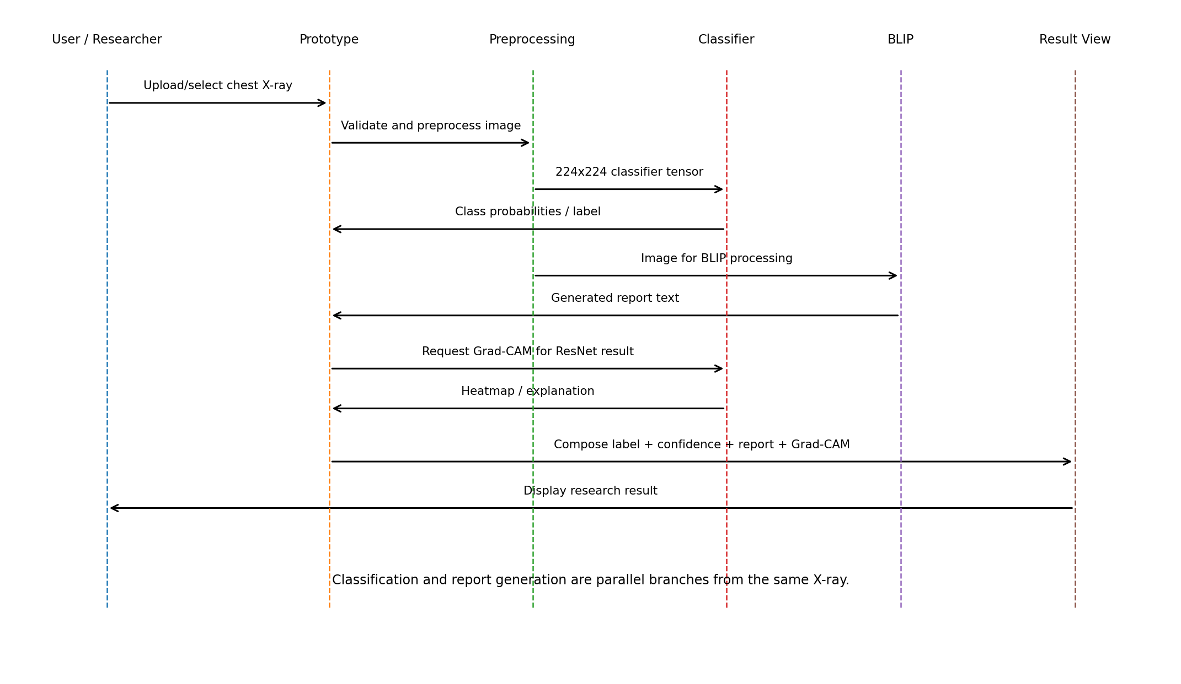

3.4 Architectural Model
The architecture separates the system into a data/input layer, two model branches, an explainability/evaluation layer, and an integrated result view. This separation supports independent experimentation while preserving a single end-to-end demonstration path.
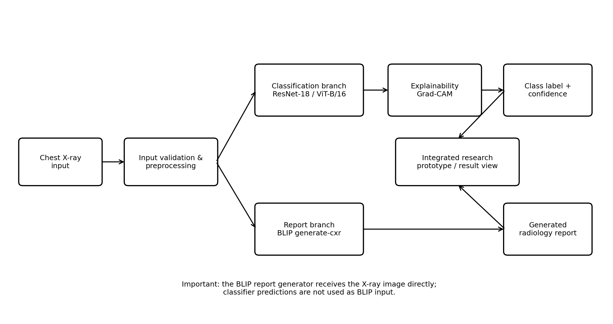
Current data flow: Indiana projection metadata and report metadata are merged on `uid`, filtered to frontal views and selected target labels, and transformed into reproducible experiment splits. The classifier branch uses 224×224 ImageNet-style preprocessing. The BLIP branch uses its own processor and image size; these preprocessing pipelines must not be mixed.

4. High-Level Tasking Plans (20%)
Project management tool: Trello. GitHub is used for source-code and notebook version control. The original project documents identify the team members and overall tasks but do not record a final per-member ownership map. Therefore, the allocation below is a preliminary proposed distribution for this Requirements & Design document and should be confirmed by the team before submission.
Semester | High-Level Task | Responsible Member(s) | Status
Fall 2026 | Dataset preparation, metadata merge, frontal-view filtering, balanced subset checks, reproducible split files | Daulet Kaskenov | In progress / baseline implemented
Fall 2026 | ResNet-18 and ViT-B/16 classification experiments, training/evaluation, Grad-CAM explainability | Daniyar Kshibekov | Baseline implemented; refinement/evaluation ongoing
Fall 2026 | BLIP report-generation baseline and Raw vs Current vs Fine-Tuned comparison notebook | Ayaulym Zhumagul | Baseline available; controlled comparison prepared/in progress
Fall 2026 | Evaluation consolidation, qualitative error review, documentation consistency, Requirements & Design support | Assel Derbissova | Ongoing
Fall 2026 | Integration of classification result, Grad-CAM, generated report, experiment outputs and repository organization | All members (coordination led by Daniyar Kshibekov) | Planned / in progress
Fall 2026 | Literature review and source tracking for medical image classification and report generation | All members | Ongoing
Spring 2027 (tentative) | Improve/fine-tune models, extend evaluation, perform ablations and error analysis | All members | Planned
Spring 2027 (tentative) | Finalize integrated research prototype, testing, limitations analysis, final report and presentation | All members | Planned

4.1 Near-Term Fall 2026 Milestones
• Freeze the documented scope for the Requirements & Design submission: chest X-ray, three controlled classes, parallel classification and report-generation branches.
• Keep the classification experiment and the 3-BLIP report-generation experiment clearly separated because they use different evaluation splits (210/30/60 versus 270/30).
• Complete and record the report-generation comparison results if the prepared fixed notebook has not yet been run to completion.
• Add/confirm classification evaluation beyond raw accuracy where feasible (for example precision, recall, F1 and confusion matrix) and preserve per-case predictions for analysis.
• Document representative failure cases, especially clinically inconsistent generated reports and disagreement between classifier and report generator.
• Assemble a stable integrated demonstration and repository documentation for the end-of-semester review.

5. Conclusion (10%)
By the end of Fall 2026, the team expects to have a reproducible chest X-ray research pipeline and a demonstrable prototype that accepts a chest X-ray and produces two parallel AI outputs: a three-class classification result and a generated radiology report. The classification side should include the ResNet-18 and ViT-B/16 baselines, held-out evaluation, and ResNet Grad-CAM examples. The report-generation side should include the current BLIP baseline and, subject to successful completion of the prepared experiment, a controlled comparison between randomized, pretrained baseline, and fine-tuned BLIP variants on the same held-out Indiana cases.
The end-of-semester result is expected to demonstrate technical feasibility and research findings rather than clinical readiness. The team should be able to show what the models predict, where the classifier appears to focus, how generated reports compare with reference text, and where the system fails or produces inconsistent outputs. These Fall 2026 results will form the foundation for deeper training, ablation studies, extended evaluation, integration, and final reporting in Spring 2027.

