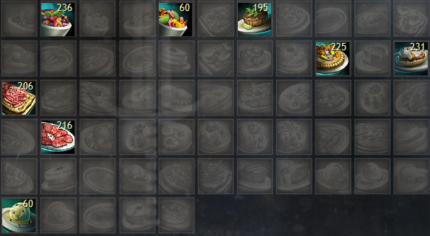

**Peppered Cured Meat Flatbread (Condi DPS for Scourge, Holosmith, Chrono, Soulbeast, Firebrand & Renegade)**

**Spherified Peppercorn-Spiced Oyster Soup (Condi Boon Chrono (Outdated Build))**

**Peppercorn-Spiced Beef Carpaccio (Power Boon)**

**Peppercorn and Veggie Flatbread (Condi DPS for Tempest, Weaver, Mirage, & Berserker)**

**Peppercorn-Spiced Eggs Benedict (Condi Boon)**

**Cilantro Lime Sous-Vide Steak (Power DPS)**

**Bowl of Spiced Fruit Salad (Handkiters)**

**Bowl of Fruit Salad with Mint Garnish (Healers)**