Computer Networks Project
Spring 2026
Roll No: 24I-2082 | Name: Muhammad Subhan
Public IP: 146.137.52.59 | Private IP: 158.16.12.18

1. Network Overview
This project implements a multi-domain enterprise network consisting of four routing domains interconnected via redistribution, simulated in Cisco Packet Tracer Instructor Version.
Routing Domains:
OSPF Area 1 — Routers 0, 1, 2, 3, 5 — Networks A, B, C
EIGRP AS 5 — Routers 5, 8, 9, 10, 11, 12, 13 — Networks D, E, F
OSPF Area 2 — Routers 13, 14, 15, 16, 21 — Networks G, H, I
RIP v2 — Routers 17, 18, 19, 20, 21 — Networks J, K
Redistribution Boundaries:
Router5 : OSPF Area 1 <-> EIGRP AS 5
Router13 : EIGRP AS 5 <-> OSPF Area 2
Router21 : OSPF Area 2 <-> RIP v2
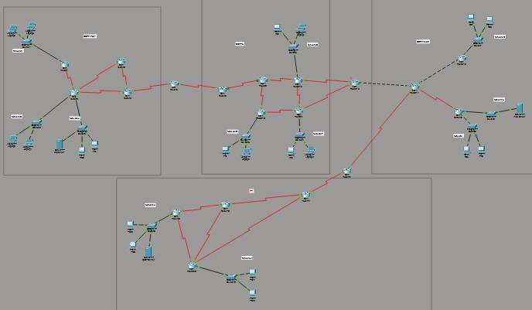

2. VLSM IP Address Plan
VLSM (Variable Length Subnet Masking) was applied to efficiently allocate address space from the pool 146.128.0.0/10. Subnets were assigned largest-first to minimize waste. Network J uses private IP space (158.16.0.0/16) because NAT is implemented on Router20.

2.1 LAN Subnets
Net | Hosts Req. | Subnet | Mask | Usable Range | Broadcast
I | 99,877 | 146.128.0.0/15 | 255.254.0.0 | 146.128.0.1 -  146.129.255.254 | 146.129.255.255
C | 99,001 | 146.130.0.0/15 | 255.254.0.0 | 146.130.0.1 -  146.131.255.254 | 146.131.255.255
F | 77,889 | 146.132.0.0/15 | 255.254.0.0 | 146.132.0.1 -  146.133.255.254 | 146.133.255.255
K | 77,665 | 146.134.0.0/15 | 255.254.0.0 | 146.134.0.1 -  146.135.255.254 | 146.135.255.255
H | 66,554 | 146.136.0.0/15 | 255.254.0.0 | 146.136.0.1 -  146.137.255.254 | 146.137.255.255
B | 55,667 | 146.138.0.0/16 | 255.255.0.0 | 146.138.0.1 -  146.138.255.254 | 146.138.255.255
E | 44,556 | 146.139.0.0/16 | 255.255.0.0 | 146.139.0.1 -  146.139.255.254 | 146.139.255.255
J* | 33,445 | 158.16.0.0/16 | 255.255.0.0 | 158.16.0.1 -  158.16.255.254 | 158.16.255.255
G | 33,221 | 146.141.0.0/16 | 255.255.0.0 | 146.141.0.1 -  146.141.255.254 | 146.141.255.255
D | 22,344 | 146.142.0.0/17 | 255.255.128.0 | 146.142.0.1 -  146.142.127.254 | 146.142.127.255
A | 11,234 | 146.142.128.0/18 | 255.255.192.0 | 146.142.128.1 -  146.142.191.254 | 146.142.191.255
* Network J uses private IP space — NAT configured on Router20 translates to public IP 146.137.52.59

2.2 WAN Links (/30 Subnets — 255.255.255.252)
All point-to-point links use /30 subnets providing exactly 2 usable addresses per link as required by the project.
Link | Network /30 | Router A | IP (A) | Router B | IP (B)
R1-R2 | 146.142.192.0/30 | Router1 S0/0/0 | 146.142.192.1 | Router2 S0/0/0 | 146.142.192.2
R2-R0 | 146.142.192.4/30 | Router2 S0/0/1 | 146.142.192.5 | Router0 S0/0/0 | 146.142.192.6
R0-R3 | 146.142.192.8/30 | Router0 S0/0/1 | 146.142.192.9 | Router3 S0/0/0 | 146.142.192.10
R3-R2 | 146.142.192.12/30 | Router3 S0/0/1 | 146.142.192.13 | Router2 S0/1/0 | 146.142.192.14
R3-R5 | 146.142.192.16/30 | Router3 S0/1/0 | 146.142.192.17 | Router5 S0/0/0 | 146.142.192.18
R5-R8 | 146.142.192.20/30 | Router5 S0/0/1 | 146.142.192.21 | Router8 S0/0/0 | 146.142.192.22
R8-R9 | 146.142.192.24/30 | Router8 S0/0/1 | 146.142.192.25 | Router9 S0/0/0 | 146.142.192.26
R9-R12 | 146.142.192.28/30 | Router9 S0/0/1 | 146.142.192.29 | Router12 S0/0/0 | 146.142.192.30
R12-R11 | 146.142.192.32/30 | Router12 S0/0/1 | 146.142.192.33 | Router11 S0/0/0 | 146.142.192.34
R11-R10 | 146.142.192.36/30 | Router11 S0/0/1 | 146.142.192.37 | Router10 S0/0/0 | 146.142.192.38
R10-R9 | 146.142.192.40/30 | Router10 S0/0/1 | 146.142.192.41 | Router9 S0/1/0 | 146.142.192.42
R12-R13 | 146.142.192.44/30 | Router12 S0/1/0 | 146.142.192.45 | Router13 S0/0/0 | 146.142.192.46
R11-R13 | 146.142.192.48/30 | Router11 S0/1/0 | 146.142.192.49 | Router13 S0/0/1 | 146.142.192.50
R13-R14 | 146.142.192.52/30 | Router13 Fa0/0 | 146.142.192.53 | Router14 Fa0/0 | 146.142.192.54
R14-R15 | 146.142.192.56/30 | Router14 Fa0/1 | 146.142.192.57 | Router15 Fa0/0 | 146.142.192.58
R14-R16 | 146.142.192.60/30 | Router14 S0/0/0 | 146.142.192.61 | Router16 S0/0/0 | 146.142.192.62
R14-R21 | 146.142.192.64/30 | Router14 S0/0/1 | 146.142.192.65 | Router21 S0/0/0 | 146.142.192.66
R21-R17 | 146.142.192.68/30 | Router21 S0/0/1 | 146.142.192.69 | Router17 S0/0/0 | 146.142.192.70
R17-R18 | 146.142.192.72/30 | Router17 S0/0/1 | 146.142.192.73 | Router18 S0/0/0 | 146.142.192.74
R18-R19 | 146.142.192.76/30 | Router18 S0/0/1 | 146.142.192.77 | Router19 S0/0/0 | 146.142.192.78
R19-R20 | 146.142.192.80/30 | Router19 S0/0/1 | 146.142.192.81 | Router20 S0/0/0 | 146.142.192.82
R20-R18 | 146.142.192.84/30 | Router20 S0/0/1 | 146.142.192.85 | Router18 S0/1/0 | 146.142.192.86
R20-R17 | 146.142.192.88/30 | Router20 S0/1/0 | 146.142.192.89 | Router17 S0/1/0 | 146.142.192.90

3. OSPF Area 1 — Configuration & Verification
OSPF Area 1 consists of Routers 0, 1, 2, 3, and 5. Networks A (146.142.128.0/18), B (146.138.0.0/16), and C (146.130.0.0/15) are in this domain. Router5 is the redistribution boundary with EIGRP AS 5.

3.1 OSPF Neighbor Relationships — Router2
Router2 is the most connected router in OSPF Area 1 with 3 neighbors: Router0, Router1, and Router3. All adjacencies are in FULL state confirming successful OSPF operation.
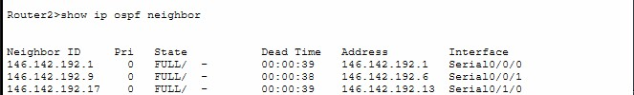
3.2
OSPF Routing Table — Router
1
Router1 routing table showing OSPF learned routes from the rest of Area 1.
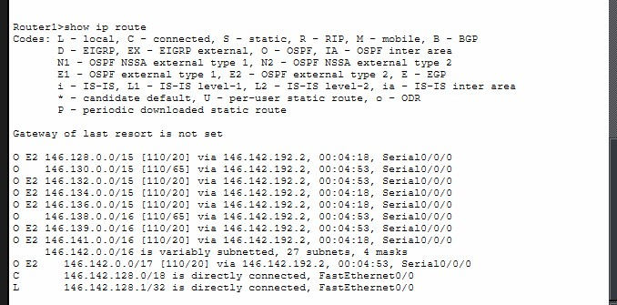

4. EIGRP AS 5 — Configuration & Verification
EIGRP Autonomous System 5 consists of Routers 5, 8, 9, 10, 11, 12, and 13. Networks D (146.142.0.0/17), E
(146.139.0.0/16), and F (146.132.0.0/15) are in this domain.

4.1 EIGRP Neighbor Relationships — Router9
Router9 has 3 EIGRP neighbors (Router8, Router12, Router10), making it the most connected router in the EIGRP domain. All neighbors showing active Hold timers confirming stable adjacencies.
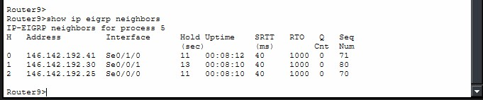

4.2 EIGRP Routing Table — Router9
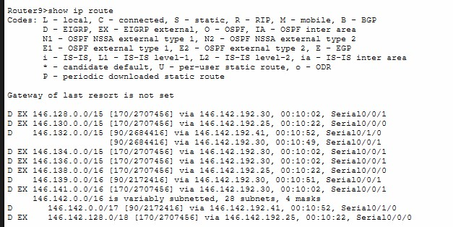

5. OSPF Area 2 — Configuration & Verification
OSPF Area 2 consists of Routers 13, 14, 15, 16, and 21. Networks G (146.141.0.0/16), H (146.136.0.0/15), and I (146.128.0.0/15) are in this domain.

5.1 OSPF Area 2 Neighbor Relationships — Router14
Router14 is the hub of OSPF Area 2, connecting to Router13, Router15, Router16, and Router21. All adjacencies confirmed FULL.
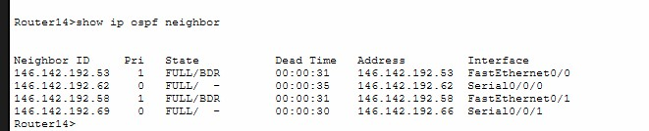

5.2 Router13 — Redistribution Boundary (EIGRP <-> OSPF Area 2)
Router13 maintains both EIGRP neighbors (Router11 and Router12) and an OSPF neighbor (Router14), confirming active redistribution between both domains.
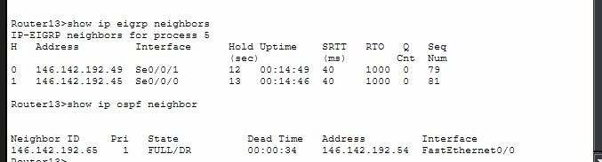

6. RIP v2 — Configuration & Verification
RIP version 2 domain consists of Routers 17, 18, 19, 20, and 21. Networks J (158.16.0.0/16 private) and K (146.134.0.0/15) are in this domain.

6.1 RIP Database — Router19
Router19 RIP database showing all 11 LAN networks and all WAN subnets learned via RIP and redistribution from OSPF/EIGRP domains. Both serial paths are visible confirming redundancy.
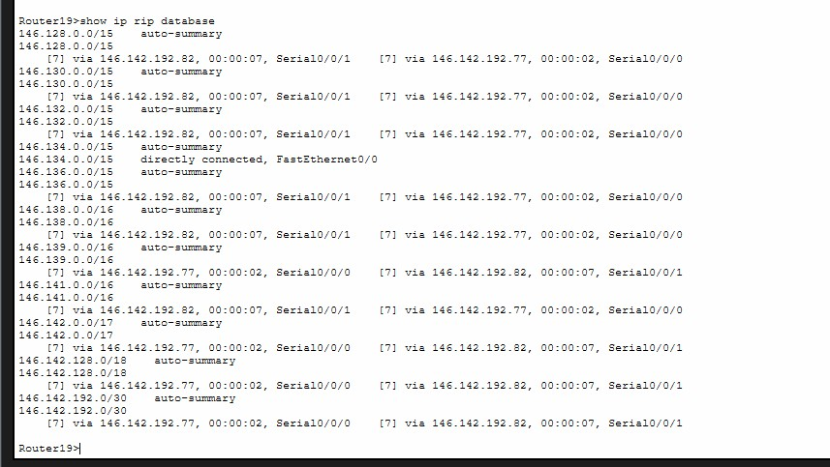
Note on Network J (158.16.0.0/16) RIP Advertisement:
Network J uses a private IP address space (158.16.0.0/16) which belongs to a different Class B range than the rest of the network (146.x.x.x). Due to a known display limitation in Cisco Packet Tracer, this network does not appear in the standard show ip route summary output even though it is correctly configured and actively being advertised.
To verify the route, show ip route 158.16.0.0 was used on both Router20 and Router19.
This verifies that Network J is fully reachable within the RIP domain and NAT translation on Router20 will correctly handle traffic from this private network to the public IP 146.137.52.59.
Router20#show ip route 158.16.0.0
Routing entry for 158.16.0.0/16, 2 known subnets
Attached (2 connections)
Variably subnetted with 2 masks
C 158.16.0.0/16 is directly connected, FastEthernet0/0
158.16.0.1/32 is directly connected, FastEthernet0/0
Router19>show ip route 158.16.0.0
Routing entry for 158.16.0.0/16
Known via "rip", distance 120, metric 1
Redistributing via rip
Last update from 146.142.192.82 on Serial0/0/1, 00:02:10 ago Routing Descriptor Blocks:
* 146.142.192.82, from 146.142.192.82, 00:02:10 ago, via Serial0/0/1 Route metric is 1, traffic share count is 1

7. Route Redistribution Verification
Redistribution allows routes from one routing protocol to be shared with another. All three redistribution boundaries are verified below.

7.1 Router5 — OSPF Area 1 <-> EIGRP
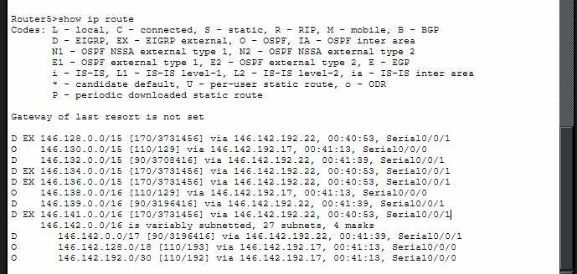

7.2 Router13 — EIGRP <-> OSPF Area 2
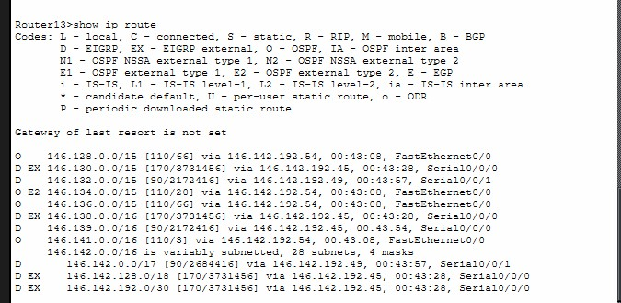

7.3 Router21 — OSPF Area 2 <-> RIP
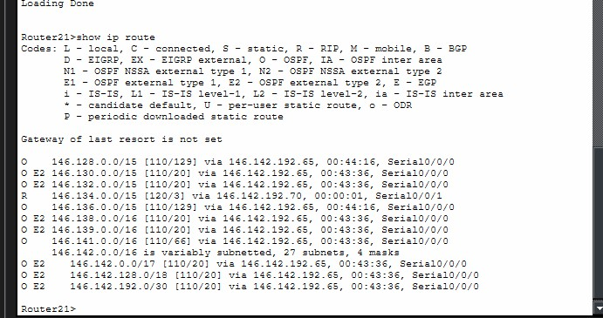

8. DHCP Configuration & Verification
A centralized DHCP server at 146.134.0.2 (Network K) provides dynamic IPs to hosts in OSPF Area 1, EIGRP, and RIP domains. The ip helper-address command was configured on each LAN-facing router interface. OSPF Area 2 hosts use static IPs.
DHCP-enabled networks: A, B, C (OSPF Area 1) | D, E, F (EIGRP) | J, K (RIP)
Static IP networks: G, H, I (OSPF Area 2) and all servers

8.1 DHCP Server Pool Configuration
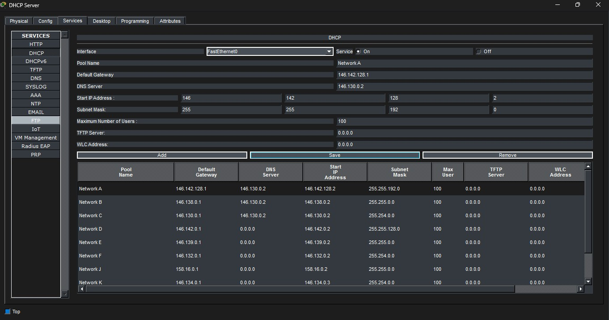

8.2 DHCP Verification — Network A (Laptop2, OSPF Area 1)
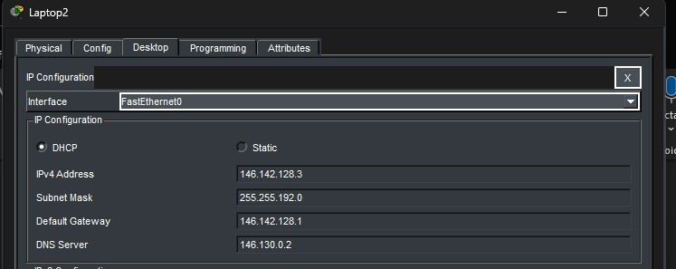

8.3 DHCP Verification — Network D (PC4, EIGRP)
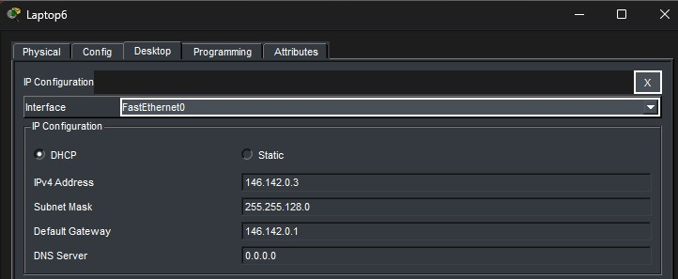

8.4 DHCP Verification — Network J (PC11, RIP / Private)
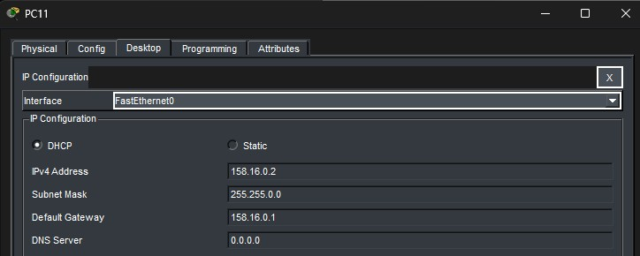
9
. Static IP Configuration

9.1 Servers
Device | IP Address | Subnet Mask | Gateway
DHCP Server (Net K) | 146.134.0.2 | 255.254.0.0 | 146.134.0.1
Web Server (Net H) | 146.136.0.2 | 255.254.0.0 | 146.136.0.1
Mail Server (Net C) | 146.130.0.2 | 255.254.0.0 | 146.130.0.1

9.2 OSPF Area 2 Hosts (Networks G and I)
Device | IP Address | Subnet Mask | Gateway
PC5 (Net I) | 146.128.0.2 | 255.254.0.0 | 146.128.0.1
PC6 (Net I) | 146.128.0.3 | 255.254.0.0 | 146.128.0.1
PC7 (Net G) | 146.141.0.2 | 255.255.0.0 | 146.141.0.1
PC8 (Net G) | 146.141.0.3 | 255.255.0.0 | 146.141.0.1

10. End-to-End Connectivity Verification
Cross-domain pings confirm full connectivity across all four routing domains.

10.1 Laptop0 (OSPF Area 1) -> DHCP Server (RIP)
Pinging from Laptop0 in Network B to DHCP Server at 146.134.0.2 in Network K, crossing OSPF Area 1 -> EIGRP -> OSPF Area 2 -> RIP.
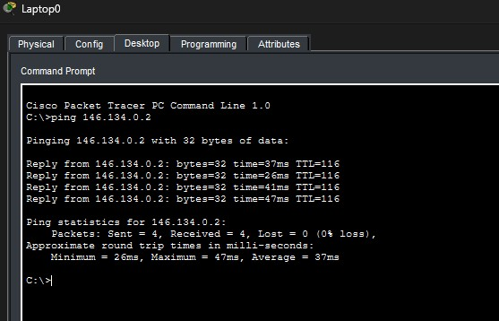

10.2 PC7 (OSPF Area 2) -> Router1 Gateway (OSPF Area 1)
Pinging from PC7 in Network G to Router1's gateway 146.142.128.1, crossing OSPF Area 2 -> EIGRP -> OSPF Area 1.
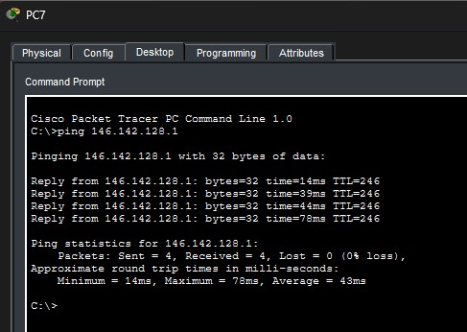

11. NAT Configuration & Verification
NAT is configured on Router20 to translate private Network J addresses (158.16.0.0/16) to the assigned public IP 146.137.52.59.
Inside interface : FastEthernet0/0 — facing Network J (private)
Outside interfaces: Serial0/0/0, Serial0/0/1, Serial0/1/0 — facing public network
Translation : 158.16.x.x -> 146.137.52.59
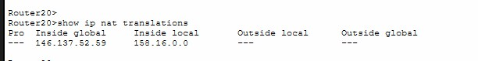
11.1
NAT Translation Table

12. Access Control List (ACL) Verification
Two ACL rules restrict access to the Web Server (146.136.0.2) as required by the project.
Rule 1: Laptop3 (146.142.128.3) in Network A is blocked from Web Server — ACL BLOCK_A on Router1 Fa0/0 inbound.
Rule 2: All hosts in Network D (146.142.0.0/17) are blocked from Web Server — ACL BLOCK_D on Router10 Fa0/0 inbound.

12.1 Laptop2 Blocked — Laptop3 Allowed (Network A)
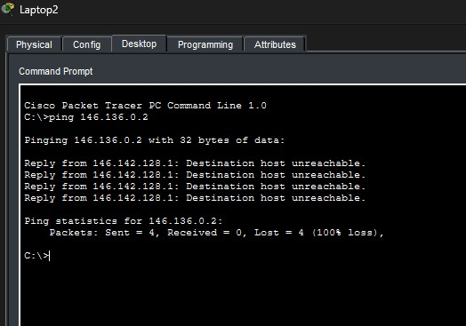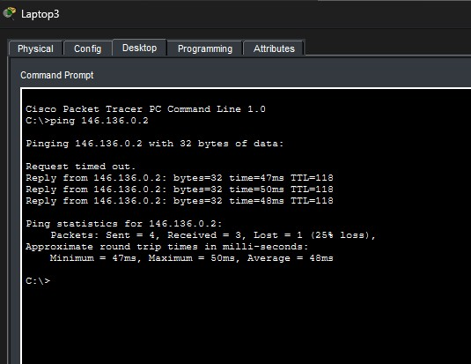

12.2 Network D Fully Blocked
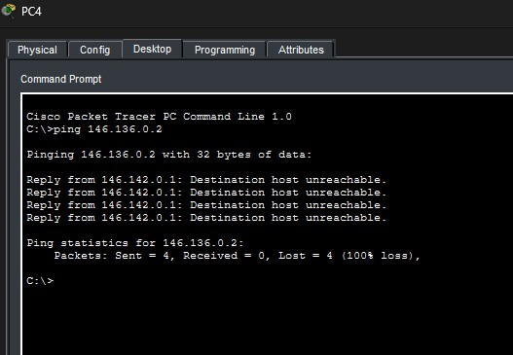

13. Email Configuration & Verification
Mail Server configured at 146.130.0.2 with domain mail.com. DNS service enabled on the Mail Server resolving mail.com to 146.130.0.2. All hosts in OSPF Area 1 (Networks A, B, C) have email accounts configured.
Accounts: laptop0@mail.com, laptop1@mail.com, laptop2@mail.com, laptop3@mail.com, pc0@mail.com, pc1@mail.com

13.1 Mail Server — EMAIL and DNS Services
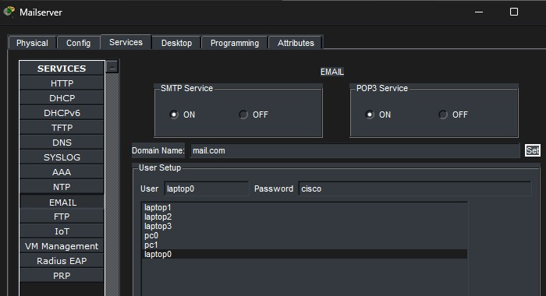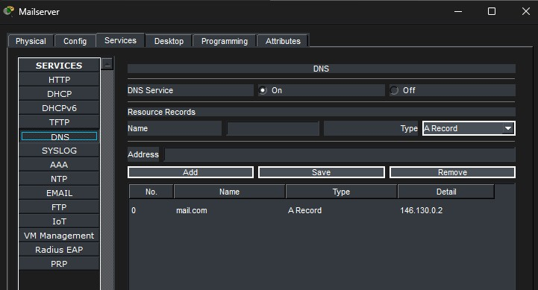

13.2 Email Send and Receive Test
Laptop1 sends an email to Laptop3. Laptop3 clicks Receive and the email appears in inbox, confirming end-toend email functionality
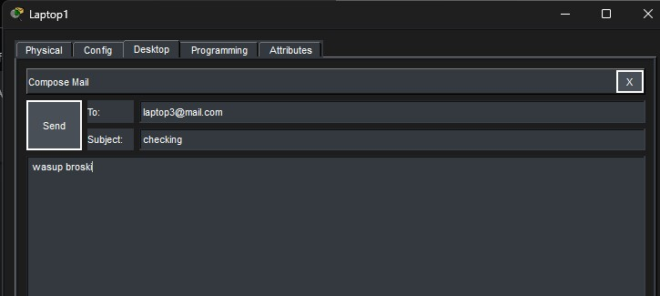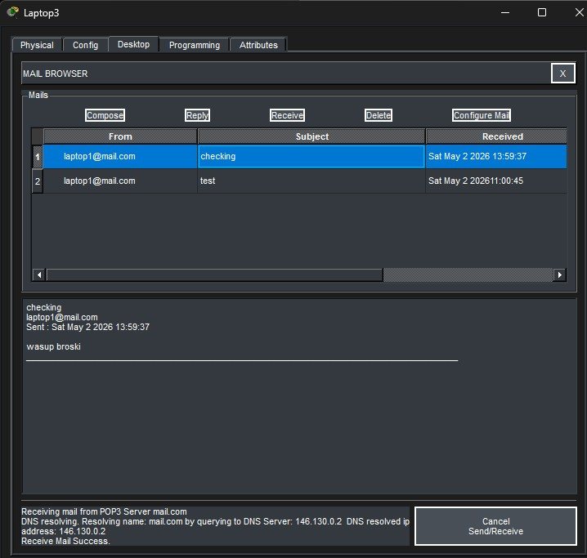

14. Network Links Summary
All 57 physical connections in the network are active and showing Green status.

# | Type | From Port | Status | To Port | Status
1 | Straight-Through | Switch1:FastEthernet0/1 | Green | Laptop2:FastEthernet0 | Green
2 | Straight-Through | Switch1:FastEthernet0/2 | Green | Laptop3:FastEthernet0 | Green
3 | Straight-Through | Switch0:FastEthernet0/1 | Green | Laptop0:FastEthernet0 | Green
4 | Straight-Through | Switch0:FastEthernet0/2 | Green | Laptop1:FastEthernet0 | Green
5 | Straight-Through | Switch2:FastEthernet0/1 | Green | Mailserver:FastEthernet0 | Green
6 | Straight-Through | Switch2:FastEthernet0/2 | Green | PC0:FastEthernet0 | Green
7 | Straight-Through | Switch2:FastEthernet0/3 | Green | PC1:FastEthernet0 | Green
8 | Straight-Through | Switch5:FastEthernet0/1 | Green | PC4:FastEthernet0 | Green
9 | Straight-Through | Switch5:FastEthernet1/1 | Green | Laptop6:FastEthernet0 | Green
10 | Straight-Through | Switch4:FastEthernet0/1 | Green | PC3:FastEthernet0 | Green
11 | Straight-Through | Switch4:FastEthernet0/2 | Green | Laptop5:FastEthernet0 | Green
12 | Straight-Through | Switch3:FastEthernet0/1 | Green | Laptop4:FastEthernet0 | Green
13 | Straight-Through | Switch3:FastEthernet0/2 | Green | PC2:FastEthernet0 | Green
14 | Straight-Through | Switch6:FastEthernet0/1 | Green | PC5:FastEthernet0 | Green
15 | Straight-Through | Switch6:FastEthernet0/2 | Green | PC6:FastEthernet0 | Green
16 | Straight-Through | Switch8:FastEthernet0/1 | Green | Web Server:FastEthernet0 | Green
17 | Straight-Through | Switch7:FastEthernet0/1 | Green | PC7:FastEthernet0 | Green
18 | Straight-Through | Switch7:FastEthernet0/2 | Green | PC8:FastEthernet0 | Green
19 | Straight-Through | Switch10:FastEthernet0/1 | Green | PC11:FastEthernet0 | Green
20 | Straight-Through | Switch10:FastEthernet0/2 | Green | PC12:FastEthernet0 | Green
21 | Straight-Through | Switch9:FastEthernet0/1 | Green | DHCP Server:FastEthernet0 | Green
22 | Straight-Through | Switch9:FastEthernet0/2 | Green | PC9:FastEthernet0 | Green
23 | Straight-Through | Switch9:FastEthernet0/3 | Green | PC10:FastEthernet0 | Green
24 | Straight-Through | Switch1:FastEthernet0/3 | Green | Router1:FastEthernet0/0 | Green
25 | Straight-Through | Switch0:FastEthernet0/3 | Green | Router2:FastEthernet0/0 | Green
26 | Straight-Through | Switch2:FastEthernet0/4 | Green | Router2:FastEthernet0/1 | Green
27 | Straight-Through | Switch5:FastEthernet2/1 | Green | Router10:FastEthernet0/0 | Green
28 | Straight-Through | Switch4:FastEthernet0/3 | Green | Router11:FastEthernet0/0 | Green
29 | Straight-Through | Switch3:FastEthernet0/3 | Green | Router12:FastEthernet0/0 | Green
30 | Cross-Over | Router14:FastEthernet0/1 | Green | Router15:FastEthernet0/0 | Green
31 | Cross-Over | Router13:FastEthernet0/0 | Green | Router14:FastEthernet0/0 | Green
32 | Straight-Through | Router15:FastEthernet0/1 | Green | Switch7:FastEthernet0/3 | Green
33 | Straight-Through | Router16:FastEthernet0/0 | Green | Switch8:FastEthernet0/2 | Green
34 | Straight-Through | Router16:FastEthernet0/1 | Green | Switch6:FastEthernet0/3 | Green
35 | Straight-Through | Router20:FastEthernet0/0 | Green | Switch10:FastEthernet0/3 | Green
36 | Straight-Through | Switch9:FastEthernet0/4 | Green | Router19:FastEthernet0/0 | Green
37 | Serial (DCE: | Router1:Serial0/0/0 | Green | Router2:Serial0/0/0 | Green

 | Router1)
38 | Serial (DCE: Router2) | Router2:Serial0/0/1 | Green | Router0:Serial0/0/0 | Green
39 | Serial (DCE: Router0) | Router0:Serial0/0/1 | Green | Router3:Serial0/0/0 | Green
40 | Serial (DCE: Router3) | Router3:Serial0/0/1 | Green | Router2:Serial0/1/0 | Green
41 | Serial (DCE: Router3) | Router3:Serial0/1/0 | Green | Router5:Serial0/0/0 | Green
42 | Serial (DCE: Router5) | Router5:Serial0/0/1 | Green | Router8:Serial0/0/0 | Green
43 | Serial (DCE: Router8) | Router8:Serial0/0/1 | Green | Router9:Serial0/0/0 | Green
44 | Serial (DCE: Router9) | Router9:Serial0/0/1 | Green | Router12:Serial0/0/0 | Green
45 | Serial (DCE: Router12) | Router12:Serial0/0/1 | Green | Router11:Serial0/0/0 | Green
46 | Serial (DCE: Router11) | Router11:Serial0/0/1 | Green | Router10:Serial0/0/0 | Green
47 | Serial (DCE: Router10) | Router10:Serial0/0/1 | Green | Router9:Serial0/1/0 | Green
48 | Serial (DCE: Router12) | Router12:Serial0/1/0 | Green | Router13:Serial0/0/0 | Green
49 | Serial (DCE: Router11) | Router11:Serial0/1/0 | Green | Router13:Serial0/0/1 | Green
50 | Serial (DCE: Router14) | Router14:Serial0/0/0 | Green | Router16:Serial0/0/0 | Green
51 | Serial (DCE: Router14) | Router14:Serial0/0/1 | Green | Router21:Serial0/0/0 | Green
52 | Serial (DCE: Router21) | Router21:Serial0/0/1 | Green | Router17:Serial0/0/0 | Green
53 | Serial (DCE: Router17) | Router17:Serial0/0/1 | Green | Router18:Serial0/0/0 | Green
54 | Serial (DCE: Router18) | Router18:Serial0/0/1 | Green | Router19:Serial0/0/0 | Green
55 | Serial (DCE: Router19) | Router19:Serial0/0/1 | Green | Router20:Serial0/0/0 | Green
56 | Serial (DCE: Router20) | Router20:Serial0/0/1 | Green | Router18:Serial0/1/0 | Green
57 | Serial (DCE: Router20) | Router20:Serial0/1/0 | Green | Router17:Serial0/1/0 | Green

