|  |  |  |
| --- | --- | --- |
| **S.No** | **Title** | **Page** |
| 1 | INTRODUCTION | 2 |
|  | 1.1 ORGANIZATION PROFILE |  |
| 2 | SYSTEM ANALYSIS | 2 |
|  | 2.1 PROPOSED SYSTEM |  |
| 3 | DEVELOPMENT ENVIRONMENT | 3 |
|  | 3.1 HARDWARE ENVIRONMENT |  |
|  | 3.2 SOFTWARE ENVIRONMENT |  |
|  | 3.3 ABOUT THE SOFTWARE |  |
|  | 3.4 BENEFITS OF THE SOFTWARE |  |
|  | 3.5. PACKAGES INCLUDED IN THIS PROJECT |  |
|  | 3.6 HTTP FRAMEWORK |  |
| 4 | SYSTEM DESIGN | 12 |
|  | 4.1 INPUT/OUTPUT DESIGN |  |
|  | 4.2 DATA DICTIONARY |  |
| 5 | SYSTEM IMPLEMENTATION | 18 |
|  | 5.1 SOFTWARE DESCRIPTION |  |
|  | 5.2 SCREENSHOTS |  |
| 6 | CONCLUSION | 20 |

**CHAPTER 1**

**INTRODUCTION**

**1.1 ORGANIZATION PROFILE:**

4D Global was founded to help our clients, Medical Billing Companies to easily scale their business and increase profitability.

The key to our success is applying our medical billing expertise with the mission to exceed expectations in delivery, performance and accuracy.

We are an analytical driven, technology enabled Data Entry, Coding and Revenue Cycle Management company providing medical billing services to Medical Billing Companies across the U.S. We currently have offices in New York, Arizona, Chennai, Bangalore & Kerala India.

**CHAPTER 2**

**SYSTEM ANALYSIS**

**2.1 PROPOSED SYSTEM**

The Proposed system is a web package done in PHP Language with operating system AWS. This system is extendable. This system is done with the user interaction. Commands can be changed by the user.

**The proposed system having the following merits**

* High Speed
* in-build database
* Getting faster of accurate information severely
* Users can interact with the program.
* The system and data are highly secured
* It produces efficient report to the user
* Output can be of the form png or jpeg

**CHAPTER 3**

**DEVELOPMENT ENVIRONMENT**

* 1. **HARDWARE ENVIRONMENT**

|  |  |
| --- | --- |
| Hard Disk | 250GB |
| RAM | 2 GB |
| Processor | Intel Pentium(R) Dual-Core E5400 @ 2.70GHz |
| Ethernet Controller | Intel® 82573L Gigabit *Ethernet Controller* |

* 1. **SOFTWARE ENVIRONMENT**

|  |  |
| --- | --- |
| Operating System | AWS |
| Language | PHP |
| Framework | CodeIgniter, Laravel |
| DataBase | MySQL |
| Editor | Atom, Sublime |

* 1. **ABOUT THE SOFTWARE**

**PHP:**

The PHP Hypertext Preprocessor (PHP) is a programming language that allows web developers to create dynamic content that interacts with databases. PHP is basically used for developing web based software applications. This tutorial helps you to build your base with PHP.

## Why to Learn PHP?

PHP started out as a small open source project that evolved as more and more people found out how useful it was. Rasmus Lerdorf unleashed the first version of PHP way back in 1994.

PHP is a MUST for students and working professionals to become a great Software Engineer specially when they are working in Web Development Domain. I will list down some of the key advantages of learning PHP:

* PHP is a recursive acronym for "PHP: Hypertext Preprocessor".
* PHP is a server side scripting language that is embedded in HTML. It is used to manage dynamic content, databases, session tracking, even build entire e-commerce sites.
* It is integrated with a number of popular databases, including MySQL, PostgreSQL, Oracle, Sybase, Informix, and Microsoft SQL Server.
* PHP is pleasingly zippy in its execution, especially when compiled as an Apache module on the Unix side. The MySQL server, once started, executes even very complex queries with huge result sets in record-setting time.
* PHP supports a large number of major protocols such as POP3, IMAP, and LDAP. PHP4 added support for Java and distributed object architectures (COM and CORBA), making n-tier development a possibility for the first time.
* PHP is forgiving: PHP language tries to be as forgiving as possible.
* PHP Syntax is C-Like.

## 

## 

## Characteristics of PHP

Five important characteristics make PHP's practical nature possible −

* Simplicity
* Efficiency
* Security
* Flexibility
* Familiarity

**MySQL Server:**

MySQL, the most popular Open Source SQL database management system, is developed, distributed, and supported by Oracle Corporation. It enables cost-effective delivery of reliable, high-performance and scalable Web-based and embedded database applications. It is the de-facto standard database system for web sites with HUGE volumes of both data and end-users (like Facebook, Twitter, and Wikipedia).Another great thing about MySQL is that it can be scaled down to support embedded database applications.

**Text Editor:**

1. **atom**

Atom is a free and open-source text and source code editor for macOS, Linux, and Microsoft Windows with support for plug-ins written in Node.js, and embedded Git Control, developed by GitHub. Atom is a desktop application built using web technologies.

* 1. **BENEFITS OF THE SOFTWARE** 
     + Handling routine **HR** tasks.
     + Monitors KPIs. Duration in the position. Employee retention. ...
     + Manages employees efficiently. Time & attendance management. ...
     + Improves employee self-service.
     + Is cost-effective.
     + Eliminates human error.
     + Offers privacy and data security.

**3.5. PACKAGES INCLUDED IN MY PROJECT:**

**JSON** Serializing and transmitting structured data over network connection

**CSV**  Inserting the csv clients data directly into database

**HTTP**  http provides HTTP client and server implementations.

**OS**  os provides a platform-independent interface to operating

system functionality.

**URL** Parses and implements query escaping.

**STRINGS** strings implements simple functions to manipulate strings.

**MySQL** is a relational database management system based on **SQL**.

**DATE** taking the current date using php function

**BASE_URL** getting the current project url using this php function

**SESSION** used to store users information across multiple pages.

**COOKIES** are text files stored on the client computer used for tracking purposes.

**3.6 HTTP FRAMEWORK**

**CodeIgniter:**

CodeIgniter is an application development framework, which can be used to develop websites, using PHP. It is an Open Source framework. It has a very rich set of functionality, which will increase the speed of website development work.

If you know PHP well, then CodeIgniter will make your task easier. It has a very rich set of libraries and helpers. By using CodeIgniter, you will save a lot of time, if you are developing a website from scratch. Not only that, a website built in CodeIgniter is secure too, as it has the ability to prevent various attacks that take place through websites.

**CodeIgniter Features:**

Some of the important features of CodeIgniter are listed below −

* Model-View-Controller Based System
* Extremely Light Weight
* Full Featured database classes with support for several platforms.
* Query Builder Database Support
* Form and Data Validation
* Security and XSS Filtering
* Session Management
* Email Sending Class. Supports Attachments, HTML/Text email, multiple protocols (send mail, SMTP, and Mail) and more.
* Image Manipulation Library (cropping, resizing, rotating, etc.). Supports GD, ImageMagick, and NetPBM
* File Uploading Class
* FTP Class
* Localization
* Pagination
* Data Encryption
* Benchmarking
* Full Page Caching
* Error Logging
* Application Profiling
* Calendaring Class
  + User Agent Class
  + Zip Encoding Class
    - Template Engine Class
    - Trackback Class
    - XML-RPC Library
    - Unit Testing Class
    - Search-engine Friendly URLs
    - Flexible URI Routing
    - Support for Hooks and Class Extensions
    - Large library of “helper” functions

**CodeIgniter Architecture :**

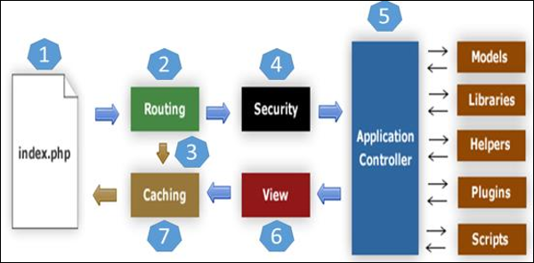

* As shown in the figure, whenever a request comes to CodeIgniter, it will first go to index.php page.
* In the second step, Routing will decide whether to pass this request to step-3 for caching or to pass this request to step-4 for security check.
* If the requested page is already in Caching, then Routing will pass the request to step-3 and the response will go back to the user.
* If the requested page does not exist in Caching, then Routing will pass the requested page to step-4 for Security checks.
* Before passing the request to the Application Controller, the Security of the submitted data is checked. After the Security check, the Application Controller loads necessary Models, Libraries, Helpers, Plugins and Scripts and passes it on to View.
* The View will render the page with available data and pass it on for Caching. As the requested page was not cached before so this time it will be cached in Caching, to process this page quickly for future requests.

**Codeigniter Installation :**

**Step 1:**

Go to codeigniter official website: <https://codeigniter.com/download>

**Step 2:**

Download CI stable version 3 and unzip then move into xampp/htdocs directory

**Step 3:**

Go to browser and run particular file like http://192.168.2.193/4dgenie

**Codeigniter File System:**

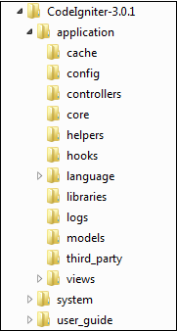

CodeIgniter directory structure is divided into 3 folders −

**Application**

**System**

**User_guide**

**Application**

The Application folder contains several other folders

**Cache −** This folder contains all the cached pages of your application. These cached pages will increase the overall speed of accessing the pages.

**Config −** This folder contains various files to configure the application. With the help of config.php file, users can configure the application. Using database.php file, users can configure the database of the application.

**Controllers −** This folder holds the controllers of your application. It is the basic part of your application.

**Core −** This folder will contain the base class of your application.

**Helpers −** In this folder, you can put a helper class of your application.

**Hooks −** The files in this folder provide a means to tap into and modify the inner workings of the framework without hacking the core files.

**Language −** This folder contains language related files.

**Libraries −** This folder contains files of the libraries developed for your application.

**Logs −** This folder contains files related to the log of the system.

**Models −** The database login will be placed in this folder.

**Third_party −** In this folder, you can place any plugins, which will be used for your application.

**Views −** Application’s HTML files will be placed in this folder.

**SYSTEM DESIGN**

**4.1 INPUT DESIGN**

Based on user role we segregate input design like agent have access to add the data and they can view their own details, supervisor/management have access to work on concern agent module details along with update and delete option

**4.2 OUTPUT DESIGN - Excel**

In the output design we can export or download the HRMS report based on date and status base filter in the excel and PDF format.

**4.3 DATA DICTIONARY**

**4D GLOBAL DATABASES**

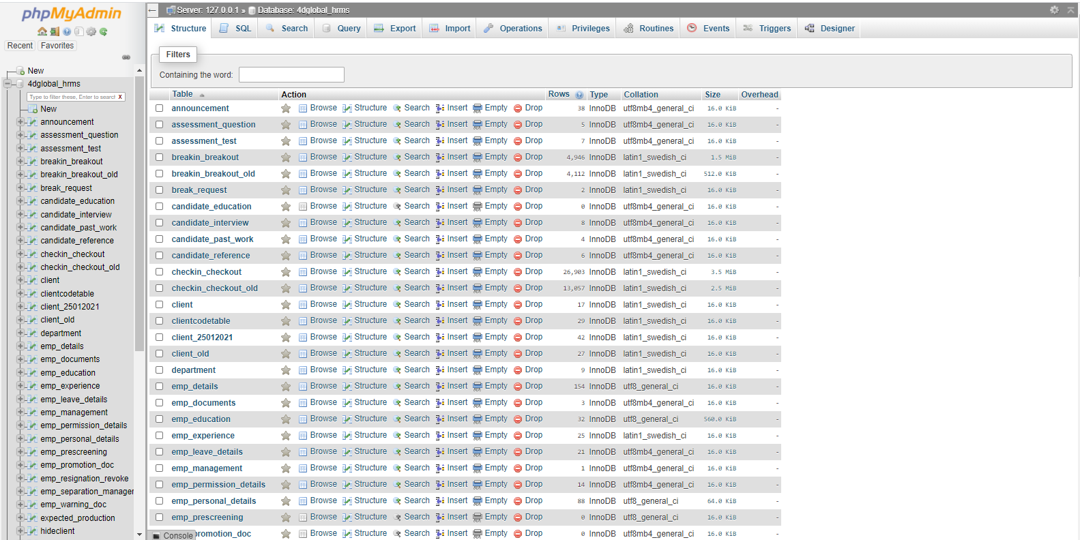

**CLIENT TABLE**

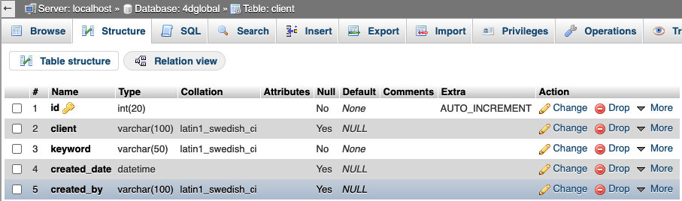

**DEPARTMENT TABLE**

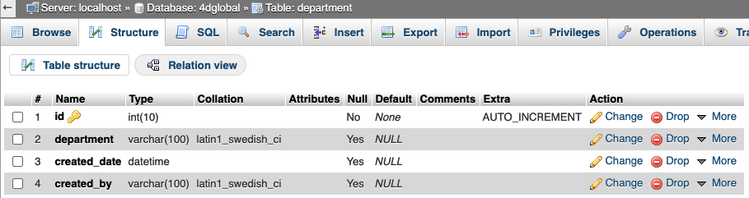

**4.4 FLOW CHART FOR SERVER-CLIENT COMMUNICATION**

**Establishing Connection:**

**Connection Request**

**Validate Date**

**Server**

**Client**

**NO**

**YES**

**Connection Established**

**Connection Refused**

**CHAPTER 5**

**SYSTEM IMPLEMENTATION**

**5.1 SOFTWARE DESCRIPTION**

There are 14 module are available in HRMS software, below we can see the entire module along with is screenshot.

* **Dashboard:**

Dashboard is a landing page of HRMS software; here users can register attendance and also register break timing using Check-in, Check-out and Break-in, Break-out tools

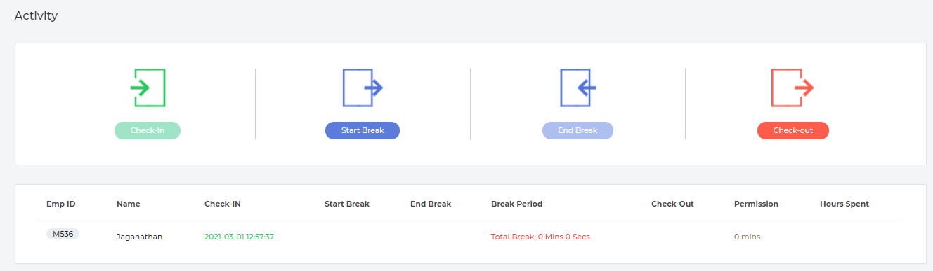

* **Registration or Setup**

There are 7 sub modules are available under the ‘Registration or Setup’ module.

1. **Employee Information**

Using Employee Information sub module to maintain agent personal details, education, work experience and other medical billing work experience details

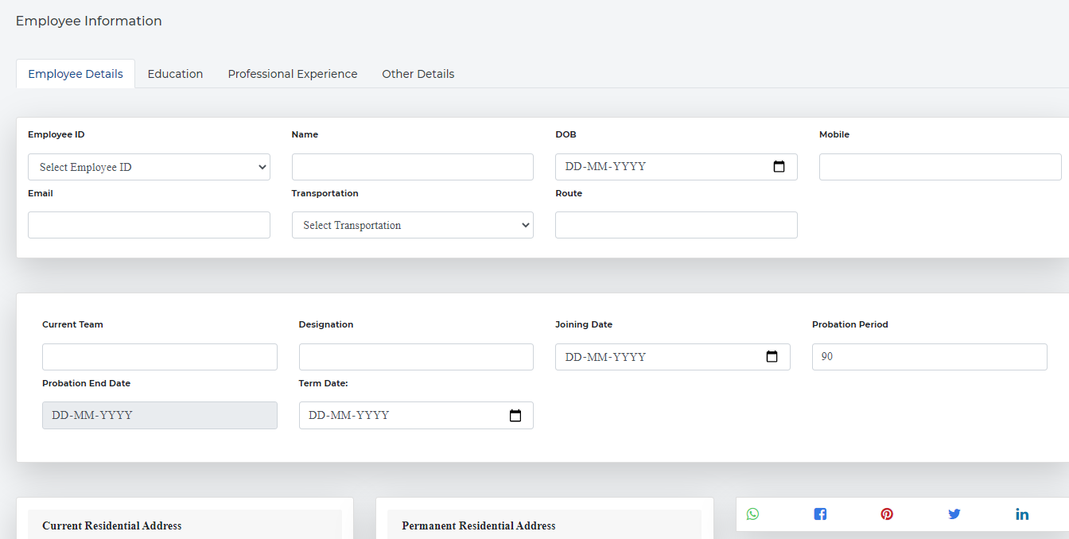

1. **Department**

Department module just a maintaining a department list and supervisor have access to add and delete department name

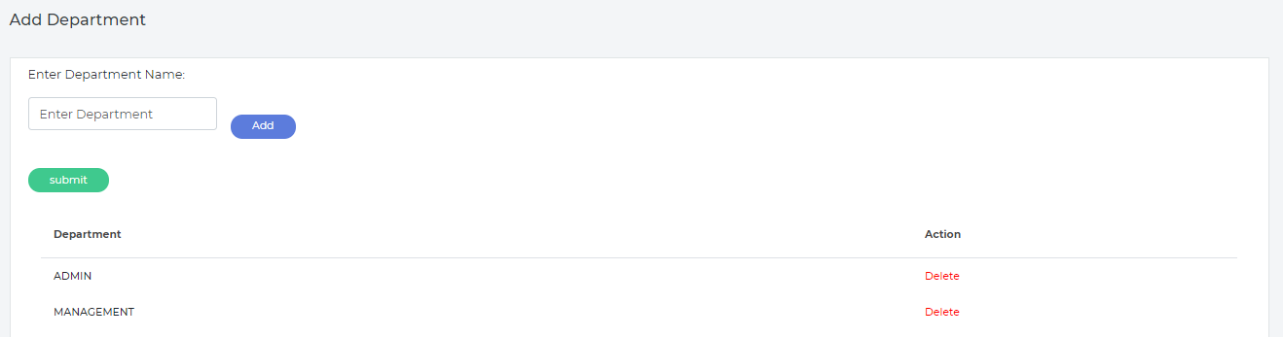

1. **Client**

Client module it’s just adding, deactivates, update or delete particular client in HRMS project. Once client as deactivated then we can’t map particular client into HRMS/CRM project.

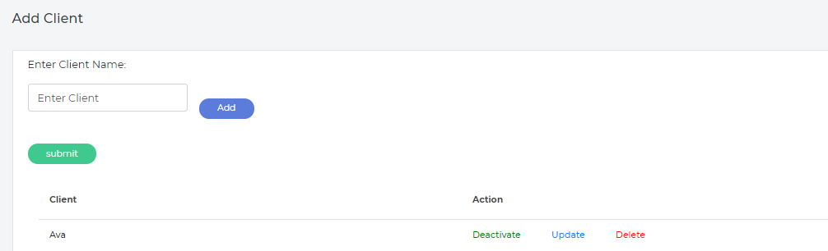

1. **Agent List**

One of the major sub modules in HRMS is agent list module. Here HR/Management has access to add a new agent, update or deactivate particular agent in HRMS.

HRMS agents have access to the production tool CRM based on assigned client

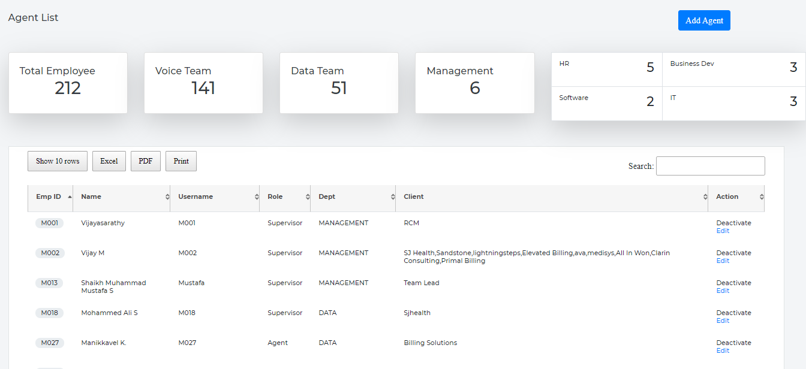

1. **Reset Agent Password**

This sub module helps us to reset particular agent password who are all mapping with particular supervisor/Manager

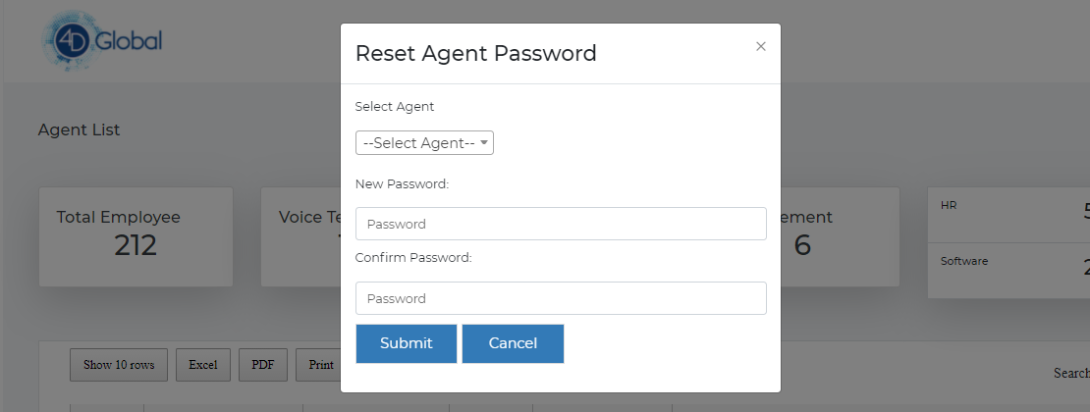

1. **Team Mapping**

Team mapping just a mapping each and every agent reporting person

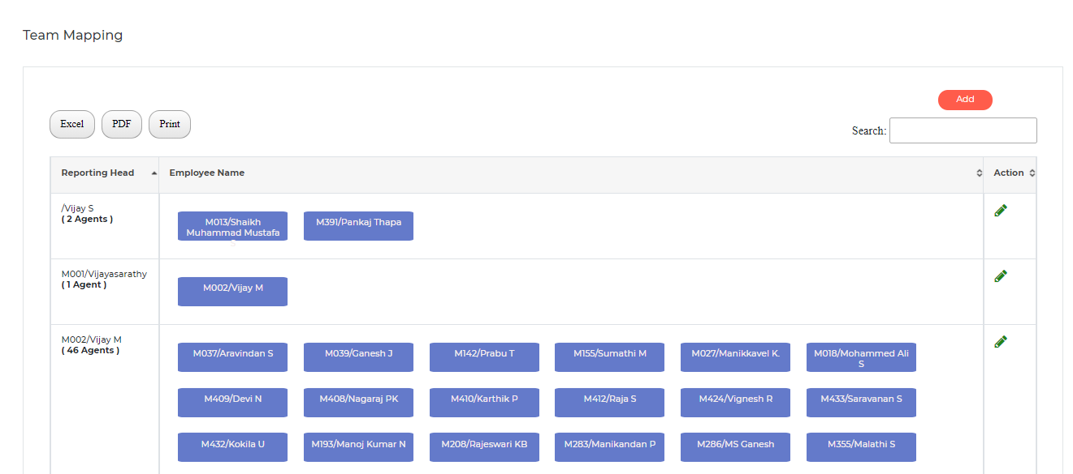

1. **Change Password**

Change password is used to change agent password for their individual HRMS id.

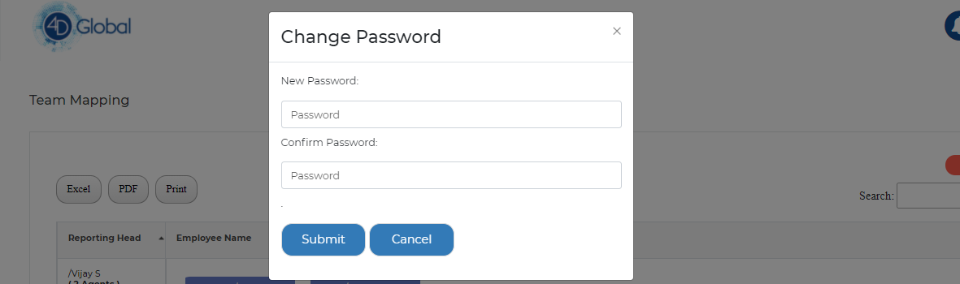

* **Employee Attendance**

Employee attendance module have monthly agent wise report will be generate, it will show no of present working days, leave taken, absent days and also late login & early logout also

Based on shift timing attendance module generate here

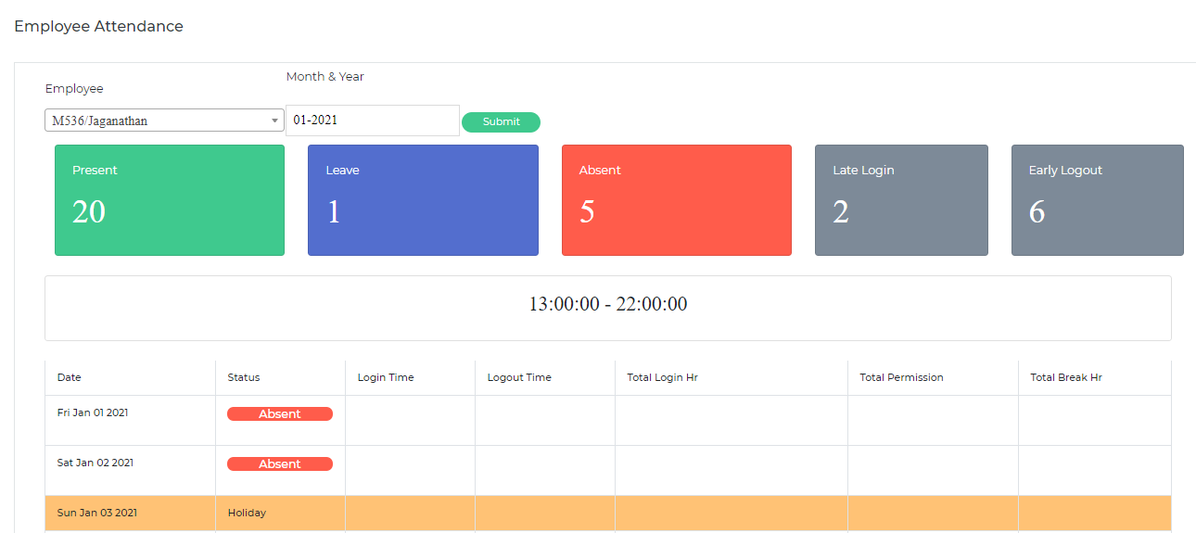

* **Employee Leave/Permission**

Agent have access to applying leave through HRMS software using this module, request will automatically indicate particular reporting supervisor/Manager

Manager/supervisor has access to approved or rejected agents leave or permission

* From Date / To Date (check box for full day leave or half a day leave)
* Type of Leave (CL or PL or Half Day or LOP)
* Reason for Leave
* Approval status (Accepted or Rejected)  
  Any leave request raised by the employee the respective Manager should get a notification to approve or reject the leave   
  If approved or rejected employee will get a notification

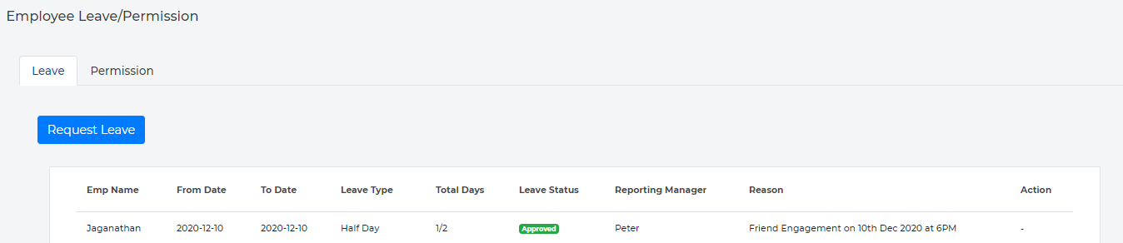

* **Documents**

There are 8 different documents upload access available in this module

1. **Certificates**

Agents have access to enter certificate name with attached documents

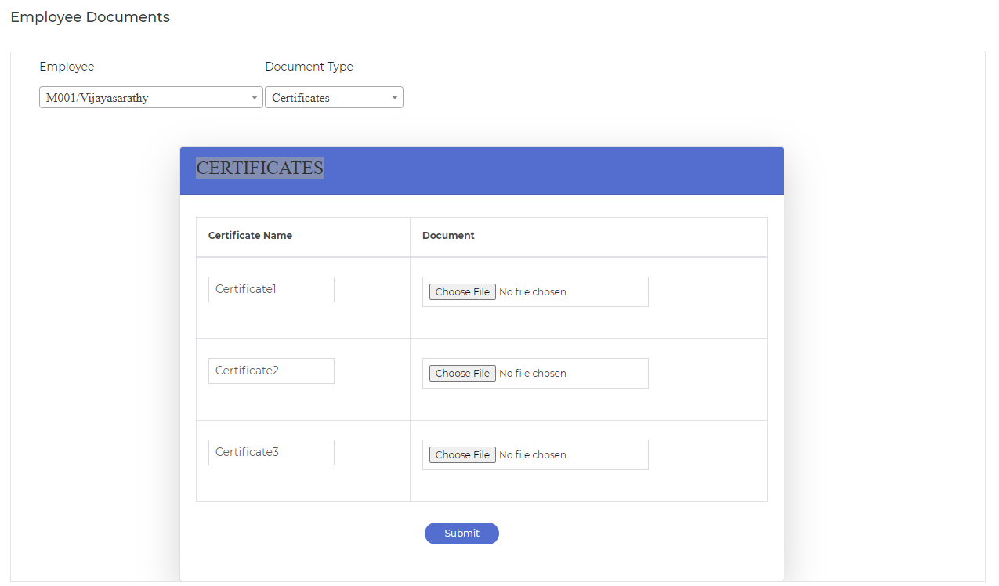

1. **Confirmation Letter**

Agents have access to just view a confirmation letter in HRMS. Manager or supervisors have access to upload agent’s confirmation letter and also have update option.

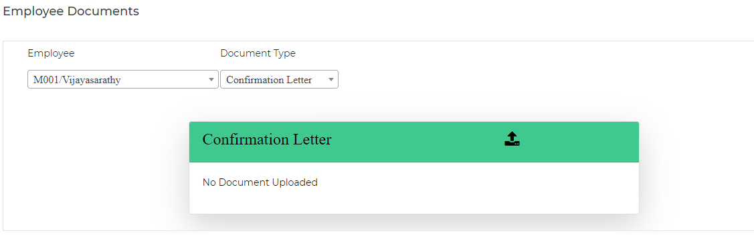

1. **Promotion Letter**

Agents have access to just view a promotion letter in HRMS. Manager or supervisors have access to upload agent’s promotion letter and also have update option.

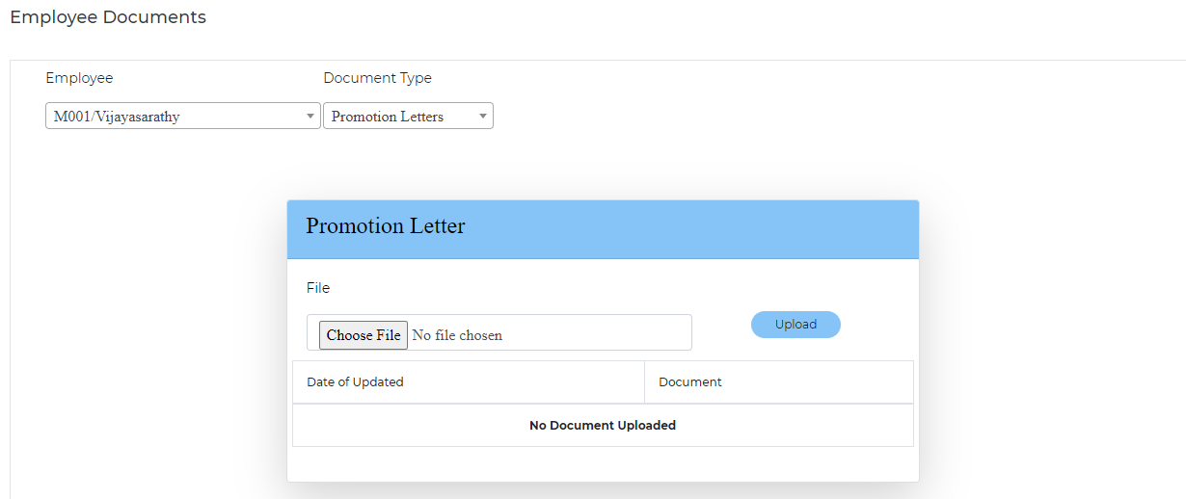

1. **Warning Letter**

Agents have access to just view a warning letter in HRMS. Manager or supervisors have access to upload agent’s warning letter and also have update option.

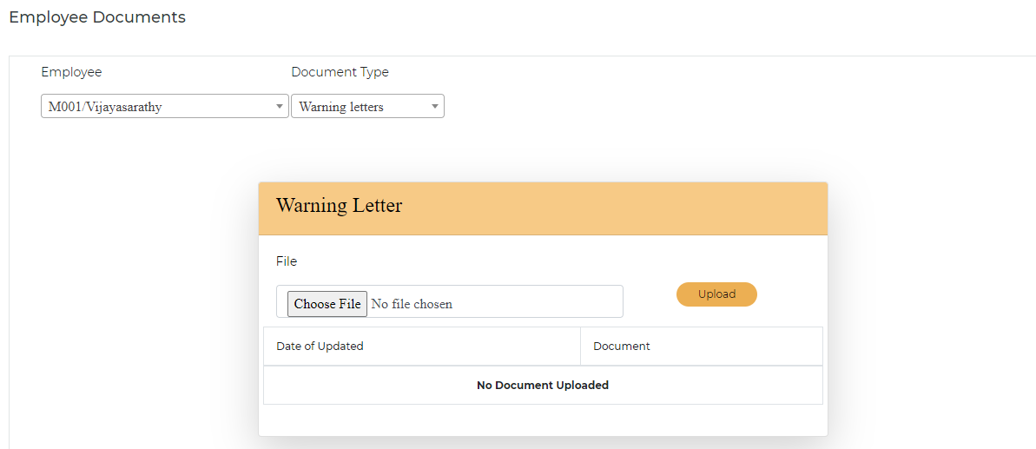

1. **Termination Letter**

Agents have access to view termination letter in HRMS. Manager or supervisors have access to upload agent’s termination letter and also have update option.

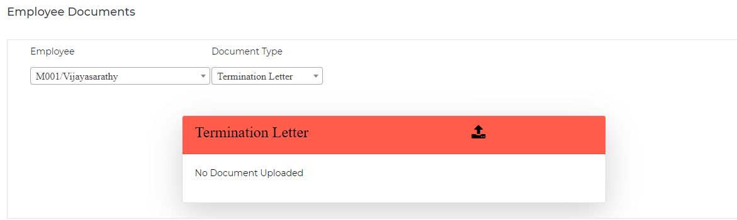

1. **Aadhar, PAN and Resume**

Here users can view the particular agent Aadhar, PAN and Resume documents.

* **4D HR/IT Policy**

Users have access to view HR/IT Policy’s like attendance policy, leave policy, medical insurance policy, code of conduct policy, exit policy

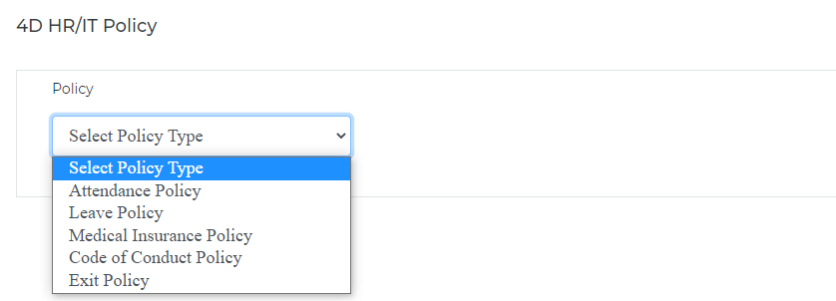

* **Onboarding New Employee**

On Progress

* **Candidate Interview**

Candidate interview module it’s just maintaining candidate interview process software.

**Step 1:** HR team enter candidate name, phone number and mailed to send an invitation candidate

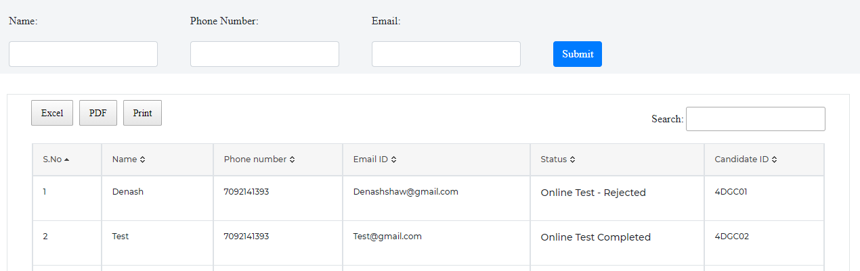

**Step 2:** Once candidate applied online application, candidate id will be generate

**Step 3:** HR Team read agent details and accept agent details

**Step 4:** Once HR Team accept candidate details then candidate should attend online test in

<http://192.168.2.193/aptitude> 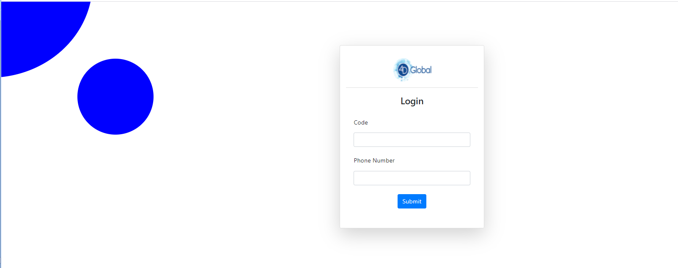

**Step 5:** Once agent aptitude test completed then HR team accept test status or reject through HRMS

* **Announcement**

Announcement just send an notification alert for selected agents in HRMS.

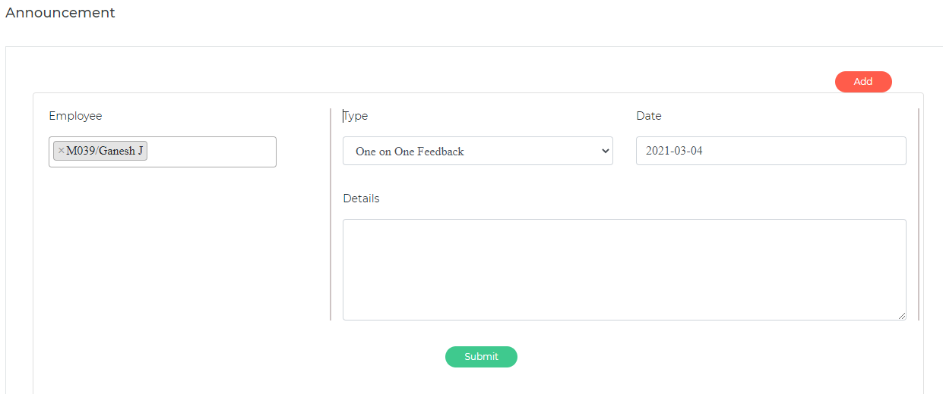

* **Employee Separation**

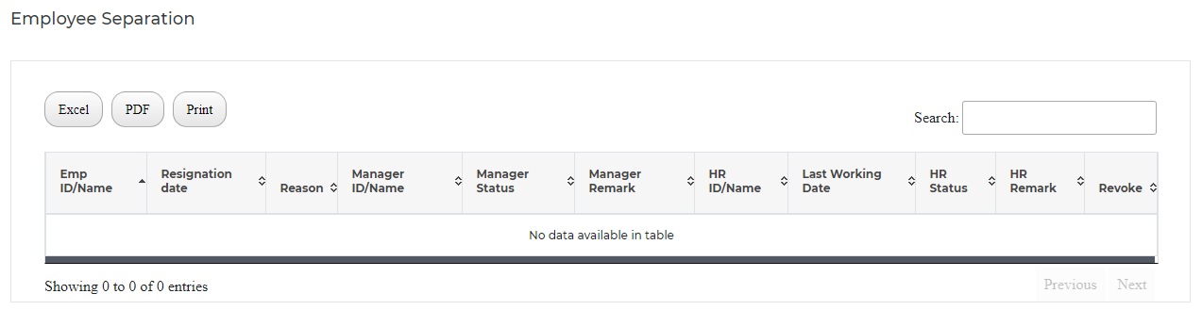

Email will be triggered to the concerned Manager for action

When Manager accepts resignation, an email will go to HR for approval of resignation an email will go to the Employee and the Manager with the last working date   
  
On the last week of employment the employee will get an automated email with an exit interview from which needs to be answered before their last working day after which HR should get an email to confirm separation

HR Admin login will have access to terminate an employee in the system if the employee is absconding and their login should get deactivated immediately

* **IT Help Desk**

**Agent Side:**

1) After agent login they can select “IT Help Desk” module for raising any IT Issues

2) Agent will need to enter the following information - Desk Number - Type of Issues Faced (Network Issue OR CPU Issue OR Desktop issue OR Keyboard/Mouse Issue) and should enter issue details AND click on the ‘SUBMIT’ button

3) Agent can track the complaint status

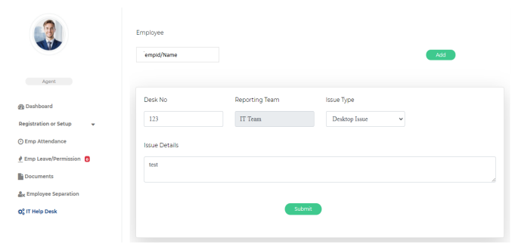

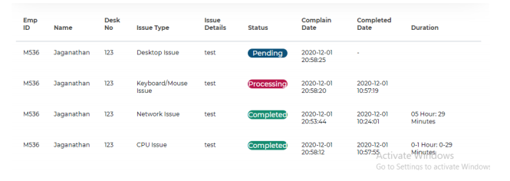

**IT Side:**

1) After IT person logs in they can see entire issues list, an email will also be sent to the email id it@4dglobalinc.com so that they are able to instantly see the complaint raised and act on them

2) IT Team can update the complaint status with status remark

3) Three Status are available:

I. Pending (When a ticket is raised by the agent)

II. Processing (When the IT team is working on an issue)

III. Completed (When the IT team has resolved the issue)

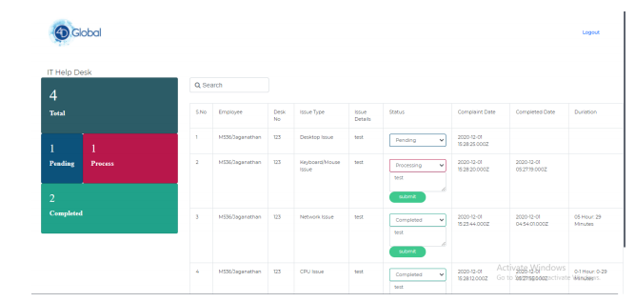

* **Assessment**

It’s just an online internal agent test through HRMS software.

Manager/Supervisor – assign test through ‘Assessment’ module based on selected agents

Agents – Select assessment test name then attend online test

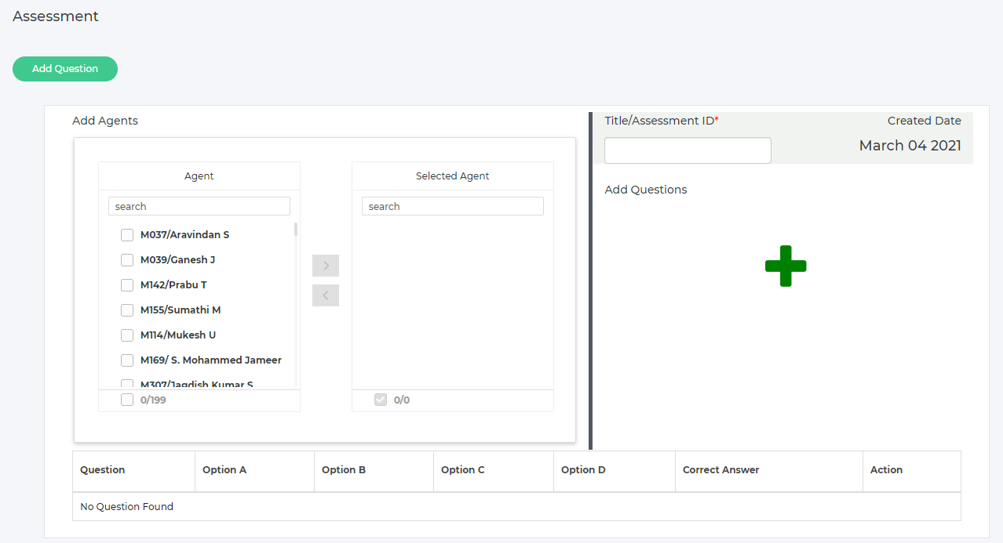

* **Employee Feedback/Appraisal**
* **HR Feedback**

One Hr discussed with agent then agent update monthly/half/year feedback

* **One on One Feedback (Manager)**

Monthly agent updates their feedback in this form then manager review and updates him/his feedback to the agent

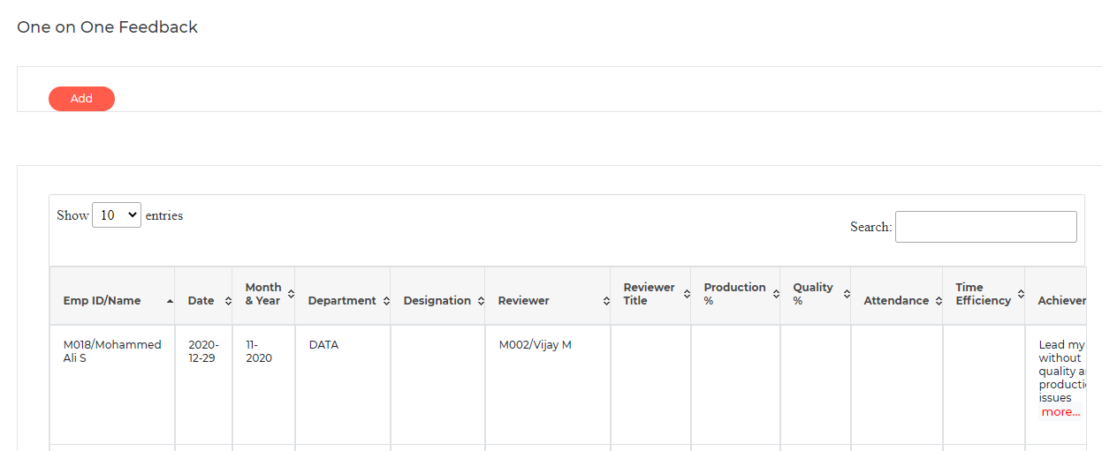

* **Report**

Currently we have 7 different reports are available in HRMS

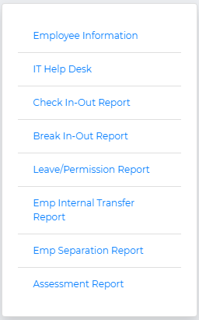

**CONCLUSION**

The system has been developed with good user-friendly methodologies and techniques. It provides a great degree of flexibility and has been designed in such a way so as to be able to handle future enhancements and modification when necessary. It is possible for any user to exploit the features of the system to get the maximum benefit. All the programs have been tested with sample data. The performance of this project will be good only if the server is kept online for 24 hours every day, every week, every year. The system is developed with great care that any user with little or even with no experience can operate without difficulty. The screens and interfaces are much user-friendly and the appropriate message is displayed properly. Each package in this system can be integrated with any other application.