各个特征的得分：

(0.041434015124350583, 'arr2ord_time'),

(0.040863867003748812, 'process2ord_time'),

(0.028682827775992521, 'duration_htl_ord_month_30_per50'),

(0.028278243269979873, 'duration_htl_ord_month_30_geomean'),

(0.025062185266505624, 'duration_htl_process_month_30_per50'),

(0.023908248039678934, 'duration_htl_ord_month_30_per25'),

(0.023801150444166769, 'duration_htl_process_hour_30_per50'),

(0.023379060568967613, 'duration_htl_process_hour_30_pre'),

(0.022600104538129259, 'duration_htl_process_hour_30_per75'),

(0.021884980003105067, 'duration_htl_ord_hour_30_per75'),

(0.021424494970194528, 'duration_htl_process_hour_30_per25'),

(0.020918755510446044, 'duration_htl_ord_hour_30_per50'),

(0.020729173475539816, 'duration_htl_process_month_30_per25'),

(0.020665109562856224, 'duration_htl_process_month_30_geomean'),

(0.020406288910898372, 'process_hour'),

(0.019838972037532099, 'duration_htl_ord_month_30_per75'),

(0.018231395415023919, 'duration_htl_ord_month_30_stddev'),

(0.017123923300840581, 'duration_htl_process_month_30_stddev'),

(0.016623965402129202, 'duration_htl_ord_hour_30_pre'),

(0.016376685611328504, 'duration_htl_ord_hour_30_per25'),

(0.016346990719688738, 'duration_htl_process_hour_30_geomean'),

(0.016128227997551786, 'duration_htl_process_month_30_per75'),

(0.015387032805786989, 'duration_htl_process_hour_30_stddev'),

(0.015339826766064286, 'duration_htl_process_month_30_pre'),

(0.015253177687916761, 'duration_htl_ord_hour_30_geomean'),

(0.014882695801631287, 'duration_htl_ord_month_30_numsord'),

(0.014515966214078973, 'ord_hour'),

(0.014120053751471238, 'duration_htl_ord_month_30_pre'),

(0.013590265451292769, 'duration_htl_process_month_30_preord'),

(0.01356742456612043, 'duration_htl_process_hour_7_geomean'),

(0.013541366992543932, 'duration_htl_process_month_30_numsord'),

(0.01347351283237247, 'duration_htl_ord_hour_30_stddev'),

(0.013471694514274784, 'duration_htl_process_week_7_geomean'),

(0.012450146557591635, 'duration_htl_process_hour_7_per75'),

(0.011995026871663615, 'duration_htl_ord_month_30_preord'),

(0.01129023300807727, 'duration_htl_process_hour_7_pre'),

(0.010520774288476352, 'duration_htl_process_hour_7_per50'),

(0.010326836739418355, 'duration_htl_ord_hour_7_per75'),

(0.010218439105086505, 'duration_htl_ord_week_7_per75'),

(0.010122184177573051, 'duration_htl_ord_hour_7_geomean'),

(0.010099973437060025, 'duration_htl_ord_hour_7_pre'),

(0.0099852638606327329, 'istodayord'),

(0.0098446806283353644, 'duration_htl_process_hour_7_per25'),

(0.0094647085150809818, 'duration_htl_process_hour_30_numsord'),

(0.009435256817524695, 'duration_htl_process_week_7_stddev'),

(0.0093888266664175733, 'duration_htl_ord_week_7_stddev'),

(0.0093846243413630015, 'duration_htl_process_week_7_per50'),

(0.0093290126721382489, 'duration_htl_ord_week_7_geomean'),

(0.0092653142662004421, 'duration_htl_process_week_7_per75'),

(0.0092200151588539298, 'duration_htl_ord_week_7_per50'),

(0.0091379198737800912, 'duration_htl_process_week_7_per25'),

(0.0090925515687702747, 'duration_htl_process_hour_30_preord'),

(0.0089041031148774843, 'duration_htl_process_week_7_pre'),

(0.0087532336573198938, 'duration_htl_ord_week_7_pre'),

(0.0085386427521979384, 'duration_htl_ord_hour_7_per25'),

(0.0084779312950827492, 'duration_htl_ord_hour_7_per50'),

(0.008404190015829276, 'duration_htl_process_hour_7_stddev'),

(0.008297210068395169, 'duration_htl_ord_week_7_per25'),

(0.0079897806668266097, 'duration_htl_process_week_7_preord'),

(0.0074676262133177591, 'duration_htl_process_week_7_numsord'),

(0.0072682618868039782, 'duration_htl_ord_week_7_numsord'),

(0.0071530851362312997, 'duration_htl_ord_hour_30_preord'),

(0.0071495583324310656, 'star'),

(0.0071407511196726354, 'duration_htl_ord_hour_30_numsord'),

(0.0066759783862644761, 'masterstar'),

(0.0065837185861637769, 'duration_htl_ord_week_7_preord'),

(0.0063862825919319471, 'duration_htl_ord_hour_7_stddev'),

(0.0061985235633495563, 'duration_htl_process_hour_7_numsord'),

(0.0054884732059865323, 'duration_htl_process_hour_7_preord'),

(0.0044580263951779497, 'submitfrom'),

(0.0038112347997213518, 'goldstar'),

(0.0033533539751898767, 'duration_htl_ord_hour_7_numsord'),

(0.002868746741951784, 'ord_roomstatus'),

(0.0027176091779432458, 'duration_htl_ord_hour_7_preord'),

(0.0013955710268148589, 'freesale'),

(0.0013897611323930512, 'isholdroom'),

(0.0007048752718727887, 'isonline')

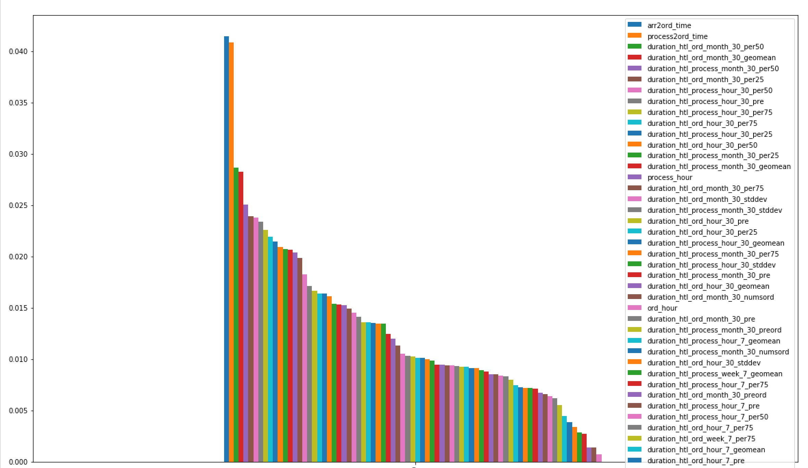

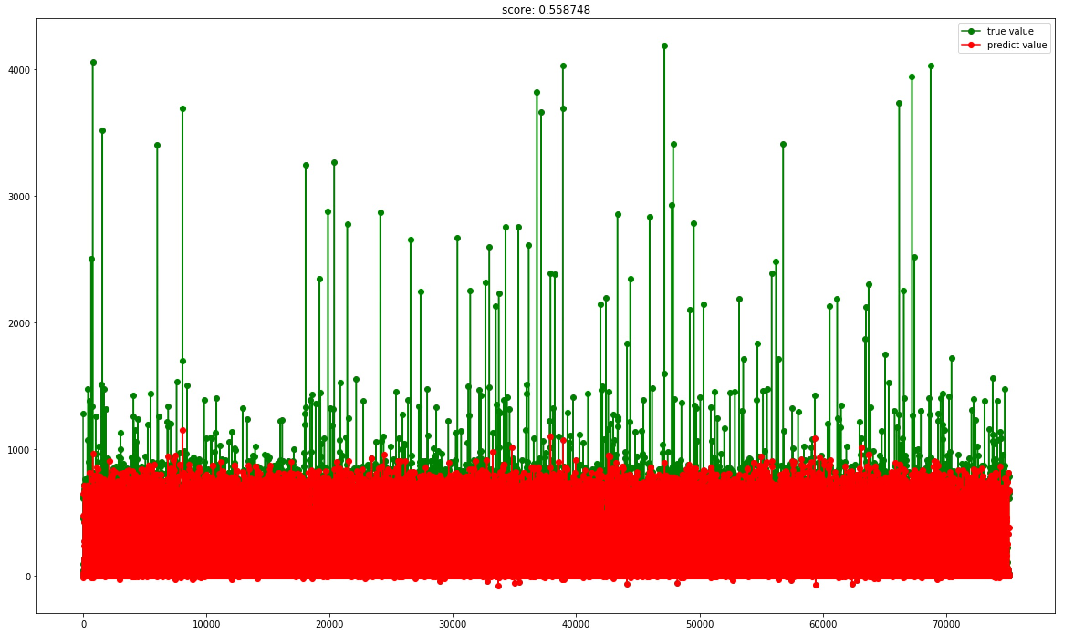

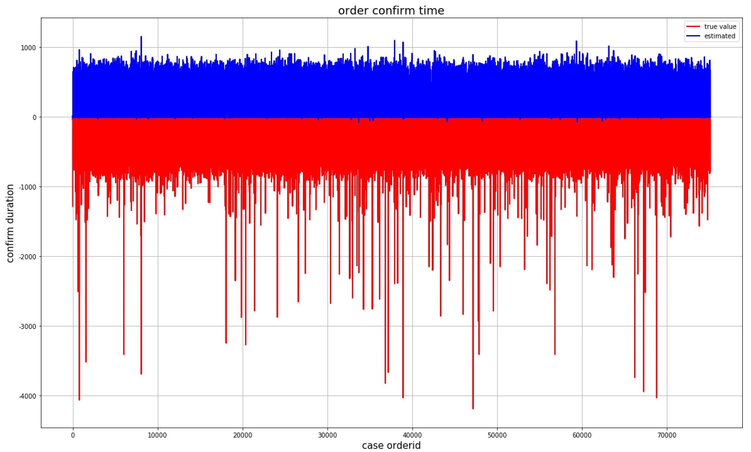

0.6427962716378163

海外订单回复时长预测

(0.1375393400453902, 'duration_htl_ord_hour_30_per50'),

(0.090734203308990569, 'duration_htl_ord_month_30_per75'),

(0.058376915563003444, 'arr2ord_time'),

(0.039796489084146507, 'duration_htl_ord_month_30_per25'),

(0.036541640701373036, 'duration_htl_ord_month_30_stddev'),

(0.035646729379715442, 'duration_htl_ord_hour_30_geomean'),

(0.03465751090860078, 'duration_htl_ord_week_7_per75'),

(0.034369385913445731, 'duration_htl_ord_hour_30_per25'),

(0.032856399668754706, 'duration_htl_ord_week_7_pre'),

(0.031719303900858468, 'duration_htl_ord_month_30_per50'),

(0.031303987132366554, 'duration_htl_ord_week_7_stddev'),

(0.031073493981401582, 'duration_htl_ord_month_30_pre'),

(0.030607256631509257, 'actualmasterhotelid'),

(0.030137210474508781, 'ord_hour'),

(0.028996242623934586, 'duration_htl_ord_hour_30_per75'),

(0.028067538669229244, 'duration_htl_ord_month_30_geomean'),

(0.028000837878298275, 'duration_htl_ord_week_7_per25'),

(0.026138725026405577, 'duration_htl_ord_week_7_per50'),

(0.022588290626279147, 'duration_htl_ord_week_7_geomean'),

(0.022251236119936749, 'duration_htl_ord_hour_30_pre'),

(0.020959027431536104, 'duration_htl_ord_hour_7_geomean'),

(0.019595401396027445, 'duration_htl_ord_hour_30_stddev'),

(0.013268969828956723, 'duration_htl_ord_month_30_numsord'),

(0.01308973008324679, 'duration_htl_ord_month_30_preord'),

(0.012113026860663395, 'duration_htl_ord_week_7_numsord'),

(0.010945610775390528, 'duration_htl_ord_hour_7_per50'),

(0.010673255550317824, 'duration_htl_ord_hour_7_per25'),

(0.010423026066364971, 'duration_htl_ord_week_7_preord'),

(0.010320969249587506, 'duration_htl_ord_hour_7_pre'),

(0.010232246154564426, 'duration_htl_ord_hour_7_stddev'),

(0.010051886045584636, 'duration_htl_ord_hour_7_per75'),

(0.0062201489896769454, 'submitfrom'),

(0.0055418525498502069, 'duration_htl_ord_hour_30_numsord'),

(0.0053692116918857974, 'ord_roomstatus'),

(0.0050136099329031701, 'masterstar'),

(0.0048163045207568278, 'star'),

(0.0047409592785490513, 'duration_htl_ord_hour_30_preord'),

(0.0042968512009757369, 'isholdroom'),

(0.002881356211660835, 'duration_htl_ord_hour_7_preord'),

(0.0026922063732904814, 'duration_htl_ord_hour_7_numsord'),

(0.0024215236040431537, 'freesale'),

(0.0020006318642248107, 'goldstar'),

(0.00057198198748211468, 'isonline'),

(0.00035747471431182734, 'istodayord'),

(0.0, 'ordertype')

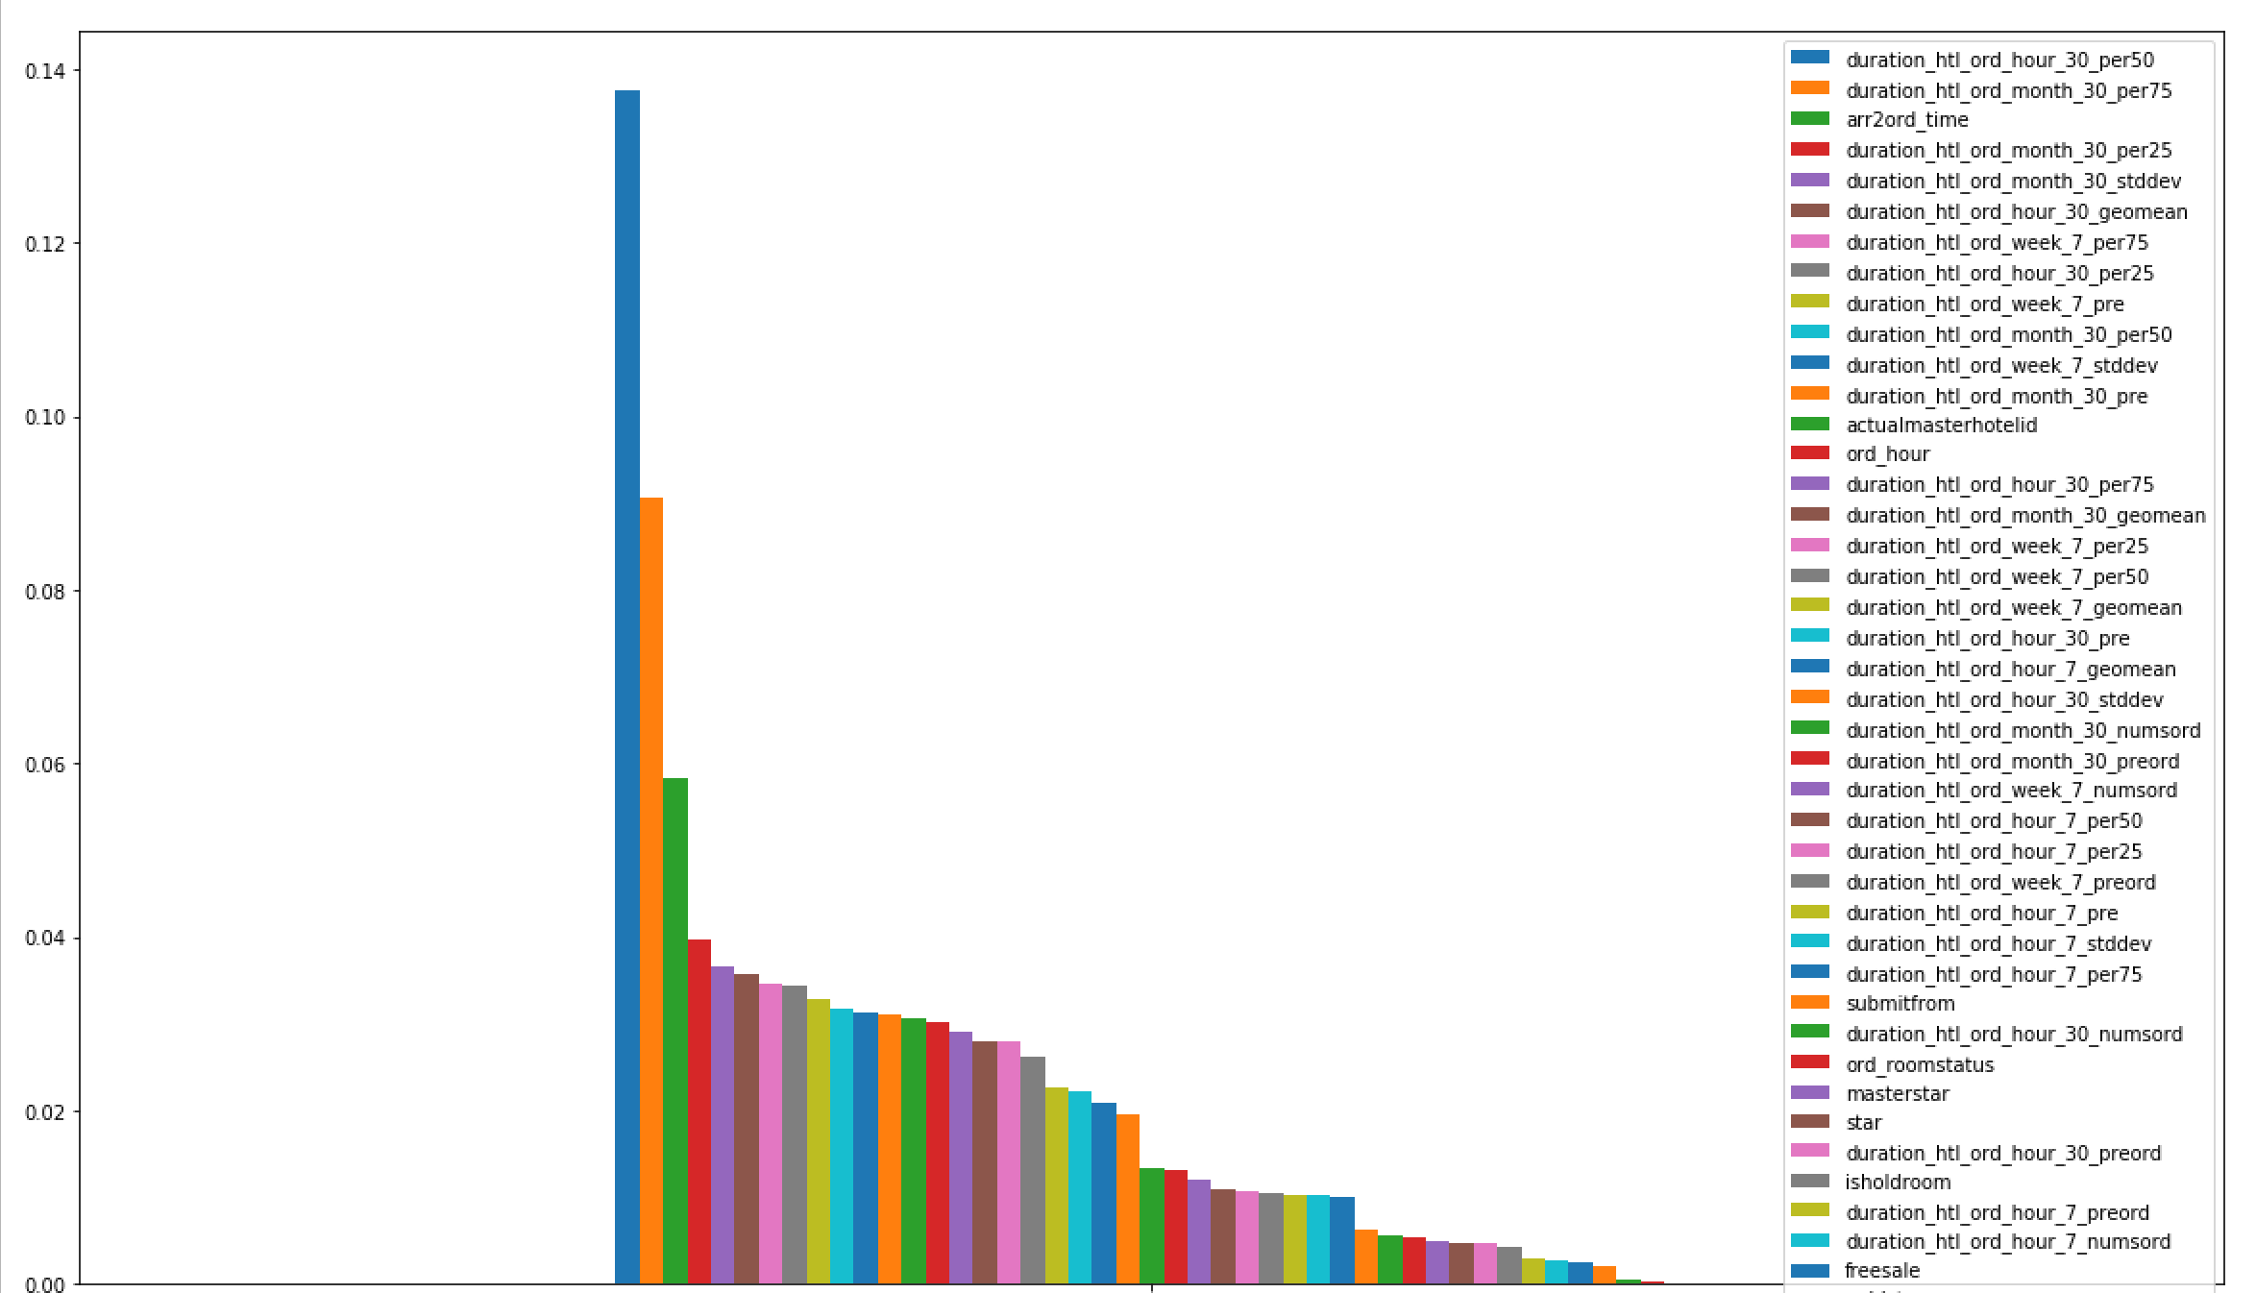

R^2系数 0.41850369278

均方误差 224200.041648

平均绝对值误差 = 156.276269221

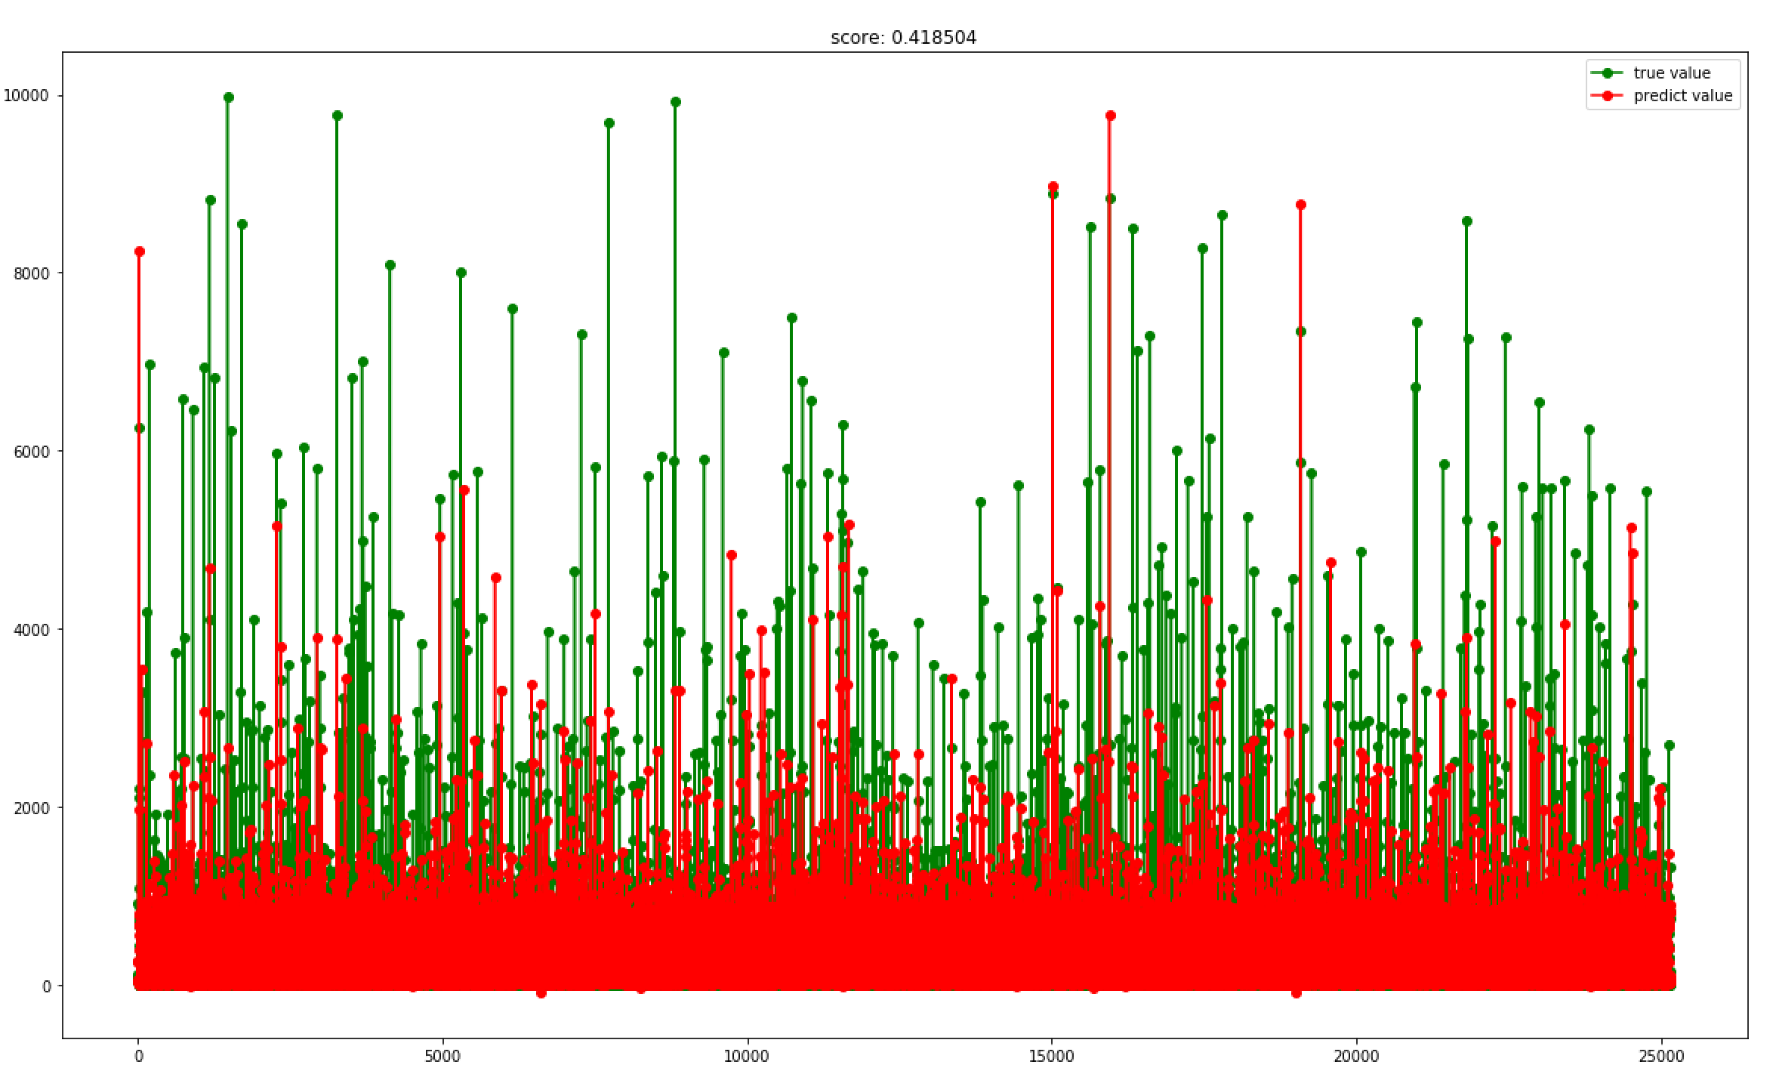

当天订单baseline等于30分钟， 隔天订单baseline240分钟，之后classreport的结果：

precision recall f1-score support

0 0.85 0.82 0.84 8550

1 0.91 0.93 0.92 16602

avg / total 0.89 0.89 0.89 25152