Theme « Camel » for gmusicbrowser 1.1.99.1

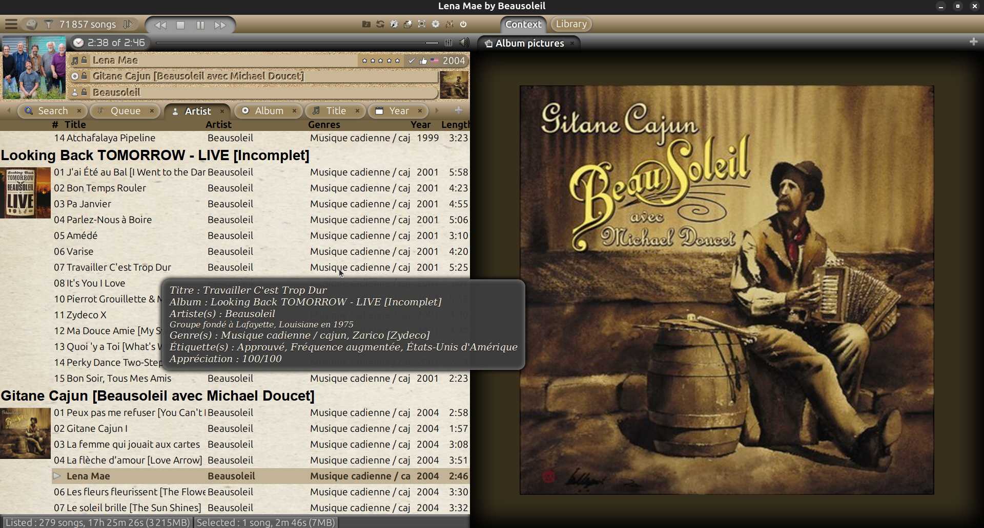
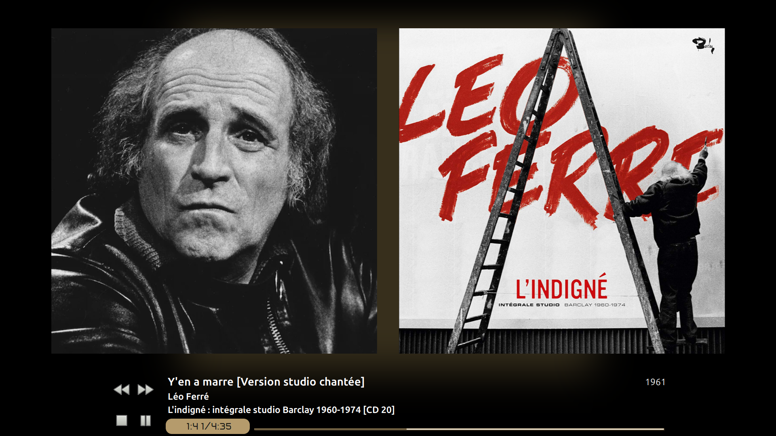

Contents
Warnings 1
Installation 1
Configuration 1
Possible changes 2
Credits 3

Warnings
- The Camel theme, distributed under the GNU General Public License version 3, was created by Loïc Guégant for gmusicbrowser 1.1.99.1 installed via flatpack on ubuntu 24.04, 24.10 or 25.04 on Wayland, GNOME Shell with the Tray Icons: Reloaded extension (https://extensions.gnome.org/extension/2890/tray-icons-reloaded/), user theme (ubuntu session) Adwaita and Camel icons theme in gmusicbrowser settings (Settings > Layouts > Icon theme).
- If you have modified your gmusicbrowser installation in any way, your changes may be lost or cause malfunctions.
- Installing this package causes various changes to gmusicbrowser that can only be undone by reinstalling it.

Installation
- Quit gmusicbrowser.
- Untar the archive to the root of the home directory (/home/[user]) then, in a terminal, run the commands:
cd gmusicbrowser_1.1.99.1-camel_theme_[YYYYMMDD]
replacing [YYYYMMDD] with the version number of the downloaded archive, and:
sudo ./install.sh

Configuration
It is possible to add a command to turn down the computer when the queue is empty, after the current song... (on GNOME:
dbus-send --system --print-reply --dest=org.freedesktop.login1 /org/freedesktop/login1 "org.freedesktop.login1.Manager.PowerOff" boolean:true
and on KDE 4:
qdbus org.kde.ksmserver /KSMServer logout 0 2 2
in the > Settings > Misc. > Shutdown command input box - source: https://doc.ubuntu-fr.org/gmusicbrowser#actions_de_fin_de_liste_d_attente).

Possible changes
- For a language other than English and French, it is possible to download the gmusicbrowser source files at https://github.com/squentin/gmusicbrowser, edit the .po file of the desired language with a simple text editor to add the entries added in the attached fr.po file. Save and close, edit with Poedit, complete the translation, compile under the name gmusicbrowser.mo and place the resulting file in /var/lib/flatpak/runtime/org.gmusicbrowser.gmusicbrowser.Locale/x86_64/stable/6ac440150c2564f217e8ce4d53a1b2c042a607ab7559d13a437b69b7ead4076d/files/[langage code]/share/[langage code]/LC_MESSAGES.
- Some column widths are not defined and user settings are not remembered correctly. It may then be necessary to delete the last column and recreate it.
- The overlay image file for the “Player” part illustration, overlay.png, can be found at /var/lib/flatpak/app/org.gmusicbrowser.gmusicbrowser/x86_64/stable/6ac440150c2564f217e8ce4d53a1b2c042a607ab7559d13a437b69b7ead4076d/files/share/gmusicbrowser/pix/elementary
- GTK3 supports some CSS rules and its own rules (which start with -gtk-): see https://docs.gtk.org/gtk3/css-overview.html#selectors and https://docs.gtk.org/gtk3/css-properties.html.
- gmusicbrowser layouts can be created or modified according to the instructions given by its developer Quentin Sculo at http://gmusicbrowser.org/layout_doc.html, http://wiki.gmusicbrowser.org/customization/songtree and http://wiki.gmusicbrowser.org/customization/skins.
- To use the “GTK Inspector”, enter a terminal:
export GTK_DEBUG=interactive
then:
/usr/bin/flatpak run --branch=stable --arch=x86_64 --command=gmusicbrowser --file-forwarding org.gmusicbrowser.gmusicbrowser
- In "ubuntu on Xorg" session, the title bar of the main window cannot be styled for gmusicbrowser alone, but for all GTK applications by creating /home/[user]/.config/gtk-4.0/gtk.css and writing in something like:
.titlebar, headerbar, UnityDecoration.top {
background: #242424;
color:white;
margin-bottom: -1px;
margin-top: -3px;
}

.titlebar:backdrop, headerbar:backdrop {
background: #242424;
color:#807D78;
}
then restart session.
- The resources/label icons folder contains some icons that can be associated with labels, provided they are placed in the /home/[user]/.var/app/org.gmusicbrowser.gmusicbrowser/config/gmusicbrowser/icons folder and renamed to label-[label name].svg.
- The provided resources/gmusicbrowser.svg file, which simply adds a background to the gmusicbrowser.svg file provided with the gmusicbrowser sources, can be used as a launcher icon for better visibility, especially on a black panel (see https://en.ubunlog.com/alacarte-edit-create-delete-application-shortcuts/ to customize a launcher in graphical mode):


Credits
- The Anta font, used for total, elapsed and remaining time indications, has been modified to equalize the widths of the digits.
- Some of the icons come from Piotr's “Colors” package (https://www.gnome-look.org/p/1108450) for gmusicbrowser, another from the icons provided with gmusicbrowser.
- The gmb-context.svg icon is based on new-window-svgrepo-com.svg ((https://www.svgrepo.com/svg/438706/new-window) licensed under PD License (https://www.svgrepo.com/page/licensing/#PD), author CFPB (https://www.svgrepo.com/author/CFPB/).
- The photo of the camel is derived from stockvault-camel-in-the-desert207977.jpg published at https://www.stockvault.net/photo/207977/camel-in-the-desert (author indicated: Pixabay, Creative Commons license – CC0).
- The sand photo is derived from from istockphoto-91630943-2048x2048.webp published at https://media.istockphoto.com/id/91630943/fr/photo/beau-fond-de-sable.webp?s=2048x2048&w=is&k=20&c=2OtOt_9t_lWCsYmsphQNSaWvExNyNT8_N4bZQmkFC7A= (credit indicated: Hydromet, iStock standard licence).
- The photo of old drift paper is derived from 126406-old-vintage-paper-background.jpg published at https://www.123freevectors.com/old-vintage-paper-background-126406/ (“Design by www.123Freevectors.com”, “License Free”).
- The photo of the desert is derived from desert-1170055_640.jpg published at https://pixabay.com/fr/photos/d%C3%A9sert-bad-lands-panorama-d%C3%A9nud%C3%A9-1170055/ (under Pixabay content license - https://pixabay.com/fr/service/license-summary/).

