
Sri Lanka Institute of Information Technology

SE3110 - Quality Management in Software Engineering
Year 3, Semester 1- 2026

Assignment 2
Emergency Resource Coordination Platform
Group submission revised 7 October 2026
# | Student ID | Student Name
1 | IT24103355 | Jathurshy.S
2 | IT24103609 | M.Thanusikan
3 | IT24102826 | Denesh N
4 | IT24103828 | Deneshkar. P

Table of Contents
1. Introduction
2. Software Quality Management
3. Quality Assurance
4. Software Testing
5. Defect Management
6. Quality Metrics
7. Risk Management
8. Continuous Improvement
9. Quality Improvement Recommendations
10. Conclusion
11. References
12. Appendices

1. Introduction

1.1 Background
The Emergency Resource Coordination Platform (ERCP) supports incident reporting, resource and inventory management, dispatch and task assignment, and volunteer or responder management. It combines an ASP.NET Core Web API, PostgreSQL, a React web application, a Flutter mobile application and four business-specific agents.
Reliable coordination requires valid incident information, suitable resources, available responders and controlled approvals. Incorrect role permissions, conflicting shifts or an incomplete database schema can interrupt the response workflow. Quality management therefore focuses on both business behaviour and the supporting technical controls.

1.2 Purpose of the Report
This report evaluates the ERCP system developed for the SEF assignment. The recorded group run on 6 October 2026 passed 270 automated cases, a separate k6 load scenario and a migration CLI check. Three demonstrated defects were repaired and retested. These results support the evaluated scope, with remaining limits for browser and physical-device workflows, live LLM behaviour and production operation.

1.3 Objectives
- Verify incident, inventory, dispatch and responder behaviour against executable assertions.
- Check API authorization, PostgreSQL constraints and the integrated response workflow.
- Measure a bounded local workload and retain reproducible performance evidence.
- Trace defects from reproduction to repair and regression retesting.
- Provide a separate test runner and presentable agent input/output evidence for every member.

2. Software Quality Management

2.1 Definition of Software Quality
For ERCP, software quality means that implemented functions behave consistently with their requirements and provide dependable, understandable support for emergency coordination. Correctness includes rejection of unsafe or unauthorized actions, rather than only successful processing of valid requests.

2.2 Quality Objectives
Quality attribute | ERCP objective
Functional suitability | Valid incidents, allocations, shifts and approved dispatch states.
Reliability | Preserve database relationships and reject conflicting or invalid assignments.
Security | Restrict public roles and protect dispatch mutations.
Performance | Meet declared response-time and failure thresholds for the local read workload.
Usability | Check selected React and Flutter interactions, validation and failure states.
Maintainability | Keep modular source, repeatable tests and traceable defect evidence.
Availability | Start QMS mode only with a reachable, migrated PostgreSQL database.

2.3 Quality Model
The evaluation uses functional correctness, reliability, security, performance, usability and maintainability as practical quality dimensions. Tests provide evidence for specific behaviours; the report does not claim a formal standards certification, a production service-level guarantee or complete feature coverage.

3. Quality Assurance

3.1 Quality Assurance Approach
ERCP uses Git history, modular controllers and services, typed request models, database migrations, automated tests and GitHub Actions. Historical commits establish implementation and test contributions; they do not independently prove a member completed the newer QMS demonstrations.
Member | Business component and respective agent
Jathurshy.S  IT24103355 | Incident Management  CoordinatorPlannerAgent
M.Thanusikan  IT24103609 | Resource and Inventory Management  SituationAnalysisAgent
Denesh N  IT24102826 | Dispatch and Task Assignment  ResourceAllocationAgent
Deneshkar. P  IT24103828 | Volunteer/Responder Management  ValidationSafetyAgent

Technical execution, repairs, packaging and report preparation used OpenAI Codex under the repository owner’s direction. Historical package verification is recorded as technical execution run by Codex. Subsequent submitted personal runs and remaining understanding work are recorded separately in Appendix G.

3.2 Quality Control
Quality control combines direct controller and service checks, internal HTTP integration, actual PostgreSQL and migration regressions, React and Flutter suites, deterministic Python-agent checks, live HTTP workflow tests and a k6 workload. Failed before-fix evidence is retained alongside successful retests.
Entry conditions include restored dependencies, controlled fixtures and reachable isolated services where needed. The exit gate requires complete recorded outcomes, passing regression checks for the demonstrated defects and explicit reporting of limitations. No skipped tests are counted as passes.

3.3 Development Tools Supporting Quality
Tool or technology | Purpose
C# and ASP.NET Core net8.0 | Backend API, business validation and authorization.
Entity Framework Core and PostgreSQL 17.10 | Data access, relational constraints and eight applied migrations.
xUnit and WebApplicationFactory | Direct tests and internal HTTP integration; InMemory fixtures where specified.
Vitest and React Testing Library | React component, service and route-permission checks.
flutter_test | Flutter units, forms, state and widgets.
pytest and Requests | Actual Python-agent checks and live HTTP tests.
k6 1.3.0 | Bounded virtual-user workload and threshold evaluation.
GitHub Actions | Backend/PostgreSQL, React and Flutter CI jobs.

Recorded local environment: Windows 11, .NET SDK 10.0.401 with net8.0 tests, Node 22.15.0, Python 3.13.2, pytest 8.3.3, Flutter 3.44.9 and API port 5009. The isolated PostgreSQL service uses port 55432. SMTP and Gemini credentials were disabled for the evaluated runs.

3.4 Test Plan
Scope. The existing ERCP system: incident planning, resources and shelters, dispatch approval, volunteer shifts, authentication, React views, Flutter units/widgets, PostgreSQL integrity and deterministic agents. Live LLM evaluation, physical-device workflows and production-scale assurance are outside the recorded scope.
Objectives. Check normal, invalid, boundary and failure behaviour; verify a complete API workflow; measure the stated load thresholds; detect authorization and data-integrity defects; preserve source, expected results, actual results and retest evidence.
Testing Area | What is Tested | Tool /  Framework | Responsible Member | Environment | Schedule
Backend/API | Controllers, services, validation and HTTP contracts | xUnit; WebApplicationFactory | All four, by component | .NET 8 test host; EF InMemory fixtures | 6 Oct group; 6-7 Oct personal
Database | Constraints, relationships, transactions and migrations | xUnit; EF Core; PostgreSQL | M.Thanusikan | Isolated PostgreSQL; port 55432 | 5 Oct repair; 6 Oct retest
React | Components, forms, protected routes and error states | Vitest; React Testing Library | Denesh N; M.Thanusikan | Node 22; mocked API fixtures | 6 Oct full rerun
Flutter | Models, forms, navigation and widget states | flutter_test | Deneshkar. P | Flutter 3.44.9; unit/widget harness | 6 Oct full rerun
Integration/E2E | Incident to plan, dispatch, validation and approval | pytest; Requests; SQL verification | Jathurshy.S; Denesh N | Local API 5009 and PostgreSQL; API workflow | 5 Oct repair; 6 Oct rerun
Performance | Authenticated reads; p95, errors and response checks | k6 1.3.0 | Denesh N | Local API; up to 10 VUs; 40 seconds | 6 Oct load run
Security | Privileged signup, role checks, JWT and hostile inputs | xUnit; pytest; Requests | Denesh N; Deneshkar. P | Test host and isolated live API | 3 Oct defects; 6 Oct retest
Agentic AI | Approval, tool limits, capacity, allocation and safe failure | pytest; deterministic JSON checks | All four, matching agents | Python 3.13; live Gemini disabled | 6 Oct group; 6-7 Oct personal

Names identify assigned review responsibility following the SEF component allocation. All four members review their own backend and agent cases. Shared-area ownership does not establish personal execution: dated raw records and individual appendices identify the actual operators.

3.4.1 Execution Schedule and Acceptance
The dates below describe recorded work. The final group run is 6 October 2026; the 6-7 October member reruns and demonstrations do not add unique tests to the group inventory.
Recorded date | Activity and retained evidence
3 October 2026 | Baseline review and initial security failures: evidence/baseline and evidence/security-before.
5 October 2026 | BUG-03 repair, four migration regressions and database/backend/workflow retests: evidence/migration-fix.
6 October 2026 | Full group rerun: evidence/final. 270 automated passes, one k6 scenario and one migration CLI check; 272 inventory records.
6 October 2026 | Deneshkar personal evidence: 4 controller, 5 HTTP and 3 safety tests; evidence/individual/IT24103828/20261006-151749.
7 October 2026 | Personal runs: Jathurshy 11, Thanusikan 17 and Denesh 26 passing tests, plus two agent scenarios each; members/personal-evidence.json.
8 October 2026 | Codex executed four before/after comparisons: eight scenarios passed. Deneshkar supplied a written boundary/overlap explanation; members/changed-input-evidence.json.
8 October 2026 personal runs | Four supplied terminal screenshots match the personal comparisons: two scenarios passed per member, eight total. See members/personal-changed-input-evidence.json.
Personal work remaining | All four explanations received. Members 1-2 review the documented D-series/C-series corrections. All members prepare to explain assertions and results in the viva.

Case-level expected results and assertions are in Test_Cases.html. Entry requires installed dependencies, isolated fixtures and reachable services. Exit for the evaluated scope requires recorded outcomes and retesting of demonstrated critical defects. The k6 gates are p95 below 1000 ms, HTTP failures below 1% and all content/status checks passing.
The supplied brief states a 5 October deadline. Later run dates are retained accurately; this report does not claim an extension or timely CourseWeb submission.
Open the consolidated plan and evidence paths
Complete the personal changed-input exercises

4. Software Testing

4.1 Testing Strategy
The strategy combines component, HTTP, database, workflow, performance and security checks. The 95 backend cases include direct controller/service tests, HTTP integration and real database regressions.
Executed suite | Passed | Failed | Skipped
Backend including PostgreSQL | 95 | 0 | 0
React | 47 | 0 | 0
Flutter | 91 | 0 | 0
Python agents | 20 | 0 | 0
Live HTTP | 17 | 0 | 0
Total automated cases | 270 | 0 | 0

A passing performance scenario and a passing migration CLI check bring the inventory to 272 records. Parameterized cases are counted individually. Member reruns, demonstration scenarios and screenshot views do not increase the unique group-test total.

4.2 Unit and Component Testing
Fixtures compare actual controller, service and agent results with assertions. React and Flutter suites check selected rendering, interactions and validation. Existing shallow checks are not treated as comprehensive behavioural coverage.

4.2.1 Incident and Resource Tests
The member selections include nine incident/planner backend tests and twelve resource, inventory, shelter, geolocation and situation-analysis backend tests. They check valid data, boundaries, availability and urgency.

4.2.2 Dispatch and Volunteer Tests
Dispatch allocation, controller and validation fixtures provide 23 selected backend cases. Volunteers contribute four shift-controller cases and five HTTP cases, covering valid windows, unknown volunteers, reversed times and invalid status.

4.2.3 Representative Test Cases
The cases below are examples from the full 272-record inventory. Test_Cases.html and test-cases.json retain every record’s source, fixture, command, expected assertions, actual result and evidence path.

BE-068 CreateShift_EndBeforeStart_ReturnsBadRequest
Precondition and input: Known volunteer; start 16:00, end 08:00 UTC. Procedure: Call CreateShift with the invalid window.
Expected: BadRequestObjectResult and zero saved shifts. Actual: Passed. Evidence: evidence/final/backend/backend.trx

BE-071 CreateShift_ValidWindow_PersistsAndReturnsCreated
Precondition and input: Known volunteer; start 08:00, end 16:00 UTC. Procedure: Call CreateShift with status Scheduled.
Expected: Created result; correct volunteer/status; one saved shift. Actual: Passed. Evidence: evidence/final/backend/backend.trx

BE-077 GetVolunteers_Anonymous_Returns401
Precondition and input: Internal test server; no authentication token. Procedure: Request the protected volunteer endpoint.
Expected: HTTP 401 Unauthorized. Actual: Passed. Evidence: evidence/final/backend/backend.trx

AI-017 test_AI08_unavailable_volunteer_is_rejected
Precondition and input: Assignment contains an unavailable volunteer. Procedure: Call the actual safety-agent validation method.
Expected: Invalid assignment; unavailable-volunteer violation. Actual: Passed. Evidence: evidence/final/agents.xml

AI-019 test_AI10_adjacent_shifts_do_not_overlap
Precondition and input: Existing shift ends when the proposed shift begins. Procedure: Evaluate the adjacent shift windows.
Expected: No overlap violation. Actual: Passed. Evidence: evidence/final/agents.xml

AI-010 test_AI05_full_shelter_is_excluded
Precondition and input: One full shelter and a shelter with spare capacity. Procedure: Run the situation assessment fixture.
Expected: The full shelter is not selected. Actual: Passed. Evidence: evidence/final/agents.xml
Open the complete test-case inventory

4.3 API Integration Testing

4.3.1 Integration Test Environment
WebApplicationFactory runs the API inside a test host for isolated HTTP cases. The selected volunteer fixtures use EF Core InMemory, which does not enforce PostgreSQL relational behaviour. Separate tests and the live workflow use a real PostgreSQL instance. QMS mode requires PostgreSQL, applies migrations and rejects silent in-memory fallback.

4.3.2 Volunteer API Tests
Test scenario | Observed result
Seeded demo data | Expected seed records exist.
Anonymous volunteer access | HTTP 401.
Coordinator login using trusted fixture setup | Token returned.
Invalid shift window over HTTP | HTTP 400.
Volunteer shift lifecycle over HTTP | Create and read flow passes.

All five VolunteersApiIntegrationTests passed. Trusted fixture provisioning is distinct from public registration: public callers cannot create Admin or Coordinator accounts. Appendix G4 retains the student-supplied HTTP result screenshots and raw report path.

4.3.3 Database and Migration Tests
PostgreSQL checks exercise uniqueness, foreign keys, cascade deletion and rollback. Four migration regressions verify clean schema creation, rollback/data preservation and upgrade behaviour after the duplicate-table defect was repaired. The originally failed isolated database upgraded through eight migrations; existing databases created outside migration history were not automatically adopted.

4.4 System and End to End Testing
The executed complete workflow is an API integration workflow driven by Requests against ASP.NET Core and PostgreSQL. It is not a Selenium/browser or physical-device end-to-end run.
Workflow step | Expected and observed result
Register citizen and create incident | Valid registration and incident creation return 201; incident persisted.
Generate response plan | Plan returned for the created incident; live LLM disabled.
Create volunteer and dispatch | Responder and proposed dispatch created; premature approval returns 400.
Assign task and validate | Task created; isValid=true and recommendation APPROVE.
Coordinator approval | Status becomes Approved with the expected task.
Verify lock and persistence | Further task creation returns 409; independent PostgreSQL query confirms Approved.

Recorded workflow identifiers: incident 4, plan 3 and dispatch 1. All 17 live HTTP cases passed. The workflow evidence stores the returned validation checks, saved dispatch and independent PostgreSQL verification.

4.4.1 Agent Input and Output Demonstrations
Each member package calls its actual Python agent with saved JSON inputs and renders the observed output. Incident planning requires human approval; situation analysis reports urgency, stock deficits and shelter capacity; allocation reports resources and gaps; safety validation checks availability and shift conflicts. The demonstrations use deterministic rules without live Gemini calls. Appendix G records member-specific results.

4.5 Performance Testing
The 6 October k6 run evaluates authenticated list reads against the local API and a small isolated dataset. It ramps through five and ten virtual users over 40 seconds. Each iteration reads incidents, dispatches and volunteers, then pauses for 0.2 seconds.
Configuration | Value
Tool | k6 1.3.0
Load and duration | Up to 10 virtual users; 40 seconds
Latency target | 95th percentile below 1000 ms
Failure target | HTTP failure rate below 1%
Content target | All status and JSON checks pass

Metric | Observed result
Total HTTP requests | 3202
Average response time | 2.25917 ms
Median response time | 2.22380 ms
95th percentile | 3.24968 ms
Maximum response time | 70.90780 ms
Throughput | 79.70 requests/second
HTTP failure rate | 0.00%
Status and JSON checks | 6402 passed; 0 failed

All three declared thresholds passed. The results describe this short local workload; they exclude sustained stress, production traffic, browser/mobile rendering and live LLM latency. They do not establish production capacity.

4.6 Security Testing
Security tests check public registration roles, protected endpoints, malformed tokens and restricted dispatch mutations. Before-fix reports preserve demonstrated authorization failures, and successful retests show the repaired behaviour.
Scenario | Expected and observed result
Public registration as Admin or Coordinator | 400 Bad Request after the fix; both previously returned 201.
Citizen or Volunteer creates dispatch | 403 Forbidden after the fix; both previously returned 201.
Citizen task, status, allocation and validation mutations | Forbidden; live tests cover the selected mutation actions.
Anonymous protected endpoint | 401 Unauthorized.
Malformed JWT | Request rejected.
SQL-injection-shaped login input | Input rejected in the submitted test.
Authorized coordinator workflow | Valid task, safety validation and approval succeed.

This evidence does not establish complete SQL-injection resistance or replace a full penetration test. No ZAP scan was executed. The system retains seeded demo credentials and development configuration that require separate production hardening. Live prompt-injection robustness was not assessed; the agent injection-shaped test covers deterministic human-approval behaviour only.

5. Defect Management

5.1 Defect Identification
The evaluated defect log contains three application defects. Each records reproduction steps, expected and actual behaviour, severity, root cause, fix and retest evidence. Environmental interruptions are retained separately and are not counted as application defects.

5.2 Defect Severity
Severity | Interpretation in this evaluation
Critical | Public privilege escalation exposes high-impact capabilities.
High | Unauthorized dispatch changes or a migration failure blocks important behaviour.
Medium or Low | No additional defects of these severities are recorded in this evaluated log.

5.3 Defect Log
Defect | Severity and priority | Status
BUG-01 Public registration grants privileged roles | Critical / P1 | Fixed and retested
BUG-02 Low privilege users can modify dispatches | High / P1 | Fixed and retested
BUG-03 Sequential PostgreSQL migrations create Shelters twice | High / P2 | Fixed and retested

5.4 Defect Life Cycle
The recorded process is identification, logging, repair, retesting and evidence review. Security-before.trx preserves four failing role/dispatch cases. Migration-before and migration-retest reports preserve four regression failures and subsequent passes. All three demonstrated defects are fixed and retested within the evaluated scope.

5.5 Defect Reproduction and Retesting

BUG-01 Public registration grants privileged roles
Reproduction: POST /api/auth/register with a unique email, valid password and role Admin or Coordinator.
Expected: 400 Bad Request; public accounts restricted to Citizen or Volunteer. Observed before repair: Before fix both role variants returned 201 Created.
Cause and repair: Registration DTO explicitly allowed privileged roles; the public controller had no role restriction. Restrict DTO roles and explicitly reject privileged roles in the public registration action. Trusted test setup provisions a coordinator before logging in.
Retest: Both public privileged roles rejected; ordinary registration and existing authentication tests remain passing.

BUG-02 Low privilege users can modify dispatches
Reproduction: Register Citizen or Volunteer, use returned JWT, POST /api/dispatches with incidentId 1 and priority High.
Expected: 403 Forbidden for Citizen and Volunteer; coordinator/admin mutation routes remain available. Observed before repair: Before fix both role variants returned 201 Created.
Cause and repair: Class-level Authorize required authentication only; mutation actions did not specify allowed roles. Add Coordinator/Admin authorization to create, status, task create/update/delete and allocation-proposal actions.
Retest: Citizen/Volunteer dispatch creation rejected; Citizen mutations and validation rejected; coordinator workflow succeeds.

BUG-03 Sequential PostgreSQL migrations create Shelters twice
Reproduction: Create a separate empty database; run dotnet ef database update with its explicit connection string. Migrations progress until AddAffectedCountToIncidents.
Expected: Migrations apply sequentially without duplicate relations. Observed before repair: Before: PostgreSQL 42P07, relation Shelters already exists. After: clean schema comparison, rollback/data-preservation and repeated-update tests pass.
Cause and repair: Overlapping table/index creation and incorrect rollback ownership; the model snapshot also contained Users, ValidationAudits and six planner fields without corresponding migration operations. Removed duplicate table/index creation, corrected both rollback methods, altered existing shelter foreign keys to match the snapshot, and added CompleteAuthenticationAndPlanningSchema for the missing tables and planner fields.
Retest: Four regression tests failed before and passed after. The originally failed isolated database upgraded through eight migrations. Backend 95/95 and live HTTP 17/17 pass. Shared/startup-created databases were not automatically adopted.

6. Quality Metrics

6.1 Automated Test Pass Rate
Test pass rate = 270 passed / 270 automated cases × 100 = 100%, with no failures or skips. This measures the implemented inventory, not complete feature coverage.
Metric | Value
Group cases and inventory | 270 automated passes; 272 inventory records
Additional checks | 1 k6 scenario and 1 migration CLI check passed
Member selections | 73 existing tests, not extra unique cases
Member agent scenarios | 10 separately checked demonstrations
Backend coverage report | 77.92% line; 31.65% branch

Cobertura coverage includes collected dependencies. These aggregate rates are not isolated application-only coverage.

6.2 Defect Metrics
Evaluated defect log | Count
Total and severity | 3 total: 1 critical, 2 high; 0 medium/low
Fixed and retested | 3
Unresolved among these three | 0

6.3 Performance Metrics
The recorded p95 is 3.24968 ms, throughput 79.70 requests/second and HTTP failure rate 0.00%. Interpretation is limited to the workload and environment in Section 4.5.

7. Risk Management
Risk ratings below are qualitative planning judgments, not measured failure probabilities. Mitigations describe tested controls and remaining work.
Risk | Likelihood / impact | Mitigation
Unauthorized dispatch or privileged signup | Medium / High | Role restrictions and negative authorization regressions.
Unavailable or overlapping responders | Medium / High | Availability validation, overlap and adjacent-boundary checks.
Invalid stock or shelter capacity | Medium / High | Quantity/capacity assertions and database constraints.
Migration or schema failure | Medium / High | Clean installation, rollback, upgrade and model-consistency checks.
Slow or failing API | Medium / High | Declared k6 thresholds; broaden to realistic deployment load.
Unsafe or misleading agent output | Medium / High | Allowed tools, structured output and mandatory human approval.
Regression after integration | Medium / High | Component, API, database and CI reruns.
Demo configuration in production | High / High | Replace secrets/demo accounts and harden deployment separately.

7.1 Risk Mitigation
The controls reduce the demonstrated risks but do not eliminate them. InMemory fixtures must be supplemented by real PostgreSQL tests; deterministic agent checks must not be extrapolated to live model behaviour. Human approval remains a control even when an agent recommends APPROVE.

8. Continuous Improvement

8.1 Increase Test Coverage
Expand meaningful assertions for incident and resource states, responder failures and authorization boundaries. Track application-only coverage separately from dependency-inclusive coverage.

8.2 Automated CI Testing
Retain backend/PostgreSQL, React and Flutter gates. Confirm the tested commit for each successful run; a historical green workflow is not evidence for later untested changes.

8.3 Regular Security Testing
Repeat negative authorization checks after route or role changes, and add a separately scoped security review before deployment.

8.4 Performance Monitoring
Repeat the workload with larger datasets and concurrent mutations, then evaluate sustained load in a deployment-like environment.

8.5 Code Refactoring
Keep business rules in focused services and remove naming ambiguity, including the situation agent field named nearest_shelter that currently selects by spare capacity.

8.6 Defect Analysis
Retain failure evidence and regression cases. Review how duplicated migrations and missing role restrictions entered the system so similar defects can be prevented.

9. Quality Improvement Recommendations
- Add a browser-driven incident-to-approved-dispatch workflow and physical-device checks; these were not part of the current complete-workflow evidence.
- Evaluate live LLM failure modes and prompt injection separately from deterministic agent tests.
- Expand production-oriented load and security testing before making readiness or availability claims.
- Review database adoption for any legacy environment created outside EF migration history.
- Complete each member’s own execution, changed-input exercise and explanation, then attach the resulting evidence.

10. Conclusion
The recorded evaluation passed 270 automated cases, the local k6 scenario and the migration CLI check. Public privileged registration, low-privilege dispatch mutation and duplicate migration/schema defects were repaired and retested. The live API workflow reaches an approved dispatch and verifies it independently in PostgreSQL.
The test evidence is reproducible and organized by component and member package. It supports the implemented scope while leaving browser/mobile end-to-end testing, live LLM evaluation, production hardening and personal understanding demonstrations as separate work. A 100% pass rate within this inventory is not a production-readiness conclusion.

11. References
The following project sources underpin the reported results. Relative evidence paths refer to the QMS folder supplied alongside this document. Testing dates are retained as recorded; the document revision date does not represent a new full-system run.
ERCP source repository
Published QMS branch
Recorded CI run for commit 61f3c06
Complete test-case inventory
Defect records and retest evidence
Reproduction commands and environment
Git commit metadata and contribution record
Member package presentation index
Submission module: SE3110 - Quality Management in Software Engineering, confirmed by the repository owner. The supplied SE3110 Assignment.pdf contains an internal SE3090 heading and refers to the underlying SEF integrated system. This source discrepancy is retained here for traceability; the report uses the confirmed SE3110 submission module. QMSE Assignment Sample.docx provides the report structure.
Execution sources: evidence/final/backend/backend.trx; react.json; flutter.jsonl; agents.xml; live-api.xml; performance.json; workflow.json; migrations.log; backend/coverage.cobertura.xml; and the dated member execution folders. These are primary project evidence, rather than copied results from the example submission.

12. Appendices

Appendix A Automated Unit and Integration Test Evidence
The complete group results are listed in Section 4.1. The 95 backend tests comprise direct controller, service, domain and database integration suites. Raw personal evidence for VolunteerShiftTests is recorded in evidence/individual/IT24103828/20261006-151749/volunteer-shifts.trx. Deneshkar's confirmed personal test execution screenshots, covering both controller and HTTP suites, are consolidated directly in Appendix G4.

Appendix B API Integration Test Evidence
The retained personal HTTP report confirms five passes. Raw evidence: evidence/individual/IT24103828/20261006-151749/volunteer-http.trx. Live PostgreSQL workflow evidence is separately retained in evidence/final/workflow.json and live-api.xml. The volunteer HTTP test execution screenshots are consolidated directly in Appendix G4.

Appendix C Test Code
This actual source excerpt verifies rejection of a shift whose end precedes its start. It asserts the HTTP-style controller result and the absence of saved shifts. The complete source remains in backend-tests/VolunteerShiftTests.cs.
public async Task CreateShift_EndBeforeStart_ReturnsBadRequest()
{
var (ctx, volunteer) = await SeedVolunteerAsync();
var controller = new VolunteersController(ctx);

var result = await controller.CreateShift(
volunteer.Id,
new CreateShiftDto
{
StartTime = new DateTime(2026, 10, 1, 16, 0, 0, DateTimeKind.Utc),
EndTime = new DateTime(2026, 10, 1, 8, 0, 0, DateTimeKind.Utc),
});

Assert.IsType<Microsoft.AspNetCore.Mvc.BadRequestObjectResult>(result.Result);
Assert.Equal(0, await ctx.Shifts.CountAsync());
}

Reproduction and independent member commands
From the complete repository or extracted submission, open the relevant member folder and run run-memberN-tests.ps1. Each runner calls the canonical backend and Python test sources, creates a fresh dated results folder and fails if selected cases are missing, failed or skipped.
Personal example for the actual student operator:
.\run-member4-tests.ps1 -ExecutionKind personal -Operator "Deneshkar. P"
The agent-only script demo-memberN-agent.ps1 accepts a copied agent-inputs.json through -InputFile. The member should predict a changed outcome, execute it and explain the result. A personal label records the operator declaration; it is not proof of understanding.

Appendix D Performance Testing Evidence
This is a transcription of the retained machine-generated k6 summary, not a terminal screenshot. The script and complete log are included in the evidence package.
Metric | Observed result
Total HTTP requests | 3202
Average response time | 2.25917 ms
Median response time | 2.22380 ms
95th percentile | 3.24968 ms
Maximum response time | 70.90780 ms
Throughput | 79.70 requests/second
HTTP failure rate | 0.00%
Status and JSON checks | 6402 passed; 0 failed

Declared thresholds: p(95)<1000; http_req_failed rate<0.01; checks rate==1. All are recorded as passing in performance.json. The 6402 checks are content/status assertions within the load scenario; they are not 6402 unique automated inventory cases.
Performance summary JSON
Performance script

Appendix E Security Testing Evidence
Before the security fixes, the seven-case regression run produced four failures and three passes. The failing variants were public Admin/Coordinator registration and Citizen/Volunteer dispatch creation. The final backend and live HTTP reports confirm repaired restrictions and the positive coordinator workflow.
Defect | Before repair | After repair
BUG-01 | Admin and Coordinator signup returned 201. | Both public role variants return 400.
BUG-02 | Citizen and Volunteer dispatch creation returned 201. | Both roles receive 403.
BUG-03 | Duplicate Shelters relation; four migration regression failures. | Four migration regressions pass; eight migrations apply.

Original security failures
Final backend results
Final live HTTP results
Migration retest evidence

Appendix F Continuous Integration Evidence
The publication record verified successful GitHub Actions run 37359381252 for commit 61f3c0613fca1c23f81e01066330597fcd88fe72 on 6 October 2026. Backend/PostgreSQL, React and Flutter jobs passed. This is recorded CI evidence for that commit, not an assertion that later documentation edits received a new CI run.
Open the verified workflow run
PR 47 was recorded as closed without merging on 6 October in Sri Lanka time. No merge, deployment or CourseWeb upload is claimed by this report. The QMS branch remains the documented source for the submission.
Job | Recorded status
Backend build, PostgreSQL and tests | Passed
React lint, tests and build | Passed
Flutter analysis and widget tests | Passed

No CI screenshot is presented as captured evidence. The workflow link and GitHub_Publication.md identify the verified run and commit. Four actual GitHub commit screenshots appear in Appendix G.

Appendix G Individual Contributions and Agent Evidence
Each member owns a business component and a matching agent. The four packages select 73 existing tests and ten demonstration scenarios. The sections below (G1 to G4) bring together each member’s verified GitHub commit, personal test execution screenshots, agent demonstration input/output records, personal changed-input evidence and comparison, and written explanation in one consolidated presentation.
Member | Backend | Agent | Total | Demos
Jathurshy.S | 9 | 2 | 11 | 2
M.Thanusikan | 12 | 5 | 17 | 2
Denesh N | 23 | 3 | 26 | 2
Deneshkar. P | 9 | 10 | 19 | 4

The historical Git records below support authorship of the stated implementation and tests. Author and committer dates are shown separately in Sri Lanka time. A contribution label does not imply the member personally executed the later technical run.

G1 Jathurshy.S IT24103355
Incident Management with CoordinatorPlannerAgent.
50f9414e8ceeb8f287112bde2a81883fa9ba4245
Exact commit message: feat: complete student 1 incident intelligence and planner agent
Author date: 2026-09-16T10:55:54+05:30; committer date: 2026-09-21T12:29:48+05:30
Incident controller tests accompany incident input handling and coordinator/planner implementation. This is backend test authorship evidence.
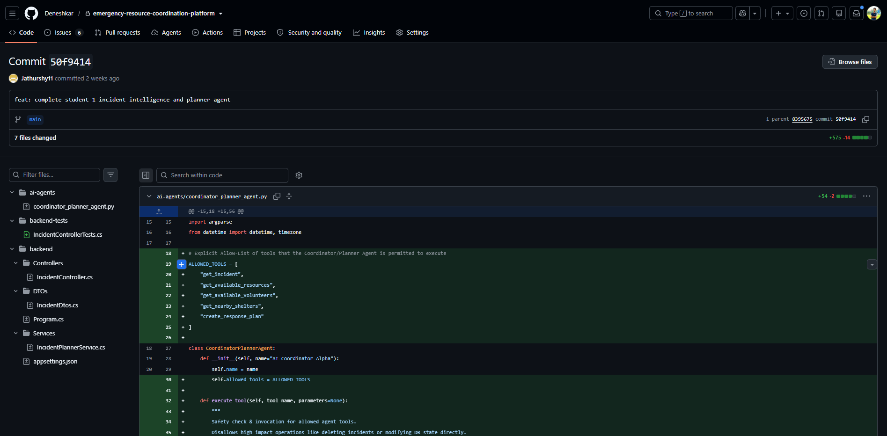
Figure 1 Jathurshy.S actual GitHub commit screenshot

G1 Personal Test Execution Screenshots
Personal execution on 7 October 2026 under declared operator Jathurshy.S. Verified raw results: 9 backend and 2 agent tests passed, no failures or skips; 2 separate agent demonstrations passed.
Declared operator: Jathurshy.S. Run started: 2026-10-07T16:24:59.058648+05:30.
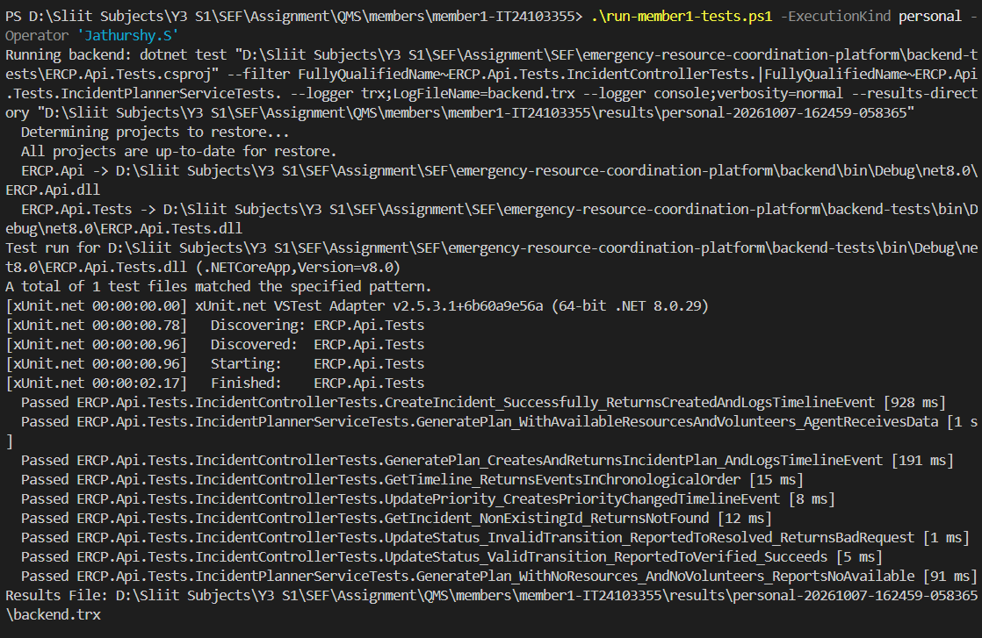
Figure 2 Jathurshy.S backend command and passing cases
Verified raw results: 9 tests passed, no failures or skips.
Original PNG: members/member1-IT24103355/results/personal-20261007-162459-058365/01-backend-tests.png
Open this run and its raw result links

G1 Jathurshy.S Screenshot 2 — Agent tests and completed run summary
Declared operator: Jathurshy.S. Run started: 2026-10-07T16:24:59.058648+05:30.
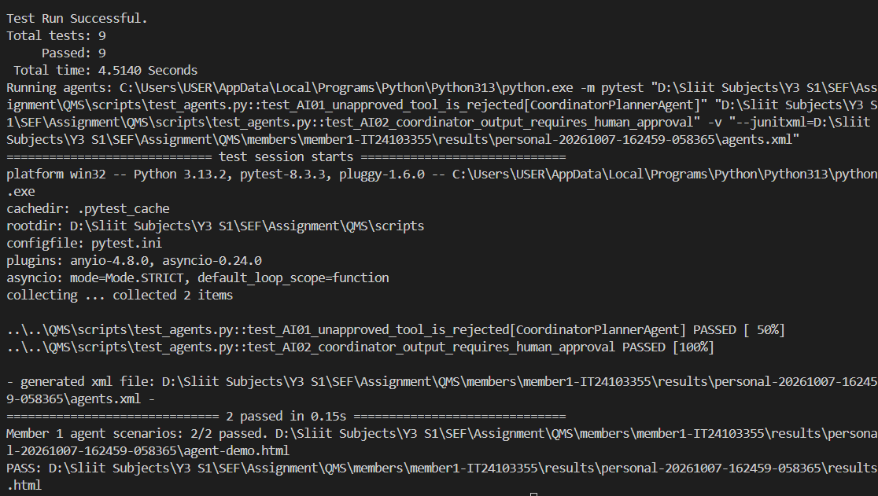
Figure 3 Jathurshy.S agent tests and completed run summary
Verified raw results: 2 tests passed, no failures or skips.
Original PNG: members/member1-IT24103355/results/personal-20261007-162459-058365/02-agent-tests-and-summary.png
Open this run and its raw result links

G1 Agent Input and Output Demonstrations
Submitted personal run with matching screenshots and raw reports; explanation received; viva assessment remains separate.
Operator: Jathurshy.S. Started: 2026-10-07T16:24:59.058648+05:30.
Executed area | Passed | Failed | Skipped
Selected backend tests | 9 | 0 | 0
Selected Python agent tests | 2 | 0 | 0
Separate agent scenarios | 2 | 0 | 0

M1-D01 Incident with available responders
Input: Incident 7; priority High; resources 1; volunteers 1.
Actual output: incidentId = 7; requiresHumanApproval = true; actions = ["Secure perimeter at Demo Sector", "Deploy allocated resources and volunteers"]. Result: PASS.

M1-D02 Incident without available resources
Input: Incident 8; priority Medium; resources 0; volunteers 0.
Actual output: requiresHumanApproval = true; reasoning = 1. Observed Medium priority General incident with 2 affected. 2. Gathered real data: No available resources found. 3. Gathered real data: No available volunteers found. 4. Identified constraint: Lack of required vehicles. 5. Identified constraint: Lack of required volunteers. 6. Formulating safe dispatch plan. Requires human validation before execution.. Result: PASS.
Incident details and supplied resources produce a response plan with actions, reasoning and required human approval. This deterministic demonstration does not call Gemini or save a plan to the database.
Open the dated test report
Open full agent input and output

G1 Personal Changed-Input Evidence and Comparison
Supplied personal terminal screenshot matched to the saved command, inputs and actual results. Both comparison scenarios passed. Declared operator: Jathurshy.S. Started: 2026-10-08T10:52:02.730954+05:30.
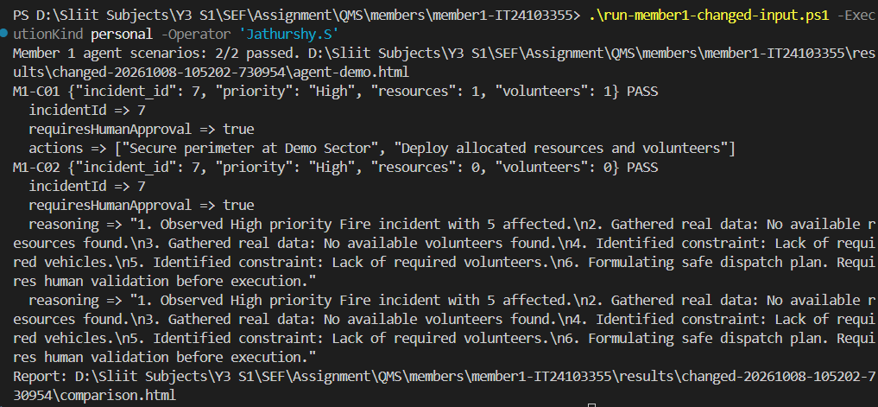
Figure 4 Jathurshy.S personal changed-input command and passing results
Observed result: Removing resources and volunteers causes the planner to report both shortages. Human approval remains true in both outputs. The plan is a proposal, not an independently executed emergency response.
Actual executed command: C:\Users\USER\AppData\Local\Programs\Python\Python313\python.exe QMS/scripts/run_changed_input.py --member 1 --operator "OpenAI Codex" --execution-kind ai-assisted
Input change: resources: 1 to 0; volunteers: 1 to 0. The incident, High priority and affected count stay unchanged.
Expected before execution: With resources and volunteers removed, reasoning should report both shortages while requiresHumanApproval remains true.
Scenario | Expected check | Actual result
M1-C01 | incidentId equals 7 | 7; PASS
M1-C01 | requiresHumanApproval equals true | true; PASS
M1-C01 | actions nonempty | 2 item(s); PASS
M1-C02 | incidentId equals 7 | 7; PASS
M1-C02 | requiresHumanApproval equals true | true; PASS
M1-C02 | reasoning contains "No available resources found" | Contains "No available resources found"; PASS
M1-C02 | reasoning contains "No available volunteers found" | Contains "No available volunteers found"; PASS

Personal comparison report and full input/output
Original screenshot and raw evidence links

G1 Written Explanation
IT24103355 | Incident Management | CoordinatorPlannerAgent
Received via the group representative on 8 October 2026. The following is an evidence-aligned editorial summary of the supplied explanation. Original wording is retained separately; assessed viva completion is not claimed.
Evidence reconciliation: The submitted High-to-Medium description matches the older M1-D01/M1-D02 examples. The supplied 8 October screenshot and raw personal run use M1-C01/M1-C02 and keep High priority. The summary below corrects that distinction; it is an edited evidence summary, not a verbatim member statement.

What input changed?
Available resources changed from one to zero and volunteers from one to zero. Priority remained High, with the same incident ID, title, category and affected count.

What was expected?
The supplied explanation expects the plan to identify resource and volunteer shortages while retaining human approval. That expectation matches the executed comparison.

What actually happened?
Both scenarios passed. The changed plan reports no available resources and no available volunteers, identifies the missing vehicles and volunteers as constraints, and returns requiresHumanApproval=true.

Which assertion or business rule explains the result?
The checks assert incidentId=7, requiresHumanApproval=true, and reasoning containing both shortage messages. The planner exposes constraints and proposes a response; it does not independently execute the plan.
Personal scenario IDs: M1-C01, M1-C02. Both passed.
Original statement
Summary and raw personal comparison

G2 M.Thanusikan IT24103609
Resource and Inventory Management with SituationAnalysisAgent.
25de8a92bee86fe982b6fdbbe65afdc35055ce43
Exact commit message: test(backend): Add edge case unit tests for shelters, inventory, and geolocation
Author date: 2026-09-16T08:24:46+05:30; committer date: 2026-09-16T08:24:46+05:30
Backend edge-case tests cover shelters, inventory and geolocation. These committed tests are distinct from the later QMS PostgreSQL and migration regressions.
6846af6080a41d8f9f02be333440d2fdcb641714
Exact commit message: test(react): Add unit tests for ShelterList, ResourceList, and InventoryList pages
Author date: 2026-09-16T08:28:53+05:30; committer date: 2026-09-16T08:28:53+05:30
React page tests cover ShelterList, ResourceList and InventoryList. Existing component tests retain the scope and limitations described in the report.
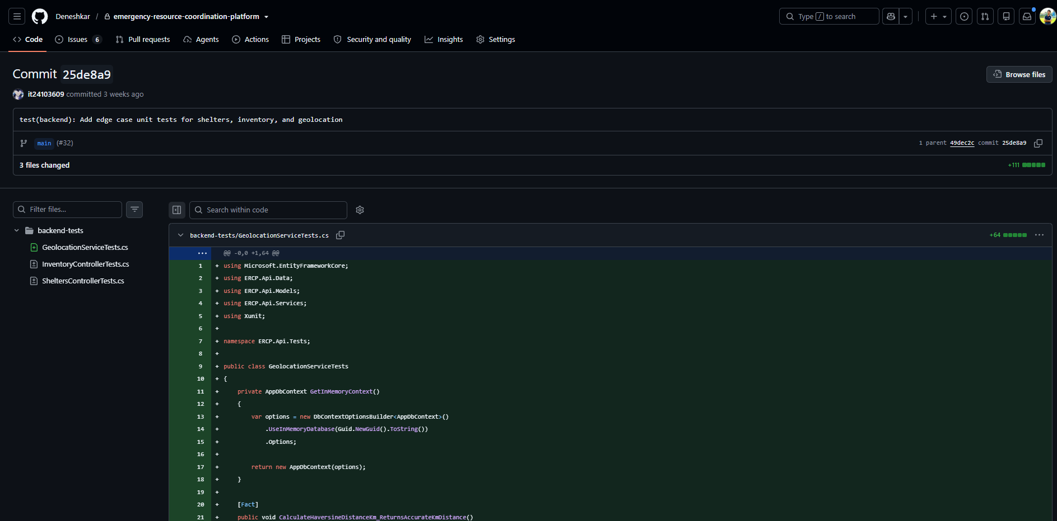
Figure 5 M.Thanusikan actual GitHub commit screenshot

G2 Personal Test Execution Screenshots
Personal execution on 7 October 2026 under declared operator M.Thanusikan. Verified raw results: 12 backend and 5 agent tests passed, no failures or skips; 2 separate agent demonstrations passed.
Declared operator: M.Thanusikan. Run started: 2026-10-07T16:26:42.902996+05:30.
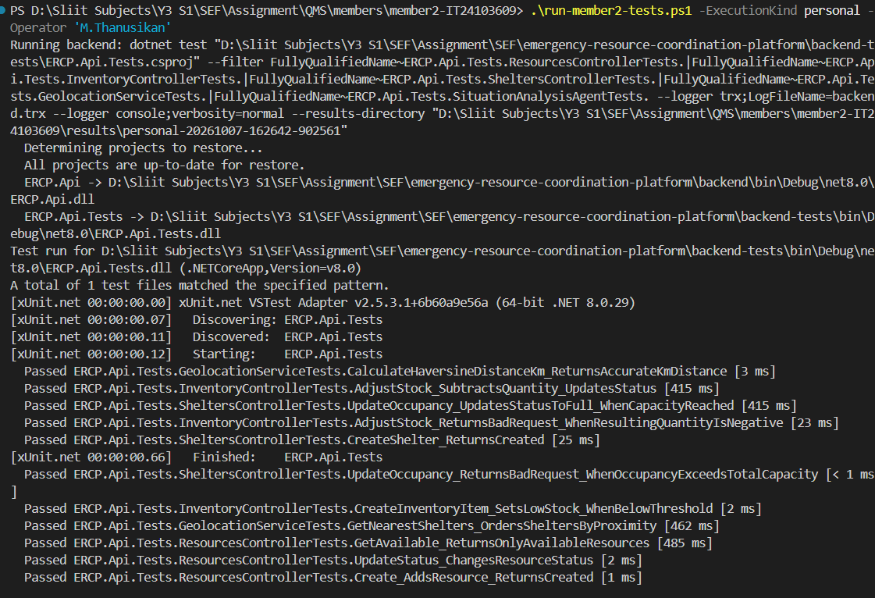
Figure 6 M.Thanusikan backend command and passing cases
Verified raw results: 12 tests passed, no failures or skips.
Original PNG: members/member2-IT24103609/results/personal-20261007-162642-902561/01-backend-tests.png
Open this run and its raw result links

G2 M.Thanusikan Screenshot 2 — Agent tests and completed run summary
Declared operator: M.Thanusikan. Run started: 2026-10-07T16:26:42.902996+05:30.
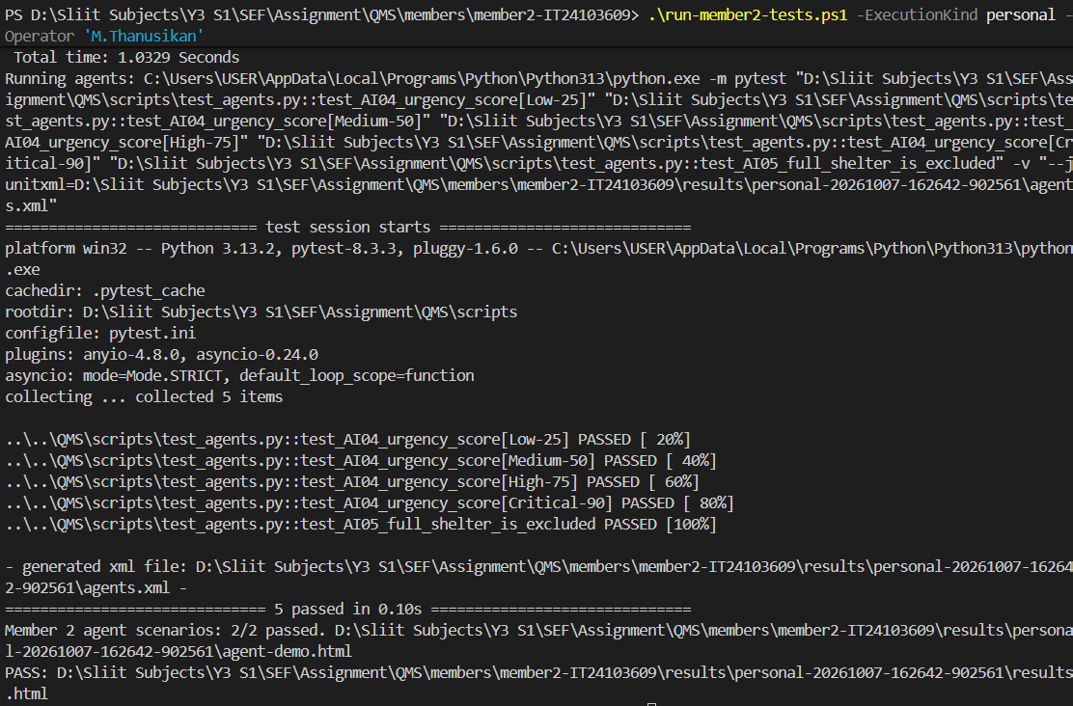
Figure 7 M.Thanusikan agent tests and completed run summary
Verified raw results: 5 tests passed, no failures or skips.
Original PNG: members/member2-IT24103609/results/personal-20261007-162642-902561/02-agent-tests-and-summary.png
Open this run and its raw result links

G2 Agent Input and Output Demonstrations
Submitted personal run with matching screenshots and raw reports; explanation received; viva assessment remains separate.
Operator: M.Thanusikan. Started: 2026-10-07T16:26:42.902996+05:30.
Executed area | Passed | Failed | Skipped
Selected backend tests | 12 | 0 | 0
Selected Python agent tests | 5 | 0 | 0
Separate agent scenarios | 2 | 0 | 0

M2-D01 Flood with inventory shortages
Input: Flood emergency; stock Medical=20, Food=100; shelters 1 occupancy 10/10, 2 occupancy 30/100.
Actual output: urgency_score = 85; nearest_shelter.id = 2; resource_deficiencies.0.isDeficit = true; llm_enhanced = false. Result: PASS.

M2-D02 Adequate stock but no shelter capacity
Input: Routine assistance; stock Medical=50, Food=100; shelters 1 occupancy 10/10.
Actual output: urgency_score = 25; nearest_shelter = null; resource_deficiencies.0.isDeficit = false; resource_deficiencies.2.isDeficit = false. Result: PASS.
Incident priority, inventory, resources and shelters produce urgency and shortage analysis. The current method named nearest_shelter selects the eligible shelter with most available capacity; it does not calculate geographic distance. Backend tests here use InMemory, not PostgreSQL.
Open the dated test report
Open full agent input and output

G2 Personal Changed-Input Evidence and Comparison
Supplied personal terminal screenshot matched to the saved command, inputs and actual results. Both comparison scenarios passed. Declared operator: M.Thanusikan. Started: 2026-10-08T10:52:29.627673+05:30.
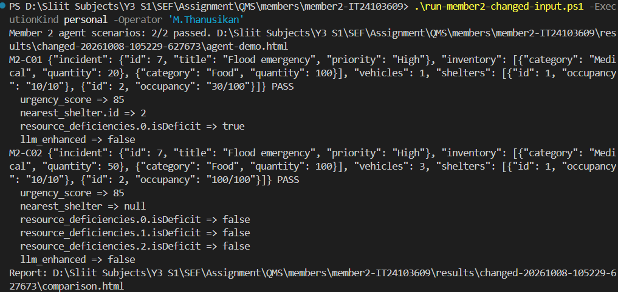
Figure 8 M.Thanusikan personal changed-input command and passing results
Observed result: Medical stock of 50, food stock of 100 and three available vehicles meet the current fixed baselines. With both shelters full, nearest_shelter is null. Despite its name, this field selects the active shelter with greatest available capacity, not geographic distance. Urgency stays 85 because the High-priority flood incident did not change.
Actual executed command: C:\Users\USER\AppData\Local\Programs\Python\Python313\python.exe QMS/scripts/run_changed_input.py --member 2 --operator "OpenAI Codex" --execution-kind ai-assisted
Input change: Medical stock: 20 to 50; available vehicles: 1 to 3; shelter 2 occupancy: 30/100 to 100/100. Food stays 100; shelter 1 stays 10/10; incident and High priority unchanged.
Expected before execution: Medical and vehicle deficits should clear; no shelter should be selected because both are full. Urgency remains 85 because the incident is unchanged.
Scenario | Expected check | Actual result
M2-C01 | urgency_score equals 85 | 85; PASS
M2-C01 | nearest_shelter.id equals 2 | 2; PASS
M2-C01 | resource_deficiencies.0.isDeficit equals true | true; PASS
M2-C01 | llm_enhanced equals false | false; PASS
M2-C02 | urgency_score equals 85 | 85; PASS
M2-C02 | nearest_shelter equals null | null; PASS
M2-C02 | resource_deficiencies.0.isDeficit equals false | false; PASS
M2-C02 | resource_deficiencies.1.isDeficit equals false | false; PASS
M2-C02 | resource_deficiencies.2.isDeficit equals false | false; PASS
M2-C02 | llm_enhanced equals false | false; PASS

Personal comparison report and full input/output
Original screenshot and raw evidence links

G2 Written Explanation
IT24103609 | Resource and Inventory Management | SituationAnalysisAgent
Received via the group representative on 8 October 2026. The following is an evidence-aligned editorial summary of the supplied explanation. Original wording is retained separately; assessed viva completion is not claimed.
Evidence reconciliation: The submitted routine-assistance description and 85-to-25 urgency change match the older M2-D01/M2-D02 examples. The supplied personal run uses M2-C01/M2-C02: both incidents are the same High-priority flood, both scores are 85, and two shelters remain. The summary below corrects the distinction; the member should review these corrections before the viva.

What input changed?
Medical stock increased from 20 to 50 and available vehicles from one to three. Food stayed at 100. Shelter 1 remained 10/10; shelter 2 changed from 30/100 to 100/100. The same High-priority flood incident remained in both inputs.

What was expected?
For this executed pair, the evidence-aligned expectation is that stock deficits clear and no shelter is selected, while urgency stays 85. The supplied expectation of lower urgency belongs to the older D-series pair, not this C-series run.

What actually happened?
Both scenarios passed. Urgency was 85 in both. The original output selected shelter 2 and showed a medical deficit. The changed output returned nearest_shelter=null and all three resource-deficiency flags false.

Which assertion or business rule explains the result?
The checks assert urgency_score=85, nearest_shelter=null, and false deficit flags after the change. Medical 50, food 100 and three vehicles meet the current baselines. Full shelters are excluded; eligible shelters are ranked by available capacity, not geographic distance.
Personal scenario IDs: M2-C01, M2-C02. Both passed.
Original statement
Summary and raw personal comparison

G3 Denesh N IT24102826
Dispatch and Task Assignment with ResourceAllocationAgent.
48a9c3b9cd87d67ce48b9c16aeb960be85baa266
Exact commit message: Implement dispatch task allocation
Resolved resource ID consistency, secured the dispatch approval workflow, completed the coordinator dispatch UI flow and added allocation and validation tests.
Author date: 2026-09-26T12:35:36+05:30; committer date: 2026-09-26T12:35:36+05:30
Backend dispatch allocation, validation and controller tests, plus React dispatch-page and validation-service tests, accompany the dispatch implementation.
cd967173f349ae343a729b885cb7182eca7a2d83
Exact commit message: fix: database migrations and prepare backend deployment
Migration: EF Core database updates for safe schema changes.
Author date: 2026-10-05T12:30:00+05:30; committer date: 2026-10-05T12:30:00+05:30
Removed duplicate migration table operations and upgraded MailKit. This is a database repair contribution; this commit does not itself prove execution of the later QMS migration tests.
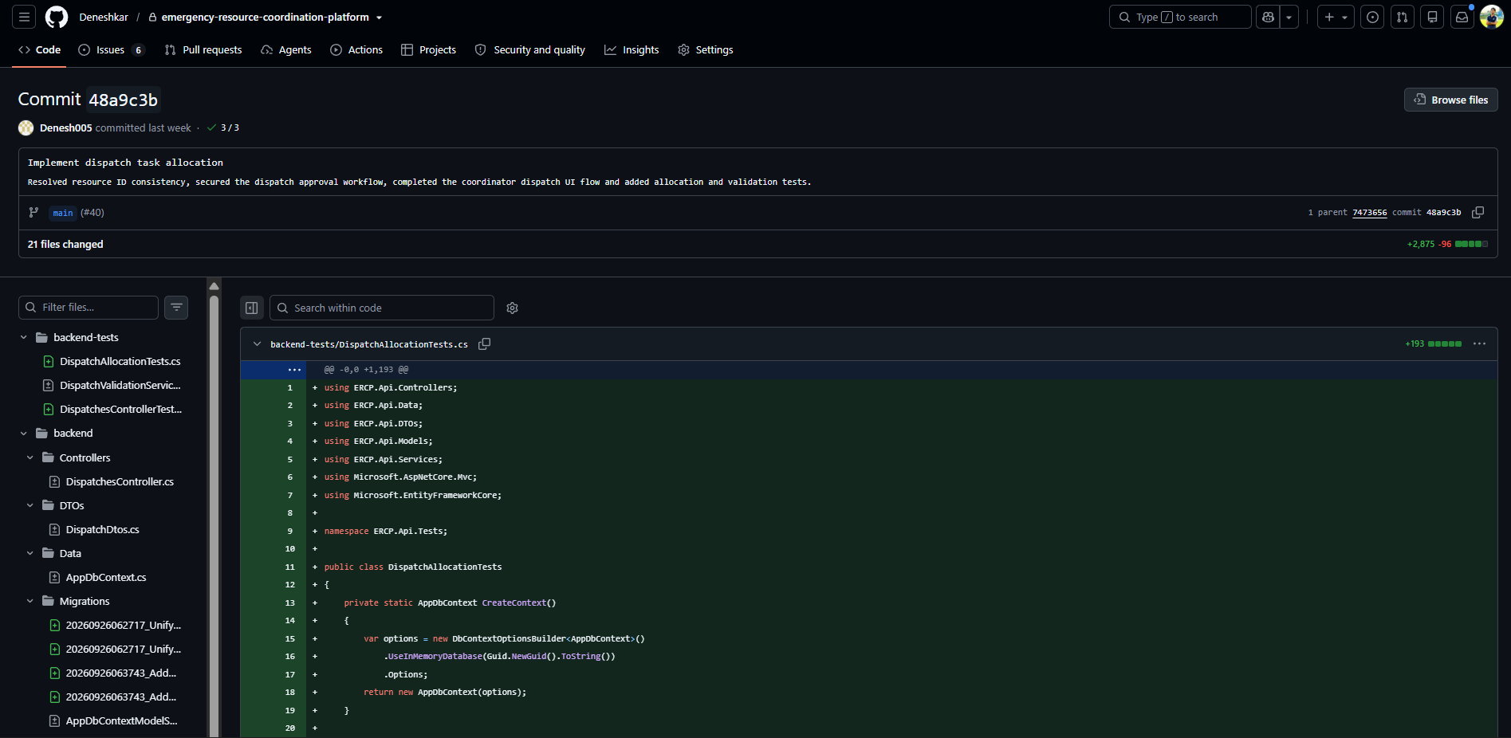
Figure 9 Denesh N actual GitHub commit screenshot

G3 Personal Test Execution Screenshots
Personal execution on 7 October 2026 under declared operator Denesh N. Verified raw results: 23 backend and 3 agent tests passed, no failures or skips; 2 separate agent demonstrations passed.
Declared operator: Denesh N. Run started: 2026-10-07T16:27:57.690871+05:30.
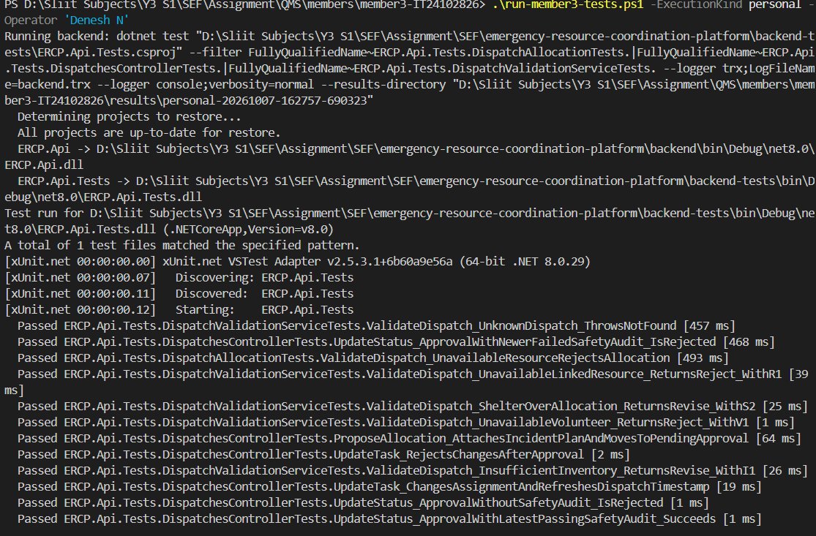
Figure 10 Denesh N backend command and passing cases
Verified raw results: 23 tests passed, no failures or skips.
Original PNG: members/member3-IT24102826/results/personal-20261007-162757-690323/01-backend-tests.png
Open this run and its raw result links

G3 Denesh N Screenshot 2 — Agent tests and completed run summary
Declared operator: Denesh N. Run started: 2026-10-07T16:27:57.690871+05:30.
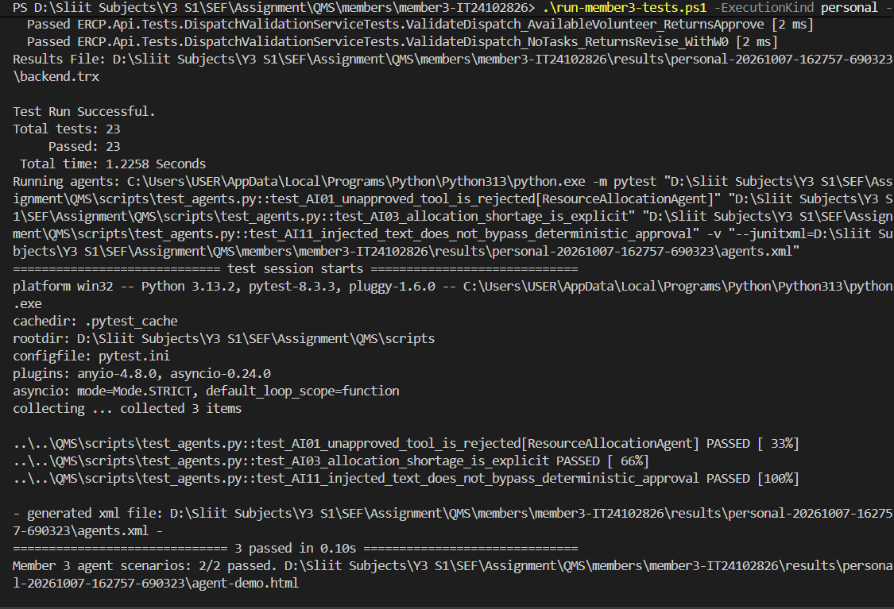
Figure 11 Denesh N agent tests and completed run summary
Verified raw results: 3 tests passed, no failures or skips.
Original PNG: members/member3-IT24102826/results/personal-20261007-162757-690323/02-agent-tests-and-summary.png
Open this run and its raw result links

G3 Agent Input and Output Demonstrations
Submitted personal run with matching screenshots and raw reports; explanation received; viva assessment remains separate.
Operator: Denesh N. Started: 2026-10-07T16:27:57.690871+05:30.
Executed area | Passed | Failed | Skipped
Selected backend tests | 23 | 0 | 0
Selected Python agent tests | 3 | 0 | 0
Separate agent scenarios | 2 | 0 | 0

M3-D01 Covered dispatch requirement
Input: Incident 7; priority Medium; available resources 1; volunteers 1.
Actual output: resource_gaps = []; allocated_resources = [{"id": 1, "name": "Response van", "resourceType": "Vehicle", "status": "Available", "purpose": "Transport"}]; allocation_plan.requires_human_approval = true; allocation_plan.recommendation = APPROVE. Result: PASS.

M3-D02 Insufficient resources for high-priority dispatch
Input: Incident 8; priority High; available resources 0; volunteers 0.
Actual output: resource_gaps = [{"resource_type": "Vehicle", "missing_qty": 2, "message": "Need 2 more Vehicle resources to meet the requirement."}, {"resource_type": "Medical", "missing_qty": 2, "message": "Need 2 more Medical resources to meet the requirement."}, {"resource_type": "Personnel", "missing_qty": 2, "message": "Need 2 more Personnel resources to meet the requirement."}]; allocated_resources = []; allocation_plan.requires_human_approval = true; allocation_plan.recommendation = REVISE. Result: PASS.
A dispatch requirement, resource pool and available volunteers produce a proposed allocation and shortage list. Human approval is always required; the displayed proposal does not execute a dispatch.
Open the dated test report
Open full agent input and output

G3 Personal Changed-Input Evidence and Comparison
Supplied personal terminal screenshot matched to the saved command, inputs and actual results. Both comparison scenarios passed. Declared operator: Denesh N. Started: 2026-10-08T10:52:50.078618+05:30.
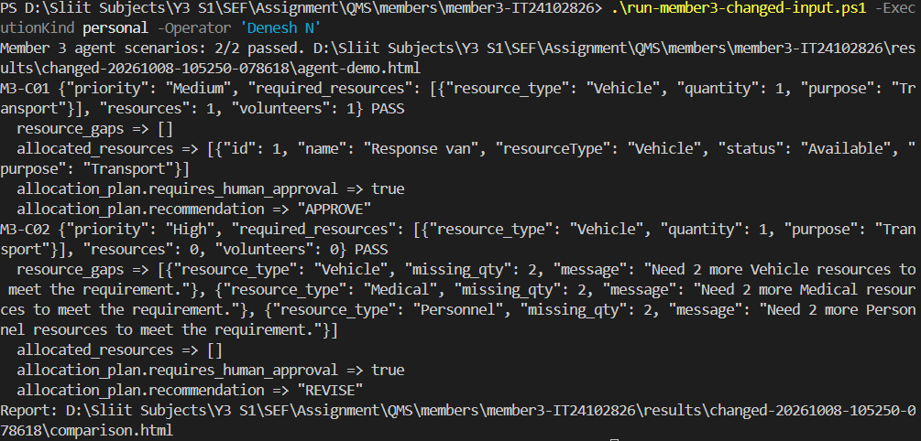
Figure 12 Denesh N personal changed-input command and passing results
Observed result: The Medium case allocates the available vehicle and has no gaps. The High case uses the current priority-based estimate, replacing the explicit one-vehicle input requirement with two vehicles, two medical resources and two personnel resources. With no resources, each category has a gap of two and the recommendation is REVISE. Human approval remains true. This comparison changes priority and availability together; it does not isolate the effect of each change.
Actual executed command: C:\Users\USER\AppData\Local\Programs\Python\Python313\python.exe QMS/scripts/run_changed_input.py --member 3 --operator "OpenAI Codex" --execution-kind ai-assisted
Input change: Priority: Medium to High; resources: 1 to 0; volunteers: 1 to 0. The explicit one-vehicle requirement and incident ID stay unchanged.
Expected before execution: The missing vehicle should produce a resource gap and REVISE; human approval remains required.
Scenario | Expected check | Actual result
M3-C01 | resource_gaps empty | 0 item(s); PASS
M3-C01 | allocated_resources nonempty | 1 item(s); PASS
M3-C01 | allocation_plan.requires_human_approval equals true | true; PASS
M3-C01 | allocation_plan.recommendation equals "APPROVE" | "APPROVE"; PASS
M3-C02 | resource_gaps nonempty | 3 item(s); PASS
M3-C02 | allocated_resources empty | 0 item(s); PASS
M3-C02 | allocation_plan.requires_human_approval equals true | true; PASS
M3-C02 | allocation_plan.recommendation equals "REVISE" | "REVISE"; PASS

Personal comparison report and full input/output
Original screenshot and raw evidence links

G3 Written Explanation
IT24102826 | Dispatch and Task Assignment | ResourceAllocationAgent
Received via the group representative on 8 October 2026. The following is an evidence-aligned editorial summary of the supplied explanation. Original wording is retained separately; assessed viva completion is not claimed.
Evidence reconciliation: The supplied explanation matches the personal run. Its submitted table labels D-series examples; the screenshot and dated comparison use M3-C01/M3-C02. The summary adds the observed High-priority requirement rule for clarity.

What input changed?
Priority changed from Medium to High, with available resources and volunteers each changing from one to zero. The input retained its explicit one-vehicle requirement.

What was expected?
The supplied expectation is an empty allocation, reported shortages and REVISE, while human approval remains required.

What actually happened?
Both scenarios passed. The original output allocated a response van, returned no gaps and APPROVE. The changed output allocated nothing, reported gaps of two Vehicles, two Medical resources and two Personnel, and returned REVISE. Human approval remained true.

Which assertion or business rule explains the result?
The checks assert empty/nonempty allocation and gap lists, requires_human_approval=true, and APPROVE/REVISE. In the current implementation, High priority replaces the explicit input requirement with the priority-based estimate. This comparison changes both priority and availability; it does not isolate their individual effects.
Personal scenario IDs: M3-C01, M3-C02. Both passed.
Original statement
Summary and raw personal comparison

G4 Deneshkar. P IT24103828
Volunteer/Responder Management with ValidationSafetyAgent.
3c059a63c9093f6347de4fbef73f9b3e7164910a
Exact commit message: feat: add volunteer shift and API integration tests, and update documentation
Author date: 2026-09-16T21:08:35+05:30; committer date: 2026-09-21T12:29:49+05:30
Volunteer shift tests and volunteer API integration tests accompany responder validation and controller changes.
ee924e23010cdc591afd7fa393c3b239c438bfef
Exact commit message: feat(security): restrict public registration to Citizen/Volunteer, lock dispatch writes to Coordinator/Admin
Author date: 2026-10-03T13:21:27+05:30; committer date: 2026-10-03T13:21:27+05:30
Committed public-role and dispatch authorization fixes, PostgreSQL/security regressions, and React protected-route/resource behaviour tests. QMS preparation and execution were AI-assisted.
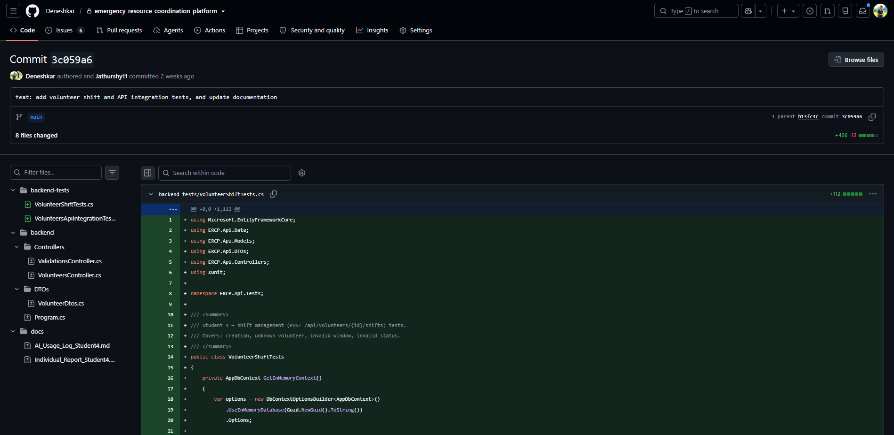
Figure 13 Deneshkar. P actual GitHub commit screenshot
GitHub records Deneshkar as author and Jathurshy11 as committer for 3c059a6. These are different Git roles.

G4 Confirmed Personal Test Execution
Deneshkar personally ran twelve existing tests on 6 October 2026. Six supplied screenshots and the raw TRX/XML reports support these results. This is the confirmed personal evidence for the volunteer component and its Validation/Safety Agent.
Personal suite | Passed | Evidence
VolunteerShiftTests | 4 | volunteer-shifts.trx; Controller test screenshot
VolunteersApiIntegrationTests | 5 | volunteer-http.trx; HTTP test screenshot
Safety checks AI08, AI09 and AI10 | 3 | safety-agent-20261006-152348.xml; Safety agent screenshot

The controller cases check a valid shift, invalid status, an unknown volunteer and an end before the start. HTTP tests cover seeded data, unauthorized access, trusted coordinator login, an invalid window and the shift lifecycle. The safety cases cover an unavailable volunteer, malformed input and adjacent shifts.
Open the personal evidence record

G4 Screenshot 1 — Controller test results
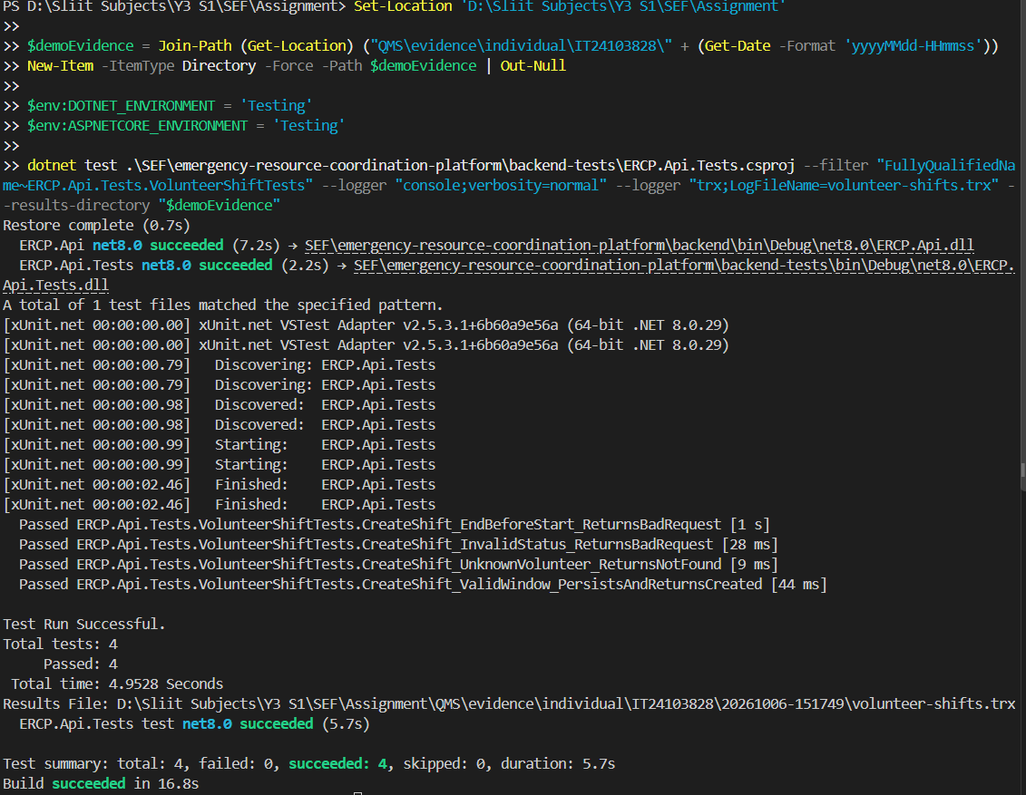
Figure 14 Deneshkar controller test results
Original supplied PNG: evidence/individual/IT24103828/20261006-151749/01-volunteer-shifts-results.png. Supporting report: volunteer-shifts.trx.

G4 Screenshot 2 — HTTP test command and startup
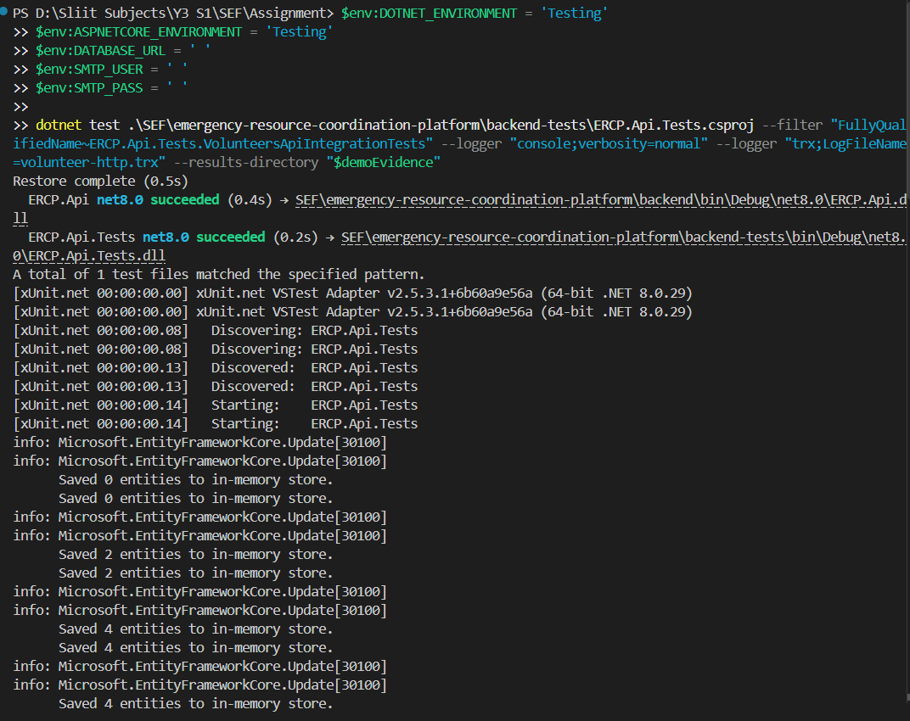
Figure 15 Deneshkar http test command and startup
Original supplied PNG: evidence/individual/IT24103828/20261006-151749/02-volunteer-http-command-and-start.png. Supporting report: volunteer-http.trx.

G4 Screenshot 3 — HTTP test in-memory database log
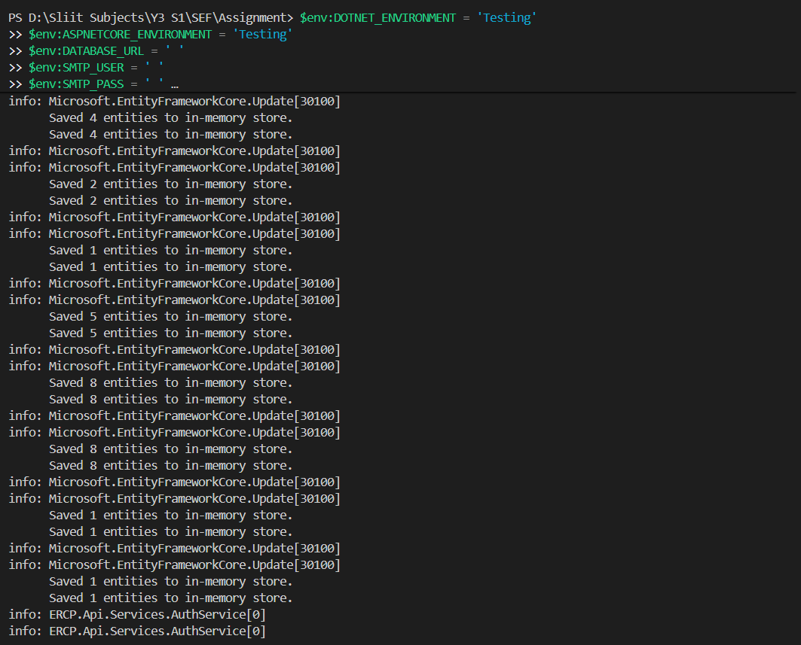
Figure 16 Deneshkar http test in-memory database log
Original supplied PNG: evidence/individual/IT24103828/20261006-151749/03-volunteer-http-database-log.png. Supporting report: volunteer-http.trx.

G4 Screenshot 4 — HTTP test authentication setup log
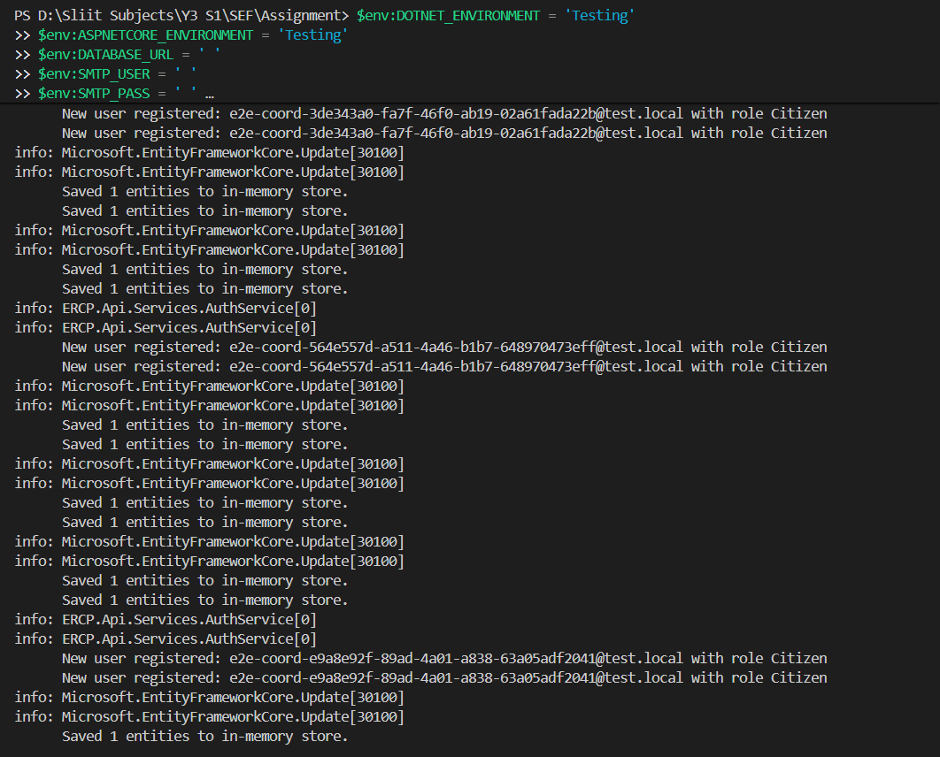
Figure 17 Deneshkar http test authentication setup log
Original supplied PNG: evidence/individual/IT24103828/20261006-151749/04-volunteer-http-authentication-log.png. Supporting report: volunteer-http.trx.

G4 Screenshot 5 — HTTP test results
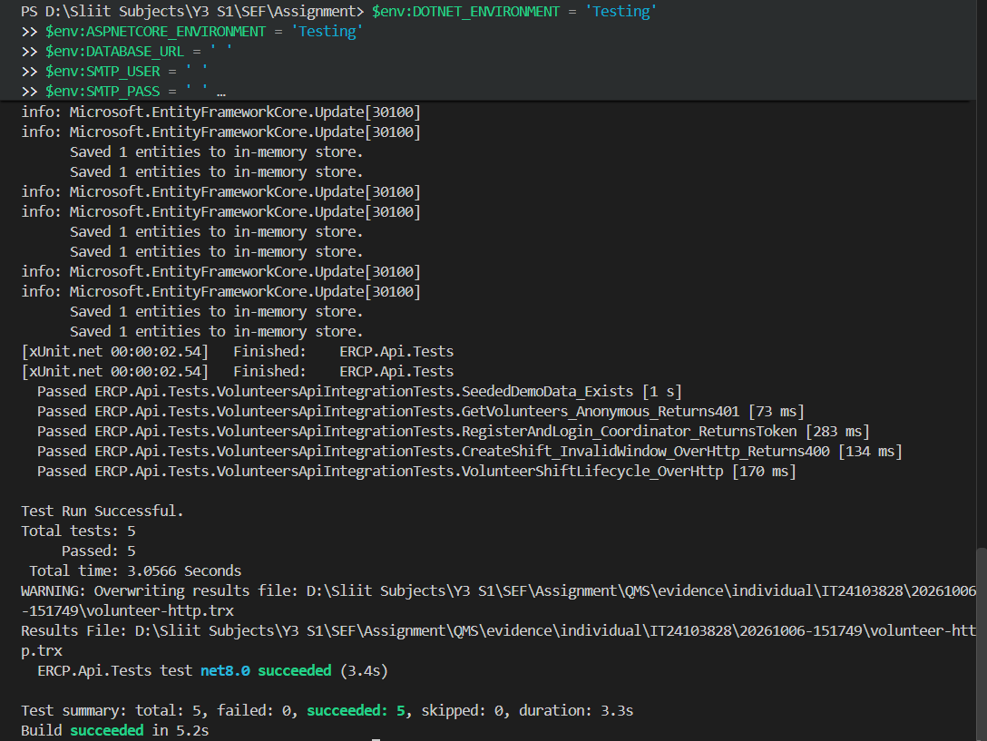
Figure 18 Deneshkar http test results
Original supplied PNG: evidence/individual/IT24103828/20261006-151749/05-volunteer-http-results.png. Supporting report: volunteer-http.trx.

G4 Screenshot 6 — Safety-agent test results
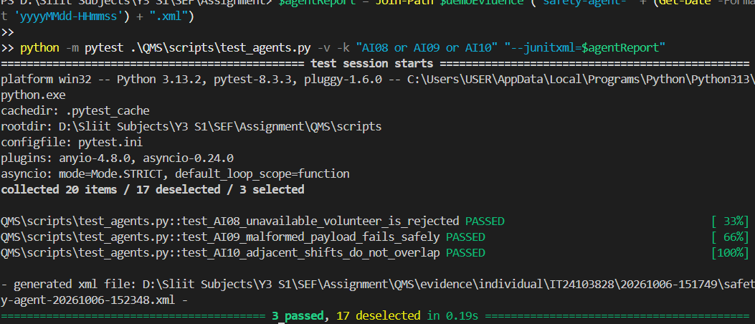
Figure 19 Deneshkar safety-agent test results
Original supplied PNG: evidence/individual/IT24103828/20261006-151749/06-safety-agent-results.png. Supporting report: safety-agent-20261006-152348.xml.

G4 Agent Input and Output Demonstrations
Historical technical execution - run by Codex; later personal evidence and explanations are recorded separately.
Operator: OpenAI Codex (on behalf of Deneshkar. P). Started: 2026-10-06T22:39:20.979275+05:30.
Executed area | Passed | Failed | Skipped
Selected backend tests | 9 | 0 | 0
Selected Python agent tests | 10 | 0 | 0
Separate agent scenarios | 4 | 0 | 0

M4-D01 Available volunteer with valid shift
Input: Available=True; proposed 10:00-11:00 UTC; existing none.
Actual output: is_valid = true; recommendation = APPROVE; checks.1.passed = true. Result: PASS.

M4-D02 Unavailable volunteer
Input: Available=False; proposed 10:00-11:00 UTC; existing none.
Actual output: is_valid = false; recommendation = REJECT; violations.0.code = V1_VOLUNTEER_UNAVAILABLE. Result: PASS.

M4-D03 Overlapping shift requires revision
Input: Available=True; proposed 09:30-11:00 UTC; existing 09:00-10:00.
Actual output: is_valid = false; recommendation = REVISE; violations.0.code = V2_DOUBLE_BOOKING. Result: PASS.

M4-D04 Adjacent shifts do not overlap
Input: Available=True; proposed 10:00-11:00 UTC; existing 09:00-10:00.
Actual output: is_valid = true; recommendation = APPROVE; checks.1.passed = true. Result: PASS.
Responder availability and shift windows produce a validation decision, individual checks and violation reasons. An overlapping assignment returns REVISE because it can be rescheduled. APPROVE is an agent recommendation; a coordinator still makes the actual approval.
Open the dated test report
Open full agent input and output

G4 Personal Changed-Input Evidence and Comparison
Supplied personal terminal screenshot matched to the saved command, inputs and actual results. Both comparison scenarios passed. Declared operator: Deneshkar. P. Started: 2026-10-08T10:51:28.171178+05:30.
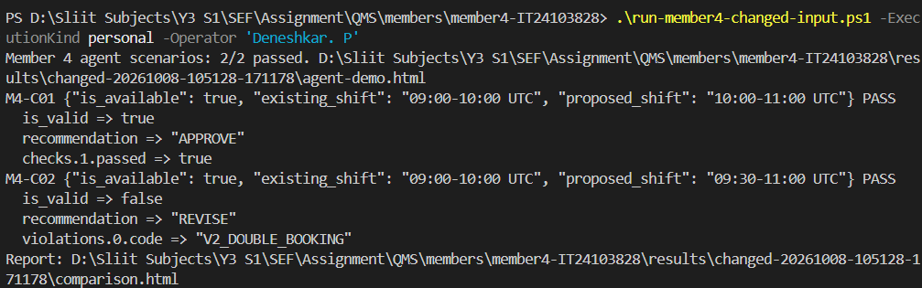
Figure 20 Deneshkar. P personal changed-input command and passing results
Observed result: The overlap predicate uses half-open intervals: new_start < existing_end and existing_start < new_end. At 10:00 the first comparison is false; at 09:30 both are true. V2_DOUBLE_BOOKING is in the agent's revisable violation set, so this available volunteer receives REVISE. Availability alone is not sufficient for approval. APPROVE is only a recommendation; coordinator approval is a separate API operation.
Actual executed command: C:\Users\USER\AppData\Local\Programs\Python\Python313\python.exe QMS/scripts/run_changed_input.py --member 4 --operator "OpenAI Codex" --execution-kind ai-assisted
Input change: Only proposed_shift.start changes: 10:00 to 09:30 UTC. Existing shift remains 09:00-10:00, end remains 11:00, volunteer remains available.
Expected before execution: The original adjacent 10:00-11:00 shift should be valid and APPROVE. Changing only its start to 09:30 should produce is_valid=false, REVISE and V2_DOUBLE_BOOKING.
Scenario | Expected check | Actual result
M4-C01 | is_valid equals true | true; PASS
M4-C01 | recommendation equals "APPROVE" | "APPROVE"; PASS
M4-C01 | checks.1.passed equals true | true; PASS
M4-C02 | is_valid equals false | false; PASS
M4-C02 | recommendation equals "REVISE" | "REVISE"; PASS
M4-C02 | violations.0.code equals "V2_DOUBLE_BOOKING" | "V2_DOUBLE_BOOKING"; PASS

Personal comparison report and full input/output
Original screenshot and raw evidence links

G4 Written Explanation
IT24103828 | Volunteer/Responder Management | ValidationSafetyAgent
Received via the group representative on 8 October 2026. The following is an evidence-aligned editorial summary of the supplied explanation. Original wording is retained separately; assessed viva completion is not claimed.
Evidence reconciliation: The prior supplied explanation is preserved verbatim in Understanding_Submitted_20261008.md. The following four-part summary combines it with the verified M4-C01/M4-C02 personal run. It is not a new verbatim statement.

What input changed?
Only the proposed shift start changed, from 10:00 to 09:30 UTC. The existing shift stayed 09:00-10:00, the proposed end stayed 11:00 and the volunteer remained available.

What was expected?
The previously supplied explanation identifies adjacent shifts as non-overlapping and the 09:30 start as a 30-minute conflict requiring revision.

What actually happened?
Both personal scenarios passed. The adjacent case returned is_valid=true and APPROVE. The changed case returned is_valid=false, REVISE and V2_DOUBLE_BOOKING.

Which assertion or business rule explains the result?
The checks assert those returned fields. Half-open intervals overlap when new_start < existing_end and existing_start < new_end. Equality at 10:00 is allowed. V2_DOUBLE_BOOKING is revisable; an agent recommendation does not itself approve the dispatch.
Personal scenario IDs: M4-C01, M4-C02. Both passed.
Original statement
Summary and raw personal comparison

G5 Assistance and Submission Status
OpenAI Codex assisted with analysis, test and repair preparation, technical execution, evidence organization and document production under the repository owner’s direction. Historical member authorship remains tied to the verified Git commits. Technical execution records identify Codex as operator. Personal explanations and understanding have not been written or confirmed on behalf of the members.
Each member’s consolidated section (G1 to G4) brings together their verified Git commits, personal test execution terminal screenshots, agent demonstration input/output records, personal changed-input screenshot and comparison table, and written explanation in one unified order.
The repository owner confirmed the submission module as SE3110 - Quality Management in Software Engineering. Remaining actions are to complete genuine member demonstrations and reflections, transfer the assistance declaration into the lecturer-provided CLEAR format and submit through CourseWeb. The brief does not define the CLEAR headings, so an alternative expansion has not been invented.
Personal changed-input demonstration instructions
The included source, case inventory, defect log, raw reports and member packages allow the results to be checked. Keep the complete submission ZIP when following relative links from this document.

Appendix H Visual Evidence — Screenshots
This appendix presents visual evidence from the live running ERCP Web Platform frontend (React and Vite) connected to the ASP.NET Core Web API and PostgreSQL backend. The screenshots capture the operational user interface across public entry points, coordinator dashboards, emergency incident tracking, resource and inventory hubs, evacuation shelters, dispatch management, responder profiles, and AI situation analysis.

H.1 Platform Overview and Authentication
Public landing page showing 24/7 AI emergency response network, rapid disaster triage, real-time metrics, emergency reporting, and operations portal access.
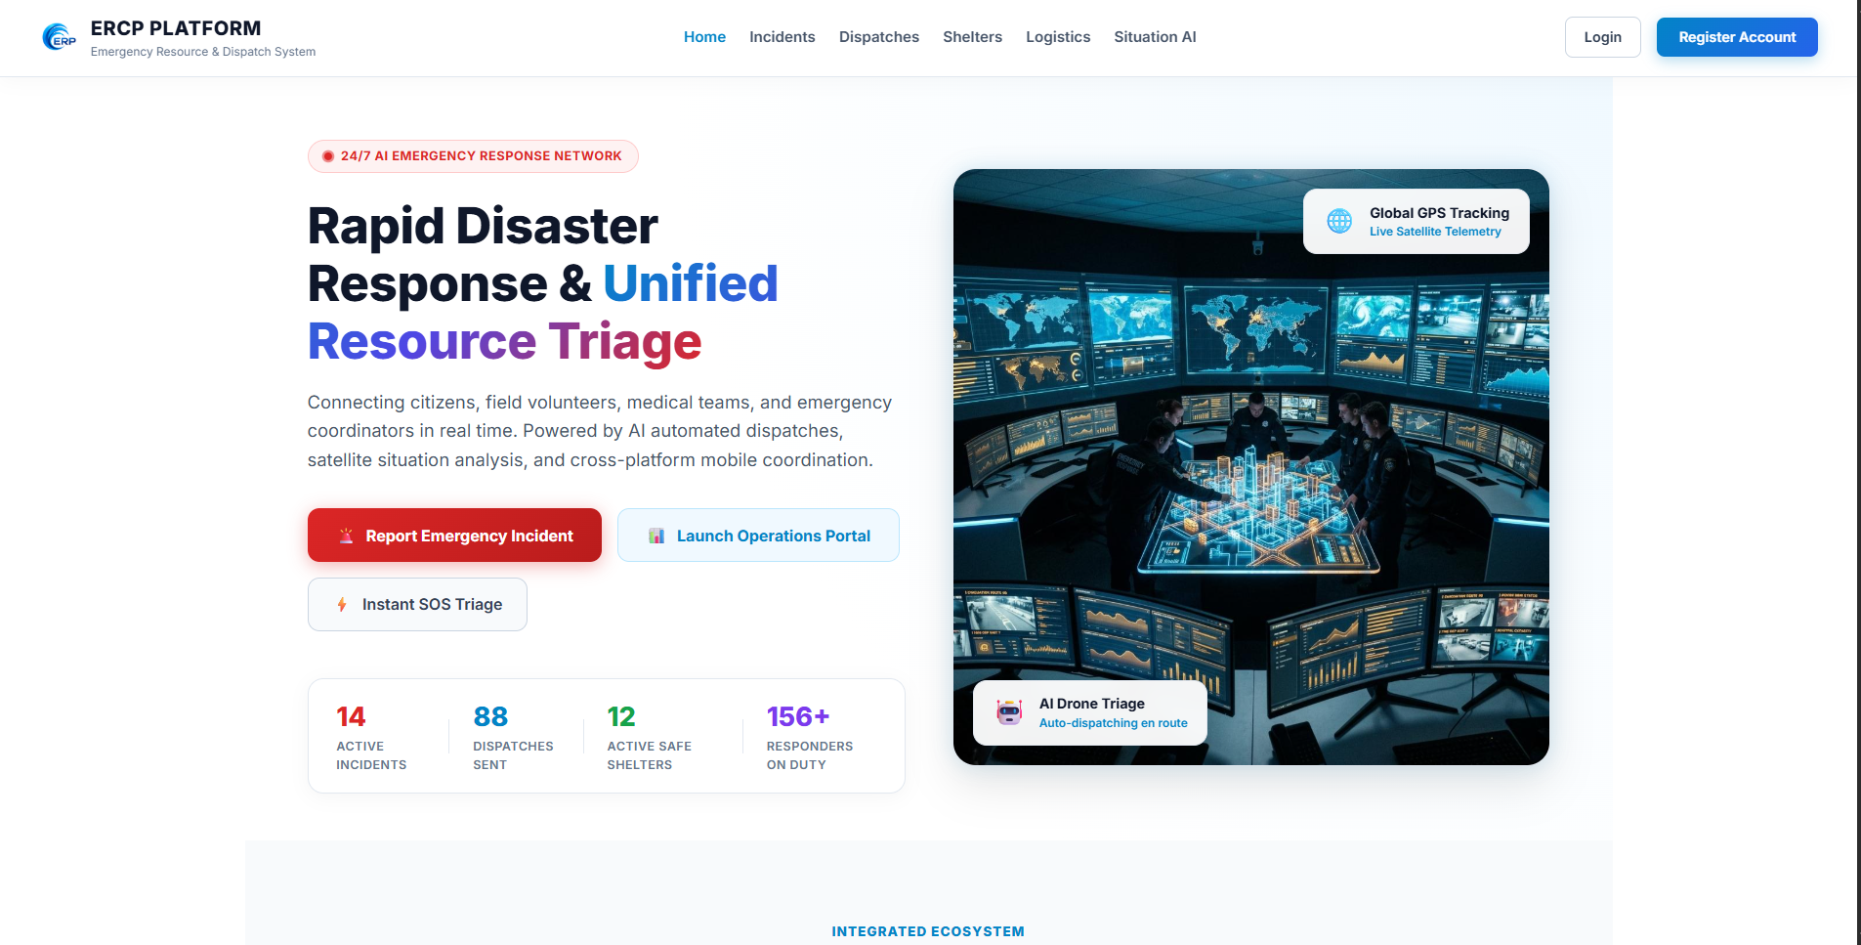
Figure 21 ERCP Platform Public Home Page — Emergency Response and Triage Portal
Role-based sign-in screen supporting Coordinator, Volunteer, Citizen, and Administrator access.
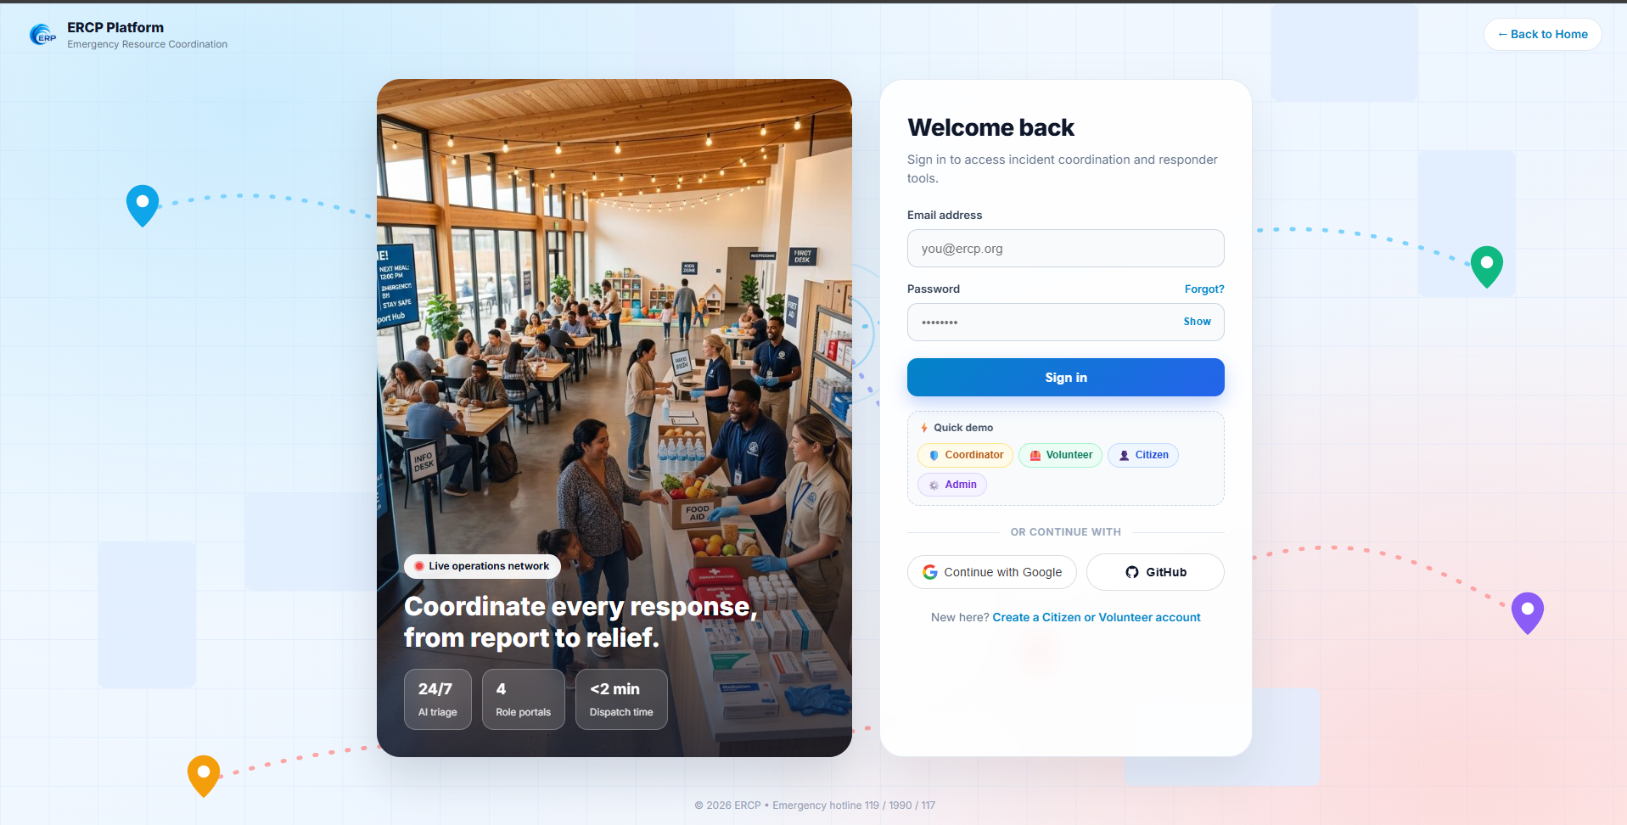
Figure 22 ERCP Platform Multi-Role Authentication Interface
Live command center dashboard displaying active emergency metrics, dispatch progress, volunteer availability, resource count, shelter occupancy, and inventory alerts.
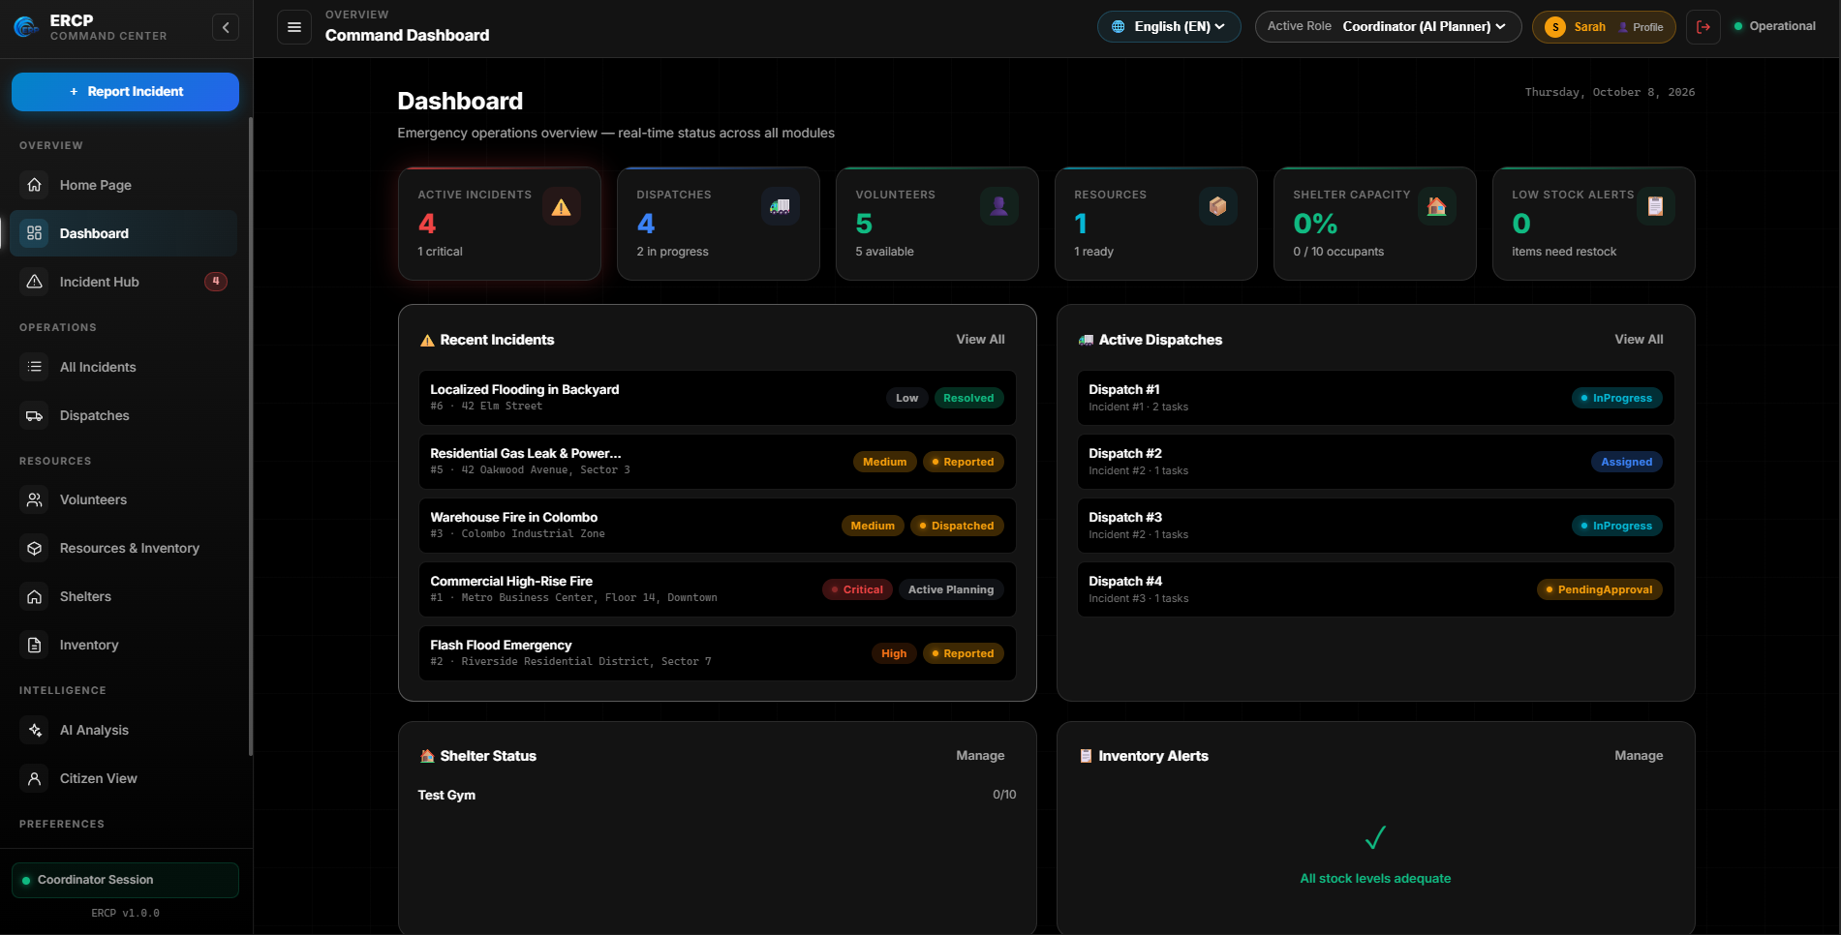
Figure 23 ERCP Operations Command Dashboard

H.2 Member 1 — Incident Management UI (Jathurshy S)
Real-time monitoring of registered emergency events, priority classification, and active AI Coordinator response plan generation.
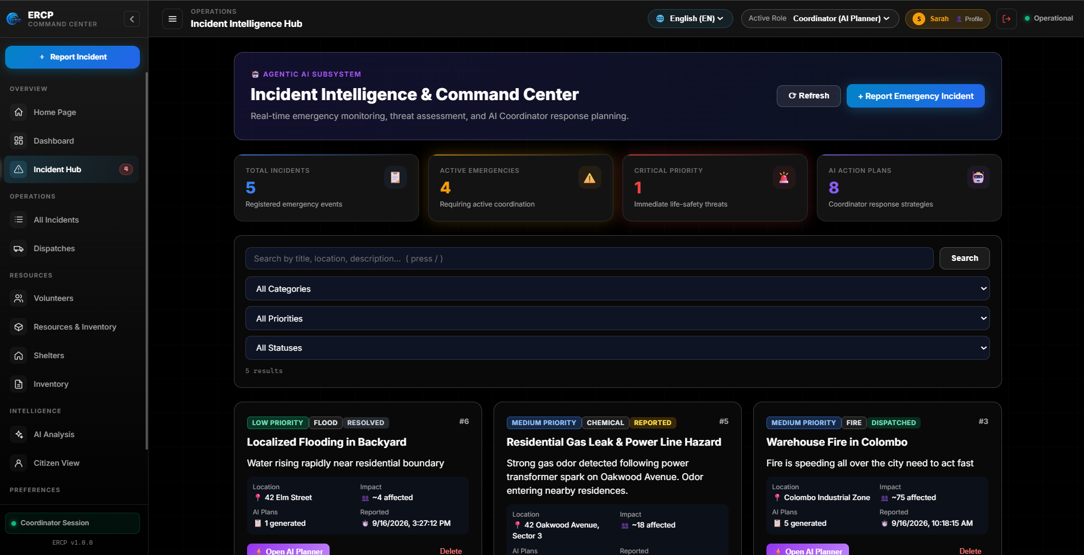
Figure 24 Incident Intelligence & Command Center (Incident Hub)
Operations table displaying reported incidents categorized by severity (Critical, High, Medium, Low) and lifecycle status.
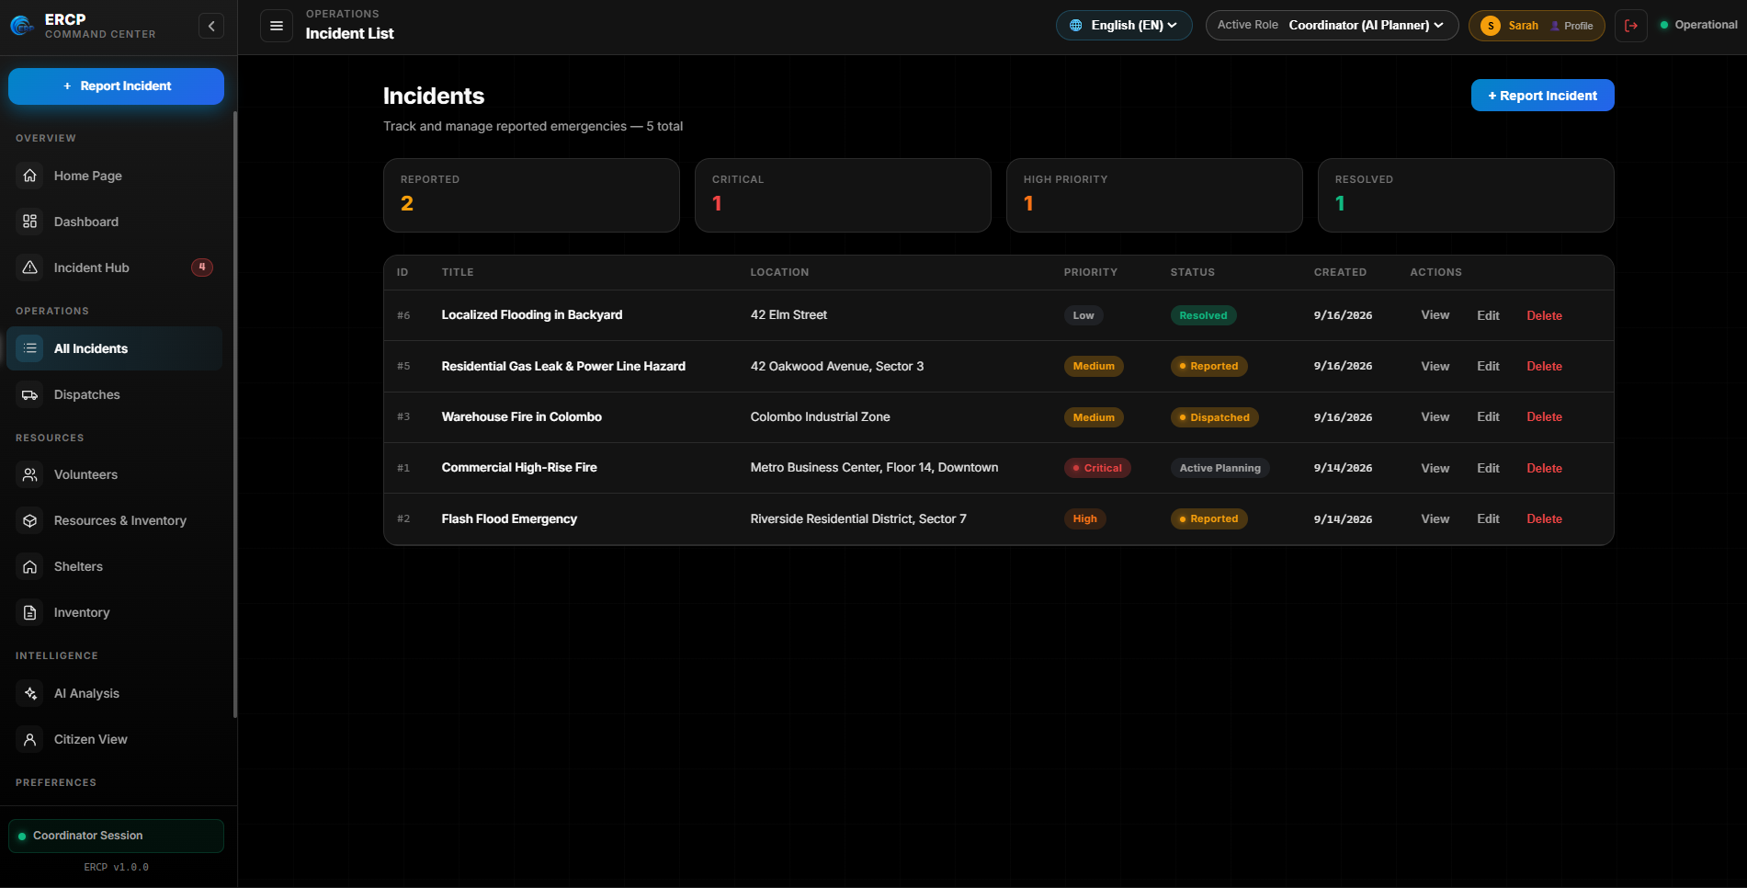
Figure 25 Incident Management and Tracking Table

H.3 Member 2 — Resource, Shelter & AI Situation Analysis UI (M. Thanusikan)
Fleet and shelter management interface displaying vehicle availability, shelter occupancy percentages, and Situation Analysis AI readiness.
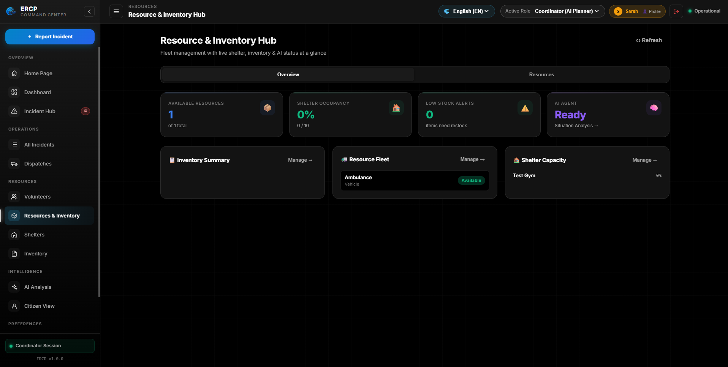
Figure 26 Resource & Inventory Hub — Operations Fleet and Shelters Overview
Real-time shelter capacity control showing total capacity, current headcount, available slots, and full-capacity exclusion.
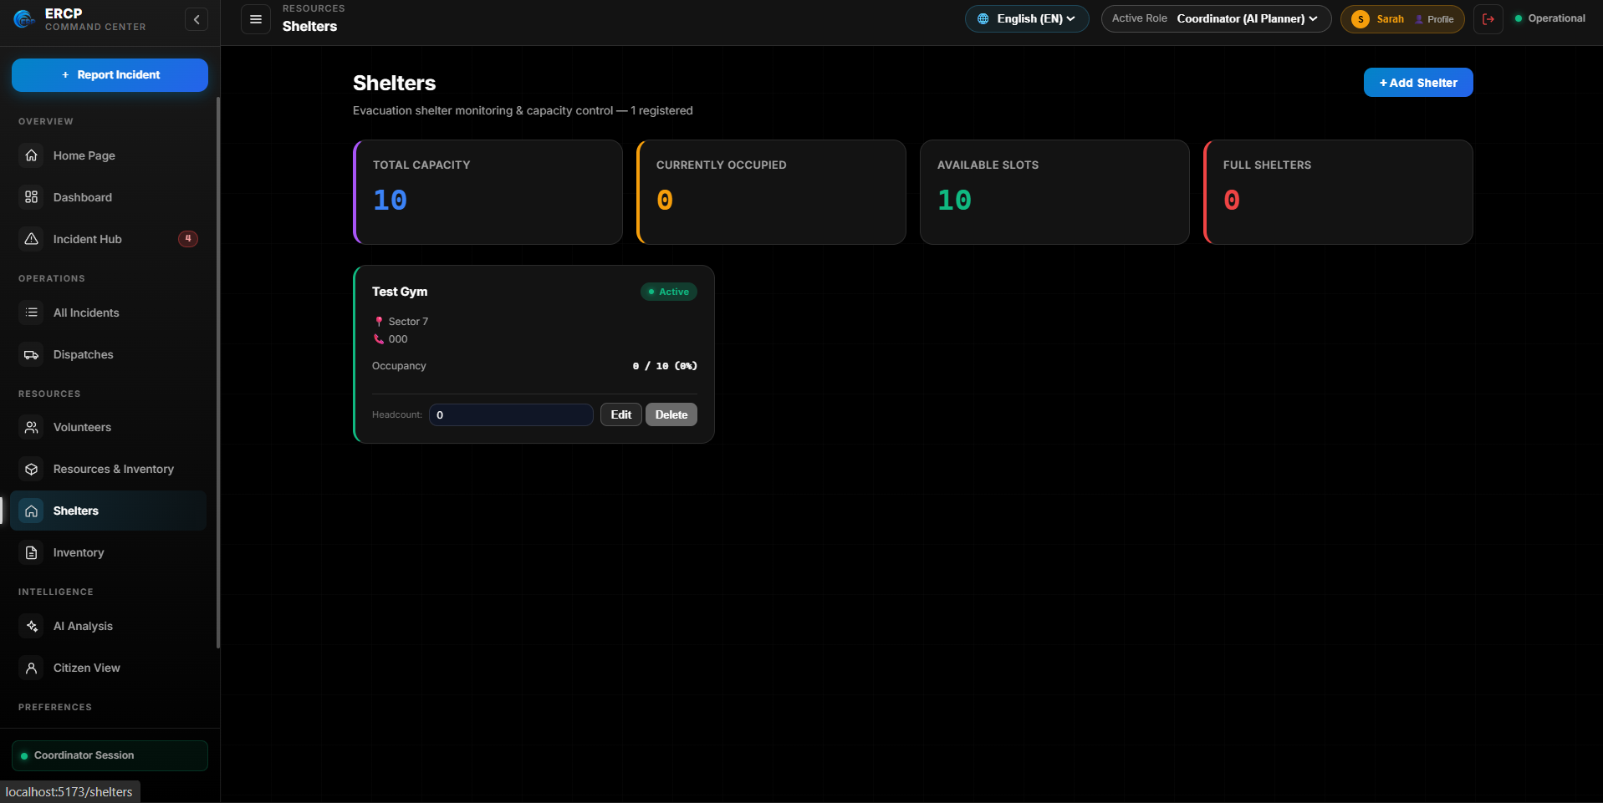
Figure 27 Evacuation Shelter Capacity and Occupancy Control
Stock monitoring interface tracking emergency supplies, item thresholds, and stock replenishment alerts.
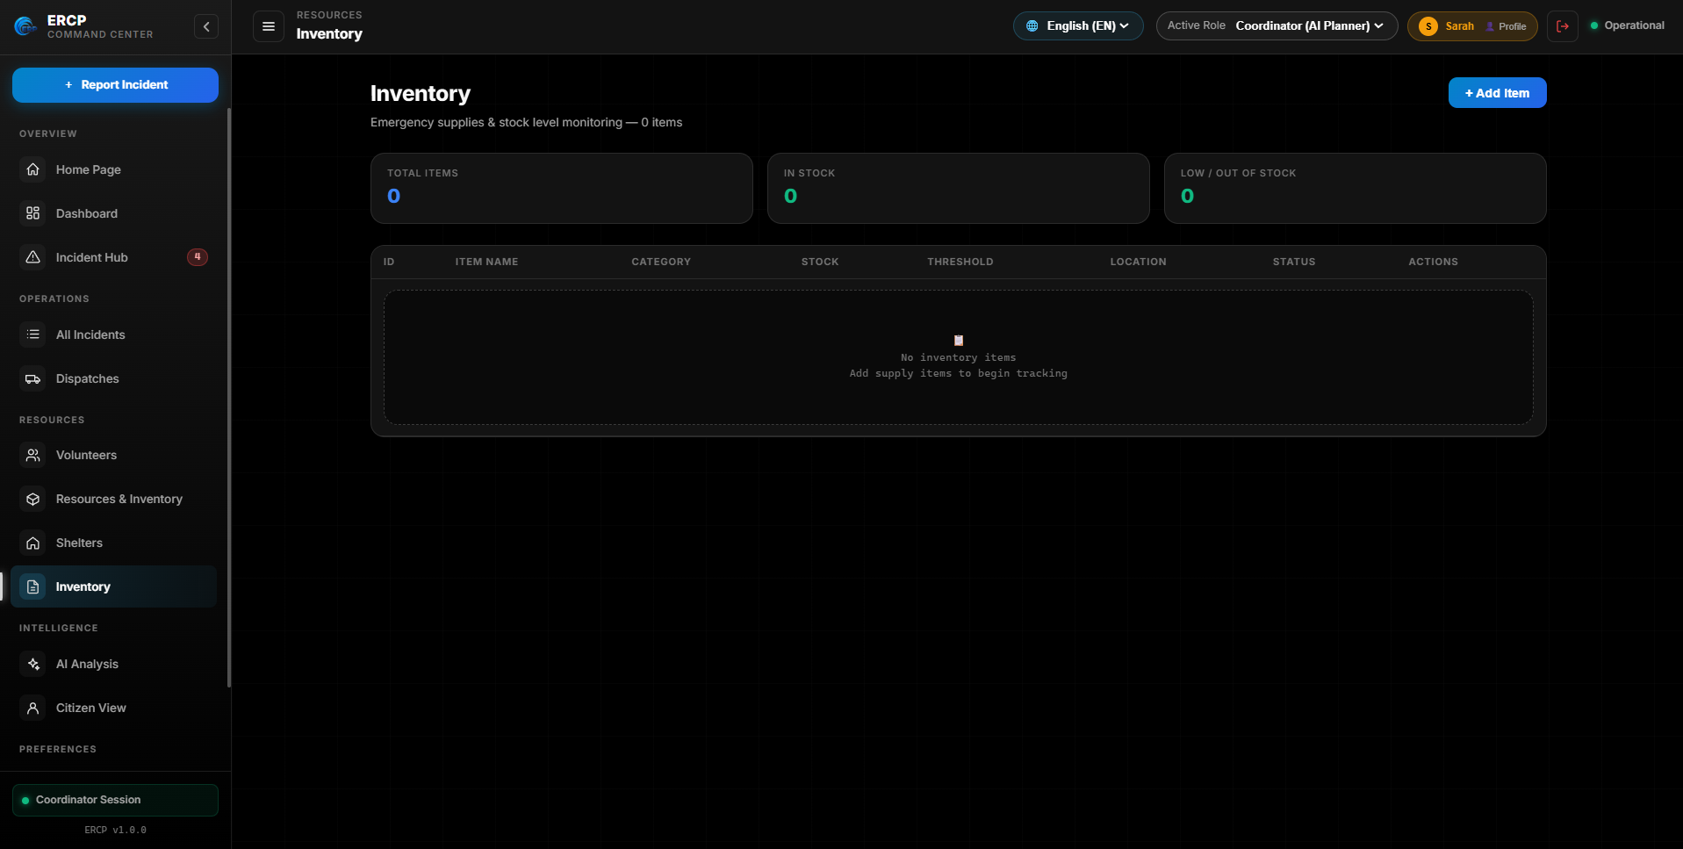
Figure 28 Relief Supplies and Emergency Inventory Monitoring
Interactive intelligence module for executing the Situation Analysis Agent to evaluate incident urgency, detect supply deficits, and match eligible shelters.
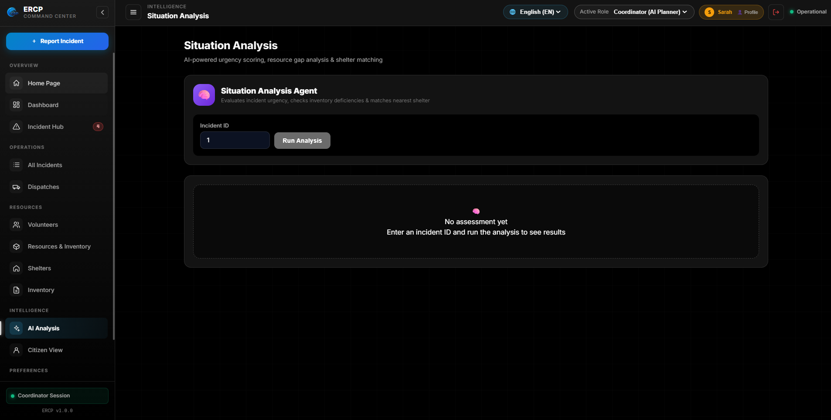
Figure 29 Situation Analysis AI Agent Assessment Interface

H.4 Member 3 — Dispatch & Task Assignment UI (Denesh N)
Resource allocation and dispatch workflow displaying pending approval, assigned, and in-progress dispatches, task assignments, and safety check controls.
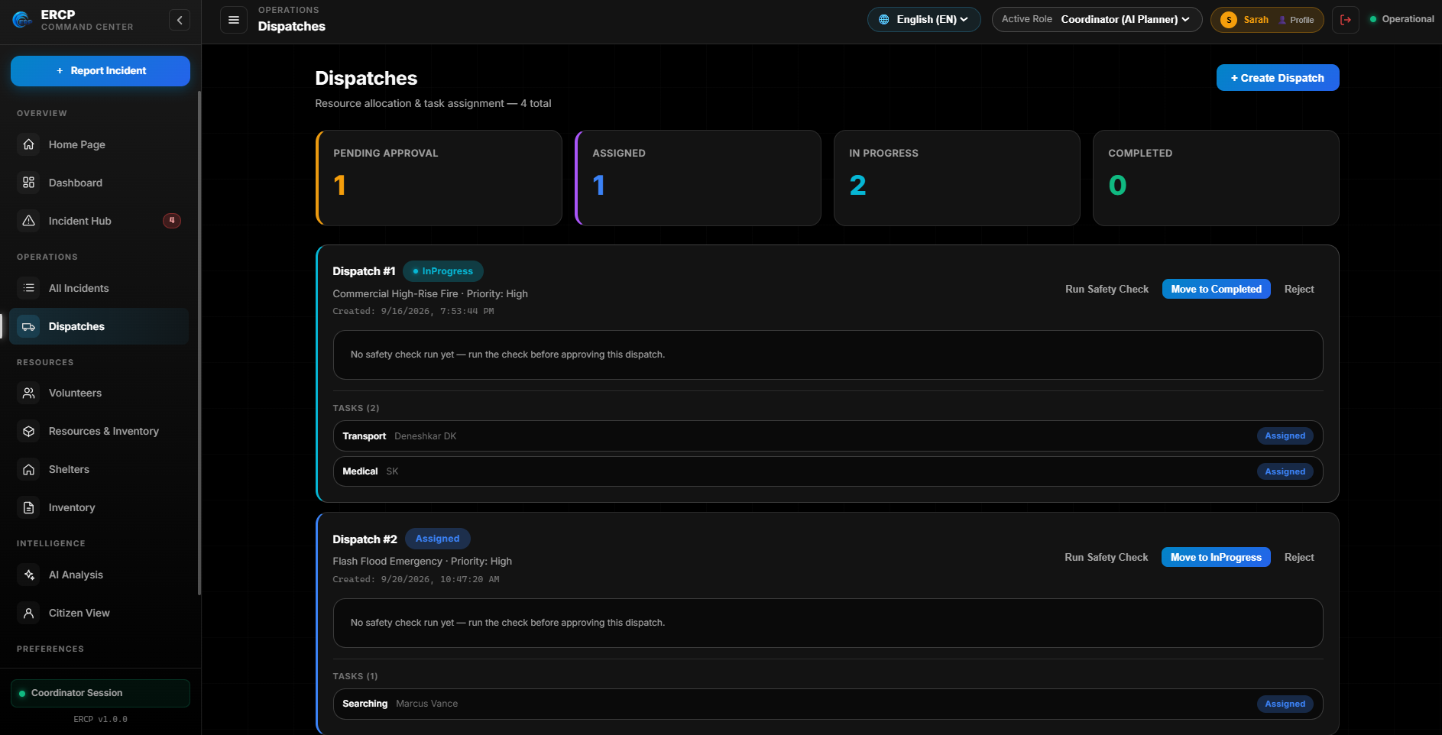
Figure 30 Dispatch Operations and Task Assignment Interface

H.5 Member 4 — Volunteer & Responder Management UI (Deneshkar P)
Volunteer coordination interface displaying responder profiles, contact information, verified skills (driving, medical EMT, search & rescue), and active availability.
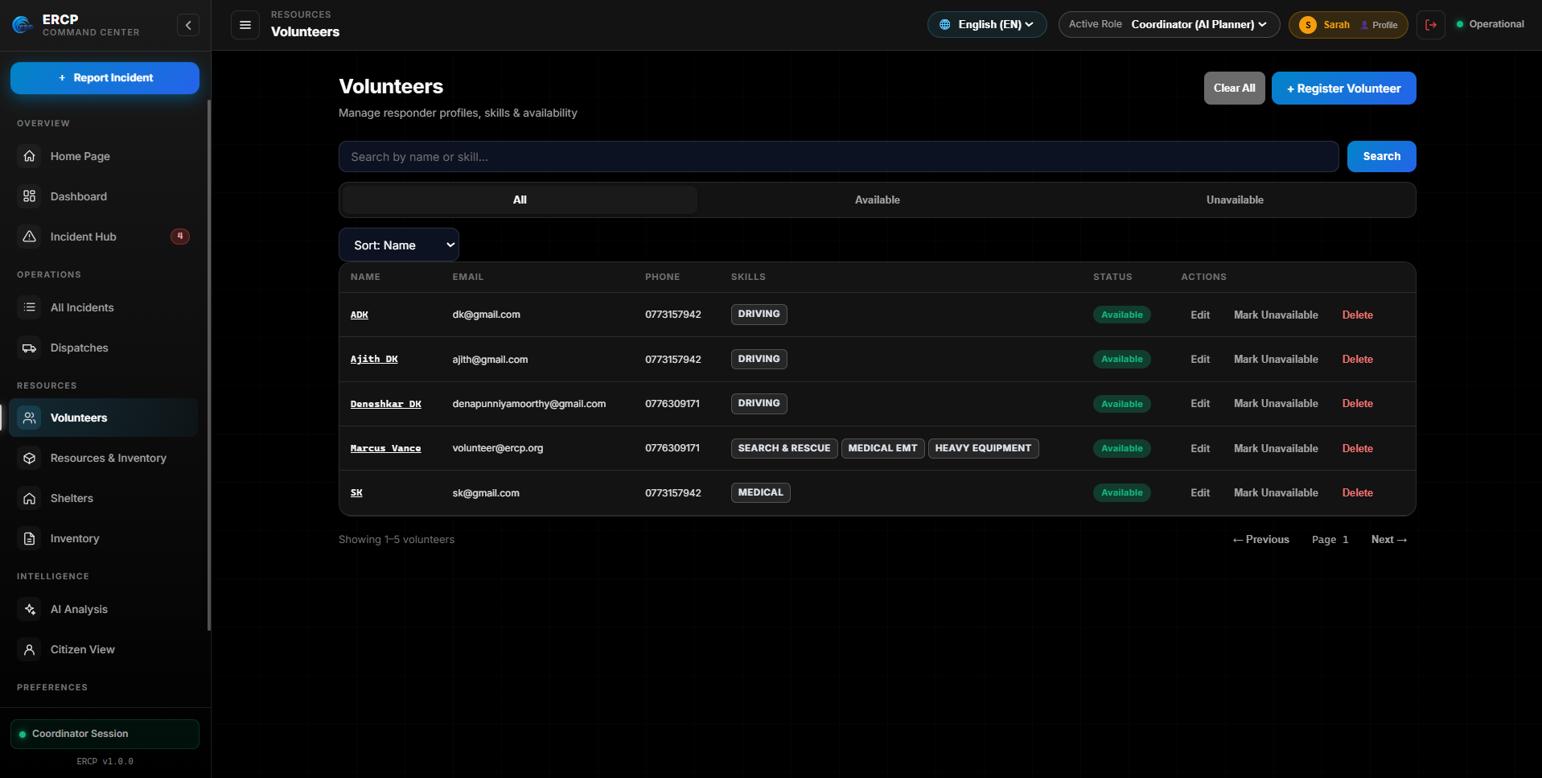
Figure 31 Volunteer and Responder Profiles Management

