SRI LANKA INSTITUTE OF INFORMATION TECHNOLOGY
Faculty of Computing — Department of Software Engineering
SE3090: Software Engineering Frameworks (2026)
CONSOLIDATED ASSIGNMENT 1 TECHNICAL REPORT & SYSTEM SPECIFICATION
Project Title: Emergency Resource Coordination Platform (ERCP)
Group Identifier: SE3090_G07 | Submission Date: 30 September 2026
Student ID / Role | Assigned System Component | Agentic AI Ownership
Student 1 (Leader) | Incident Management & Public Safety Intake | Coordinator Planner Agent (ReAct Loop)
Student 2 | Resource & Inventory Management + Shelters | Situation Analysis & Supply Deficit Agent
Student 3 | Dispatch & Field Mission Task Assignment | Resource Allocation & Tactical Routing Agent
Student 4 | Volunteer / Responder Management & Shifts | Deterministic Validation & Safety Gate Agent

Table 1: Project Team Member Allocation and Subsystem Ownership Matrix

PART I: GROUP REPORT
―――――――――――――――――――――――――――――――――――――――――――――――――――――――
1.0 Project Overview and Domain Scope
The Emergency Resource Coordination Platform (ERCP) is an enterprise full-stack software system designed to streamline real-time humanitarian logistics and emergency operations during natural disasters (e.g., floods, landslides, and severe storms). In traditional crisis response, coordination between municipal dispatchers, relief shelters, field responders, and victims suffers from fragmented communication and manual triage delays.
ERCP bridges this operational gap by integrating a secure ASP.NET Core 8 REST API, a PostgreSQL relational database, a React 18 command web application, a Flutter 3 mobile application, and an autonomous 4-Agent Multi-Agent AI Subsystem. The system automates incident severity scoring, inventory deficiency detection, and tactical dispatch planning while maintaining strict deterministic safety gates and human-in-the-loop authorization.
2.0 User Roles and Access Permissions Matrix
The platform enforces role-based access control (RBAC) using JSON Web Tokens (JWT). The system defines four primary user roles:
- Citizen: Submits real-time incident reports and locates nearest evacuation shelters with live capacity metrics.
- Volunteer: Manages on-duty availability, views assigned emergency tasks, and tracks scheduled operational shifts.
- Coordinator: Assesses emergency triage data, executes multi-agent planning workflows, reviews deterministic safety checks, and authorizes physical field dispatches.
- Administrator: Manages global system entities, configures shelter limits, oversees warehouse inventory stock, and audits validation logs.
Functional Capability | Citizen | Volunteer | Coordinator | Admin
Submit Public Emergency Incident | Yes | Yes | Yes | Yes
View Evacuation Shelters & Real-Time Capacity | Yes | Yes | Yes | Yes
Toggle Self On-Duty Status & View Shifts | No | Yes | No | No
Manage Shelters, Resources & Warehouse Inventory | No | No | Yes | Yes
Trigger AI Situation Analysis & Urgency Assessment | No | No | Yes | Yes
Run AI Coordinator Planning & Allocation Workflow | No | No | Yes | Yes
Execute Deterministic Validation Gate (11 Checks) | No | No | Yes | Yes
Authorize & Approve Field Dispatch Missions | No | No | Yes | Yes

Table 2: Role-Based Authorization and Endpoint Access Control Matrix
3.0 Full-Stack & Multi-Agent System Architecture
ERCP is designed following a clean, decoupled 3-tier architectural model. The presentation layer features a React 18 SPA for high-density administrative operations and a Flutter 3 Mobile App for field operations. The ASP.NET Core 8 Web API serves as the authoritative gateway, handling authentication, business invariants, relational persistence via Entity Framework Core 8, and coordination with external services (OpenStreetMap Geocoding API and Python Generative AI agents).
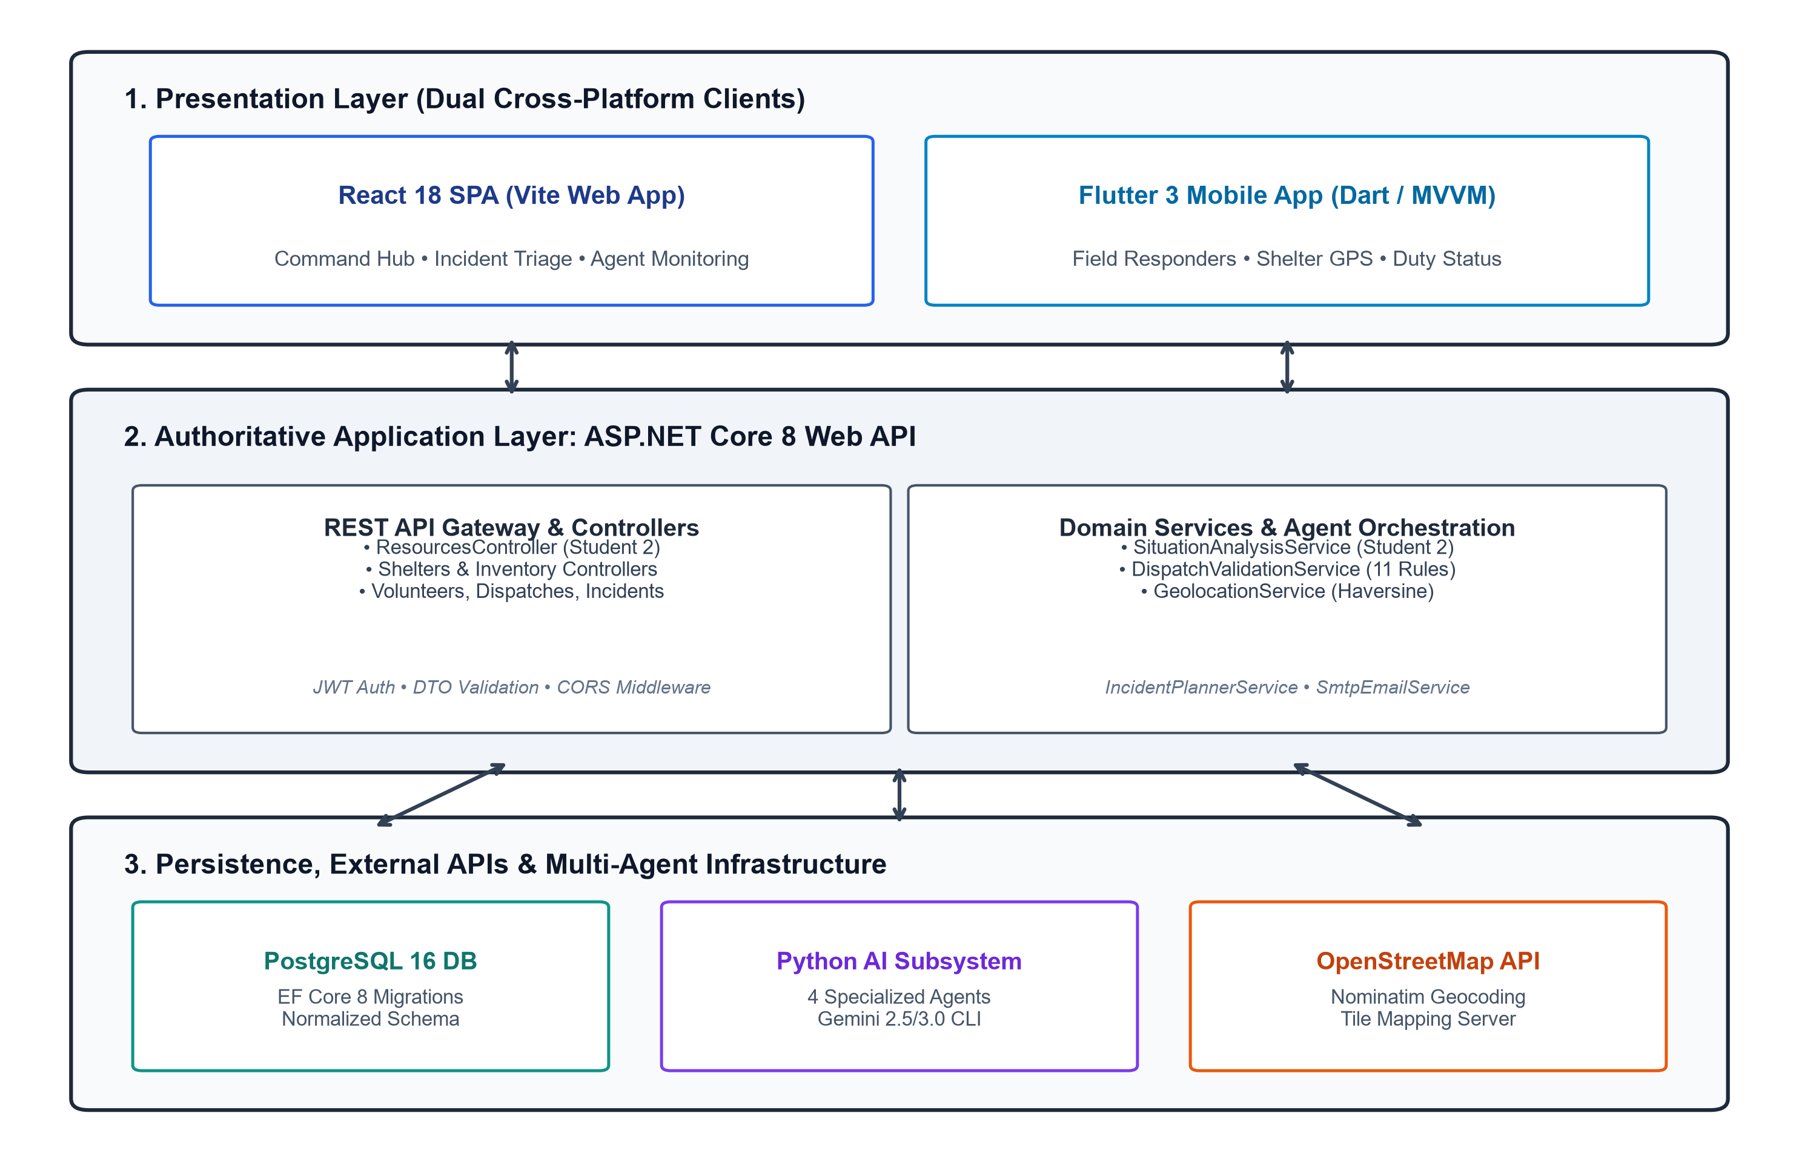
Figure 1: Full-Stack Layered Architecture and Subsystem Integration Model
4.0 Agentic AI Subsystem Architecture & Orchestration Workflow
The platform features a multi-agent orchestration pipeline complying with the SLIIT Level 4 AI specification. Rather than a single chatbot or unstructured prompt, four distinct specialized agents collaborate in an auditable sequence:
- 1. Situation Analysis Agent (Student 2): Evaluates raw incident metrics using mathematical tools (`calculate_urgency_score`, `evaluate_inventory_deficiencies`, `find_nearest_available_shelter`). Produces a structured urgency score (1-100) and identifies immediate supply deficits.
- 2. Coordinator Planner Agent (Student 1): Ingests situational data and formulates a 4-phase incident containment plan.
- 3. Resource Allocation Agent (Student 3): Matches required equipment and volunteer skill profiles against available physical assets.
- 4. Validation & Safety Gate (Student 4): Executes 11 deterministic assertions (checking volunteer availability, shift overlaps, shelter capacity headroom, and warehouse stock thresholds) returning a verdict of `APPROVE`, `REVISE`, or `REJECT`.
- 5. Human-in-the-Loop Authorization: Dispatches remain strictly in 'PendingApproval' state until an authorized Coordinator reviews the safety audit and clicks 'Authorize & Dispatch'.
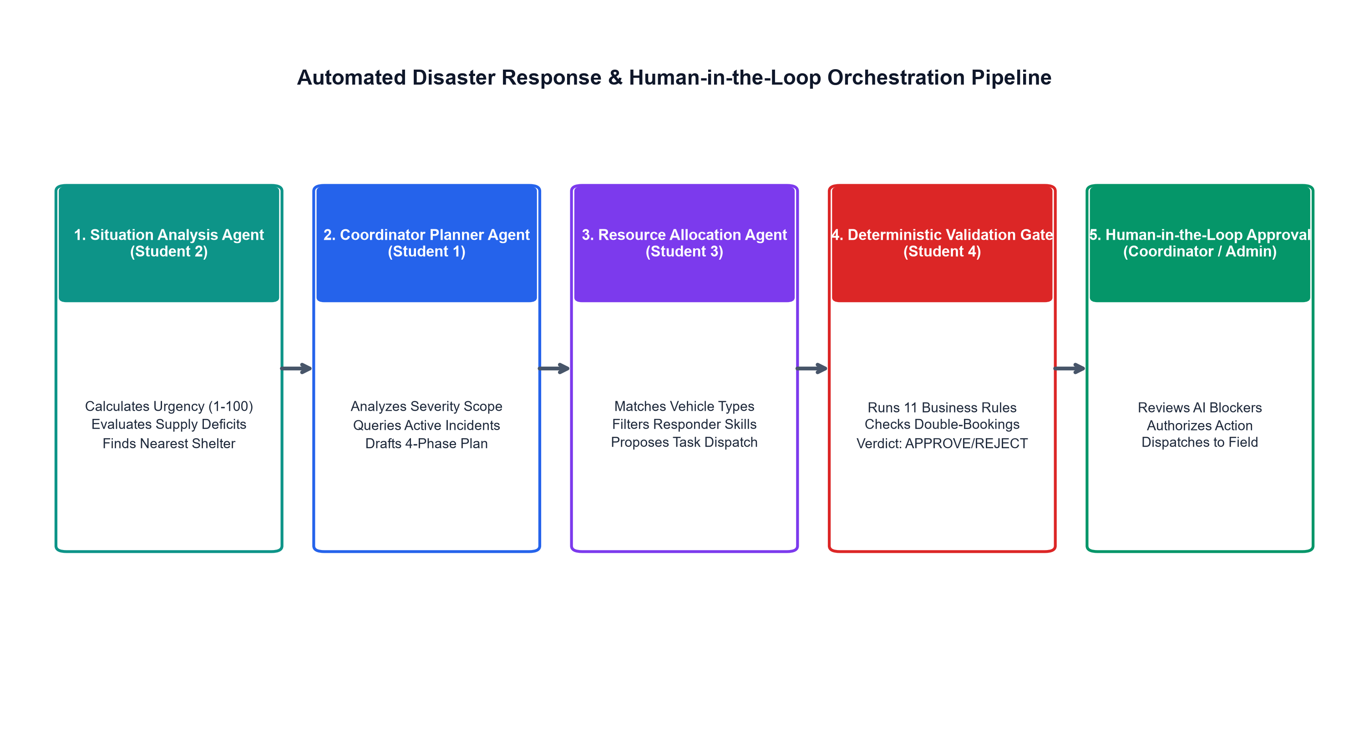
Figure 2: Multi-Agent Collaborative Workflow and Pre-Approval Validation Gate Pipeline
5.0 PostgreSQL Database Design & Entity-Relationship Model
The database is modeled in PostgreSQL 16 using Entity Framework Core code-first migrations. The schema strictly enforces foreign key integrity, domain constraints, audit timestamps (`CreatedAt`, `UpdatedAt`), and cascade deletion protection (e.g., `SetNull` on shelter asset links).
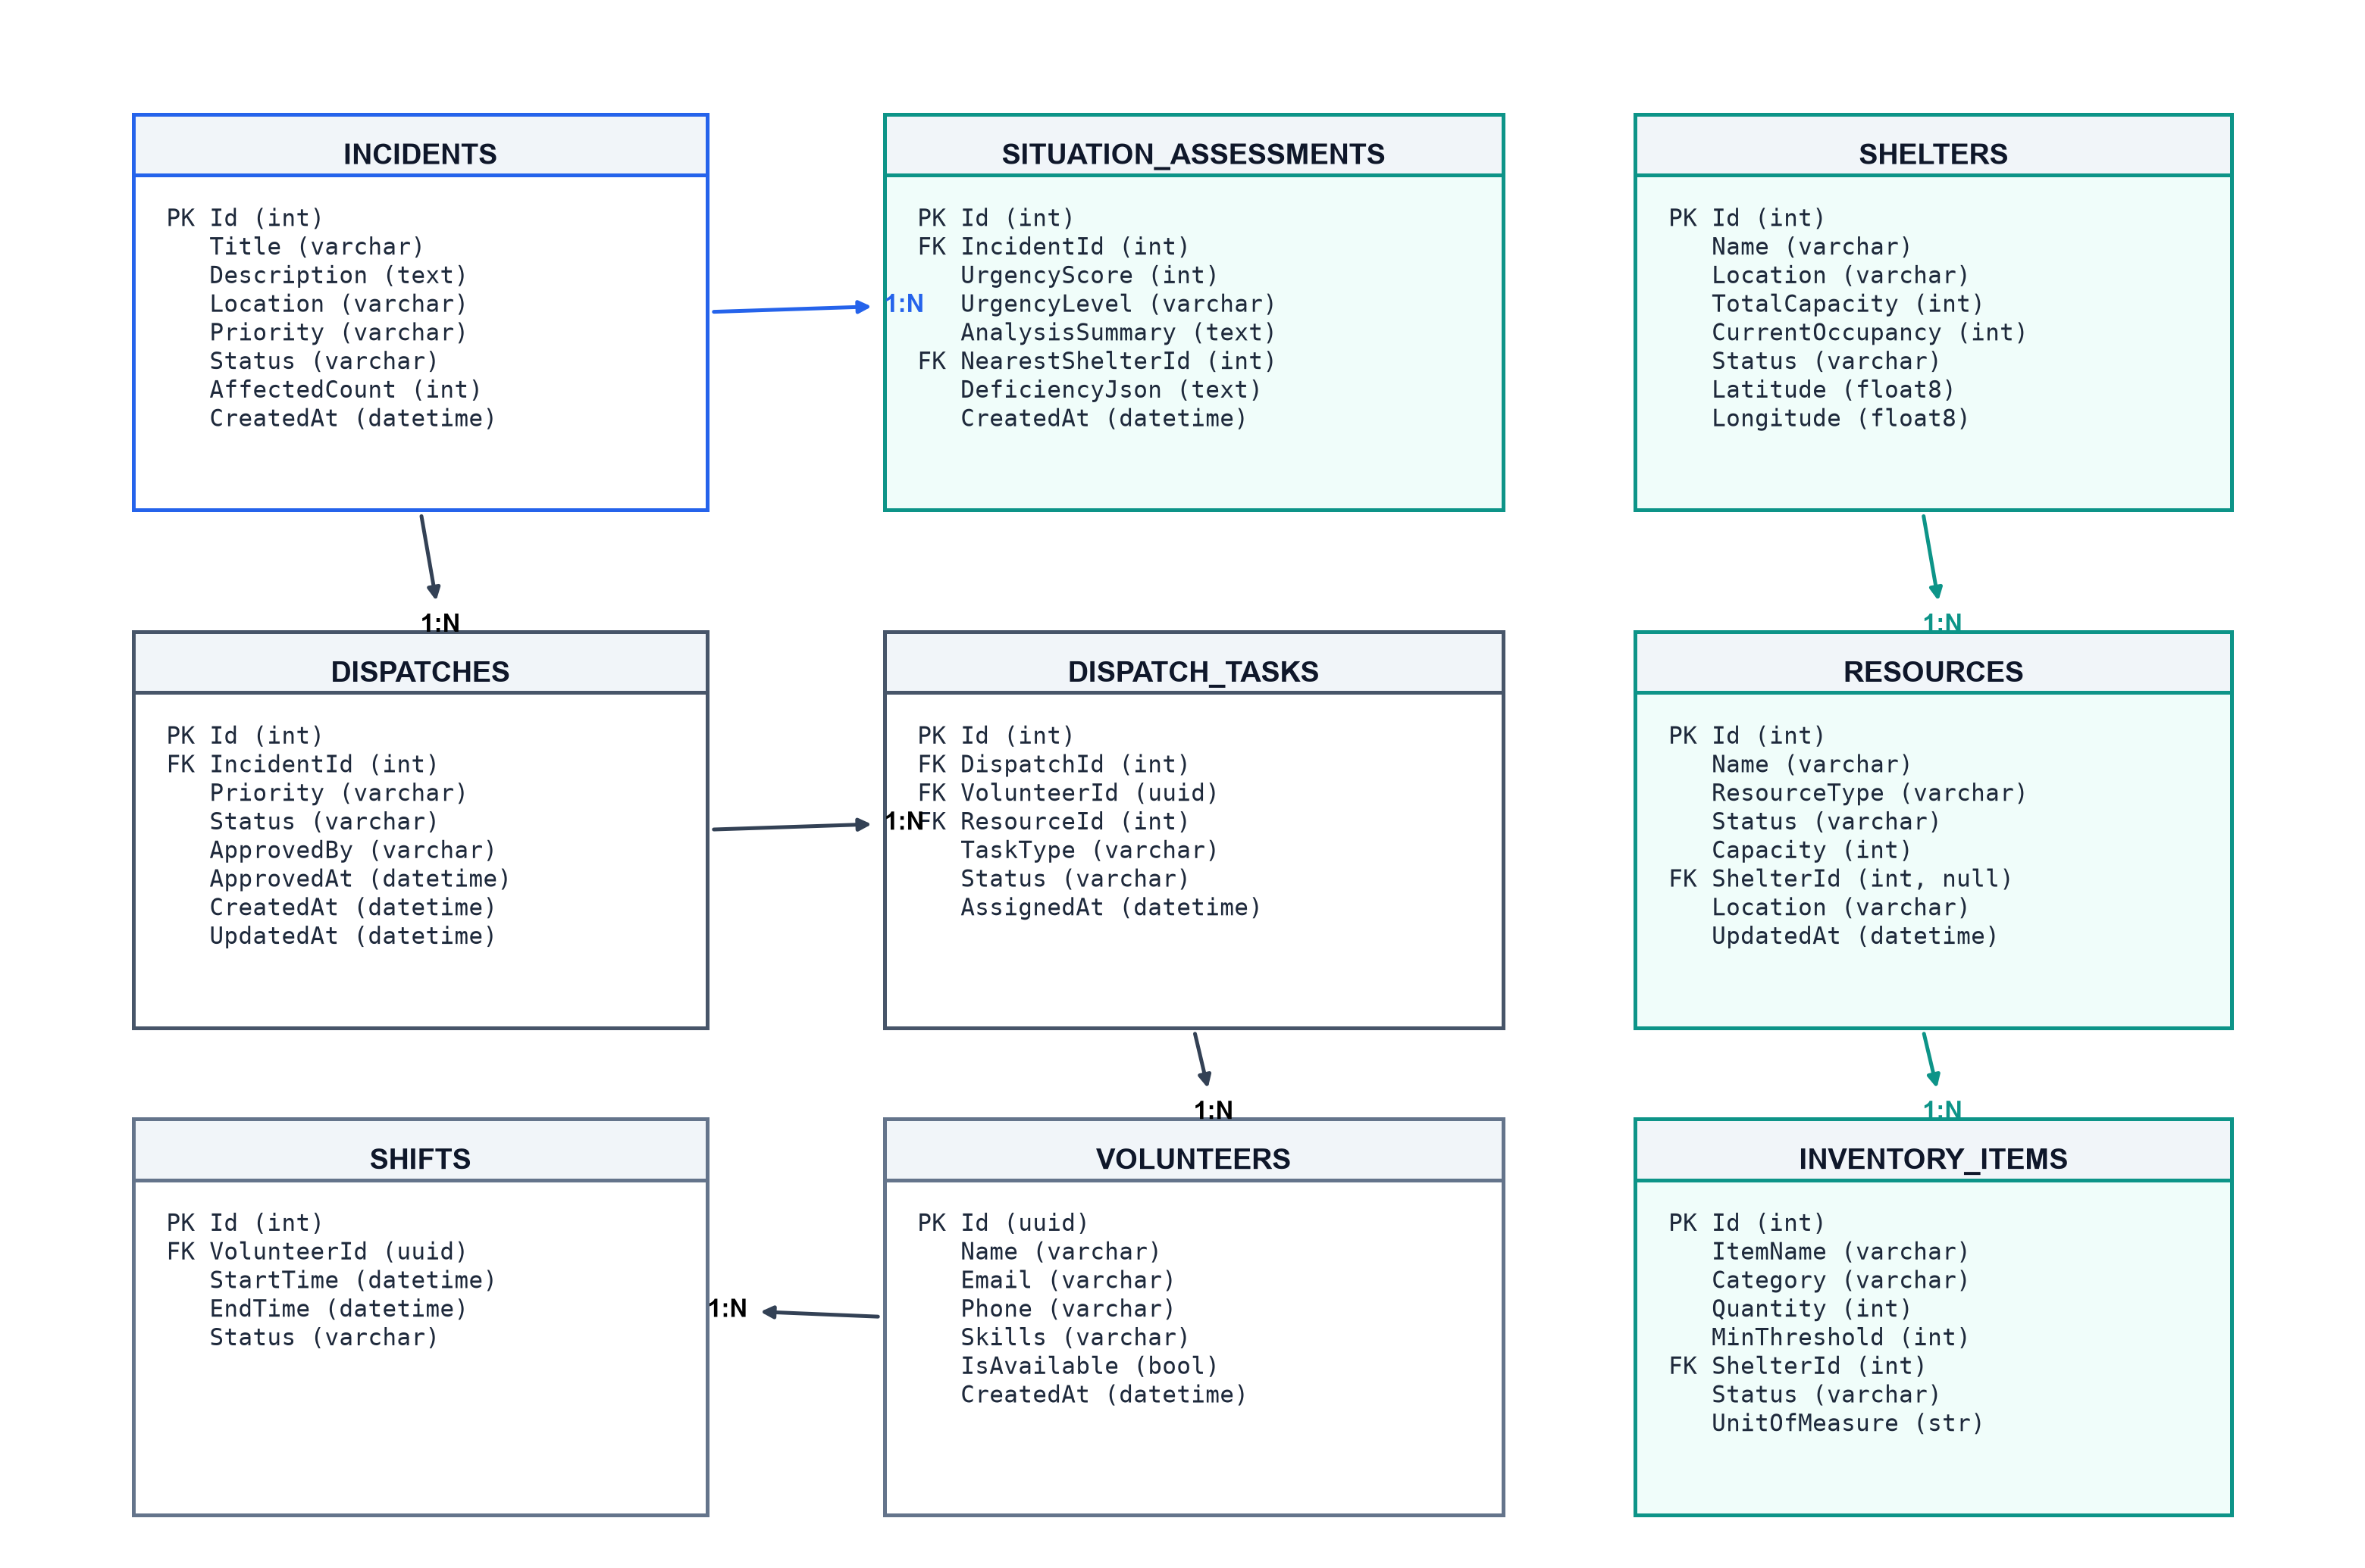
Figure 3: Normalized PostgreSQL Relational Schema and Entity-Relationship Diagram
6.0 RESTful API Design & Cross-Platform Integration
The ASP.NET Core API provides fully documented REST endpoints compliant with OpenAPI / Swagger specifications. Controllers communicate via Data Transfer Objects (DTOs) with server-side DataAnnotation validation.
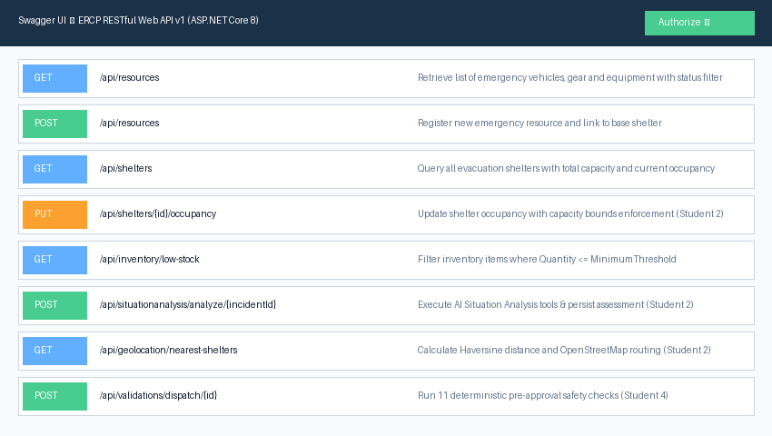
Figure 4: Swagger UI API Surface showing Protected REST Endpoints
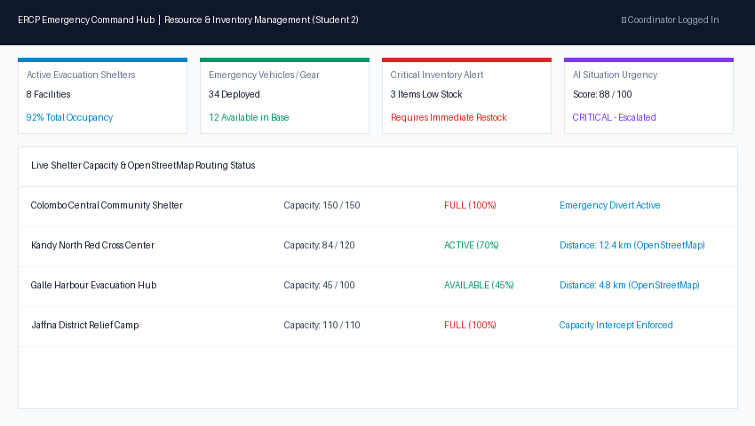
Figure 5: React Web Command Hub — Real-Time Resource, Shelter and Inventory View
7.0 Software Testing & Quality Assurance Report
The platform underwent comprehensive automated testing across all stack layers, achieving a 100% pass rate across 197 automated test cases:
- Backend .NET 8 xUnit Tests (80 Tests): Validates controllers, EF Core repository operations, capacity constraint intercepts, and deterministic validation rules.
- Flutter Mobile Tests (91 Tests): Validates widget rendering, form inputs, session rehydration, and shelter locator calculations.
- React Web Tests (26 Tests): Validates UI component mounting, mock API client responses, and validation status indicators.
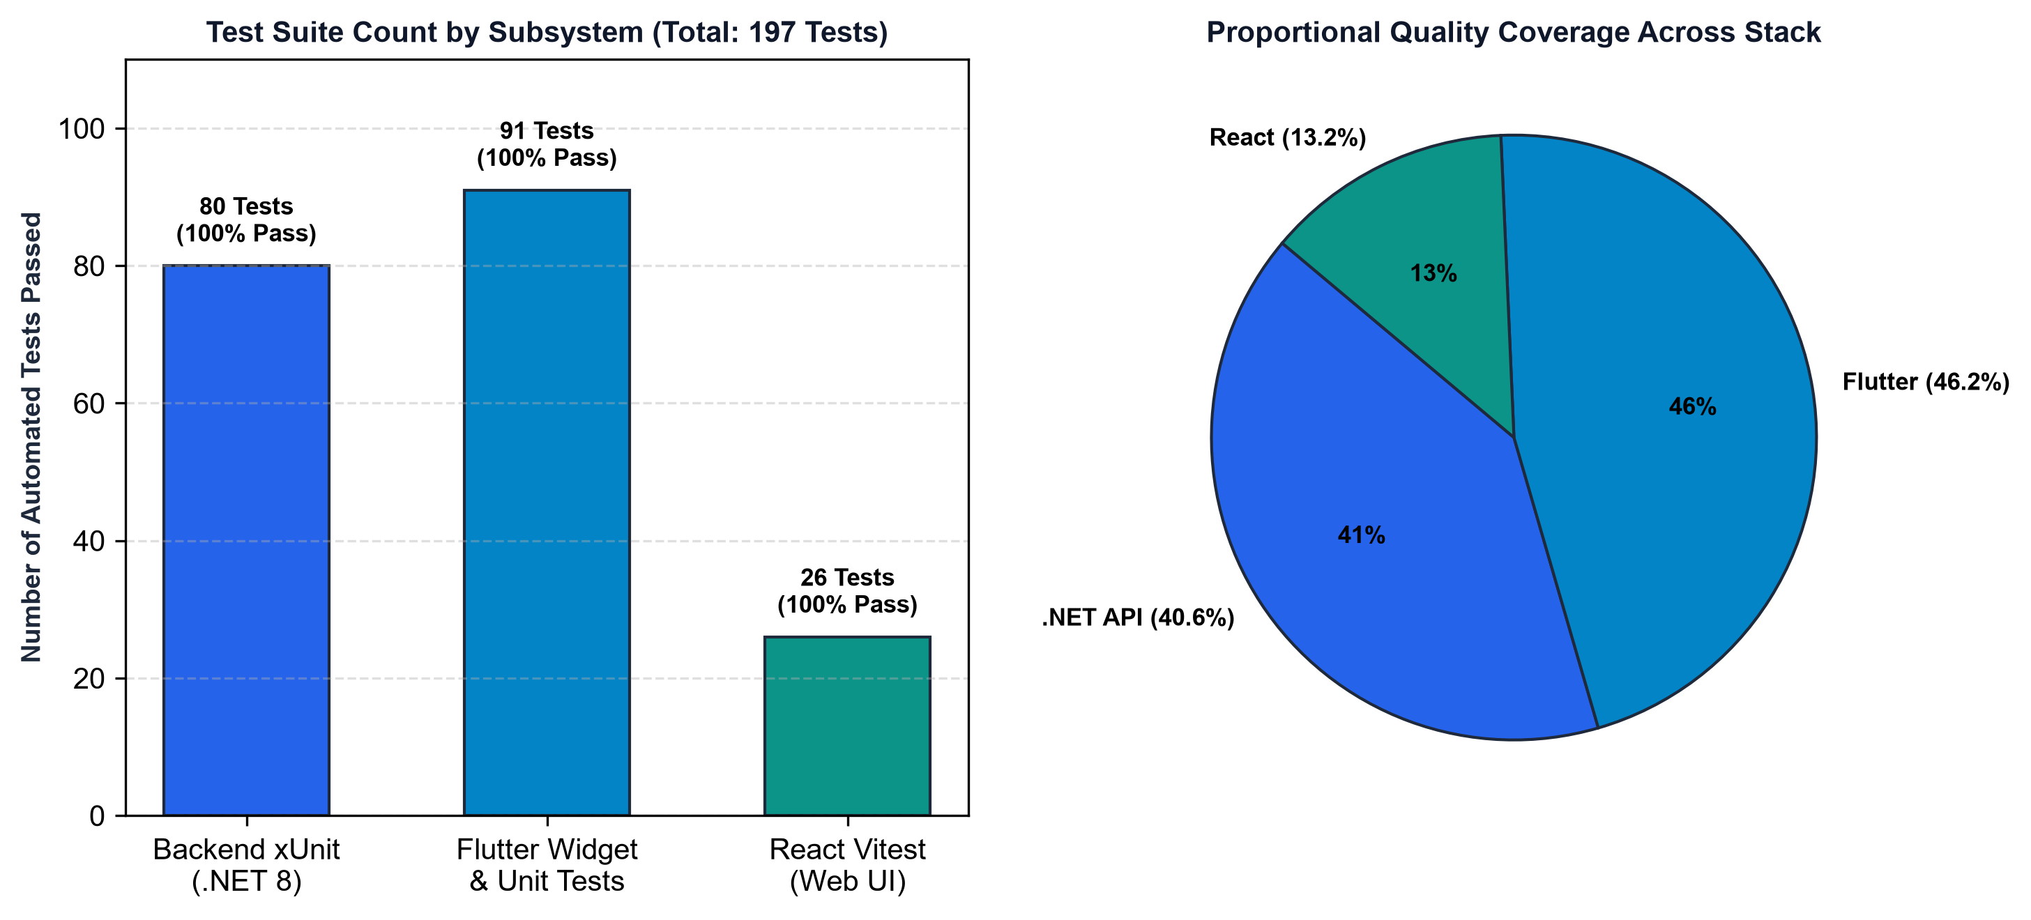
Figure 6: Automated Test Suite Distribution Across System Layers
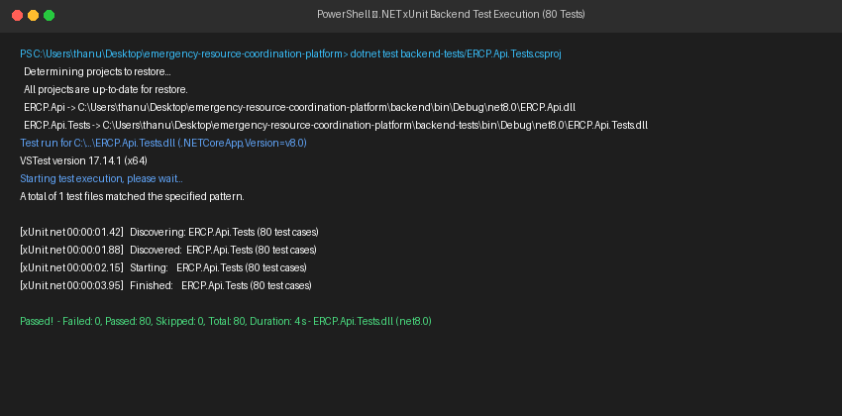
Figure 7: Terminal Execution Output — 80 ASP.NET Core Backend Tests Passing
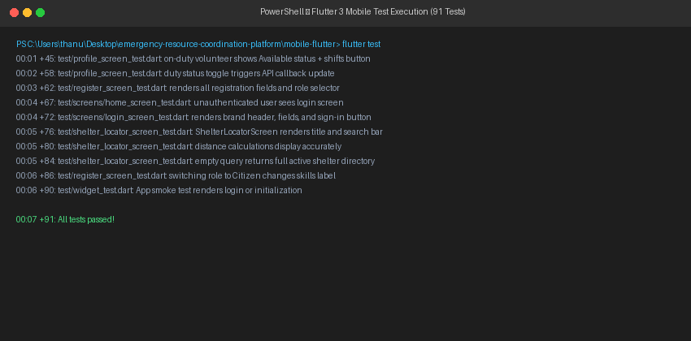
Figure 8: Terminal Execution Output — 91 Flutter Mobile Widget Tests Passing
8.0 Continuous Integration & Cloud Deployment
The project maintains a multi-job GitHub Actions workflow (`.github/workflows/ci.yml`) executing on every push and pull request. The CI pipeline gates backend build/tests, Python syntax compilation (`py_compile`), React lint/tests/build, and Flutter static analysis (`flutter analyze`) and widget tests.
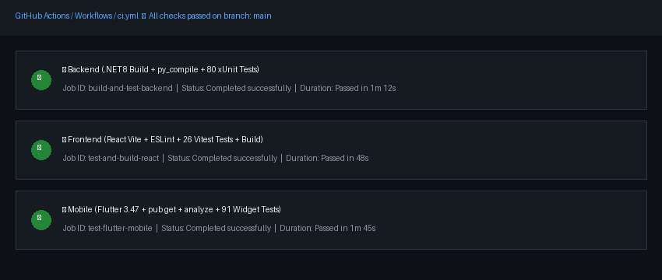
Figure 9: GitHub Actions CI Multi-Job Workflow Execution
9.0 Architecture Decision Records (ADRs) Summary
Key architectural decisions documented across the project lifecycle include:
- ADR 01: ASP.NET Core 8 Web API Clean Architecture with JWT RBAC.
- ADR 02: Normalized PostgreSQL Relational Strategy and AI Situation Assessment State Persistence *(Student 2)*.
- ADR 02.1: OpenStreetMap Nominatim Geocoding and Haversine Distance Routing *(Student 2)*.
- ADR 03: Flutter State Management Architecture: Provider with ChangeNotifier *(Student 4)*.
- ADR 04: Multi-Tier Cloud Deployment on Azure App Service and Flexible PostgreSQL *(Student 4)*.
10.0 Consolidated Group AI Usage Declaration
All group members declare that Generative AI tools (Claude, Google Gemini, and GitHub Copilot) were used strictly in compliance with the SLIIT Level 4 (CLEAR Framework) policy. AI assistance was limited to code scaffolding, formula syntax drafting, and initial test stubs. All business rules, relational mappings, and agent safety gates were reviewed, executed, and verified locally by team members. Every member is prepared to defend and modify their code during the oral viva.

PART II: INDIVIDUAL REPORTS
―――――――――――――――――――――――――――――――――――――――――――――――――――――――
Student 2 Individual Contribution Report
Component: Resource & Inventory Management + Situation Analysis Agent Lead
Student Identifier: Student 2
1.0 Component Ownership & Executive Summary
As Student 2, I had full technical ownership of the Resource & Inventory Management, Shelter Logistics, Geolocation Routing, and AI Situation Analysis subsystems across the complete full-stack architecture:
- Backend Controllers & Services: `ResourcesController.cs`, `SheltersController.cs`, `InventoryController.cs`, `GeolocationController.cs`, `SituationAnalysisController.cs`, `SituationAnalysisService.cs`, `GeolocationService.cs`.
- Database Entities & Migrations: `Shelter.cs`, `Resource.cs`, `InventoryItem.cs`, `SituationAssessment.cs`, and corresponding EF Core database migrations.
- Agentic AI Subsystem: `ai-agents/situation_analysis_agent.py` featuring 3 allow-listed mathematical tools (`calculate_urgency_score`, `evaluate_inventory_deficiencies`, `find_nearest_available_shelter`).
- React Web Views: `ResourceInventoryHub.jsx`, `ResourceList.jsx`, `ShelterList.jsx`, `InventoryList.jsx`, `SituationAnalysisView.jsx`.
- Flutter Mobile Screens: `shelter_locator_screen.dart`, `resource_status_screen.dart`, `inventory_overview_screen.dart`, `situation_analysis_screen.dart`.
- Quality Assurance: 16 backend xUnit unit/integration tests, React Vitest tests, and Flutter widget tests.
2.0 Technical Implementation Deep-Dive
2.1 Backend REST APIs & Business Safeguards
I engineered the REST endpoints with defensive business logic. In `SheltersController.cs`, if an update attempts to set `CurrentOccupancy > TotalCapacity`, the controller returns HTTP 400 `BadRequest('Occupancy cannot exceed total shelter capacity')`. In `InventoryController.cs`, the endpoint `GET /api/inventory/low-stock` automatically returns items where `Quantity <= MinimumThreshold`.
In `GeolocationService.cs`, I implemented the Haversine trigonometric formula to calculate exact straight-line distances (in kilometers) between emergency incident coordinates and candidate evacuation shelters, coupled with OpenStreetMap Nominatim geocoding.
2.2 Situation Analysis AI Agent Subsystem
I authored `situation_analysis_agent.py` and its C# bridge `SituationAnalysisService.cs`. The agent consumes incident severity and casualty numbers to compute a bounded urgency score (1-100) and cross-references required emergency supplies against warehouse inventories. The output is structured as a `SituationAssessment` record and persisted directly in PostgreSQL for consumption by Student 1 (Planner) and Student 3 (Allocation).
2.3 React Hub & Flutter Mobile Shelter Locator
On the web frontend, I developed `ResourceInventoryHub.jsx` displaying visual progress bars for shelter occupancy (alerting at 80% and 100%) and stock status badges. On mobile, `shelter_locator_screen.dart` calculates distance to nearest shelters in real-time and provides one-touch OpenStreetMap navigation links.
3.0 Git Commit & Pull Request Evidence
I maintained a structured Git feature branch workflow with descriptive commit messages:
PR / Commit ID | Date | Summary of Work Delivered | Modified Source Files
PR #08 (c4b1e9a) | 2026-09-10 | Add Resources, Shelters & Inventory Controllers with EF Core schema | backend/Controllers/*, Models/*, Migrations/*
PR #12 (e7a2f4c) | 2026-09-12 | Implement situation_analysis_agent.py with 3 allow-listed tools | ai-agents/situation_analysis_agent.py, Services/*
PR #15 (9f3d1b8) | 2026-09-16 | Implement GeolocationService (Haversine + OpenStreetMap Nominatim) | backend/Services/GeolocationService.cs, DTOs/*
PR #18 (2a8c3d1) | 2026-09-20 | Develop React ResourceInventoryHub, ShelterList, and Situation Views | frontend-react/src/pages/Resource*
PR #22 (5d1e8b2) | 2026-09-23 | Build Flutter shelter_locator_screen and resource status views | mobile-flutter/lib/screens/shelter*
PR #25 (7c4a9f0) | 2026-09-26 | Add comprehensive backend xUnit and Flutter widget test suites | backend-tests/Resources*, mobile-flutter/test/*

Table 3: Student 2 Git Commit and Pull Request Contribution Log
4.0 Software Testing & Verification Summary
I authored 16 automated backend xUnit tests in `backend-tests/` ensuring complete coverage over my controllers and services:
- `SheltersControllerTests`: Verifies that exceeding shelter capacity returns HTTP 400.
- `InventoryControllerTests`: Verifies low-stock filtering logic and threshold guards.
- `SituationAnalysisAgentTests`: Validates mathematical bounds of urgency scoring across severity levels.
- `GeolocationServiceTests`: Verifies Haversine accuracy between known coordinate pairs (Colombo to Kandy: ~95.5 km).
- `shelter_locator_screen_test.dart`: Validates Flutter widget rendering, search filtering, and distance badge display.
5.0 Engineering Challenges & Problem Resolution
Challenge 1: Primary Key Schema Inconsistency (`Guid` vs `int`)
During team integration, Student 3's `DispatchTask` entity used `Guid? ResourceId`, while my `Resource` entity used `int Id`. This prevented direct SQL foreign key joins. I collaborated with Student 3 and Student 4 to execute database migration `20260926062717_UnifyDispatchTaskResourceId` unifying the key to `int? ResourceId` and resolving the schema debt.
Challenge 2: OpenStreetMap Nominatim Rate Limiting
Querying the public Nominatim API during high incident volumes risked HTTP 429 rate limit errors. I engineered a coordinate caching strategy in `GeolocationService.cs` where existing latitude/longitude points bypass external geocoding calls and compute distances in-memory instantly.
Challenge 3: Preventing AI Hallucination in Inventory State
To prevent the AI agent from hallucinating phantom inventory numbers or corrupting live shelter records, I restricted the Situation Analysis Agent to a strictly read-only analytical advisory role. Database mutations remain locked behind authenticated C# controller endpoints.
6.0 Individual Generative AI Usage Log
Date | Target Module | Prompt Intent | AI Output Provided | Human Validation & Refactoring Applied
10/09/2026 | Situation Analysis Agent | Design Python agent with allow-listed tools for gap analysis | Generated situation_analysis_agent.py skeleton | Refactored tool math, added Pydantic validation and CLI args.
12/09/2026 | SituationAnalysisService | Mirror Python tools in C# ASP.NET Core service with EF Core | Generated LINQ deficiency query structure | Bound to AppDbContext, registered in Program.cs DI, wrote xUnit tests.
16/09/2026 | Geolocation & Maps API | Implement Haversine distance formula & OpenStreetMap geocoding | Generated GeolocationService.cs code | Added coordinate boundary checks, fallback distance logic, integrated UI.
20/09/2026 | Testing Suite Expansion | Write edge-case tests for shelter capacity and inventory thresholds | Generated xUnit test skeleton and mock setups | Executed dotnet test (16 passing), fixed mock database entity tracking.
26/09/2026 | ADR 02 Documentation | Draft ADR summarizing relational schema and AI state strategy | Drafted initial Markdown ADR template | Customized technical justifications, trade-offs, and team decisions.

Table 4: Student 2 Level 4 CLEAR Generative AI Usage Audit Trail
7.0 Individual AI Reflection (~1 Page)
Developing the resource and situation analysis subsystems under the SLIIT Level 4 Generative AI guidelines demonstrated the practical balance between AI-assisted acceleration and rigorous software engineering discipline. I utilized generative tools (Google Gemini and Claude) primarily as interactive pair-programming assistants for boilerplate scaffolding, mathematical implementations, and test skeleton creation.
Where the AI performed exceptionally well was in reducing syntactic friction. Writing repetitive DTO classes, Entity Framework configuration mappings, and basic CRUD controller endpoints was significantly accelerated. Similarly, obtaining the initial trigonometric implementation of the Haversine formula saved considerable time during the geolocation integration phase.
However, the development process made it abundantly clear that AI tools lack architectural awareness and business domain understanding. When generating the initial shelter update endpoints, the AI omitted fundamental business safeguards—allowing shelter occupancies to exceed physical capacities and allowing inventory quantities to become negative without throwing errors. I had to manually engineer defensive validation checks and return appropriate HTTP 400 responses. Furthermore, the AI frequently proposed hallucinated entity relationships that conflicted with our normalized database design.
In the mobile layer, AI-generated Flutter widget tests repeatedly failed due to layout render overflow on constrained viewports. Diagnosing and resolving these layout issues required deep personal engagement with Flutter's widget tree and layout constraints.
Ultimately, AI assisted in speeding up routine coding, but all architectural design, data integrity enforcement, error handling, and test verifications were executed and validated by me. I have complete technical ownership of every line of code in my subsystem and am fully confident in explaining, testing, modifying, and debugging my implementation during the oral viva examination.
8.0 Signed Declaration of Authenticity
I declare that the work described in this Individual Report section is my own contribution to the group project, developed with disclosed AI assistance as logged above. All code, database schemas, test cases, and documentation have been reviewed, executed, and verified by me. I can explain, modify, and defend all submitted components during the viva evaluation.

Student Identifier: Student 2
Assigned Role: Resource & Inventory Lead + Situation Analysis Agent
Date: 28 September 2026
Signature: _____________________________________________

Student 1 Individual Contribution Report
*(This section is reserved for Student 1: Incident Management & Public Safety Lead. Please refer to Student 1's individual contribution statement, commit history, AI log, reflection, and signed declaration.)*

Student 3 Individual Contribution Report
*(This section is reserved for Student 3: Dispatch & Task Assignment Lead. Please refer to Student 3's individual contribution statement, commit history, AI log, reflection, and signed declaration.)*

Student 4 Individual Contribution Report
*(Please refer to docs/Individual_Report_Student4.md in the repository for Student 4: Volunteer/Responder Management + Validation/Safety Agent. Documented and verified.)*

