Introduction to Client/Server Architecture

Computer Network
- A computer network is a collection of connected devices that communicate and share resources.
- Connections can be:
  - Wired (cables)
  - Wireless (radio waves, infrared)

Client-Server Model
- Model of a computer network in which many clients (remote processors) request and receive service from a centralized server (host computer)
- A network model where:
  - Clients request services
  - Server provides services
- Also called Two-Tier Architecture (clients + server only). It allows devices to share files and resources.
The client will follow this process:

1. Initiate a request: The client caller requests access to some resource or information from the remote server.
2. Wait for a reply: A participating server issues a reply, either permitting or forbidding the connection, which may require authentication in some cases.
3. Connect and interact: If access is granted, the client possibly authenticates and then begins interacting in some fashion with the server.
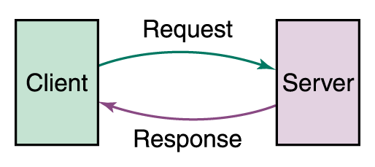

Client
- A client is a device/user requesting services
- Example: Web browser requesting a webpage

Server
- A server is a powerful computer that provides services to multiple clients

Key Features:
- Handles many users at once
- Fast response
- Reduces network congestion
- Runs server operating systems (e.g., Windows Server 2008)
- High performance:
  - Large memory (8GB+)
  - Huge storage (TB/PB)
  - Backup systems (mirroring, striping)
  - Redundant power supply

Roles of Client-Server
- Server provides services, client requests
- Services can be shared among many clients
- Communication is message-based
- Server location is transparent to clients
- System is scalable:
  - Horizontal → add more clients
  - Vertical → add more servers
- Server is centralized, clients are independent

Types of Servers

1. File Server
- Stores and manages files
- Allows file sharing

2. Database Server
- Handles database queries
- Example: DBMS query request

3. Transaction Server
- Manages transactions
- Executes remote procedures

4. Web Server
- Uses HTTP protocol
- Serves web pages to clients

Advanced Concepts

Clustering

Linking two or more discrete computer systems so they appear to function as though they are one

Advantages:
- Higher speed
- More computing power
- Better performance

Peer-to-Peer (P2P) Model
- No central server
- Each device acts as both:
  - Client
  - Server

Features:
- Users share resources directly
- Performance improves as users increase
- Example: BitTorrent

