Department of Information Technology
Faculty of Computing

Software Management-SE4111

Risk Management - Tutorial

M.A.K.A Masinghe
F20011006013
IT_IFLS_001/B003/0030

- Draw the full decision tree for this scenario. Your diagram must include: the decision node, both chance nodes, all four end nodes, branch labels showing probabilities and costs, and the correct node symbols (square, circle, diamond).
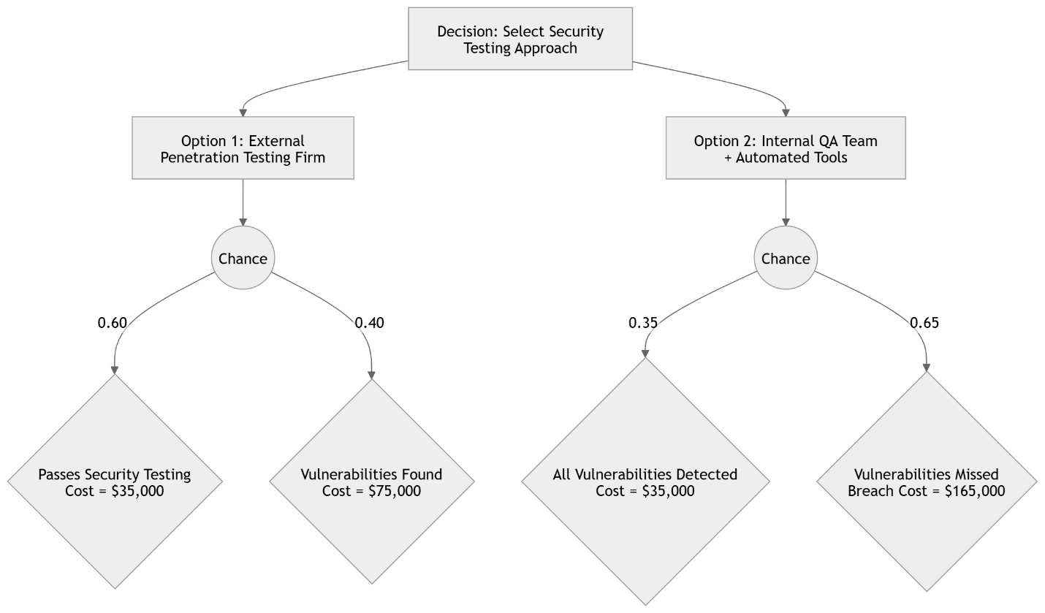
- Calculate the EMV for each option, showing full working. Remember to include the upfront cost in each total outcome value before applying probabilities.
Option 1: External Penetration Testing Firm
Outcome 1 : System Passes
35,000+0=35,000
Outcome 2 : Vulnerabilities Found
35,000+40,000=75,000
EMV
EMV= (0.60×35,000)+(0.40×75,000)
EMV= 21,000+30,000
EMV= $51,000
Option 2: Internal QA Team
Outcome 1 : All Vulnerabilities Detected

15,000+20,000=35,000
Outcome 2: Vulnerabilities Missed
15,000+150,000=165,000
EMV
EMV= (0.35×35,000)+(0.65×165,000)
EMV=12,250+107,250
EMV=$119,500
- State which option the decision tree recommends and identify the option the PM should actually choose
The PM should also choose Option 1 (External Penetration Testing Firm) because:
- It has the lowest expected cost.
- It significantly reduces the likelihood of a post-launch security breach.
- A hospital system handles sensitive patient data.
- A breach could cause:
  - Regulatory fines
  - Legal liability
  - Reputational damage
  - Loss of patient trust
  - Service disruption during emergencies
Therefore, both the decision tree analysis and practical risk management considerations support choosing Option 1 – External Penetration Testing Firm.

