
KYAMBOGO UNIVERSITY
FACULTY OF ENGINEERING
DEPARTMENT OF MECHATRONICS AND BIOMEDICAL ENGINEERING
BACHELOR OF MECHATRONICS AND
BIOMEDICAL EMGINEERING.
TOPIC: INERNET OF THINGS (IoT)
TEM1105: COMPUTING 1
No. | NAME. | REG. NUMBER
 | OTIM AMOS | 25/U/BIO/01416/PD
 | ODORA STEPHEN | 25/U/BIO/01411/PD
 | KIBI DARIUS | 25/U/BIO/01383/PD
 | DENG YAK DENG ATER | 25/X/BIO/01367/PD
 | NAMUGANZA MAARIA GORRET | 25/U/BIO/027/PD
 | JAKIRA JUMA FAHAD | 25/U/BIO/01374/PD
 | KUSENA JIMMY | 25/U/BIO/01389/PD

SUBMISSION DATE: 17/11/2025

TABLE CONTENT:
Contents
TABLE CONTENT: i
ABSTRACT. ii
INTRODUCTION. 1
METHODOLOGY. 2
RESULTS AND DISCUSSION ON INTERNET OF THINGS (IoT) 3
HOW INTERNET OF THINGS WORKS 3
APPLICATION OF IoT; 4
ADVANTAGES OF IoT. 5
DISADVANTAGES OF IoT. 6
RELEVANCE AND POTENTIAL IMPACT. 7
CONCLUSION. 8
REFERENCES 9
APPENDICES 11

LIST OF FIGURES
Figure 1 EXAMPLES OT IoT 11
Figure 2 IoT RELEVANCE 11
Figure 3 POTENTIAL IMPACTS IN BIOMEDICAL 11
Figure 4: PIE CHART 12
Figure 5: GRAPH 14

LIST OF TABLE
Table 1: A TABLE OF IOT TRENDS 13

ABSTRACT.

The IoT is a network of interrelated devices that connect and exchange data with other IoT devices and the cloud.
The foundation of IoT began with the invention of internet itself in 1960’s (ARPANET) which demonstrated how computers would exchange data across networks.
The IoT has both the positive and negative impacts to the society in the political, social and economic development since its one of the prevalent emerging technologies and the future outlook are further satisfying in the modern hospitals, homes and other automated device

INTRODUCTION.

Internet of things is a network of interrelated devices that connect and exchange data with other IoT devices and cloud.
The foundation of internet of things begun with the inversion of the internet itself in 1960s (ARPANET) which demonstrated how computers could exchange data across networks.
IoT begun to gain popularity among early adopters and technology enthusiasts in the late 1990s and early 2000s. The first step in developing a commercial internet system was characterised by Amazon entry into online in 1995. The emergency EPAY online communication information discovery and safe transactions of further enhanced by innovations like hot mail, google search.
The 2000s saw explosive growth with IPv6 addressing low-power protocols like ZigBee, and Cisco’s 2008 declaration of IoT’s “birth” as devices outnumbered people.
From 2010 onwards, adoption surged via cloud platforms, 5G, and AI integration-powering applications like predictive maintenance and remote monitoring accelerated by COVID-19 pandemic. Yet challenges persist, cyber security vulnerable, and privacy risks. Looking ahead, IoT’s fusion with edge computing, 6G and block chain promises trillions of autonomous devices by 2030, fostering sustainable, intelligent ecosystem.

METHODOLOGY.

- Surveying method.
This involves asking questions to a predefined group of people to gather information on their opinions. We made an online survey that was answered by 22 people containing questions like; have you heard of IoT, how would you rate your familiarity with IoT.
- Interviewing method.
Interviewing is a data collection technique in which information is obtained directly from the individuals through verbal communication.
We interviewed five people about the advantages of internet of things and the most given responses were; helps in monitoring data, it is cost saving and easy to access.

RESULTS AND DISCUSSION ON INTERNET OF THINGS (IoT)

HOW INTERNET OF THINGS WORKS

IoT works by gathering data from sensors embedded in IoT devices, which is then transmitted through an IoT gateway for analysis by an application or back-end system.
Sensors devices;
An IoT ecosystem consists of web-enabled smart devices that use embedded devices such as processors to collect, send and act on data acquired from their environments.
Connectivity;
IoT devices can communicate with one another through a network over the internet. These devices share sensor data by connecting to an IoT gateway, which acts a central hub where IoT devices can send data.
Data analysis;
Only the relevant data is used to identify patterns, offer recommendations and identify potential issues before they escalate.
Graphical User Interface;
A graphical user interface is typically used to manage IoT devices for example a website can be used as a UI to manage, control and register smart devices.

Smart homes: Automated lighting, climate control and sec

APPLICATION OF IoT;
- Urity system enhance convenience, efficiency and safety.
- Wearable technology; Devices like fitness trackers and medical sensors monitor personal health data.
- Industrial automation: In manufacturing, IoT is used for machine monitoring quality, control and asset tracking.
- Retail; IoT sensors track customer behaviours, optimise inventory and personalise marketing.
- Healthcare; remote patient monitoring, smart medical devices and medication trackers allow for continuous health management.
- Energy management; Smart grids and smart lighting systems help monitor and reduce energy consumption.

ADVANTAGES OF IoT.

- Reduced cost. The more business use IoT devices to streamline operations and increased profitability, the more Iot will be tailored to allow these businesses to succeed.
- Higher efficiency and productivity. It can be used to cut down repetitive tasks e.g. an automated pdf conversion and creation tool
- Creating new business opportunities. IoT is a game changer, as advanced analytics, artificial intelligence and smart utility, which makes it easy to collect actionable data needed to provide the value their customers, are seeking e.g. sensors on automobiles that track speeds, and driving habits.
- Improved customer experience. The modern customer expects to be able to interact with business through their phones whether that is using an automated shirt boards, available mobile website or a dedicated app.

DISADVANTAGES OF IoT.

- Data interception and exploitation. The data that goes between the IoT devices and clouds can be intercepted by data hackers, and then used to exploit companies.
- Devices on breach opportunities. Every connected device is a potential entry point for a hacker; they can be used as convenient access point for a network or to introduce malware.
- Compromised devices affecting the manufacturing processes. Because IoT devices can control the critical machine a manufacturer uses, they need to be carefully secured.
- Interruption or hacking of critical infrastructure. IoT becoming incorporated in transportation, chemical refinery etc. in every infrastructure. If these were hacked, pivotal services could be interrupted.

RELEVANCE AND POTENTIAL IMPACT.

- IoT enabled biomedical devices:
IoT has enabled the development of sophisticated biomedical systems that play a vital role in monitoring, diagnosing and treating medical conditions.
Devices such as wearable health monitors, smart medical implants and remote patient monitoring systems have made it possible to track patient’s health and diagnosis to early detection of anomalies and intervention.

- IoT patient care:
It has made health care multifaceted, more personalised, accessible and efficient. Telemedicine and remote patient monitoring have gained prominence due to IoT’s integration (e.g. COVID-19) pandemic.
It has also enabled the concept of connected care where various medical devices and wearables communicate with each other providing a comprehensive picture of patient’s health status. This interconnected approach focuses better collaboration among health care providers leading to more accurate diagnosis and tailored treatment plans.

- Data analytics and predictive health care:
The influx of data generated by IoT devices in health care has presented an enormous opportunity for data analytics and predictive modelling. By engaging A.I and machine, learning algorithms health care provides analysed large data sets to identify patterns, correlations and potential health risks.
Predictive analytics can anticipate diseases or complications before they occur allowing for early intervention and preventive measures.

CONCLUSION.

IoT has gradually brought about many technological changes in our daily life, which in turn helps make sure lives simpler and more comfortable through various technologies and applications. There is an infinite benefit to IoT applications in all fields. The IoT holds an important role in the social and economic benefits to the emerging and developing economy. This includes sustainable agriculture, water quality and health care. However, the issues and challenges associated with IoT must be considered and addressed in order to realize the potential benefits to individuals, society and economy.

The future outlook is focussed on how IoT is yet to disrupt and transform industries, possible challenges and solutions. It provides systematic exploration of existing IoT products in the market place and highlights of potentially significant research directions and trends.

REFERENCES
[1] L. Atzori, A. Iera, and G. Morabito, "The Internet of Things: A survey," Computer Networks, vol. 54, no. 15, pp. 2787–2805, Oct. 2010, doi: 10.1016/j.comnet.2010.05.010.

[2] J. Gubbi, R. Buyya, S. Marusic, and M. Palaniswami, "Internet of Things (IoT): A vision, architectural elements, and future directions," Future Generation Computer Systems, vol. 29, no. 7, pp. 1645–1660, Sep. 2013, doi: 10.1016/j.future.2013.01.010.

[3] A. Al-Fuqaha, M. Guizani, M. Mohammadi, M. Aledhari, and M. Ayyash, "Internet of Things: A survey on enabling technologies, protocols, and applications," IEEE Communications Surveys & Tutorials, vol. 17, no. 4, pp. 2347–2376, Fourthquarter 2015, doi: 10.1109/COMST.2015.2444095.
[4] K. Ashton, "That 'internet of things' thing," RFID Journal, vol. 22, no. 7, pp. 97–114, Jun. 2009. [Online]. Available: https://www.rfidjournal.com/that-internet-of-things-thing

[5] P. Friess and O. Vermesan, Eds., Digitising the Industry: Internet of Things Connecting the Physical, Digital and Virtual Worlds. River Publishers, 2016.
[6] A. Zanella, N. Bui, A. Castellani, L. Vangelista, and M. Zorzi, "Internet of Things for smart cities," IEEE Internet of Things Journal, vol. 1, no. 1, pp. 22–32, Feb. 2014, doi: 10.1109/JIOT.2014.2306328.

[6] T. Qiu, N. Chen, K. Li, M. Atiquzzaman, and W. Zhao, "How can heterogeneous Internet of Things build our future: A survey," IEEE Communications Surveys & Tutorials, vol. 20, no. 3, pp. 2011–2027, thirdquarter 2018, doi: 10.1109/COMST.2018.2803740.

[7] S. Madakam, R. Ramaswamy, and S. Tripathi, "Internet of Things (IoT): A literature review," Journal of Computer and Communications, vol. 3, no. 05, pp. 164–173, 2015, doi: 10.4236/jcc.2015.35021.

[8] A. R. Sfar, E. Natalizio, Y. Challal, and Z. Chtourou, "A roadmap for security challenges in the Internet of Things," Digital Communications and Networks, vol. 4, no. 2, pp. 118–137, Apr. 2018, doi: 10.1016/j.dcan.2017.04.003.
[9] H. Sundmaeker, P. Guillemin, P. Friess, and S. Woelfflé (Eds.), Vision and Challenges for Realising the Internet of Things. Brussels, Belgium: European Commission, 2010. [Online]. Available: https://www.internet-of-things-research.eu/pdf/IoT_Clusterbook_March_2010.pdf
[10] Mouha, R.A, (2021) internet of Things, journal of Data Analysis & information Processing

ACRONYMS
IoT: Internet of Thing

APPENDICES
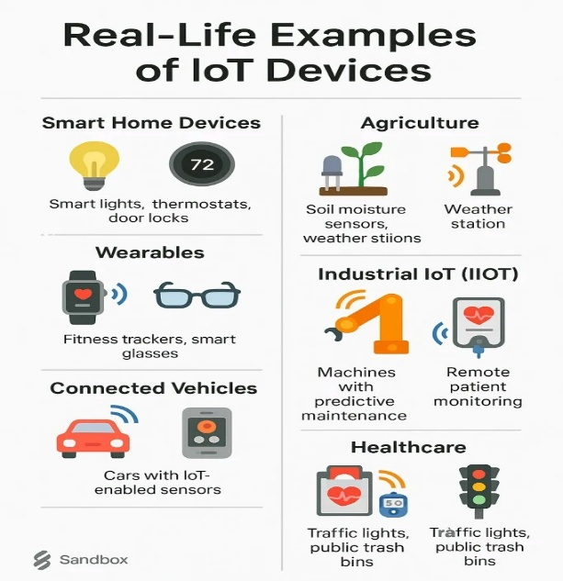
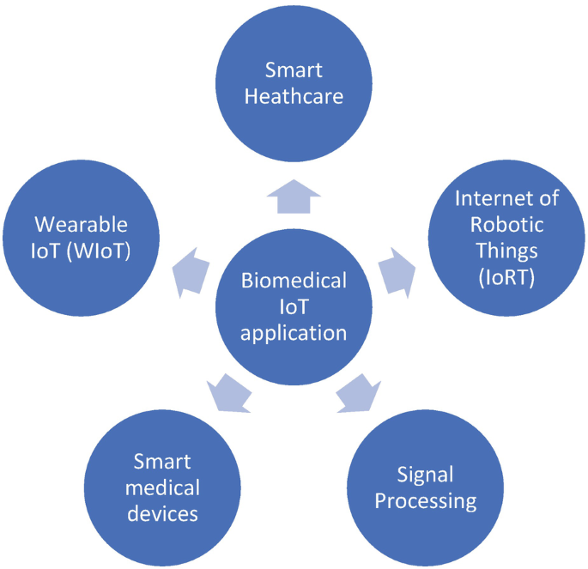
Figure 1 EXAMPLES OT IoT
Figure 2 IoT RELEVANCE

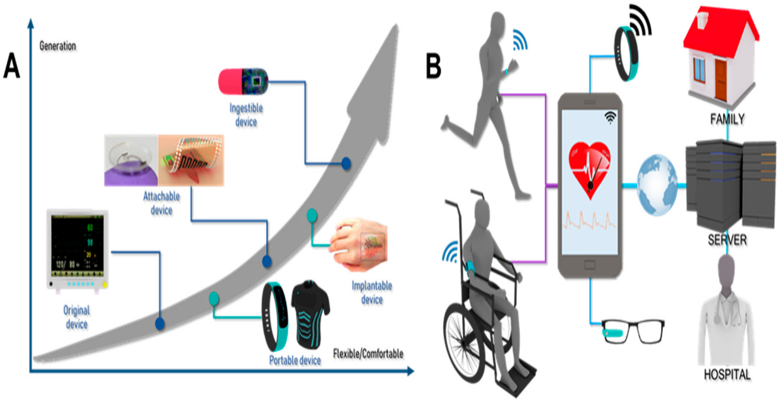
Figure 3 POTENTIAL IMPACTS IN BIOMEDICAL

A pie chart of IoT trends

Figure 4: PIE CHART

A table of IoT Trends

Table 1: A TABLE OF IOT TRENDS
YEARS | CONNECTED DEVICES(MILLIONS) | COST(HEALTHCARE MARKET) (USD)
2015 | 15.41 | $ 64.00
 | 17.68 | $ 79.00
  2016
2017 | 20.35 | $ 120.00
2018 |  | $ 147.00
  23.14
2019 | 26.66 | $ 180.00
2020 | 30.73 | $ 219.00
2021 | 35.82 | $ 265.00
2022 | 42.62 | $ 319.00
2023 | 51.11 | $ 382.00
2024 | 62.12 | $ 435.00
2025 | 75.44 | $ 534.00
AVERAGE | 36.46181818 | $ 249.45
TOTAL DEVICES | 401.08
TOTAL COST |  | $ 2,744.00

A graph of IoT trends

Figure 5: GRAPH

How the website was created
- We created the website in html, with tailwindcss, and some java script, with many lines of codes that cannot be listed here.
For the Database;
- We created a file called schema, .sql: which was supposed to contain the structure of the database (how the data is arranged, and tables)
- We wrote the tables and their fields (columns) and the data types in each schema in, sql (a programming language)
- Also, in the schema, since our survey was not much, we manually inserted data into the tables.
- Using SQlite3, we created a database with the schema and that is it
- We later installed the DB browser to view the tables and data.
For the blog;
- We went to medium.com, signed up for an account, created and edited the blog posts from the home page through the call to action “write” button there.

We used Chat GPT, Gemini as the learning languages to search for some of the relevance and potential Impact for Internet of Things in Biomedical and Mechatronics Engineering.

