ARPS Instrument Manual

1 Configurate rorating motor

1.1 Initialize Motor
We need to use OWIS software to initialize the motor(download link is here: Downloads - OWIS). On this website, you can find many useful manuals and software. I have downloaded the two manuals we need: 1. OWIS Manual, and 2. PS_10 Manual.
By following the OWIS manual, you will get to know the software in detail. Here, I will just introduce how to initialize the motor quickly.
1.Connecting the components correctly
Don't forget to use the white cable to connect the PS10 and the computer.
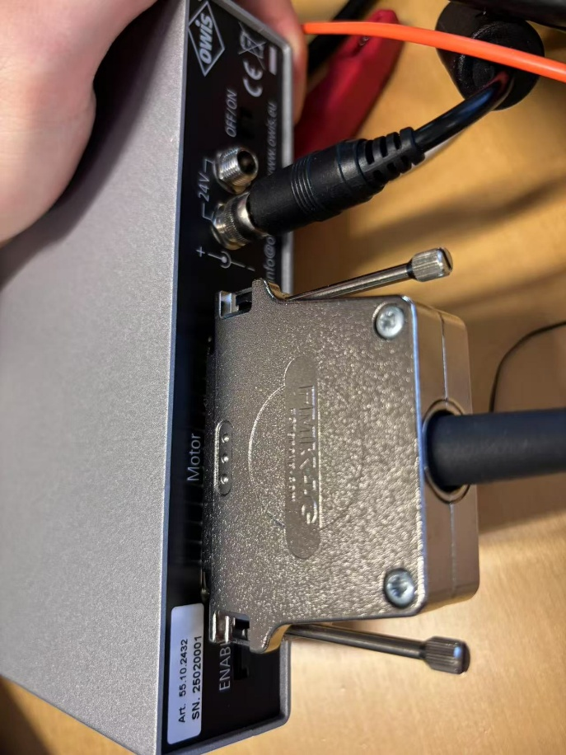
2.Switch on the PS10 and open OWIS
Click the button on the top left corner to create a new control unit.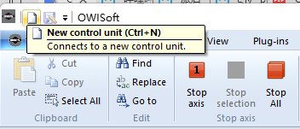 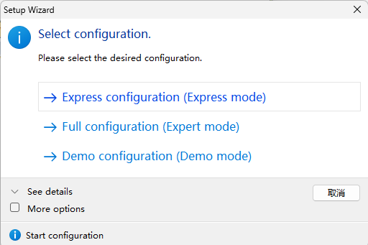
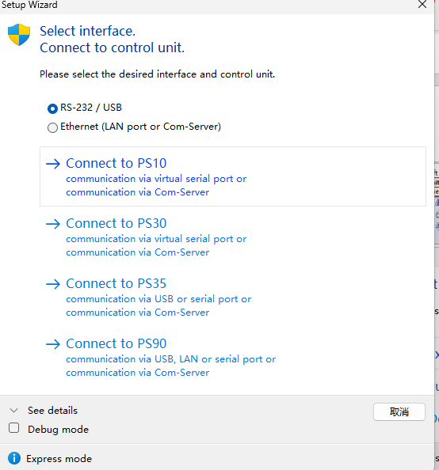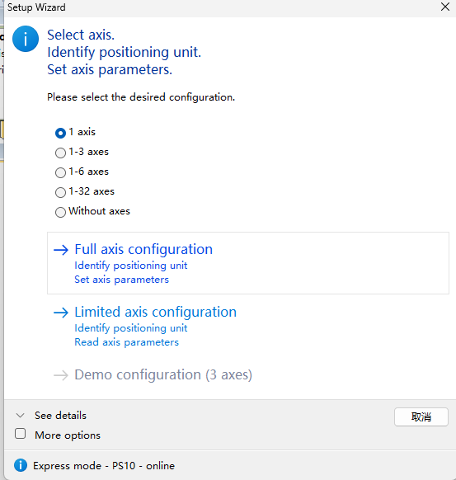
After clicking these buttons, you can see the status of the motor.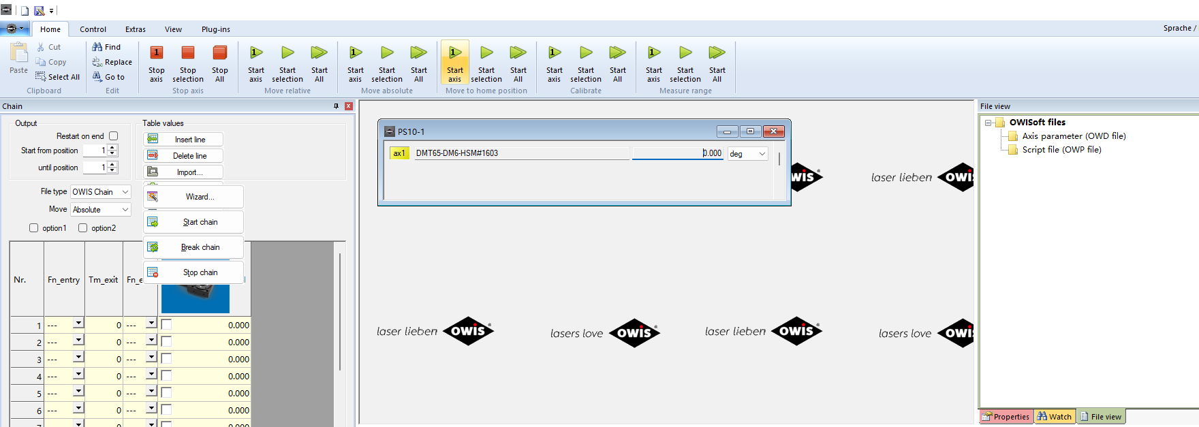
Choose “Initialize”
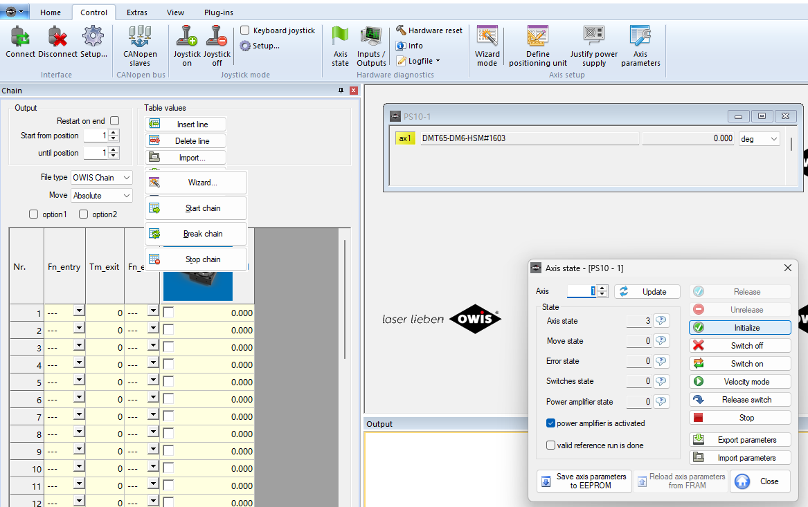
Choose “Wizard mode”, pick”Find”,”Identity”,”Auto-configuration”,”Close‘’
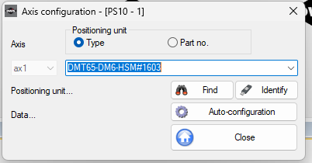
Choose”Define positioning unit”, you can find “full resoultion per microstep” here. Remember to pick “apply”
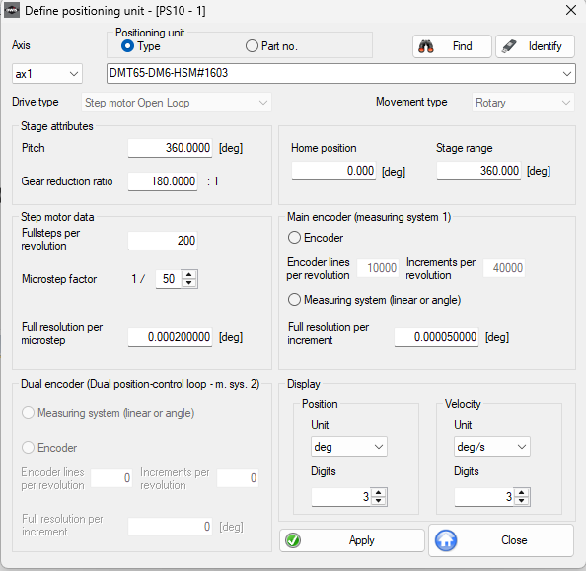
Pick “Jusitify power supply”,”Find”, “Identity”, “set”
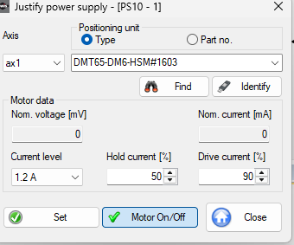

“Define axis paramters” is a function we will use frequently. We can change rotating speed and acceleration here. Velocity choose 22~28 is suitable(10 deg/s also work). In the “Check values”, you can see the effect of the parameters.
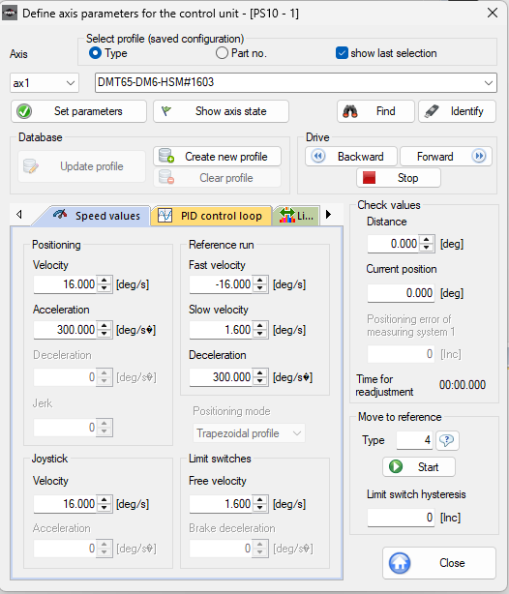
After setting the parameters you want, go to “Axis state,” and choose “Save axis parameters to EEPROM.” Then you can save the settings document. I saved my working settings (PS10-1) in the “Documents” folder. You can open my setting in Owisoft and save it to EPPROM.
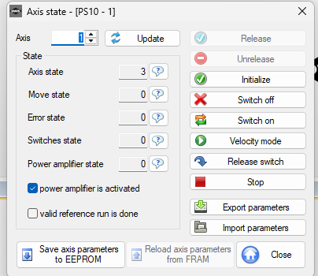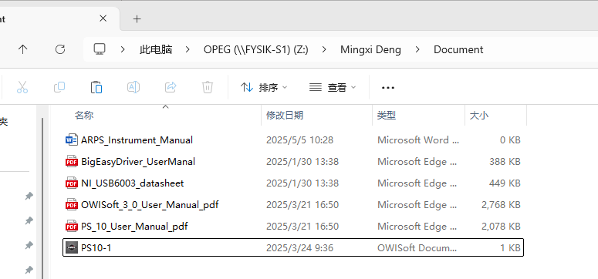

1.2 Contorl Motor in SweepMe
Delete the Initialzation function in the code. I save my workable code(“Real_Motor.py”) in the “motor” foler.
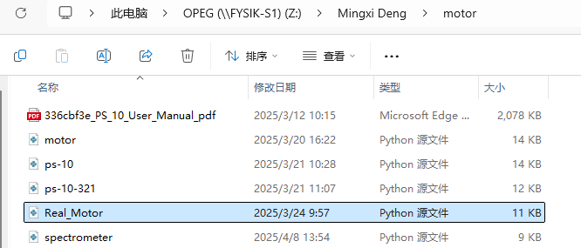

2 Spectromrter
- Download software driver OceanView(OceanView 2.0.8 光谱软件下载 | 海洋光学 · Ocean Optics)
- In the SweepMe, The version of a Python library used for timing does not match. I replaced it with a matching library. I can directly use my modified code(“spectrometer.py” in motor floder) to overwrite the code and then use it directly.
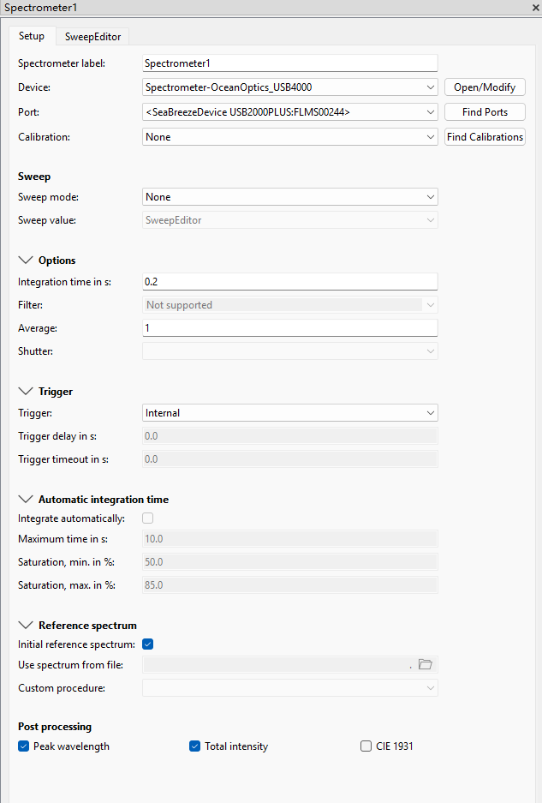

3 SweepMe
I store feasible settings(SuperYellow.set) in the document folder, which can be used as a basis for adaptive modification. If you want to know more about the operation process and demonstration cases of the equipment, you can participate in my undergraduate thesis.

Author: MingXi Deng
Time: 2025/05

