1. INTRODUCTION
1.1About the Project
2. ORGANIZATION PROFILE
3. SYSTEM ANALYSIS
3.1 Existing System
3.2 Limitations
3.3 Proposed System
3.4 Advantages of proposed system
4. problem formulation
4.1 Objectives
4.2 Hardware Specification
4.3 Software Specification
4.4 Software Descriptions
5. SYSTEM DESIGN
5.1 Design Overview
5.2 Context Analysis Diagram
5.3 Data Flow Diagram

6. SYSTEM TESTING
6.1 Unit Testing
6.2 Integration Testing
6.3 Acceptance Testing
7. SYSTEM IMPLMENTATION
8. CONCLUSION & FUTURE ENCHANCEMENTS
9. BIBLIOGRAPHY

Truth Discovery with Multiple Conflicting Information
Providers on the Web.

1. Abstract

The world-wide web has become the most important information source for most of us. Unfortunately, there is no guarantee for the correctness of information on the web. Moreover, different web sites often provide conflicting in-formation on a subject, such as different specifications for the same product. In this paper we propose a new problem called Veracity that is conformity to truth, which studies how to find true facts from a large amount of conflicting information on many subjects that is provided by various web sites. We design a general framework for the Veracity problem, and invent an algorithm called Truth Finder, which utilizes the relationships between web sites and their information, i.e., a web site is trustworthy if it provides many pieces of true information, and a piece of information is likely to be true if it is provided by many trustworthy web sites. Our experiments show that Truth Finder successfully finds true facts among conflicting information, and identifies trustworthy web sites better than the popular search engines.

1.1. Introduction

THE World Wide Web has become a necessary part of our lives and might have become the most important information source for most people. Everyday, people retrieve all kinds of information from the Web. For example, when shopping online, people find product specifications from websites like Amazon.com or ShopZilla.com. When looking for interesting DVDs, they get information and read movie reviews on websites such as NetFlix.com or IMDB.
com. When they want to know the answer to a certain question, they go to Ask.com or Google.com. “Is the World Wide Web always trustable?” Unfortunately, the answer is “no.” There is no guarantee for the correctness of information on the Web. Even worse, different websites often provide conflicting information, as shown in the following examples.

Example 1 (Height of Mount Everest). Suppose a user is interested in how high Mount Everest is and queries Ask.com with “What is the height of Mount Everest?” Among the top 20 results, 1 he or she will find the following facts: four websites (including Ask.com itself) say 29,035 feet, five websites say 29,028 feet, one says29, 002 feet, and another one says 29,017 feet. Which answer should the user trust?

Example 2 (Authors of books). We tried to find out who wrote the book Rapid Contextual Design (ISBN: 0123540518). We found many different sets of authors from different online bookstores, and we show several of them in Table 1. From the image of the book cover, we found that A1 Books provides the most accurate information. In comparison, the information from Powell’s books is incomplete, and that from Lakeside books is incorrect.

The trustworthiness problem of the Web has been realized by today’s Internet users. According to a survey on the credibility of websites conducted by Princeton Survey Research in 2005, 54 percent of Internet users trust news websites at least most of time, while this ratio is only 26 percent for websites that offer products for sale and is merely 12 percent for blogs. There have been many studies on ranking web pages according to authority (or popularity) based on hyperlinks. The most influential studies are Authority-Hub analysis, and Page Rank, which lead to Google.com. However, does authority lead to accuracy of information? The answer is unfortunately no. Top-ranked websites are usually the most popular ones. However, popularity does not mean accuracy. For example, according to our experiments, the bookstores ranked on top by Google (Barnes & Noble and Powell’s books) contain many errors on book author information. In comparison, some small bookstores (e.g., A1 Books) provide more accurate information.

In this paper, we propose a new problem called the Veracity problem, which is formulated as follows: Given a large amount of conflicting information about many objects, which is provided by multiple websites (or other types of information providers), how can we discover the true fact about each object? We use the word “fact” to represent something that is claimed as a fact by some website, and such a fact can be either true or false. In this paper, we only study the facts that are either properties of objects (e.g., weights of laptop computers) or relationships between two objects (e.g., authors of books). We also require that the facts can be parsed from the web pages. There are often conflicting facts on the Web, such as different sets of authors for a book. There are also many websites, some of which are more trustworthy than others.2 A fact is likely to be true if it is provided by trustworthy websites (especially if by many of them).

A website is trustworthy if most facts it provides are true. Because of this interdependency between facts and websites, we choose an iterative computational method. At each iteration, the probabilities of facts being true and
the trustworthiness of websites is inferred from each other. This iterative procedure is rather different from Authority-Hub analysis. Thus, we cannot compute the trustworthiness of a website by adding up the weights of its facts as in, nor can we compute the probability of a fact being true by adding up the trustworthiness of websites providing it. Instead, we have to resort to probabilistic computation. Second and more importantly, different facts influence each other. For example, if a website says that a book is written by “Jessamyn Wendell” and another says “Jessamyn Burns Wendell,” then these two websites actually support each other although they provide slightly different facts. We incorporate such influences between facts into our computational model.

In summary, we make three major distributions in this paper. First, we formulate the Veracity problem about how to discover true facts from conflicting information. Second, we propose a framework to solve this problem, by defining the trustworthiness of websites, confidence of facts, and influences between facts. Finally, we propose an algorithm called TRUTHFINDER for identifying true facts using iterative methods. Our experiments show that TRUTHFINDER achieves very high accuracy in discovering true facts, and it can select better trustworthy websites than authority-based search engines such as Google.

2. Organization Profiles
In this world of increasing globalization, Knowx moves forward to meet the challenges of the future through the development of R & D projects in various domains. R & D project sector attracts the most prominent thinkers and practitioners in a range of fields that impinge on development. The global presence and reach attained by Stupors are not only substantiated by its presence, but also in terms of the training students in R & D project development.
Over the decade, Knowx, a Subsidiary of Knowx Innovations Pvt. Ltd provides a wide range of R & D project development training. Our uniqueness lies in the exclusive R & D project development. Accordingly, we created a setting that is enabling, dynamic and inspiring for the increase of solutions to global problems by R & D project development. Developing appropriate, responsible, innovative and practical solutions to students, by assisting in R & D project development. All our research is stranded in the need to provide an industry based training for students.

About team
Our team consists of more than 300 enthusiastic experts, drawn from a range of disciplines and experience, supported by infrastructure and facilities, which are world class and distinctively state-of-the-art. The strength of the organization lies in not only identifying and articulating intellectual challenges across a number of disciplines of knowledge but also in mounting research, training and demonstration projects leading to development of specific problem-based advanced technologies. The organization growth has been evolutionary, driven by a vision of the future and ingrained in challenges frightening today. The organization continues to grow in size, spread and intensity of work undertaken. Our experts are involved in a wide range of R & D project development training to student wishing to undertake professional development, or just wanting to learn about a new subject or area of study.

Technologies
We provide training in following domain for R & D project development:
Networking
Grid Computing
Data Mining
Image Processing,
Neural Network
Multimedia
Embedded systems
Power systems, Power electronics
Control systems, communication
Bio Informatics
Web Technologies
Grid Computing
About R & D
Research and development Training makes students to understand new concepts, understand the strength and far reaching potential of your conception. It helps student to understand and prepare for the future of your technology.
Vision
Our vision doesn't begin and end with the execution of R & D projects. The main intension is to provide world-class training to the students in R & D project development by sharing our knowledge and expertise to create value is our ultimate goal.

3. System Analysis

3.1. Existing System

- Page Rank and Authority-Hub analysis is to utilize the hyperlinks to find pages with high authorities.
- These two approaches identifying important web pages that users are interested in, Unfortunately, the popularity of web pages does not necessarily lead to accuracy of information

3.1.1. Disadvantage

1. The popularity of web pages does not necessarily lead to accuracy of information.
2. Even the most popular website may contain many errors.
3. Where as some comparatively not-so-popular websites may provide more accurate information.

3.2. Proposed System

- We formulate the Veracity problem about how to discover true facts from conflicting information.
- Second, we propose a framework to solve this problem, by defining the trustworthiness of websites, confidence of facts, and influences between facts.
- Finally, we propose an algorithm called TRUTHFINDER for identifying true facts using iterative methods.

3.2.1. Advantage

- Our experiments show that TRUTHFINDER achieves very high accuracy in discovering true facts.
- It can select better trustworthy websites than authority-based search engines such as Google.

3.3. Limitations
- New users of the application need to get used to the application environment themselves as there are no help files included.
- The Database has to be uploaded again by clicking the upload database and then search you particular object.

  - Problem Formulation
4.1.1. Problem Definition

The World Wide Web has become the most important information source for most of us. Unfortunately, there is no guarantee for the correctness of information on the Web. Moreover, different websites often provide conflicting information on a subject, such as different specifications for the same product. In this paper, we propose a new problem, called Veracity, which is conformity to truth, which studies how to find true facts from a large amount of conflicting information on many subjects that is provided by various websites

4.2. Objectives
This project was implemented in Web browser .The aim of the project is to Truth Finder successfully finds true facts among conflicting information, and identifies trustworthy web sites better than the popular search engines. So user no needs to go for another search.

4.3. Hardware Specification

PROCESSOR : PENTIUM IV 2.6 GHz
RAM : 512 MB DD RAM
MONITOR : 15” COLOR
HARD DISK : 20 GB
CDDRIVE : LG 52X
KEYBOARD : STANDARD 102 KEYS
MOUSE : 3 BUTTONS

4.4. Software Specification

FRONT END : Java, J2ee (JSP, Servlet)
TOOL USED : Dream weaver 8
SERVER : Web logic 8.1
OPERATING SYSTEM : Window’s Xp
BACK END : Sql Server 2000

4.5. Software Descriptions

About J2ee

The J2EE platform uses a multitiered distributed application model. Application logic is divided into components according to function, and the various application components that make up a J2EE application are installed on different machines depending on the tier in the multitiered J2EE environment to which the application component belongs. Figure 1-1 shows two multitiered J2EE applications divided into the tiers described in the following list. The J2EE application parts shown in Figure 1-1 are presented in J2EE Components.
- Client-tier components run on the client machine.
- Web-tier components run on the J2EE server.
- Business-tier components run on the J2EE server.
- Enterprise information system (EIS)-tier software runs on the EIS server.
Although a J2EE application can consist of the three or four tiers shown in Figure 1-1, J2EE multitiered applications are generally considered to be three-tiered applications because they are distributed over three different locations: client machines, the J2EE server machine, and the database or legacy machines at the back end. Three-tiered applications that run in this way extend the standard two-tiered client and server model by placing a multithreaded application server between the client application and back-end storage.
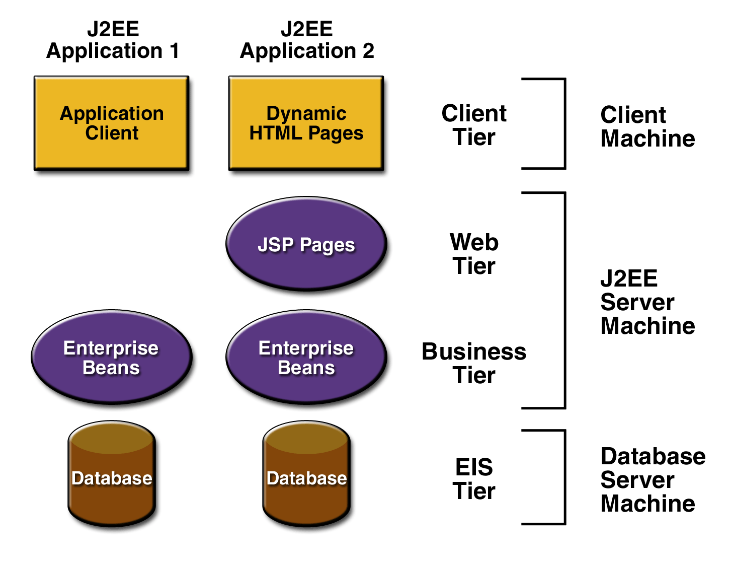
Figure 1-1 Multitiered Applications

J2EE Components
J2EE applications are made up of components. A J2EE component is a self-contained functional software unit that is assembled into a J2EE application with its related classes and files and that communicates with other components. The J2EE specification defines the following J2EE components:

- Application clients and applets are components that run on the client.
- Java Servlet and Java Server Pages (JSP) technology components are Web components that run on the server.
- Enterprise JavaBeans (EJB) components (enterprise beans) are business components that run on the server.
J2EE components are written in the Java programming language and are compiled in the same way as any program in the language. The difference between J2EE components and "standard" Java classes is that J2EE components are assembled into a J2EE application, verified to be well formed and in compliance with the J2EE specification, and deployed to production, where they are run and managed by the J2EE server.

J2EE Clients
A J2EE client can be a Web client or an application client.

Web Clients
A Web client consists of two parts: dynamic Web pages containing various types of markup language (HTML, XML, and so on), which are generated by Web components running in the Web tier, and a Web browser, which renders the pages received from the server.
A Web client is sometimes called a thin client. Thin clients usually do not do things like query databases, execute complex business rules, or connect to legacy applications. When you use a thin client, heavyweight operations like these are off-loaded to enterprise beans executing on the J2EE server where they can leverage the security, speed, services, and reliability of J2EE server-side technologies.

Applets
A Web page received from the Web tier can include an embedded applet. An applet is a small client application written in the Java programming language that executes in the Java virtual machine installed in the Web browser. However, client systems will likely need the Java Plug-in and possibly a security policy file in order for the applet to successfully execute in the Web browser.
Web components are the preferred API for creating a Web client program because no plug-ins or security policy files are needed on the client systems. Also, Web components enable cleaner and more modular application design because they provide a way to separate applications programming from Web page design. Personnel involved in Web page design thus do not need to understand Java programming language syntax to do their jobs.

Application Clients
A J2EE application client runs on a client machine and provides a way for users to handle tasks that require a richer user interface than can be provided by a markup language. It typically has a graphical user interface (GUI) created from Swing or Abstract Window Toolkit (AWT) APIs, but a command-line interface is certainly possible.
Application clients directly access enterprise beans running in the business tier. However, if application requirements warrant it, a J2EE application client can open an HTTP connection to establish communication with a servlet running in the Web tier.

JavaBeans Component Architecture
The server and client tiers might also include components based on the JavaBeans component architecture (JavaBeans component) to manage the data flow between an application client or applet and components running on the J2EE server or between server components and a database. JavaBeans components are not considered J2EE components by the J2EE specification.
JavaBeans components have instance variables and get and set methods for accessing the data in the instance variables. JavaBeans components used in this way are typically simple in design and implementation, but should conform to the naming and design conventions outlined in the JavaBeans component architecture.

J2EE Server Communications
Figure 1-2 shows the various elements that can make up the client tier. The client communicates with the business tier running on the J2EE server either directly or, as in the case of a client running in a browser, by going through JSP pages or servlets running in the Web tier.
Your J2EE application uses a thin browser-based client or thick application client. In deciding which one to use, you should be aware of the trade-offs between keeping functionality on the client and close to the user (thick client) and off-loading as much functionality as possible to the server (thin client). The more functionality you off-load to the server, the easier it is to distribute, deploy, and manage the application; however, keeping more functionality on the client can make for a better perceived user experience.
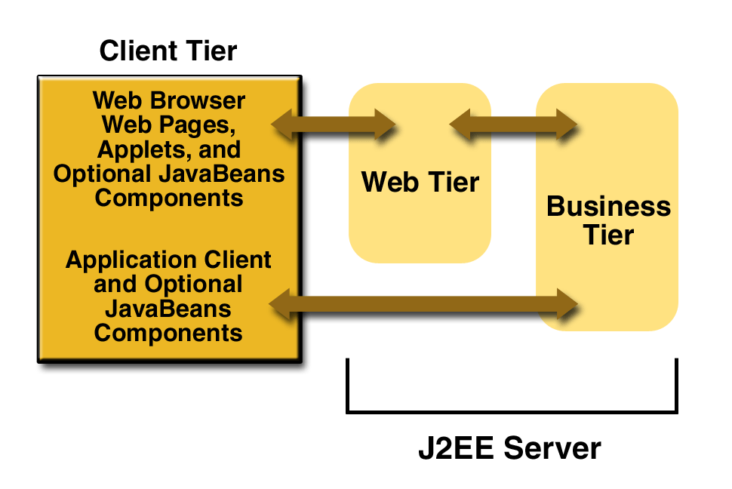

Figure 1-2 Server Communications

Web Components
J2EE Web components can be either servlets or JSP pages. Servlets are Java programming language classes that dynamically process requests and construct responses. JSP pages are text-based documents that execute as servlets but allow a more natural approach to creating static content.
Static HTML pages and applets are bundled with Web components during application assembly, but are not considered Web components by the J2EE specification. Server-side utility classes can also be bundled with Web components and, like HTML pages, are not considered Web components.
Like the client tier and as shown in Figure 1-3, the Web tier might include a JavaBeans component to manage the user input and send that input to enterprise beans running in the business tier for processing.

Business Components
Business code, which is logic that solves or meets the needs of a particular business domain such as banking, retail, or finance, is handled by enterprise beans running in the business tier. Figure 1-4 shows how an enterprise bean receives data from client programs, processes it (if necessary), and sends it to the enterprise information system tier for storage. An enterprise bean also retrieves data from storage, processes it

(if necessary), and sends it back to the client program.
Figure 1-3 Web Tier and J2EE Application
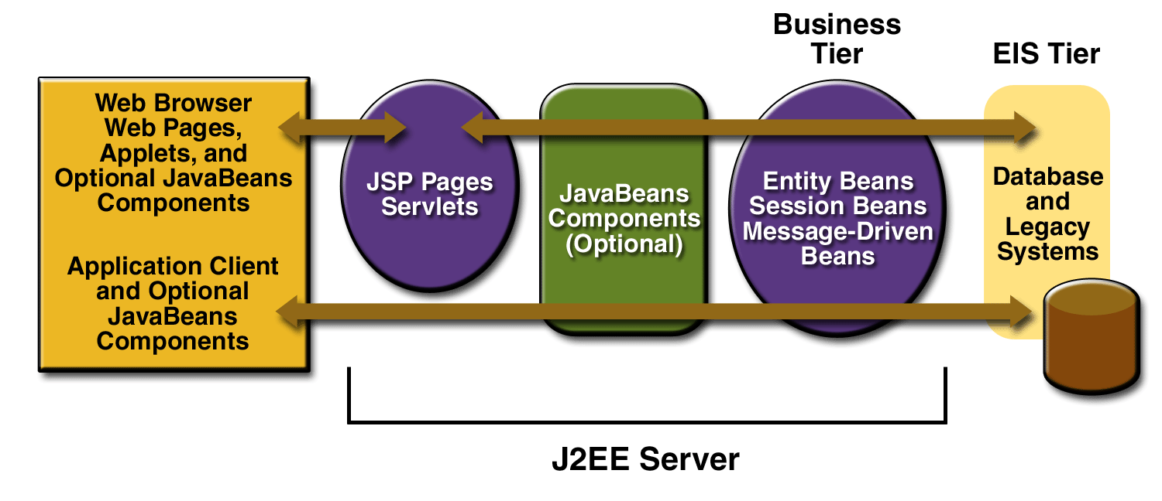

Figure 1-4 Business and EIS Tiers
There are three kinds of enterprise beans: session beans, entity beans, and message-driven beans. A session bean represents a transient conversation with a client. When the client finishes executing, the session bean and its data are gone. In contrast, an entity bean represents persistent data stored in one row of a database table. If the client terminates or if the server shuts down, the underlying services ensure that the entity bean data is saved.
A message-driven bean combines features of a session bean and a Java Message Service ("JMS") message listener, allowing a business component to receive JMS messages asynchronously. This tutorial describes entity beans and session beans.

Packaging
J2EE components are packaged separately and bundled into a J2EE application for deployment. Each component, its related files such as GIF and HTML files or server-side utility classes, and a deployment descriptor are assembled into a module and added to the J2EE application. A J2EE application is composed of one or more enterprise bean, Web, or application client component modules. The final enterprise solution can use one J2EE application or be made up of two or more J2EE applications, depending on design requirements.
A J2EE application and each of its modules has its own deployment descriptor. A deployment descriptor is an XML document with an .xml extension that describes a component's deployment settings. An enterprise bean module deployment descriptor, for example, declares transaction attributes and security authorizations for an enterprise bean. Because deployment descriptor information is declarative, it can be changed without modifying the bean source code. At run time, the J2EE server reads the deployment descriptor and acts upon the component accordingly.
A J2EE application with all of its modules is delivered in an Enterprise Archive (EAR) file. An EAR file is a standard Java Archive (JAR) file with an .ear extension. In the GUI version of the J2EE SDK application deployment tool, you create an EAR file first and add JAR and Web Archive (WAR) files to the EAR. If you use the command line packager tools, however, you create the JAR and WAR files first and then create the EAR
- files, and related Each EJB JAR file contains a deployment descriptor, the enterprise bean files.
- Each application client JAR file contains a deployment descriptor, the class files for the application client, and related files.
- Each WAR file contains a deployment descriptor, the Web component files, and related resources.
Using modules and EAR files makes it possible to assemble a number of different J2EE applications using some of the same components. No extra coding is needed; it is just a matter of assembling various J2EE modules into J2EE EAR files.

Development Roles
Reusable modules make it possible to divide the application development and deployment process into distinct roles so that different people or companies can perform different parts of the process.
The first two roles involve purchasing and installing the J2EE product and tools. Once software is purchased and installed, J2EE components can be developed by application component providers, assembled by application assemblers, and deployed by application deployers. In a large organization, each of these roles might be executed by different individuals or teams. This division of labor works because each of the earlier roles outputs a portable file that is the input for a subsequent role. For example, in the application component development phase, an enterprise bean software developer delivers EJB JAR files. In the application assembly role, another developer combines these EJB JAR files into a J2EE application and saves it in an EAR file. In the application deployment role, a system administrator at the customer site uses the EAR file to install the J2EE application into a J2EE server.
The different roles are not always executed by different people. If you work for a small company, for example, or if you are prototyping a sample application, you might perform the tasks in every phase.

J2EE Product Provider
The J2EE product provider is the company that designs and makes available for purchase the J2EE platform, APIs, and other features defined in the J2EE specification. Product providers are typically operating system, database system, application server, or Web server vendors who implement the J2EE platform according to the Java 2 Platform, Enterprise Edition Specification.

Tool Provider
The tool provider is the company or person who creates development, assembly, and packaging tools used by component providers, assemblers, and deployers. See the section Tools for information on the tools available with J2EE SDK version 1.3.

Application Component Provider
The application component provider is the company or person who creates Web components, enterprise beans, applets, or application clients for use in J2EE applications.

Enterprise Bean Developer
An enterprise bean developer performs the following tasks to deliver an EJB JAR file that contains the enterprise bean:
- Writes and compiles the source code
- Specifies the deployment descriptor

Web Component Developer
A Web component developer performs the following tasks to deliver a WAR file containing the Web component:
- Writes and compiles servlet source code
- Writes JSP and HTML files
- Specifies the deployment descriptor for the Web component
- Bundles the .class, .jsp, .html, and deployment descriptor files in the WAR file.

J2EE Application Client Developer
An application client developer performs the following tasks to deliver a JAR file containing the J2EE application client:
- Writes and compiles the source code
- Specifies the deployment descriptor for the client
- Bundles the .class files and deployment descriptor into the JAR file

Application Assembler
The application assembler is the company or person who receives application component JAR files from component providers and assembles them into a J2EE application EAR file. The assembler or deployer can edit the deployment descriptor directly or use tools that correctly add XML tags according to interactive selections. A software developer performs the following tasks to deliver an EAR file containing the J2EE application:
- Assembles EJB JAR and WAR files created in the previous phases into a J2EE application (EAR) file.
- Specifies the deployment descriptor for the J2EE application.
- Verifies that the contents of the EAR file are well formed and comply with the J2EE specification.

Application Deployer and Administrator
The application deployer and administrator is the company or person who configures and deploys the J2EE application, administers the computing and networking infrastructure where J2EE applications run, and oversees the runtime environment. Duties include such things as setting transaction controls and security attributes and specifying connections to databases.
During configuration, the deployer follows instructions supplied by the application component provider to resolve external dependencies, specify security settings, and assign transaction attributes. During installation, the deployer moves the application components to the server and generates the container-specific classes and interfaces.
A deployer/system administrator performs the following tasks to install and configure a J2EE application:
- Adds the J2EE application (EAR) file created in the preceding phase to the J2EE server.
- Configures the J2EE application for the operational environment by modifying the deployment descriptor of the J2EE application.
- Verifies that the contents of the EAR file are well formed and comply with the J2EE specification.
- Deploys (installs) the J2EE application EAR file into the J2EE server.

Reference Implementation Software
The J2EE SDK is a noncommercial operational definition of the J2EE platform and specification made freely available by Sun Microsystems for demonstrations, prototyping, and educational use. It comes with the J2EE application server, Web server, relational database, J2EE APIs, and complete set of development and deployment tools.
The purpose of the J2EE SDK is to allow product providers to determine what their implementations must do under a given set of application conditions, and to run the J2EE Compatibility Test Suite to test that their J2EE products fully comply with the specification. It also allows application component developers to run their J2EE applications on the J2EE SDK to verify that applications are fully portable across all J2EE products and tools.

Database Access
The relational database provides persistent storage for application data. A J2EE implementation is not required to support a particular type of database, which means that the database supported by different J2EE products can vary. See the Release Notes included with the J2EE SDK download for a list of the databases currently supported by the reference implementation.

JDBC API 2.0
The JDBC API lets you invoke SQL commands from Java programing language methods. You use the JDBC API in an enterprise bean when you override the default container-managed persistence or have a session bean access the database. With container-managed persistence, database access operations are handled by the container, and your enterprise bean implementation contains no JDBC code or SQL commands. You can also use the JDBC API from a servlet or JSP page to access the database directly without going through an enterprise bean.
The JDBC API has two parts: an application-level interface used by the application components to access a database, and a service provider interface to attach a JDBC driver to the J2EE platform.

Java Servlet Technology 2.3
Java Servlet technology lets you define HTTP-specific servlet classes. A servlet class extends the capabilities of servers that host applications accessed by way of a request-response programming model. Although servlets can respond to any type of request, they are commonly used to extend the applications hosted by Web servers.

Java Server Pages Technology 1.2
Java Server Pages technology lets you put snippets of servlet code directly into a text-based document. A JSP page is a text-based document that contains two types of text: static template data, which can be expressed in any text-based format such as HTML, WML, and XML, and JSP elements, which determine how the page constructs dynamic content.

J2EE Connector Architecture 1.0
The J2EE Connector architecture is used by J2EE tools vendors and system integrators to create resource adapters that support access to enterprise information systems that can be plugged into any J2EE product. A resource adapter is a software component that allows J2EE application components to access and interact with the underlying resource manager. Because a resource adapter is specific to its resource manager, there is typically a different resource adapter for each type of database or enterprise information system.

Tools
The J2EE reference implementation provides an application deployment tool and an array of scripts for assembling, verifying, and deploying J2EE applications and managing your development and production environments.

Application Deployment Tool
The J2EE reference implementation provides an application deployment tool (deploytool) for assembling, verifying, and deploying J2EE applications. There are two versions: command line and GUI.
The GUI tool includes wizards for:
- Packaging, configuring, and deploying J2EE applications
- Packaging and configuring enterprise beans
- Packaging and configuring Web components
- Packaging and configuring application clients
- Packaging and configuring resource adaptors
In addition, configuration information can be set for each component and module type in the tabbed inspector panes.

Introduction jsp

The goal of the java server page specification is to simplify the creation and management of dynamic web page by separating content and presentation jsp as basically files that combine html and new scripting tags. the jsp there look somewhat like HTML but they get translated into java servlet the first time are invoked by a client. The resulting servlet is a combination of the html from the jsp file and embedded dynamic content specified by the new tag.

For our example in this c:/projavaserver/chapter11/jsp example hold our web application save the above in the file called simple jsp. Jsp and place it in the root of the web application (in the words save it as)
C:/localhost/project folder name/sourcename.jsp
You should output similar to the following.
In other words the first time jsp is loaded by the jsp container (also called the jsp ehgine)
The servlet code necessary to fulfill the jsp tages is automatically generated compiled and loaded into the servlet container. From then on as long as the jsp source for the page is not modified this compiled servlet process any browser request for the jsp page. If you modify the mouse source code for the jsp it is automatically recompiled and relocated the next time that page is request

The nuts and bolts

The structure of a jsp page is a cross between a servlet and a html page with java code enclosed between the html.

- DIRECTIVES these affect the overall structure of the servlet that result from translation
- Scripting elements these let you insert java code into the jsp page.
- Action these are special tags available jsp
- You can also write your own tags as we shall

Some general rule of JSP page:
- JSP tag are case sensitive
- Directive and scripting element have a syntax which is not based on xml alternative page.
- Tags based on html Syntax is also available.
- If the URL does not start with a it is interpreted relative to the current jsp.

The page directive

The page directive is used to define and manipulate a number of important page dependent attributed that affect the whole jsp the enter compiled class file and communication these attributed to the jsp container. The page can contain any number of page directive in any jsp . they are all assimilated during translated and applied together to the page.

Language: define the scripting language to be used for future use if jsp containers support multiple language.” java”.

Import: comma separated list of package of class just like import statement in usual java code. “omitted by default” session .the page http session when true the import object session and can be java. servlet. Http session is available for page. “true”

The http protocol
In distributed application development, the application level or wire level communication protocol determines the nature of client and servers. This is true in the case of web based application as well. The complexity of feature possible in your web browser and on the web server(say the on line store you frequent) depends on the underlying protocol that is the HYPER TEXT TRANSFER PROTOCOL(HTTP).

Http Request Methods

As an application level protocol, HTTP defines types of request that clients can send to server .The protocol also specifies how the request and responses be structured. HTTP specifies three type of request method GET,POST and HEAD has addition request meet most of the common application development needs.

The Get Request Method

Of all types of request the GET request the simplest and most frequently used Method for accessing static resource such as HTML document image etc. Get Request can also be used to retrieve dynamic information, by using additional query parameter in the request URL. For instance, you can send a parameter name= joe appended to a URL as http://www.domain.com?name=joe. The web server can use this parameter name=joe, to send content to “joe”.

The Post Request Method

The post method is commonly used for accessing dynamic resource. Typically, POST request are meant to transmit information that is request dependent, and Are used when you need to send large amount of complex information to the server. The POST request allows the encapsulation of multipart message into the request body. For example you can use POST REQUEST TO UPLOAD TEXT OR BINARY FILES. Similarly, you can use POST you can use POST request in your applets to send serializable java objects, or even to the web server . POST REQUEST THEREFORE OFFER A WIDER CHOICE IN TERMS of the request.

Http response

In responses to a HTTP request, the server responds with the status of the responses, all these are part of the response header. Except for the case of the HEAD request, the server also sends the body content that corresponds to the resource specified in the request. In the http://java.sun.com/index.html URL, your Browser receives the method of the index file as part of the message and renders, the body is typical interested.

Features of Http

- HTTP is very simple and lightweight protocol.

- In the protocol the client always initiate request the server can never make a callback connection to the client.

- The HTTP requires the client to establish connection prior to each request and the server to close the connection after sending the response this guarantees that the client cannot hold on to a connection even after receiving the request .Also note that either the client or the server can premature terminate a connection.

Script lets

A scriptlets is a block of java code that is executed during the request
processing time and is enclosed between <% and %> tags. What the scriptlets actually does depends on the code itself and can include producing output for the client. Multiple script are combination in the generation servlet class in the order they appear in the JSP. Scriptlets like any other java code block or method can modify object inside then as a result of method invocation.

JSP provider certain implicit object based on the servlet API. These objects are accessed using standard variable and are automatically available for use in your JSP without writing any extra code. The impact objects available in a JSP page are.

- request
- response
- page context
- session
- application
- out
- config
- page

Request Object

The request object represent the request that the server invocation. It is the http servlet request that provided access to the incoming HTTP header request type and request parameter, among other thing. Strictly speaking the
Object itself will be a protocol and implement specific subclass of javax. servlet servlet request but few container currently support on HTTP servlet. It has request scope.

The Response Object

The response object is the http servlet response instance that response instance that the server to the request. It is legal to set HTTP status code and header in the JSP page once output has been sent to the client since the output stream is buffered . Again the object itself javax. Servlet. Servlet response. It has page scope.

The Session Object

The object represent the session create for the request client. Session are created automatically and this variable is available even is no incoming session have used a session = false attribute in the page directive in which case this variable javax. Servlet .http . http session and has session scope.

The Application Object

The application object represent the servlet context obtained from the servlet configuration object. It is of type javax. Servlet context and has application scope.

The Out Object

The out object is the that write into the output stream to the client . To make the represent usefull this is a buffered version of the java . io . print writer class of type the buffer size can be adjusted via the buffer attribute of the page directive.

The Config Object

The config object is the servlet config for this JSP and has page scope. It is of type javax. Servlet servlet config.

Tomcat Server
Tomcat is a web server which can be used to execute the j2EE components. Tomcat provides many new and changed features, including the following:
Dynamic reloading and compilation - You can configure Tomcat to dynamically recompile and reload servlets, servlet helper classes, and
JavaServer Page (JSP) helper classes when a servlet or JSP is called. When the compile and reload features are enabled, Tomcat dynamically recompiles and reloads a servlet when it is called. Tomcat also dynamically recompiles and reloads classes in the WEB-INF/classes directory and tag library classes when they are called by a servlet or JSP. This feature is disabled by default. For more information, see Tomcat Assembly and Deployment Guide.
Dynamic creation of database tables for entity beans - When you deploy an entity bean and its required database tables do not yet exist, Tomcat generates tables for you if you configured the appropriate settings in the Tomcat deployment descriptor. For more information, see Tomcat Programmer’s Guide.
JRun Management Console (JMC) - The redesigned, JMX-enabled JMC provides an easy-to-use, intuitive graphical user interface for managing your local and remote JRun servers.
Web server configuration tool - JRun provides

JAVA DATABASE CONNECTIVITY (JDBC)

JDBC AND ODBC IN JAVA:

Most popular and widely accepted database connectivity called Open Database Connectivity (ODBC) is used to access the relational databases. It offers the ability to connect to almost all the databases on almost all platforms. Java applications can also use this ODBC to communicate with a database. Then we need JDBC why? There are several reasons:

- ODBC API was completely written in C language and it makes an extensive use of pointers. Calls from Java to native C code have a number of drawbacks in the security, implementation, robustness and automatic portability of applications.
- ODBC is hard to learn. It mixes simple and advanced features together, and it has complex options even for simple queries.
- ODBC drivers must be installed on client’s machine.

Architecture of JDBC:
JDBC Architecture contains three layers:
JDBC Application
JDBC Drivers
JDBC Drivers

Application Layer: Java program wants to get a connection to a database. It needs the information from the database to display on the screen or to modify the existing data or to insert the data into the table.
Driver Manager: The layer is the backbone of the JDBC architecture. When it receives a connection-request form.

The JDBC Application Layer: It tries to find the appropriate driver by iterating through all the available drivers, which are currently registered with Device Manager. After finding out the right driver it connects the application to appropriate database.
JDBC Driver layers: This layer accepts the SQL calls from the application and converts them into native calls to the database and vice-versa. A JDBC Driver is responsible for ensuring that an application has consistent and uniform m access to any database.

when a request received by the application, the JDBC driver passes the request to the ODBC driver, the ODBC driver communicates with the database and sends the request and gets the results. The results will be passed to the JDBC driver and in turn to the application. So, the JDBC driver has no knowledge about the actual database, it knows how to pass the application request o the ODBC and get the results from the ODBC.

The JDBC and ODBC interact with each other, how? The reason is both the JDBC API and ODBC are built on an interface called “Call Level Interface” (CLI). Because of this reason the JDBC driver translates the request to an ODBC call. The ODBC then converts the request again and presents it to the database. The results of the request are then fed back through the same channel in reverse.
Structured Query Language (SQL)

SQL (Pronounced Sequel) is the programming language that defines and manipulates the database. SQL databases are relational databases; this means simply the data is store in a set of simple relations. A database can have one or more table. You can define and manipulate data in a table with SQL commands. You use the data definition language (DDL) commands to creating and altering databases and tables.

You can update, delete or retrieve data in a table with data manipulation commands (DML). DML commands include commands to alter and fetch data.

The most common SQL commands include commands is the SELECT command, which allows you to retrieve data from the database.

In addition to SQL commands, the oracle server has a procedural language called PL/SQL. PL/SQL enables the programmer to program SQL statement. It allows you to control the flow of a SQL program, to use variables, and to write error-handling procedures

About Ms-Access

What is a Database?

A database is a collection of information that's related to a particular subject or purpose, such as tracking customer orders or maintaining a music collection. If your database isn't stored on a computer, or only parts of it are, you may be tracking information from a variety of sources that you're having to coordinate and organize yourself.
Using Microsoft Access, you can manage all your information from a single database file. Within the file, divide your data into separate storage containers called tables; view, add, and update table data by using online forms; find and retrieve just the data you want by using queries; and analyze or print data in a specific layout by using reports. Allow users to view, update, or analyze the database's data from the Internet or an intranet by creating data access pages.
To store your data, create one table for each type of information that you track. To bring the data from multiple tables together in a query, form, report, or data access page, define relationships between the tables.
To find and retrieve just the data that meets conditions that you specify, including data from multiple tables, create a query. A query can also update or delete multiple records at the same time, and perform predefined or custom calculations on your data.
To easily view, enter, and change data directly in a table, create a form. When you open a form, Microsoft Access retrieves the data from one or more tables, and displays it on the screen with the layout you choose in the Form Wizard, or a layout that you create from scratch.

To analyze your data or present it a certain way in print, create a report. For example, you might print one report that groups data and calculates totals, and another report with different data formatted for printing mailing labels.
To make data available on the Internet or an intranet for interactive reporting, data entry, or data analysis, use a data access page. Microsoft Access retrieves the data from one or more tables and displays it on the screen with the layout you choose in the Page Wizard, or a layout that you create from scratch. Users can interact with the data by using features on the data access page.

Tables: What They Are And How They Work
A table is a collection of data about a specific topic, such as products or suppliers. Using a separate table for each topic means that you store that data only once, which makes your database more efficient, and reduces data-entry errors.Tables organize data into columns (called fields) and rows (called records).
A common field relates two tables so that Microsoft Access can bring together the data from the two tables for viewing, editing, or printing.
In table Design view, you can create an entire table from scratch, or add, delete, or customize the fields in an existing table.
In table Datasheet view, you can add, edit, view, or otherwise work with the data in a table. You can also display records from tables that are related to the current table by displaying subdatasheets within the main datasheet. With some restrictions, you can work with the data in subdatasheets in many of the same ways that you work with data in the main datasheet.

Queries: What They Are And How They Work
You use queries to view, change, and analyze data in different ways. You can also use them as the source of records for forms, reports, and data access pages.
The most common type of query is a select query. A select query retrieves data from one or more tables by using criteria you specify and then displays it in the order you want.

Forms: What they are and how they work

You can use forms for a variety of purposes.Most of the information in a form comes from an underlying record source. Other information in the form is stored in the form's design.
You create the link between a form and its record source by using graphical objects called controls. The most common type of control used to display and enter data is a text box.

Modules: What they are and how they work

What is a module?
A module is a collection of Visual Basic for Applications declarations and procedures that are stored together as a unit.
There are two basic types of modules: class modules and standard modules. Each procedure in a module can be a Function procedure or a Sub procedure.

Class modules
Form and report modules are class modules that are associated with a particular form or report. Form and report modules often contain event procedures that run in response to an event on the form or report. You can use event procedures to control the behavior of your forms and reports, and their response to user actions, such as clicking the mouse on a command button.
When you create the first event procedure for a form or report, Microsoft Access automatically creates an associated form or report module. Procedures in your form and report modules can call procedures you have added to standard modules.
In Access 95, class modules exist in association only with a form or report. In Access 97 or later, class modules can also exist independent of a form or report, and this type of class module is listed in Modules under Objects on the Database window. You can use a class module in Modules to create a definition for a custom object.

Standard modules
Standard modules contain general procedures that aren't associated with any other object and frequently used procedures that can be run from anywhere within your database.
You can view the list of standard modules in your database by clicking Modules under Objects in the Database window. Form, report, and standard modules are also listed in the Object Browser.

Why define relationships?
After you've set up different tables for each subject in your Microsoft Access database, you need a way of telling Microsoft Access how to bring that information back together again. The first step in this process is to define relationships between your tables. After you've done that, you can create queries, forms, and reports to display information from several tables at once. For example, this form includes information from five tables:

How do relationships work?
In the previous example, the fields in five tables must be coordinated so that they show information about the same order. This coordination is accomplished with relationships between tables. A relationship works by matching data in key fields — usually a field with the same name in both tables. In most cases, these matching fields are the primary key from one table, which provides a unique identifier for each record, and a foreign key in the other table. For example, employees can be associated with orders they're responsible for by creating a relationship between the Employees table and the Orders table using the EmployeeID fields.

A one-to-many relationship
A one-to-many relationship is the most common type of relationship. In a one-to-many relationship, a record in Table A can have many matching records in Table B, but a record in Table B has only one matching record in Table A.

A many-to-many relationship
In a many-to-many relationship, a record in Table A can have many matching records in Table B, and a record in Table B can have many matching records in Table A. This type of relationship is only possible by defining a third table (called a junction table) whose primary key consists of two fields — the foreign keys from both Tables A and B. A many-to-many relationship is really two one-to-many relationships with a third table. For example, the Orders table and the Products table have a many-to-many relationship that's defined by creating two one-to-many relationships to the Order Details table.

A one-to-one relationship
In a one-to-one relationship, each record in Table A can have only one matching record in Table B, and each record in Table B can have only one matching record in Table A. This type of relationship is not common, because most information related in this way would be in one table. You might use a one-to-one relationship to divide a table with many fields, to isolate part of a table for security reasons, or to store information that applies only to a subset of the main table. For example, you might want to create a table to track employees participating in a fundraising soccer game.

Defining relationships
You define a relationship by adding the tables that you want to relate to the Relationships window, and then dragging the key field from one table and dropping it on the key field in the other table. You can also define relationships by using the keyboard.
The kind of relationship that Microsoft Access creates depends on how the related fields are defined:
- A one-to-many relationship is created if only one of the related fields is a primary key or has a unique index.
- A one-to-one relationship is created if both of the related fields are primary keys or have unique indexes.
- A many-to-many relationship is really two one-to-many relationships with a third table whose primary key consists of two fields — the foreign keys from the two other tables.
Offered System

The existing system is the harder one to bid the product. The blue-collar (manual) system is prone to blunder. It is time consuming. It is very intricate for a person to turn out the testimony. There are odds for changing the scheme testimony and do malpractice. This system engages a lot of blue-collar entries with the appliance to achieve the preferred task. This existing system is intricate to be aware of.
Usage of documents in the imbursement process leads to less competence, less accurateness and less productivity.
And other shortcomings in blue-collar system are as follows:
- Increased disbursement for papers shuffle and storage.
- Less control of Amounts
- Personnel who are sited in poles apart of the world cannot transact resourcefully.

Anticipated System
The anticipated system is premeditated to eradicate the negative aspect of the offered system. The anticipated system is designed by keeping to eradicate the negative aspect of the offered system in order to afford an enduring solution to the tribulations. The primary aim of the new system is to accelerate business dealings. The testimony is primed for the schemes and put into practice under the regulation of the concerned bureaucrat.
This anticipated System is used to trim down the difficulties. Anticipated system is very constructive and is trouble-free. Dozens of companies are in the race to convince auction and bidding that a pot of auction product awaits those who conduct their business on the Internet. In this fast battle of commerce and moneymaking, no country, no corporation and no creature would like to descend back. One and all want to lead the group. Now, no more individual aspires at the local market is also just a click of button away. Hence, everyone is trying to make the best use of Internet; our anticipated system also meets up the desires of the patron who can bid all the way through online.

Performance And Limitations

Performance

- HTTP is a very simple and light weight protocol in this protocol the client always initiate request to the server.
- No memory required.
- The application uses session to track the user.
- Simplifies the operation.
- Consisting and flexible page navigation.
- Reduce of upload and download time.
- No lost of the data.

Limitations

- New users of the application need to get used to the application environment themselves as there are no help files included.
- The backup file has to be uploaded again by clicking the upload module and then selecting the backup that has to be uploaded.

Tables: What they are and how they work
A table is a collection of data about a specific topic, such as products or suppliers. Using a separate table for each topic means that you store that data only once, which makes your database more efficient, and reduces data-entry errors.Tables organize data into columns (called fields) and rows (called records).
A common field relates two tables so that Microsoft Access can bring together the data from the two tables for viewing, editing, or printing.
In table Design view, you can create an entire table from scratch, or add, delete, or customize the fields in an existing table.
In table Datasheet view, you can add, edit, view, or otherwise work with the data in a table. You can also display records from tables that are related to the current table by displaying subdatasheets within the main datasheet. With some restrictions, you can work with the data in subdatasheets in many of the same ways that you work with data in the main datasheet.

Queries: What they are and how they work
You use queries to view, change, and analyze data in different ways. You can also use them as the source of records for forms, reports, and data access pages.
The most common type of query is a select query. A select query retrieves data from one or more tables by using criteria you specify and then displays it in the order you want.

Forms: What they are and how they work

You can use forms for a variety of purposes.Most of the information in a form comes from an underlying record source. Other information in the form is stored in the form's design.
You create the link between a form and its record source by using graphical objects called controls. The most common type of control used to display and enter data is a text box.

Modules: What they are and how they work

What is a module?
A module is a collection of Visual Basic for Applications declarations and procedures that are stored together as a unit.
There are two basic types of modules: class modules and standard modules. Each procedure in a module can be a Function procedure or a Sub procedure.

Class modules
Form and report modules are class modules that are associated with a particular form or report. Form and report modules often contain event procedures that run in response to an event on the form or report. You can use event procedures to control the behavior of your forms and reports, and their response to user actions, such as clicking the mouse on a command button.
When you create the first event procedure for a form or report, Microsoft Access automatically creates an associated form or report module. Procedures in your form and report modules can call procedures you have added to standard modules.
In Access 95, class modules exist in association only with a form or report. In Access 97 or later, class modules can also exist independent of a form or report, and this type of class module is listed in Modules under Objects on the Database window. You can use a class module in Modules to create a definition for a custom object.

Standard modules
Standard modules contain general procedures that aren't associated with any other object and frequently used procedures that can be run from anywhere within your database.
You can view the list of standard modules in your database by clicking Modules under Objects in the Database window. Form, report, and standard modules are also listed in the Object Browser.

Why define relationships?
After you've set up different tables for each subject in your Microsoft Access database, you need a way of telling Microsoft Access how to bring that information back together again. The first step in this process is to define relationships between your tables. After you've done that, you can create queries, forms, and reports to display information from several tables at once. For example, this form includes information from five tables:

How do relationships work?
In the previous example, the fields in five tables must be coordinated so that they show information about the same order. This coordination is accomplished with relationships between tables. A relationship works by matching data in key fields — usually a field with the same name in both tables. In most cases, these matching fields are the primary key from one table, which provides a unique identifier for each record, and a foreign key in the other table. For example, employees can be associated with orders they're responsible for by creating a relationship between the Employees table and the Orders table using the EmployeeID fields.

A one-to-many relationship
A one-to-many relationship is the most common type of relationship. In a one-to-many relationship, a record in Table A can have many matching records in Table B, but a record in Table B has only one matching record in Table A.

A many-to-many relationship
In a many-to-many relationship, a record in Table A can have many matching records in Table B, and a record in Table B can have many matching records in Table A. This type of relationship is only possible by defining a third table (called a junction table) whose primary key consists of two fields — the foreign keys from both Tables A and B. A many-to-many relationship is really two one-to-many relationships with a third table. For example, the Orders table and the Products table have a many-to-many relationship that's defined by creating two one-to-many relationships to the Order Details table.

A one-to-one relationship
In a one-to-one relationship, each record in Table A can have only one matching record in Table B, and each record in Table B can have only one matching record in Table A. This type of relationship is not common, because most information related in this way would be in one table. You might use a one-to-one relationship to divide a table with many fields, to isolate part of a table for security reasons, or to store information that applies only to a subset of the main table. For example, you might want to create a table to track employees participating in a fundraising soccer game.

Defining relationships
You define a relationship by adding the tables that you want to relate to the Relationships window, and then dragging the key field from one table and dropping it on the key field in the other table. You can also define relationships by using the keyboard.
The kind of relationship that Microsoft Access creates depends on how the related fields are defined:
- A one-to-many relationship is created if only one of the related fields is a primary key or has a unique index.
- A one-to-one relationship is created if both of the related fields are primary keys or have unique indexes.
- A many-to-many relationship is really two one-to-many relationships with a third table whose primary key consists of two fields — the foreign keys from the two other tables.
A level of dfd also called as fundamental model or a content model represent the entire software element as a single bubble with i/p and o/p data indicated by incoming outgoing arrows respectively, additional process and information flow paths are represented as the level.
5. System Design

5.1 Design Overview

1. Designing the WebPages
2. Collection of unrelated data
3. Data search
4. Truth Finder algorithm
5. Result calculation

Module Description

- Designing The WebPages

In this module we are Design All the WebPages with help of web components Java server pages and hyper text markup languge

- Collection of data

First we have to collect the specific data about an object and it is stored in related database. Create table for specific object and store the facts about a particular object.

- Data search

Searching the related data link according to user input. In this module user retrieve the specific data about an object.

- Truth algorithm

We design a general framework for the Veracity problem, and invent an algorithm called Truth Finder, which utilizes the relationships between web sites and their information, i.e., a web site is trustworthy if it provides many pieces of true information, and a piece of information is likely to be true if it is provided by many trustworthy web sites.

- Result calculation

For each response of the query we are calculating the Performance. Using the count calculated find the best link and show as the out put. Finally calculate the website trustworthiness and display the chart in graphical manner

5.2. Context Analysis Diagram

Use Case Diagram
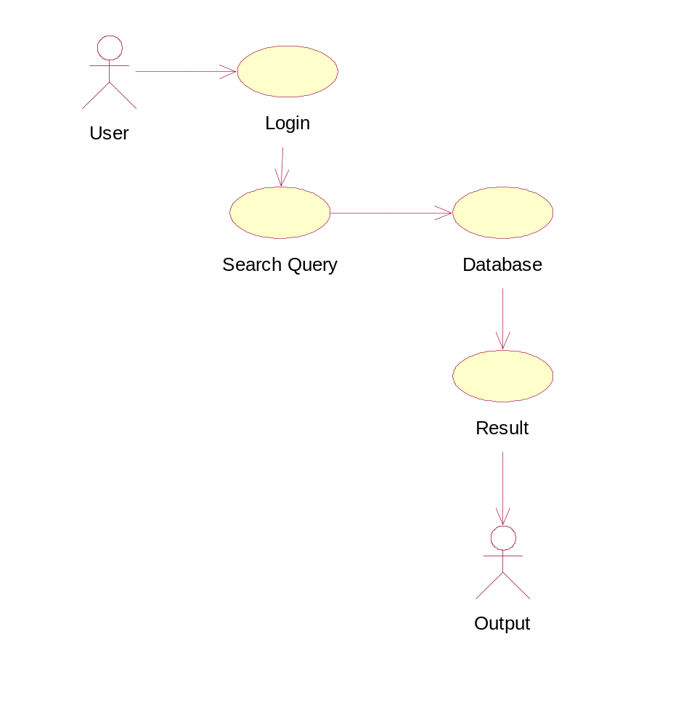

State Diagram

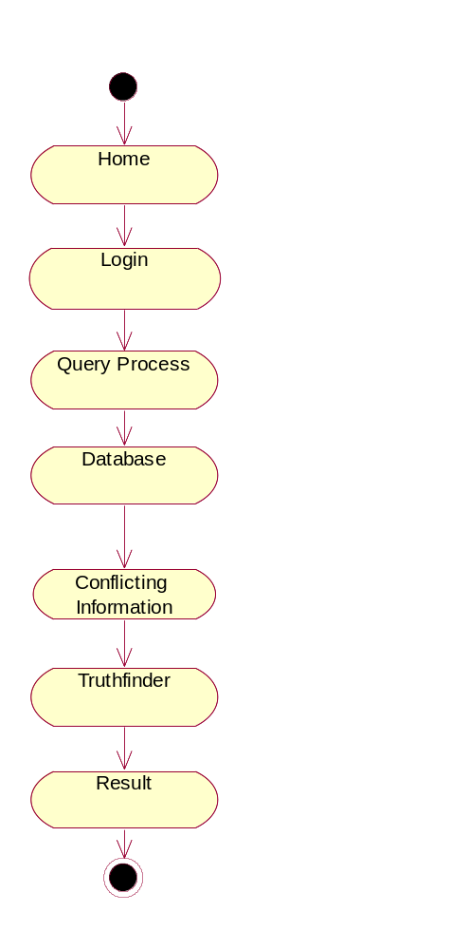

Activity Diagram
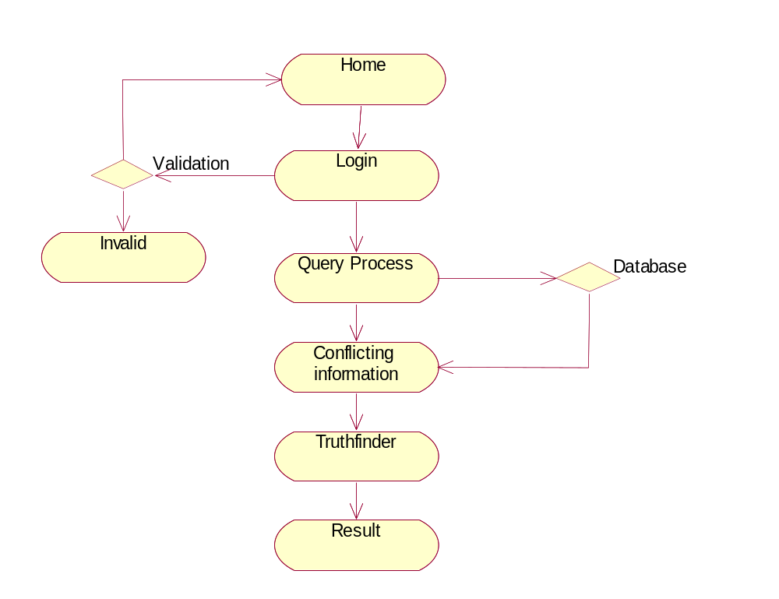

Collaboration Diagram

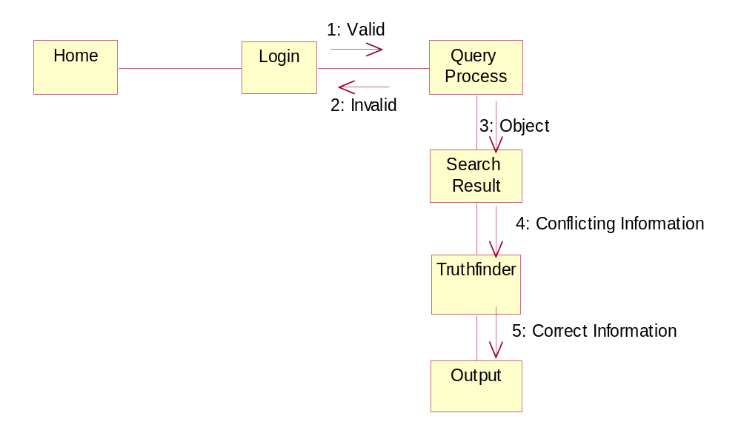

Sequence Diagram
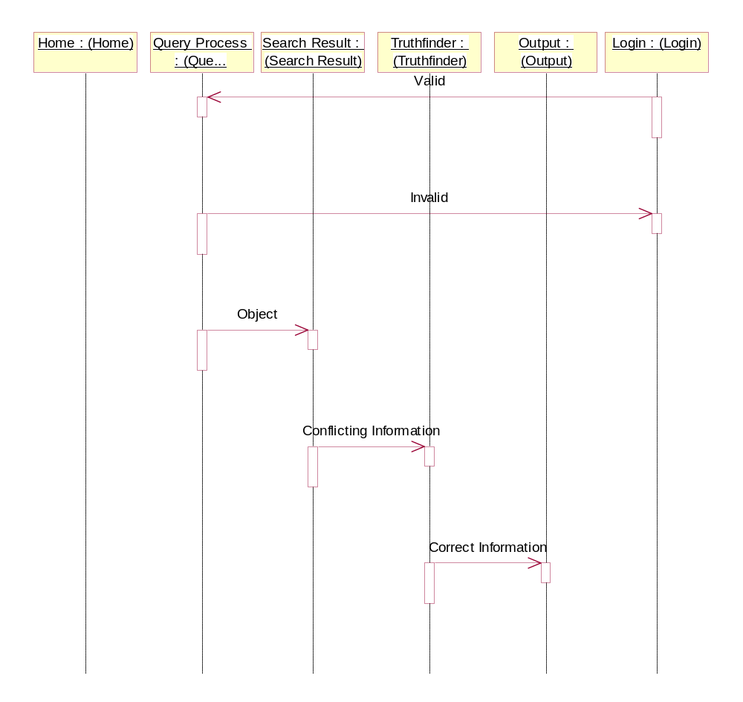

5.4. Data Flow Diagram

Web sites
Facts
Objects
W1
f₁
f₂
W2
W3
W4
f₄
o₁
o₂
f₃

System Architecture
Home
Login
Query
Page Rank
Truth Finder
Normal
Search
Validation
Correct
Incorrect
Conflicting
Information
Hit listed
Page
Truth Finder
Information
Result
Page
Truth Discovery with Multiple Conflicting Information Providers On The Web

Index
About Us
Contact Us
Products
Login
Services
New User
About Us Page
Contact Us Page
Products Page
Products Page
Services Page
Designing the WebPages

Collection Of Data
Database Upload
Truth Database
Main Db Table
Collection Data

Search Page
Search Word
Database Server
Retrieve Search Word
Displayed Specific
Information
Data Search

Search
Conflicting
Information
Truth Finder
Algorithm
Iteration
Method
Calculate
Support
Truth Finder
Pages
Truth Finder Algorithm
Calculate
Confidence
And Fact
Database
Result
Result Calculation

- System Testing

Software Testing:

The purpose of testing is to discover errors. Testing is the process of trying to discover every conceivable fault or weakness in a work product. It provides a way to check the functionality of components, sub assemblies, assemblies and/or a finished product It is the process of exercising software with the intent of ensuring that the Software system meets its requirements and user expectations and does not fail in an unacceptable manner. There are various types of test. Each test type addresses a specific testing requirement.

Types of Tests

6.1 Unit testing
Unit testing involves the design of test cases that validate that the internal program logic is functioning properly, and that program input produce valid outputs. All decision branches and internal code flow should be validated. It is the testing of individual software units of the application .it is done after the completion of an individual unit before integration. This is a structural testing, that relies on knowledge of its construction and is invasive. Unit tests perform basic tests at component level and test a specific business process, application, and/or system configuration. Unit tests ensure that each unique path of a business process performs accurately to the documented specifications and contains clearly defined inputs and expected results.

6.1.1 Functional test
Functional tests provide systematic demonstrations that functions tested are available as specified by the business and technical requirements, system documentation, and user manuals.
Functional testing is centered on the following items:
Valid Input : identified classes of valid input must be accepted.
Invalid Input : identified classes of invalid input must be rejected.
Functions : identified functions must be exercised.
Output : identified classes of application outputs must be exercised.
Systems/Procedures: interfacing systems or procedures must be invoked.

6.1.2 System Test
System testing ensures that the entire integrated software system meets requirements. It tests a configuration to ensure known and predictable results. An example of system testing is the configuration oriented system integration test. System testing is based on process descriptions and flows, emphasizing pre-driven process links and integration points.
6.1.3 Performance Test
The Performance test ensures that the output be produced within the time limits,
and the time taken by the system for compiling, giving response to the users and request being send to the system for to retrieve the results.

6.2 Integration Testing
Software integration testing is the incremental integration testing of two or more integrated software components on a single platform to produce failures caused by interface defects.
The task of the integration test is to check that components or software applications, e.g. components in a software system or – one step up – software applications at the company level – interact without error.

Integration testing for Database Synchronization:

- Testing the links that the signup request being send by the New user to the group controller for to join in the Group.
- If the login user does not have enough privileges to invoke a screen, the link should be disabled.
- The Encryption and Decryption process is performed as side of the Users Requisitions.

6.3 Acceptance Testing

User Acceptance Testing is a critical phase of any project and requires significant participation by the end user. It also ensures that the system meets the functional requirements.

Acceptance testing for Data Synchronization:

- The Group controller’s have separate roles to modify the database tables.
- The Group controller’s have the provision for to do Multicast operations.
- The Key Generation Center is act as a Router while Encrypted message is transferred between the groups.
- The Key Generation Center can only generate the keys for the groups.

7. System Implementation
7.1. Related Work

The quality of information on the Web has always been a major concern for Internet users. There have been studies on what factors of data quality are important for users and on machine learning approaches for distinguishing high-quality and low-quality web pages, where the quality is defined by human preference. It is also shown that information quality measures can help improve the effectiveness of Web search. In 1998, two pieces of groundbreaking work, Page Rank and Authority-Hub analysis, were proposed to utilize the hyperlinks to find pages with high authorities. These two approaches are very successful at identifying important web pages that users are interested in, which is also shown by a subsequent study, the authors propose a framework of link analysis and provide theoretical studies for many link-based approaches. Unfortunately, the popularity of web pages does not necessarily lead to accuracy of information. Two observations are made in our experiments: 1) even the most popular website (e.g., Barnes & Noble) may contain many errors, whereas some comparatively not-so-popular websites may provide more accurate information, and 2) more accurate information can be inferred by using many different websites instead of relying on a single website.

TRUTHFINDER studies the interaction between websites and the facts they provide and infers the trustworthiness of websites and confidence of facts from each other. An analogy can be made between this problem and Authority- Hub analysis, by considering websites as hubs (both of them indicate others’ authority weights) and facts as authorities. However, these two problems are very different, and Authority-Hub analysis cannot be applied to our problem. In Authority-Hub analysis, a hub’s weight is computed by summing up the weights of authorities linked to it. This is unreasonable in computing the trustworthiness of a website, because a trustworthy website should be one that provides accurate facts instead of many of them, and a website providing many inaccurate facts is an untrustworthy one. Moreover, the confidence of a fact is not simply the sum of the trustworthiness of the websites providing it. Instead, it needs to be computed using some nonlinear transformations according to a probabilistic analysis. Another difference between TRUTHFINDER and Authority- Hub analysis is that TRUTHFINDER considers the relationships (implications) between different facts and uses such information in inferring the confidence of facts. This is related to existing studies on inferring similarities between objects using links. Collaborative filtering infers the similarity between objects based on their ratings to or from other objects. There are also studies on link-based similarity analysis, which defines the similarity between two objects as the average similarity between objects linked to them. the authors propose an approach that uses the trust or distrust relationships between some users (e.g., user ratings on eBay.com) to determine the trust relationship between each pair of users.

TRUTHFINDER uses iterative methods to compute the website trustworthiness and fact confidence, which is widely, used in many link analysis approaches. The common feature of these approaches is that they start from some initial state that is either random or uninformative. Then, at each iteration, the approach will improve the current state by propagating information (weights, probability, trustworthiness, etc.) through the links. This iterative procedure has been proven to be successful in many applications, and thus, we adopt it in TRUTHFINDER.

7.2. Algorithm Used

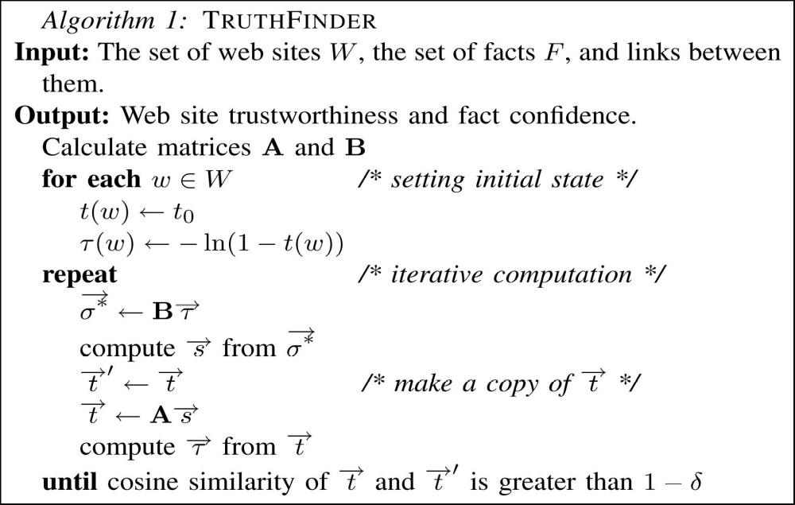
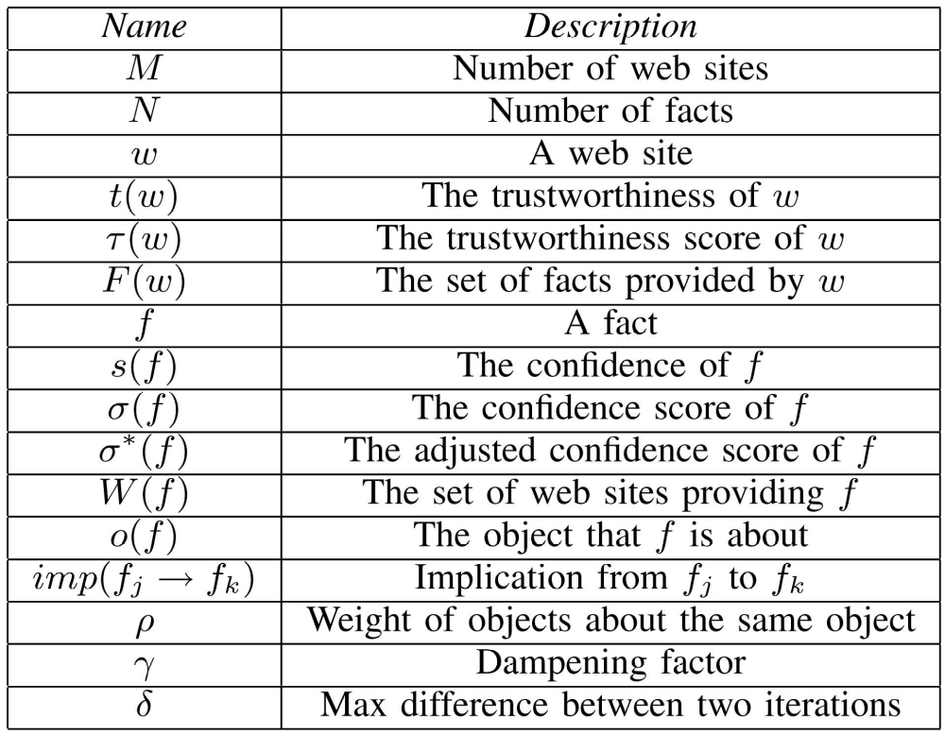

Iterative Computation

As described above, we can infer the website trustworthiness if we know the fact confidence and vice versa. As in Authority-Hub analysis and Page Rank, TRUTHFINDER adopts an iterative method to compute the trustworthiness of websites and confidence of facts. Initially, it has very little information about the websites and the facts. At each iteration, TRUTHFINDER tries to improve its knowledge about their trustworthiness and confidence, and it stops when the computation reaches a stable state. As in other iterative approaches, TRUTHFINDER needs an initial state. We choose the initial state in which all websites have uniform trustworthiness t0. (t0 should be set to the estimated average trustworthiness, such as 0.9.) From the website trustworthiness TRUTHFINDER can infer the confidence of facts, which are very meaningful because the facts supported by many websites are more likely to be correct. On the other hand, if we start from a uniform fact confidence, we cannot infer meaningful trustworthiness for websites. Before the iterative computation, we also need to calculate the two matrices and B, as they are calculated once and used at every iteration. In each step of the iterative procedure, TRUTHFINDER first uses the website trustworthiness to compute the fact confidence and then recomputes the website trustworthiness from the fact confidence. The matrices are stored in sparse formats, and the computational cost of multiplying such a matrix and a vector is linear with the number of nonzero entries in the matrix. TRUTHFINDER stops iterating when it reaches a stable state. The stableness is measured by how much the trustworthiness of websites changes between iterations. If only changes a little after an iteration (measured by cosine similarity between the old and the new), then TRUTHFINDER will stop.

7.3. Literature Survey
Data quality
Data quality is the quality of data. Data are of high quality "if they are fit for their intended uses in operations, decision making and planning" (J. M. Juran). Alternatively, the data are deemed of high quality if they correctly represent the real-world construct to which they refer. These two views can often be in disagreement, even about the same set of data used for the same purpose.
Before the rise of the inexpensive server, massive mainframe computers were used to maintain name and address data so that the mail could be properly routed to its destination. The mainframes used business rules to correct common misspellings and typographical errors in name and address data, as well as to track customers who had moved, died, gone to prison, married, divorced, or experienced other life-changing events. Government agencies began to make postal data available to a few service companies to cross-reference customer data with the National Change of Address registry (NCOA). This technology saved large companies millions of dollars compared to manually correcting customer data. Large companies saved on postage, as bills and direct marketing materials made their way to the intended customer more accurately. Initially sold as a service, data quality moved inside the walls of corporations, as low-cost and powerful server technology became available.
Companies with an emphasis on marketing often focus their quality efforts on name and address information, but data quality is recognized as an important property of all types of data. Principles of data quality can be applied to supply chain data, transactional data, and nearly every other category of data found in the enterprise. For example, making supply chain data conform to a certain standard has value to an organization by: 1) avoiding overstocking of similar but slightly different stock; 2) improving the understanding of vendor purchases to negotiate volume discounts; and 3) avoiding logistics costs in stocking and shipping parts across a large organization.
While name and address data has a clear standard as defined by local postal authorities, other types of data have few recognized standards. There is a movement in the industry today to standardize certain non-address data. The non-profit group GS1 is among the groups spearheading this movement.
For companies with significant research efforts, data quality can include developing protocols for research methods, reducing measurement error, bounds checking of the data, cross tabulation, modeling and outlier detection, verifying data integrity, etc.
Web mining
Web mining - is the application of data mining techniques to discover patterns from the Web. Without any doubt we certainly can declare that the Internet is the world’s largest data repository, considering the fact that the available data is increasing exponentially we can conclude that there is a huge potential to collect data through the web than any other means. The ever increasing number of individuals connecting to the Internet adds up to the factor. This technology is chiefly used to improve the intelligence of search engines and web marketing
Web usage mining is the application that uses data mining to analyze and discover interesting patterns of user’s usage data on the web. The usage data records the user’s behavior when the user browses or makes transactions on the web site. It is an activity that involves the automatic discovery of patterns from one or more Web servers. Organizations often generate and collect large volumes of data; most of this information is usually generated automatically by Web servers and collected in server log. Analyzing such data can help these organizations to determine the value of particular customers, cross marketing strategies across products and the effectiveness of promotional campaigns, etc.
The first web analysis tools simply provided mechanisms to report user activity as recorded in the servers. Using such tools, it was possible to determine such information as the number of accesses to the server, the times or time intervals of visits as well as the domain names and the URLs of users of the Web server. However, in general, these tools provide little or no analysis of data relationships among the accessed files and directories within the Web space. Now more sophisticated techniques for discovery and analysis of patterns are emerging. These tools fall into two main categories: Pattern Discovery Tools and Pattern Analysis Tools.
Another interesting application of Web Usage Mining is Web Link recommendation. One of the last trends is represented by the online monitoring of page accesses to render personalized pages on the basis of similar visit patterns.
Link Analysis
The separation of an intellectual or material whole into its constituent parts for individual study. The study of such constituent parts and their interrelationships in making up a whole. A spoken or written presentation of such study: published an analysis of poetic meter
7.4. Feasibility Study

TECHNICAL REQUIREMENTS
- Advanced Java
- J2EE
- SQL Server 2000
- Web logic 8.1
- ECNOMICAL REQUIREMENTS
- Proposed system is cheaper
- Easily adaptable for both user and developer.

8. Conclusion
In this paper, we introduce and formulate the Veracity problem, which aims at resolving conflicting facts from multiple websites and finding the true facts among them. We propose TRUTHFINDER, an approach that utilizes the inter dependency between website trustworthiness and fact confidence to find trustable websites and true facts. Experiments show that TRUTHFINDER achieves high accuracy at finding true facts and at the same time identifies websites that provide more accurate information.

9. References

[1] B. Amento, L.G. Terveen, and W.C. Hill, “Does ‘Authority’ Mean Quality? Predicting Expert Quality Ratings of Web Documents,” Proc. ACM SIGIR ’00, July 2000.
[2] M. Blaze, J. Feigenbaum, and J. Lacy, “Decentralized Trust Management,” Proc. IEEE Symp. Security and Privacy (ISSP ’96), May 1996.
[3] A. Borodin, G.O. Roberts, J.S. Rosenthal, and P. Tsaparas, “Link Analysis Ranking: Algorithms, Theory, and Experiments,” ACM Trans. Internet Technology, vol. 5, no. 1, pp. 231-297, 2005.
[4] J.S. Breese, D. Heckerman, and C. Kadie, “Empirical Analysis of Predictive Algorithms for Collaborative Filtering,” technical report, Microsoft Research, 1998.
[5] R. Guha, R. Kumar, P. Raghavan, and A. Tomkins, “Propagation of Trust and Distrust,” Proc. 13th Int’l Conf. World Wide Web (WWW), 2004.
[6] G. Jeh and J. Widom, “SimRank: A Measure of Structural-Context Similarity,” Proc. ACM SIGKDD ’02, July 2002.
[7] J.M. Kleinberg, “Authoritative Sources in a Hyperlinked Environment,” J. ACM, vol. 46, no. 5, pp. 604-632, 1999.
[8]Logistical Equation from Wolfram MathWorld, http://mathworld.wolfram.com/LogisticEquation.html, 2008.
[9] T. Mandl, “Implementation and Evaluation of a Quality-Based Search Engine,” Proc. 17th ACM Conf. Hypertext and Hypermedia, Aug. 2006.
[10] L. Page, S. Brin, R. Motwani, and T. Winograd, “The PageRank Citation Ranking: Bringing Order to the Web,” technical report, Stanford Digital Library Technologies Project, 1998.
[11] Princeton Survey Research Associates International, “Leap of faith: Using the Internet Despite the Dangers,” Results of a Nat’l Survey of Internet Users for Consumer Reports WebWatch, Oct. 2005.
[12] Sigmoid Function from Wolfram MathWorld, http://mathworld. wolfram.com/SigmoidFunction.html, 2008.
[13] R.Y. Wang and D.M. Strong, “Beyond Accuracy: What Data Quality Means to Data Consumers,” J. Management Information Systems, vol. 12, no. 4, pp. 5-34, 1997.

Screen Shorts
