**1 (1) implement n-dimensional joint histogram and test the code on two-dimensional data; plot the results. (2) implement computation of local histograms of an image using the efficient update of local histogram method introduced in local histogram processing.**

Note that because only one row or column of the neighborhood changes in a one-pixel translation of the neighborhood, updating the histogram obtained in the previous location

with the new data introduced at each motion step is possible and efficient in computation.

**2 Implement a piecewise linear transformation function (below figure) for image contrast stretching. The code should read in an image; for intensity of all pixels, use the function to compute new intensity values; and finally output/ save the image with new intensity values.**

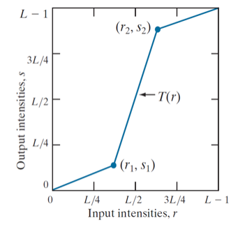

**3 Implement the algorithm of local histogram equalization: (1) first implement histogram equalization algorithm, and then (2) implement the local histogram equalization using efficient computation of local histogram. Please test your code on images and show the results in your report.**