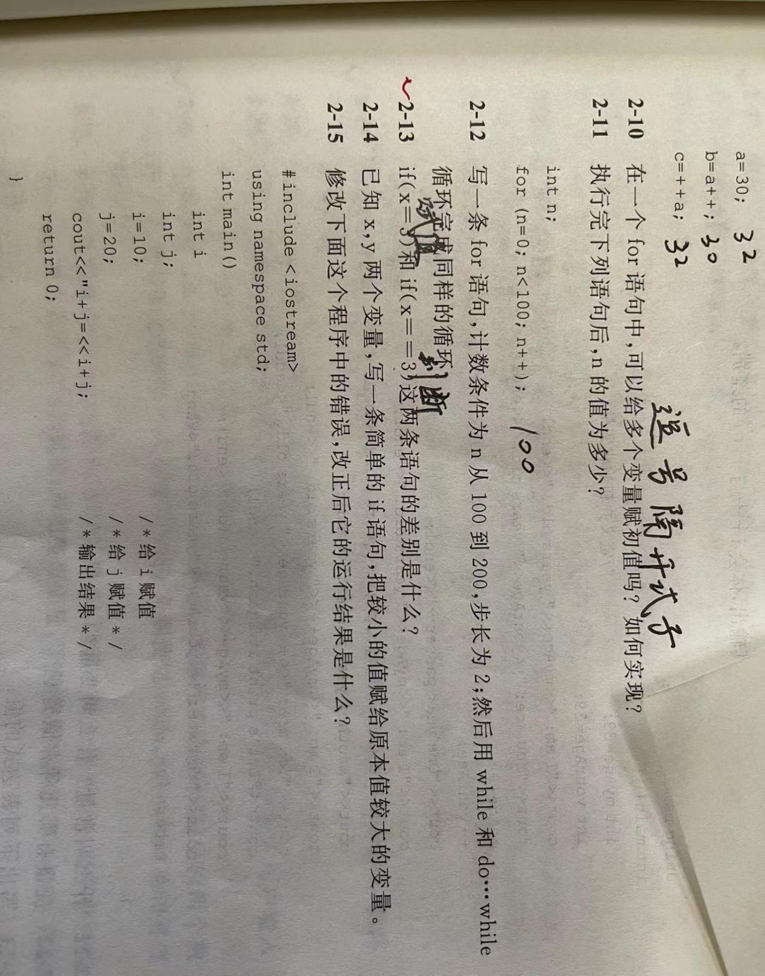
前者表示给x赋值为3，后者表示判断x与3的大小关系

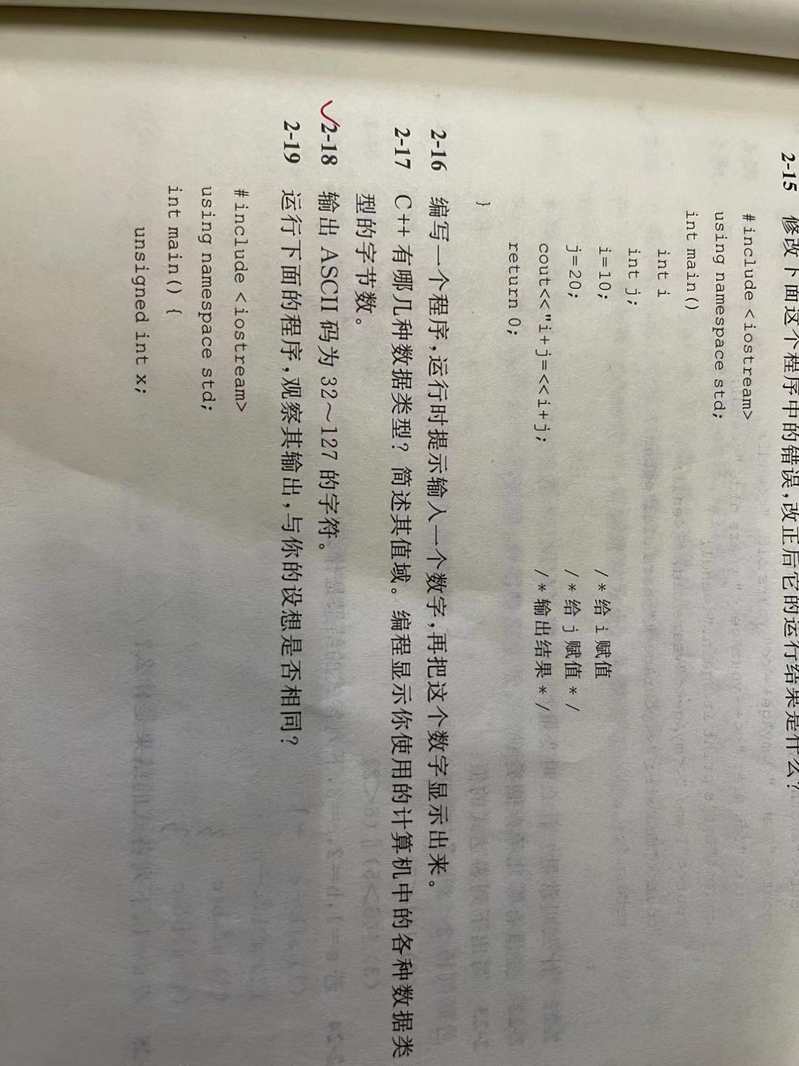
#include <iostream>
using namespace std;
int main()
{
for (int a = 32;a <= 127;a++)

cout << (char)a << " ";

system("pause");

return 0;
}
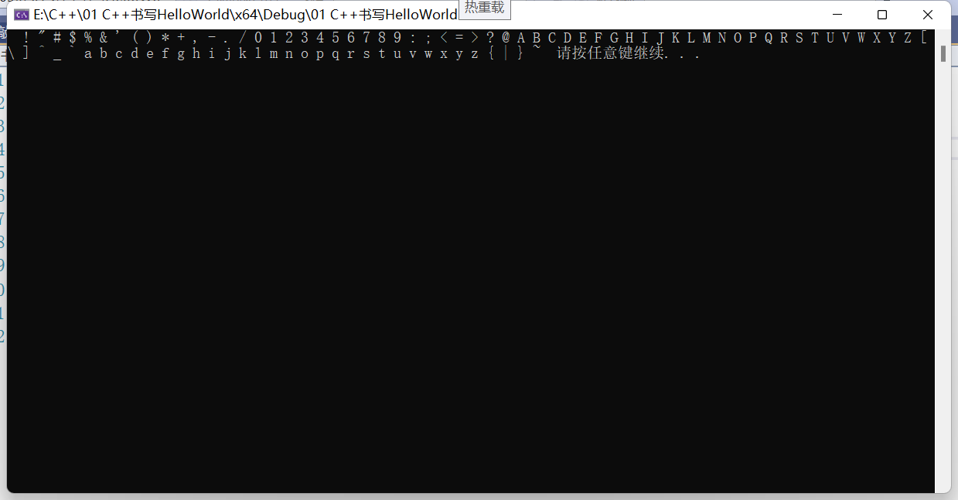

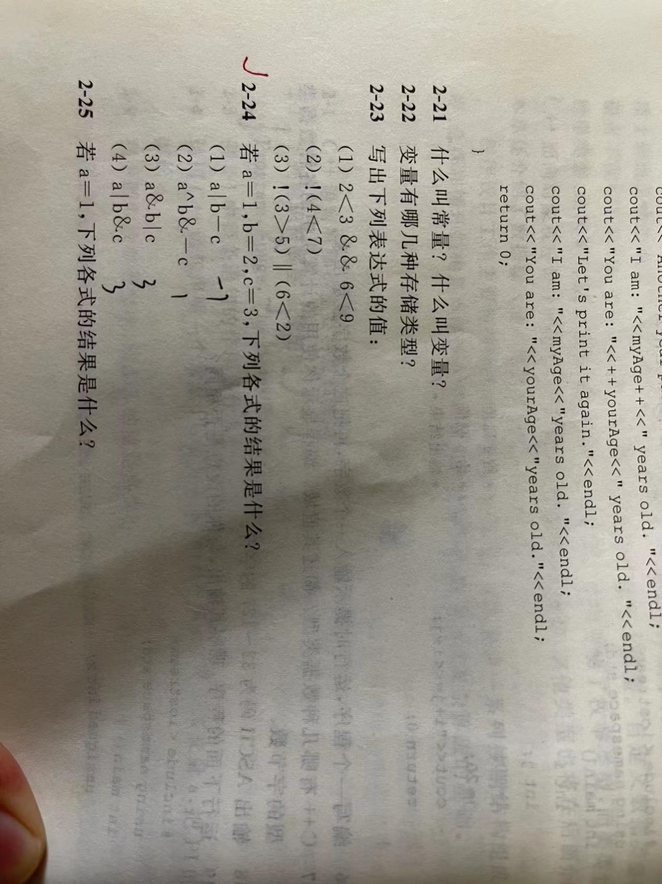
#include <iostream>
using namespace std;
int main()
{
int a = 1;
int b = 2;
int c = 3;

cout << (a | b - c) << endl;
cout << (a ^ b - c) << endl;
cout << (a & b - c) << endl;
cout << (a | b & c) << endl;

system("pause");

return 0;
}

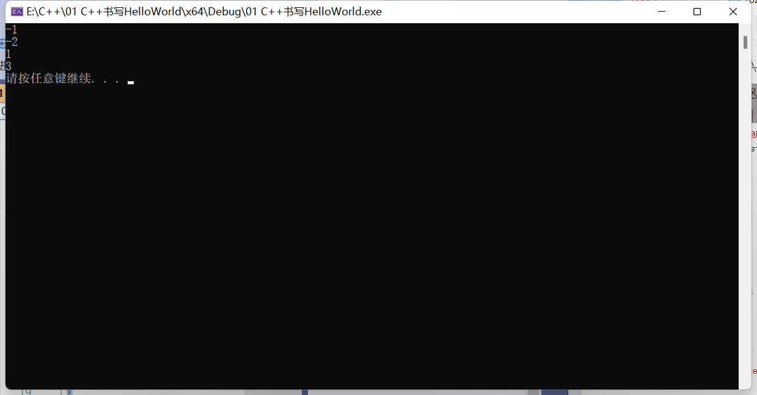

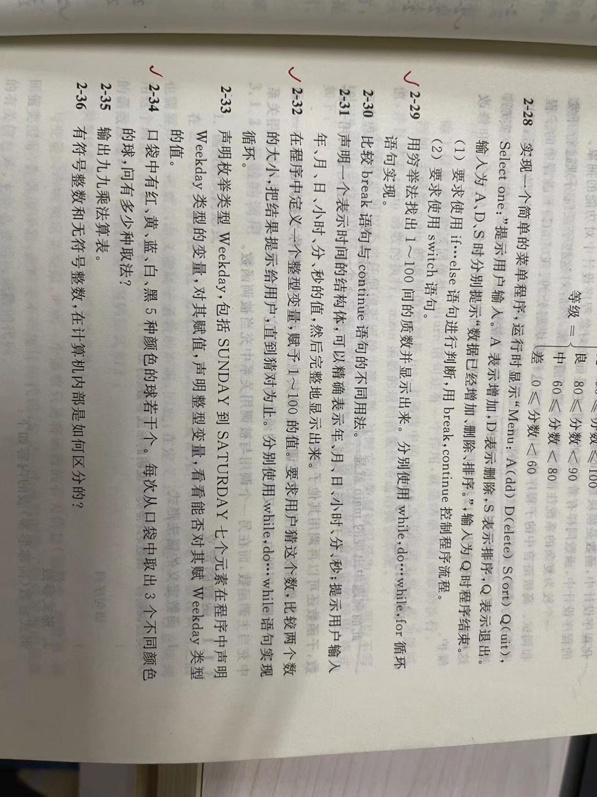
#include <iostream>
using namespace std;
int main()
{
int i = 1 ;
bool a = 1;
i++;
if (i == 1)
;
else if (i == 2)
cout << i<<" ";
else
{
for ( i = 3;i <= 100;i++)
{
for (int j = 2;j < i;j++)
{
if (i % j != 0)
continue;
else
a = 0;break;
}
if (a = 1)
cout << i << " ";
}
}

system("pause");

return 0;
}

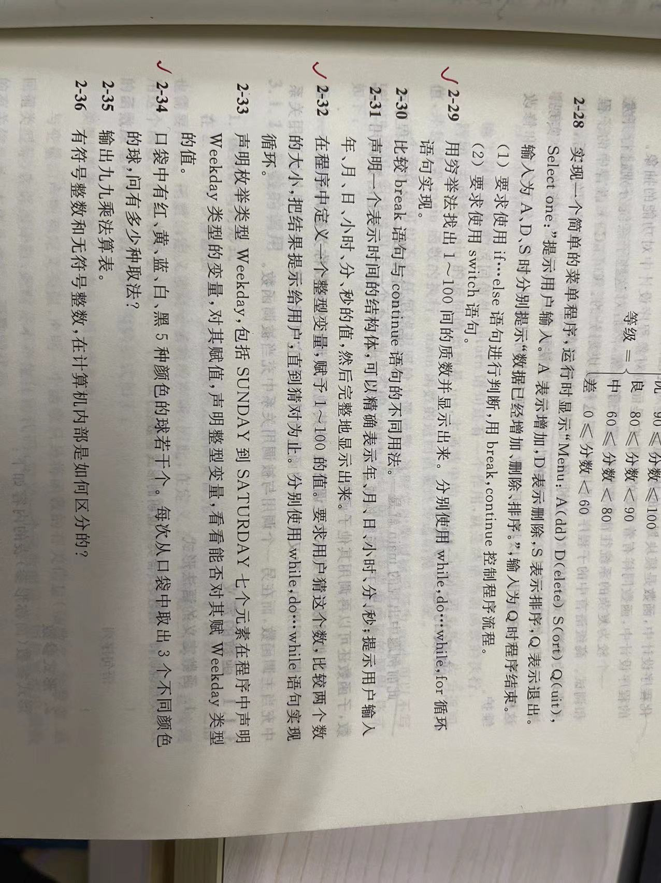
#include <iostream>
using namespace std;
//time系统时间头文件包含
#include<ctime>
int main() {

//添加随机数种子 防止随机数一样
srand((unsigned int)time(NULL));

//1、系统生成随机数
int num = rand() % 100 + 1; //生成0+1~99+1的随机数

//2、玩家进行猜测
int val = 0;
cout << "请输入你猜测的数字：" << endl;

//3、判断玩家猜测
while (1)
{
cin >> val;

if (val > num)
{
cout << "猜测过大" << endl;
}
else if (val < num)
{
cout << "猜测过小" << endl;
}
else
{
cout << "恭喜你猜对了" << endl;
break;
}
}
system("pause");

return 0;

}

或者：do
{
cin >> val;
if (val > num)
{
cout << "猜测过大" << endl;
}
else if (val < num)
{
cout << "猜测过小" << endl;
}
else
{
cout << "恭喜你猜对了" << endl;
break;
}
}
while (1);

