#include <iostream>
#include<string>
using namespace std;

int Count(string s)
{
int n = 0;
for (int i = 0;i < s.length();i++)
{
if ((s[i] >= 'a' && s[i] <= 'z') || (s[i] >= 'A' && s[i] <= 'Z'))
{
n++;
}
}
return n;
}

int main() {

string s;
cout << "请输入一个英文句子：" << endl;
getline(cin, s);
cout << "字母个数为：" << Count(s) << endl;

system("pause");

return 0;
}
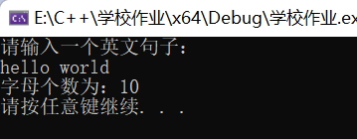

#include<iostream>
#include<string>
using namespace std;

void reserve(string& s)
{
int start = 0;
int end = s.length() - 1;
while (start < end)
{
swap(s[start], s[end]);
start++;end--;
}
}
int main() {

string s;
cout << "请输入一个字符串：" << endl;
getline(cin, s);
reserve(s);
cout << "倒序后：" << endl;
for (int i = 0;i < s.length();i++)
{
cout << s[i];
}

system("pause");

return 0;
}
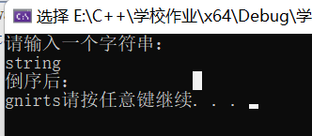

#include<iostream>
using namespace std;
int main() {

double arr[8]={ };
cout << "请输入八位同学的成绩：" << endl;
cin >> arr[0] >> arr[1] >> arr[2] >> arr[3] >> arr[4] >> arr[5] >> arr[6] >> arr[7] ;
double m=0;
for (int i = 0;i <= 7;i++)
{
m += arr[i];
}
cout << "平均成绩为：" << (m /8)<< endl;
system("pause");

return 0;
}

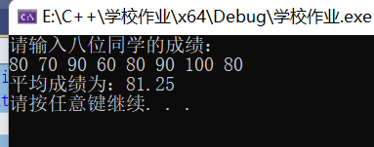

#include <iostream>
using namespace std;

void Swap(int *arr1, int* arr2, int r, int c)
{
int i, j;

for (i = 0;i < r;i++)
{
cout << "请输入矩阵的第" << i+1 << "行元素" << endl;
for (j = 0;j < c;j++)
{
cin >> arr1[i * c + j];
}
}

cout << "置换前：" << endl;
for (int m = 0;m < r;m++)
{
for (int n = 0;n < c;n++)
{
cout << arr1[m*c+n]<<" ";
}
cout << endl;
}

for (int m = 0;m < c;m++)
{
for (int n = 0;n < r;n++)
{
arr2[m * r + n] = arr1[n * c + m];
}
}

cout << "置换后：" << endl;
for (int a = 0;a < i;i++)
{
for (int b = 0;b < j;b++)
{
cout << arr2[a*r+b]<<" ";
}
cout << endl;
}

}

int main() {

int r, c;
cout << "请输入行数：" << endl;
cin >> r;
cout << "请输入列数：" << endl;
cin >> c;
int* P1 = new int[r * c];
int* P2 = new int[r * c];
Swap(P1,P2,r,c);

system("pause");

return 0;
}

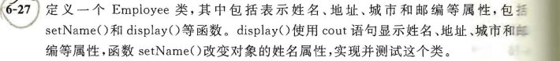
#include <iostream>
using namespace std;
class Employee
{
public:
void setName(string name)
{
m_Name = name;
}
void displayName()
{
cout << "姓名：" << m_Name << endl;
}
void displayAddress()
{
cout << "地址：" << m_Address << endl;
}
void displayCity()
{
cout << "城市：" << m_City << endl;
}
void displayNum()
{
cout << "邮编：" << m_Num << endl;
}
string m_Address;
string m_City;
string m_Num;

private:
string m_Name;

};
int main() {

Employee E;
E.setName("张三");
E.m_Address = "中国";
E.m_City = "宣城";
E.m_Num = "110";
E.displayName();
E.displayCity();
E.displayAddress();
E.displayNum();

system("pause");

return 0;
}

