实验四 类、继承与派生

一．实验目的要求
- 掌握类的定义和实现。
- 掌握对象创建及使用的基本方法。
- 掌握单继承程序设计的基本方法。
- 掌握多继承程序设计的基本方法。

二．实验内容
（1）下面程序定义了一个以hours, minutes和seconds作为数据成员的Time类。设计了成员函数将两个Time对象相加（即时间相加），并进行相应的检查，查看增加的分钟数及秒数是否大于59。如果秒数大于59，则分钟数向前递增1。类似地，如果分钟数大于59，则小时数向前增1。
#include <iostream.h>

class Time
{
private:
int hours, minutes, seconds;
public:
void get_time()
{
cin>>hours>>minutes>>seconds;
}
void display_time()
{
cout<<hours<<':'<<minutes<<':'<<seconds<<endl;
}
void add_time(Time & t1, Time & t2)
{
hours=t1.hours+t2.hours;
minutes=t1.minutes+t2.minutes;
seconds=t1.seconds+t2.seconds;
if(seconds>=60)
{
seconds-=60;
minutes++;
}
if(minutes>=60)
{
minutes-=60;
hours++;
}
}
};

void main()
{
Time one, two, three;
cout<<"\nEnter the first time(hours minutes seconds):";
one.get_time();
cout<<"\nEnter the second time(hours minutes seconds):";
two.get_time();
three.add_time(one,two);
cout<<"the result is:"<<endl;
three.display_time();
}

[基本要求]
- 上机录入、调试上面程序。
- 运行程序，输入下面两组数据：
- 2 34 45
1 47 56

② 2 67 100
1 56 200
分析运行结果是否正确。

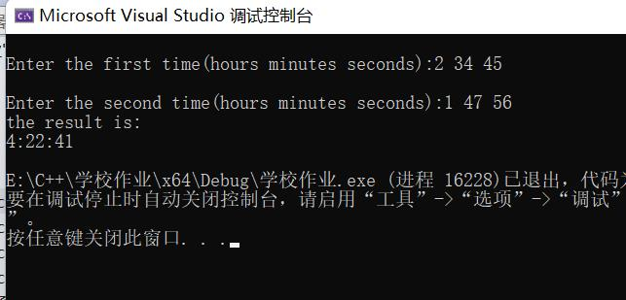
结果正确
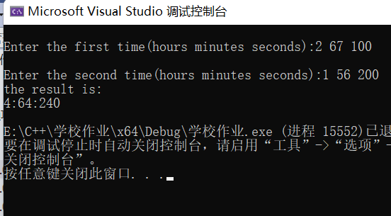
结果错误，该程序要求用户输入的分钟数和秒数必须小于60，否则错误

[分析与思考]
实验内容（1）中：
定义构造函数对Time类的对象进行初始化（即不用成员函数get_time）。
该程序要求用户输入的分钟数和秒数必须小于60，如何修改程序使得用户在输入分钟数和秒数大于等于60时，也能得到正确的结果。

#include<iostream>
using namespace std;
class Time
{
private:
int hours, minutes, seconds;

public:
Time(int a,int b,int c)
{
hours = a;
minutes = b;
seconds = c;
}
void display_time()
{
cout<< hours << ':' << minutes << ':' << seconds << endl;
}
void renew_time(Time& t)
{
while (t.seconds >= 60)
{
t.seconds -= 60;
t.minutes++;
}
while (t.minutes >= 60)
{
t.minutes -= 60;
t.hours++;
}
}
void add_time(Time& t1, Time& t2)
{
renew_time(t1);
renew_time(t2);
hours = t1.hours + t2.hours;
minutes = t1.minutes + t2.minutes;
seconds = t1.seconds + t2.seconds;
if (seconds >= 60)
{
seconds -= 60;
minutes++;
}
if (minutes >= 60)
{
minutes -= 60;
hours++;
}
}
};

void main()
{
Time one(2,67,100);
Time two(1, 56, 200);
Time three(0,0,0);

three.add_time(one, two);
cout << "the result is:" << endl;
three.display_time();
}

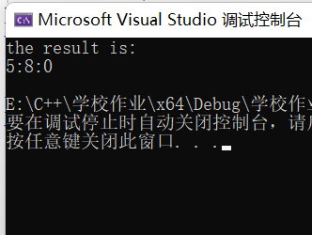

（2）阅读下面的一段程序代码，代码可能有错误，请仔细分析并体会。
class Date {
public:
void Date(){};
int Date(int year,int month,int day);
void ~Date(){};
int &GetYear(){return year;}
int &GetMonth(){return month;}
int &GetDay(){return day;}
private:
int year=2000;
int month=12;
int day=31;
static bool IsLeapyear;//是否闰年
};
bool Date::IsLeapyear=true;
int Date::Date(int year,int month,int day)
{
(*this).year=year;
(*this).month=month;
(*this).day=day;
}

void main()
{
int year,month,day;
cin>>year>>month>>day;
Date mydate(year,month,day);
int &myyear=mydate.GetYear();
int &mymonth=mydate.GetMonth();
int &myday=mydate.GetDay();
cout<<myyear<<endl<<mymonth<<endl<<myday<<endl;
myyear=8888;
cout<< mydate.GetYear();
}
[基本要求]
·仔细阅读上面程序，如果有错误，请更正。
·上机录入、调试上面程序。

#include<iostream>
using namespace std;

class Date {
public:
Date() {};
Date(int year, int month, int day);
~Date() {};
int& GetYear() { return year; }
int& GetMonth() { return month; }
int& GetDay() { return day; }
private:
int year = 2000;
int month = 12;
int day = 31;
static bool IsLeapyear;//是否闰年
};
bool Date::IsLeapyear = true;
Date::Date(int year, int month, int day)
{
(*this).year = year;
(*this).month = month;
(*this).day = day;
}

void main()
{
int year, month, day;
cin >> year >> month >> day;
Date mydate(year, month, day);
int& myyear = mydate.GetYear();
int& mymonth = mydate.GetMonth();
int& myday = mydate.GetDay();
cout << myyear << endl << mymonth << endl << myday << endl;
myyear = 8888;
cout << mydate.GetYear();
}
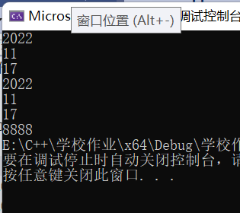

[分析与思考]
实验内容（2）中：
main函数中int &myyear=mydate.GetYear(); 、int &mymonth=mydate.GetMonth(); 和int &myday=mydate.GetDay();语句表达的是什么思想？这样做的目的是什么？这种方法是否“好”呢？为什么？如果“不好”应该怎样修改？

引用，让Date类中的成员属性赋值给myyear , mymonth , myday并输出。
不好。修改如下：
void main()
{
int year, month, day;
cin >> year >> month >> day;
Date mydate(year, month, day);
cout << mydate.GetYear() << endl << mydate.GetMonth() << endl << mydate.GetDay() << endl;
mydate.GetYear() = 8888;
cout << mydate.GetYear();
}

(3) 下面程序定义一个vehicle类，并派生出car和truck两个派生类。
#include<iostream.h>
class vehicle
{
protected:
int wheels;
double weight;
public:
void initialize(int whls, double wght);
int get_wheels() { return wheels; }
double get_weight() { return weight; }
double wheel_loading() { return weight/wheels; }
};

class car: public vehicle
{
private:
int passenger_load;
public:
void initialize(int whls, double wght, int people =4);
int passengers() { return passenger_load; }
};

class truck: public vehicle
{
private:
int passenger_load;
double payload;
public:
void init_truck(int number =2, double max_load =24000.0);
double efficiency();
int passengers() { return passenger_load; }
};

void vehicle::initialize(int whls, double wght)
{
wheels=whls;
weight=wght;
}

void car::initialize(int whls, double wght, int people)
{
wheels=whls;
weight=wght;
passenger_load=people;
}

void truck::init_truck(int number, double max_load)
{
passenger_load=number;
payload=max_load;
}

double truck::efficiency()
{
return payload/(payload+weight);
}

void main()
{
vehicle bicycle;
bicycle.initialize(2,25);
cout<<"the bicycle has "<<bicycle.get_wheels()<<" wheels.\n";
cout<<"the bicycle weighs "<<bicycle.get_weight()<<" pounds.\n";
cout<<"the bicycle's wheel loading is "<<bicycle.wheel_loading()<<" pounds per tire.\n\n";

car audi;
audi.initialize(4,3500.0,5);
cout<<"the audi has "<<audi.get_wheels()<<" wheels.\n";
cout<<"the audi weighs "<<audi.get_weight()<<" pounds.\n";
cout<<"the audi's wheel loading is "<<audi.wheel_loading()<<" pounds per tire.\n\n";

truck jief;
jief.initialize(18,12500.0);
jief.init_truck(2,33675.0);
cout<<"the jief has "<<jief.get_wheels()<<" wheels.\n";
cout<<"the jief weighs "<<jief.get_weight()<<" pounds.\n";
cout<<"the jief's efficiency is "<<100.0*jief.efficiency()<<" percent.\n";
}

[基本要求]
- 上机录入、调试上面程序。
- 运行程序，观察运行结果是否正确且满足题意要求。
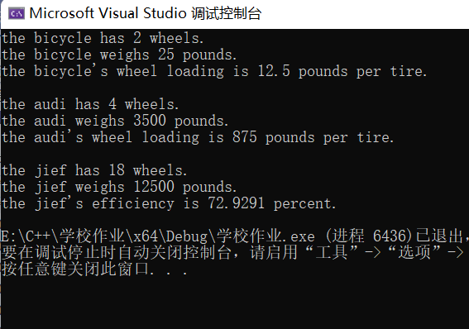
- 将class car: public vehicle和class truck: public vehicle分别改为：
class car: private vehicle和class truck: private vehicle程序运行结果有无变化，为什么？

有变化。
私有继承，让子类中成员对象和成员函数的属性变为私有，类外不能访问

[分析与思考]
实验内容（3）中：
定义并实现vehicle类、car类和truck类的构造函数，完成vehicle类、car类和truck类的数据成员初始化工作。
将vehicle中数据成员wheels和weight改为private性质，如何修改程序以达到相同的输出结果。

#include<iostream>
using namespace std;

class vehicle
{
private:
int wheels;
double weight;
public:

vehicle()
{
cout << "vehicle构造函数调用" << endl;
}
int get_wheels() { return wheels; }
double get_weight() { return weight; }
int set_wheels(int m) { return wheels=m; }
double set_weight(double n) { return weight=n; }
double wheel_loading() { return weight / wheels; }

vehicle(int a, double b)
{
cout << "vehicle重载构造函数调用" << endl;
wheels = a;
weight = b;
}
};

class car : public vehicle
{
private:
int passenger_load;
public:
car(int a, double b,int c)
{
cout << "car构造函数调用" << endl;
set_wheels(a);
set_weight(b);
passenger_load = c;
}
int passengers() { return passenger_load; }
};

class truck : public vehicle
{
private:
int passenger_load;
double payload;
public:
truck(int a, double b, int c,double d)
{
cout << "truck构造函数调用" << endl;
set_wheels(a);
set_weight(b);
passenger_load = c;
payload = d;
}
double efficiency();
int passengers() { return passenger_load; }
};

double truck::efficiency()
{
return payload / (payload + get_weight());
}

void main()
{
vehicle bicycle(2,25);
cout << "the bicycle has " << bicycle.get_wheels() << " wheels.\n";
cout << "the bicycle weighs " << bicycle.get_weight() << " pounds.\n";
cout << "the bicycle's wheel loading is " << bicycle.wheel_loading() << " pounds per tire.\n\n";

car audi(4, 3500, 5);
cout << "the audi has " << audi.get_wheels() << " wheels.\n";
cout << "the audi weighs " << audi.get_weight() << " pounds.\n";
cout << "the audi's wheel loading is " << audi.wheel_loading() << " pounds per tire.\n\n";

truck jief(18, 12500.0, 2, 33675.0);
cout << "the jief has " << jief.get_wheels() << " wheels.\n";
cout << "the jief weighs " << jief.get_weight() << " pounds.\n";
cout << "the jief's efficiency is " << 100.0 * jief.efficiency() << " percent.\n";

}
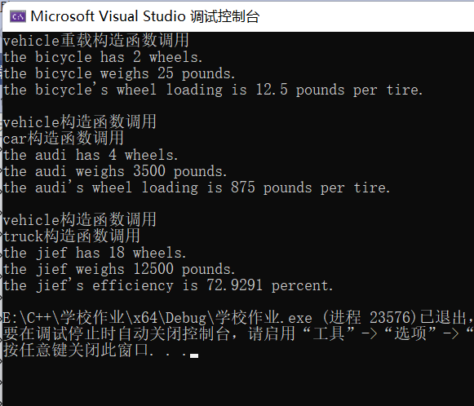

（4）下面程序对应图1所示的类层次继承结构:
person

#include <iostream.h>
person

#include <iomanip.h>
#include <string.h>
graduate

teacher

class person
{
protected:
char name[20];
int birth_year;
in-service_graduate

public:
person(char *na, int year) {
strcpy(name,na);
birth_year=year;
}
int cal_age(int this_year) {
return this_year-birth_year;
}
};

class graduate :public person
{
protected:
int grade;
char specialty[20];
public:
graduate(char *na, int y, int g, char *spec):person(na,y) {
grade=g;
strcpy(specialty,spec);
}
void display(int this_year) {
cout<<" graduate age grade specialty\n";
cout<<setw(20)<<name<<setw(5)<<cal_age(this_year);
cout<<setw(7)<<grade<<setw(17)<<specialty<<endl;
}
};

class teacher :public person
{
protected:
char title[15];
char specialty[20];
public:
teacher(char *na, int y, char *ti, char *spec):person(na,y) {
strcpy(title,ti);
strcpy(specialty,spec);
}
void display(int this_year) {
cout<<" teacher age title specialty\n";
cout<<setw(20)<<name<<setw(5)<<cal_age(this_year);
cout<<setw(14)<<title<<setw(17)<<specialty<<endl;
}
};

class in_service_graduate:public teacher, public graduate
{
public:
in_service_graduate(char *na, int y, char *ti, char *spec1, int g, char *spec2):
teacher(na, y, ti, spec1), graduate(na, y, g, spec2)
{ }
void display(int this_year) {
cout << " in_service_graduate age title work_specialty grade study_specialty\n";
cout<< setw(20) << teacher::name << setw(5) << teacher::cal_age(this_year);
cout << setw(10) << title << setw(14) << teacher::specialty;
cout << setw(10) << grade << setw(10) << graduate::specialty << endl;

}
};

void main()
{
graduate gr("zhang_ling",1978,2001,"computer");
teacher te("wang_qiang", 1976,"tutor","electronics");
in_service_graduate sg("liu_hua",1975,"lectuer","automation",2002,"computer");
gr.display(2002);
cout<<endl;
te.display(2002);
cout<<endl;
sg.display(2002);
}

[基本要求]
- 阅读程序，填空完成in_service_graduate类中的display()函数的程序。
- 上机录入、调试上面程序。
- 运行程序，观察运行结果是否正确且满足题意要求。

#include <iostream>
#include <iomanip>
#include <string>
using namespace std;

class person
{
protected:
char name[20];
int birth_year;
public:
person(const char* na, int year) {
strcpy_s(name, na);
birth_year = year;
}
int cal_age(int this_year) {
return this_year - birth_year;
}
};

class graduate :public person
{
protected:
int grade;
char specialty[20];
public:
graduate(const char* na, int y, int g,const char* spec) :person(na, y) {
grade = g;
strcpy_s(specialty, spec);
}
void display(int this_year) {
cout << " graduate age grade specialty\n";
cout << setw(20) << name << setw(5) << cal_age(this_year);
cout << setw(7) << grade << setw(17) << specialty << endl;
}
};

class teacher :public person
{
protected:
char title[15];
char specialty[20];
public:
teacher(const char* na, int y,const char* ti,const char* spec) :person(na, y) {
strcpy_s(title, ti);
strcpy_s(specialty, spec);
}
void display(int this_year) {
cout << " teacher age title specialty\n";
cout << setw(20) << name << setw(5) << cal_age(this_year);
cout << setw(14) << title << setw(17) << specialty << endl;
}
};

class in_service_graduate :public teacher, public graduate
{
public:
in_service_graduate(const char* na, int y,const char* ti,const char* spec1, int g,const char* spec2) :
teacher(na, y, ti, spec1), graduate(na, y, g, spec2)
{

}
void display(int this_year) {
cout << " in_service_graduate age title work_specialty grade study_specialty\n";
cout<< setw(20) << teacher::name << setw(5) << teacher::cal_age(this_year);
cout << setw(10) << title << setw(14) << teacher::specialty;
cout << setw(10) << grade << setw(10) << graduate::specialty << endl;

}
};

void main()
{
graduate gr("zhang_ling", 1978, 2001, "computer");
teacher te("wang_qiang", 1976, "tutor", "electronics");
in_service_graduate sg("liu_hua", 1975, "lectuer", "automation", 2002, "computer");
gr.display(2002);
cout << endl;
te.display(2002);
cout << endl;
sg.display(2002);
}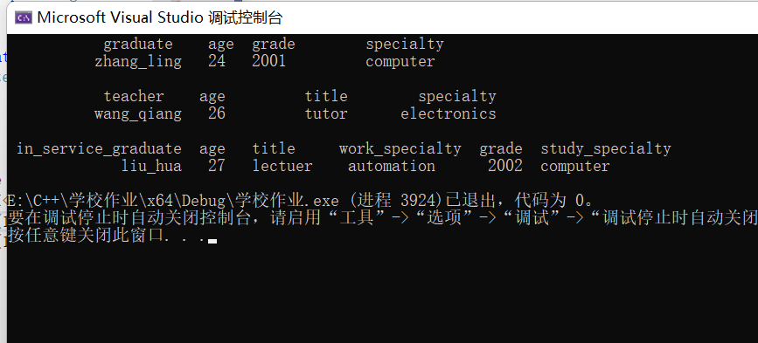

[分析与思考]
实验内容（4）中：
程序中类person中的数据成员name和birth_year在in_service_graduate类中有两个副本，请使用虚基类使它们在in_service_graduate类中只有一个副本。注意同时修改程序的其他相关部分。
#include <iostream>
#include <iomanip>
#include <string>
using namespace std;

class person
{
protected:
char name[20];
int birth_year;
public:
person()
{}
person(const char* na, int year) {
strcpy_s(name, na);
birth_year = year;
}
int cal_age(int this_year) {
return this_year - birth_year;
}
};

class graduate :virtual public person
{
protected:
int grade;
char specialty[20];
public:
graduate(const char* na, int y, int g,const char* spec) :person(na, y) {
grade = g;
strcpy_s(specialty, spec);
}
void display(int this_year) {
cout << " graduate age grade specialty\n";
cout << setw(20) << name << setw(5) << cal_age(this_year);
cout << setw(7) << grade << setw(17) << specialty << endl;
}
};

class teacher :virtual public person
{
protected:
char title[15];
char specialty[20];
public:
teacher(const char* na, int y,const char* ti,const char* spec) :person(na, y) {
strcpy_s(title, ti);
strcpy_s(specialty, spec);
}
void display(int this_year) {
cout << " teacher age title specialty\n";
cout << setw(20) << name << setw(5) << cal_age(this_year);
cout << setw(14) << title << setw(17) << specialty << endl;
}
};

class in_service_graduate :public teacher, public graduate
{
public:
in_service_graduate(const char* na, int y,const char* ti,const char* spec1, int g,const char* spec2) :
teacher(na, y, ti, spec1), graduate(na, y, g, spec2)
{}
void display(int this_year) {
cout << " in_service_graduate age title work_specialty grade study_specialty\n";
cout<< setw(20) << teacher::name << setw(5) << teacher::cal_age(this_year);
cout << setw(10) << title << setw(14) << teacher::specialty;
cout << setw(10) << grade << setw(10) << graduate::specialty << endl;

}
};

void main()
{
graduate gr("zhang_ling", 1978, 2001, "computer");
teacher te("wang_qiang", 1976, "tutor", "electronics");
in_service_graduate sg("liu_hua", 1975, "lectuer", "automation", 2002, "computer");
gr.display(2002);
cout << endl;
te.display(2002);
cout << endl;
sg.display(2002);
}
三、实验总结
1、引用&的使用方法
2、程序调试需要耐心
3、区分只读、只写、可读可写
4、构造函数调用方法
5、单继承、多继承方法

