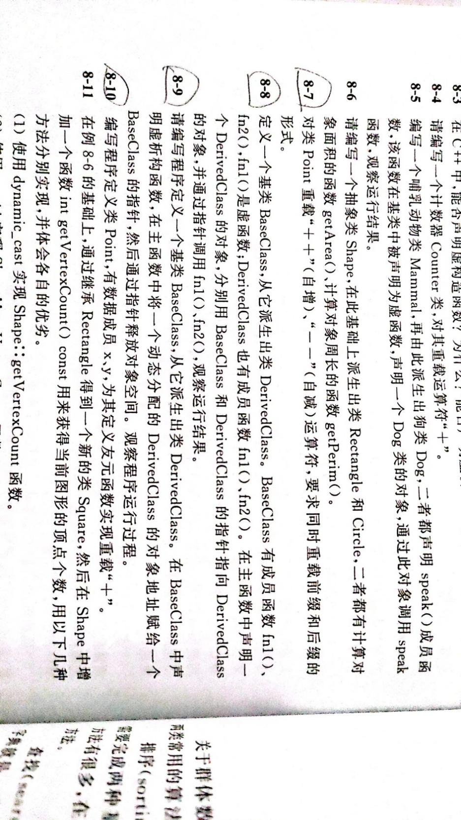

#include<iostream>
using namespace std;

class Point
{
friend ostream& operator<<(ostream& cout, Point p);
public:
Point(int a)
{
m_a = a;
}
//前置递增
Point& operator++()
{
//先增
m_a++;
//再赋值
return *this;
}

//后置递增
Point& operator++(int)
{
//先赋值
Point temp = *this;
//再递增
m_a++;
return temp;
}

//前置递减
Point& operator--()
{
//先减
m_a--;
//再赋值
return *this;
}

//后置递减
Point& operator--(int)
{
//先赋值
Point temp = *this;
//再递减
m_a--;
return temp;
}

private:
int m_a;
};

ostream& operator<<(ostream& cout, Point p)
{
cout << p.m_a << endl;
return cout;
}

int main()
{
Point p(3);
cout << p++ << endl;//3
cout << p-- << endl;//4
cout << ++p << endl;//4
cout << --p << endl;//3

system("pause");

return 0;
}
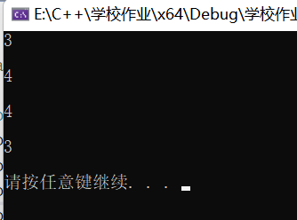

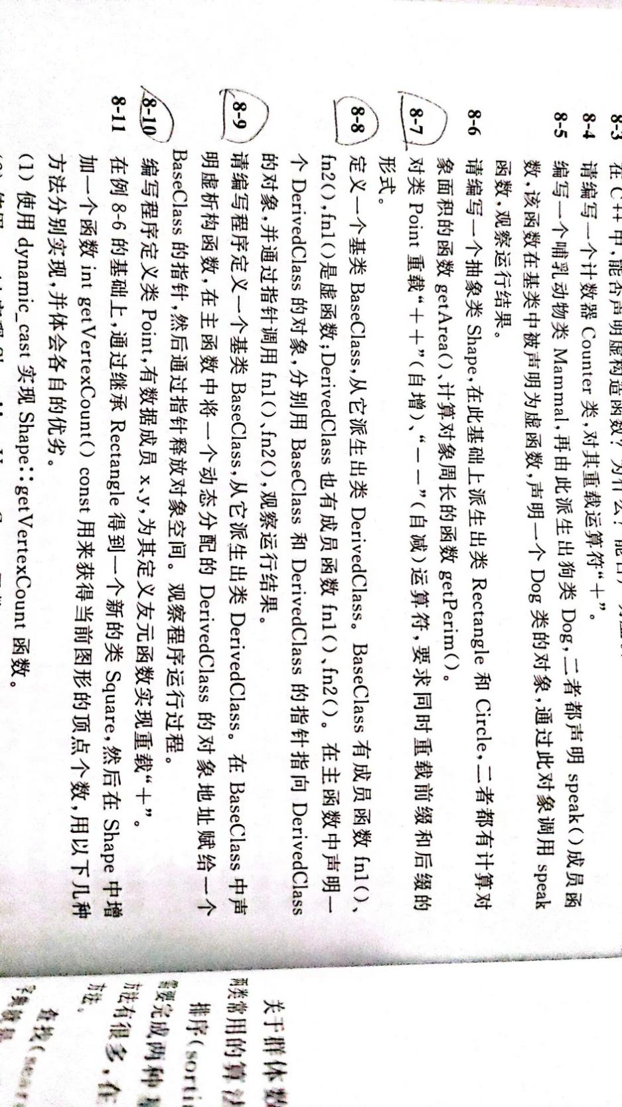

#include<iostream>
using namespace std;

class BaseClass
{
public:
virtual void fn1()
{
cout << "父类fn1函数调用" << endl;
}

void fn2()
{
cout << "fn2函数调用" << endl;
}
};

class DerivedClass :public BaseClass
{
public:
void fn1()
{
cout << "子类fn1函数调用" << endl;
}
};

int main()
{
DerivedClass d;
BaseClass* bc = &d;
bc->fn1();
bc->fn2();

DerivedClass* dc = &d;
dc->fn1();
dc->fn2();

system("pause");

return 0;
}
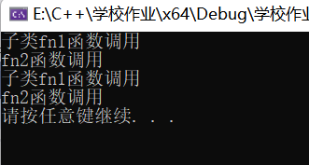

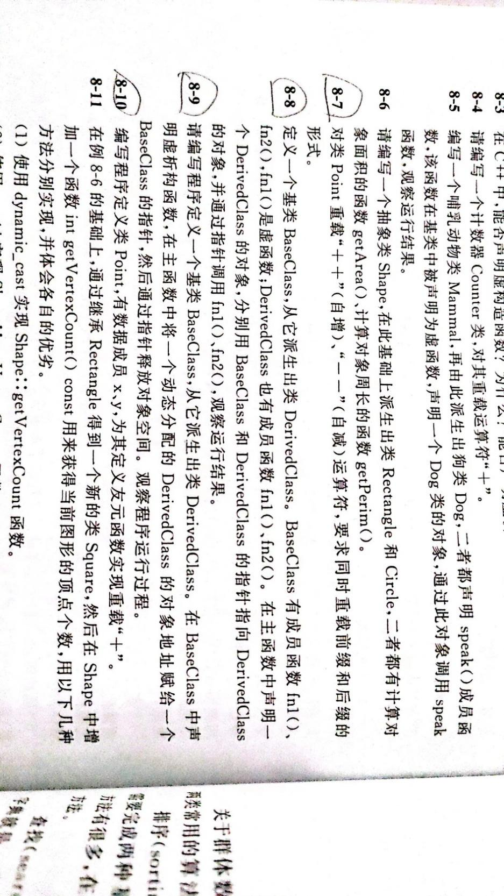
#include<iostream>
using namespace std;

class BaseClass
{
public:
virtual ~BaseClass()
{
cout << "父类虚析构函数调用" << endl;
}
};

class DerivedClass :public BaseClass
{
public:
~DerivedClass()
{
cout << "子类析构函数调用" << endl;
}

};

int main()
{
BaseClass* p = new DerivedClass;
delete p;

system("pause");

return 0;
}

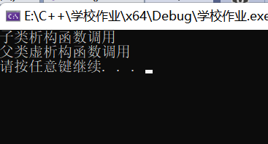

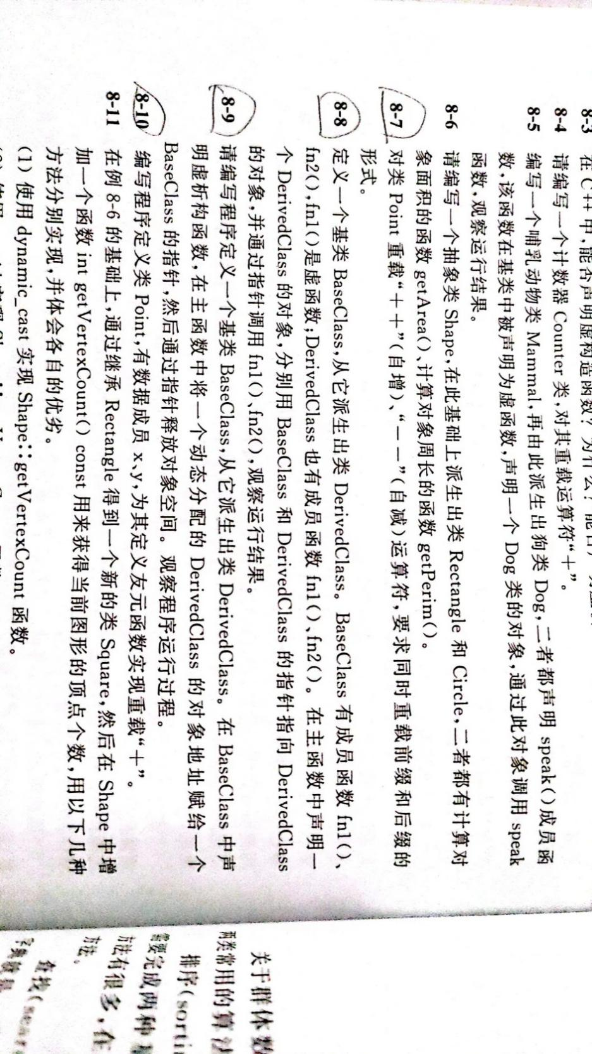
#include<iostream>
using namespace std;

class Point
{
friend Point operator+(Point& p1, Point& p2);
friend ostream& operator<<(ostream& cout, Point& p);
public:
Point(int a, int b)
{
x = a;
y = b;
}
Point()
{

}
private:
int x;
int y;
};

Point operator+(Point& p1,Point& p2)
{
Point temp;
temp.x = p1.x + p2.x;
temp.y = p1.y + p2.y;
return temp;
}

ostream & operator<<(ostream &cout, Point &p)
{
cout << "x = " << p.x << endl;
cout << "y = " << p.y << endl;
return cout;
}

int main()
{
Point p1(3, 4);
Point p2(8, 9);
Point p3;

p3=p1 + p2 ;
cout << "p1+p2后结果为" << endl;
cout << p3 << endl;

system("pause");

return 0;
}}