# **This file is to demonstrate the process of using PickNet picking first P and S wave arrivals from IRIS data center.**

1. First, you should prepare seismic data, specifically waveform data, earthquake catalog and seismic station information. For example, you can easily download these data from IRIS (<https://www.iris.edu/>) with Obspy (<https://github.com/obspy/obspy>). We prepared a simple script named ‘download_data.py’ under folder ‘PickingDataFromIRISExample’. Make sure you have Obspy installed (<https://github.com/obspy/obspy/wiki#installation>) in your environment and you should be able to download example data by simply running the script under folder 'PickingDataFromIRISExample'.

*python download_data.py*

The download may take a few minutes depending on your Internet connection. Once the download finished, you should be able to get data under ‘ori_data’ folder. The earthquake catalog is under folder ‘ori_data/events’. The station information is under folder ‘ori_data/stations’. The waveforms are under folder ‘ori_data/waveforms/E?’. The index of waveform folder is the same as event index in catalog file.

1. Once you have your data downloaded, you can slice data with a roughly calculated arrival time with TauP and ak135. The model inputs consist of 12-second-long slices from the vertical (Z) component and 16-second-long slices from the radial (R) and transverse (T) components of the seismograms for the first P- and S-wave arrival time picking, respectively. Each slice is centered on its theoretical arrival time, which is calculated using TauP and the AK135 velocity model. Both inputs of P- and S-waves slices are processed using zero-mean normalization and then divided by maximum-absolute-value. You can do this on example data by simply running the script ‘gen_input_for_pick.py’ under folder 'PickingDataFromIRISExample'.

*python gen_input_for_pick.py*

You should be able to generate input files under folder ‘input_output/P_input’ and folder ‘input_output/S_input’.

The final input data is a list of Numpy arrays (N×1200×1 for first P-wave picking and N×1600×2 for first S-wave picking) saved into npy format file with function numpy.save(). You can generate your own input data with some modification on script ‘gen_input_for_pick.py’

1. Write config file and use PickNet to pick. We have prepared configuration files under folder ‘input_output’ (P_config.yaml, S_config.yaml). (conda install pyyaml)

You can enter folder ‘picknet’ and run following command in your terminal:

*python seismic_pick_run.py --test --config-file PickingDataFromIRISExample/input_output/P_config.yaml*

and

*python seismic_pick_run.py --test --config-file PickingDataFromIRISExample/input_output/S_config.yaml*

to pick first P and S arrivals from sliced data.

You should be able to get pick results under folder ‘input_output/P_input’ and folder ‘input_output/S_input’’

1. Visualize picks and generate txt file of picks.

Before you generate txt file of picks. You can plot picks with corresponding waveforms simply by running the script ‘ViewAndGatherP.py [dataDir] [Prefix] [1.0]’ and ‘ViewAndGatherS.py [dataDir] [Prefix] [1.0]’ under folder 'PickingDataFromIRISExample'.

For example:

*python ViewAndGatherP.py input_output/P_input E0_E6_ 1*

*python ViewAndGatherS.py input_output/S_input E0_E6_RT_ 1*

After running scripts you should get pictures under folder ‘input_output/P_input/E0_E6_View’ and ‘input_output/S_input/E0_E6_RT_View’.

A snip of picture is shown below:

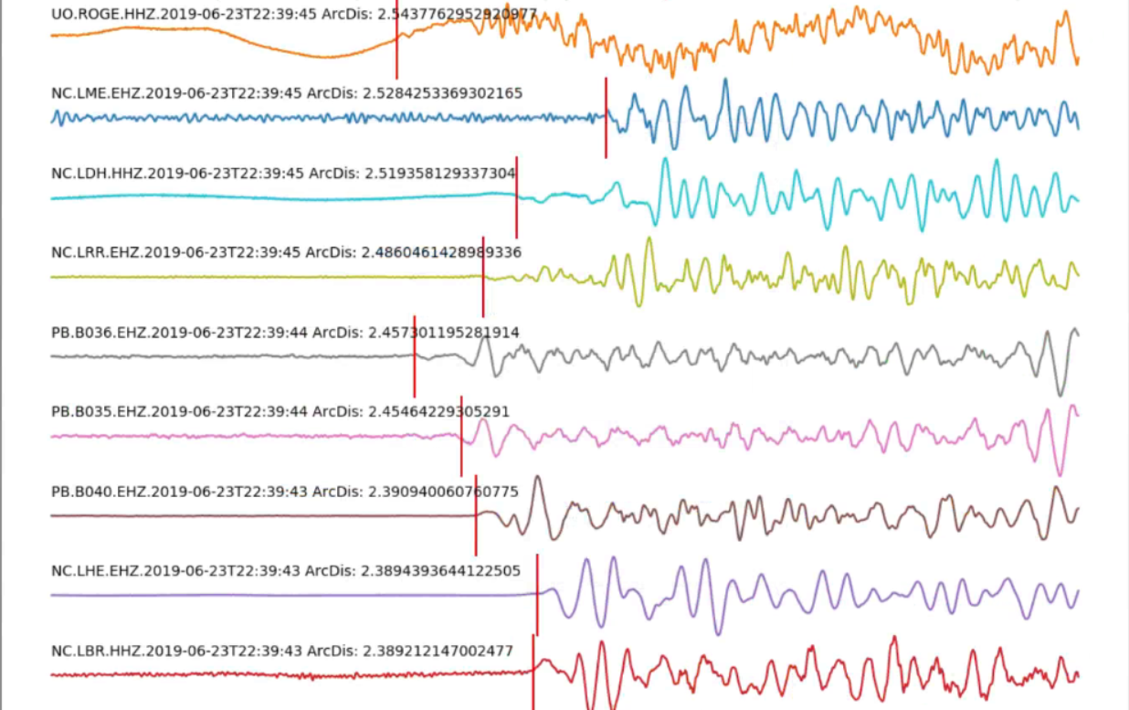

To generate txt pick file, run

*python gen_tomo_arrivals_inputfile_p_s.py 'input_output/P_input/' 'input_output/S_input/' 'txt_pickfile/' IRIS*

The txt pick file is ‘txt_pickfile/IRISpicks.txt’

To generate station txt file, run

*python gen_tomo_stations_inputfile.py 'ori_data/stations/' 'txt_pickfile/'*

The txt station file is ‘txt_pickfile/stations.txt’

We thank NIED Hi-net for providing high quality waveform data in our research. However, we are sorry that we are not able to provide training and testing datasets used in our JGR study due to NIED Hi-net’s data policy, ***which requests all users to download the data from NIED Hi-net web page and does not offer a data hosting service for users.*** Therefore, we are not allowed to redistribute Hi-net waveform data.

An alternative solution is for researchers to download the waveform data and arrival information data directly from Hi-net web page (<https://hinetwww11.bosai.go.jp/auth/?LANG=en>).

If you use PickNet in your study, you should cite our paper ‘Deep Learning for Picking Seismic Arrival Times’ (Wang et al., 2019, JGR, doi:10.1029/2019JB017536).

If you have any trouble using PickNet, please contact Jian Wang (jianwang@mail.iggcas.ac.cn) or Zhuowei Xiao ([xiaozhuowei@mail.iggcas.ac.cn](mailto:xiaozhuowei@mail.iggcas.ac.cn)) for help.