|  |
| --- |
| 南京大学 |
| 体系结构 |
| Assignment-2 |

|  |
| --- |
| 管登荣 MF1632020  2017-1-4 |

## Component 1

1. **Performance**

Performance is one of the critical quality attributes to a big data platform or infrastructure because the platform should process a huge amount of data during a very short time and it must calculate the result timely. If the platform is blocked for a long time, it will affect the user or requester’s experience a lot. All systems have performance requirements, even if they are not explicitly expressed. Processing time and blocked time are two basic contributors to the response time.

1. **Interoperability**

Interoperability is also a quality attributes which is critical to a big data platform. Interoperability is about the degree to which two or more systems can usefully exchange meaningful information via interfaces in a particular context. A big data platform cannot only use one system to process a huge amount of data, so it must exchange information among two or more systems. One system should be discovered by other systems when consumer wants to use it to process some particular data.

1. **Extendibility**

Extendibility is a quality attribute which is critical to most of software system because the requirement of software system cannot be static and it is changing all the time. In a development of a big data platform, the change and the cost in time or money of making a change, including the extent to which this modifiability affects other functions or quality attributes should be considered.

1. **Security**

Security should be considered as a critical quality attribute because a big data platform containing a huge amount of data must keep its data safe and make sure its data cannot be stolen by attackers. The data in a big data platform is very valuable and it may help the person who will make a strategic decision. If the data are stolen by attackers, the trade secrets will be revealed at same time.

1. **Usability**

Another critical quality attribute is usability. Usability is concerned with how easy it is for user to accomplish a desired task and the kind of user support the system provides.

## Component 2

To improve the performance, there are some tactics on two side. On the demand side, you can manage sampling rate or reduce sampling frequency and limit event response. When discrete events arrive at the system too rapidly to be processed, the events must be queued until they can be processed. We can also prioritize events if not all events are equally important and reduce overhead by using intermediaries to increase the resources in processing an event stream. On the resource side, we can increase resources including adding faster processor and additional memory, making network faster. A known directory service can be used to locate a service and the directory should have multiple levels of indirection. To manage interfaces for interoperability, we can use a control mechanism to coordinate and manage and sequence the invocation of particular services. Splitting module and deferring binding may be the most useful tactics for modifiability. If the module being modified includes a great deal of capabilities, the modification costs will likely be high. Binds the value of some parameters at different phase in the life cycle than the one in which they are initially defined. To protect the data from being stolen, we can limit access to computing resources, identify actors-source of any external input to the system. The actors who or what they purport to be should be authenticated. Data should also be encrypted and when an attack is underway, access should be revoked to sensitive resources. For usability, a data platform should offer enough operations to users and should also provide the document which can be read easily and describe the platform service completely.

## Component 3

I use Tencent cloud as example to illustrate how the architectural strategies and technical tactics are used and combined together to tackle a set of specific quality attributes, which interrelate or even intertwind together. Tencent Cloud is a secure, reliable and high-performance cloud compute service provided by Tencent. Tencent is now the largest Internet company in China, and even Asia. It's providing services for hundreds of millions of people via its flagship products like QQ and WeChat. Cloud Block Storage is a low-delay, high-performance, and highly reliable block storage service provided by Tencent Cloud for CVMs. You can format the block storage that's mounted onto CVM instances, create file systems, and store data persistently on the storage, similar to computer hard disks.

The cloud block storage supports efficient migration of virtual machines in hot mode, to prevent service interruption caused by physical faults. It is applicable to high-load core key service systems. The cloud block storage provides three copies of data redundancy and supports sound data backup, snapshot, and second-level data restoration. The cloud block storage can be freely mounted and unmounted with no need of shutting down/restarting CVMs. The capacity of the cloud block storage can be flexibly configured and expanded as required. A maximum of 10 cloud block storages can be mounted to a single virtual machine, achieving a total capacity of 40 TB.

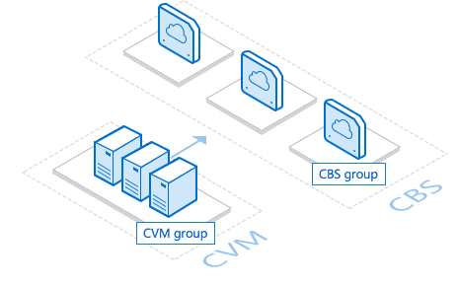

Cloud Block Storage brings high multi-threading ability and supports Hadoop-Mapreduce and HDFS. With high offline processing abilities for TBs/PBs of data, Cloud Block Storage can help improve the efficiency of data analysis, data digging and business intelligence.

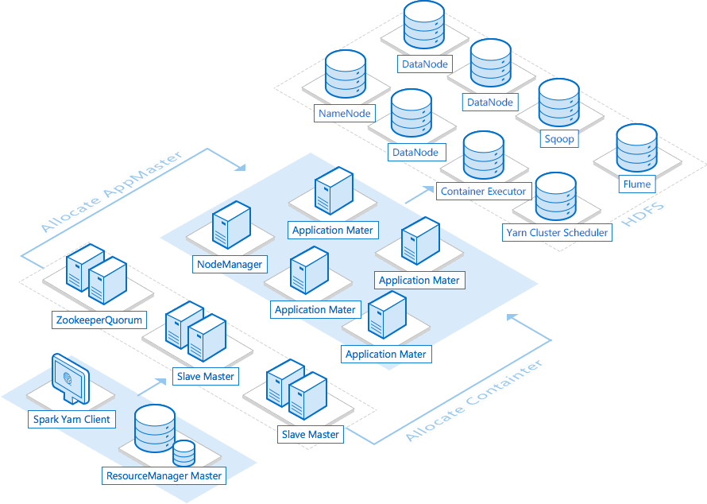

Tencent Cloud SSD Cloud disks are based on SSD storage medias and CBS distributed architecture, bringing high performance and reliability.

