**Reusability**

1. General scenario

|  |  |
| --- | --- |
| Portion of Scenario | Possible Values |
| Source | Software, people |
| Stimulus | Have partial of an existing program used in another program |
| Artifact | Framework or component that is going to be reused |
| Environment | After development |
| Response | Component is reused in another system |
| Response Measure | Time to understand the functionality of a component.  Modification needed to adapt one component to the specific functional requirement in a new system.  Proportion of precondition violation get handled by exception signaling. |

1. Concrete scenario

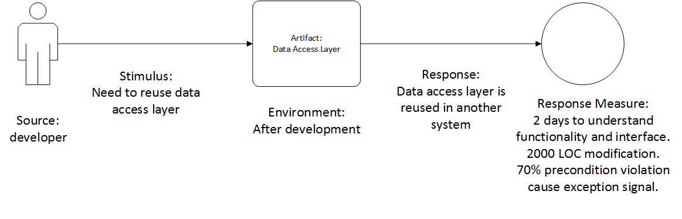

**Recoverability**

1. General scenario

|  |  |
| --- | --- |
| Portion of Scenario | Possible Values |
| Source | Software, physical infrastructure, physical environment, people |
| Stimulus | Process crash, power off, hardware failure |
| Artifact | Process, persistent storage |
| Environment | Overloaded operation, degraded operation |
| Response | Log the fault  Restore system to a consistent state |
| Response Measure | Time to detect the fault  Time to recover from the fault  Time in which system can work in degraded state |

1. Concrete scenario

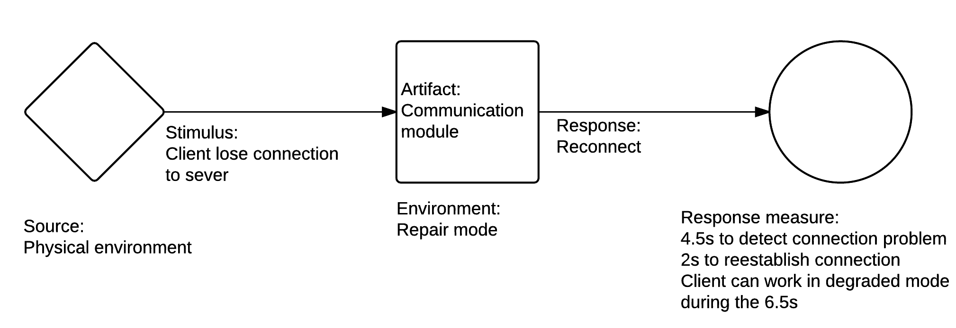

**Supportability**

1. General scenario

|  |  |
| --- | --- |
| Portion of Scenario | Possible Values |
| Source | End user, technical support staff |
| Stimulus | Maintainer also need to install, configure and upgrade the program. Maintainer needs to identify and resolve issues when the program works incorrectly. |
| Artifact | monitoring component, logging component |
| Environment | installation, upgrading, normal operation |
| Response | Log the fault, together with global variables and execution path |
| Response Measure | Time to find cause of a problem  Time to find solution of the problem in document  Time to actually solve the problem |

1. Concrete scenario

