**Start SPM 1.2**

**Start a measurement**

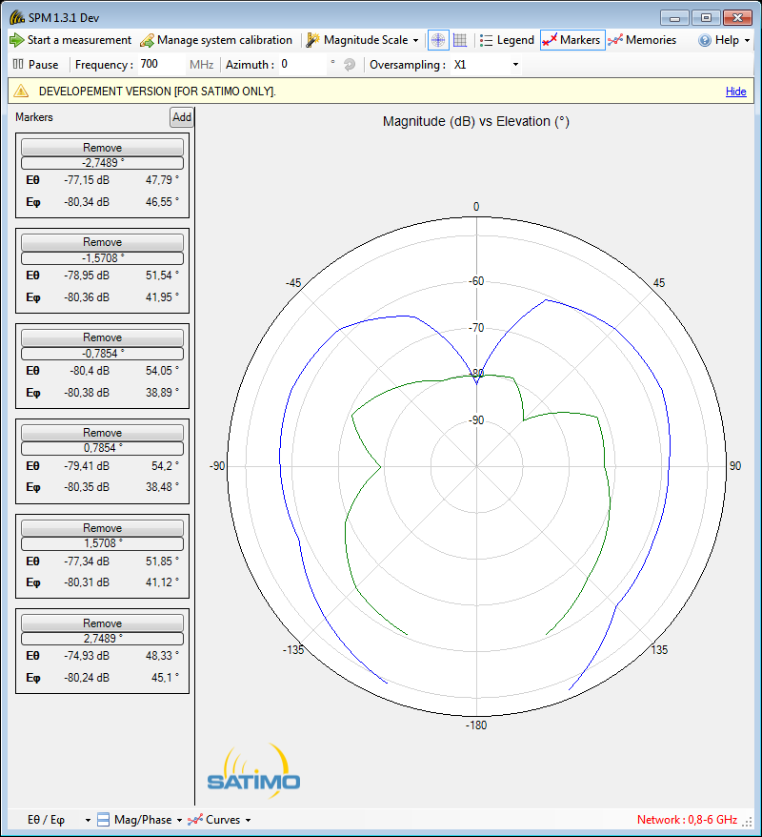

**1**

**Choose the following settings** (Matlab hard coded for range [700-1000] MHz and 2.5 MHz resolution)

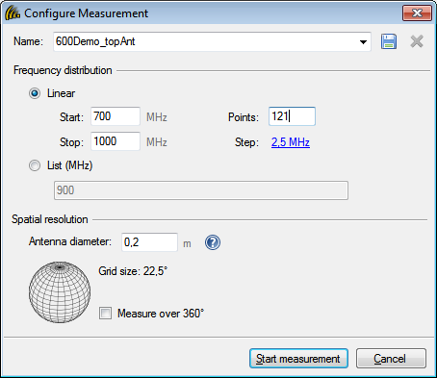

**Export the raw data**

