Enemies
Enemies have their own max Action Points and different AP requirments for different actions. For movement, first number indicates cost to adjacent squares, second number is for diagonal movement.

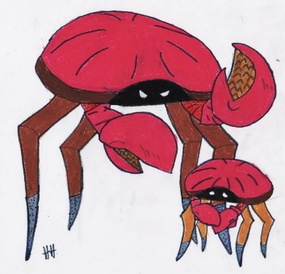
Cave Crab Tier 1
Health: 5
Defense: 1
Action Points: 6
Damage: 2, 2, 4 (3AP)
To hit: 12
Move: 3AP/4AP

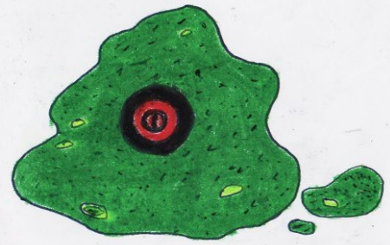
Slime Tier 2
Health: 4
Defense: 4
Action Points: 6
Damage: 3, 5, 6 (4AP)
To hit: 12
Move: 3AP/4AP
Weakness for sharp weapons: -2 defense

Goblin Tier 3
Health: 8
Defense: 2
Action Points: 8
Damage: 4, 5, 7 (6AP)
To hit: 12
Move: 2AP/3AP

Ogre Miniboss
Health: 16
Defense: 2
Action Points: 9
Damage: 7, 9, 12
To hit: 14
Move: 3AP/4AP
Attacks:
Club: Ogre's primary attack. Has 2 range and knocks 2 squares to the right with weak attack and 2 squares to the left with mediocre attack, while critical hit knocks you back 2 squares and stuns for 1 turn. Hits all units in that square. Deals -2 damage to adjacent units. (6AP)
Rock Throw: Ogre will use this attack if he didn't get to attack anyone last turn and can't get in melee range to anyone this turn. Has 8 range and stuns for 1 turn on hit. (8AP)

AI: Always targets whoever last attacked him. If no such target exists in Ogre’s line of sight, he will attack a random closest hero.

