Agile Process Development and DevOps Lab
Model Exam

Name: Denis A
Reg.No: 23MIS0656
Faculty: Dr.N Bala Ganesh
Problem Statement: 67
Feedback Collection System
Ensure user feedback is recorded and stored correctly.
Tasks:
- Develop feedback submission logic
- Write JUnit tests for input validation
- CI/CD pipeline with automated testing
- Deploy microservice on Docker and Kubernetes
Folder structure
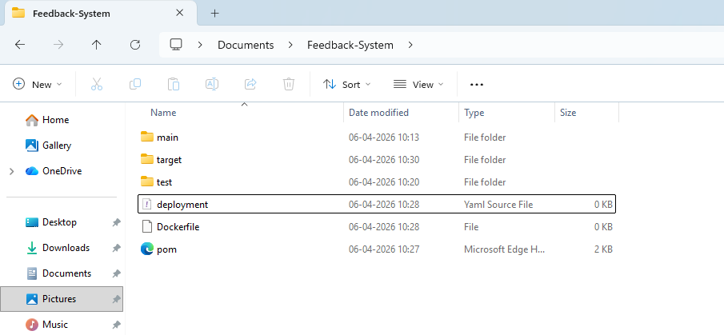
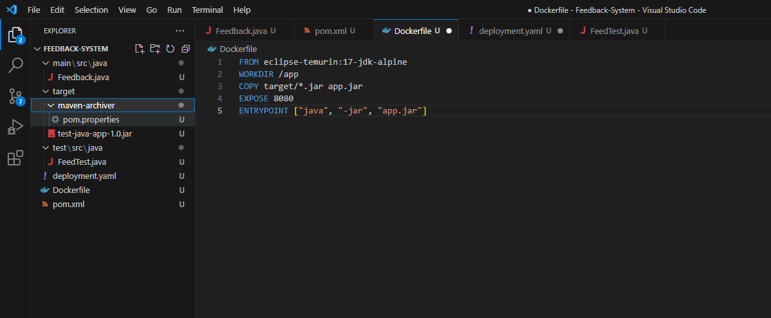
mvn clean test
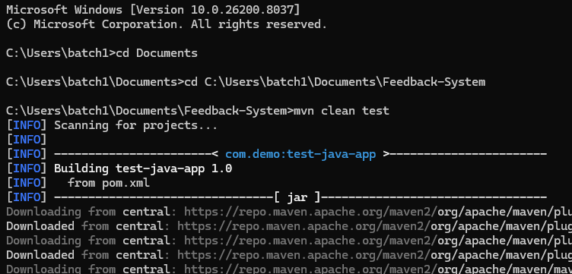
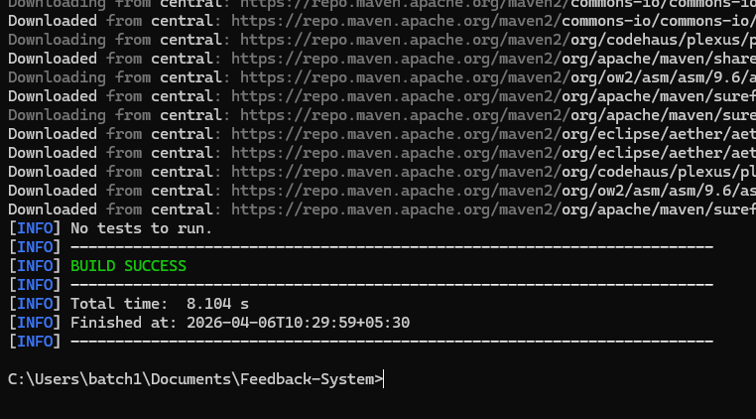
mvn clean package
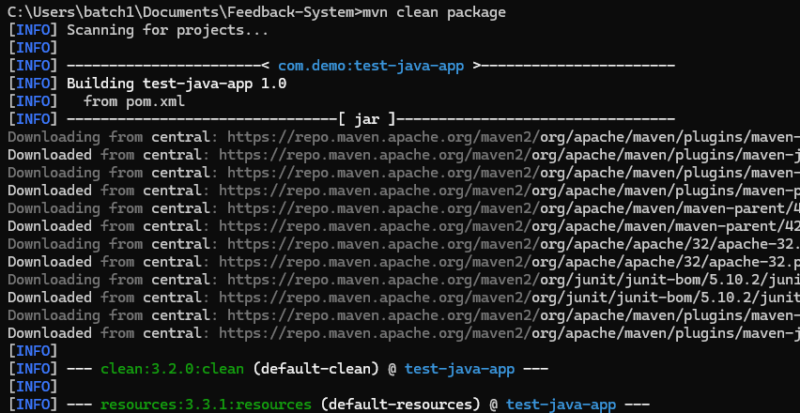
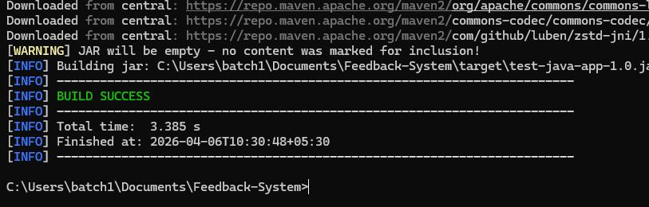
In my Jenkins
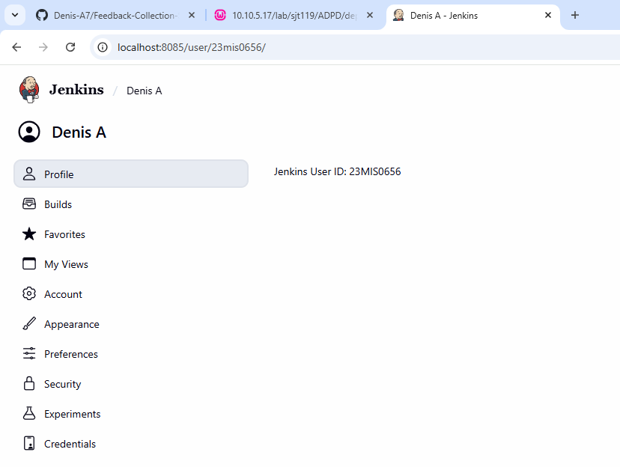

Check Installed plugins:
- Docker Plugin
- Docker Pipeline
- Kubernetes CLI
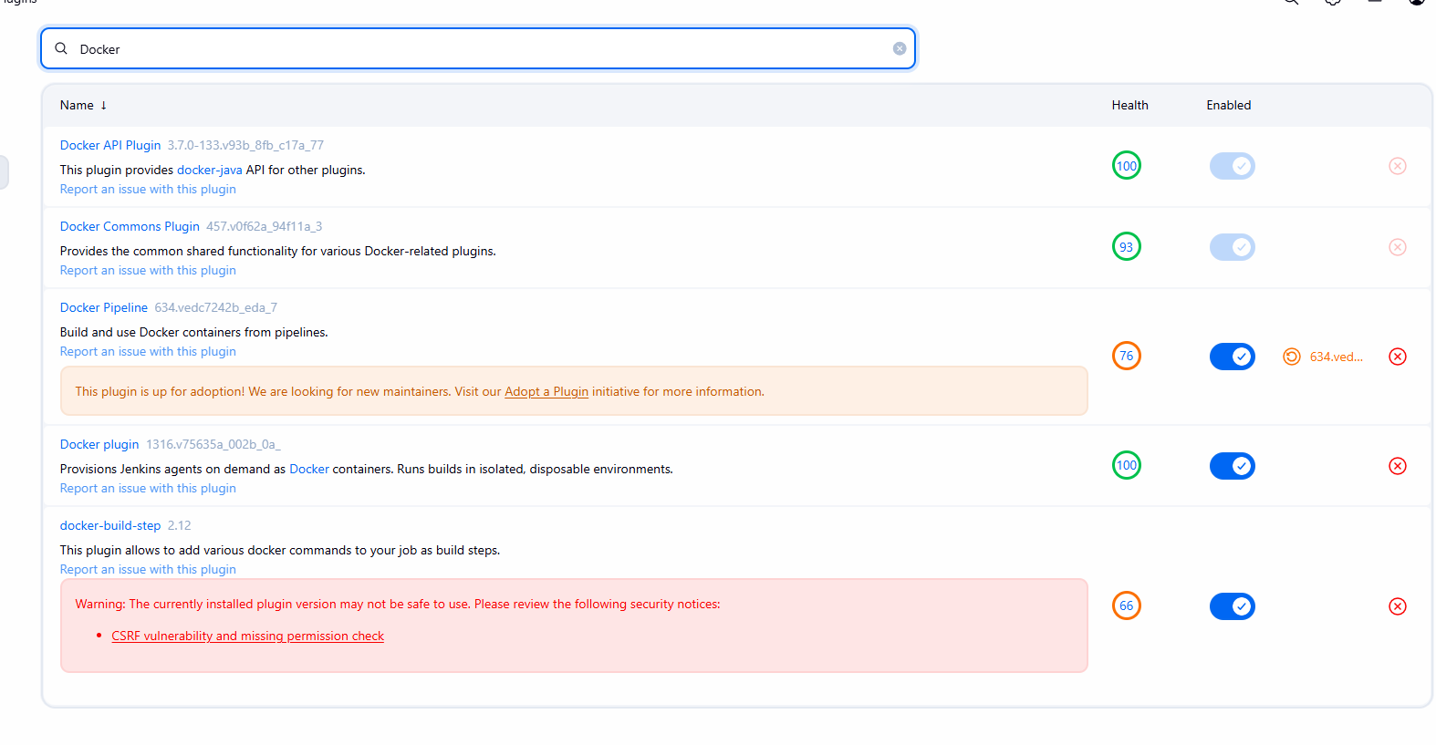
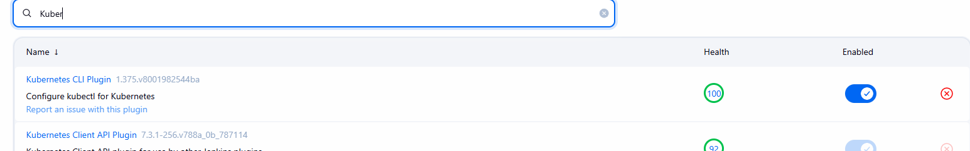

Set Credentials in Jenkins to be used by the Jenkins pipeline

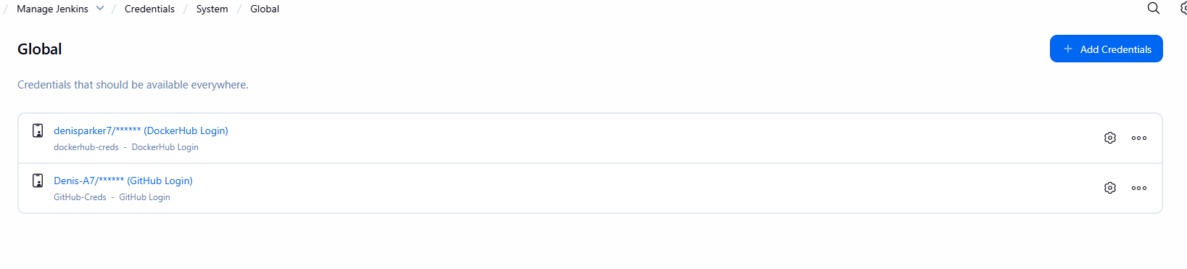

Create a new Pipeline
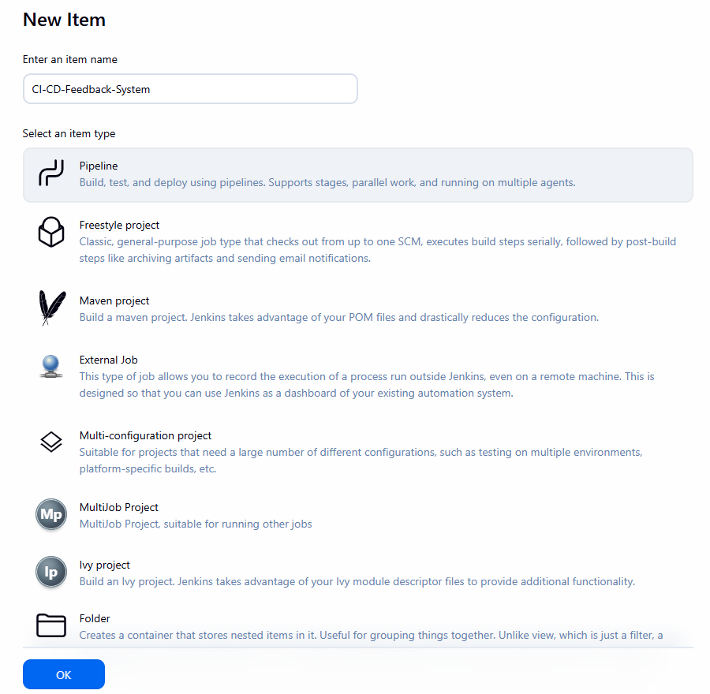

In Docker Desktop
Go to Kubernetes and create a cluster with 1 Node

My username in Docker Desktop
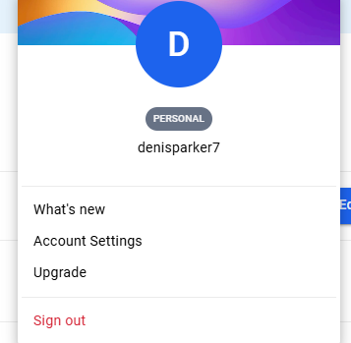

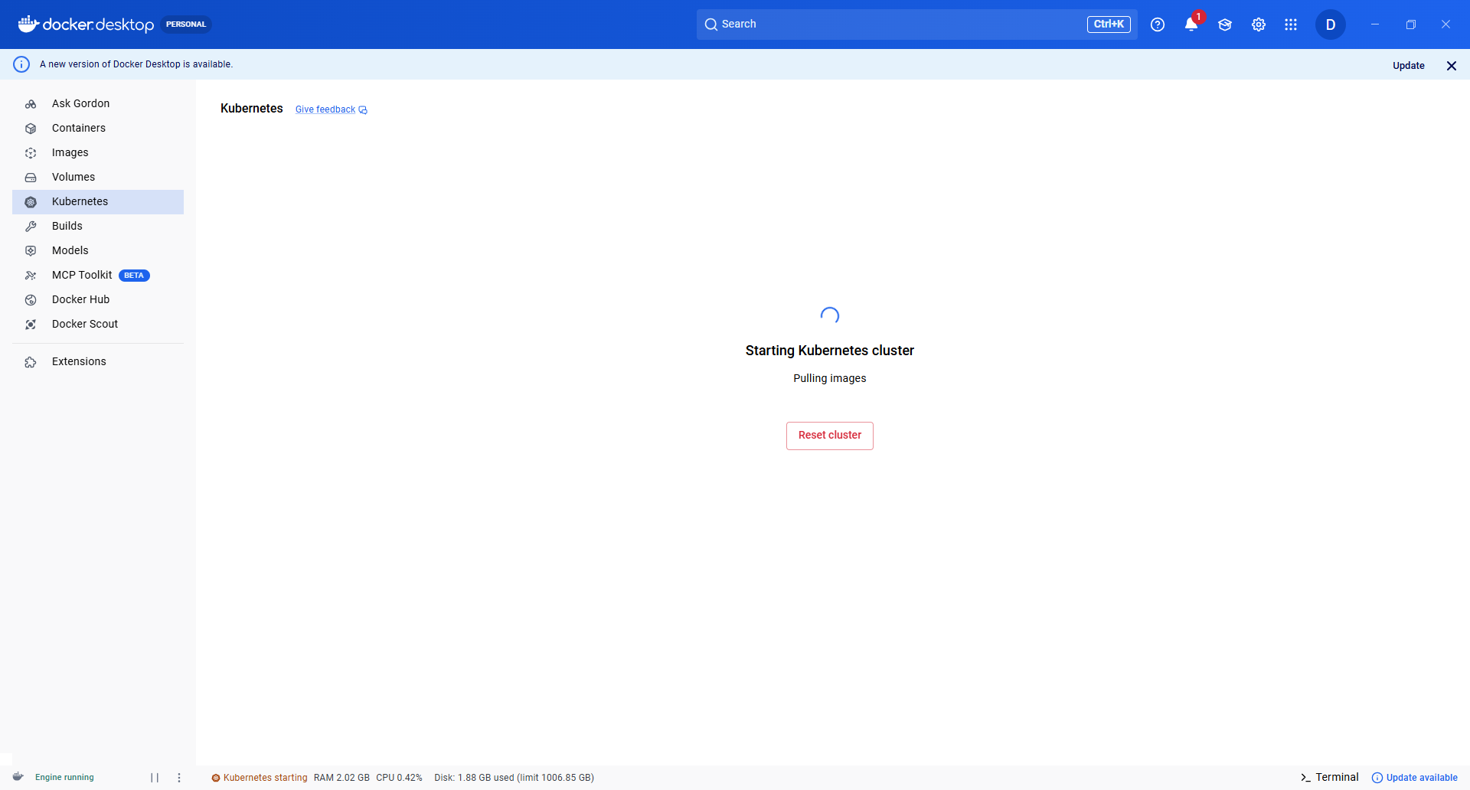

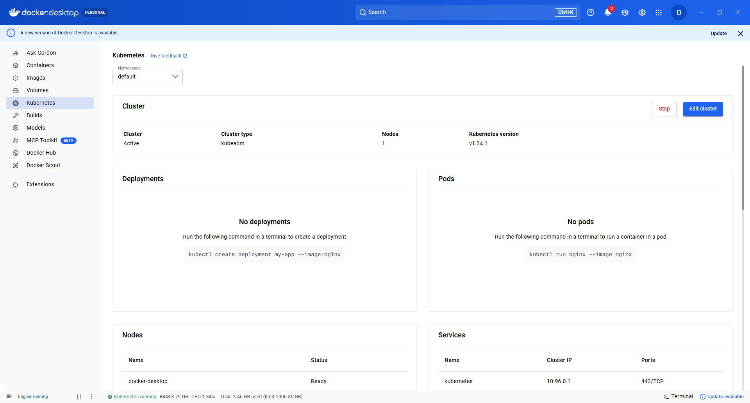

Cluster created
Currently running services
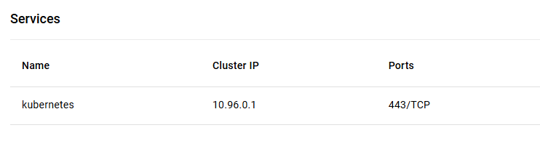
Check it in Command Prompt
-kubectl get svc
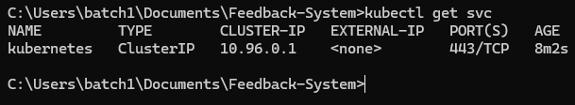

Check if maven is installed
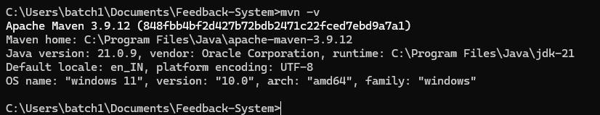
Maven is not configured in Jenkins

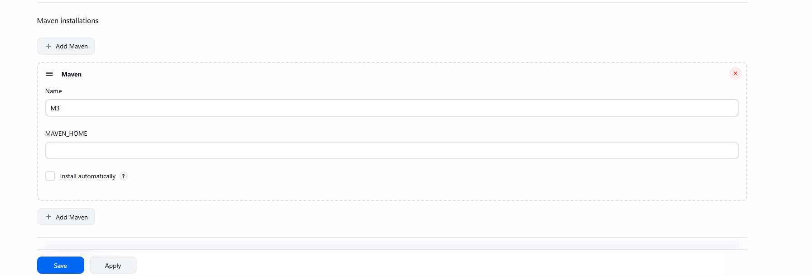

So the pipeline script has failed
Pipeline Script:
pipeline {
agent any

tools {
// Install the Maven version configured as "M3" and add it to the path.
maven "M3"
}

stages {
stage('Build') {
steps {
// Get some code from a GitHub repository
git 'https://github.com/Denis-A7/Feedback-Collection-System.git'

// Run Maven on a Unix agent.
sh "mvn -Dmaven.test.failure.ignore=true clean package"

// To run Maven on a Windows agent, use
// bat "mvn -Dmaven.test.failure.ignore=true clean package"
}

post {
// If Maven was able to run the tests, even if some of the test
// failed, record the test results and archive the jar file.
success {
junit '**/target/surefire-reports/TEST-*.xml'
archiveArtifacts 'target/*.jar'
}
}
}
}
}

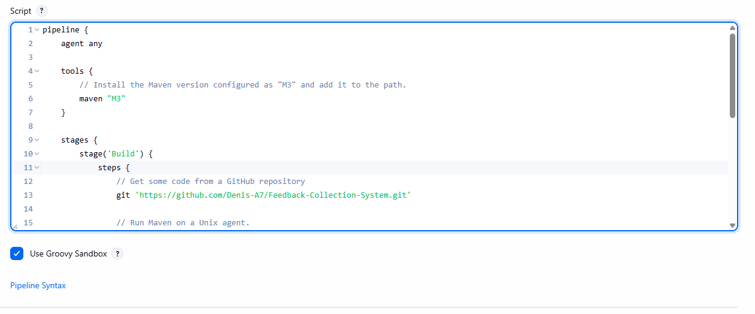

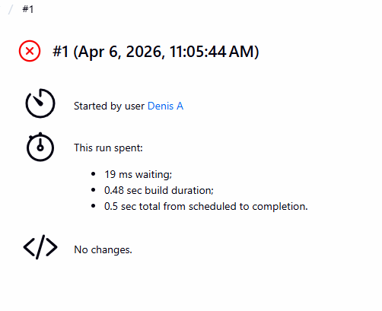
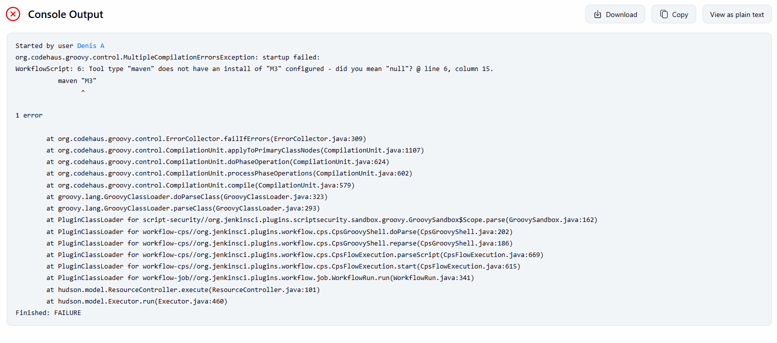

Since Maven is not configured Jenkins Pipeline cannot run the build successfully
So the local maven test is used above already.
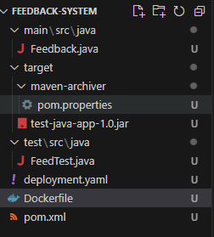
The .jar file created after running mvn test package
If the pipeline worked, then the Docker image will be created using our Docker Credentials and the image will be pushed to DockerHub and the microservice will be deployed using Kubernetes Cluster.

Git Hub Repository
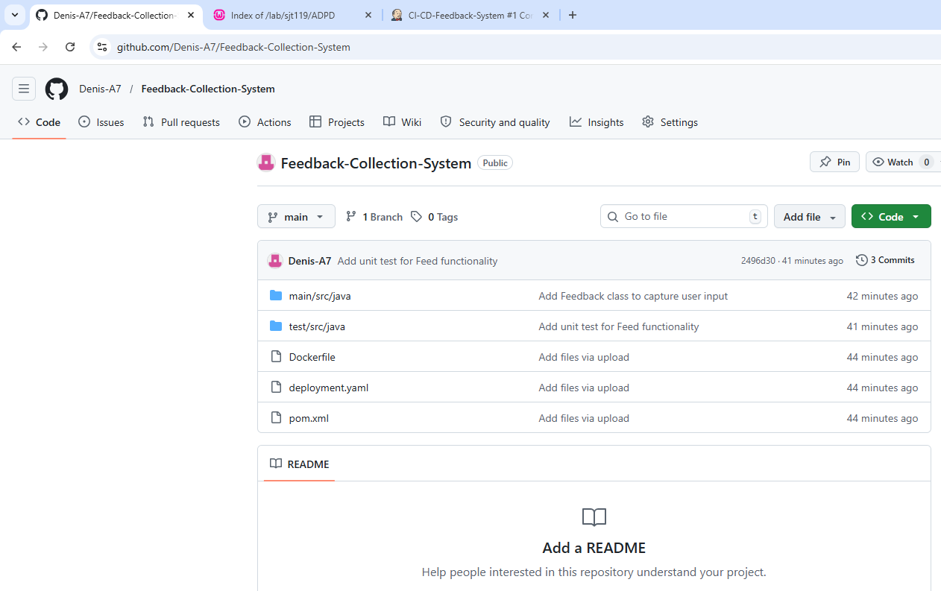
https://github.com/Denis-A7/Feedback-Collection-System.git

Thank You!

