Leasson 05

SPA: single page application  
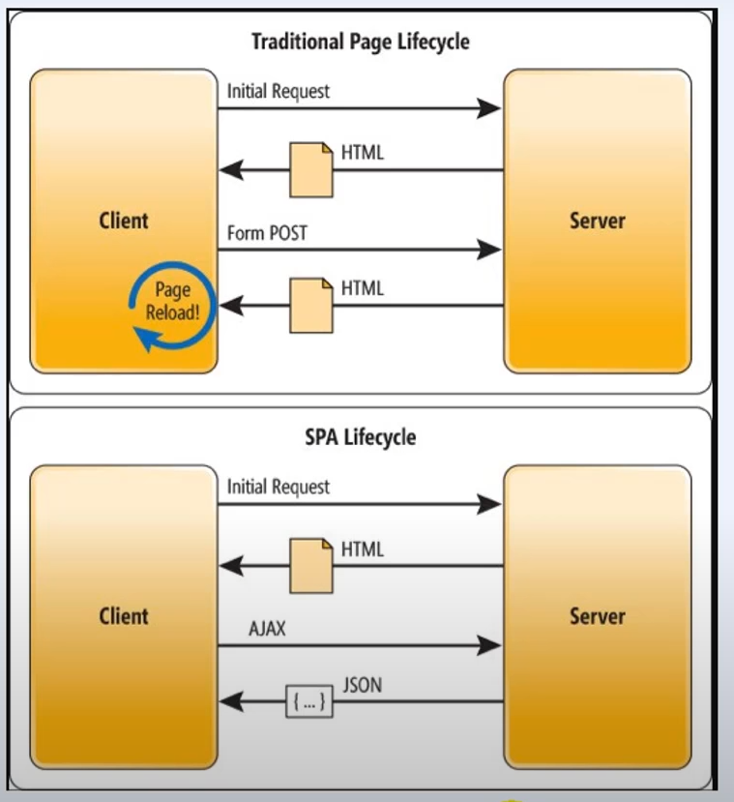

Leasson 07

Component

Component is function/class, that return web element (markup JSX).

Functional examples:

**function** App() {  
 **return** (  
 <**div** className="App">  
 Start  
 </**div**>  
 );  
}

**let** App = **function**() {  
 **return** (  
 <**div** className="App">  
 Start  
 </**div**>  
 );  
}

**let** App = () => {  
 **return** (  
 <**div** className="App">  
 Start  
 </**div**>  
 );  
}

Classes example:

**class** App **extends** React.Component {  
 render() {  
 **return** (  
 <**div** className="App">  
 Start  
 </**div**>  
 );  
 }  
}

Leasson 14

*.module.css 🡪 import s from “./*.module.css”

Inside s there will be an object with classes from *.module.css

**import** s **from** "./Profile.module.css";  
  
**export let** Profile = () => (  
 <**div** className={s.content}>  
 <**img** src={header} alt="Header" className={s.header} />  
 <**PageBlock** />  
 <**Posts** />  
 </**div**>  
);

Leasson 14

Props

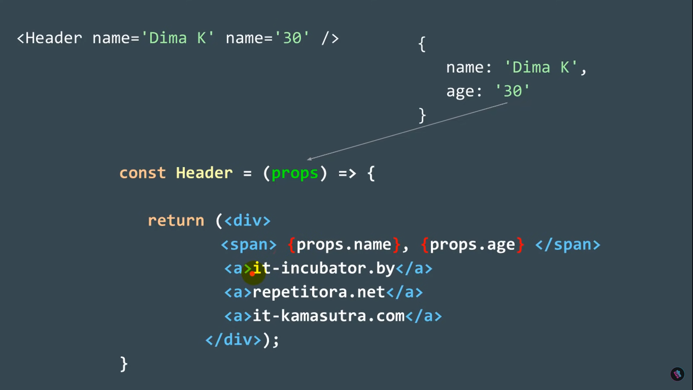

props.children 🡪 text or others components is embedded here.