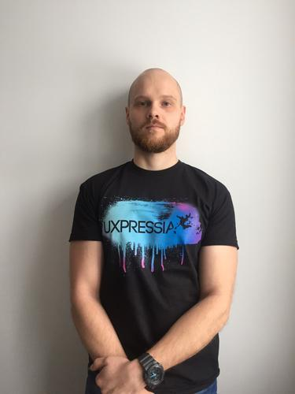 |  | Anischenko Denis Nikolaevich  Male, 29 years, born on 12 February 1988  +375 (29) 5114666  denisanischenko@gmail.com — preferred means of communication  Skype: dennisanischenko  LinkedIn: https://www.linkedin.com/in/denis-anischenko-813540137/  Reside in: Minsk  Citizenship: Belarus  Ready to relocate, ready for business trips
Desired position and salary
QA Engineer
IT, Internet, Telecom
• Testing

Employment: full time
Work schedule: full day
travel time to work: any
Work experience —2 years 9 months
August 2016 — till now  10 months |  | Uxpresso  Minsk, uxpresso.by/  QA Engineer  - Responsibilities:  • iPhone/Android applications testing;  • Web applications testing;  • Writing test cases and creating test designs in English;  • Сommunication with development team and BA teams;  • Test report writing;  - Tools:  • Jira, Assembla, WebStorm IDE, Cloud9 IDE;  - Extra:  • Basic knowledge in HTML, CSS, JavaScript;  • Basic knowledge in automation testing (Used Tools: WebdriverIO, JavaScript, Node Js, Git, Chai, Mocha)  • Basic knowledge in Bash  Projects:  5. EyeFitU https://www.eyefitu.com/  Description:  EyeFitU is mobile and web application that helps you choose the right size for your clothes from over 50 high street and luxury brands.  Project Responsibilities:  • Manual iPhone/Android application testing;  • Manual web testing (smoke, functional, regression, cross-browser testing);  • Writing test cases and creating test designs in English;  • Communication with development and BA teams;  • Test report writing;  4. UXPressia https://uxpressia.com/  Description:  • Online tool for creating professional customer journey maps and personas with simple and flexible visualisation, sharing, collaboration, maps export and customization (over 15 types of sections).  Project Responsibilities:  • Manual web testing (smoke, functional, regression, cross-browser testing);  • Writing test cases and creating test designs in English;  • Communication with development and BA teams;  • Test report writing;
September 2014 — August 2016  2 years |  | Artezio, ООО  Vitebsk, artezio.com  QA  - Responsibilities:  • Manual testing (smoke, functional, regression, cross-browser testing);  • Writing test cases and creating test designs;  • Test result reports writing  • Сommunication with BA and development teams;  - Tools:  • Jira, Assembla, PgAdmin III, DBeaver  - Extra:  • Basic SQL knowledge  • Working in tech support experience  Projects:  3. State information system of housing and communal services https://dom.gosuslugi.ru/#!/main  Description:  State information system of housing and communal services designed to store all existing data on housing and communal services throughout Russia. The system contains a variety of information on housing funds, work carried out, communication systems, tariffs reports and etc.  Project Responsibilities:  • Manual web testing (smoke, functional, regression, cross-browser testing);  • Writing test cases and creating test designs in English;  • Communication with development and BA teams;  • Test report writing;  • Tech support;  • Database query;  Tools:  • Jira, PgAdmin III, DBeaver  2. B2WSoftware https://www.b2wsoftware.com/  Description:  Specialized applications for heavy civil construction estimating, operations and business intelligence where teams can collaborate, make better decisions and optimize performance.  Project Responsibilities:  • Manual web testing (smoke, functional, regression, cross-browser testing);  • Writing test cases and creating test designs in English;  • Communication with development and BA teams;  • Test report writing;  1. Federal contract system http://www.zakupki.gov.ru/epz/main/public/home.html  Description:  Official website of the Russian Federation designed for information placement for goods deliveries, performance of work, rendering services for federal needs, needs of subjects of the Russian Federation, municipal needs and etc.  Project Responsibilities:  • Manual web testing (smoke, functional, regression, cross-browser testing);  • Writing test cases and creating test designs in English;  • Communication with development and BA teams;  • Test report writing;
Education
Higher
2006 |  | Vitebsk Masherov State University, Vitebsk  Philological, Teacher of English and German Languages
Key skills
Languages |  | Russian — native  English — I am a fluent speaker  German — basic knowledge
Skills |  | QA Business English HTML CSS iOS software testing Android software testing SQL (basics) Bash Scrum JavaScript (basics)
Additional information
About me |  | - 3 years of web/iOS/Android testing experience;  - Profound English skills;  - iPhone/Android application testing experience;  - Basic HTML, CSS, JavaScript, SQL, Bash knowledge;  - Experience of working independently on a project;  - German (Elementary);  - Keen on playing Drums, Guitar playing and Muay Thai;

