Energy-Aware GPS Spoofing Detection for Electric Vehicle Eco-Routing Using Multi-Sensor Fusion
Research project report
Submitted to
College of Sciences and Engineering of
Southern University and A&M College

By
Denis Asaba
Master of Science in Computer Science
Baton Rouge, Louisiana
May 15, 2027

Academic advisor: Dr. Krutthika Hirebasur Krishnappa
Energy-Aware GPS Spoofing Detection for Electric Vehicle Eco-Routing Using Multi-Sensor Fusion

APPROVAL PAGE
Name: Asaba, Denis
APPROVED BY:
_____________________________________________
Krutthika Hirebasur Krishnappa, Ph.D.
Principal investigator
Academic designation: to be confirmed
_____________________________________________
Mentor name and designation (to be confirmed)
Approval signatures and any additional institutional roles are pending.

ABSTRACT
This study developed a simulation-only workflow for examining GPS manipulation detection and energy-aware routing in electric-vehicle (EV) trips. Across milestones M0-M9, a SUMO/TraCI environment produced separate simulator truth, noisy GPS observations, attack labels, detector predictions, and route/battery outcomes. The detector sequence included an oracle-assisted GPS-to-truth residual reference (M4), a causal GPS-only motion baseline (M5), an enhanced persistent GPS-only detector (M8), and hybrid output analysis (M9). M6 evaluated robustness across held-out seeds and two routes; M7 tested GPS-responsive rerouting and a SUMO-state fallback.
Results are mixed and bounded by small synthetic test matrices. The oracle-assisted M4 detector outperformed GPS-only M5 in the M6 macro-F1 results, but it requires simulator truth and is not a deployable GPS-only method. M8 did not improve active-event detection over M5 in its final held-out matrix and exceeded the 5% false-positive target in two motion profiles. M9 exposed trade-offs: OR increased event coverage while raising false positives; AND lowered false positives while missing more events; the staged fast-suspect result matched M5. M7 produced zero successful mitigations and zero protected-versus-unprotected paired improvements in the measured outcomes. GPS motion anomalies in these experiments do not establish spoofing attribution. The checkpoint also omits three local-only M1/M2 inputs, so it is not fully self-contained for reproduction.
Keywords: GPS spoofing; GNSS; electric vehicles; anomaly detection; SUMO; energy-aware routing; sensor security.

ACKNOWLEDGEMENTS
Acknowledgements will be finalized after confirmation of individuals and any funding support. No funding acknowledgement is asserted here.

TABLE OF CONTENTS
APPROVAL PAGE 2
ABSTRACT 3
ACKNOWLEDGEMENTS 4
TABLE OF CONTENTS 5
LIST OF FIGURES 7
LIST OF ABBREVIATIONS 8
CHAPTER 1 INTRODUCTION 9
1.1 Background and Context 9
1.2 Problem Statement 9
1.3 Significance of the Study 9
1.4 Research Objectives 9
1.5 Research Questions and Hypotheses 10
1.6 Scope and Delimitations 10
1.7 Research Contributions 11
1.8 Organization of the Report 11
CHAPTER 2 LITERATURE REVIEW 12
CHAPTER 3 METHODOLOGY 13
3.1 Simulation foundation and data boundaries 13
3.2 Milestone development and evidence provenance 13
3.3 GPS spoofing attack models 14
3.4 Detection methods (M4, M5, M8, M9) 15
M4: oracle-assisted residual reference 15
M5: GPS-only temporal baseline 15
M8: persistent GPS-only detector 15
M9: hybrid output analysis 16
3.5 Experimental design and evaluation metrics 16
CHAPTER 4 RESULTS AND DISCUSSION 17
4.1 Baseline and initial detector results (M0-M5) 19
4.2 M6 robustness evaluation 20
4.3 M8 held-out comparison 21
4.4 M9 hybrid trade-offs 22
M9 per-profile normal false-positive rates 22
M9 jump-duration comparison 23
4.5 Energy-aware routing and mitigation findings (M7) 23
CHAPTER 5 CONCLUSION AND FUTURE WORK 25
5.1 Research contributions and integrated interpretation 25
5.2 Conclusions and answers to the research questions 25
5.3 Limitations and threats to validity 26
5.4 Future Work 27
REFERENCES 28
Appendices 31
Appendix A - Evidence paths and provenance 31
Appendix B - Reproducibility and configurations 33
Appendix C - Institutional items to confirm 34

LIST OF FIGURES
1. M1 baseline battery charge and state of charge over time. 17
2. M2 horizontal GPS observation error over time. 18
3. M3 GPS position error during the finite-jump observation scenario. 19
4. M6 held-out trip-level F1 comparison for oracle-assisted M4 and GPS-only M5. 20
5. M8 held-out active-event detection rates for M5 and M8. 21
6. M8 profile-specific normal false-positive rates for M5 and M8. 22
7. M7 active detection, fallback, and mitigation rates by attack type. 24
8. M7 protected-minus-unprotected paired differences in distance, travel time, and energy. 24

LIST OF ABBREVIATIONS
Abbreviation | Meaning
EV | Electric vehicle
FN | False negative
FPR | False-positive rate
FP | False positive
GNSS | Global Navigation Satellite System
GPS | Global Positioning System
IMU | Inertial measurement unit
M0-M9 | Completed project milestones 0 through 9
SOC | State of charge
SUMO | Simulation of Urban MObility
TraCI | Traffic Control Interface
TN | True negative
TP | True positive

CHAPTER 1
INTRODUCTION

1.1 Background and Context
EV routing depends on route choice and uncertain energy consumption, motivating eco-routing and stochastic energy-aware routing research [1], [2]. Autonomous-vehicle security research describes adversarial risks to navigation and perception sensors [3], [4]. GPS spoofing surveys, secure position estimation, location-spoofing detection, and crowd-sourced corroboration address related threat and defense questions [5]-[8]. This study tests selected simulated GPS anomalies, GPS-only motion detection, and whether GPS-responsive routing changes executed paths or measured energy outcomes.
The template title includes "Multi-Sensor Fusion." M9 combined outputs from two GPS-only detectors; it did not combine independent physical sensors. This title/method mismatch is flagged for institutional review.

1.2 Problem Statement
A GPS coordinate anomaly alone does not establish that a route changed, that the changed route was executed, or that energy use changed. Detection, attack attribution, route response, and mitigation are separate steps. A detector using simulator ground truth is not GPS-only, and a motion anomaly is not proof of spoofing.

1.3 Significance of the Study
The project makes data boundaries explicit and retains negative findings. M7 found no successful mitigation or paired improvement. M8 and M9 expose operating trade-offs rather than a uniformly better detector. These results constrain claims that can responsibly be made from simulation.

1.4 Research Objectives
1. Establish a repeatable SUMO/TraCI EV simulation and telemetry workflow.
2. Generate seeded normal GPS observations and offset, jump, and drift scenarios while keeping a physical route-deviation trip distinct.
3. Evaluate oracle-assisted M4, GPS-only M5 and M8, and M9 detector-output combinations.
4. Assess robustness across specified held-out seeds, routes, and profiles.
5. Test GPS-responsive routing and measure actual path, arrival, energy, regeneration, and SOC outcomes in paired conditions.

1.5 Research Questions and Hypotheses
RQ1. How did oracle-assisted M4 compare with GPS-only M5 in the initial and M6 test matrices? RQ2. Did M8 improve active-event detection over M5 while controlling normal false positives? RQ3. Did M7 fallback mitigate tested scenarios or improve paired route and energy outcomes? RQ4. What false-positive and event-coverage trade-offs resulted from M9 OR, AND, and staged policies?
These propositions organize retrospective analysis; they were not preregistered and were not tested inferentially:
? H1: M8 would improve event detection over M5 without exceeding the 5% normal FPR target. Not supported by the final matrix.
? H2: M7 fallback would change paired route or energy outcomes. Not supported by the final paired matrix.
? H3: M9 fusion policies would trade event coverage against FPR. Consistent with the descriptive results.

1.6 Scope and Delimitations
This study covers completed M0-M9 work in simulation. It uses SUMO road-network coordinates in meters, simplified Gaussian GPS noise, synthetic attacks, and small trip/seed/route/profile matrices. No physical transmitter, real vehicle, receiver-level GNSS model, production detector, or deployment condition was evaluated. M4 uses simulator truth; M7 fallback reads SUMO route state. M5 and M8 are GPS-only motion anomaly methods. M9 combines detector outputs, not independent sensors.
Three M1/M2 input files remain local-only and are absent from the pushed checkpoint, so it is not self-contained for reproducing those runs. Unique M3 verification evidence remains in the older root project.

1.7 Research Contributions
? A SUMO/TraCI telemetry workflow with recorded configuration and seeds and separated truth/observation data.
? Separate normal GPS and attack artifacts with offline label sidecars.
? A comparison of an oracle-assisted residual reference with causal GPS-only temporal detectors.
? Held-out seed, route, profile, event-level, and paired evaluations retaining mixed and negative results.
? A GPS-responsive routing experiment recording actual route choices, executed paths, and battery outcomes.
? Quantified M9 OR, AND, and staged-output trade-offs.

1.8 Organization of the Report
Chapter 2 reviews literature and the research gap. Chapter 3 describes simulation, data boundaries, attacks, detectors, and evaluation. Chapter 4 presents M0-M9 findings and discussion. Chapter 5 answers the research questions and outlines future work. Appendices map claims to evidence and describe reproducibility limits.

CHAPTER 2
LITERATURE REVIEW
EV eco-routing studies motivate energy-aware route choice and account for uncertainty in energy consumption [1], [2]. Autonomous-vehicle security surveys frame the broader adversarial setting and the security of navigation and perception sensors [3], [4]. GPS-focused literature addresses spoofing threats, secure position estimation and sensor fusion, location-spoofing detection, and crowd-sourced corroboration [5]-[8].
The supplied references [9]-[12] are retained as supplementary literature, not as evidence for GPS detector performance or energy mitigation. Reference [9] concerns class-imbalanced vehicular-network intrusion detection; [10] concerns spoofed messages and trust in connected-vehicle communications; [11] applies SUMO in an urban transport social-acceptance assessment; and [12] concerns UAV detection, security, and communications. Their topics do not establish the project's GPS-position or EV-routing findings.
Threat and countermeasure work [13], [14] and vehicle-trajectory-based anomaly detection [15] provide additional background on spoofing and motion context.

CHAPTER 3
METHODOLOGY

3.1 Simulation foundation and data boundaries
The project used Python, SUMO, and TraCI. The seed-42 baseline used SUMO 1.28.0, one EV (ev_001), a one-lane, one-edge road_0 network of length 1,000 m, a 1 s simulation step, and a configured battery capacity of 50,000 Wh with 25,000 Wh initial charge. The baseline completed 80 simulation steps and yielded 79 queryable telemetry samples at seconds 1 to 79. SUMO had removed the vehicle before arrival-step telemetry could be queried; no arrival row or state was synthesized. Battery state of charge (SOC) was derived as charge divided by capacity. The SUMO Electric documentation describes battery-device outputs, and the SUMO paper describes the microscopic simulator [16], [17]. The recorded verification was headless; this report does not claim SUMO-GUI visual verification.
The workflow kept distinct: (1) SUMO truth telemetry; (2) GPS observations; (3) attack labels and provenance sidecars used for offline scoring; (4) detector predictions and metrics; and (5) actual SUMO route, distance, battery, and SOC outcomes. M4 was an explicit oracle-assisted exception because it compared GPS coordinates with simulator truth. M5 and M8 used GPS-only features; M9 combined their prediction outputs. M7 fallback queried SUMO route/edge state and was therefore also oracle-assisted.
Normal GPS was generated using independent, zero-mean Gaussian noise with 3 m standard deviation per coordinate axis and recorded random seeds. This is a simplified stationary metric-coordinate approximation, not a receiver-level GNSS, multipath, or temporally correlated error model.

3.2 Milestone development and evidence provenance
Milestone | Development and evidence-backed result | Canonical evidence
M0 | Established the SUMO/TraCI simulation foundation and fixed-seed configuration; baseline EV completed 80 steps on the 1,000 m one-edge road. | See Appendix A (M0)
M1 | Added truth telemetry and battery outputs; 79 active/queryable samples, initial charge 25,000 Wh, capacity 50,000 Wh, with no queryable arrival-step state. | See Appendix A (M1)
M2 | Created separate seeded normal GPS observations. Across 79 matched fixes: mean error/MAE 3.995736 m, RMSE 4.504651 m, p95 6.999907 m, and zero unmatched records. | See Appendix A (M2)
M3 | Added offset, finite-jump, and capped gradual-drift GPS observations with separate labels; also evaluated a physical alternative-route trip. That route trip was separate and was not caused by GPS manipulation. | See Appendix A (M3)
M4 | Evaluated an oracle-assisted GPS-to-truth residual detector. It used the normal-only threshold and one-trip chronological evaluation described in Section 3.5. | See Appendix A (M4)
M5 | Evaluated a causal GPS-only temporal baseline using current and previous observations. It was weak on offset and drift in its initial single-trip result. | See Appendix A (M5)
M6 | Evaluated M4 and M5 across held-out seeds and two route definitions. Both routes also appeared in calibration, so this did not constitute leave-one-route-out generalization. | See Appendix A (M6)
M7 | Implemented GPS-responsive routing and a SUMO-state fallback; the paired final matrix found no successful mitigation or paired outcome improvement. | See Appendix A (M7)
M8 | Added temporal features and persistence to a GPS-only detector; final held-out results were mixed/negative relative to M5. | See Appendix A (M8)
M9 | Evaluated paired M5/M8 outputs using OR, AND, and staged combinations; quantified the resulting false-alarm and event-coverage trade-offs. | See Appendix A (M9)
The nested project is authoritative for M0-M9 implementation and canonical later-milestone reports. The root-only M3 final-verification artifacts are cited above by their original provenance and are not represented as nested-repository files. Exact report paths and limitations are cataloged in the final evidence inventory.

3.3 GPS spoofing attack models
M3 generated three GPS-observation manipulation patterns: a position offset, a finite sudden jump, and a capped gradual drift. Truth telemetry and attack labels were kept in separate artifacts for offline evaluation. A fourth M3 scenario changed the physical SUMO route on a connected alternative route; it was a separate route-deviation experiment, not an effect caused by spoofed GPS input. M4-M9 detector evaluations focused on the stated GPS attack scenarios and do not establish detection of all real-world spoofing techniques.

3.4 Detection methods (M4, M5, M8, M9)

M4: oracle-assisted residual reference
M4 calculated Euclidean distance between observed GPS and simulator-truth coordinates and flagged residuals above a normal-calibrated threshold. The threshold was the 95th percentile, 6.999907 m, calibrated on the first 39 of 79 normal samples. The held-out normal suffix contained 40 samples; false-positive rate (FPR) was 2/40 = 5%. Each attack scenario had 79 records. F1 was 0.9524 for offset, 0.7143 for jump, and 0.9000 for drift. Confusion counts (TP/FP/TN/FN) were offset 30/3/46/0, jump 5/4/70/0, and drift 27/3/46/3. This is an oracle-assisted offline benchmark, not a GPS-only or deployable detector.

M5: GPS-only temporal baseline
M5 used causal current/previous GPS fixes to calculate estimated speed, speed change, and heading change, then applied frozen upper-quantile thresholds with an OR rule. The first fix was ineligible. On the initial one-trip test, normal suffix FPR was 2/40 = 5%. There were 78 eligible attack observations per scenario. F1/recall were offset 0.308/0.200 (6 TP, 24 FN), jump 0.571/0.800 (4 TP, 1 FN), and drift 0.216/0.133 (4 TP, 26 FN). These are single-trip/single-intensity demonstration results; the detector reports motion anomalies, not confirmed spoofing.

M8: persistent GPS-only detector
M8 added causal acceleration and rolling speed-consistency features with persistence and clearing logic. Thresholds were calibrated on normal trips; validation selected operating persistence. M5 remained unchanged for comparison. In Stage 1, selected validation FPR was 8.74%, above the 5% target. Stage 2A selected a 2-of-5 rule with 4.23% validation FPR. In final Stage 2B, M5/M8 pooled normal FPR was 2.50%/4.81% over 520 normal fixes. Active-event results (M5/M8; 24 events per attack class for each detector) were offset 24/24 vs. 22/24, jump 24/24 vs. 12/24, and drift 15/24 vs. 7/24. M8's profile-specific normal FPR was 6.98% for turns/light, 0% for stop/restart, and 7.78% for brake/acceleration. Thus its pooled FPR was below 5%, while two profiles exceeded the target, and active-event detection was lower than M5 in all three attack classes.

M9: hybrid output analysis
M9 combined paired M5/M8 predictions using OR, AND, and staged outputs. OR alerts when either detector alerts; AND requires both; staged emits M5 fast-suspect immediately and records M8 corroboration separately. It does not delay or suppress the M5 alert. A corroborated anomaly remains an anomaly signal, not proof of spoofing.

3.5 Experimental design and evaluation metrics
Early M4/M5 evaluations used a chronological calibration prefix and held-out suffix from one trip; they are not held-out-trip generalization estimates. M6 used normal-only calibration and final-test seeds across two route definitions, but both routes were represented during calibration. M8 separated calibration, validation, and reserved final-test data; M9 kept its six-trip validation split separate from its six-trip final test. M8 and M9 event recall counts detections during active attack intervals; post-attack alerts are reported separately. Observation-level metrics use eligible fixes and their stated denominators.
The project reports sample-level confusion counts and FPR where applicable, F1 and recall, held-out macro-F1 means and standard deviations, active-event detection counts/rates, detection delay, and post-attack alerts. M7 reports paired protected-minus-unprotected changes in arrival, route distance, travel time, energy consumption, regeneration, and SOC. The reporting keeps point-level and event-level performance separate, consistent with time-series evaluation concerns [18], [19]. Results from different milestones are not pooled because their attack grids, trip matrices, exclusions, and denominators differ.

CHAPTER 4
RESULTS AND DISCUSSION
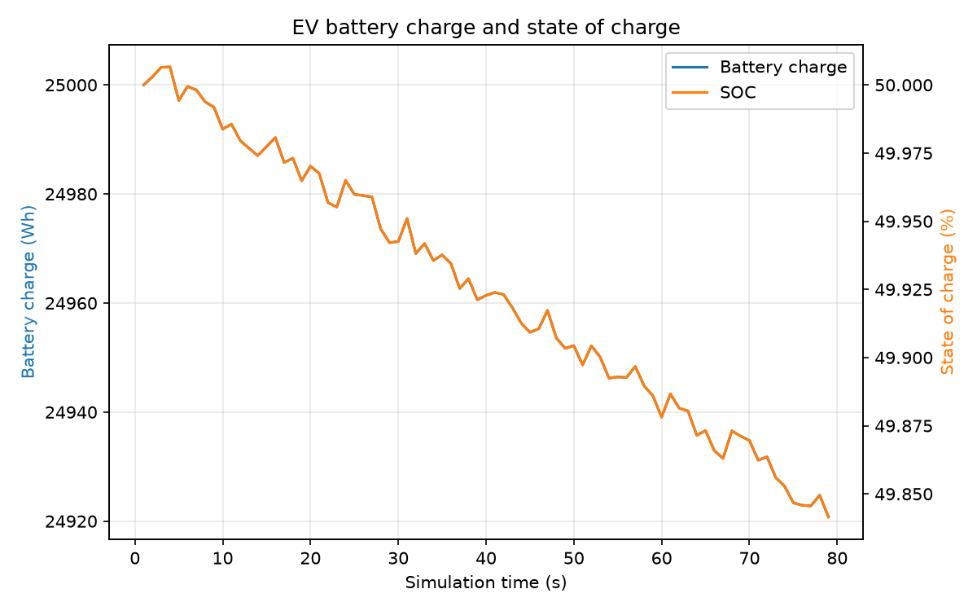
Figure 1. Battery charge and state of charge over the 79 queryable one-second samples of the seed-42 EV baseline. Initial battery charge was 25,000 Wh against a 50,000 Wh capacity; the arrival-step state was unavailable. This plot illustrates battery charge and SOC, not cumulative energy consumption or regeneration.
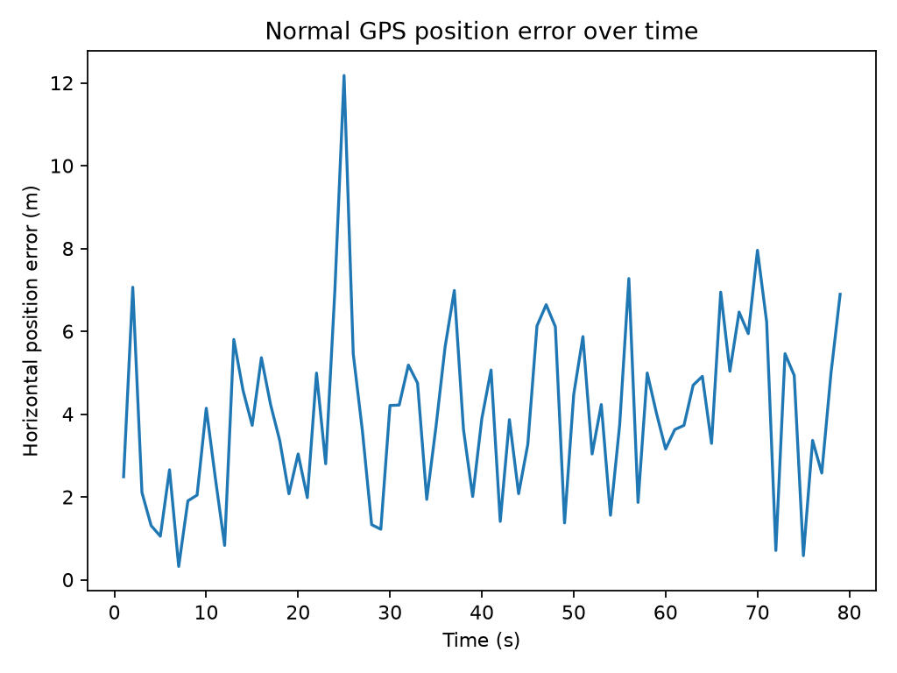
Figure 2. Horizontal GPS observation error across 79 active samples in the seed-2026 normal GPS baseline trip. This represents one simulated trip.
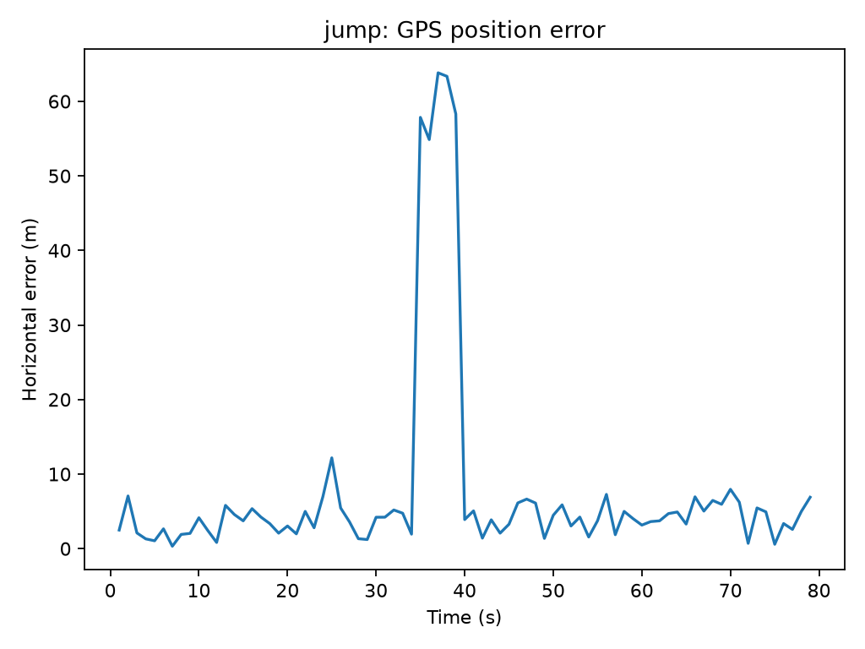
Figure 3. Position error during a simulated finite-jump GPS observation attack. This is an illustrative demonstration run, not the canonical final quantitative experiment; the manipulated GPS observation did not physically redirect the vehicle.

4.1 Baseline and initial detector results (M0-M5)
M0 established the SUMO/TraCI environment; the seed-42 EV completed 80 steps on a 1,000 m one-edge route. M1 recorded 79 queryable active samples, 25,000 Wh initial charge, and a 50,000 Wh battery capacity; arrival-step state was unavailable. M2 matched 79 normal GPS observations to truth, with mean error/MAE 3.995736 m, RMSE 4.504651 m, p95 6.999907 m, and zero unmatched records. M3 added offset, finite-jump, and capped gradual-drift observation scenarios plus a separate physical route-deviation trip; the latter was not caused by spoofed GPS.
Initial evaluation | Method | Normal FPR | Attack results | Scope
M4 | Oracle-assisted GPS-to-truth residual | 2/40 = 5% | F1: offset 0.9524, jump 0.7143, drift 0.9000; each attack scenario had 79 records. | One trip; uses truth.
M5 | GPS-only temporal thresholds | 2/40 = 5% | 78 eligible fixes/scenario; F1/recall: offset 0.308/0.200, jump 0.571/0.800, drift 0.216/0.133. | One trip and one intensity; first fix excluded.
The M4 and M5 normal FPRs are both 5% on the initial suffix, but their attack results are not directly interchangeable because the methods and attack metrics differ. M4 is an oracle-assisted reference, not GPS-only capability.

4.2 M6 robustness evaluation
The M6 matrix contained 52 held-out configurations and 104 detector evaluations, with 16 scenario trips per attack group. Macro F1 (mean +/- standard deviation) for M4/M5 was offset 0.894 +/- 0.080 / 0.080 +/- 0.100, jump 0.592 +/- 0.228 / 0.355 +/- 0.106, and drift 0.533 +/- 0.292 / 0.000 +/- 0.000. Mean normal FPR across four final-test normal trips was 0.032 +/- 0.017 for M4 and 0.019 +/- 0.020 for M5. The M4 values retain its oracle-assisted status. Only two final-test seeds and two routes were used, the routes also occurred in calibration, and the tests used one EV without traffic; broad route or population generalization is not supported.
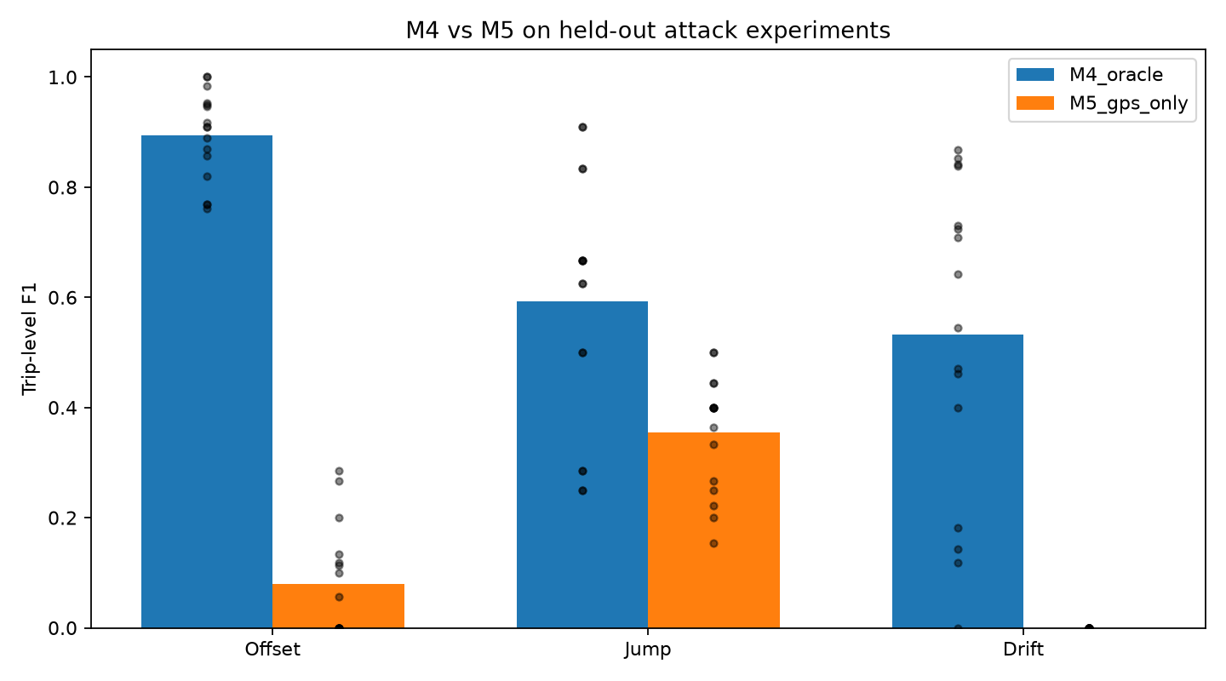
Figure 4. Held-out trip-level F1 by attack type for the oracle-assisted M4 residual detector and GPS-only M5 temporal detector. The evaluation matrix is small; M4 uses simulator ground truth and is not a GPS-only capability.

4.3 M8 held-out comparison
M8's pooled false-positive rate does not tell the full profile story: the final M8 rate exceeded 5% for brake/acceleration and turns/light, but not stop/restart. Across offset, jump, and drift, M8's active-event counts were lower than M5's. These are held-out results from the specified two-seed matrix, not a universal claim about temporal persistence or spoofing detection.
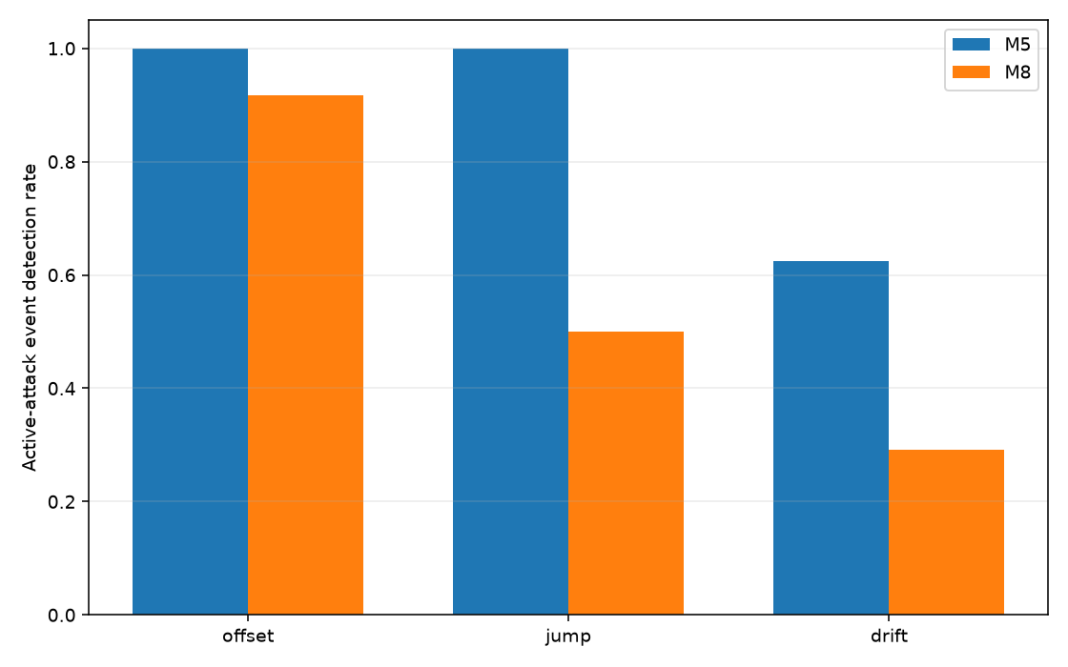
Figure 5. Held-out active-event detection rates for M5 and M8 across offset, jump, and drift scenarios. Canonical event counts (M5 vs. M8) were offset 24/24 vs. 22/24, jump 24/24 vs. 12/24, and drift 15/24 vs. 7/24; each detector had 24 events per attack class.
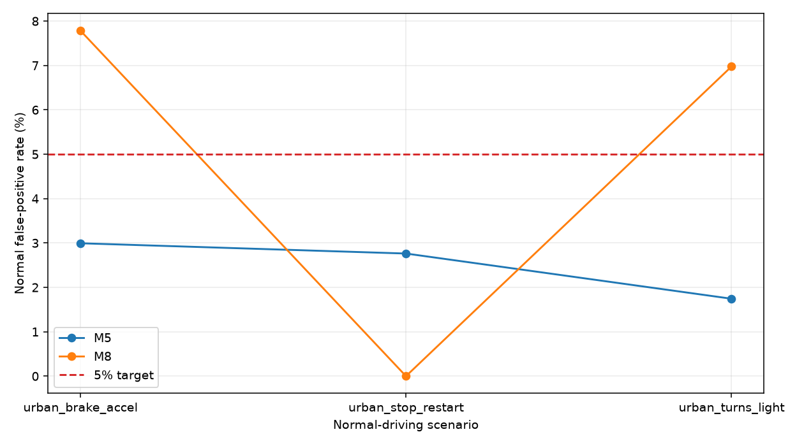
Figure 6. Profile-specific normal false-positive rates for M5 and M8 on the held-out evaluation matrix; the dashed line indicates the 5% target. Eligible-fix denominators were 167, 181, and 172 for brake/acceleration, stop/restart, and turns/light respectively (520 total). M8 exceeded the target in brake/acceleration and turns/light despite its pooled rate being below 5%.

4.4 M9 hybrid trade-offs
On 537 eligible normal fixes, final M9 normal FPR was 2.98% for M5, 7.26% for M8, 9.12% for OR, 1.12% for AND, 2.98% for staged fast-suspect, and 5.77% for staged corroborated. In the same order, active-event counts were 58/72, 60/72, 66/72, 50/72, 58/72, and 52/72. OR increased event coverage relative to M5 but had the highest false-positive rate. AND reduced false positives while reducing event detection. Staged fast-suspect matched M5 exactly; the corroboration state is a separate signal and not attack confirmation. These six-trip results are descriptive.

M9 per-profile normal false-positive rates
Profile | M5 | M8 | OR | AND | Staged fast suspect | Staged corroborated
Turns/light | 3.54% | 9.60% | 11.62% | 1.52% | 3.54% | 8.59%
Stop/restart | 3.49% | 9.88% | 12.21% | 1.16% | 3.49% | 5.23%
Brake/accel | 1.80% | 1.80% | 2.99% | 0.60% | 1.80% | 2.99%
Pooled eligible-fix denominators were 198 turns/light, 172 stop/restart, and 167 brake/acceleration (537 total). M8, OR, and staged corroborated exceeded 5% pooled FPR; OR was highest. The staged-fast candidate was selected on validation data under the 5% pooled validation limit; final-test data were not used to tune it.

M9 jump-duration comparison
System | 1-second jump events | Mean delay | 5-second jump events | Mean delay
M5 | 12/12 | 0 s | 12/12 | 0 s
M8 | 8/12 | 0 s | 12/12 | 0.33 s
OR | 12/12 | 0 s | 12/12 | 0 s
AND | 8/12 | 0 s | 12/12 | 0.33 s
Staged fast suspect | 12/12 | 0 s | 12/12 | 0 s
Staged corroborated | 8/12 | 0 s | 12/12 | 0.33 s
Each duration contains 12 events across two jump magnitudes, three profiles, and two seeds per profile. This six-trip matrix is descriptive. In M8 Stage 2B specifically, M8 missed all one-second jumps (0/6 per magnitude) while M5 detected all six; the M9 combined result has a denominator of 12 across both magnitudes and all three profiles.

4.5 Energy-aware routing and mitigation findings (M7)
M7 implemented GPS-responsive route selection while the EV remained on a shared approach edge and logged actual SUMO route changes and executed edges. In some 180 m offset runs, the vehicle took the alternative path (2/8 per spoofed condition). The protected condition retained M5 thresholds and invoked SUMO's route finder after an alert. Because fallback reads SUMO route/edge state, it is oracle-assisted.
In the Stage 1 smoke pair, an unprotected offset trip used 1,449.65 m and 224.53 Wh, compared with 1,378.50 m and 162.06 Wh for the normal-GPS direct trip. This single pair does not establish a repeatable effect. In the final Stage 2 paired matrix, there were 48 attack runs (24 pairs) and two normal controls. Active M5 detection was 0/8 for offset, jump, and drift; every attack condition had 8/8 post-attack alerts and 8/8 fallback activations, but 0/8 successful mitigations. Across all 24 pairs, protected-minus-unprotected mean changes were zero for arrival, route distance, travel time, consumed energy, regeneration, and SOC. The fallback acted after attack recovery. The results support neither a mitigation benefit nor an energy-saving claim. Published EV energy models also treat consumption and regenerative braking as dependent on the modeled vehicle and operating conditions [20]; this experiment does not validate a physical EV model.
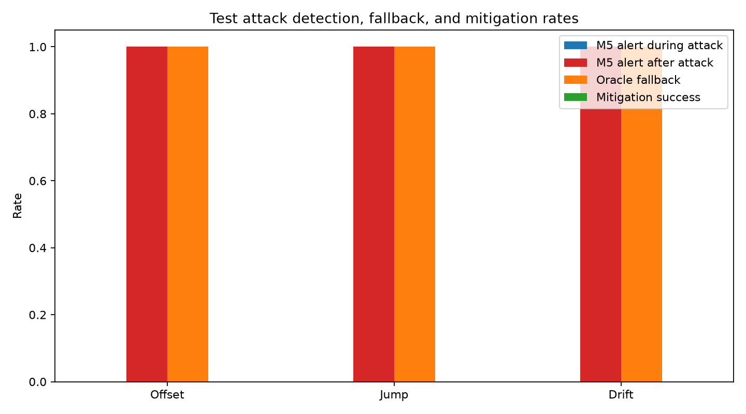
Figure 7. M7 detection and fallback outcomes across the paired test matrix. Each attack type recorded 0/8 active-attack detections and 0/8 successful mitigations, despite 8/8 post-attack alerts and fallback activations. Fallback activation is not successful mitigation.
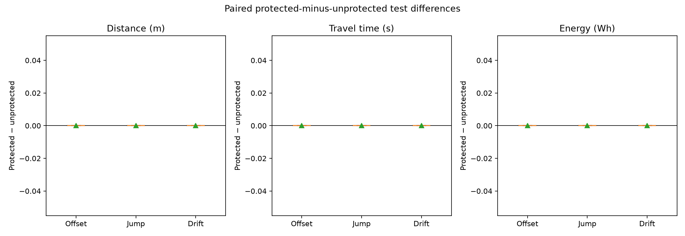
Figure 8. Protected-minus-unprotected mean paired differences in distance, travel time, and energy consumption were zero across the tested M7 attack pairs. The plot does not show SOC or regenerated energy.

CHAPTER 5
CONCLUSION AND FUTURE WORK

5.1 Research contributions and integrated interpretation
The project's contributions are an auditable SUMO/TraCI telemetry pipeline with explicit data boundaries; separate normal GPS and attack artifacts; a direct comparison between an oracle-assisted residual reference and GPS-only temporal detectors; held-out, event-level, and multi-profile evaluations; and a GPS-responsive routing test that measured executed paths and battery outcomes. M9 further made the trade-offs among OR, AND, and staged outputs measurable rather than presenting fusion as an unqualified improvement.
The central finding is methodological: detection, attribution, and mitigation are different tasks. M4's strong initial residual result depends on ground truth. M5 provides a transparent GPS-only baseline, but it performs poorly for offset and drift in its initial test and across the M6 matrix. M8's persistence changed the error profile without improving event detection over M5 in the final matrix. M9 changed coverage and false-alarm trade-offs but did not turn motion anomalies into proof of spoofing. M7 did not mitigate the tested attacks or improve paired energy outcomes.

5.2 Conclusions and answers to the research questions
RQ1: M4 outperformed M5 in the initial test and M6 macro-F1 results, but M4 requires simulator truth and is not GPS-only capability. RQ2: M8 did not improve active-event detection over M5 in its final held-out matrix; two profiles exceeded 5% FPR. RQ3: M7 produced zero successful mitigations and zero paired improvements in route and energy outcomes; its oracle-assisted fallback acted after recovery. RQ4: OR increased event coverage and false positives; AND reduced false positives while missing more events; staged fast-suspect reproduced M5, and corroboration is not confirmation.
The project establishes a simulation/evaluation workflow and bounded findings, not a validated production detector or demonstrated energy-saving intervention.

5.3 Limitations and threats to validity
1. Simulation realism: SUMO networks, vehicle behavior, and traffic are simplified. Independent Gaussian coordinate noise is not a receiver-level, multipath, or temporally correlated GNSS model.
2. Sample size and scope: Many experiments use one EV and small synthetic networks. M6 has two final-test seeds and two routes; M8 and M9 final matrices each cover six trips. Results are descriptive and do not establish population effects.
3. Route generalization: Both M6 route definitions appear in calibration; M6 is not leave-one-route-out evaluation.
4. Observability: For the M5/M8 feature design, a constant translation leaves successive coordinate differences unchanged, while sufficiently slow drift can remain below motion thresholds. These are limitations of the tested GPS-only features, not universal claims about GNSS spoofing. Maneuvers can also cause motion anomalies. An anomaly is not confirmation of an attack.
5. Unequal evaluation scopes: M4/M5, M6, M8, and M9 use different trip matrices, attack severities, exclusions, and denominators. Their metrics must be interpreted within each experiment.
6. Oracle conditions: M4 uses simulator truth and M7 fallback reads SUMO route state; neither represents an operational GPS-only capability.
7. Energy model: Energy outcomes come from SUMO's configured vehicle/battery model. The experiments do not validate physical-EV consumption or establish real-world range or safety effects [20].
8. GUI verification: Historical records document headless checks. Interactive SUMO-GUI visual verification was not completed.
9. Reproducibility inputs: Three M1/M2 files remain local-only and are not included in the pushed GitHub checkpoint: data/raw/truth_ev_001_20261104T073118.622118Z.csv, data/raw/truth_ev_001_20261104T073118.622118Z_metadata.yaml, and data/processed/gps_normal_ev_001_20261104T073118.622118Z.csv. The checkpoint is not fully self-contained for reproducing those runs.
10. Reference verification: References [5], [9], and [10] are partially verified. Their bibliographic details were supported by secondary records or accessible manuscripts but were not independently confirmed against accessible publisher records. This disclosure does not imply they are fabricated or invalid.

5.4 Future Work
This M0-M9 project establishes a simulation and evaluation workflow, not a validated production detector. Its evidence favors keeping simulator truth, GPS observations, labels, predictions, and route/energy outcomes distinct; separating anomaly detection from attack attribution; and requiring actual route changes and executed-path measurements before making energy claims.
The evaluated M4 residual detector is an oracle-assisted reference. M5 is the GPS-only baseline with weak offset/drift results in the tested settings. M8's enhanced temporal features and persistence did not improve active-event detection over M5 in the final matrix. M9 quantified false-alarm and event-coverage trade-offs, while staged fast-suspect reproduced M5. M7 recorded zero successful mitigations and zero paired outcome improvements.
Future work should use more independently held-out roads, traffic, vehicle configurations, and trips; model temporally correlated receiver-level GNSS effects; test observable sensors and map/topology constraints without simulator truth; and improve the timeliness and observability of routing protection. Larger independent test matrices are needed before inferential or deployment claims. Future energy experiments should continue to report route choice, executed route, arrival, distance, consumption, regeneration, and SOC for matched pairs.

REFERENCES
Bibliographic verification note: References [5], [9], and [10] are partially verified. Their details were supported by secondary records or accessible manuscripts, but were not independently confirmed against accessible publisher records. This status does not imply that the references are fabricated or invalid.
[1] N. Salahi, J. Ryu, J. Y. Kim, G. Bang, K. Hyun, and J. Y. Park, “Data-driven eco-routing for optimizing energy efficient electric vehicle driving,” Sustainable Cities and Society, vol. 149, Art. no. 107812, 2026, doi: 10.1016/j.scs.2026.107812.
[2] A. Spinelli, D. Bezzi, O. Jabali, and F. Maggioni, “A stochastic electric vehicle routing problem under uncertain energy consumption,” Transportation Research Part C: Emerging Technologies, vol. 183, Art. no. 105480, Feb. 2026, doi: 10.1016/j.trc.2025.105480.
[3] A. N. Devanesan, S. Hanoun, B. Karthikeyan, and A. Z. Kouzani, “Adversarial attacks in autonomous vehicles: A comprehensive review of threats and defence strategies,” IEEE Access, vol. 14, pp. 135233–135253, 2026, doi: 10.1109/ACCESS.2026.3727983.
[4] A. Solanki, W. Al Amiri, M. Mahmoud, B. Swieder, S. R. Hasan, and T. N. Guo, “Survey of navigational perception sensors’ security in autonomous vehicles,” IEEE Access, vol. 13, pp. 104937–104965, 2025, doi: 10.1109/ACCESS.2025.3578891.
[5] S. Jeyaseelan, P. G. S. Velmurugan, and S. Rajaram, “A comprehensive survey of GPS spoofing attacks and detection mechanisms in autonomous vehicles,” in Proc. 2025 IEEE 17th Int. Conf. Computational Intelligence and Communication Networks (CICN), Goa, India, Dec. 2025, pp. 702–707, doi: 10.1109/CICN67655.2025.11367991.
[6] Q. Chen, G. Li, P. Liu, and Z. Wang, “Anomaly detection and secure position estimation against GPS spoofing attack: A security-critical study of localization in autonomous driving,” IEEE Transactions on Vehicular Technology, vol. 74, no. 1, pp. 87–99, Jan. 2025, doi: 10.1109/TVT.2024.3454416.
[7] M. Arsalan, M. A. Ayaz, I. A. Khan, F. Ullah, M. Kamal, F. Khan, and K. Alshammari, “A novel GPS location spoofing attack detection mechanism for autonomous vehicles,” Wireless Personal Communications, vol. 146, no. 6, pp. 3695–3715, 2026, doi: 10.1007/s11277-026-12095-0.
[8] G. Oligeri, S. Sciancalepore, O. A. Ibrahim, and R. Di Pietro, “GPS spoofing detection via crowd-sourced information for connected vehicles,” Computer Networks, vol. 216, Art. no. 109230, 2022, doi: 10.1016/j.comnet.2022.109230.
[9] P. Dubey and D. Agrawal, “Comparative analysis of hybrid machine learning and deep learning models for intrusion detection in vehicular networks under severe class imbalance,” in Proc. 4th Int. Conf. Inventive Computing and Informatics (ICICI), Bangalore, India, 2026, pp. 760–767, doi: 10.1109/ICICI68773.2026.11581012.
[10] S. O. Ajakwe and D.-S. Kim, “EQAI: Explainable quantum-empowered antispoofing intelligence for trustworthy connected autonomous vehicles communication,” IEEE Internet of Things Journal, vol. 13, no. 6, pp. 10213–10232, 2026, doi: 10.1109/JIOT.2025.3638378.
[11] N. España, J. Murillo-Hoyos, and E. Caicedo, “Social acceptance assessment of alternative urban sustainable transport technologies in intermediate cities using AHP and SUMO,” World Development Sustainability, vol. 6, Art. no. 100229, 2025, doi: 10.1016/j.wds.2025.100229.
[12] G. E. M. Abro, S. A. B. M. Zulkifli, R. J. Masood, V. S. Asirvadam, and A. Laouiti, “Comprehensive review of UAV detection, security, and communication advancements to prevent threats,” Drones, vol. 6, no. 10, Art. no. 284, 2022, doi: 10.3390/drones6100284.
[13] T. E. Humphreys, B. M. Ledvina, M. L. Psiaki, B. W. O’Hanlon, and P. M. Kintner, “Assessing the spoofing threat: Development of a portable GPS civilian spoofer,” in Proc. 21st Int. Tech. Meeting Satellite Division of the Institute of Navigation (ION GNSS 2008), Savannah, GA, USA, Sep. 2008, pp. 2314–2325. [Online]. Available: https://www.ion.org/publications/abstract.cfm?articleID=8132.
[14] C. Günther, “A survey of spoofing and counter-measures,” NAVIGATION, vol. 61, no. 3, pp. 159–177, 2014, doi: 10.1002/navi.65.
[15] Z. Yang, J. Ying, J. Shen, Y. Feng, Q. A. Chen, Z. M. Mao, and H. X. Liu, “Anomaly detection against GPS spoofing attacks on connected and autonomous vehicles using learning from demonstration,” IEEE Transactions on Intelligent Transportation Systems, vol. 24, no. 9, pp. 9462–9475, 2023, doi: 10.1109/TITS.2023.3269029.
[16] German Aerospace Center (DLR), “Electric,” Eclipse SUMO Documentation. [Online]. Available: https://sumo.dlr.de/docs/Models/Electric.html. Accessed: Nov. 12, 2026.
[17] P. Alvarez Lopez, M. Behrisch, L. Bieker-Walz, J. Erdmann, Y.-P. Flötteröd, R. Hilbrich, L. Lücken, J. Rummel, P. Wagner, and E. Wießner, “Microscopic traffic simulation using SUMO,” in Proc. 21st IEEE Int. Conf. Intelligent Transportation Systems (ITSC), 2018, pp. 2575–2582, doi: 10.1109/ITSC.2018.8569938.
[18] N. Tatbul, T. J. Lee, S. Zdonik, M. Alam, and J. Gottschlich, “Precision and recall for time series,” in Advances in Neural Information Processing Systems, vol. 31, 2018. [Online]. Available: https://papers.nips.cc/paper_files/paper/2018/hash/8f468c873a32bb0619eaeb2050ba45d1-Abstract.html.
[19] A. Garg, W. Zhang, J. Samaran, R. Savitha, and C.-S. Foo, “An evaluation of anomaly detection and diagnosis in multivariate time series,” IEEE Transactions on Neural Networks and Learning Systems, vol. 33, no. 6, pp. 2508–2517, 2022, doi: 10.1109/TNNLS.2021.3105827.
[20] C. Fiori, K. Ahn, and H. A. Rakha, “Power-based electric vehicle energy consumption model: Model development and validation,” Applied Energy, vol. 168, pp. 257–268, 2016, doi: 10.1016/j.apenergy.2016.01.097.

Appendices

Appendix A - Evidence paths and provenance
The nested repository is authoritative for M0-M9 implementation, configurations, methods, and canonical later-milestone reports. The older root project is historical material. Unique M3 final-verification artifacts remain at their original root-project locations and are not represented as files inside the nested repository. The final evidence inventory maps milestones to evidence and limitations.
Milestone | Evidence location
M0-M1 | TASKS.md verification; config/experiment_config.yaml; sumo/network/m0.net.xml; M1 telemetry (some inputs local-only).  Detailed canonical references:  TASKS.md M0 work log  README.md  config/experiment_config.yaml  sumo/network/m0.net.xml.  TASKS.md M1 verification  local-only data/raw/truth_ev_001_20261104T073118.622118Z.csv, matching config and metadata files  tests/test_m1_telemetry.py.
M2 | reports/m2/gps_normal_ev_001_20261104T073118.622118Z_metrics.json.  Detailed canonical references:  docs/M2_NORMAL_GPS.md  reports/m2/gps_normal_ev_001_20261104T073118.622118Z_metrics.json  local-only processed GPS input listed in the reproducibility disclosure.
M3 | Root-project reports/m3/m3_final_verification/ and data/attacks/m3_final_verification/; inventory provenance prefix external_historical_root_project/.  Detailed canonical references:  docs/M3_GPS_ATTACKS.md  provenance-preserving root evidence external_historical_root_project/reports/m3/m3_final_verification/ and external_historical_root_project/data/attacks/m3_final_verification/.
M4 | reports/m4/m4_final_02/.  Detailed canonical references:  docs/M4_GPS_DETECTION.md  reports/m4/m4_final_02/{summary.csv,normal_metrics.json,offset_metrics.json,jump_metrics.json,drift_metrics.json}.
M5 | reports/m5/m5_final_02/.  Detailed canonical references:  docs/M5_GPS_ONLY_DETECTION.md  reports/m5/m5_final_02/{summary.csv,normal_metrics.json,offset_metrics.json,jump_metrics.json,drift_metrics.json}.
M6 | reports/m6/m6_full_02/ and reports/m6/m6_full_03/.  Detailed canonical references:  docs/M6_ROBUSTNESS_EVALUATION.md  reports/m6/m6_full_02/ and repeat reports/m6/m6_full_03/, including summaries and per-trip aggregates.
M7 | reports/m7/full_matrix/m7_full_02/ and reports/m7/full_matrix/m7_full_03/.  Detailed canonical references:  docs/M7_GPS_AWARE_ENERGY_ROUTING.md  complete runs reports/m7/full_matrix/m7_full_02/ and reports/m7/full_matrix/m7_full_03/, including paired CSVs and figures.
M8 | reports/m8/stage2b/m8_stage2b_final_02/.  Detailed canonical references:  docs/M8_IMPROVED_GPS_DETECTION.md  reports/m8/stage2a/  canonical final reports/m8/stage2b/m8_stage2b_final_02/.
M9 | Corrected canonical reports/m9/m9_stage2_final_03/ and reports/m9/m9_stage2_final_04/.  Detailed canonical references:  docs/M9_DETECTOR_ERROR_ANALYSIS.md  corrected canonical final runs reports/m9/m9_stage2_final_03/ and reports/m9/m9_stage2_final_04/.

Appendix B - Reproducibility and configurations
Three M1/M2 inputs remain local-only and are not in the pushed GitHub checkpoint:
– data/raw/truth_ev_001_20261104T073118.622118Z.csv
– data/raw/truth_ev_001_20261104T073118.622118Z_metadata.yaml
– data/processed/gps_normal_ev_001_20261104T073118.622118Z.csv
The M0-M9 checkpoint provides inspectable source code, configurations, methods, and substantial result tables, predictions, and figures, but it is not a self-contained package for independently reproducing every historical experiment from a clean clone. In addition to the three previously listed local-only M1/M2 inputs, nine distinct CSV inputs referenced by the M4/M5 configuration are absent from Git. Unique M3 final-verification evidence remains in the external historical project. Exact input names and evidence locations are documented in docs/REPRODUCIBILITY_LIMITATIONS.md.
The frozen M9 preservation manifest references 1,061 files absent from Git. Although all preservation prerequisites were present in the audited local workspace, 509 M8 files (434 YAML and 75 XML) differed from the manifest's raw-byte SHA-256 values while matching the committed checkpoint. These are unresolved historical-byte discrepancies, not demonstrated changes to numerical research findings. Available local Git evidence does not establish their cause or the disappearance of the earlier working-tree differences. The present M9 final evaluator would reject these mismatches; historical successful preservation checks should not be interpreted as current clean-clone reproducibility.
Windows Git newline conversion can also change filesystem SHA-256 values without changing parsed experimental content. Raw-byte preservation therefore requires compatible file representation as well as matching scientific inputs. This issue does not explain the 509 M8 discrepancies without further evidence. No results, preservation manifests, checksums, or Git settings were changed to resolve either limitation.
The corrected canonical M9 final results are in reports/m9/m9_stage2_final_03/ and reports/m9/m9_stage2_final_04/; earlier _01/_02 runs remain audit history. Researchers can inspect the committed summaries, per-trip metrics, predictions, and figures through the evidence inventory even where historical reproduction is blocked. Future regeneration requires the documented environment and inputs, satisfied preservation prerequisites, and new output IDs. No experiment or test was rerun for this documentation correction.
Relevant configurations include config/experiment_config.yaml, config/m3_route_deviation.yaml, config/m6_robustness.yaml, config/m7_energy_routing.yaml, config/m8_stage2b.yaml, and config/m9_analysis.yaml.

Appendix C - Institutional items to confirm
– Faculty mentor, department representative (if required), signatures, and approval dates remain unconfirmed.
– Whether to retain "Multi-Sensor Fusion" in the title given that M9 combines GPS-only detector outputs.
– Confirm any department-specific pagination, margins, font, binding, and citation-placement requirements before final typesetting.
– Acknowledgements and funding statements should be included only if applicable and confirmed.

