**Design Document**

V1

**Members:**

Atanas Marchev 3437930

Denis Bogdanov 3069672

Marc Owen Dane 3318605

Shinnosuke Hirota 3703096

**Class:**

E-S34

**Teacher:**

Roxana Paval

**Table of Contents**

**Class Diagram 3**

**Sequence Diagrams 4**

**Sequence Diagram 2.1 –** Animal Registration **4**

**Sequence Diagram 2.2 –** Animal Adoption **5**

**Sequence Diagram 2.3 –** Animal Reclaiming **6**

**Sequence Diagram 2.4 –** Walking the Dogs **7**

**Class Diagram**

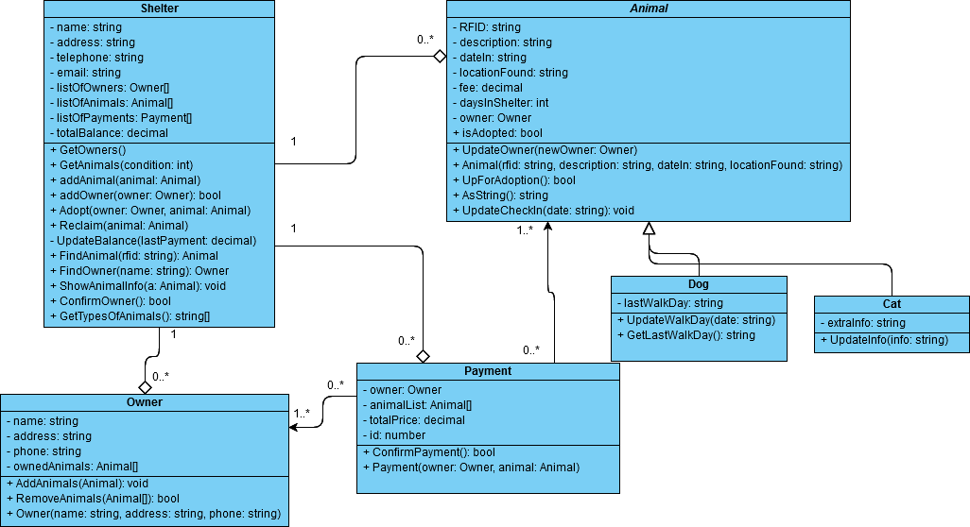V1

**Sequence Diagrams**

**Animal Registration – 2.1**

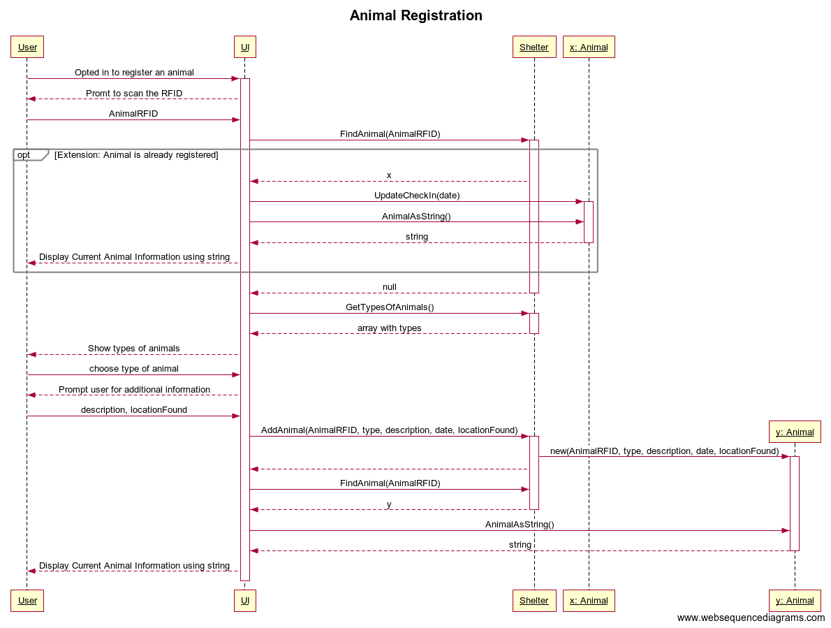

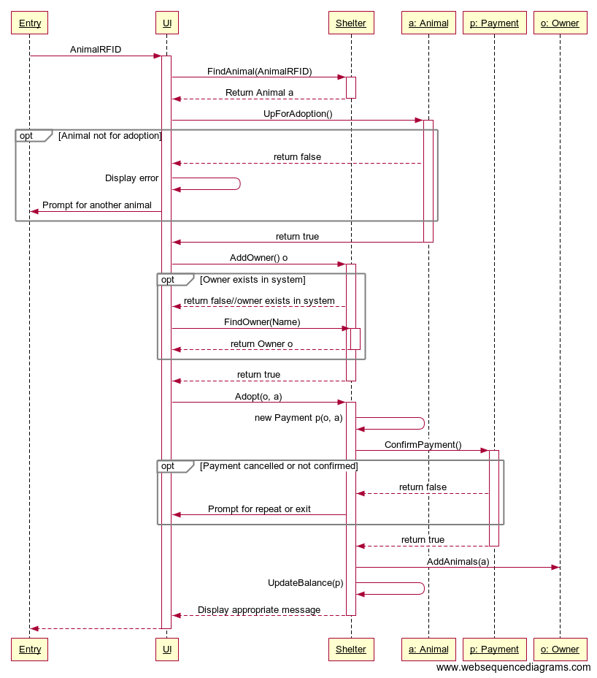**Animal Adoption – 2.2**

**Animal Reclaiming – 2.3**

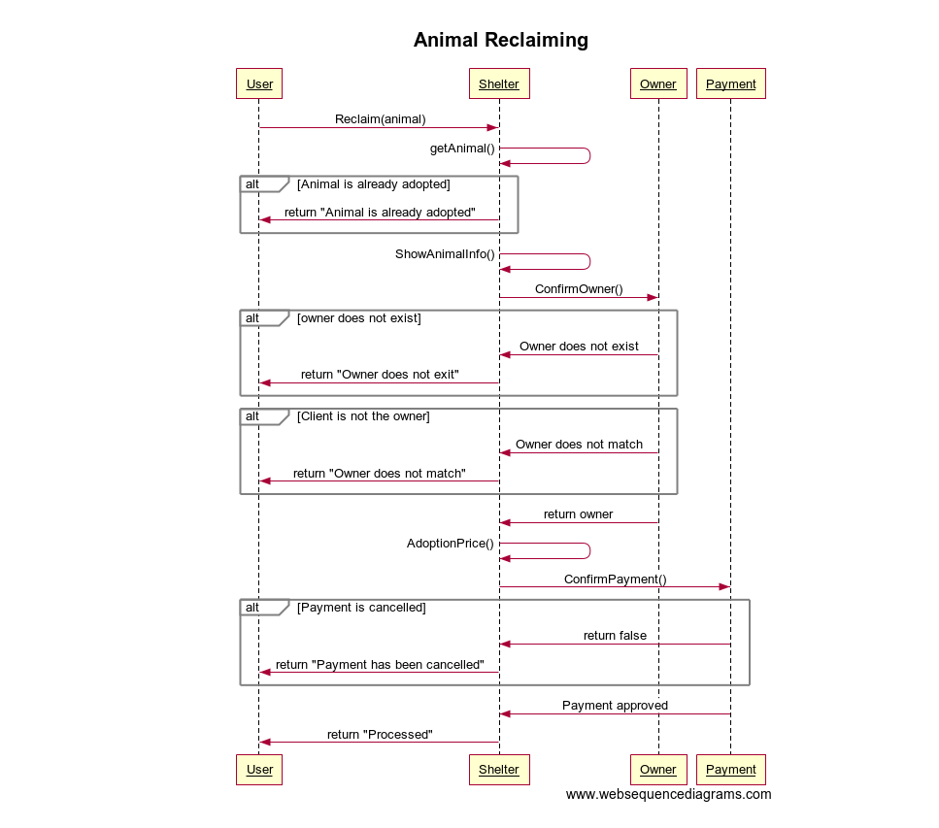

**Walking the dogs – 2.4**

